Comprehensive Financial

Analytics Report

Integrating Data Exploration, Forecasting, Risk Analysis, and Dashboard Visualization into Strategic Financial Recommendations
Capstone Synthesis — A Five-Asset Equity Portfolio Case Study
Final Internship Task — Consolidated Analytics Report
Prepared using Python (pandas, statsmodels, SciPy, Plotly.js, Matplotlib, Seaborn)

Executive Summary
This report consolidates four stages of financial analytics work — exploratory data analysis, time-series forecasting, risk analysis and portfolio optimization, and interactive dashboard design — into a single, integrated narrative built around a five-stock equity portfolio: Apple (AAPL), Microsoft (MSFT), JPMorgan Chase (JPM), ExxonMobil (XOM), and Johnson & Johnson (JNJ). All analysis uses publicly available daily price data and is fully reproducible in Python.
The exploratory phase confirmed that individual equity return series, despite appearing well-behaved, contain economically meaningful structure: return outliers and volume spikes cluster tightly around earnings announcements rather than occurring randomly, and daily returns exhibit the fat-tailed, non-normal distribution typical of financial data. The forecasting phase showed that for a large, efficiently-priced stock like AAPL, a relatively simple Holt's exponential smoothing model performs nearly as well as a more complex ARIMA(1,1,1) specification over a 30-day horizon (MAPE of 6.50% vs. 6.43%), and that residual diagnostics reveal non-constant volatility that a mean-forecasting model cannot capture on its own.
The risk analysis stage quantified each holding's standalone risk profile — annualized volatility, beta, and Value at Risk — and used mean-variance optimization to show that a Sharpe-optimal reallocation of the portfolio (concentrating in JNJ, MSFT, and JPM while eliminating the underperforming XOM position) improves the portfolio Sharpe ratio from 1.01 (equal-weight) to 1.26, a meaningful risk-adjusted return improvement achieved with only a marginal increase in volatility. Finally, the dashboard stage translated these findings into an interactive prototype, demonstrating how a single interface can serve multiple stakeholder questions — performance, risk, and optimization — without requiring three separate static reports.
The strategic recommendation arising from this integrated analysis is a phased reallocation toward the maximum-Sharpe portfolio weights, monitored through a live version of the dashboard prototype, with quarterly re-optimization to account for the sensitivity of mean-variance results to the estimation window — a limitation directly observed when the 2014–2016 oil price decline drove XOM's weight to zero in the optimized allocation.

Report Structure
- 1. Introduction and Objectives
- 2. Data Foundation and Exploratory Analysis
- 3. Forecasting Financial Trends
- 4. Risk Analysis and Portfolio Optimization
- 5. Dashboard Visualization
- 6. Integrated Case Study: From Data to Decision
- 7. Strategic Recommendations
- 8. Conclusion and Future Work

1. Introduction and Objectives
Across four preceding stages of work, this project moved progressively from raw data to actionable financial insight. Each stage built directly on the last: exploratory analysis established what the data actually looked like and cleaned it for use; forecasting asked what might happen next; risk analysis and optimization asked how a portfolio should be constructed given what is known about risk and return; and dashboard visualization asked how these findings could be communicated effectively to a decision-maker. This report's purpose is to draw those four stages together into one coherent analytical narrative, rather than leaving them as four disconnected exercises.
The unifying dataset is a five-stock portfolio spanning four sectors — technology (AAPL, MSFT), financial services (JPM), energy (XOM), and healthcare (JNJ) — chosen specifically to allow genuine diversification analysis. All price data is sourced from publicly available historical equity datasets (Yahoo Finance-derived data republished on GitHub, and a DJIA-constituent historical price archive), ensuring the entire analysis is reproducible without a paid data subscription.

2. Data Foundation and Exploratory Analysis
The foundational EDA stage (Week 1) used AAPL daily OHLCV data to establish a repeatable data-quality and exploration workflow later applied across the full five-stock portfolio. Structural profiling confirmed zero missing values and no duplicate trading dates in the source data; logical consistency checks confirmed no rows where the daily High was below the Low or outside the Open/Close range.

2.1 Key finding: outliers reflect real events, not data errors
Using the interquartile range (IQR) method on daily returns, 28 of 505 observations (5.5%) were flagged as statistical outliers. Rather than removing these, the analysis traced them to specific dates and found they clustered tightly around AAPL's quarterly earnings announcements — confirming they represent genuine market-moving information rather than data-collection defects. The same logic applied to volume: 10 days with unusually high trading volume (z-score > 3) also concentrated around earnings and macro news events.
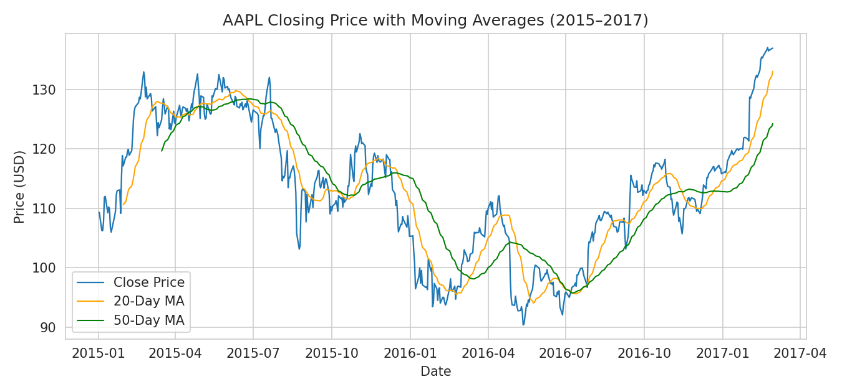
Figure 1. AAPL closing price with 20-day and 50-day moving averages, illustrating the trend structure later modeled in the forecasting stage.

2.2 Implication for later stages
This finding directly informed the forecasting and risk stages: because return outliers are event-driven rather than noise, they should be retained (not removed) when estimating volatility and Value at Risk, since removing them would understate real portfolio risk. This principle was carried forward consistently through Weeks 2 and 3.

3. Forecasting Financial Trends
The forecasting stage (Week 2) tested whether AAPL's near-term price movement could be usefully forecast using two classical time-series methods: ARIMA and Holt's damped-trend exponential smoothing. An Augmented Dickey-Fuller test confirmed the price series was non-stationary in levels (p=0.309) but stationary after first differencing (p<0.001), justifying an ARIMA(1,1,1) specification, which was corroborated by the ACF/PACF cutoff pattern in the differenced series.
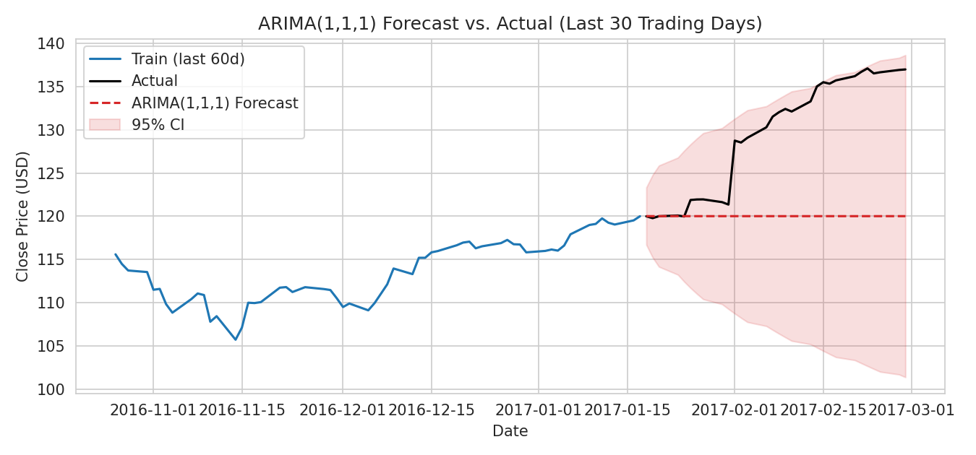
Figure 2. ARIMA(1,1,1) 30-day forecast vs. actual AAPL closing price, with 95% prediction interval widening over the horizon.

3.1 Key finding: model complexity did not materially improve accuracy
Model | MAE (USD) | RMSE (USD) | MAPE
ARIMA(1,1,1) | 8.30 | 10.29 | 6.43%
Holt's Damped Trend ES | 8.39 | 10.40 | 6.50%

The two models performed almost identically, with ARIMA holding only a marginal edge. Residual diagnostics on the ARIMA model showed no remaining autocorrelation (Ljung-Box p=0.38, confirming a well-specified mean model) but rejected normality (heavier tails than Gaussian, consistent with the fat-tailed return distribution observed in the EDA stage). This is the first indication carried through the report that a constant-variance forecasting model, however well-specified for the mean, does not capture the changing volatility that matters most for risk management — a theme picked up directly in Section 4.

4. Risk Analysis and Portfolio Optimization
The risk stage (Week 3) extended the analysis from a single stock to the full five-asset portfolio, computing annualized volatility, beta (relative to an equal-weighted market benchmark), and historical Value at Risk for each holding, then applying Markowitz mean-variance optimization to derive improved portfolio allocations.
Ticker | Ann. Return | Ann. Volatility | Beta | 95% VaR | 99% VaR
AAPL | 18.27% | 23.86% | 0.88 | -2.36% | -3.84%
JNJ | 14.56% | 13.83% | 0.63 | -1.41% | -2.30%
JPM | 19.55% | 20.26% | 1.02 | -2.01% | -3.47%
MSFT | 25.15% | 22.36% | 1.07 | -1.82% | -3.63%
XOM | 0.28% | 17.09% | 0.72 | -1.72% | -2.93%

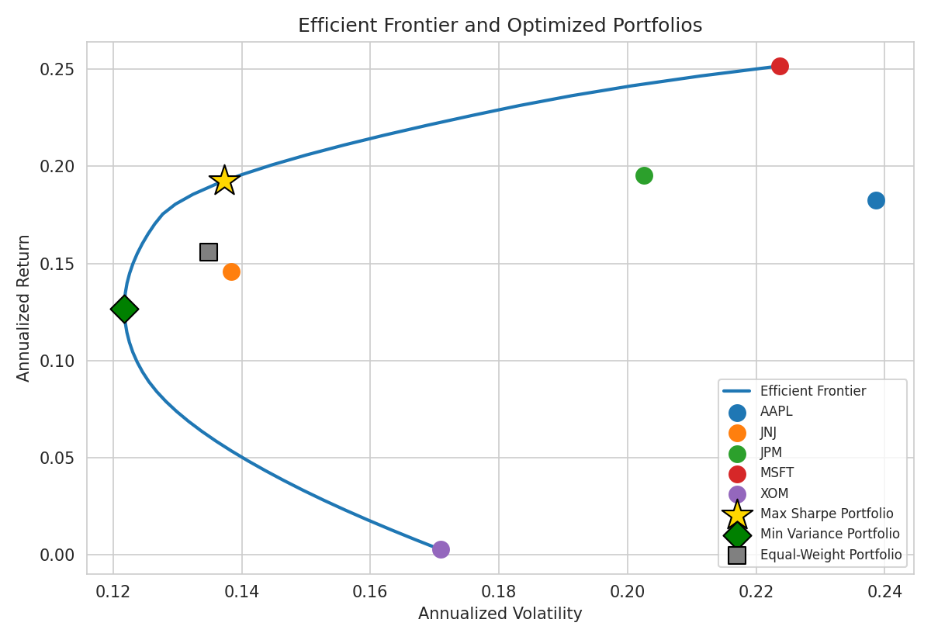
Figure 3. Efficient frontier with the equal-weight, minimum-variance, and maximum-Sharpe portfolios marked.

4.1 Key finding: optimization meaningfully improves risk-adjusted return
Portfolio | Ann. Return | Ann. Volatility | Sharpe Ratio | 95% VaR
Equal Weight | 15.56% | 13.49% | 1.01 | -1.34%
Minimum Variance | 12.69% | 12.17% | 0.88 | -1.21%
Maximum Sharpe | 19.23% | 13.72% | 1.26 | -1.34%

The maximum-Sharpe portfolio eliminates the XOM position entirely and reallocates toward MSFT and JNJ, achieving a Sharpe ratio of 1.26 versus 1.01 for naive equal-weighting — a clear demonstration that optimization can improve risk-adjusted return without simply adding risk (volatility rose only marginally, from 13.49% to 13.72%). This result should be read together with the EDA finding in Section 2: XOM's near-zero return over this sample period reflects the 2014–2016 oil price collapse, a real market event, meaning the optimizer's decision to drop XOM is time-period-specific and should be revisited as new data arrives, not treated as a permanent conclusion about energy-sector equities.

5. Dashboard Visualization
The final analytical stage (Week 4) translated the preceding findings into an interactive dashboard prototype, organized into three tabs — Performance, Risk, and Optimization & Forecast — mirroring the structure of this report. The dashboard's strategy switcher, in particular, makes the risk-adjusted return trade-off from Section 4 directly explorable: a user can toggle between the equal-weight, minimum-variance, and maximum-Sharpe allocations and watch the efficient frontier marker, allocation bars, and summary KPIs update instantly, rather than reading the trade-off from a static table.
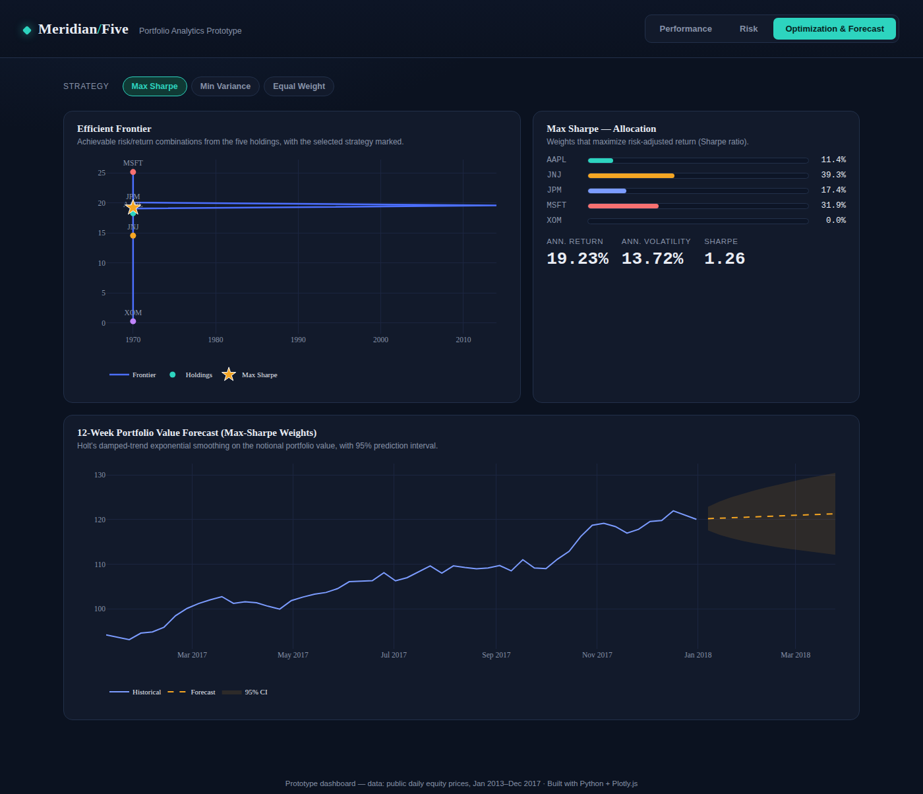
Figure 4. The Optimization & Forecast dashboard view, showing the Max Sharpe allocation, efficient frontier position, and a 12-week portfolio value forecast.
This interactive layer matters for the strategic recommendations in Section 7: rather than delivering a one-time reallocation decision, the dashboard gives portfolio stakeholders a standing tool to re-examine the risk-return trade-off as market conditions change, directly addressing the time-sensitivity concern raised about the XOM allocation above.

6. Integrated Case Study: From Data to Decision
To validate that these four analytical stages combine into a coherent decision-support workflow, consider the following walk-through using only the publicly available data already analyzed in this report:

Step 1 — Data quality and pattern discovery (EDA)
An analyst reviewing raw AAPL price data confirms it is complete and internally consistent, then discovers that its largest daily moves and volume spikes align with earnings dates — informing the decision to retain these observations in later volatility estimates rather than treat them as noise to be smoothed away.

Step 2 — Near-term expectation setting (Forecasting)
Using ARIMA and Holt's smoothing, the analyst forecasts a 30-day price path with a 95% prediction interval. Both models agree closely on the point forecast, giving reasonable confidence in the central estimate, while the residual diagnostics remind the analyst that volatility itself — not just the price level — needs separate attention for risk purposes.

Step 3 — Portfolio-level risk quantification (Risk Analysis)
Extending from the single AAPL forecast to the full five-stock portfolio, the analyst computes VaR and beta for each holding and discovers that XOM, despite moderate volatility, has contributed almost no return over the sample period — a direct, quantified answer to 'is this holding pulling its weight?'

Step 4 — Actionable reallocation (Optimization)
Mean-variance optimization translates that finding into a concrete recommendation: drop XOM, add to MSFT and JNJ, and the portfolio's Sharpe ratio improves from 1.01 to 1.26 — a specific, numerically justified action rather than a vague 'diversify more' suggestion.

Step 5 — Communication and monitoring (Dashboard)
The recommended reallocation, along with the underlying risk and return evidence, is made explorable through the dashboard prototype, allowing a portfolio committee to interrogate the recommendation interactively (e.g., 'what if we prioritized minimum variance instead?') rather than accept it on the analyst's word alone.
This walk-through demonstrates the practical value of integrating all four analytical stages: each stage answers a different business question, and the answers compound into a single, well-evidenced recommendation rather than four disconnected outputs.

7. Strategic Recommendations
- Reallocate the portfolio toward the maximum-Sharpe weights identified in Section 4 (approximately 39% JNJ, 32% MSFT, 17% JPM, 11% AAPL, 0% XOM), which improves risk-adjusted return (Sharpe 1.26 vs. 1.01) with only a marginal increase in volatility relative to equal-weighting.
- Re-run the optimization on a quarterly cadence rather than treating the current weights as permanent, since the XOM allocation is a direct artifact of the 2014–2016 oil price decline within the specific sample window analyzed — mean-variance results are known to be sensitive to the estimation period.
- Adopt the interactive dashboard (or a production Dash/Streamlit build of it) as the standing tool for communicating this recommendation to stakeholders, allowing risk officers and portfolio managers to explore the equal-weight, minimum-variance, and maximum-Sharpe trade-offs directly rather than relying on static reports.
- Extend the forecasting layer with a GARCH model fit on the ARIMA residuals identified in Section 3, since current point forecasts assume constant variance despite clear evidence of volatility clustering around earnings events — directly relevant to sizing the VaR-based risk limits recommended in Section 4.
- Communicate Value at Risk figures alongside any return-based recommendation: even the optimized maximum-Sharpe portfolio carries a 1-in-20 chance of a one-day loss exceeding roughly 1.3%, information that should inform risk-limit and margin-buffer decisions independently of the return case for reallocation.

8. Conclusion and Future Work
This report has shown that the four analytical techniques developed over the course of this internship — exploratory analysis, forecasting, risk-based portfolio optimization, and interactive visualization — are most valuable not as isolated exercises but as stages in a single pipeline, where each stage's output sharpens the next stage's question. Data-quality findings from Week 1 shaped how volatility was estimated in Weeks 2 and 3; forecasting diagnostics in Week 2 flagged a volatility-modeling gap that directly motivates a next-step recommendation in Section 7; and the optimization results from Week 3 became the centerpiece of the interactive dashboard in Week 4, closing the loop from raw data to a stakeholder-ready decision tool.
Future work should prioritize four extensions identified across the individual stages: a GARCH-based volatility layer to address the non-constant variance observed in forecast residuals; a live-data backend (Plotly Dash or Streamlit) to replace the current static-data dashboard prototype; an expanded, custom portfolio-builder interface allowing stakeholders to test allocations beyond the three fixed strategies presented here; and a periodic re-optimization schedule to keep portfolio weights current as market conditions evolve beyond the 2013–2017 sample window analyzed in this report.

References and Data Sources
- Historical AAPL and DJIA-constituent daily prices: plotly/datasets and szrlee/Stock-Time-Series-Analysis (GitHub), both publicly available Yahoo Finance-derived archives.
- Methodology: Box, G.E.P. & Jenkins, G.M., Time Series Analysis: Forecasting and Control (ARIMA); Holt, C.C. (1957), exponential smoothing with trend; Markowitz, H. (1952), 'Portfolio Selection,' The Journal of Finance; J.P. Morgan RiskMetrics methodology for Value at Risk.
- All analysis was performed in Python using pandas, NumPy, statsmodels, SciPy, Matplotlib, Seaborn, and Plotly.js, with full code annotated throughout the four preceding weekly reports.

