NETFLIX
Content Analytics Dashboard
Project Report: Data Summary, Dashboard Walkthrough & Key Findings
Prepared by: Debashis Mahanta
Date: October 2026
Dashboard pages: Home · Catalog Preview · Global Content Dash
8,807  Total Titles | 6,131  Movies | 2,676  TV Shows | 123  Countries

1. Project Overview
This project is an interactive, three-page dashboard that explores Netflix's content catalog. It turns a raw titles dataset into a visual story about what the platform offers, how its catalog has grown over time, and where its content comes from around the world.

Objectives
- Summarise the size and composition of the catalog (movies vs. TV shows).
- Track how content releases have changed over time.
- Identify the most common genres on the platform.
- Compare content production across countries and measure international co-productions.
- Provide filters so any viewer can explore the data on their own.

2. Data Summary
The dataset covers the Netflix titles catalog with release years from 1925 to 2021. The headline figures below are taken directly from the dashboard.
Metric | Value
Total titles | 8,807
Movies | 6,131 (69.62%)
TV shows | 2,676 (30.38%)
Countries represented | 123
Co-productions | 1,320
Release-year range | 1925 – 2021
Top producing country | United States

Fields analysed
- Type: Movie or TV Show.
- Genre: Listed categories such as International Movies, Dramas and Comedies.
- Release year: Used for the time-trend analysis.
- Country: Production country, used for the map, ranking and co-production count.

3. Dashboard Walkthrough
The dashboard has three pages connected by a shared navigation bar: Home, Catalog Preview and Global Content Dash.

Page 1: Home

Figure 1: Home page with navigation
- Landing page with a Netflix-themed background and logo to set the visual identity.
- Navigation links to Catalog Preview and Global Content Dash.
- Dark, red-accented design carried through every page for a consistent brand feel.

Page 2: Catalog Preview
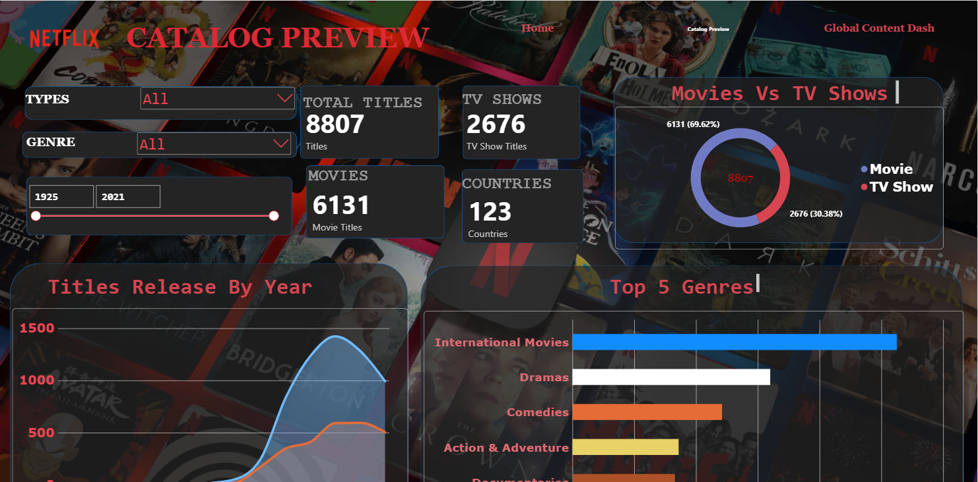
Figure 2: Catalog Preview page
This page answers the question: what is in the catalog?
- Filters: Type (Movie / TV Show), Genre and a release-year slider (1925–2021) that update the visuals.
- KPI cards: Total Titles (8,807), Movies (6,131), TV Shows (2,676) and Countries (123).
- Movies vs TV Shows: Donut chart showing a 69.62% / 30.38% split.
- Titles Release By Year: Area chart comparing movie and TV show releases over time.
- Top 5 Genres: Bar chart ranking the most common genres.

Page 3: Global Content Dash
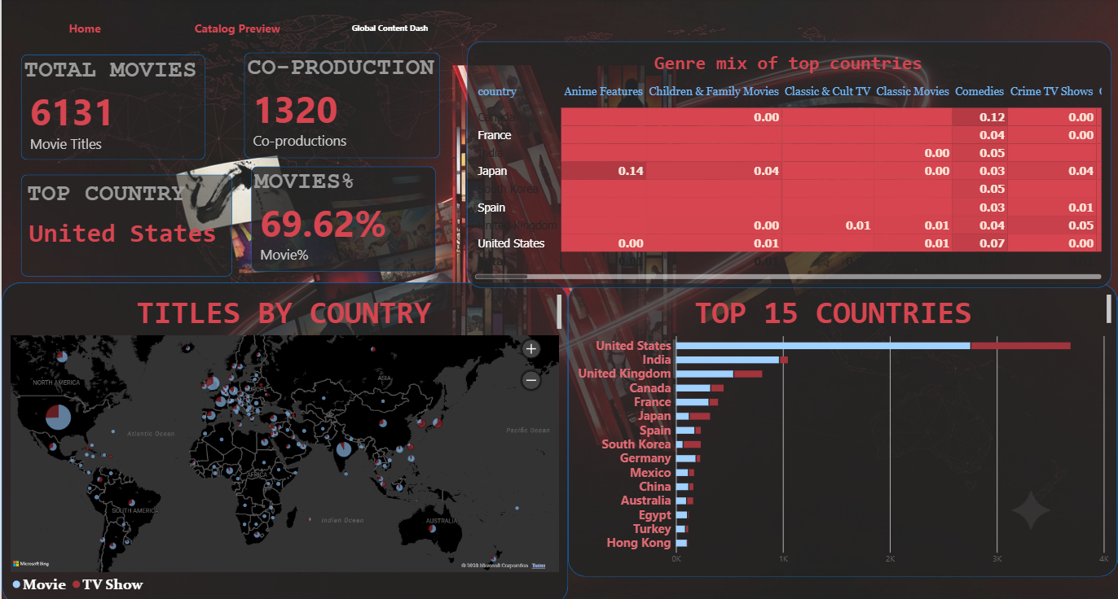
Figure 3: Global Content Dash page
This page answers the question: where does the content come from?
- KPI cards: Total Movies (6,131), Co-production (1,320), Top Country (United States) and Movies % (69.62%).
- Titles by Country: World map with pie-chart bubbles splitting Movie vs TV Show for each country.
- Top 15 Countries: Stacked bar chart ranking countries by title count, split by type.
- Genre mix of top countries: Heatmap matrix showing each top country's share of titles per genre.

4. Key Findings & Analysis

Catalog composition
- Movies make up about 70% of the catalog (6,131 of 8,807), more than double the number of TV shows (2,676).
- The catalog spans nearly a century of releases (1925–2021), but the bulk of titles are recent.

Release trends
- Releases of both movies and TV shows rise sharply in the later part of the timeline, peaking at roughly 1,400 movie titles in a year and about 600 TV titles.
- Movie releases consistently outnumber TV show releases in every period shown.
- The curve flattens at the right edge, likely because the data for the most recent year is incomplete.

Genres
- International Movies is the most common genre, followed by Dramas, Comedies, Action & Adventure and Documentaries.
- The prominence of International Movies points to a deliberate global content strategy.

Geography
- The United States leads by a wide margin, with roughly 3,600+ titles, followed by India and the United Kingdom.
- India's catalog is overwhelmingly movies, whereas South Korea and Japan have a noticeably larger TV show share.
- The remaining top 15 includes Canada, France, Japan, Spain, South Korea, Germany, Mexico, China, Australia, Egypt, Turkey and Hong Kong, showing content from every continent.
- 1,320 titles are co-productions, which shows meaningful cross-border collaboration.

Genre mix by country
- Japan stands out for anime: Anime Features account for about 0.14 of its genre mix, the highest value visible in the heatmap.
- Comedies are a strong share in the United States (about 0.07) and the United Kingdom (about 0.04).

5. Key Takeaways
Theme | Insight
Scale | 8,807 titles from 123 countries.
Format | Movies dominate at 69.62%; TV shows are 30.38%.
Genres | International Movies and Dramas lead the catalog.
Geography | The US is the top producer, with India and the UK next.
Collaboration | 1,320 co-productions highlight global partnerships.

Possible next steps
- Add a time-based view of when titles were added to the platform, not only when they were released.
- Add rating and duration analysis.
- Add director and cast insights.

