Application No: No. of Sheets: 02
Applicant Name: Sheet No: 01/02

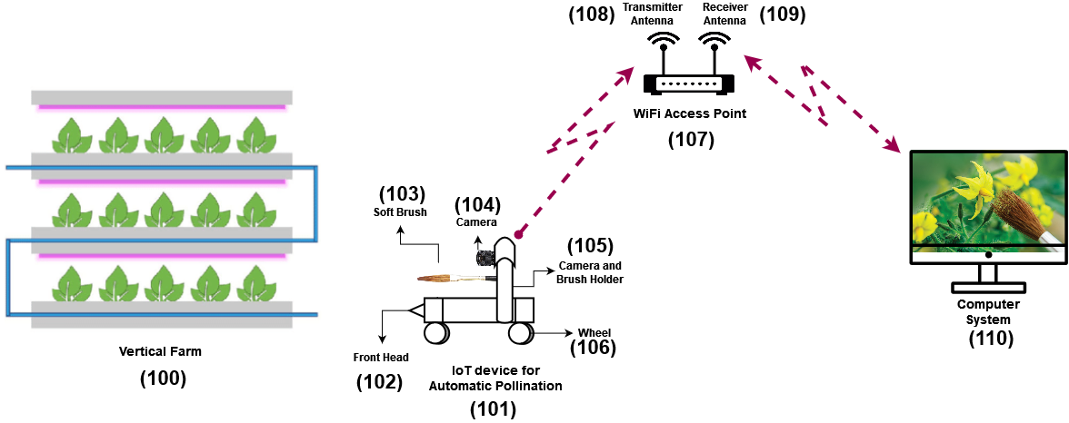

Fig. 1: Schematic diagram of the IoT based automatic pollination for vertical farming.
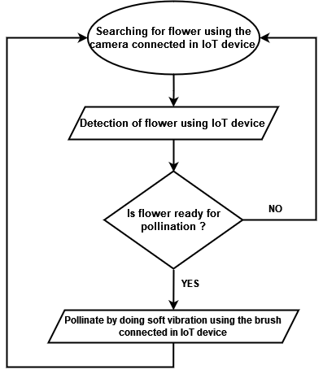

Fig. 2: Schematic flow chart of the overview of the system.


Date: 01/07/2022 Signature of Applicants

Application No: No. of Sheets: 02
Applicant Name: Sheet No: 02/02

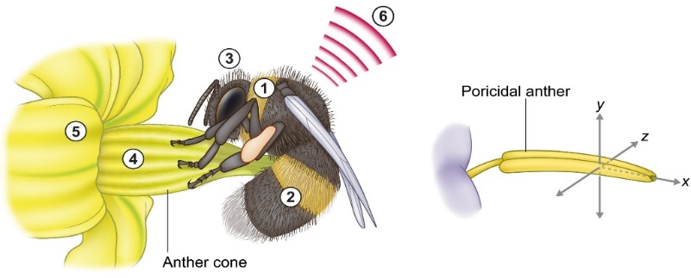
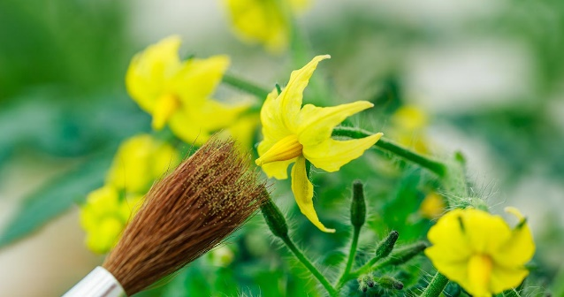

Fig-3: Buzz pollination by bees on tomato flower. Fig-4: Pollination using soft brush.
Fig-5: Schematic diagram of tomato flower and fruit development stages.




Date: 01/07/2022 Signature of Applicants

