- Log In screen
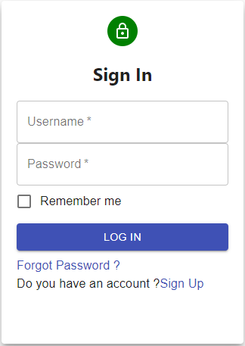
- Reduce the height of User name and password text box
- Caption of log in button should be Log In not LOG IN

- Menu Form
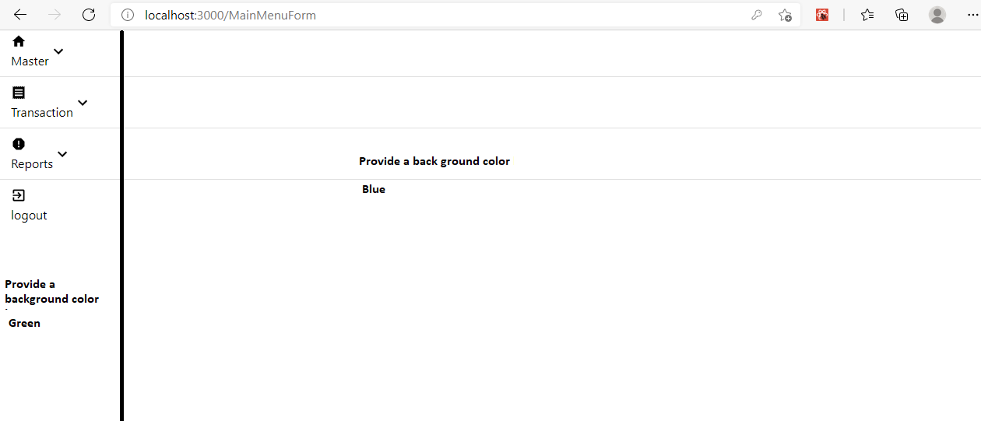
- Draw a Vertical line in black color beside menu item as shown above
- Give back ground color Green on left side and Blue on right side
- On click of Category under master menu the category form should appear
- Category Form

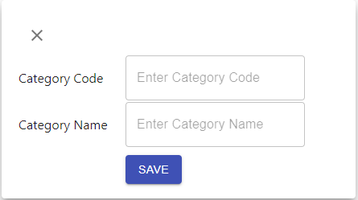

- Reduce the height of Category Code and Category Name text box
- Cross button should appear on right corner
- Clicking the cross button should close the Category Form
- There should be a bar on the top of the form
- In the body of the form give any color.

