EXPERIMENT-02
AIM: To implement linear search in Python and analyze its best, average, and worst cases using medical records from the Breast Cancer Diagnosis dataset..
Theory:
Linear search is used on a collections of items. It relies on the technique of traversing a list from start to end by exploring properties of all the elements that are found on the way.
For example, consider an array of integers of size . You should find and print the position of all the elements with value . Here, the linear search is based on the idea of matching each element from the beginning of the list to the end of the list with the integer , and then printing the position of the element if the condition is `True'.
.
Code:
import pandas as pd
import numpy as np
from sklearn.datasets import load_breast_cancer
import time
dataval=load_breast_cancer()
df=pd.DataFrame(dataval.data)
value=df[3].tolist()
val=float(input("Entre Saple Length"))
start=time.time()
def linearSearch(val):
for i in value:
if(i==val):
return True
return False
end=time.time()
print(linearSearch(val))
print("Time Required:",end-start)
Complexity Analysis:
Best Case = O(1) – If data is present at very first index
Worst Case= O(n) – If data is present at last index or not present at all.

OUTPUT:
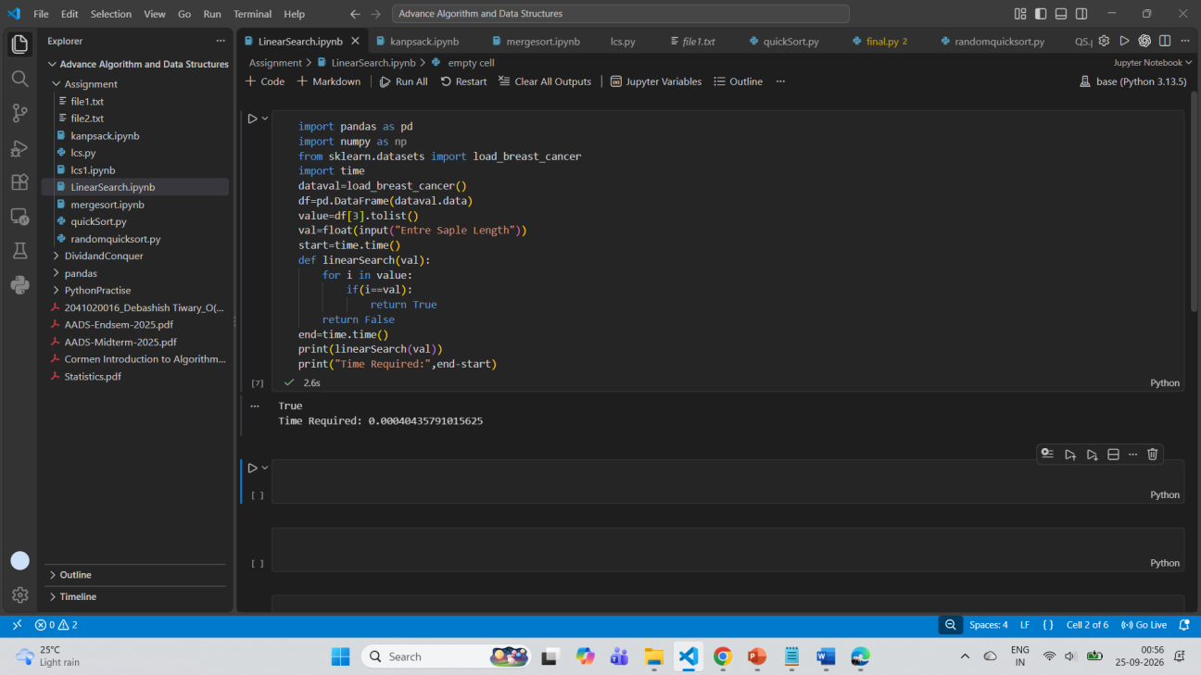

EXPERIMENT-02
AIM: To implement the Fourier Transform using the divide-and-conquer technique in Python.
Theory:
The Fourier Transform converts a signal from the time domain into the frequency domain or vice versa. For example, a signal may contain several frequencies mixed together. In the time domain, these frequencies are difficult to identify. After applying the Fourier Transform, the contribution of each frequency becomes visible. In other words, instead of asking how the signal changes moment by moment, it disentangles which pure tones or repeating patterns are mixed together to make the signal. Think of it like a prism separating white light into its component colors.
For a sequence containing 𝑁samples, the Discrete Fourier Transform is 𝑁−1 𝑋[𝑘] = ∑𝑥𝑛=0
where:
• 𝑥[𝑛]is the input signal.
• 𝑋[𝑘]is the frequency-domain output.
• 𝑁is the number of samples.
• 𝑗=√−1 . [𝑛]𝑒−𝑗2𝜋𝑘𝑛/𝑁
Directly implementing this equation requires approximately 𝑁^2 calculations.
Its time complexity is therefore 𝑂(𝑁^2).
The Fast Fourier Transform (FFT) calculates the same result more efficiently using divide and conquer.
Uses
• Audio and Image Processing: Compresses MP3 files and JPEGs.
• Telecommunications: Decodes Wi-Fi, radio, and digital cable signals.
• Science and Medicine: Powers MRI scans, seismic monitoring, and vibration analysis.
Divide-and-conquer idea: The input sequence is divided into two smaller sequences:
• Samples at even indices
• Samples at odd indices
For example: Input: [1, 2, 3, 4] Even-indexed samples: [1, 3] Odd-indexed samples: [2, 4] The Fourier Transform is recursively calculated for both parts. Their results are then combined using complex exponential factors called twiddle factors. The process is: 1. Divide the input into even- and odd-indexed samples. 2. Recursively calculate the FFT of both parts. 3. Combine their results. 4. Stop when only one element remains. .

.
Code:
import numpy as np
import pandas as pd
import matplotlib.pyplot as plt
#Loading real weather data
file_path = r"Assignment/india_2000_2024_daily_weather.csv"
df = pd.read_csv(file_path)
df["date"] = pd.to_datetime(df["date"])
#Using delhi
city = "Kolkata"
data = (df[df["city"] == city].sort_values("date").reset_index(drop=True))
print("City:", city)
print("Observations:", len(data))
print("Date range:", data["date"].min().date(),"to", data["date"].max().date())
#1)Fourier Series : Temperature Reconstruction
temperature = data["temperature_2m_max"].to_numpy(dtype=float)
N = len(temperature)
t = np.arange(N)
# Approximate number of days in one year

YEAR = 365.2425
# Number of Fourier harmonics
K = 6
# Constant component
a0 = np.mean(temperature)
reconstructed = np.full(N, a0)
for n in range(1, K + 1):
an = (2 / N) * np.sum(temperature *np.cos(2*np.pi*n*t/YEAR)) bn = (2 / N)*np.sum(temperature*np.sin(2*np.pi*n*t/ YEAR))
reconstructed += (an * np.cos(2 * np.pi * n * t / YEAR)+ bn * np.sin(2 * np.pi * n * t / YEAR))
# Calculate errors
rmse = np.sqrt(np.mean((temperature - reconstructed) ** 2)) mae = np.mean(np.abs(temperature - reconstructed))
print("\nFOURIER SERIES")
print("Variable: Daily Maximum Temperature")
print("Harmonics:", K)
print("RMSE:", round(rmse, 3), "°C")
print("MAE :", round(mae, 3), "°C")
# Plot actual vs reconstructed temperature
plt.figure(figsize=(14, 5))
plt.plot(data["date"],temperature,label="Actual Temperature",linewidth=0.7)

plt.plot(data["date"],reconstructed,label="Fourier Series Reconstruction",linewidth=2)
plt.xlabel("Date")
plt.ylabel("Temperature (°C)")
plt.title("Delhi Temperature - Fourier Series Reconstruction") plt.legend()
plt.grid(True)
plt.tight_layout()
plt.show()
#2)DFT/FFT : Rainfall Frequency Analysis
rainfall = data["precipitation_sum"].to_numpy(dtype=float)
# Remove mean
rainfall_centered = rainfall - np.mean(rainfall)
# FFT computes the DFT efficiently
fft_result = np.fft.fft(rainfall_centered)
# Sampling interval = 1 day
frequencies = np.fft.fftfreq(N, d=1)
# Only positive frequencies
positive = frequencies > 0
freq = frequencies[positive]
amplitude = (2 / N) * np.abs(fft_result[positive])

# Strongest frequency
index = np.argmax(amplitude)
dominant_frequency = freq[index]
dominant_period = 1 / dominant_frequency
print("\nDFT / FFT")
print("Variable: Daily Rainfall")
print("Dominant Frequency:",round(dominant_frequency, 8),"cycles/day")
print("Dominant Period:",round(dominant_period, 2),"days")
print("Dominant Period:",round(dominant_period / 30.44, 2),"months")
# Frequency spectrum
plt.figure(figsize=(14, 5))
plt.plot(freq, amplitude)
plt.xlabel("Frequency (cycles/day)")
plt.ylabel("Amplitude")
plt.title("Delhi Rainfall - DFT / FFT Frequency Spectrum")
# Show low-frequency region clearly
plt.xlim(0, 0.1)
plt.grid(True)

plt.tight_layout()
plt.show()
#3)Doing extra fft on temp
temperature_centered = temperature - np.mean(temperature) temperature_fft = np.fft.fft(temperature_centered)
temperature_freq = np.fft.fftfreq(N, d=1)
positive_temp = temperature_freq > 0
temp_freq = temperature_freq[positive_temp]
temp_amplitude = (2 / N *np.abs(temperature_fft[positive_temp])) temp_index = np.argmax(temp_amplitude)
temp_dominant_frequency = temp_freq[temp_index]
temp_dominant_period = 1 / temp_dominant_frequency
print("\nEXTRA FFT")
print("Variable: Temperature")
print("Dominant Frequency:",round(temp_dominant_frequency, 8),"cycles/day")
print("Dominant Period:",round(temp_dominant_period, 2),"days")
# Temperature frequency spectrum
plt.figure(figsize=(14, 5))
plt.plot(temp_freq, temp_amplitude)
plt.xlabel("Frequency (cycles/day)")
plt.ylabel("Amplitude")
plt.title("Delhi Temperature - DFT / FFT Frequency Spectrum")

plt.xlim(0, 0.02)
plt.grid(True)
plt.tight_layout()
plt.show()
#Final Result
print("\nFINAL RESULT")
print("Fourier Series was used to reconstruct the seasonal ""pattern of Delhi's daily maximum
temperature.")
print("DFT/FFT was used to convert the rainfall data from ""the time domain to the frequency
domain.")
print("The dominant frequency was converted into a period ""using: Period = 1 / Frequency.")
print("The results show the periodic components present in ""the real-world weather data.")
OUTPUT:

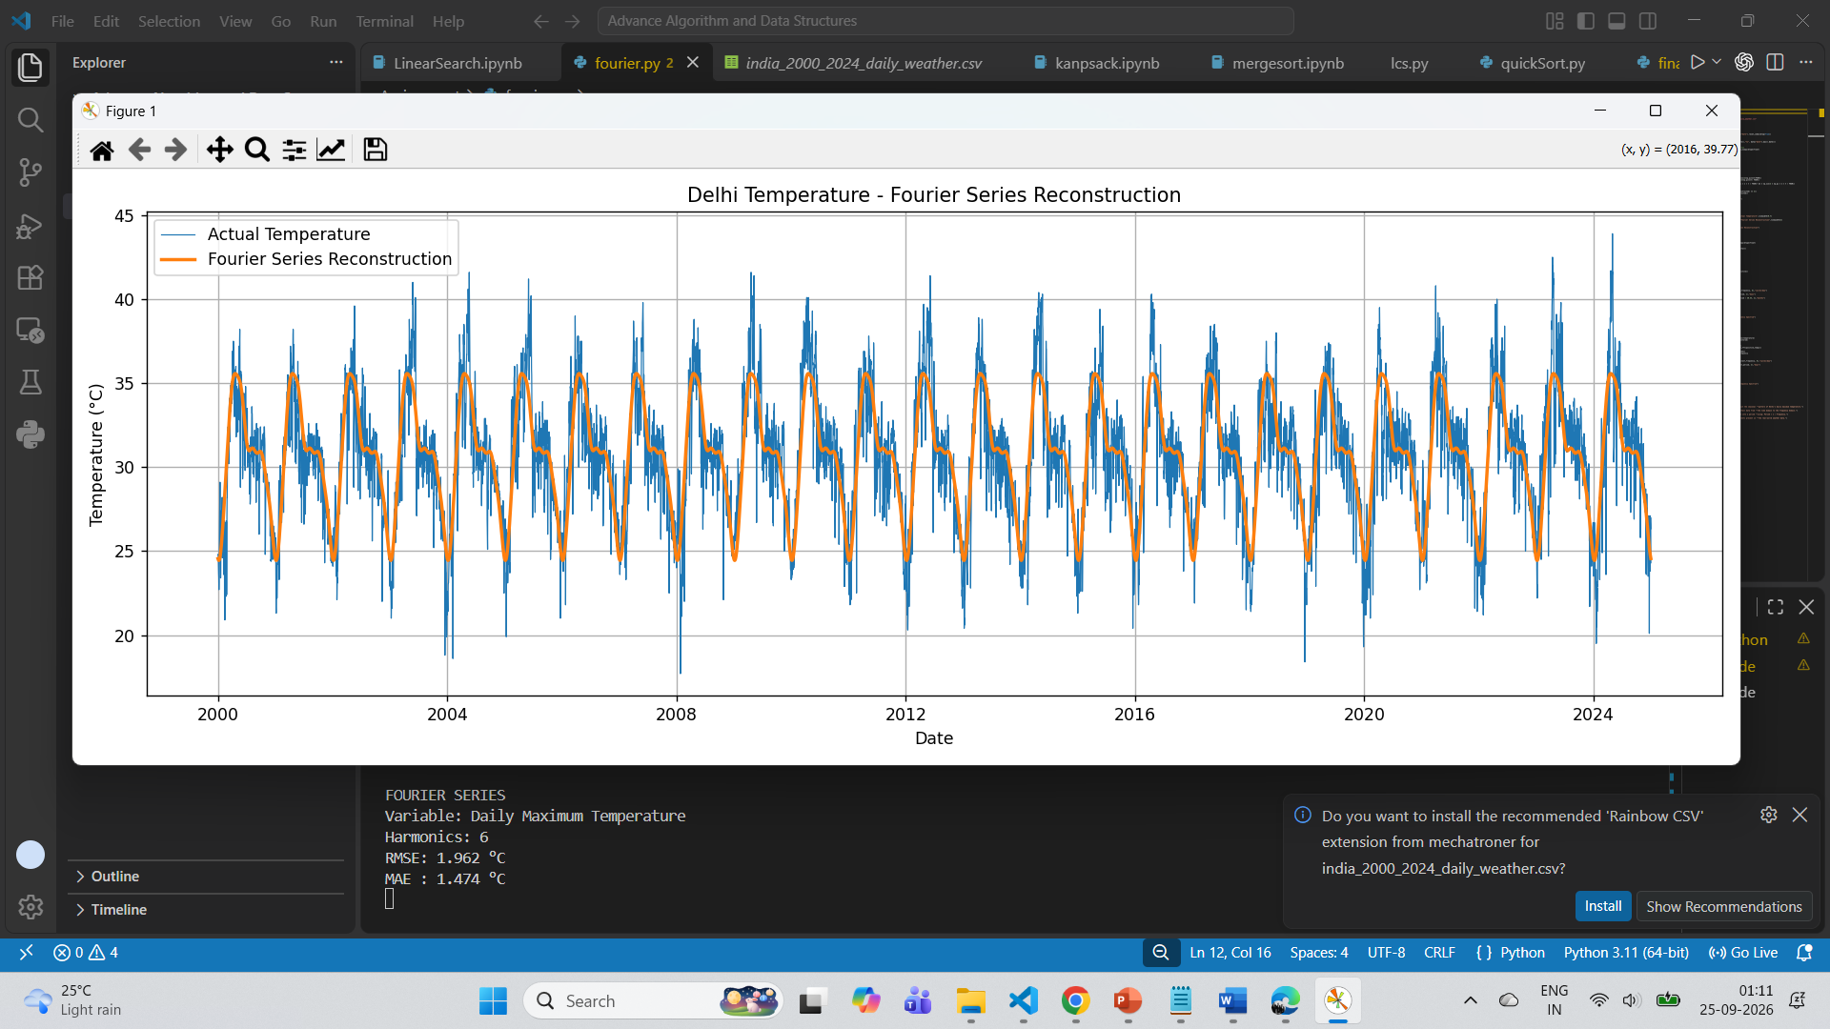
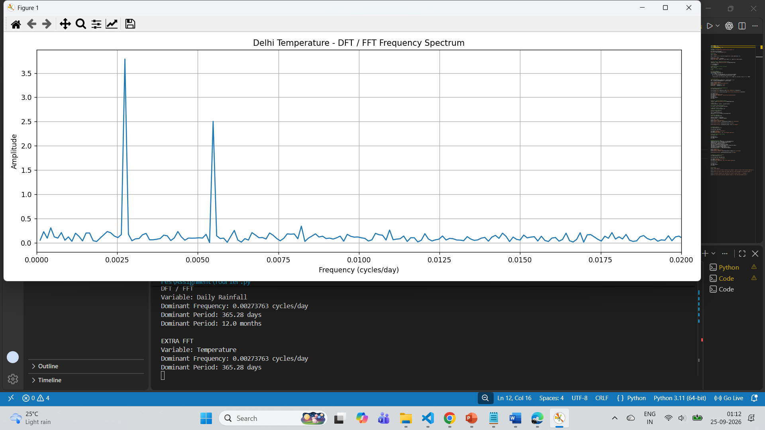

EXPERIMENT-03
AIM: To implement the Merge Sort using the divide-and-conquer technique in Python.
Theory:
Merge sort is a divide-and-conquer algorithm based on the idea of breaking down a list into several sub-lists until each sublist consists of a single element and merging those sublists in a manner that results into a sorted list.
Idea:
• Divide the unsorted list into sublists, each containing element.
• Take adjacent pairs of two singleton lists and merge them to form a list of 2 elements. will now convert into lists of size 2.
• Repeat the process till a single sorted list of obtained.
While comparing two sublists for merging, the first element of both lists is taken into consideration. While sorting in ascending order, the element that is of a lesser value becomes a new element of the sorted list. This procedure is repeated until both the smaller sublists are empty and the new combined sublist comprises all the elements of both the sublists.
Code:
import random
data=[]
for i in range(1,100):
data.append(random.randint(-1000,1000))
print("Unsorted:",data)
def divide(data,left,right):
if(left<right):
mid=(left+right)//2
divide(data,left,mid)
divide(data,mid+1,right)
conquer(data,left,mid,right)
def conquer(data,left,mid,right):
leftpart=data[left:mid+1]
rightpart=data[mid+1:right+1]
i=0

j=0
k=left
while i < len(leftpart) and j < len(rightpart):
if(leftpart[i]<=rightpart[j]):
data[k]=leftpart[i]
i+=1
else:
data[k]=rightpart[j]
j+=1
k+=1
while i < len(leftpart):
data[k] = leftpart[i]
i += 1
k += 1
while j < len(rightpart):
data[k] = rightpart[j]
j += 1
k+=1
divide(data,0,len(data)-1)
print("Sorted:",data)
Complexity Analysis:
Time Complexity: Merge Sort takes O(NlogN) time in all cases considering representation of data in any order
Space Complexity: It takes an extra space of O(N) (N: length of data) and also auxiliary space due to recursion call.
OUTPUT:

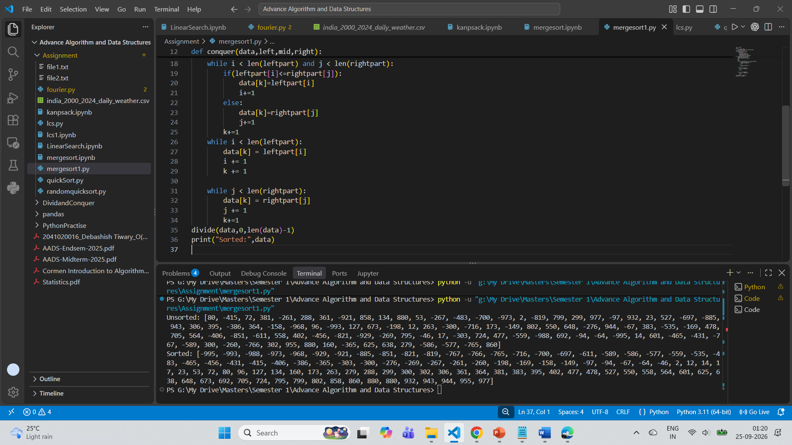

EXPERIMENT-04
AIM: To implement the Topological Sorting is Directed Acyclic Graph in Python.
Theory:
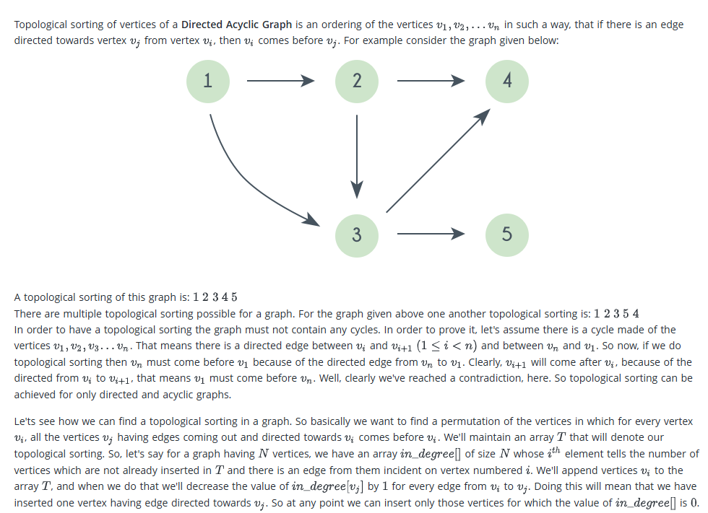
Code:
from collections import defaultdict, deque
class Graph:
def __init__(self, vertices):
self.V = vertices
self.adj = defaultdict(list)
def add_edge(self, u, v):
"""Adds a directed edge from vertex u to vertex v (u -> v).""" self.adj[u].append(v)

def topological_sort(self):
"""Performs Topological Sort using Kahn's Algorithm (Indegree/BFS approach).""" # Step 1: Calculate in-degrees of all vertices
in_degree = [0] * self.V
for node in range(self.V):
for neighbor in self.adj[node]:
in_degree[neighbor] += 1
# Step 2: Queue all vertices with in-degree 0
queue = deque([i for i in range(self.V) if in_degree[i] == 0])
topo_order = []
# Step 3: Process nodes in queue
while queue:
node = queue.popleft()
topo_order.append(node)
# Reduce in-degree of neighboring nodes
for neighbor in self.adj[node]:
in_degree[neighbor] -= 1
if in_degree[neighbor] == 0:
queue.append(neighbor)
# Step 4: Check for cycle dependency
if len(topo_order) != self.V:
print("Error: The graph contains a cycle! Topological sort is not possible.") return []
return topo_order

if __name__ == "__main__":
g = Graph(6)
g.add_edge(5, 2)
g.add_edge(5, 0)
g.add_edge(4, 0)
g.add_edge(4, 1)
g.add_edge(2, 3)
g.add_edge(3, 1)
print("Graph adjacency list:")
for node in range(g.V):
print(f"{node} -> {g.adj[node]}")
print("\nPerforming Topological Sort...")
result = g.topological_sort()
if result:
print("Topological Order:", result)
Complexity Analysis:
Time Complexity: It generally takes O(NlogN) time mainly dominated by the sorting approach that we take.
Space Complexity: It takes an extra space of O(1) or O(N) based on situation or desired outcomes.
OUTPUT:

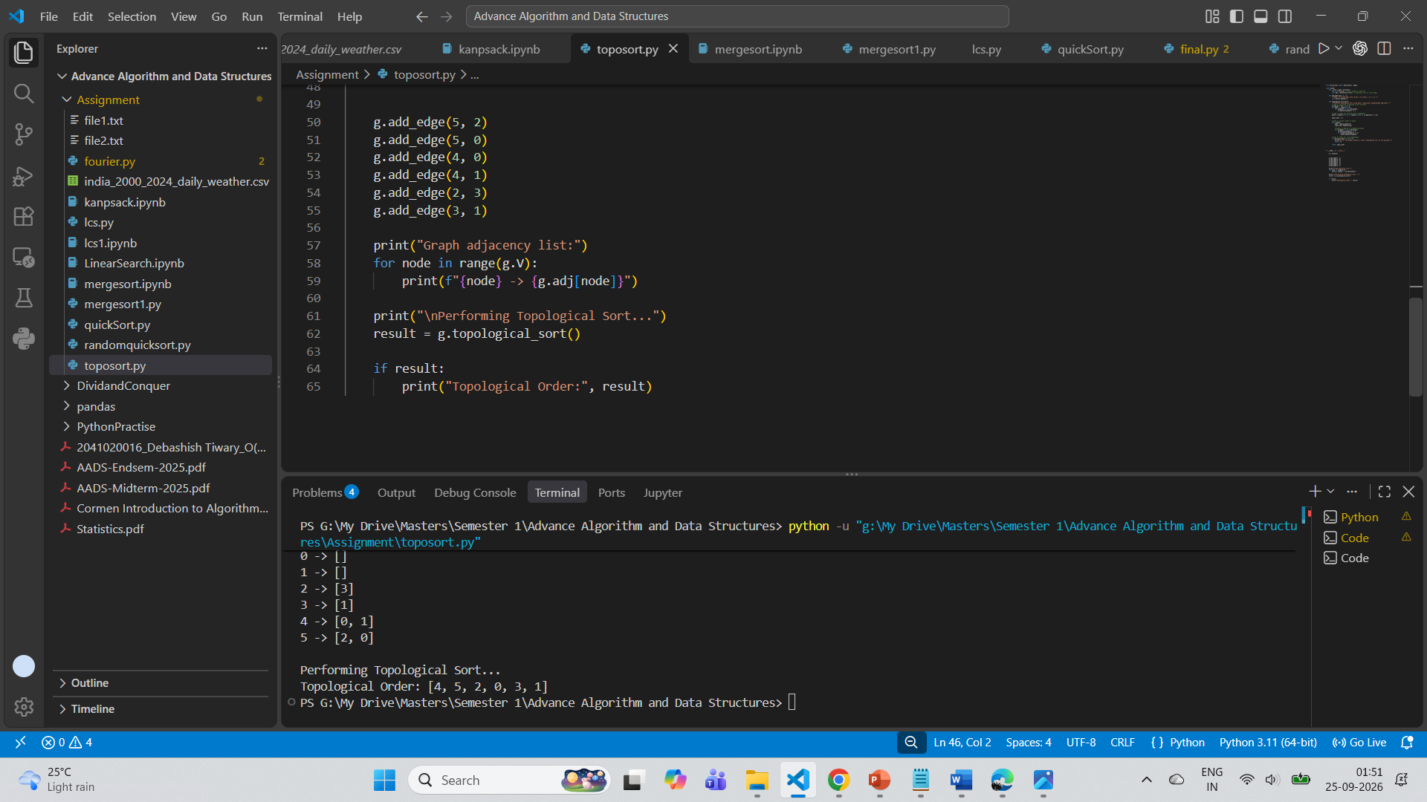

EXPERIMENT-03
AIM: To implement the Quick Sort using the divide-and-conquer technique in Python.
Theory:Quick sort is based on the divide-and-conquer approach based on the idea of choosing one element as a pivot element and partitioning the array around it such that: Left side of pivot contains all the elements that are less than the pivot element Right side contains all elements greater than the pivot
It reduces the space complexity and removes the use of the auxiliary array that is used in merge sort. Selecting a random pivot in an array results in an improved time complexity in most of the cases.
Below is the approach:
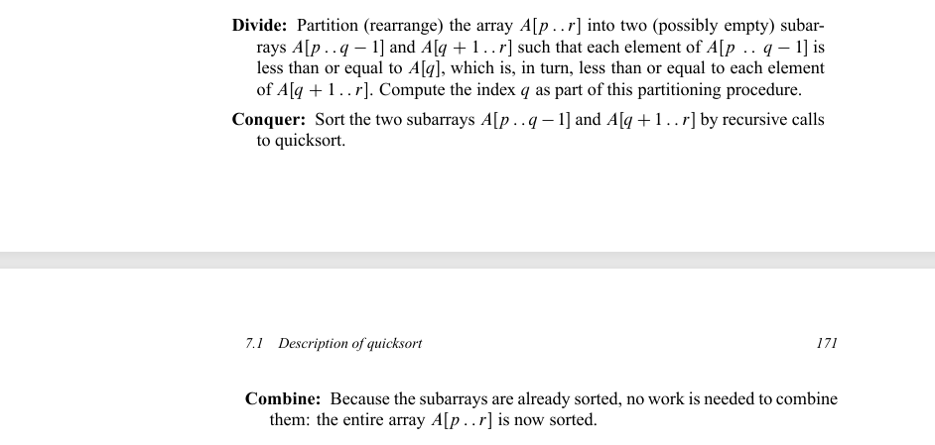
Code:
import random
def partition(low,high,nums):
pivot=low
while(low<=high):
while(low<=high and nums[low]<=nums[pivot]):
low+=1
while(low<=high and nums[high]>nums[pivot]):
high-=1
if(low<high):
swap(low,high,nums)
swap(pivot,high,nums)
return high
def swap(low,high,nums):

temp=nums[low]
nums[low]=nums[high]
nums[high]=temp
def quicksort(low,high,nums):
if(low<high):
partition_point=partition(low,high,nums)
quicksort(low,partition_point-1,nums)
quicksort(partition_point+1,high,nums)
def main():
list=[]
for i in range(0,100):
list.append(random.randint(-100,100))
print("Unsorted:",list)
quicksort(0,len(list)-1,list)
print("Sorted:",list)
if __name__ == "__main__":
main()
Randomized Quick Sort:
import random
def partition(low,high,nums):
pivot=random.randint(low,high)
while(low<=high):
while(low<=high and nums[low]<=nums[pivot]):
low+=1
while(low<=high and nums[high]>nums[pivot]):
high-=1
if(low<high):
swap(low,high,nums)
swap(pivot,high,nums)

return high
def swap(low,high,nums):
temp=nums[low]
nums[low]=nums[high]
nums[high]=temp
def quicksort(low,high,nums):
if(low<high):
partition_point=partition(low,high,nums)
quicksort(low,partition_point-1,nums)
quicksort(partition_point+1,high,nums)
def main():
list=[]
for i in range(0,100):
list.append(random.randint(-100,100))
print("Unsorted:",list)
quicksort(0,len(list)-1,list)
print("Sorted:",list)
if __name__ == "__main__":
main()
Complexity Analysis:
Time Complexity: Quick Sort takes O(N^2) time in worst cases(for already for almost sorted data) whereas the avg case is O(NlogN) N- size of data
Space Complexity: It takes an extra space of O(1) but auxiliary space due to recursion call.
OUTPUT:

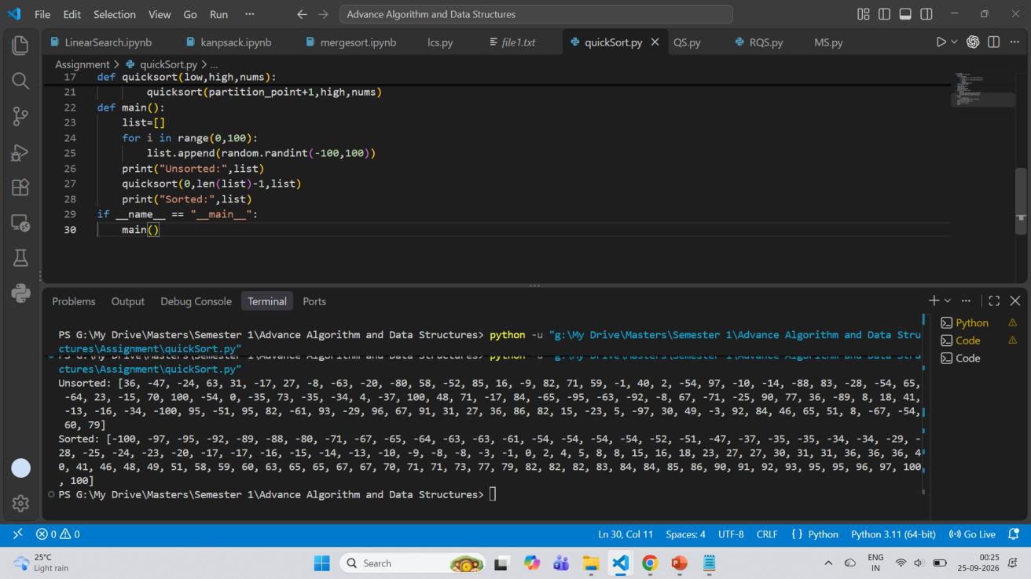
Using randomised way:
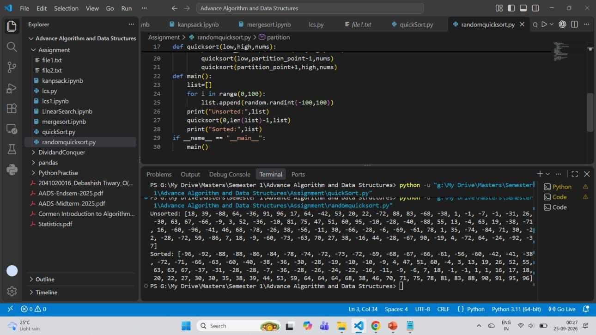

EXPERIMENT-06
AIM: To implement the Fractional Knapsack using the Greedy Approach technique in Python.
Theory:
The Fractional Knapsack problem is a classic optimization problem in computer science where the goal is to fill a container (a "knapsack") with a combination of items to maximize the total value without exceeding the knapsack's weight capacity.
The idea is to always pick items greedily based on their value-to-weight ratio. Take the item with the highest ratio first, then the next highest, and so on, until the knapsack is full. If any item doesn’t fully fit, then take its fractional part according to the remaining capacity.
Steps to solve the problem:
1.Calculate the ratio (value/weight) for each item.
2.Sort all the items in decreasing order of the ratio.
3.Iterate through items:
if the current item fully fits, add its full value and decrease capacity otherwise, take the fractional part that fits and add proportional value.
4.Stop once the capacity becomes zero
Code:
data=[['A',6000,650],['B',5750,700],['C',4000,500],['D',3000,300]] for i in data:
i.append(i[2]/i[1]*100)
data=sorted(data,key= lambda x:x[3],reverse=True)
fund = int(input("Entre Fund Amount"))
def knapsack(data,fund):
totalreturn=0
for i in data:
if(fund>0 and fund//i[1]!=0):
totalreturn+=i[2]
fund=fund-i[1]
elif(fund>0):
totalreturn+=(fund*i[3]/100)
fund=0

return totalreturn
Complexity Analysis:
Time Complexity: It generally takes O(NlogN) time mainly dominated by the sorting approach that we
take.
Space Complexity: It takes an extra space of O(1) or O(N) based on situation or desired outcomes.
OUTPUT:
