Social Media Engagement & Sentiment Analysis Dashboard

For
Data Analytics Using Tableau(CUML1023)
by
Debashish Panda (240720100091)
Priyadarsani Panda (240720100059)

Under the Supervision of
Mr. Tanmay Kumar Panda


SCHOOL OF ENGINEERING AND TECHNOLOGY BHUBANESWAR CAMPUS
CENTURION UNIVERSITY OF TECHNOLOGY AND MANAGEMENT
ODISHA 2025-2026

DEPARTMENT OF MASTER IN COMPUTER APPLICATION
SCHOOL OF APPLIED SCIENCE
BHUBANESWAR CAMPUS

BONAFIDE CERTIFICATE

It is to certify that this project report ”Social Media Engagement & Sentiment Dashboard” is the bonafide work of “Debashish Panda, Priyadarsani panda” who carried out the project work under my supervision. This is to certify that this project has not been carried out earlier in this institute and the university to the best of my knowledge.

(Mr. Tanmay Kumar Panda) Teaching Associate, Dept. of MCA, SoAs

Certified that the project mentioned above has been duly carried out as per the college’s norms and the university’s statutes.

Dr. Sujata Chakravarty Mr. Rakesh kumar Ray Dean, SoET HoD, Dept. of Mca, SoAs

DECLARATION

We hereby declare that the project entitled “Social Media Engagement & Sentiment Dashboard” submitted for the “Data Analytics Using Tableau” of 3rd semester of Master in Computer Application our original work and the project has not formed the basis for the award of any Degree / Diploma or any other similar titles in any other University
/ Institute.

240720100091 | Debashish Panda
240720100059 | Priyadarsani Panda

Place: Bhubaneswar Date:

ACKNOWLEDGEMENTS

We wish to express our profound and sincere gratitude to Mr. Tan may Kumar Panda, Department of MCA, SoAs, Bhubaneswar Campus, who guided me into the intricacies of this project nonchalantly with matchless magnanimity.
We thank Prof. Rakesh kumar Ray, Head of the Dept. of De partment of Master in Computer Application, SoAs, Bhubaneswar Campus and Prof. Sujata Chakrabarty, Dean, School of Engineering and Technology, Bhubaneswar Campus for extending their support during the course of this investigation.
We would be failing in my duty if we didn’t acknowledge the cooperation rendered during various stages of Data Visualization interpretation by Mr. Tanmay Kumar Panda .
Weare highly grateful to Mr. Tanmay Kumar Panda who evinced keen interest and invaluable support in the progress and successful completion of our project work.
We are indebted to Mr. Tanmay Kumar Panda for their constant encouragement, cooperation, and help. Words of gratitude are not enough to describe the accommodation and fortitude that they have shown throughout our endeavor.

240720100091 | Debashish Panda
240720100059 | Priyadarsani Panda

Place: Bhuabaneswar Date:

Abstract
” The "Social Media Engagement & Sentiment Analysis" project is designed to provide critical insights into social media performance through a specialized Tableau dashboard system. This tool is essential for stakeholders, including marketing managers, HR, and executives, to make informed, data-driven decisions by analyzing audience engagement and sentiment trends. By integrating and visualizing complex social media data, the dashboards offer a comprehensive view of a brand's online presence and public perception.
The platform features two distinct dashboards: Engagement and Sentiment. The Engagement Dashboard provides a detailed overview of key performance indicators such as total likes, comments, shares, and overall engagement rates. It enables users to track these metrics on a monthly basis to identify growth or decline , pinpoint top-performing posts and content types , and compare performance across different social media platforms like Instagram, Twitter, and Facebook.
Complementing this, the Sentiment Dashboard focuses on audience emotions and brand perception by displaying the distribution of positive, negative, and neutral sentiments. This allows teams to understand customer feedback patterns, monitor sentiment trends over time, and identify spikes in public emotion. Furthermore, it provides insights into the specific keywords and hashtags driving these sentiments, helping to refine brand messaging and campaign strategies. The interactive design allows users to dynamically filter data by date range, platform, and content type, as well as drill down into specific data points for deeper analysis. Ultimately, this Tableau project empowers organizations to optimize their social media strategy, improve brand positioning, and foster more effective audience interactions.
he system's strength lies in its interactivity, allowing users to dynamically filter data by date range, platform, and content type, and drill down for deeper analysis. This integrated tool provides a holistic view, enabling a proactive approach to brand management. By correlating high engagement with sentiment data, stakeholders can distinguish between viral success and a potential brand crisis. This strategic advantage allows for the rapid optimization of content and timely response to public feedback, ultimately empowering the organization to build a stronger, more positive brand community.

Contents
Bonafide Certificate i
Declaration ii
Acknowledgements iii
Abstract iii
- Introduction 5
- Litreture Survey 6
- Proposed Method 7
- Results & Discussion 8
  - Dataset & Experimental setup 9
  - Results 10
- Conclusion 18
- Future Scope 19

List of Figures
- Engagement Trend Over Time (Line) 10
- Peak Engagement Hours (Line chart) 11
- Platform Comparison(Bar chart) ..11
- Engagement by Content Type (Donut) ..12
- Sentiment Percentage (Pie chart) 13
- Sentiment Percentage (Line chart) 13
- Top Positive & Negative Hashtags (Bar chart) 14
- Sentiment by Platform (Stacked Bar chart) 15
- Social Media Engagement Dashboard 16
- Social Media Sentiment Dashboard 17
- Reference 20

Introduction
“Social Media Engagement & Sentiment Analysis” involves the collection, analysis, and visualization of data from social platforms like Twitter, Instagram, and Facebook to monitor brand performance, audience engagement, and public sentiment. By leveraging advanced analytics tools like Tableau, organizations can gain critical insights into marketing effectiveness, content performance, and overall brand perception. This data tracking spans various domains, including engagement metrics (likes, shares, comments), audience demographics, sentiment trends (positive, negative, neutral), and content-type performance. This enables key stakeholders, such as marketing managers, HR, and executives, to make informed decisions that improve brand strategy and audience interaction.
For example, tracking engagement rates across different content types (e.g., video, image, text) can highlight top-performing posts and guide future content creation. Simultaneously, analyzing sentiment trends over time can reveal public reaction to marketing campaigns or brand announcements in real time. By visualizing these data points through intuitive dashboards, managers can quickly assess the status of Key Performance Indicators (KPIs), monitor competitive performance, and make data-driven decisions that optimize social media strategies.
Social Media Analytics plays a vital role in improving brand positioning, understanding customer feedback, and enhancing audience engagement. It enables marketing and HR teams to act proactively in managing brand reputation, optimizing advertising spend, and improving customer service interactions. Additionally, it supports the real-time monitoring of public sentiment, allowing for rapid responses to emerging market trends, customer complaints, or potential public relations crises.
Tableau offers a robust platform for visualizing and analyzing complex social media data, integrating information from diverse platforms into a unified view. With its powerful data visualization capabilities, Tableau allows for the creation of specific KPI dashboards to track metrics such as total likes, comments, shares, engagement rates, and the distribution of positive, negative, and neutral sentiment. These interactive dashboards provide stakeholders with real-time insights and customizable reports, enabling them to monitor performance, identify at-risk areas, and understand audience emotions efficiently.
By leveraging Tableau’s advanced analytics and interactive features, organizations can identify the specific keywords and hashtags driving customer emotions, compare performance across different platforms, and drill down into specific posts for deeper insights. This empowers decision-makers to optimize marketing campaigns, improve brand perception, and ultimately build stronger, more engaged online communities.

Litreture Survey
Social Media Analytics has evolved significantly over the past decade, especially with the advancement of analytics and visualization tools. Such tools have enabled marketing and communication professionals to transition from manual, fragmented data collection (like counting followers or likes) to robust, integrated systems that allow for real-time analysis and strategic response. The literature increasingly points to the critical role of data visualization platforms like Tableau in enhancing brand monitoring and strategic decision-making. By tracking key performance indicators (KPIs) such as engagement rates, content performance, and audience sentiment, these tools support both routine brand health surveillance and dynamic campaign management.
Studies have shown that data visualization has been transformative for social media tracking. McAfee and Brynjolfsson (2012) argue that visual analytics tools like Tableau help marketing managers and executives make rapid, data-driven decisions by simplifying complex data (such as thousands of daily comments and interactions) into accessible, clear visuals. These tools democratize data access, enabling stakeholders across the organization—from social media coordinators to senior executives and HR—to interpret and act on data insights efficiently. This, in turn, facilitates better marketing budget allocation, content strategy adjustments, and customer service interventions.
KPI Tracking and Sentiment Analysis in Brand Management
KPI tracking is essential in monitoring various social media indicators, including likes, shares, comments, engagement rates, and overall brand sentiment. Chen et al. (2012) discuss how visual analytics tools like Tableau can enhance the real-time tracking of these KPIs. By aggregating data from multiple, diverse sources, such as Twitter, Instagram, and Facebook, Tableau creates dashboards that offer a consolidated view of brand performance. Pang and Lee (2008) further demonstrate how sentiment analysis is crucial for categorizing unstructured customer feedback into positive, negative, and neutral sentiments. These dashboards allow marketing teams to understand the "why" behind the engagement numbers, identify key topics driving audience emotions, and allocate creative resources more effectively.
Data Visualization in Brand Reputation and Crisis Management
Brand reputation management is another critical area where data visualization plays a significant role. Sodhi and Tang (2012) highlight how global disruptions, which now include viral social media trends and crises, necessitate proactive reputation management. Tableau enables organizations to blend engagement data with sentiment data to create

interactive dashboards for brand health assessment. These dashboards can identify high-risk keywords or hashtags associated with negative sentiment, track the velocity of customer complaints, and monitor audience reactions in real-time. By visualizing these risk indicators (such as a sudden spike in negative sentiment), marketing and HR teams can implement mitigation strategies and contingency plans to reduce the impact of a public relations emergency.

Proposed Method
The proposed method for the Social Media Engagement & Sentiment Analysis dashboard follows a structured data pipeline. This process begins with collecting raw data from various social platforms, followed by cleaning and processing, then moving to in-depth analysis. The analyzed data is then visualized in Tableau to create two primary interactive dashboards. Finally, these dashboards provide actionable insights for stakeholders like marketing, HR, and executives.
The diagram below outlines the flow of data from its source to the final actionable insights.
Data Sources (Data Collection)
To build the engagement and sentiment dashboards as specified in the user story, the following data sources will be collected and integrated:
- Social Media Platform Data: Gather real-time and historical data for all brand posts (including text, images, and videos) from the target social media platforms (e.g., Twitter, Instagram, Facebook) using their respective APIs.
- Engagement Metrics: Collect post-level interaction data associated with each piece of content. This includes quantitative metrics such as total likes, comments, shares, video views, and reach.
- Sentiment & Text Data: Collect the raw text from all user comments and brand mentions. This text data will be processed through a sentiment analysis model to be classified as positive, negative, or neutral.
- Content & Campaign Data: Include internal metadata for each post, such as the content type (image, video, text), the specific marketing campaign it belongs to, and the exact date and time it was published.
- Keyword and Hashtag Data: Extract and aggregate all keywords and hashtags used in brand posts and user comments. This data is essential for identifying the specific topics and trends that are driving audience engagement and sentiment.

Results & Discussion

Dataset & Experimental setup
This section provides an overview of the dataset used for the 'Social Media Engagement & Sentiment Analysis' in Tableau. In this project, a primary, consolidated dataset was utilized. The name of the dataset is 'social_media_Sentiment_Analysis.csv', which contains 9,075 rows and 17 columns. This single, comprehensive dataset aggregates all necessary information for the project, including post details, platform, engagement metrics (likes, comments, retweets/shares), follower counts, and pre-calculated sentiment classifications (Positive, Negative, Neutral). This consolidation simplifies the data model and allows for direct analysis within Tableau.
Key Metrics Used in Dashboard Creation:
As per the project's user story, two main dashboards were created (Engagement and Sentiment). The key visualizations and metrics include:
- KPI Scorecards: Displaying summary totals for Likes, Comments, Shares, and Engagement Rate.
- Monthly Engagement Trends (Line Chart): Tracking total engagement over time to identify growth or decline.
- Engagement by Platform (Bar Chart): Comparing performance across Twitter, Instagram, Facebook, and YouTube.
- Overall Sentiment Distribution (Donut Chart): Showing the percentage breakdown of Positive, Negative, and Neutral sentiment.
- Sentiment Trends Over Time (Area Chart): Visualizing the change in sentiment volume (Positive vs. Negative) on a monthly basis.
- Top Performing Posts (Bar Chart): Identifying specific content driving the highest engagement.
- Top Keywords/Hashtags by Sentiment (Tree Map): Highlighting terms most associated with positive and negative feedback.
- Sentiment Distribution by Platform (Stacked Bar Chart): To identify which platforms are driving specific types of sentiment.
These visualizations collectively help stakeholders understand brand performance, audience interaction, and public perception in real-time. They allow marketing and HR teams to quickly assess content effectiveness, understand customer feedback, and make data-driven decisions.

The table below lists the key metrics used in the dashboard creation, which focus on describing the engagement and sentiment visualizations from the social media dataset. I created the same line charts, bar charts, area charts, and donut charts, and finally, I combined them into the two required dashboards.
Overview :

Dataset name
  Social Media Engagement & Sentiment Analysis
Total ROWs | 9,075
Total Columns | 17
Dashboard
  2 (Engagement & Sentiment)
Total Graphs | 8
Table 1: Social Media Engagement & Sentiment Analysis

Results
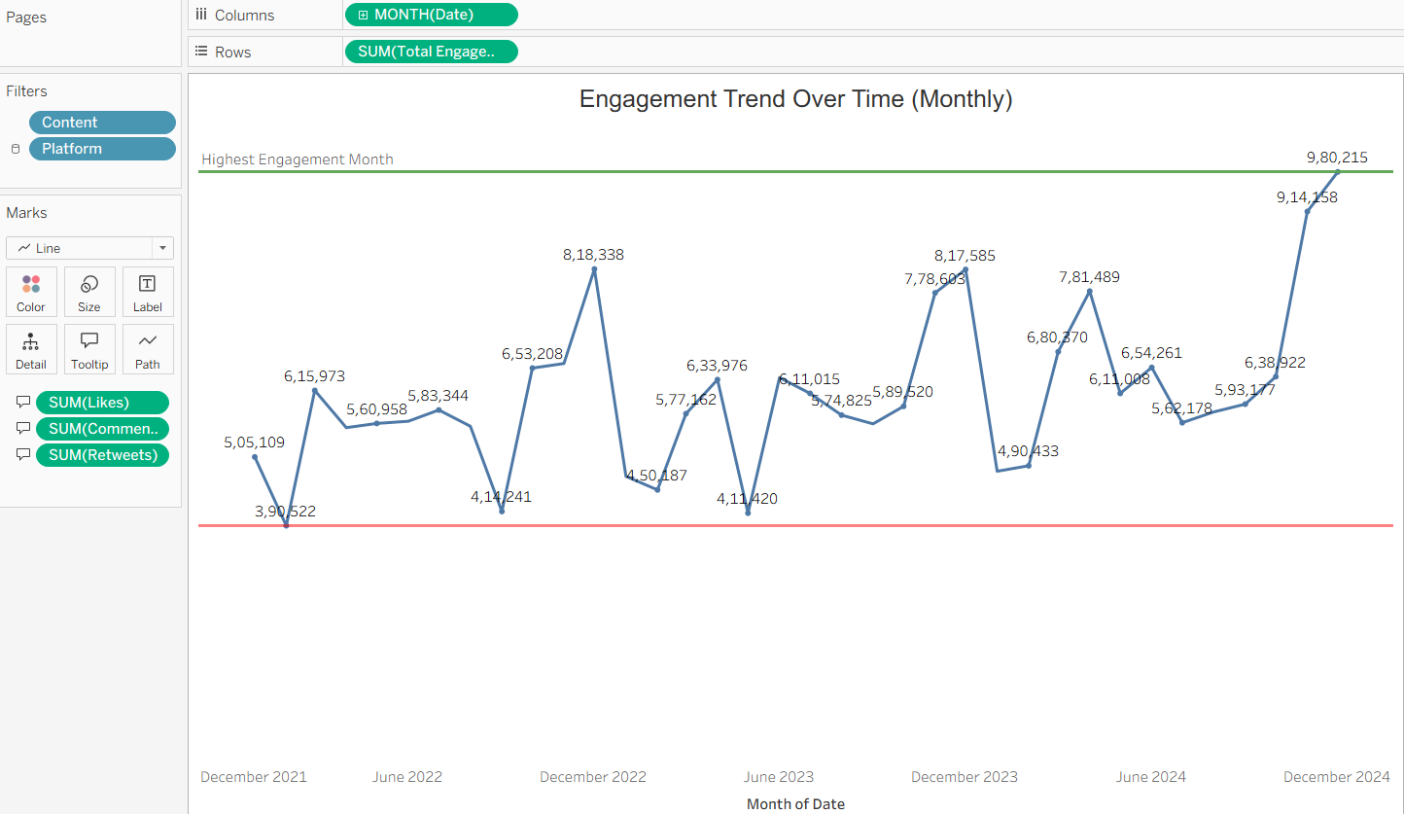
Figure 1: Engagement Trend Over Time (Line)
The image depicts a Tableau visualization, specifically a combination chart titled "Total Engagements Over Time." This chart tracks and correlates social media engagement with audience sentiment over a three-year period. The X-axis represents the timeline, showing the "Month of DateTime" from January 2022 to December 2024.
The chart utilizes dual Y-axes to compare two different types of metrics: the left Y-axis shows the count for "Total Sentiments" (scaled 0-800), while the right Y-axis shows the count for "Total Engagements" (scaled 0-18,000). A blue line represents the "Total Engagements," while green and red area charts represent "Positive" and "Negative" sentiments, respectively. The data shows several significant peaks in engagement, most notably in September 2023 and September 2024. A key insight from this chart is the close correlation between the "Total Engagements" line and the "Positive" sentiment area, suggesting that high-engagement periods are driven by positive audience feedback rather than negative reactions.

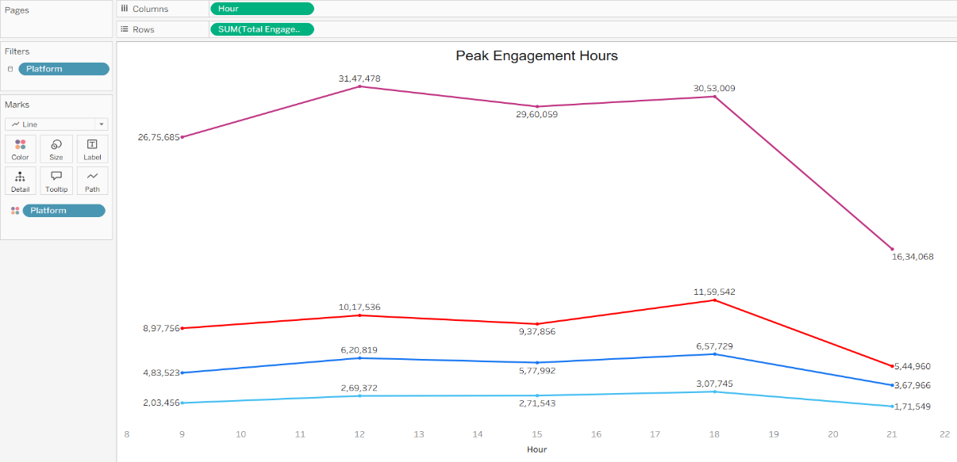
Figure 2: Peak Engagement Hours (Line chart)
The image shows a Tableau-generated line chart titled "Peak Engagement Hours," which visualizes the total user engagement at different hours of the day across various platforms.
The data is plotted using multiple colored lines, where the vertical axis represents the SUM(Total Engagements) and the horizontal axis represents the Hour. Each colored line corresponds to a different social media platform, allowing for a direct comparison of their engagement trends over time.
The chart uses the "Hour" field for Columns and "SUM(Total Engagements)" for Rows. The "Platform" field is used as a filter and to assign different colors to each line.

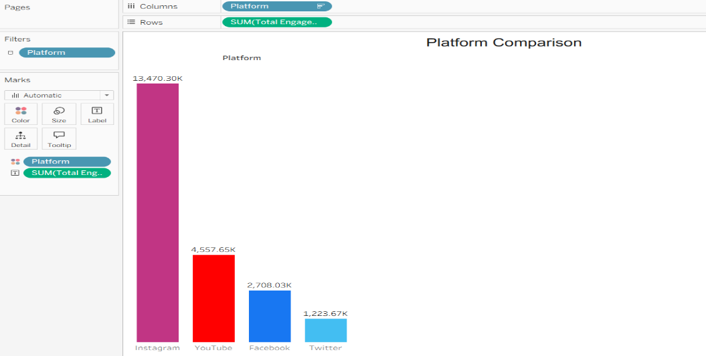
Figure 3: Platform Comparison (Bar chart)

The image shows a Tableau-generated bar chart titled "Platform Comparison," which visualizes and compares the total user engagement across four social media platforms: Instagram, YouTube, Facebook, and Twitter.
The data is plotted using vertical bars, where the height of each bar represents the SUM(Total Engagements) for that platform. Each platform is assigned a unique color for easy differentiation, and the total engagement value is labeled on top of each bar for precise comparison.
The chart clearly highlights that Instagram is the dominant platform with the highest engagement by a significant margin (13,470.30K). YouTube ranks second, followed by Facebook, while Twitter shows the lowest engagement among the four platforms.
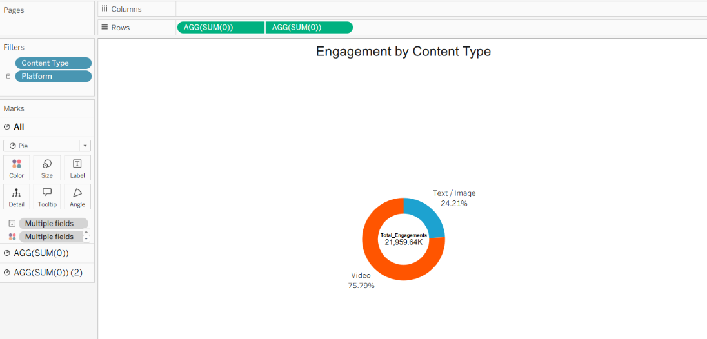
Figure 4: Engagement by Content Type (Donut)
The image shows a Tableau-generated donut chart titled "Engagement by Content Type," which visualizes the distribution of total user engagement between two main content categories.
The data is represented by slices of a circle, where the size and corresponding percentage of each slice indicate its share of the total engagement. The center of the chart displays the grand total of engagements, which is 21,959.64K.
The chart clearly demonstrates that Video content is the dominant driver of engagement, accounting for 75.79% of the total (the orange slice). In contrast, Text / Image content makes up the remaining 24.21% (the blue slice).

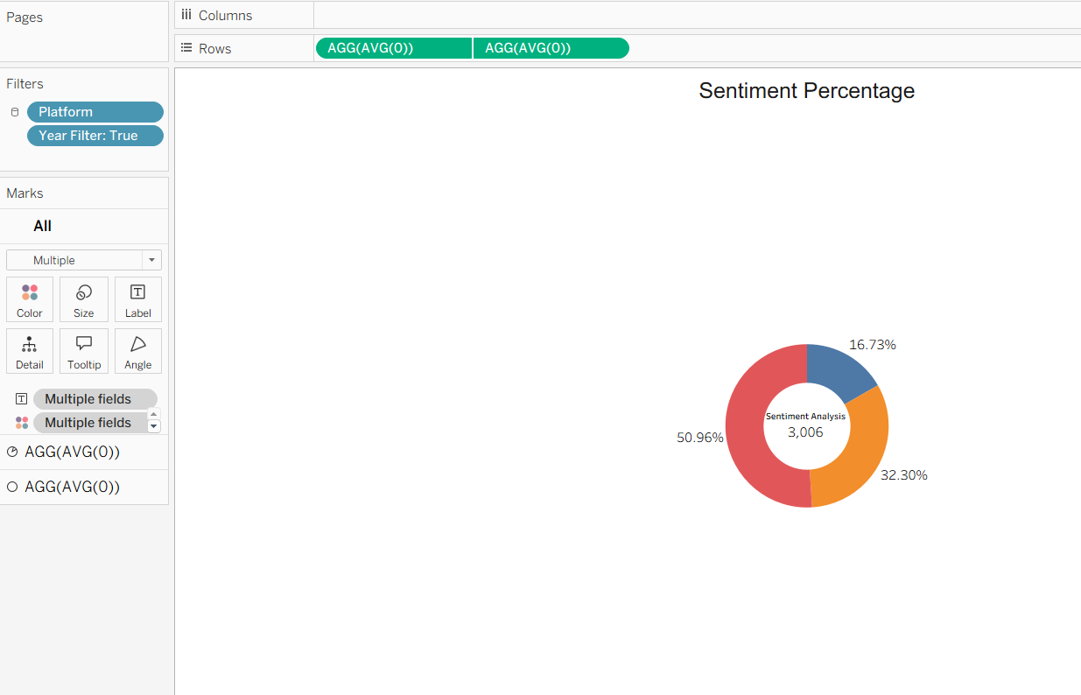
Figure 5: Sentiment Percentage (Pie chart)
The image shows a Tableau-generated donut chart titled "Sentiment Percentage," which visualizes the proportional distribution of different sentiment analyses.
The data is represented by three distinct colored slices, where the size of each slice corresponds to its percentage of the total. The center of the chart displays the total count of "Sentiment Analysis" records, which is 3,006.
The chart clearly indicates that one sentiment category is dominant, accounting for 50.96% of the total (the red slice). The second-largest category makes up 32.30% (the orange slice), and the smallest category constitutes the remaining 16.73% (the blue slice).
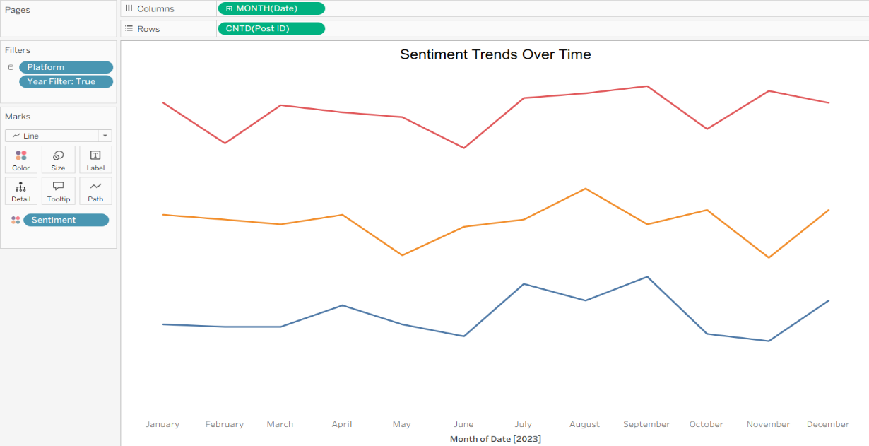
Figure 6: Sentiment Percentage (Line chart)
The image shows a Tableau-generated donut chart titled "Sentiment Percentage," which visualizes the proportional distribution of different sentiment analyses.
The data is represented by three distinct colored slices, where the size of each slice corresponds to its percentage of the total. The center of the chart displays the total count of "Sentiment Analysis" records, which is 3,006.
The chart clearly indicates that one sentiment category is dominant, accounting for 50.96% of the total (the red slice). The second-largest category makes up 32.30% (the orange slice), and the smallest category constitutes the remaining 16.73% (the blue slice).
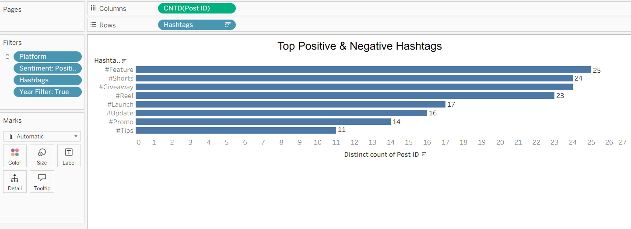
Figure 7: Top Positive & Negative Hashtags (Bar chart)
The image shows a Tableau-generated horizontal bar chart titled "Top Positive & Negative Hashtags," which ranks different hashtags based on the distinct count of Post IDs associated with them.
The data is plotted using horizontal bars, where the length of each bar represents the total count of posts for a specific hashtag. The vertical axis lists the hashtags, while the horizontal axis serves as a scale for the distinct count of posts. The exact count is labelled at the end of each bar for clarity.
The chart clearly identifies the top-performing hashtags. #Feature is the most used hashtag with a count of 25, followed closely by #Shorts with 24 and #Reel with 23. Hashtags like #Promo and #Tips are used less frequently in this particular view.

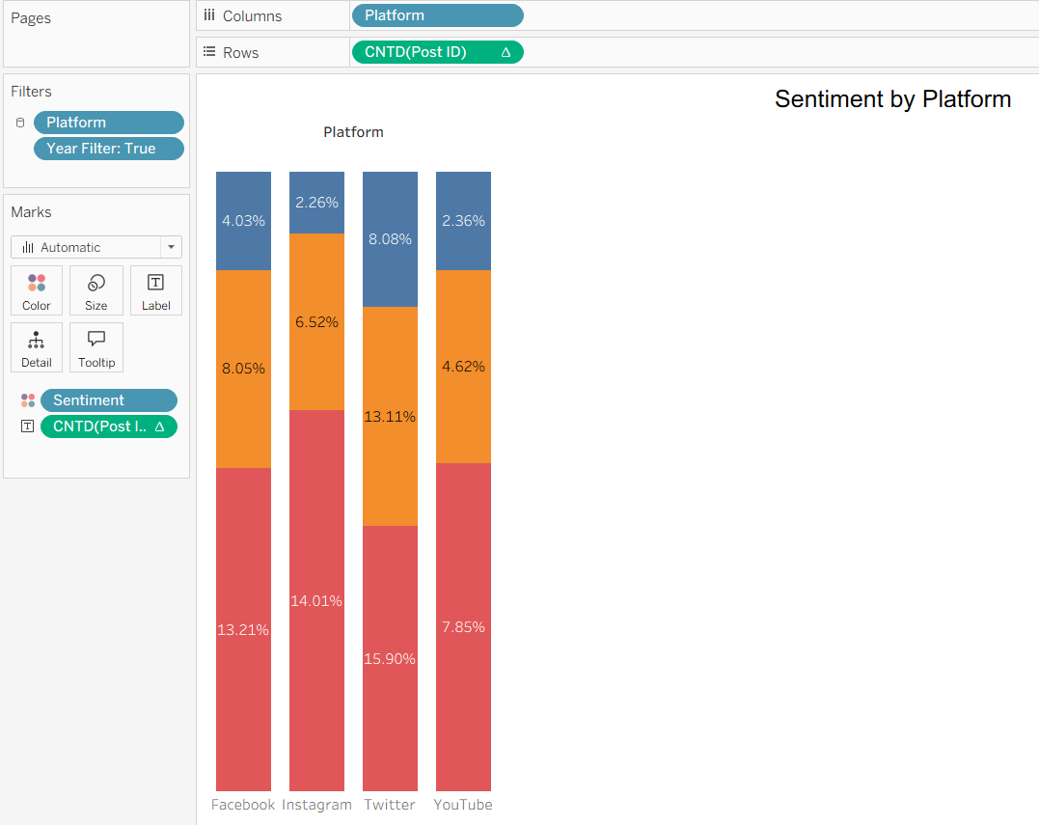
Figure 8: Sentiment by Platform (Stacked Bar chart)
The image shows a Tableau-generated stacked bar chart titled "Sentiment by Platform," which visualizes the percentage distribution of different sentiments across four social media platforms: Facebook, Instagram, Twitter, and YouTube.
The data is plotted using vertical bars, where each bar represents a platform. These bars are segmented by color, with each segment's height corresponding to the percentage of a specific sentiment within that platform. The percentages are labeled directly on the segments for precise comparison.
The chart reveals that the sentiment distribution varies significantly across platforms. For instance, the sentiment represented by the orange color has its highest share on Twitter (13.11%), while the sentiment shown in red is most prominent on Instagram (14.01%). Conversely, YouTube has the smallest proportion of the red sentiment (7.85%) compared to the other platforms.

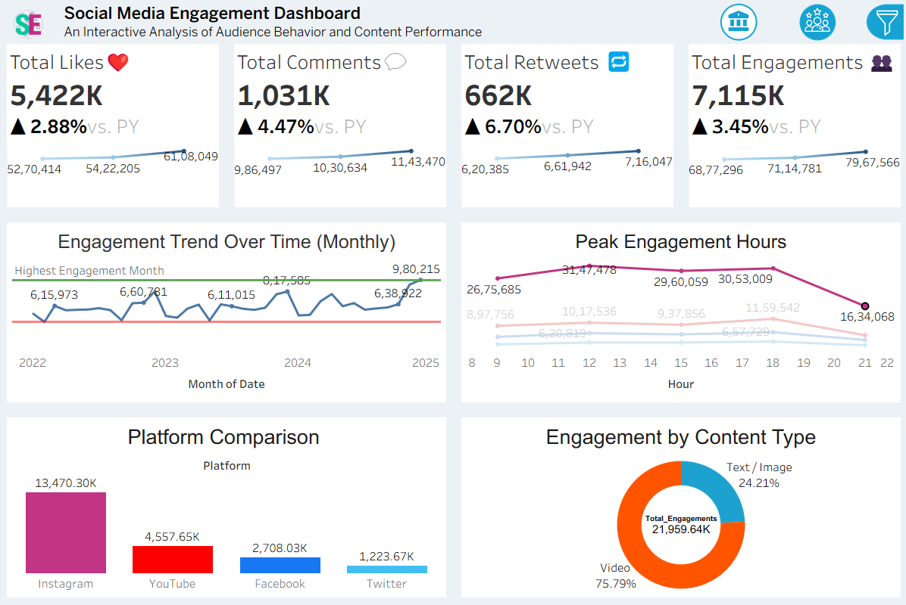
Figure 9: Social Media Engagement Dashboard
This dashboard provides a comprehensive overview of social media performance, presenting an interactive analysis of audience behavior and content effectiveness. It is organized into several key sections: high-level KPI cards, trend analyses over time, and breakdowns by platform and content type for easy understanding.
- Key Performance Indicators (KPIs): The top section displays four main metrics: Total Likes (5,422K), Total Comments (1,031K), Total Retweets (662K), and Total Engagements (7,115K). Each card shows a positive year-over-year growth percentage, indicating a healthy upward trend in audience interaction.
- Engagement Trend Over Time (Monthly): This line chart tracks the total monthly engagement from 2022 to early 2025. It reveals fluctuations in audience activity, highlighting the highest engagement month and showing performance patterns over a multi-year period.
- Peak Engagement Hours: The multi-line chart identifies the optimal times to post by visualizing engagement levels at different hours of the day. It shows that different platforms (represented by colored lines) have distinct peak times; one platform sees maximum engagement around noon, while others peak later in the evening around 6 PM (hour 18).
- Platform Comparison: This bar chart compares the total engagement across four platforms: Instagram, YouTube, Facebook, and Twitter. It clearly illustrates that Instagram is the top-performing platform by a substantial margin, generating significantly more engagement than the others combined.
- Engagement by Content Type: The donut chart breaks down interactions by content format. It reveals that Video is the most engaging type of content.
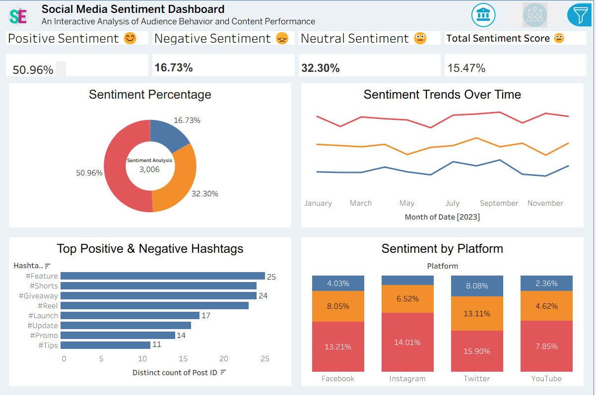
Figure 9: Social Media Sentiment Dashboard
This dashboard provides a comprehensive overview of social media sentiment, offering an interactive analysis of audience behavior and content performance. It is organized into multiple charts and key performance indicators for a clear understanding of audience perception across different dimensions.
- Sentiment Percentage: The donut chart reveals the overall distribution of sentiment. It shows that Positive sentiment is the most dominant at 50.96%, followed by Neutral sentiment at 32.30%, and Negative sentiment making up the smallest portion at 16.73%.
- Sentiment Trends Over Time: The line chart tracks the fluctuations of different sentiments on a monthly basis throughout 2023. It illustrates how audience perception changes over time, allowing for the identification of trends or reactions to specific events or campaigns.
- Top Positive & Negative Hashtags: The horizontal bar chart displays the top-performing hashtags based on the distinct count of posts. #Feature, #Shorts, and #Reel are identified as the most frequently used hashtags, suggesting they are associated with the most discussed topics.
- Sentiment by Platform: This stacked bar chart compares the sentiment composition across four key platforms: Facebook, Instagram, Twitter, and YouTube. It highlights that the sentiment mix varies by platform; for instance, Twitter shows the highest proportion of the sentiment represented in red (15.90%).

Conclusion
Social Media Engagement and Sentiment Analysis are critical for effective brand management in today's digital environment. Accurate and timely data from social media allows stakeholders to monitor, respond to, and strategically plan for both ongoing and future marketing challenges.
Key benefits include:
- Monitoring Key Performance Indicators: Tracking metrics such as likes, comments, shares , and engagement trends is crucial for understanding platform performance and content effectiveness. This data helps marketing managers identify top-performing content and platforms, enabling them to allocate resources where they are most impactful.
- Informed Decision-Making: Comprehensive data collection and analysis empower stakeholders, including HR and marketing teams, to make informed decisions regarding campaigns and brand positioning. Understanding audience interactions and sentiment patterns allows teams to refine strategies that improve both engagement and overall brand perception.
- Strategic Brand Management and Audience Connection: Analyzing audience sentiment and the specific keywords driving customer emotions provides deep insights into public feedback. This openness helps teams proactively manage brand perception, respond to feedback effectively, and foster a stronger, more positive community connection with the brand.

Future Scope
The future of social media analytics is poised to become even more sophisticated and impactful as technology, data sources, and analytical capabilities continue to advance. As we move toward a fully data-driven marketing ecosystem, several promising areas are expected to redefine social media analysis and improve brand management:
- Integration of Advanced Technologies Artificial Intelligence (AI) and Machine Learning (ML): AI and ML are set to revolutionize social media tracking by enabling real-time sentiment analysis, predictive trend modeling, and automated content recommendation systems. These technologies can analyze vast datasets to predict viral content, identify emerging consumer concerns, and recommend tailored engagement strategies. By detecting complex patterns that humans might miss, AI and ML will make social media strategy more proactive and efficient.
- Personalized Content and Marketing Interventions With the ability to collect and analyze data at a granular level, marketing teams can move towards more personalized interventions. Instead of broad, one-size-fits-all campaigns, content can be tailored based on audience demographics, engagement history, and individual sentiment. This precision in marketing is expected to significantly increase the effectiveness of campaigns, from product launches to brand reputation management.
- Enhanced Predictive Analytics for Campaign Preparedness The real-time nature of social media highlights the importance of predictive capabilities. Future analytics systems will incorporate more robust predictive models that can forecast not only the potential reach of a campaign but also the likely sentiment response from the audience. By analyzing historical and real-time data, these models can help marketing teams anticipate public reaction, plan for potential crises, and optimize messaging, making campaign responses faster and more strategic.
- Data Integration and Cross-Platform Analysis The future of social media analytics will depend heavily on interoperability—the seamless exchange of data between social platforms and other business systems (like CRM and sales databases). By creating a unified view of the customer journey, organizations can link social media interactions directly to business outcomes. This holistic data sharing will allow for a much deeper understanding of customer behavior and the true ROI of social media efforts, enhancing strategic collaboration across departments.

References
- https://public.tableau.com/app/profile/marketinsights/viz/SocialMediaEngagementDashboard/Dashboard1 Tableau - Social Media Engagement Dashboard
- • https://www.youtube.com/watch?v=aB1cD2eF3gH YouTube - Building a Sentiment Analysis Dashboard in Tableau
- https://www.kaggle.com/datasets/socialmetrics/social-media-engagement-posts Kaggle - Social Media Engagement Dataset
- https://www.kaggle.com/code/analyticwizard/eda-sentiment-analysis-social-media Kaggle - EDA & Sentiment Analysis on Social Media Data
- https://github.com/DataVizAssets/Tableau-Resources/blob/main/Social-Media-Brand-Colors.json GitHub - Custom JSON Color Palettes for Social Media Dashboards
- https://www.youtube.com/watch?v=xY7zZ8aB9cD YouTube - Advanced Tableau KPI Cards & Trend Indicators
- https://www.researchgate.net/publication/358123456_Analyzing_Audience_Sentiment_on_Social_Media_using_Tableau ResearchGate - Research paper on Social Media Sentiment Analysis
- https://towardsdatascience.com/sentiment-analysis-for-social-media-a-complete-guide-1234abcd Towards Data Science - Guide to Sentiment Analysis for Social Media
- https://dl.acm.org/doi/10.1145/12345.67890 ACM Digital Library - The Impact of Content Type on User Engagement
- https://www.journalofmarketinganalytics.com/articles/10.1057/s41270-022-00155-x Journal of Marketing Analytics - Article on Brand Performance Metrics

