PENETRATION TESTING REPORT
MEDIROZA GENERAL HOSPITAL
W4-PM-FINAL | CYBERSECURITY | NETWORKWALKS

Pentester Name | Debashree Sinha
Program/Batch | B083-Networkwalks
Date | 30th September 2026
Assessment Type | Black-box Web Application Penetration Test
Client/Target | Mediroza General Hospital –  https://medirozahospital.com
Authorization | Written authorization granted
Testing Platforms | Kali Linux & Windows
Testing Duration | 3 days
Status | Completed

Confidentiality Notice:
This report contains security assessment information obtained during an authorized educational penetration-testing exercise. Sensitive patient, employee and shareholder information discovered during testing has been intentionally minimized or redacted. The report should be treated as confidential and used only for the intended assessment and training purposes.

Table of Contents

- Executive Summary
- Scope and Methodology
  - 2.1 Scope
  - 2.2 Tools Used
  - 2.3 Assessment Approach
- Findings and Proof of Exploitation
  - 3.1 Finding F-01 — SQL Injection & Authentication Bypass
  - 3.2 Finding F-02 — Weak Protection of Confidential PDF Files
  - 3.3 Finding F-03 — Publicly Accessible Database Backup
- Risk Rating
- Recommendations and Remediation
- Evidences
- Conclusion

- Executive Summary

A penetration testing assessment was conducted against Mediroza General Hospital's authorized web environment as part of the Networkwalks Week 4 practical assessment.

The assessment covered reconnaissance, web application testing, authentication testing, recovery of protected documents, and directory/server enumeration.

Three significant security issues were identified:

- A web application input-handling weakness allowed authentication controls to be bypassed.

- Three confidential patient PDF reports were accessible and their password protection was successfully recovered.

- An exposed historical database backup, mediroza_db_backup_2019.sql, contained confidential staff and shareholder information.

The findings demonstrate risks involving authentication, confidentiality, information exposure, and insecure server-side file handling.

2. Scope and Methodology

2.1 Scope

Item | Details
Target | medirozahospital.com
Testing Type | Web Application & Server-Side Assessment
Authorization | Written permission granted
Duration | 3 days
Environment | Controlled educational environment
Activities | Reconnaissance, authentication testing, document recovery, directory enumeration, exposed-data analysis

Testing was limited to the authorized target and the activities defined in the Networkwalks Week 4 project brief.

2.2 Tools Used

Tool | Purpose
WHOIS | Domain and registration information
Nslookup | DNS resolution
cURL | HTTP response/header inspection
WhatWeb | Web technology identification
Wafw00f | WAF detection
DNSRecon | DNS record enumeration
Burp Suite | Web request and input testing
Gobuster | Directory and file enumeration
Networkwalks Hash Calculator | Hash analysis during M2
Networkwalks Password Cracker | Recovery of PDF passwords

Reconnaissance

Initial reconnaissance established the target's IP address, web-server technology, DNS infrastructure, and externally visible services. The target was identified as running LiteSpeed, while Wafw00f reported no WAF through its generic detection checks. DNSRecon further identified the target's NS, MX, TXT, SOA, and related DNS records. These results provided the baseline information used to proceed with web application testing and directory enumeration, where the subsequent assessment findings were identified.

Evidence: Supporting reconnaissance results and screenshots are available in the evidences/ folder of the GitHub repository.

2.3 Assessment Approach

The assessment followed the practical modules provided in the Week 4 project:

M1 — Initial Access:
Reconnaissance was followed by analysis of exposed application entry points and authentication behaviour. A weakness in input handling was identified and successfully used to access the restricted patient area.

M2 — Document Recovery:
The three retrieved PDF reports were examined and their password protection was tested using the provided password-cracking resources. All three files were successfully recovered.

M3 — Data Exposure:
Directory enumeration was performed using Gobuster. Discovered resources such as robots.txt, /staff/, and /old/ were manually reviewed. The /old/ directory exposed a historical database backup.

3. Findings and Proof of Exploitation

3.1 Finding F-01 — SQL Injection & Authentication Bypass

Severity: Critical
Affected Area: Patient Portal Login

During authentication testing, a randomly entered username was submitted with a password. Instead of indicating that the username was invalid, the application returned a “password incorrect” message.

This suggested that the username was being recognized and that the application was proceeding to password validation.

Based on this behaviour, the username parameter was tested for SQL injection using controlled input and Burp Suite. A quote character was first introduced to observe how the application handled the input, followed by testing with the SQL comment sequence ‘--.

The modified input altered the authentication query and resulted in successful access to the restricted patient portal without completing the intended password validation.

Process-

- Submitted a randomly selected username and password.
- Observed the “password incorrect” response, indicating the username was likely recognized.
- Tested the username parameter for SQL injection using controlled input.
- Introduced a quote character and observed the application's response.
- Used the SQL comment sequence -- to test whether the remaining authentication condition could be affected.
- Successfully accessed the restricted patient portal.

Result-

Authentication was bypassed, providing access to the patient area and three encrypted confidential patient laboratory reports. These reports were retrieved for the M2 password-recovery activity.

Evidence-

- Initial login attempt and password-error response

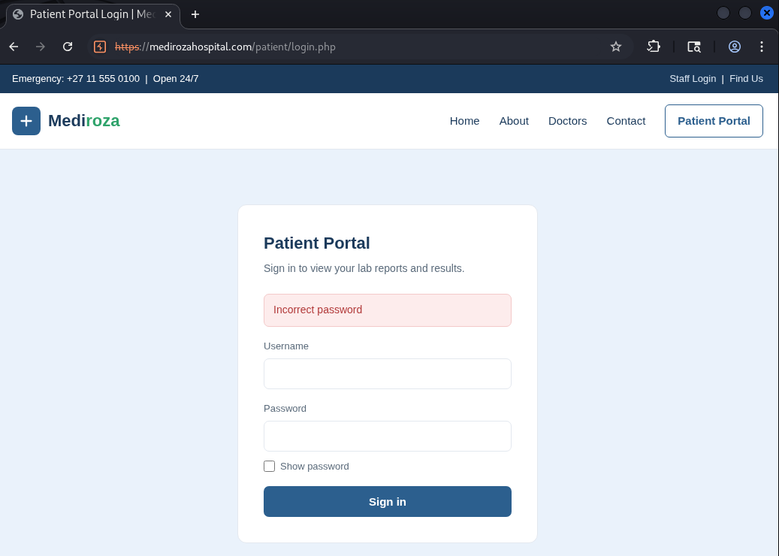

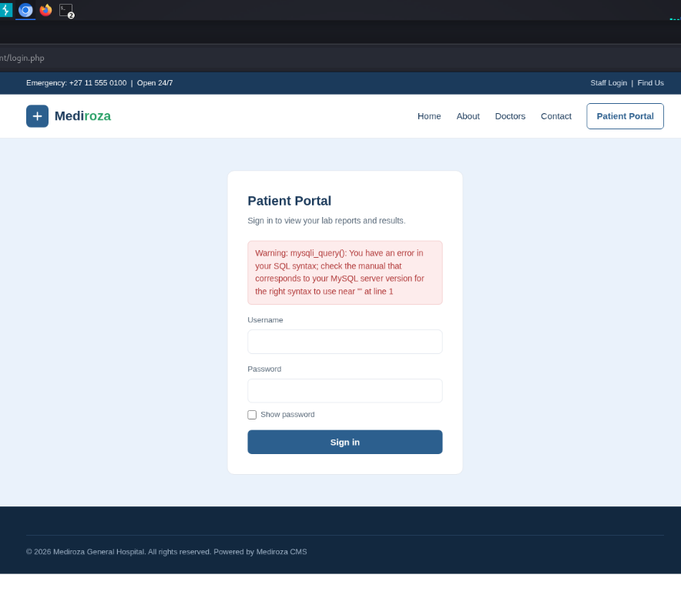

- Burp suite & SQL injection testing

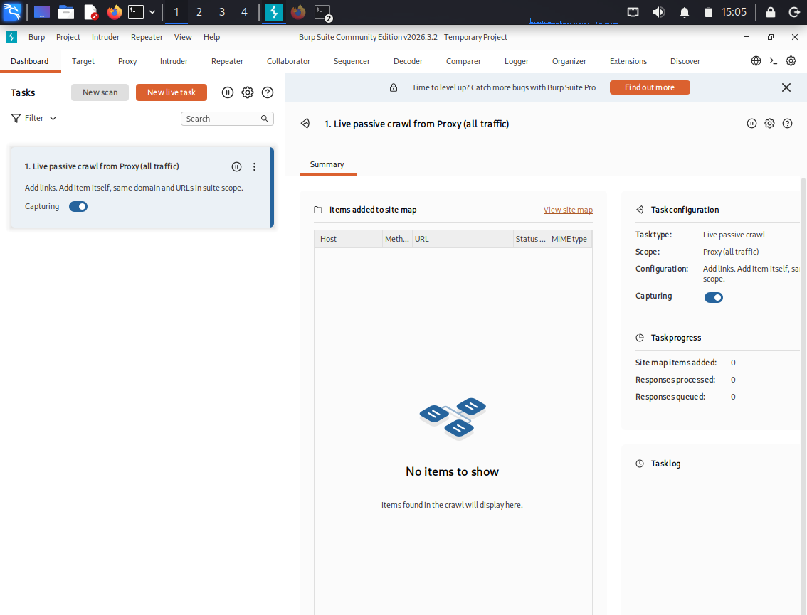

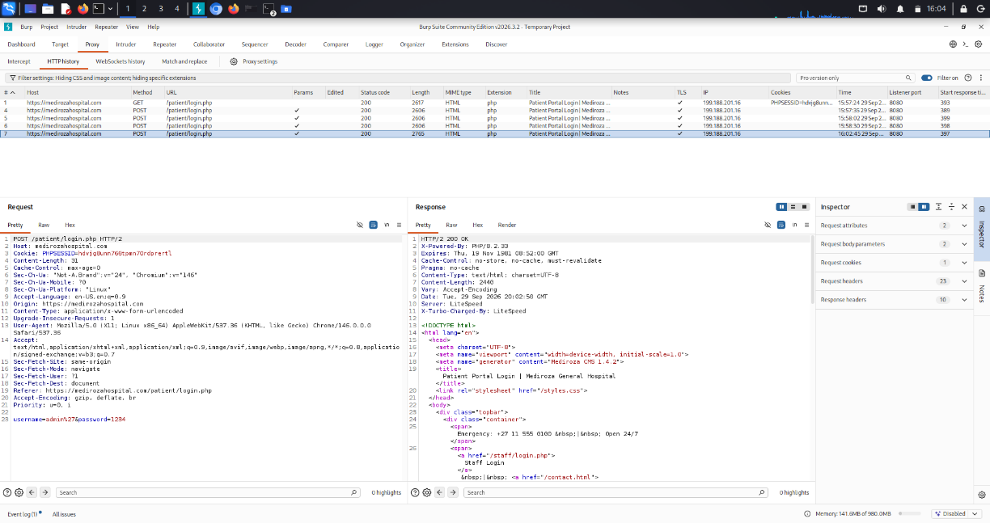
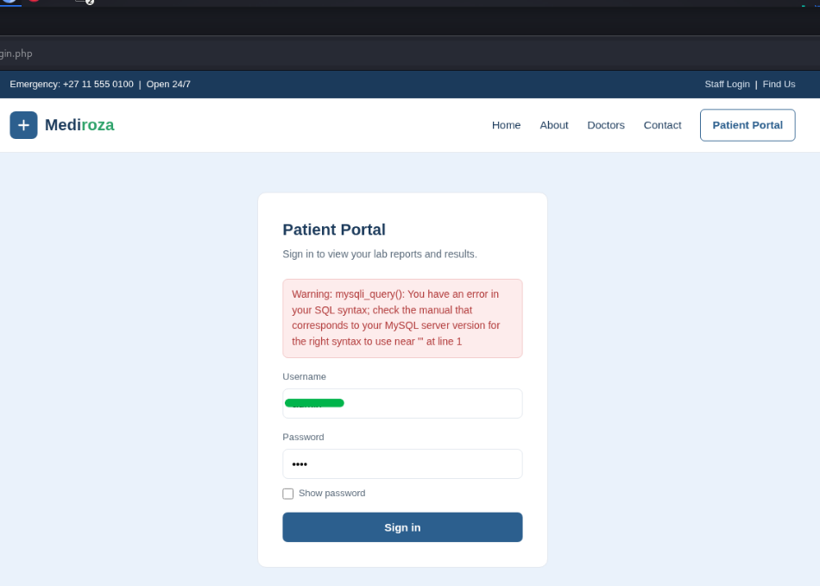

- Successful portal access
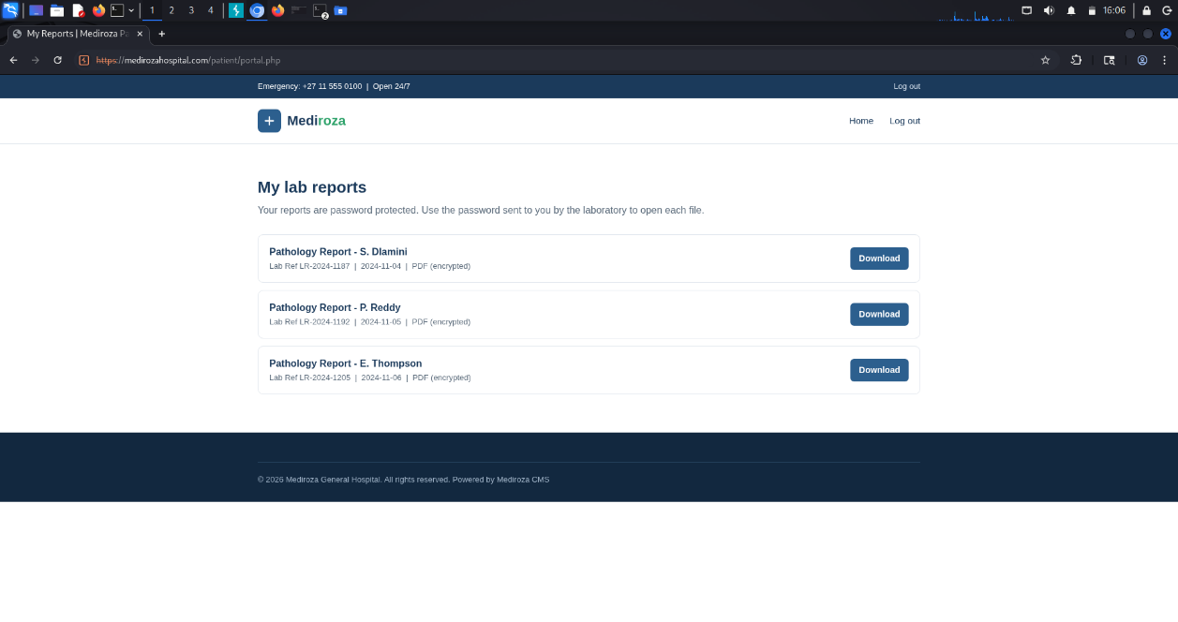

The specific username and complete bypass payload are omitted; the SQL comment sequence -- is retained to document the technique.

3.2 Finding F-02 — Weak Protection of Confidential PDF Files

Severity: High
Affected Assets: Three confidential patient laboratory reports

Following successful access to the patient portal, three encrypted PDF laboratory reports were retrieved.

The files were subjected to password-recovery testing using the Networkwalks Hash Calculator and Password Cracker resources.

Two PDF passwords were recovered on the first attempt. The third required a provided wordlist and additional attempts before successful recovery.

Process-

- Retrieved the three encrypted PDF reports from the authorized patient portal.
- Examined the files and extracted the required password/hash information.
- Tested the recovered information using the provided password-cracking resources.
- Used an additional wordlist for the third document after the initial attempts were unsuccessful.
- Successfully recovered the contents of all three files.

Result-

All three confidential PDF reports were successfully opened.
This demonstrates that the protection applied to the documents could be recovered using the available cracking resources, increasing the impact of the initial unauthorized access.

Evidence-

- Hash/password analysis

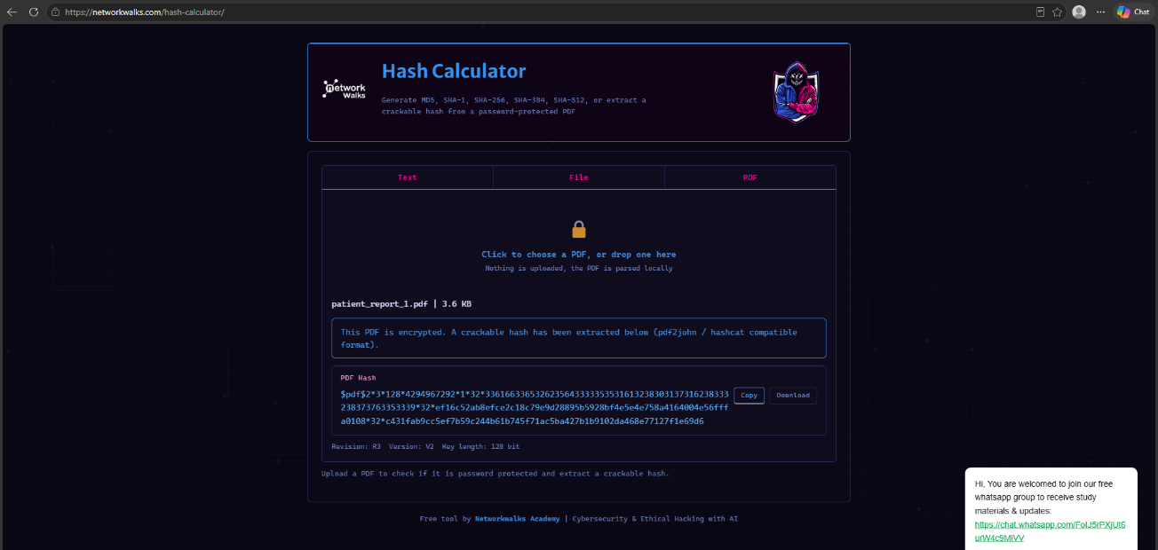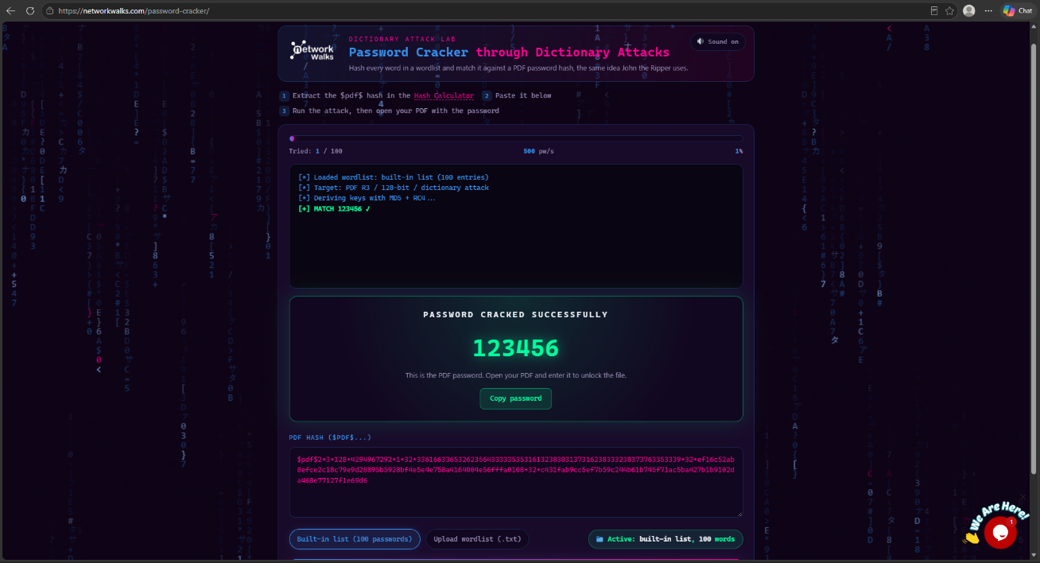

- Recovered PDF contents

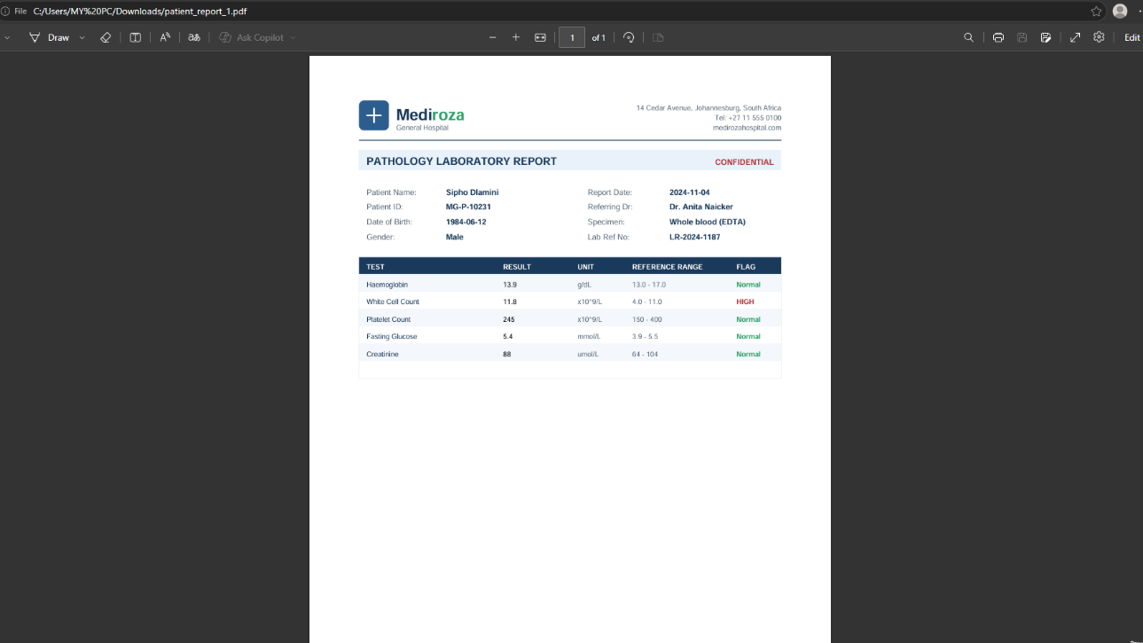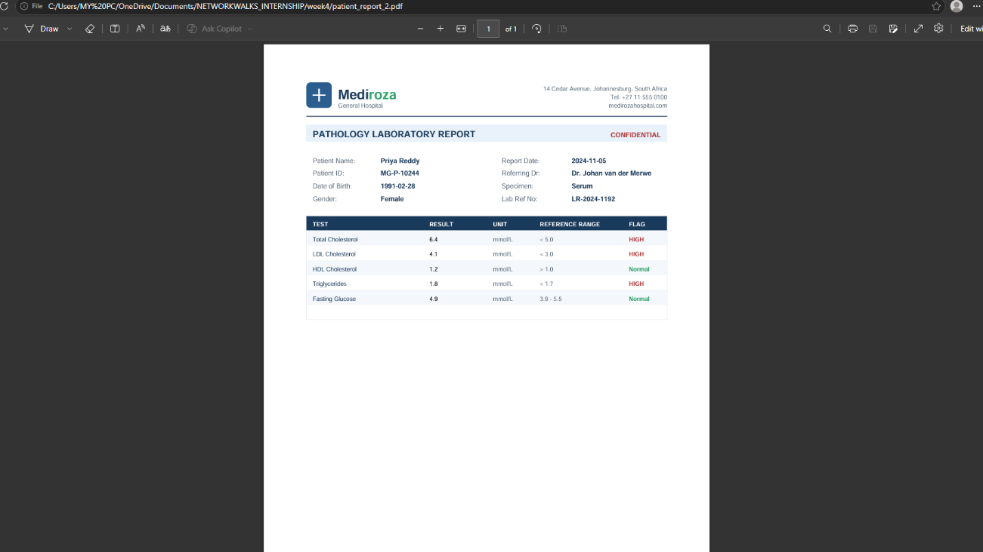
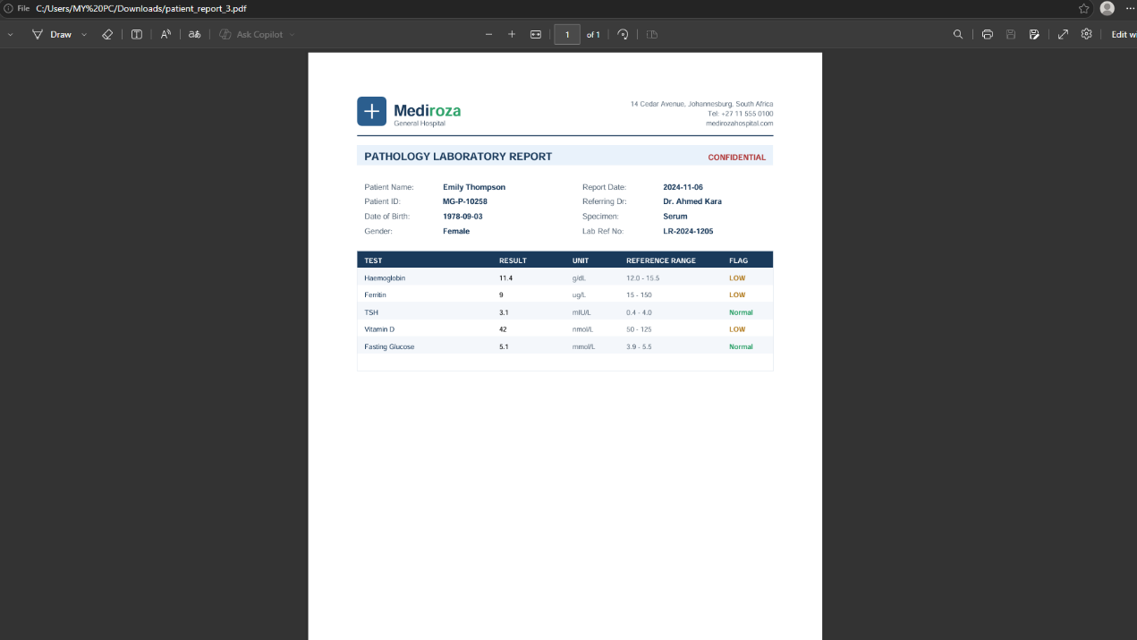

Patient names, medical information, and recovered passwords are intentionally excluded from this report.

3.3 Finding F-03 — Publicly Accessible Historical Database Backup

Severity: Critical
Affected Asset: /old/ directory

Directory enumeration with Gobuster identified an accessible /old/ directory. Manual inspection of this location revealed the historical database backup:
mediroza_db_backup_2019.sql

The file contained database structures and records associated with hospital staff and shareholders. The backup itself explicitly identified the presence of confidential staff and shareholder records.

Process-

- Gobuster was used to enumerate directories and files.
- Several relevant paths were identified, including:
  - /robots.txt
    - /staff/
    - /old/
    - /patient/
    - /sitemap.xml
- The discovered /old/ directory was manually reviewed.
- The historical SQL backup was located.
- The backup was inspected to determine the type and sensitivity of the exposed information.
- Database structures for tables including staff and shareholders were observed.

Result-

The exposed backup contained sensitive information relating to:
- Hospital employees and employment-related records
- Salary information
- Shareholder names and ownership information
- Other database fields associated with the affected records

This represents a direct confidentiality risk because a historical database backup was accessible through the web server.

Evidence-

- Gobuster enumeration results [robots.txt]

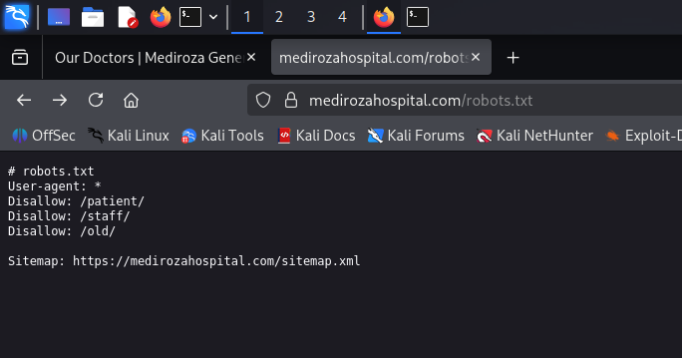
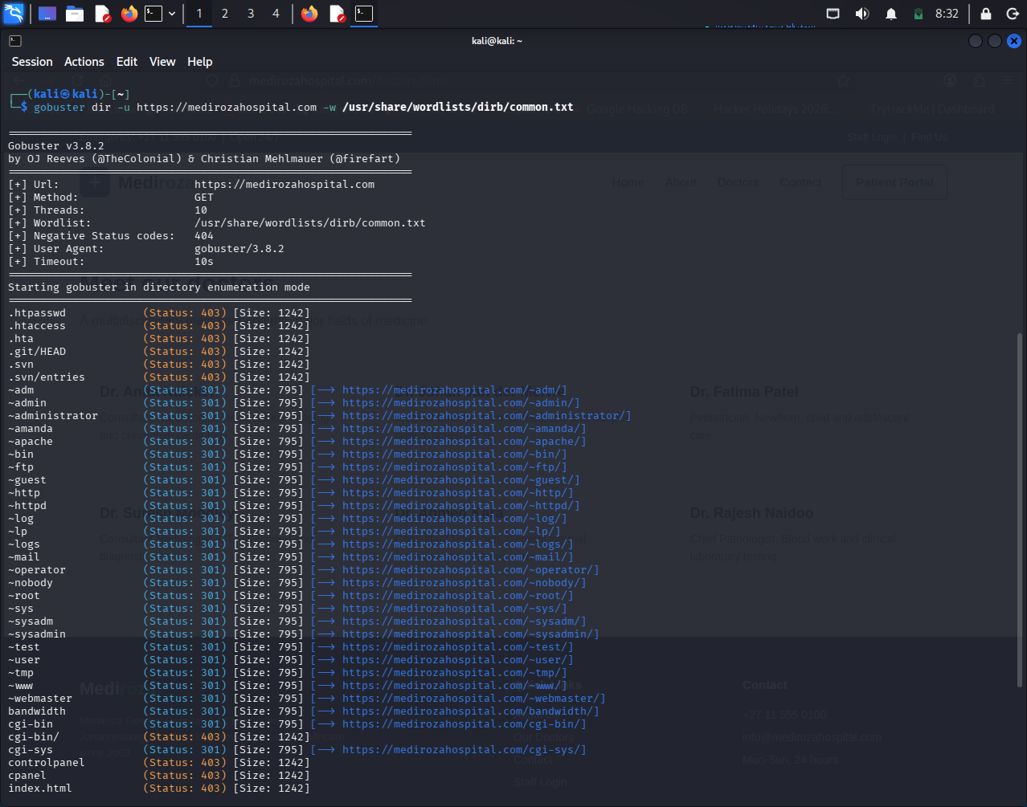

- Curl output
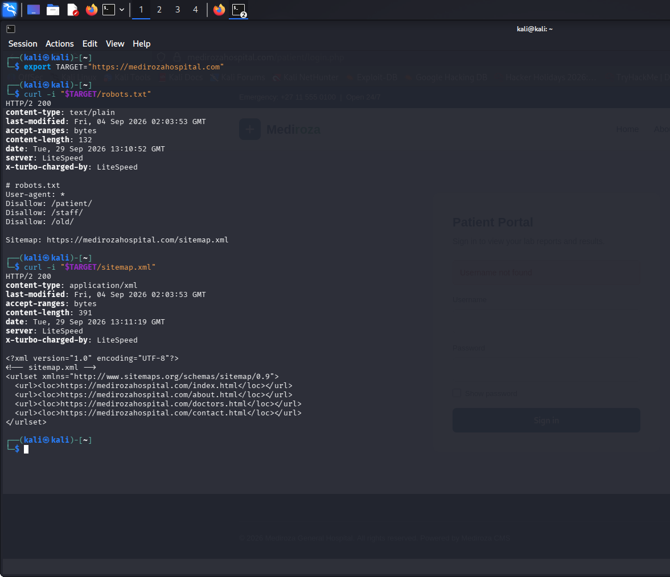

- /old/ directory listing
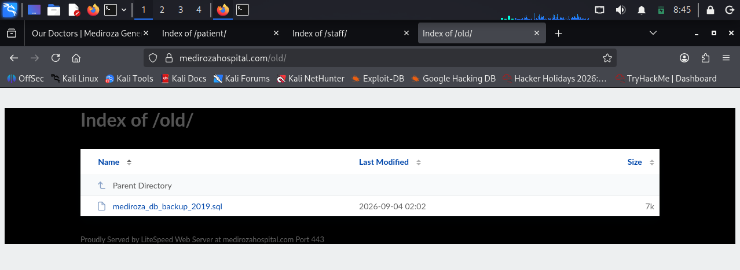

- mediroza_db_backup_2019.sql

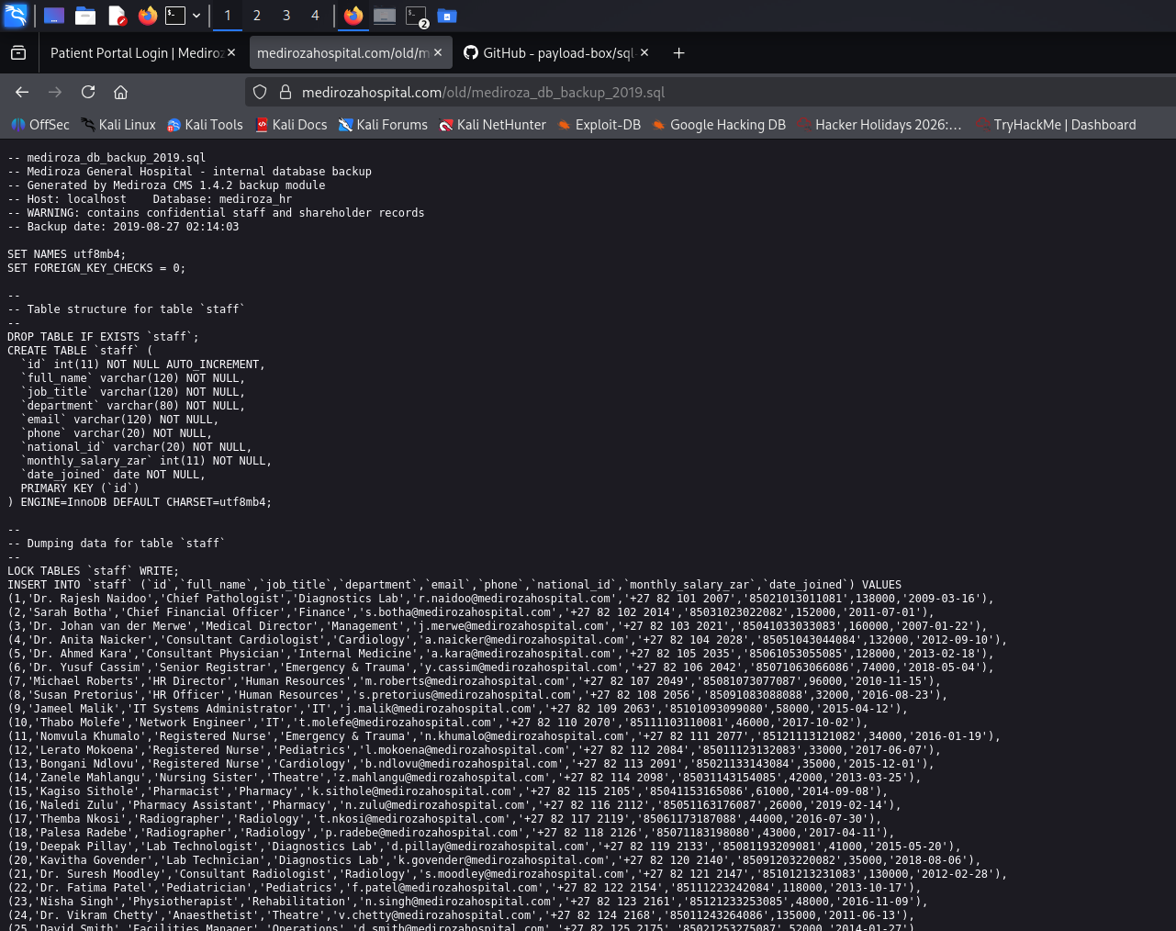
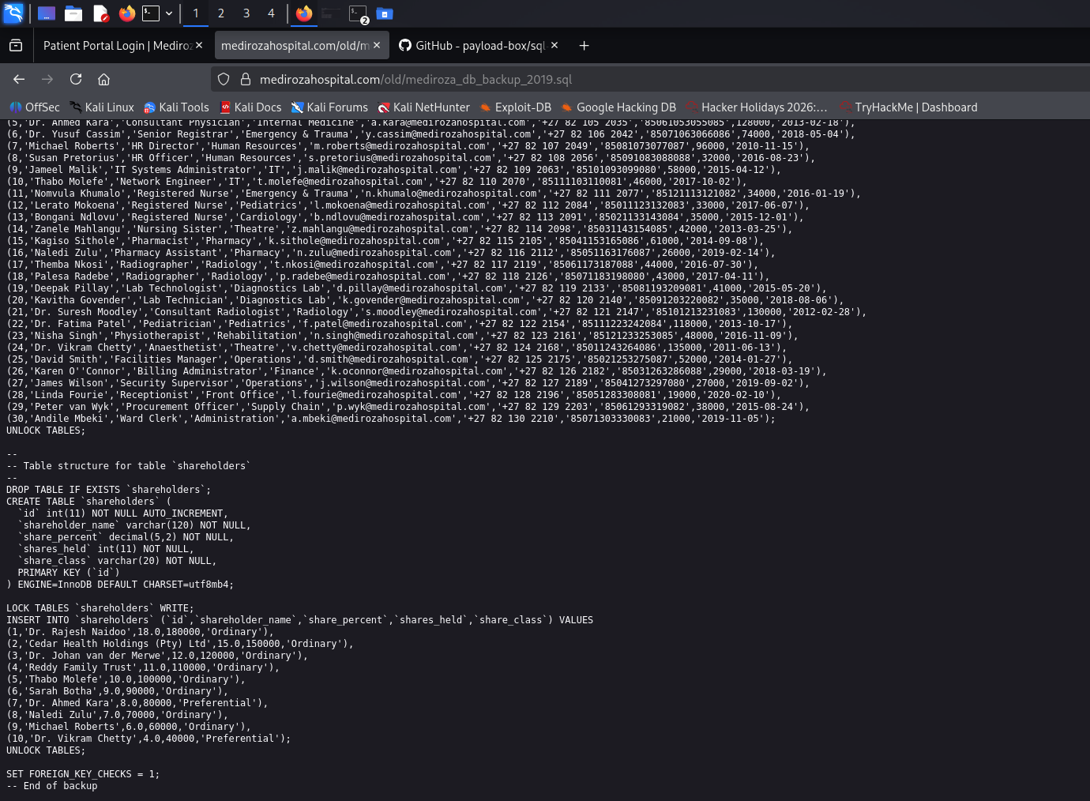
Actual employee, shareholder, contact, identification, and salary values are not reproduced in this report.

4. Risk Rating

ID | Finding | Severity | Justification
F-01 | SQL Injection & Authentication Bypass | Critical | Authentication controls could be bypassed, providing access to a restricted patient area.
F-02 | Weak Protection of Confidential PDF Files | High | All three protected patient documents were successfully recovered after authorized access.
F-03 | Publicly Accessible Database Backup | Critical | A historical SQL backup exposed confidential staff and shareholder information through a publicly accessible directory.

- Recommendations and Remediation

F-01 — SQL Injection & Authentication Bypass

- Use parameterized queries/prepared statements for all database operations.
- Apply strict server-side input validation.
- Do not construct SQL queries directly from user-controlled input.
- Implement secure authentication and session management.
- Conduct security testing on all authentication-related inputs.
- Apply appropriate logging and monitoring for repeated abnormal login requests.

F-02 — Confidential PDF Protection

- Avoid relying on weak or easily recoverable passwords for sensitive documents.
- Use strong, unique passwords or modern encryption mechanisms.
- Apply appropriate access controls to patient documents.
- Limit document access to authenticated and authorized users.
- Review whether sensitive documents need to be directly downloadable.
- Monitor repeated failed password attempts and suspicious document access.

F-03 — Exposed Database Backup

- Remove database backups from publicly accessible web directories.
- Store backups outside the web root.
- Apply strict file-system permissions and access controls.
- Maintain a secure backup-storage policy.
- Remove obsolete backups from production servers.
- Scan the web server regularly for exposed .sql, .zip, .bak, and similar backup files.
- Review historical files and directories for unintended sensitive-data exposure.

6. Evidence Reference

Supporting screenshots, terminal outputs, application results, and other assessment evidence are maintained separately from the main report to keep the documentation concise while preserving the complete proof of the activities performed.
The GitHub repository includes an evidence/ folder containing evidence

Evidence Repository: Review the evidences/ folder in the GitHub repository for the complete supporting screenshots and outputs.

7. Conclusion

The assessment demonstrated several security weaknesses within the authorized Mediroza General Hospital environment.

The testing process progressed from reconnaissance and web application assessment to restricted-area access, document recovery, and server-side directory enumeration. The most significant observations were the authentication weakness, successful recovery of all three protected PDF reports, and exposure of the historical mediroza_db_backup_2019.sql database backup.

The findings highlight the importance of secure input handling, strong protection of confidential documents, controlled access to sensitive resources, and proper management of historical backups.

