Document Loader findings
Observations:
- 2 pages, clean text-based PDF (no scanned images) — PyPDF extracts text perfectly
- Page 1 ends mid-section (section 5 cuts off) — so page-level splitting is not ideal, content
flows across pages

Solution:
Merge all pages of the same PDF into one Document
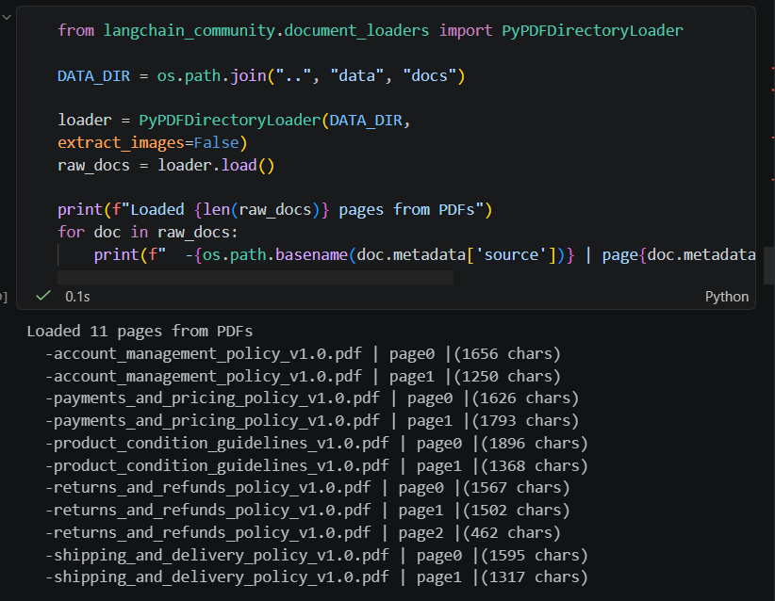

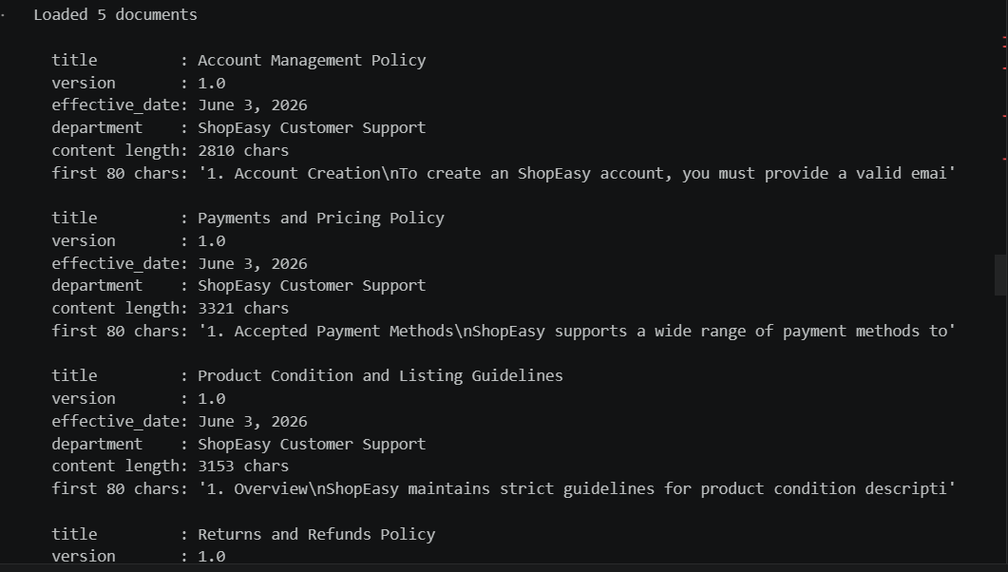

Chunking

Used RecursiveCharacterTextSplitter with a chunk_size of 500 and chunk_overlap of 80. This parameter setting gave the best splits but still many points were segmented into different chunks.

Since every section starts with a pattern like 1., 2., 3.
etc., we can use a regex-based splitter that splits exactly on those section
boundaries. LangChain has RecursiveCharacterTextSplitter.from_tiktoken_encoder
but more relevant here is splitting on a custom regex pattern.

The best approach for your docs is RecursiveCharacterTextSplitter with a regex
separator that matches section headers like \n1. , \n2. etc. — this keeps each
numbered section as one chunk.
