**ASSIGNMENT-02**

**SOFTWARE REQUIREMENT SPECIFICATION**

**SYSTEM SPECIFICATION**

**HARDWARE REQUIREMENTS**

Processor : X86 Compatible processor with 1.7 GHz Clock speed

RAM : 512 MB or more

Hard disk : 20 GB or more

Monitor : VGA/SVGA

Keyboard : 104 Keys

Mouse : 2 buttons/ 3 buttons

**SOFTWARE REQUIREMENTS**

Operating System : Windows 2000/XP

Front end : Visual Studio 2008

Back end : SQL Server 2005

ASSIGNMENT-05

USE CASE DIAGRAM

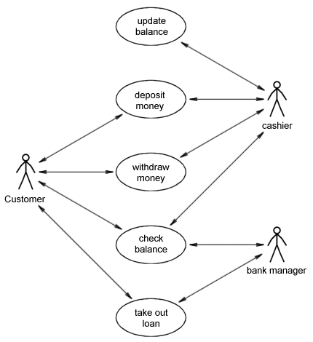

UML DIAGRAM

ASSIGNMENT-03

DFD (DATA FLOW DIAGRAM)

Customer Management

Zero Level DFD – Banking Management System

Fixed Deposit Management

Accounts Management

Saving Account Management

Employees Management

Current Account Management

Generate Customer Report

Customer Management

First Level DFD – Banking Management System

Saving Account Management

Current Account Management

Generate Current Account Report

Check Saving Account Details

Generate Fixed Deposit Report

Generate Account Report

Generate Employee Report

Fixed Deposit Management

Accounts Management

Employees Management