NXP SEMICONDUCTORS
Senior Principal Data & AI Engineer
Electricity Maps — Enterprise ETL & AI Architecture

Submission strategy
Strictly implement the required PySpark + Delta Lake + Parquet contract first, then layer enterprise capabilities—object storage, orchestration, advanced DQ, security/PII, performance engineering, CI/CD and governed RAG/LLM architecture—without introducing unnecessary platform dependencies.

Prepared as a reviewer-oriented, production-grade technical design

1. Executive Summary
This solution implements a production-oriented, modular and extensible ETL framework for Electricity Maps France (FR) hourly electricity flows and production-mix data. The mandatory implementation follows the assignment's permitted PySpark option and required Bronze → Silver → Gold medallion model. Silver and Gold are persisted as Delta Lake tables with Parquet data files; Bronze remains raw and immutable without schema enforcement.
The design extends the assignment into a reusable enterprise data platform with incremental and idempotent ingestion, advanced data quality and domain validation, data contracts, schema evolution, PII/security controls, encryption and secrets management, observability, performance optimization, automated testing, CI/CD, orchestration, and a governed RAG/LLM data-agent architecture.
Principal-level architectural principle
The lakehouse/data products are the system of record. The semantic layer is the analytical contract. The Data Agent orchestrates tools. RAG provides contextual knowledge. The LLM synthesizes a grounded response; it is not the source of truth for numerical analytics.

2. Assignment Requirement Traceability
The table below maps the requested assignment contract to the proposed implementation.
NXP requirement | Implementation decision | Status
Python framework | PySpark | Mandatory
Bronze | Raw immutable JSON/JSONL; no schema enforcement | Mandatory
Bronze metadata | Ingestion timestamp + source URL; additional request/audit metadata | Mandatory + enterprise
Bronze partition | year/month/day from ingestion timestamp | Mandatory
Silver | Delta Lake + Parquet physical data files | Mandatory
Silver transformation | Flattening, timestamp normalization, strong schema, deduplication | Mandatory
Silver partition | year/month/day from data timestamp | Mandatory
Gold | Delta Lake + Parquet; flat schemas | Mandatory
Gold products | Daily Mix + Daily Net Imports + Daily Net Exports | Mandatory/extended
Cloud storage | Abstract object-storage layer; S3-compatible deployment option | Enterprise extension
Orchestration | Reusable DAG/workflow interface | Enterprise extension
DQ + contracts | Multi-layer DQ engine + versioned contracts | Enterprise extension
Retries/rate limits | Exponential backoff, jitter, 429/5xx handling | Enterprise extension
Incremental ingestion | Watermarks + idempotent writes + replay support | Enterprise extension
CI/CD | Lint, tests, security scan, build and deployment gates | Enterprise extension
RAG/LLM | Governed Data Agent with SQL + RAG + metrics tools | Design extension

3. Target Enterprise Architecture
Figure 1 — End-to-End Enterprise Architecture
Enterprise-standard vector-style architecture diagram. The SVG version is included in the companion package for import into Visio/draw.io.
The architecture deliberately separates the mandatory data-engineering implementation from optional enterprise infrastructure. This preserves assignment compliance while demonstrating how the solution would evolve into a governed production platform.

4. Medallion Data Architecture
Figure 2 — Bronze → Silver → Gold Data Flow
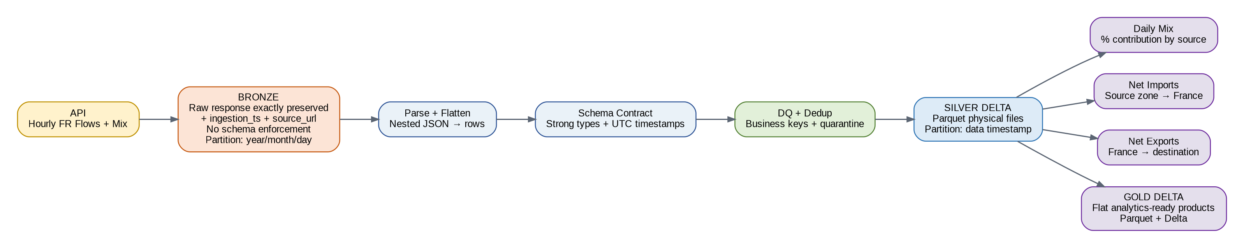

4.1 Bronze — Raw Immutable Data
- Store the raw API response as returned by Electricity Maps, without business transformation.
- Add ingestion timestamp and source URL as the required metadata.
- Use ingestion timestamp for year/month/day partitioning.
- Keep a request identifier and checksum as enterprise metadata for replay, traceability and idempotency.
- Do not enforce a business schema at Bronze.
bronze/
├── flows/
│ └── year=YYYY/month=MM/day=DD/
│ └── <request_id>.json
└── mix/
└── year=YYYY/month=MM/day=DD/
└── <request_id>.json

4.2 Silver — Clean Structured Data
- Read Bronze payloads using PySpark.
- Parse and flatten nested JSON structures.
- Normalize timestamps to a canonical timezone representation.
- Apply explicit, versioned schemas and compatible schema-evolution rules.
- Run structural, completeness, validity, uniqueness and domain-specific DQ.
- Deduplicate using business keys and deterministic latest-ingestion selection.
- Persist Delta tables with Parquet data files.
- Use data timestamp—not ingestion timestamp—for year/month/day partitioning.

4.3 Gold — Business Data Products
- Daily relative electricity mix by source and zone.
- Daily net imports by source zone → France.
- Daily net exports by France → destination zone.
- Optional derived energy-transition metrics for trend analysis.
- Keep Gold schemas flat and optimized for analytical consumption.

5. Data Product and Schema Design

5.1 Daily Relative Electricity Mix
Column | Type | Purpose
date | date | Business/reference date
zone_code | string | Electricity zone identifier
zone_name | string | Human-readable zone
energy_source | string | Generation source
generation_mwh | double | Daily generation
generation_percentage | double | Relative contribution
reference_timestamp | timestamp | Source reference timestamp
data_version | string | Dataset contract version
pipeline_run_id | string | Lineage/audit identifier

5.2 Daily Net Imports / Exports
Column | Type | Purpose
date | date | Business/reference date
source_zone | string | Source zone
source_zone_name | string | Source zone name
target_zone | string | Target zone
target_zone_name | string | Target zone name
gross_import_mwh | double | Gross import quantity
gross_export_mwh | double | Gross export quantity
net_import_mwh / net_export_mwh | double | Derived net quantity
reference_timestamp | timestamp | Source reference timestamp

6. Reusable Enterprise PySpark Framework
The ETL implementation is structured as a reusable framework rather than a one-off script. Dataset behavior is controlled through versioned configuration and metadata, while reusable engines handle ingestion, schemas, transformations, DQ, security, optimization, audit and observability.
src/electricity_maps/
├── ingestion/
├── bronze/
├── silver/
├── gold/
├── dq/
├── security/
├── optimization/
├── contracts/
├── audit/
├── observability/
└── common/

6.1 Metadata-driven configuration
dataset:
name: electricity_flows
domain: energy
source: electricity_maps
ingestion:
type: rest
method: GET
incremental: true
bronze:
format: json
partition_by: [year, month, day]
silver:
format: delta
parquet: true
partition_by: [year, month, day]
dq:
enabled: true
profile: energy
security:
classification: INTERNAL
pii_scan: true
masking: true

7. Advanced Data Quality Framework
The DQ framework combines generic data-quality controls with electricity-domain rules. Every rule is versioned, measurable, severity-based and auditable.
Category | Examples
Structural | Schema, datatype, required columns, unexpected columns
Completeness | Null rate, hourly record coverage, missing timestamps, missing zones
Uniqueness | Business-key duplicates, repeated source records
Validity | Timestamp validity, allowed zones, MWh ≥ 0, percentage 0–100
Consistency | Cross-field consistency, source/target zone relationships
Freshness | Maximum data latency/SLA
Statistical | Distribution changes, outliers, anomaly detection
Domain | Mix percentages reconcile, net-flow arithmetic, temporal continuity
Referential | Zone and energy-source reference integrity

7.1 Severity model
CRITICAL → stop pipeline
ERROR → fail/quarantine affected dataset
WARNING → continue + alert
INFO → audit only

7.2 Energy-domain controls
- Validate that generation values are non-negative unless the source semantics explicitly permit otherwise.
- Validate source percentages within expected bounds and reconcile daily totals within a configurable tolerance.
- Validate source and destination zones against the approved zone reference.
- Detect missing hourly observations and distinguish incomplete source data from pipeline failure.
- Validate net import/export arithmetic against the defined source semantics.
- Monitor sudden distribution changes using configurable statistical thresholds.
- Maintain quarantine outputs for failed records without silently dropping them.

8. Advanced PySpark Performance Engineering
Figure 3 — Performance Optimization Strategy
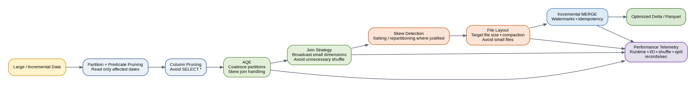
Optimization | Implementation principle
Incremental processing | Read/process only newly arrived or affected data
Partition pruning | Filter by required date partitions before transformation
Predicate pushdown | Push filters toward storage/source where supported
Column pruning | Select only required columns; avoid SELECT *
AQE | Runtime partition coalescing and skew-join optimization
Broadcast joins | Broadcast only genuinely small reference datasets
Skew handling | Detect hot keys; use AQE, salting or repartitioning when justified
Shuffle reduction | Avoid unnecessary repartition, distinct, global sort and groupBy
File optimization | Control output file sizes and mitigate small-file proliferation
Caching | Cache only reused, bounded datasets after measurement
Compression | Use efficient columnar compression appropriate to workload
Performance telemetry | Track runtime, I/O, shuffle, spill, task failures and throughput

8.1 Spark configuration baseline
spark.sql.adaptive.enabled=true
spark.sql.adaptive.coalescePartitions.enabled=true
spark.sql.adaptive.skewJoin.enabled=true
# Tune partition counts from observed workload,
# not by blindly applying a single constant.
Performance principle
The framework should optimize for elapsed time and resource efficiency, not simply maximize cluster size. The primary strategy is to avoid reading, shuffling and rewriting data that does not need to be processed.

9. Enterprise Security, PII and Governance
Figure 4 — Security and Data Protection Architecture
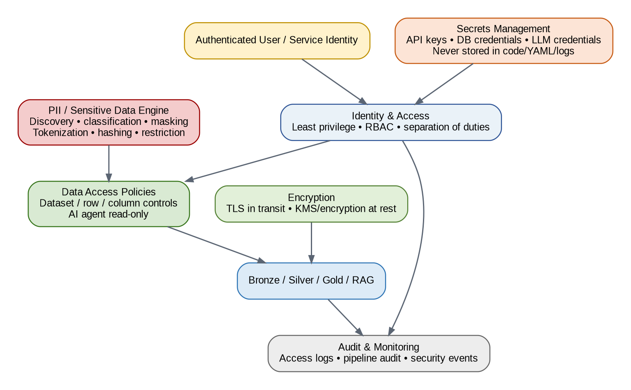
Control | Design
Identity | Strong service/user identity with least privilege
Authorization | RBAC plus dataset/row/column controls where required
Secrets | Secret manager/runtime injection; never hard-code credentials
Encryption | TLS in transit; managed encryption at rest
PII discovery | Pattern/metadata-based detection and classification
PII protection | Masking, tokenization, hashing or encryption according to policy
Audit | Access, pipeline, DQ and security events
AI access | Read-only approved tools; no unrestricted database access
SQL safety | SELECT-only, allow-listed tables/columns, resource limits
RAG security | Metadata/authorization filtering before context reaches LLM

9.1 PII classification
- PUBLIC
- INTERNAL
- CONFIDENTIAL
- PII
- SENSITIVE_PII
- PCI
The current Electricity Maps dataset is not expected to contain personal data; the PII capability is therefore implemented as a reusable framework control rather than artificially introducing PII into the assignment dataset.

10. Incremental, Idempotent and Resilient Processing
Source
↓
Watermark / checkpoint
↓
New or changed data
↓
Bronze append
↓
Silver deterministic deduplication
↓
Incremental MERGE
↓
Affected Gold partitions
↓
Audit + checkpoint commit

10.1 API resilience
- Connection and read timeouts.
- HTTP 429 rate-limit handling.
- Retry transient 5xx failures.
- Exponential backoff with jitter.
- Maximum retry count and dead-letter/error state.
- Request correlation IDs.
- Structured error logging without exposing secrets.
- Replay from the last successful watermark.

11. Audit, Observability and Operations
Area | Tracked information
Pipeline audit | run_id, pipeline, dataset, start/end, status
Volume | records read/written/rejected
Quality | DQ score, failed rules, quarantine counts
Freshness | watermark, data latency, SLA status
Performance | runtime, throughput, I/O, shuffle, spill
API | latency, response code, retries, rate limits
Security | authentication/access events, policy violations
Lineage | source → Bronze → Silver → Gold → AI tool

12. Orchestration and CI/CD
validate_config
↓
ingest_flows ──────┐
├── validate_bronze
ingest_mix ────────┘
↓
transform_flows
transform_mix
↓
validate_silver
↓
build_daily_mix
build_net_imports
build_net_exports
↓
validate_gold
↓
publish / notify

12.1 CI/CD gates
- Linting and formatting checks.
- Unit tests for transformations and utility functions.
- Schema and contract tests.
- Data-quality regression tests.
- Integration tests using representative sample data.
- Security/dependency scanning.
- Build validation.
- Controlled deployment promotion.

13. RAG-Enabled AI Data Agent
Figure 5 — AI Data Agent and RAG Architecture
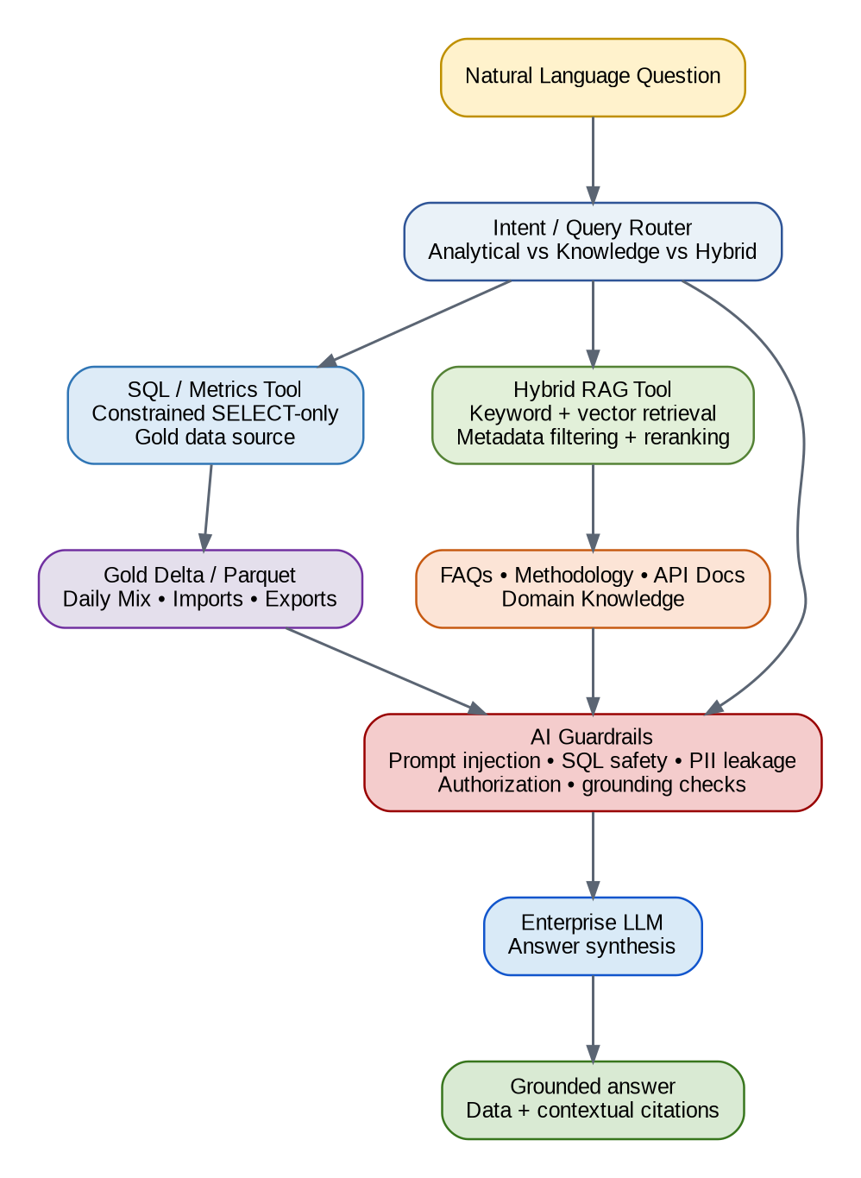
The assignment asks for a design connecting the ETL pipeline to an LLM conversational interface. The recommended design uses separate tools for structured analytics and unstructured knowledge retrieval rather than embedding all numerical data into a vector store.

13.1 Analytical question path
User question
↓
Intent classification
↓
SQL / Metrics tool
↓
Gold Delta / Parquet
↓
Validated result
↓
LLM explanation
↓
Grounded answer

13.2 Knowledge question path
User question
↓
Query rewriting
↓
Hybrid retrieval
↓
Metadata/security filtering
↓
Reranking
↓
Documentation / FAQs
↓
LLM
↓
Grounded answer + citation

13.3 Hybrid question
Example: "Why did France's renewable share decline compared with the previous month?"
- Query Gold data for the relevant periods.
- Calculate the observed change using deterministic logic.
- Retrieve methodology/domain documentation.
- Provide the LLM with the structured result and authorized contextual evidence.
- Generate an explanation that clearly distinguishes observed data from interpretation.

14. AI Safety and Governance
Risk | Control
Prompt injection | Input validation, tool boundaries, instruction hierarchy
Unsafe SQL | Parser, SELECT-only policy, allow-list, resource limits
PII leakage | Classification/masking and output policy
Unauthorized data | Identity-aware tool authorization and retrieval filters
Hallucination | Grounding checks and source-backed responses
Data exfiltration | Tool scopes and result-size controls
Prompt/system disclosure | Protected system instructions and refusal policy
Auditability | Trace intent, tool calls, query, retrieved context and response

15. Proposed GitHub Repository
electricity-maps-enterprise-etl/
├── README.md
├── ARCHITECTURE.md
├── REQUIREMENT_TRACEABILITY.md
├── SECURITY.md
├── PERFORMANCE.md
├── DATA_QUALITY.md
├── DATA_CONTRACTS.md
├── RAG_ARCHITECTURE.md
├── OPERATIONS.md
├── pyproject.toml
├── requirements.txt
├── Makefile
├── .env.example
│
├── config/
│ ├── dev.yaml
│ ├── test.yaml
│ └── prod.yaml
│
├── src/electricity_maps/
│ ├── ingestion/
│ ├── bronze/
│ ├── silver/
│ ├── gold/
│ ├── dq/
│ ├── security/
│ ├── optimization/
│ ├── contracts/
│ ├── audit/
│ ├── observability/
│ └── common/
│
├── rag/
│ ├── ingestion/
│ ├── chunking/
│ ├── embeddings/
│ ├── retrieval/
│ ├── reranking/
│ └── prompts/
│
├── orchestration/
├── infrastructure/
├── tests/
│ ├── unit/
│ ├── integration/
│ ├── dq/
│ ├── security/
│ ├── performance/
│ └── contract/
├── sample_data/
└── .github/workflows/

16. End-to-End Execution Model
# Install
python -m venv .venv
source .venv/bin/activate
pip install -r requirements.txt
# Configure
cp .env.example .env
# Run ingestion + transformations
python -m electricity_maps.main --config config/dev.yaml
# Run tests
pytest -q
# Run data-quality suite
pytest tests/dq -q
The production deployment can map the same framework interfaces to managed object storage, a distributed Spark runtime and an enterprise orchestration service. The core transformation logic remains independent of a specific cloud vendor.

17. Sample Output Expectations
- Partitioned Bronze raw files for flows and mix.
- Silver Delta tables with Parquet data files and data-date partitions.
- Gold Delta tables with flat schemas and Parquet outputs.
- DQ result report showing passed/failed/warning rules.
- Pipeline audit record.
- Representative execution logs.
- Architecture diagrams.
- Unit/integration test results.

18. Reviewer-Oriented Submission Strategy
First five minutes
The reviewer should be able to open README.md, understand the architecture, see the requirement traceability matrix, run the pipeline, and locate Bronze/Silver/Gold outputs without navigating unnecessary infrastructure.

- Mandatory requirements are visibly mapped to implementation.
- Enterprise features are additive and modular.
- The code is runnable without requiring Databricks or Snowflake.
- Cloud deployment is an extension, not a hidden prerequisite.
- AI architecture is sophisticated but does not overclaim a production frontend or trained model.
- Security and PII are framework capabilities without fabricating PII in the Electricity Maps dataset.
- Performance claims are supported by measurable optimization and telemetry rather than arbitrary cluster-size claims.

19. Key Architectural Decisions and Rationale
Decision | Rationale
PySpark | Explicitly permitted by the assignment and provides distributed processing and reusable ETL patterns.
Delta Lake | Required for Silver/Gold and provides transactional table semantics for reliable data products.
Parquet | Required output format and efficient columnar storage.
No mandatory Databricks/Snowflake | Neither platform is specified; avoiding a hard dependency maximizes assignment compliance and portability.
Bronze raw | Preserves source fidelity and enables replay/debugging.
Metadata-driven framework | Makes the solution reusable beyond a single dataset.
Domain-specific DQ | Detects semantic failures generic null/schema checks cannot catch.
Incremental/idempotent design | Reduces runtime, cost and duplicate risk.
SQL + RAG tools | Separates deterministic numerical analytics from documentation retrieval.
Security-by-design | Prevents sensitive-data and AI access risks from becoming downstream fixes.

20. Conclusion
The proposed solution is intentionally balanced: it follows the NXP assignment exactly where requirements are explicit, while demonstrating how the implementation can evolve into a reusable enterprise Data & AI platform. The core engineering capability is a robust PySpark Bronze/Silver/Gold pipeline with Delta Lake and Parquet. Around it sit advanced capabilities for reliability, performance, quality, security, governance, operations and AI.
Final architectural statement
The lakehouse is the system of record; Gold is the business data contract; DQ and security are enforced before AI consumption; the Data Agent uses constrained tools; RAG supplies authorized domain context; and the LLM provides the natural-language experience.

Appendix A — Diagram Package
Five enterprise architecture diagrams are included in the companion package in both PNG and SVG formats. The SVG files are vector graphics suitable for import into Visio or draw.io for further editing and branding.
- 01_overall.svg — End-to-End Enterprise Architecture
- 02_medallion.svg — Bronze → Silver → Gold
- 03_security.svg — Security and PII Architecture
- 04_performance.svg — PySpark Performance Engineering
- 05_ai.svg — AI Data Agent and RAG Architecture

Appendix B — Scope Boundary
The NXP assignment explicitly states that the chatbot portion is design-focused and that a production-ready frontend, full chatbot implementation and LLM training are not required. Accordingly, this document provides a production-grade target architecture and control model without pretending that an unrequested full conversational application has been implemented.

