|  |
| --- |
| Photo displaying partial image of two pie charts on a canvas-textured page |
| Zomato Data-Analysis Report  A SQL report project |
| |  |  |  | | --- | --- | --- | | **Debasish Biswas** |  |  | |

**CREATING THE DATABASE:**

Created a database of a food website like Zomato with and inserted some dummy data to do some analysis upon the data.  
The database, named zomato_data contains 4 tables:  
goldusers_signup, users, sales, and product.

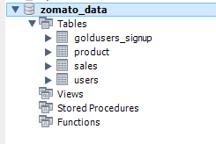

The goldusers_signup table has two columns - userid and gold_signup_date. It is used to track users who signed up for a premium (gold) service and the date they signed up.

- creating table goldusers_signup:

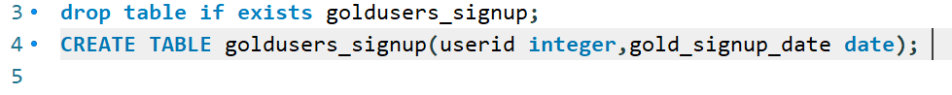

- inserting values:



The product table has three columns - product_id, product_name, and price. It contains information on all the products available for purchase on the platform, including the product name and price.

- creating table product:



- inserting values:

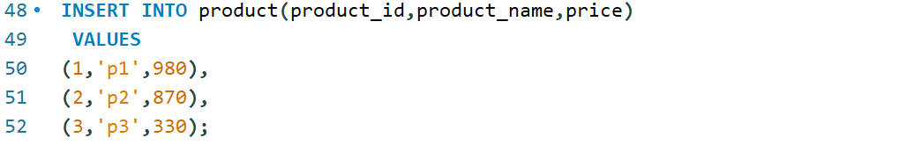

The users table also has two columns - userid and signup_date. It stores the basic information of all users who signed up on the platform.

- creating table users:



- inserting values:

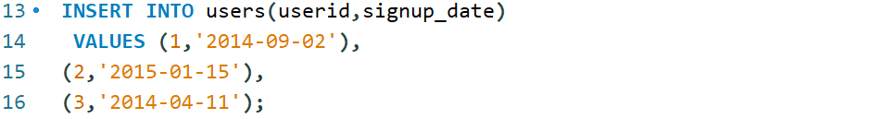

The sales table has three columns - userid, created_date, and product_id. It records all sales transactions made on the platform, including the user who made the purchase, the date the purchase was made, and the product that was purchased.

- creating table sales:



- inserting values:  
  
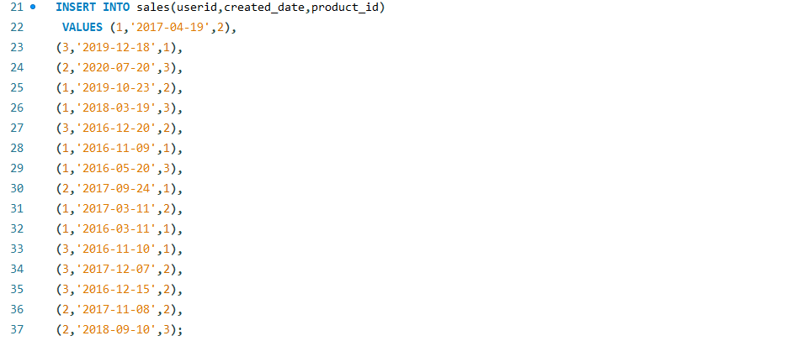

- sales table:

  
  
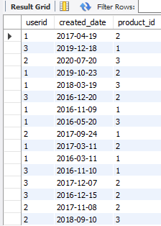

- product table:



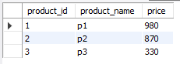

- goldusers_signup table:



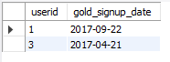

- Users table:



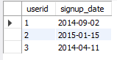

📌 From next are some important questions based on which analysis is performed.  
 Some these questions are really important in improving upon any particular product, the business model or any other thing.

**Questions:**

1. What is the total amount each customer spent on Zomato ?

This query joins the sales and product tables and calculates the total amount spent by each user.



-Result  
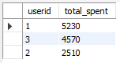

2. How many days has each customer visited Zomato ?

This query counts the distinct number of days each user has visited Zomato.



-Result  
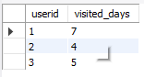

3. What was the First product purchased by each of the customers ?

This query ranks the products purchased by each user by date and selects the first one.

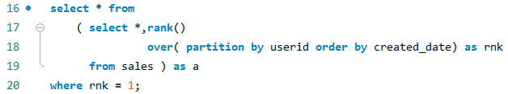

-Result  
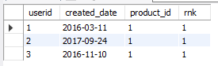

4. What is the most purchased item on the menu and how many times was it purchased by all customers ?

This query has two parts: the first part selects the most purchased product from the sales table and the second part counts the number of times the most purchased product was bought by each user.

1st part

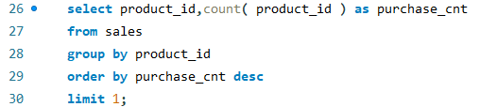

-Result  


2nd part

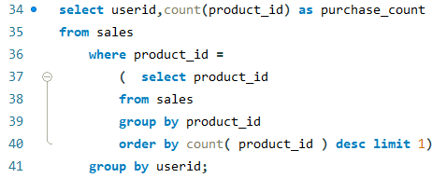

-Result  
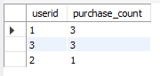

5. Which item was the most popular for each customer ?

This query is trying to find out which item was the most popular for each customer.

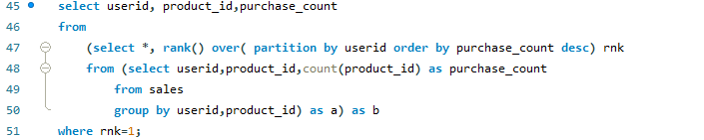

-Result  
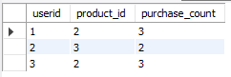

6. Which item was first purchased by the customer after they took gold membership ?

This query is trying to find out which item was first purchased by each customer after they became a gold member.

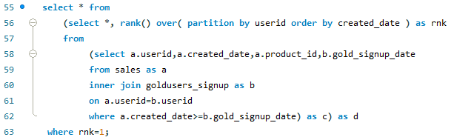

-Result  
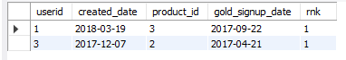

7. Which item was purchased just before the customer became a gold member ?

This query is trying to find out which item was purchased just before the customer became a gold member.

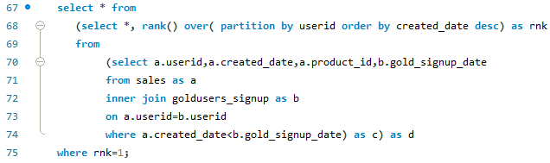

-Result  


8. What is the total orders and amount spent by each member before they became gold members ?

This query is trying to find out the total orders and amount spent by each member before they became gold members.

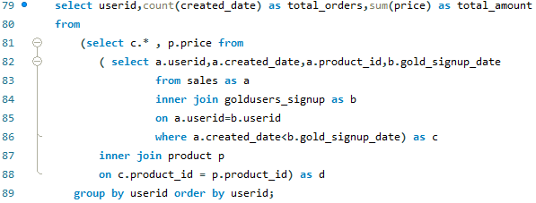

-Result  


9. If buying each product generates points for example 5rs=2 zomato points and each product has different purchasing points for example for p1 5rs=1 point, for p2 10rs=5 points, for p3 5rs=1 point calculate points collected by each customer and for which product most points have been given till now ?

This query is asking to calculate the number of points earned by each customer based on their purchases, where each product generates a certain number of points depending on its price. Specifically, for every 5 Indian Rupees spent, 2 Zomato points are earned, but each product has a different purchasing points rate: for product p1, 5rs equals 1 point, for product p2, 10rs equals 5 points, and for product p3, 5rs equals 1 point.

1st part

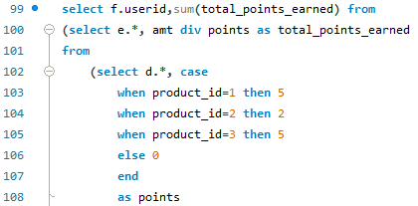

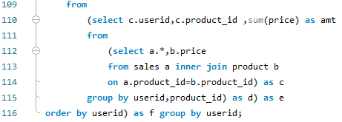

-Result  
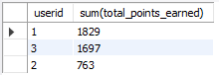

2nd part

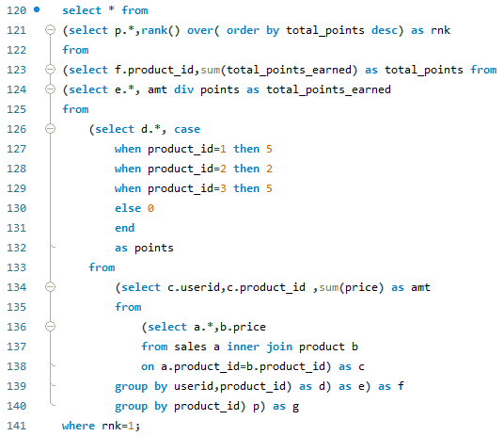

-Result  


10. In the first year after a customer joins a gold program (including their join date) irrespective of what the customer has purchased they earn 5 zomato points for every 10rs spent who earned more 1 or 3 and what was their point earnings in their first year ?

The SQL question is asking for the calculation of the point earnings for customers in their first year after joining a gold program. The earning rate is 5 Zomato points for every 10 rupees spent, and this applies regardless of what the customer has purchased.

The question is also asking to compare the point earnings of two customers: customer 1 and customer 3, and determine who earned more points in their first year. The customer data should include their join date and their point earnings.

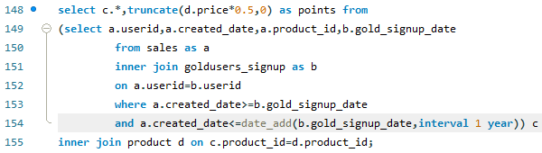

-Result  
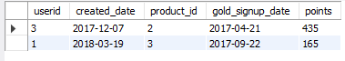

11. Rank all transactions of the customers.



-Result  
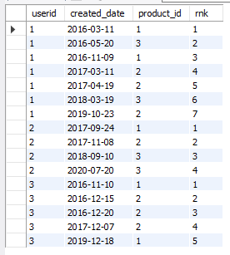

12. rank all the transactions for each member whenever they are a zomato gold member and for every non-gold member transaction mark as 0.

The SQL question is asking to rank all the transactions for each member based on their Zomato Gold membership status. For members who have a Zomato Gold membership, the query should rank all their transactions in descending order based on the transaction amount. For members who do not have a Zomato Gold membership, the query should mark all their transactions with a rank of 0.

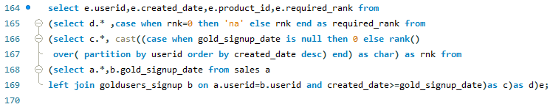

-Result

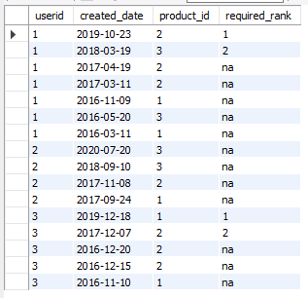

**Thank You**