Clinical Studies – Web Tracking Tool

General Information:

This tool will be able to integrate data from internal and external data sources within the data warehouse and will provide the scientific end user to analyze the status data for the study.

General Work Flow:

The work flow will primarily consists of three steps:

1. Study Creation
2. Raw data file uploads
3. Analyze the uploaded data in visualization

Work Flow in Detail:

1. Study Creation: The admin users will be able to create study and authorize the users to upload raw data files, mapping file and also provide users the data visualization right to the study. The admin user will be able to update or delete study as well.
2. Raw data file uploads: The authorized users of the study will be able to upload raw data files (.csv) against the study. The user will also provide the mandatory column mapping file by downloading a template file and populating with required data in defined format and upload it against the study. { for detail explanation refer to page 2}
3. Analyze the uploaded data in visualization: The authorized user will be able to view the study status data and other aggregated values in report and other gender visualizations in form of pie charts, age visualizations in form of bar graph. The user will also be able to view the grid view data and will be able to export as well.

Apart from this primary functionalities, the tool will have login, user management, user role assignment (to Study) and template management screens.

Technology Stacks:

Open Source: Angular, Express, NodeJS, MongoDB (for database), d3.js (for visualization), Amazon (for Cloud Based)

DATA MODEL: Some of the important database tables:

CLINICAL_STUDY: It will store the study information.

PATIENT_DIMENSION: It will store the subjects who have taken part in the study events. *Some of the columns: PATIENT_NUM, STUDY_ID, SITE_CD, VITAL_STATUS_CD, AGE, SEX_CD, COUNTRY_CD etc.*

CONCEPT_DIMENSION: It will contain the navigation information of the study. *Some of the columns:CONCEPT_CD, CONCEPT_PATH, STUDY_ID etc.*

OBSERVATION_FACT: This table will be linked to the tables namely patient_dimension and concept_dimension via separate primary keys (patient_num and concept_id respectively). This will help in determining the aggregate values.

COLUMN MAPPING IN DETAIL

The raw file format: (for e.g.)

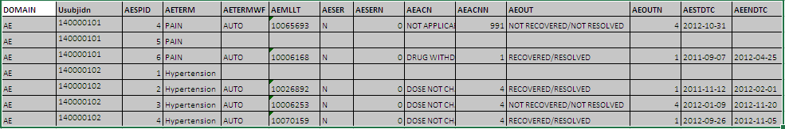

COMLUMN Mapping (tab delimited file to be uploaded for e.g.)

This file will be tab delimited and will follow the defined format and it will be uploaded to be stored in database table against the study. The mapping data will be stored in database table with following fixed columns. However the user will be able to design variables as per his needs in the Category_Code text value.

1. First Column: Filename - Name of the raw data file (e.g. abc.txt)
2. Second Column: Category_Code – Navigation string or the path of the tree that appears on the UI. ‘+’ will denote the node demarcation and will ‘_’denote space in category code.
3. Third Column: Column_Num – Will denote the corresponding column number in raw data file.
4. Fourth Column: Data_Label – Variable Name that will displayed. “\” symbol will denote grouping of this column data to be used
5. Fifth Column: Data_Label_Source – For grouping purpose: denotes the column number of data file, according to which the grouping has to be done. For e.g. “3” for grouping to be done on 3rd column in raw data file.
6. Comments: The user will be able to add any relevant comments for the variable
7. Non-comment: The user will be able to add any relevant non-comment for the variable

|  |  |  |  |  |
| --- | --- | --- | --- | --- |
| FILENAME | CATEGORY_CODE | COLUMN_NUM | DATA_LABEL | DATA_LBL_SRC |
| abc.txt |  | 1 | OMIT |  |
| abc.txt |  | 2 | SUBJID |  |
| abc.txt |  | 3 | OMIT |  |
| abc.txt |  | 4 | OMIT |  |
| abc.txt | Clinical_Data + AE + Pain | 5 | \ | 4 |
| xyz.txt | Subjects+Demographics+Gender | 12 | Male |  |

Report Displayed (Data visualization for e.g.):

Study Name

* + Clinical Data
    - AE
      * Pain
        + Auto (2)
      * Hypertension
        + Auto (3)

…. So on…

* + Subjects
    - Demographics
      * Gender
        + Male (10)
        + Female (8)
    - Treatment Status
      * Completed (5)
      * Wish for Pregnancy (2)
      * Adverse Event (1)