Child’s Pose

1 of 30

Next

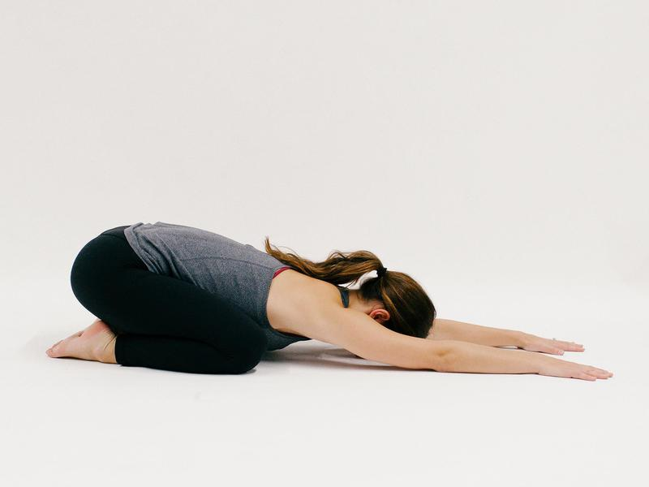

Kneel, then take your knees wide and big toes to touch.

Walk your hands forward until your forehand rests gently on the ground.

Practice deep, steady inhales and exhales for about 3-5 breaths as you let go of distraction and focus on your yoga practice.

Tabletop

2 of 30

Next



Rise from child’s pose to tabletop, with your shoulders stacked over wrists and your hips stacked over knees.

Place equal weight through your hands and knees, relax your feet, engage your abdominal muscles and lengthen your spine.

Gaze is down in between your hands.(Tip: if this bothers your knees, place a towel or rolled up edge of a yoga mat underneath your knees for more support.)

Cat Pose

3 of 30

Next

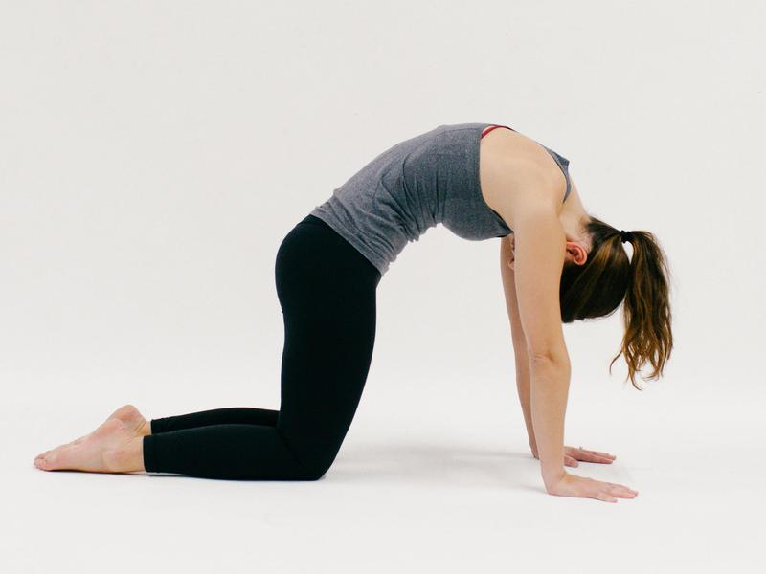

Press into your hands to round your upper back, as if a string were pulling the middle of your back to the ceiling.

Drop your head and tuck your chin to chest, hugging your belly toward spine.

Cow Pose

4 of 30

Next



Lower your belly and lift your chest.

Stay grounded through your hands as you broaden your shoulders. Lift your gaze to look forward or up, and hollow out your lower back.

Drop your shoulders away from ears.

Alternate between cat and cow two or three more times.

Downward Facing Dog

5 of 30

Next



Walk your hands forward an inch or two, curl your toes underneath and lift your hips up into downward facing dog.

Your legs can keep a slight bend, but reach your heels toward the floor.

Ground down through all your fingers, especially the space between your thumb and first finger, and press through your arms while lifting your hips up and back.

Stay for 3-5 breaths.

Forward Fold

6 of 30

Next



Slowly walk your feet toward your hands, and step shoulder-width apart.

With a slight bend through your knees, lower the top of your head toward the ground, belly reaching to thighs, and let your hands dangle down to your toes.

Relax your upper body. Try moving your neck around here, exploring how it feels to bend or straighten your knees, acknowledging stiffness or tension in any part of your body.

Stay for a few breaths.

Halfway Lift

7 of 30

Next



On an inhale, place hands on your shins and lift your shoulders to be in line with your hips.

Breathe here, as your body forms a right angle. Engage your core and open your chest forward. Look down to lengthen the back of your neck, and keep your neck safe.

Exhale to forward fold, and repeat.

Tadasana

8 of 30

Next



Swoop your arms up to the sky, standing tall.

Keep equal weight through both of your feet, with strong legs and an active core.

Soften your shoulders away from your ears and extend your fingertips up as your palms face one another.

Your body is one long line of energy: head over shoulders over hips over heels.

Breath for 3-5 counts, close your eyes and set an intention for your day.

Side Stretch

9 of 30

Next

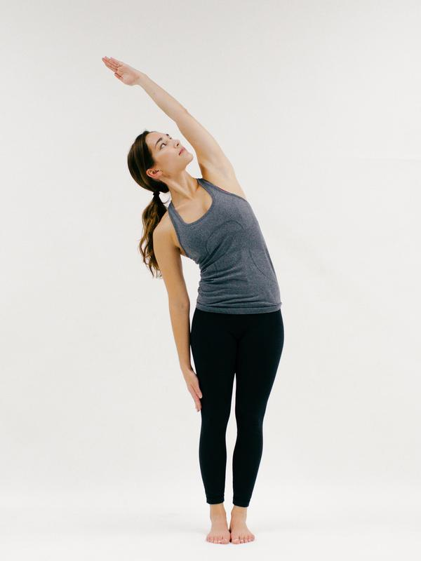

Exhale to stretch to one side of your body, keeping weight equal through both feet.

Return to center, then stretch to the other side. Engage your abs to protect your low back.

Only go far enough to keep your breath easy, and avoiding crunching through either side of your body.

Repeat two more times, for a total of three stretches on each side of your body.

Mini Backbend

10 of 30

Next

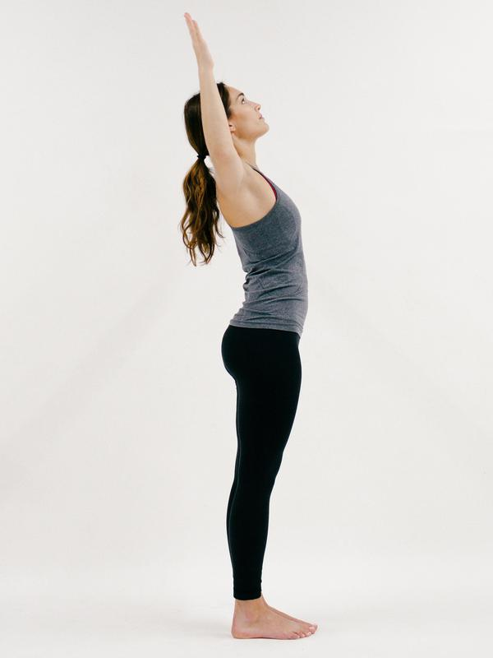

Come back to tadasana for a mini-backbend: bend your elbows to either side of your body at shoulder-height, like a goalpost, and lift your chest and chin up.

Keep the front side of your body, quadriceps and core strong.

Draw your shoulders down your back as you open your heart toward the ceiling.

Stay for a breath, then rise back up to standing.

Plank

11 of 30

Next



From tadasana, fold forward and step back into plank pose. Your hands are shoulder-width wide with feet together.

Stack your shoulders over your elbows over your wrists, and align your hips to your shoulders and heels.

Look down in between your hands and activate your entire body, engaging all your muscles.

Drop to your knees for less sensation, and hold for 3-5 breaths.

Low Cobra

12 of 30

Next



Lower slowly to your belly. Bring your hands to your sides, near your low ribs, and hug your elbows in tightly.

Strongly press the tops of your feet to the floor to lift your knees off of the ground.

On an inhale, raise your chest up a couple of inches and lighten the weight through your hands.

Gaze is down, neck is long, and shoulders relax away from your ears.

Exhale to release your forehead to the ground, inhale press back up to plank (on your knees or toes), and exhale to return to downward facing dog.

Downward Facing Dog with Leg Lift

13 of 30

Next

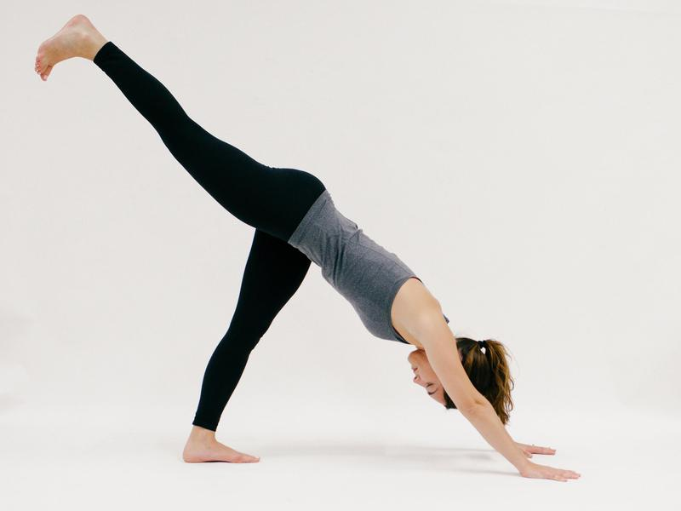

From downward facing dog, lift one leg up with intention, flexing your foot toward the ground to keep your hips level.

Send the heel of your other foot a little closer to the ground, and press through hands and arms evenly.

Stay for a few breaths, and on an exhale, release your lifted foot to the ground.

Repeat with the other leg.

Low Lunge

14 of 30

Next

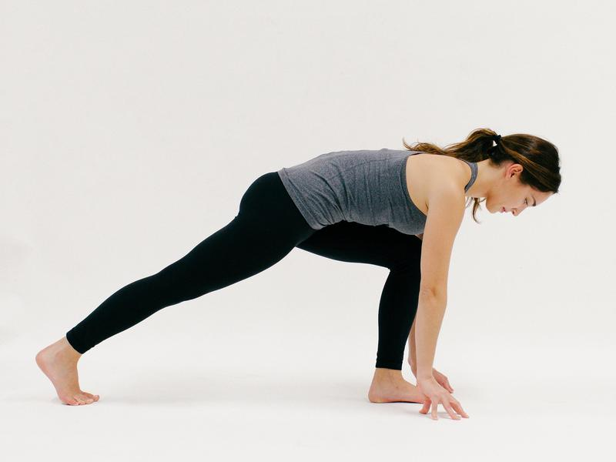

Inhale to lift your left leg high, then exhale to step forward as you bring your left foot in between your hands. Breathe.

Your fingers frame your left foot, and your belly lifts up and away from your left thigh.

Squeeze your right leg and stack your right heel over your right toes.

Warrior II

15 of 30

Next



Exhale to spin your right heel down. On an inhale, lift your torso up as arms reach out wide.

Your left knee is directly atop your left ankle. Pull your belly in, stack your shoulders over your hips and keep equal weight in both of your feet.

Draw your left knee toward your left pinkie toe. Look past your left hand, and ignite the muscles throughout your arms as your pelvis sinks down.

Hold here for 3-5 breaths.

Extended Side Angle

16 of 30

Next



On your next exhale, bring your left elbow to the inside of your left leg. Keep your bottom half exactly the same as warrior II.

Press firmly through the outer edge of your back foot. Lift your right arm to open your chest toward the right and stack your shoulders on top of each other.

Continue to bend through your left knee as you create length through the left side of your body, and pull right hip back slightly.

Your gaze can be down, to the side or up. Stay for 3-5 breaths.

Reverse Warrior

17 of 30

Next

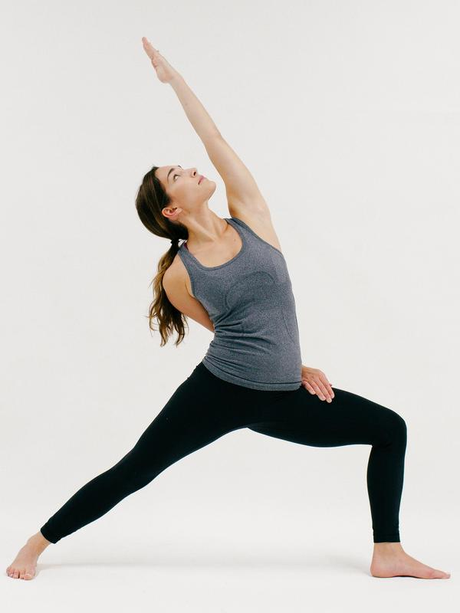

On an inhale, lift your left arm up and back. Again, lower half stays the same.

Your right hand can rest softly on your back thigh, or reach around your lower back for a bind.

Think about evenly distributing weight through your legs and feet, as you find length in your spine and create space between shoulders and ears.

Keep your chest open toward the right, and gaze down to your back foot or up to your lifted hand.

Hold for 3-5 breaths, remembering to sustain the bend through your left knee.

Side Plank

18 of 30

Next

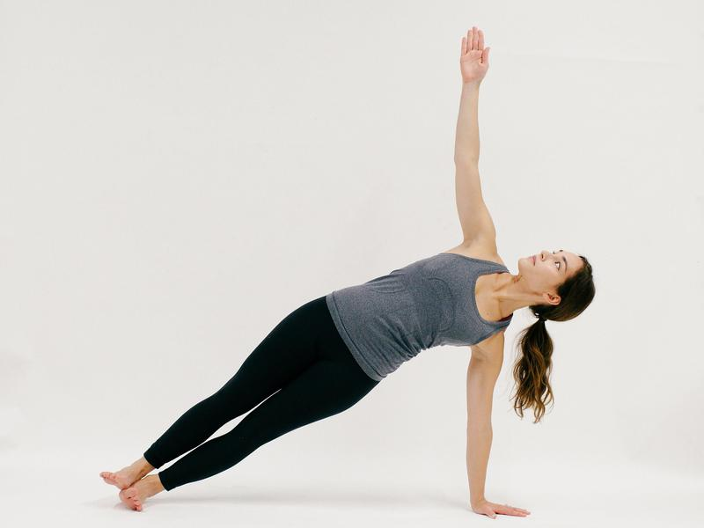

Windmill your arms down to the ground, and transition to high plank.

Shift weight to the left side of your body, and slowly peel your right hand and foot away from the ground as your hips lift up.

You can stack your ankles on top of each other, as your right arm raises, or bring your left knee to the ground for a less intense variation.

Either way, use your core to lift your hips. Gaze can be down, neutral or up.

Breathe as you build strength.

Chaturanga

19 of 30

Next

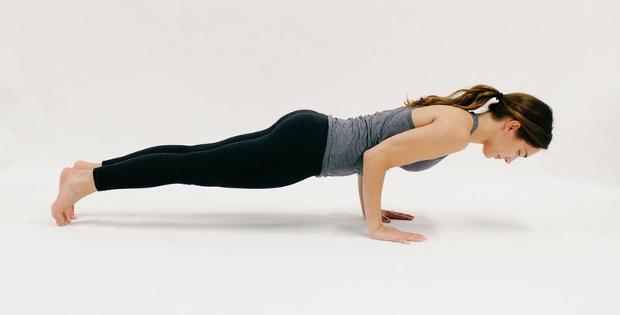

From side plank, return to high plank on your toes or knees.

Shift your shoulders forward slightly, and exhale to lower your body until your elbows reach 90 degrees.

Avoid going lower to protect your shoulder, elbow and wrist joints.

Keep your core engaged.

(Tip: this is the same pose as high plank, only your elbows are bent this time!)

Upward Facing Dog

20 of 30

Next



On your next inhale, press through your hands to lift your shoulders up, stacking them over your elbows and wrists.

Draw your chest forward as your belly, upper thighs and knees move away from the ground.

The only body parts touching the floor are your palms and the tops of your feet.

Drop your shoulders away from your ears and look forward (not back) to find openness through the chest, shoulders and abs.

Exhale to downward facing dog, then repeat the entire sequence (from low lunge to upward facing dog) on the other side.

Repeat one more full round on both your right and left sides.

Chair Pose

21 of 30

Next

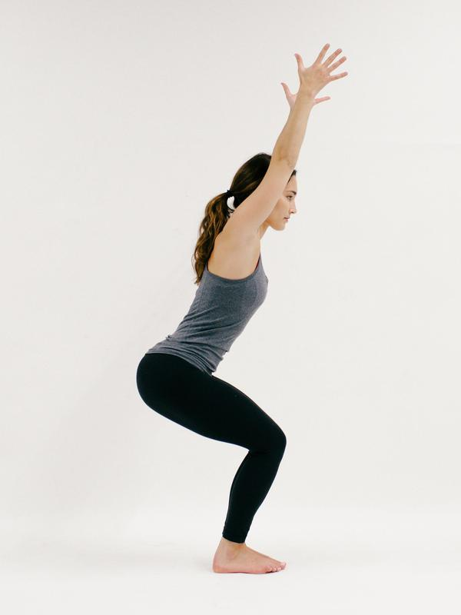

After you return to downward facing dog, look forward and step both of your feet to your hands.

Inhale to halfway lift, and exhale to fold forward. Inhale to find chair pose: sit your hips down and back with your feet about hip width distance apart.

Your toes and knees point forward in the same direction. Keep your spine long and your abs engaged.

Relax your shoulders away from your ears, lift your arms high.

Palms face one another. Breathe here.

Prayer Twist

22 of 30

Next



Bring your hands to heart center and press your palms together at your sternum.

Keep your lower half as it is in chair pose. Now,  twist to the right by connecting your left elbow to the outside of your right knee.

Hips stay lower than shoulders and elbows stack over one another. Pull your left knee and hip slightly back, so they stay in line with your right knee and hip.

Firmly press your palms together to deepen the twist. Stay for a few breaths, then return to center.

Repeat on the other side, with right elbow moving toward the outer left knee.

Tree Pose

23 of 30

Next



From chair pose, stand straight up with both of your feet on the ground. Shift your weight into your right foot.

Lift your left leg and bend through your left knee.

Bring your left foot to the inside of your right calf or inner right thigh—you can put the bottom of your foot anywhere on your standing leg, just avoid putting pressure on your right knee!

Stand tall to engage your standing leg, and press your left knee slightly outward. Arms can come together at heart center, or lift up like tadasana.

Keep your balance steady by focusing one thing in front of you that is not moving.

Balance for a couple of breaths, then do the other side.

Horse Pose

24 of 30

Next



Step your feet wide, and turn your toes out. Bend your knees, lowering your pelvis toward the ground.

Send your knees in the direction of your pinkie toes to find an external rotation.

Options for your arms are: hands on hips, arms extended wide, or bending through each elbow as shown.

Stack your shoulders over your hips as you continue to sink your hips down and turn your knees out.

Stay for a couple breaths.

Wide Legged Forward Fold

25 of 30

Next



Rise from horse pose, and turn your feet and knees forward in the same direction as your hip points.

With a long spine, lower your torso over your thighs to wide-legged forward fold.

Your arms can grab opposite elbows, or dangle toward the ground. Keep a gentle bend through each knee, and equal out the weight between the heel and ball of each foot.

Breathe deeply through this stretch.

Camel Pose

26 of 30

Next

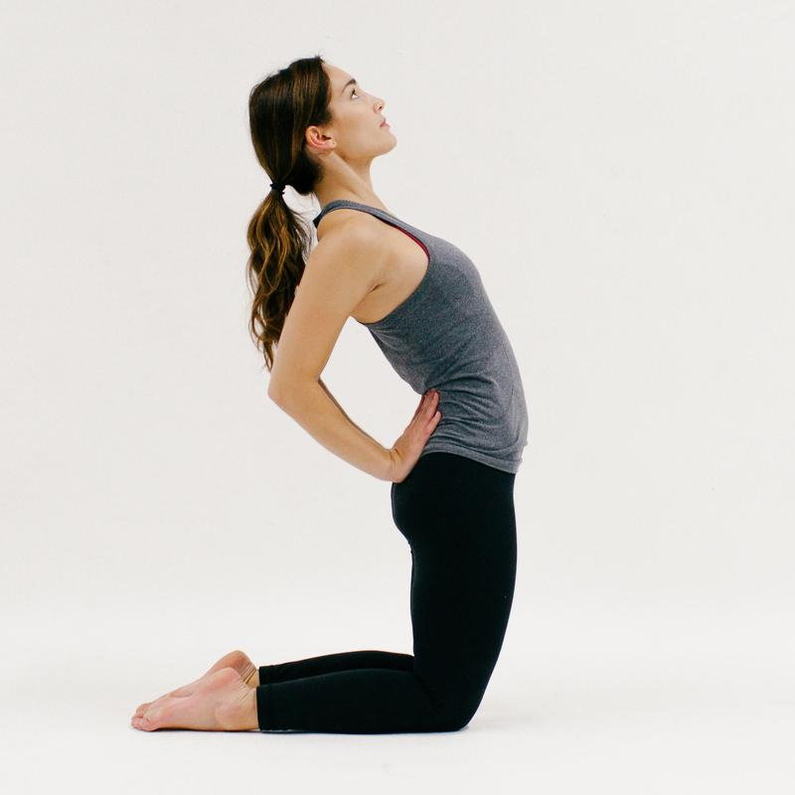

Stand on your knees, about hip distance apart. Release the tops of your feet to the ground, with your heels directly behind your knees.

Bring your palms to your lower back/sacrum for support, and relax your shoulders down and back as elbows squeeze together.

With a strong belly, slowly press your hips forward an inch as your chest lifts an inch toward the ceiling.

On every inhale, lift your chest upward, and on every exhale, press your hips forward in the same direction as your knees.

Keep your neck gentle; your gaze can be forward or up, but if you start to feel tension through your neck, release out of the pose, breathe and try again.

After a few breaths, carefully use your hands to guide your spine and low back up out of the posture. Sit your hips on your heels to allow your spine to recalibrate.

Seated Forward Fold

27 of 30

Next



Swing both of your legs out in front of you.

Flex your feet toward your face, and sit up tall. Inhale both arms high above your head, then fold forward over your legs.

Hands can rest on your thighs, shins or feet. Draw a straight line from your head to your tailbone, and keep your abs active.

Inhale to lengthen your spine, and exhale to fold forward a bit deeper.

Breathe here until you’re ready to move on.

Boat Pose

28 of 30

Next



Hug your knees into your chest, and roll your bodyweight to your tailbone until you feel your abdominal muscles activate.

Bend your knees so that your heels touch the ground in a right angle. You can stay here, or lift your heels to line up with your knees.

Reach your fingertips toward your heels, as you continue to lift through your chest and soften your shoulders away from your ears.

Stay for three breaths.

Seated Twist

29 of 30

Next



Send your legs out long one more time, and cross your left foot over your right knee. Your right leg remains extended.

Sit up tall, and bring your left hand behind you like a second spine, with left hand resting behind your tailbone.

Inhale for length, then exhale to slowly twist toward the left. Bring your right elbow or palm to the outside of your left bent knee.

Breathe in this twist, and then release and repeat on the other side.

Easy Pose

30 of 30

Next



Find a comfortable cross-legged position. Your spine is long, and your shoulders relax away from your ears.

Rest the backs of your hands on your thighs, palms up.

Or, bring your first finger and thumb together on each hand for “[gyana mudra](https://www.doyouyoga.com/7-common-yoga-mudras-explained-23667/" \t "_blank),” which symbolizes unity and consciousness.

Soften your gaze or close your eyes.

Cultivate a sense of gratitude for your body’s ability to move with power, grace and health.