**Lesson 05 Demo 01**

**Implementing Job Import Plugin**

**Objective:** To install the job import plugin for importing jobs from an existing Jenkins instance, streamlining job management, and enhancing productivity

**Tools required:** Jenkins

**Prerequisites:** Jenkins must be operational.

Steps to be followed:

1. Install the job import plugin in Jenkins
2. Configure the job import plugin
3. Access the job import plugin

**Step 1:** **Install the job import plugin in Jenkins**

1. Sign in to the **Jenkins** platform

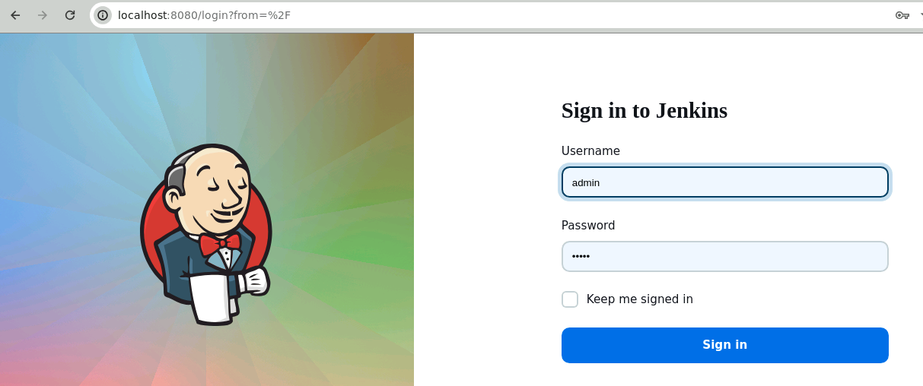

**Note:** The credentials for accessing Jenkins in the lab are Username: **admin** and Password: **admin**.

1. Select **Manage Jenkins**

1. Now, click on **Plugins** under **System Configuration**

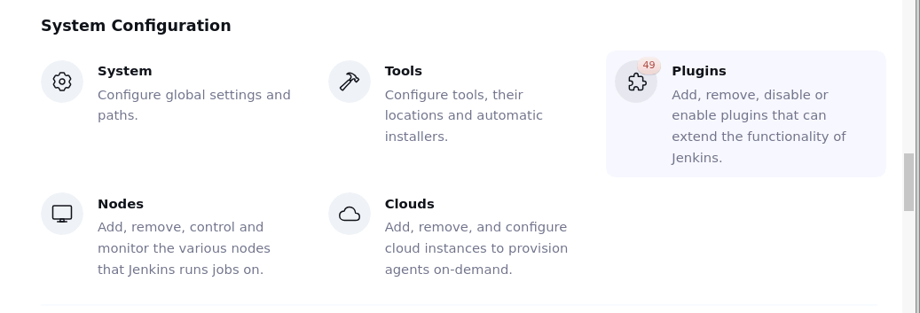

1. In the **Available plugins** tab, search for the **Job import plugin**

1. Select it and click on **Install**

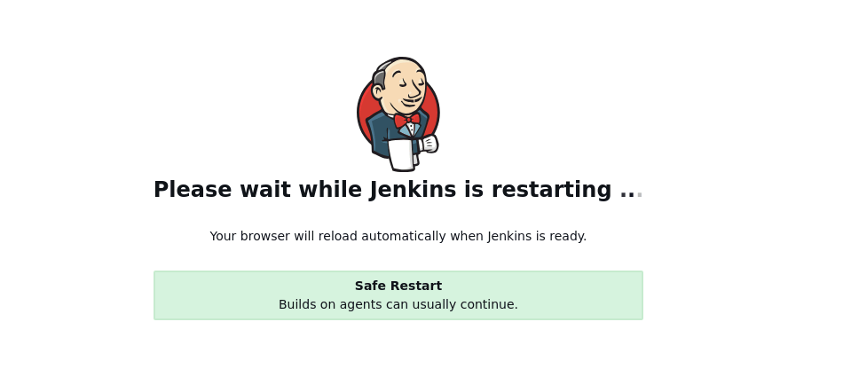

Once the plugin is installed, restart Jenkins to activate the plugin in Jenkins.