First I extracted all the excel sheets from the given spreadsheet.

Then, I converted it into \*.csv files.

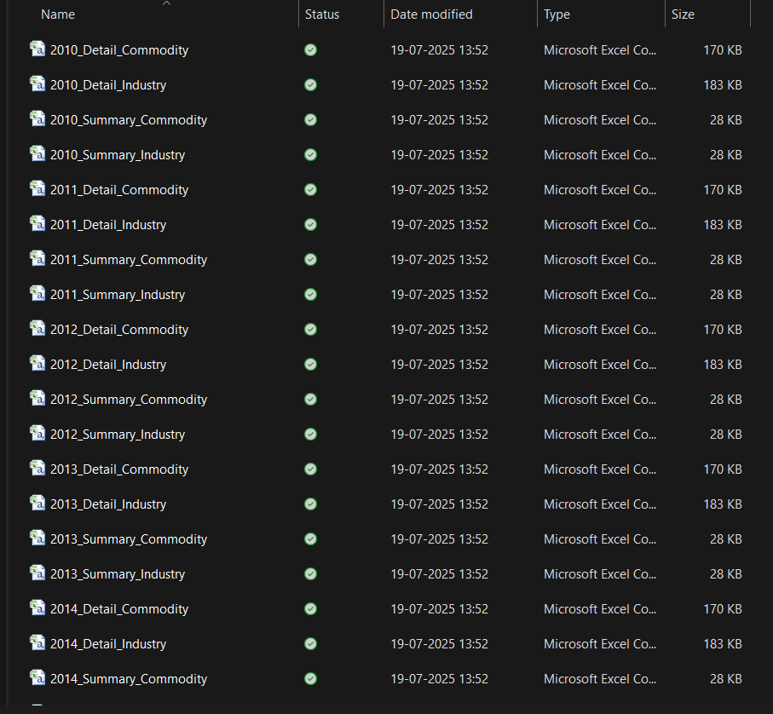

Then, I uploaded all the files one by one in the Weka tool and cleaned it by removing the missing values. For data visualization, this will help to get more clear and accurate result for the project description.

