Detailed Research Content: Major Economic Events in India (Timeline + Key Insights)

1. 1991 – LPG Reforms (Liberalization, Privatization, Globalization)
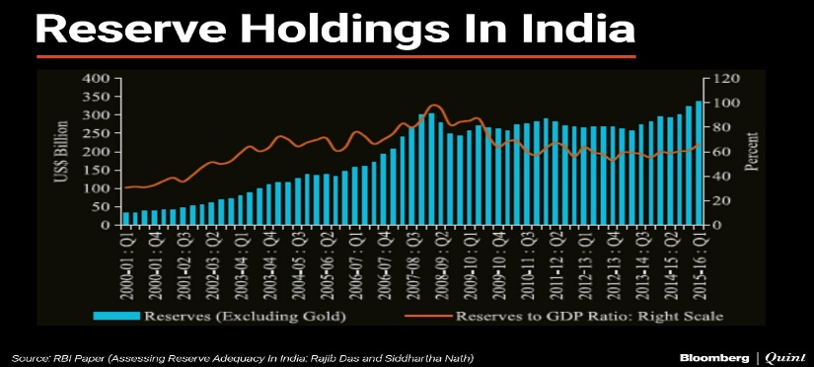
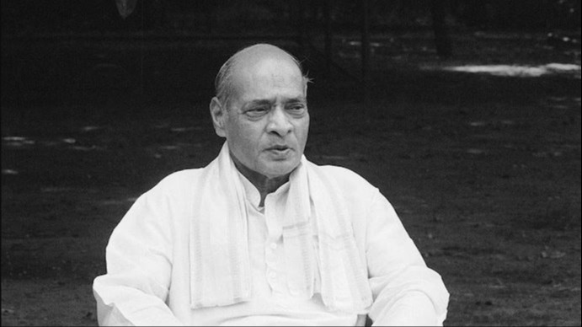
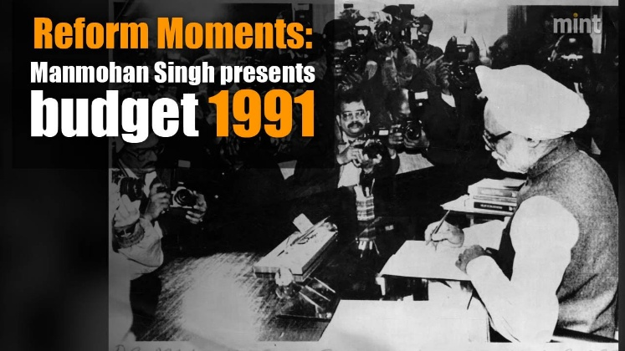

Background
- India entered a major Balance of Payments crisis
- Foreign exchange reserves fell to < USD 1 billion → only 2 weeks of imports
- High fiscal deficit (> 8%
- debt + low investor confidence
- IMF demanded structural of GDP)
- High inflation (~13%)
- Rising external economic reforms
- Economic leadership:
  - PM P.V. Narasimha Rao
  - Finance Minister Dr. Manmohan Singh
Major Action Taken — New Industrial Policy, July 1991
Reform model: LPG – Liberalization, Privatization & Globalization
A) Liberalization
- Abolished Industrial Licensing System for most industries
- Reduced import tariffs & quantitative restrictions
- Deregulated capital markets → SEBI strengthened
- Rupee devalued → export competitiveness improved
B) Privatization
- Government began disinvestment of PSUs
- Reduced public sector monopoly in industries
- Encouraged private sector in areas like:
  - Telecom, airlines, banking, manufacturing
C) Globalization
- Allowed FDI in multiple sectors
- Encouraged entry of MNCs, joint ventures
- Boosted foreign trade, opened markets to global competition

Outcomes / Impact
Structural Transformation
- Shift: Closed, controlled economy → Open, market-driven economy
- Higher GDP growth trajectory (towards 6–7% in 2000s)
- Increased FDI inflows + foreign exchange reserves stabilized
Winners
- Private sector expansion
- IT, telecom, finance sectors boomed
- Rise in middle-class consumption
Continuing Challenges
- Inequality gaps widened initially
- Some PSUs struggled due to competition

Economic Indicators (Around 1991)
Indicator | Approx. Value | Situation
Inflation Rate | ~13% | Very high due to crisis
Unemployment Rate | ~4.3% (official) | But disguised unemployment high
Poverty Rate | ~45% | Economic stress on poor households
Fiscal Deficit | ~8.4% of GDP | Government overspending major issue

Tooltip
1991 Reforms opened India’s economy to the world — ending the License Raj, boosting private sector growth, and attracting global investment.

2. 2008 – Global Financial Crisis & India’s Economic Response

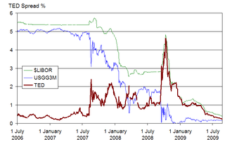

Background
The U.S. subprime mortgage crisis triggered a global banking collapse
Lehman Brothers’ bankruptcy led to panic in world financial markets
India was less exposed due to strong banking regulations but still impacted:
  - Stock market crash (Sensex fell >50% from Jan–Oct 2008)
  - Drop in exports & capital inflows
  - Reduced consumer and business confidence

Government & RBI Actions
A) Monetary Measures (RBI)
- Repo rate cut from 9% → 4.75% (to increase liquidity)
- Cash Reserve Ratio (CRR) lowered to boost lending
- Special refinance facilities for banks & NBFCs
B) Fiscal Stimulus Packages
- Government increased public spending — mainly infrastructure
- Tax cuts to encourage consumption
- Support for export industries (textiles, gems & jewelry, IT)
C) Banking Safety Measures
- Tight supervision on banks ensured no major failures
- Strong domestic banking acted as a cushion against contagion

Outcome / Impact
- Slowed GDP growth: from ~9.3% (2007) → ~6.7% (2008-09)
- Export slowdown hurt manufacturing, especially SMEs
- India recovered faster than many Western economies
- Foreign investment & stock markets rebounded by 2010
- Confidence in RBI’s regulatory framework strengthened
Economic Indicators (Around 2008)
Indicator | Approx. Value | Impact of Crisis
Inflation Rate | ~8–9% | High due to global commodity shock
Unemployment Rate | ~6.8% | Job losses in export-led industries
Poverty Rate | ~22% | Reduction slowed due to growth dip
Fiscal Deficit | ~6% of GDP | Increased due to stimulus spending

Tooltip
2008 Crisis: India protected by strong banking regulation — growth slowed but quick recovery followed due to effective RBI actions and government stimulus.

3. 2016 – Demonetization & Digital Economy Push


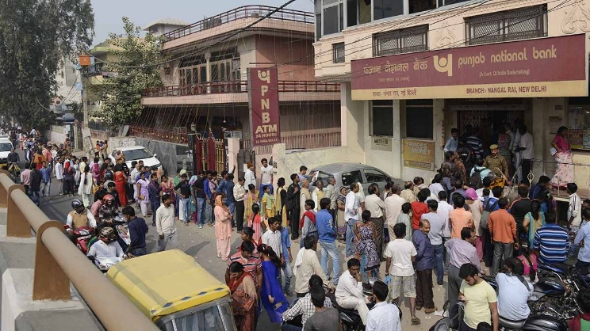

Background
- High circulation of ₹500 & ₹1000 notes (≈ 86% of cash in economy)
- Concerns over:
  - Black money (undisclosed income)
  - Fake currency (counterfeit security threat)
  - Terror financing through illegal cash channels
- Government aimed to move India towards:
  - Formal economy
  - Tax compliance
  - Digital transaction
Major Action Taken
- On 8 November 2016, PM Narendra Modi announced:
  - ₹500 & ₹1000 notes invalid overnight
- Citizens had to deposit/exchange notes in banks within set limits
- RBI introduced new ₹500 & ₹2000 denomination notes

Digital Economy Push
Post-demonetization, India saw a rapid adoption of:
- UPI (Unified Payments Interface)
- Wallets like Paytm, PhonePe
- Aadhaar-linked banking & e-KYC
- Government schemes:
  - Digital India
  - BHIM app
  - Direct Benefit Transfer (DBT)

Outcome / Impact
Positive
- Huge surge in digital payments (100%+ YoY growth in UPI)
- Boost to tax base and financial inclusion
- More money entered formal banking system → liquidity increased
Challenges
- Cash shortages hit small businesses & daily wage workers
- Short-term GDP slowdown to ~6.8% (from 8% previous year)
- Cash usage eventually rebounded in rural areas

Economic Indicators (Around 2016)
Indicator | Approx. Value | Impact
Inflation Rate | ~4.9% | Controlled; falling trend
Unemployment Rate | ~6.1% | Shock in informal sector
Poverty Rate | ~21% | Slowed reduction
Fiscal Deficit | ~3.5% of GDP | Government kept target

Tooltip
2016 Demonetization: ₹500 & ₹1000 notes banned to curb black money and push digital payments — formal economy expanded but short-term disruptions occurred.

4. 2017 – GST (Goods and Services Tax) Implementation
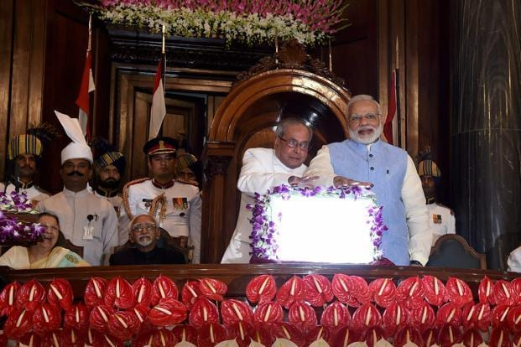
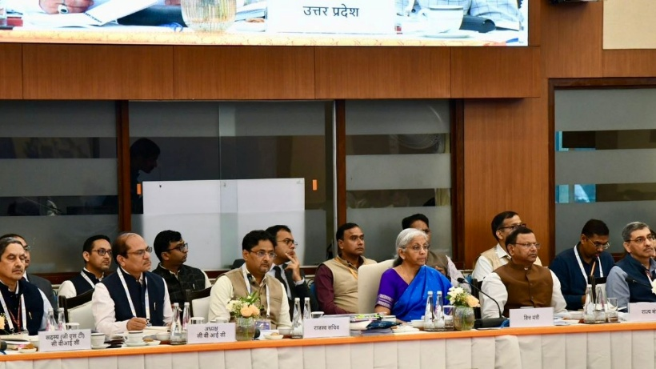

Background
- Before GST, India had a complex indirect tax system:
  - Excise duty, Service tax, VAT, CST, Octroi, Entry tax etc.
- Taxes were cascading in nature (tax on tax)
- Goods became costlier and interstate trade was inefficient
- The GST Constitutional Amendment Act (2016) paved the way
- Collaborative decision-making through GST Council (Union + States)

Major Action Taken
- Implemented on: ➝ 1 July 2017
- Replaced 17 taxes & 22 cesses
- Structure: Destination-based consumption tax
- Common law & compliance through:
  - GSTN portal for online filing
  - E-invoice system (later introduced)
- Uniform tax slabs:
  - 0%, 5%, 12%, 18%, 28%
- Compensation Cess for certain luxury/sin goods
- One Market → One Tax → One Nation

Outcome / Impact
Positive
- Removal of interstate check-posts → faster logistics
- Improved ease of doing business
- Transparency & reduction in tax evasion via IT trail
- Increase in taxpayer base (formalization of economy)
- Boost to Make in India + Digital compliance
Challenges
- Initial compliance burden for small businesses
- Technical issues with GST portal
- Frequent rate changes caused uncertainty

Economic Indicators (Around 2017)
Indicator | Approx. Value | Trend
Inflation Rate | ~3.6% | Low & stable
Unemployment Rate | ~6% | Moderate but informal sector stress
Poverty Rate | ~20% | Gradual decline
Fiscal Deficit | ~3.5% of GDP | Within set target

Tooltip
GST 2017: Unified national tax system replacing multiple indirect taxes — simplified trade, boosted transparency, and strengthened the formal economy, despite early challenges.


5. 2020 – COVID-19 Economic Impact & Atmanirbhar Bharat Mission
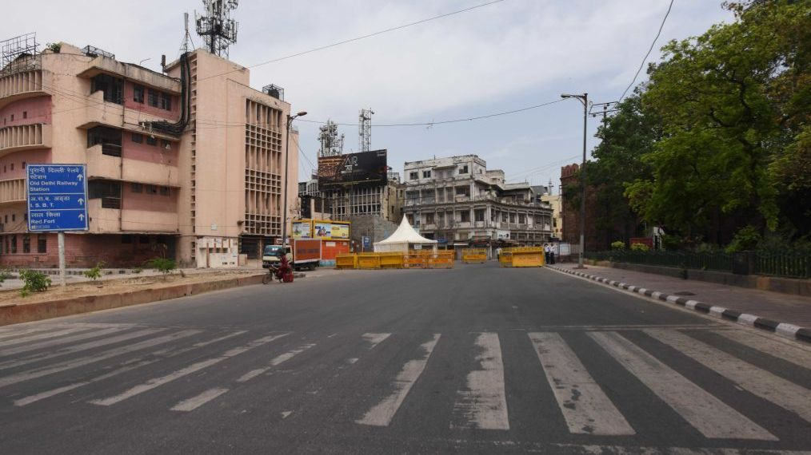

4

Background
- Global COVID-19 outbreak → severe health + economic crisis
- India imposed nationwide lockdown (March 2020) — one of the largest in the world
- Economic activities halted → demand + supply shock simultaneously
- Key challenges:
  - Collapse of tourism, retail, MSMEs, transportation
  - Migrant workers crisis & job losses
  - Decline in global trade & investment

Major Government Actions
Fiscal Measures - ₹20 lakh crore stimulus under Atmanirbhar Bharat Abhiyan
- Focus areas:
  - Liquidity support to MSMEs
  - Free food grains to poor under PM Garib Kalyan Yojana
  - Cash transfers: women, farmers, MGNREGA wage increase
  - Production Linked Incentive (PLI) schemes to boost domestic manufacturing
B) Monetary Policies (RBI)
- Repo rate cut: 5.15% → 4%
- Loan moratorium for individuals & businesses
- Liquidity support to NBFCs & banking sector
C) Healthcare & Digital Push
- Ramp-up of medical infrastructure, vaccination, testing
- Boost to Digital India:
  - Rise in UPI, online education, telemedicine, remote work

Outcome / Impact
Negative Short-Term
- Historic GDP contraction: −7.3% in FY 2020-21
- Sharp unemployment spike (especially informal sector)
- MSMEs & daily wage earners worst hit
Positive Recovery Trends
- Strong rebound in manufacturing & exports
- V-shaped recovery indicators in 2021–22
- Domestic industry support through Atmanirbhar Bharat
- Digital transformation accelerated India’s long-term growth path
Economic Indicators (Around 2020)
Indicator | Approx. Value | Situation
Inflation Rate | ~6.6% | Food inflation elevated
Unemployment Rate | ~10–12% (peak) | Lockdown-driven job losses
Poverty Rate | Slight temporary rise | Due to income shocks
Fiscal Deficit | ~9.5% of GDP | Highest in decades (stimulus spending)

Tooltip
2020 Pandemic: India faced a historic downturn, but Atmanirbhar Bharat, digital adoption, and strong policy support helped the economy recover and build self-reliance.

6. Comparative Research Content: India’s GDP vs China’s GDP
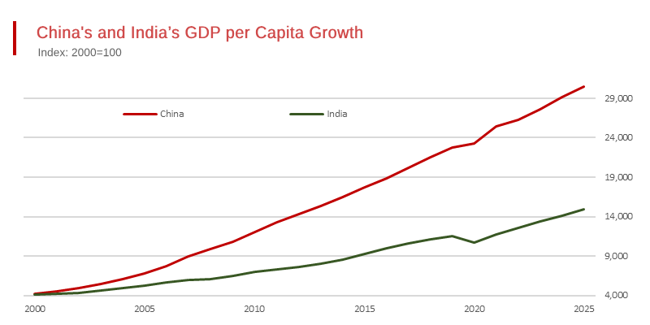
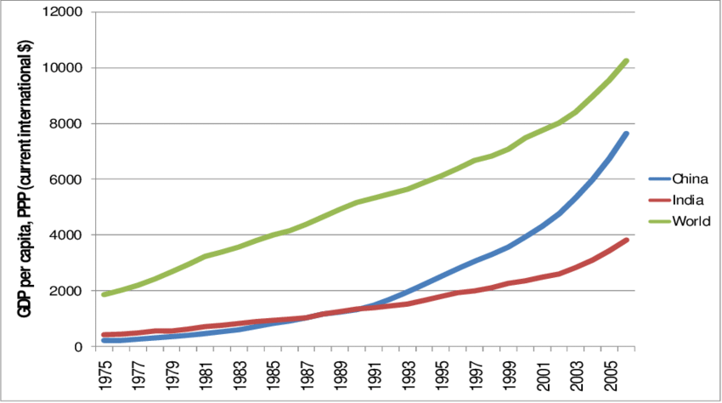

Background
- India and China are Asia’s two largest emerging economies.
- China adopted market reforms in 1978, India followed later in 1991 with LPG reforms.
- China’s rapid industrialization and export-led model allowed faster structural transformation.
- India’s growth has been strong but from a lower economic base and more dependent on services.
- Currently:
  - China = 2nd largest economy (Nominal GDP)
  - India = 5th largest economy (Nominal GDP)

Basic Comparison (Overall Trend)
Year | India GDP (US$ Billion) | China GDP (US$ Billion) | Who is Bigger?
1960 | ~37 | ~60 | China slightly higher
1980 | ~190 | ~305 | China bigger
2000 | ~468 | ~1,200 | China almost 3×
2010 | ~1,676 | ~6,087 | China ~4×
2021 | ~3,173 | ~17,734 | China ~5–6×
1960–1980: Difference small
After 1990: China’s GDP jumped very fast
2021: Huge gap → China way ahead

Growth Rate Comparison
- China grew very fast after 1978 reforms
(manufacturing, exports, big investment)
- India grew slower until after 1991 reforms
(more service-sector growth)
From 1960–2021 average growth:
- China: ~9–10% per year
- India: ~5–6% per year
This is why the gap became very large.

Per Capita GDP (Average income)
Year | India (US$) | China (US$) | Who is richer per person?
1960 | Almost equal | Almost equal | Same
2000 | ~450 | ~950 | China 2×
2021 | ~2,300 | ~12,500 | China 5×
China people earn much more on average.

Key Reason for Difference
China | India
Started reforms early (1978) | Reforms later (1991)
Strong manufacturing | Service-sector dominant
Export powerhouse | Large domestic focus
High investment in factories | Lower investment
Big technology jump | Informal sector still high
China’s model = Industry + Exports
India’s model = Services + Consumers

Simple Conclusion (1960–2021)
✔️ China’s GDP grew faster and bigger
✔️ India is growing rapidly now, but gap still large
✔️ India has young population → good future chance

One-Line Summary
1960: similar level → 2021: China 5× bigger
But India now growing faster → may reduce gap in future
DAX FORMULA
Avg Growth % (India) = AVERAGE('EconomicData'[India_Growth_Percent])
Avg Growth % (China) = AVERAGE('EconomicData'[China_Growth_Percent])

CAGR % =
VAR StartYear = MIN('EconomicData'[Year])
VAR EndYear = MAX('EconomicData'[Year])
VAR StartGDP = CALCULATE(SUM('EconomicData'[GDP_Billion_USD]), 'EconomicData'[Year] = StartYear)
VAR EndGDP = CALCULATE(SUM('EconomicData'[GDP_Billion_USD]), 'EconomicData'[Year] = EndYear)
VAR Years = EndYear - StartYear
RETURN IF(Years > 0 && StartGDP > 0, ((EndGDP / StartGDP) ^ (1 / Years) - 1) * 100, BLANK())
GDP per Capita = AVERAGE('EconomicData'[PerCapita_Rupees])
Growth Diff (China - India) = [Avg Growth % (China)] - [Avg Growth % (India)]

Key Event =
SWITCH(
TRUE(),
'EconomicData'[Year] = 1991, "LPG Reforms (Economic Liberalization)",
'EconomicData'[Year] = 2008, "Global Financial Crisis & India's Response",
'EconomicData'[Year] = 2016, "Demonetization & Digital Economy Push",
'EconomicData'[Year] = 2017, "GST Implementation",
'EconomicData'[Year] = 2020, "COVID-19 Pandemic & Atmanirbhar Bharat",
BLANK()
)
Max Growth Year =
CALCULATE(
MAX('EconomicData'[Year]),
FILTER('EconomicData', 'EconomicData'[India_Growth_Percent] = MAX('EconomicData'[India_Growth_Percent]))
)
Total GDP (Billion USD) = SUM('EconomicData'[GDP_Billion_USD])

YoY Growth % =
VAR CurrentYear = SELECTEDVALUE('EconomicData'[Year])
VAR PrevGDP = CALCULATE(SUM('EconomicData'[GDP_Billion_USD]), 'EconomicData'[Year] = CurrentYear - 1)
VAR CurrentGDP = SUM('EconomicData'[GDP_Billion_USD])
RETURN IF(NOT ISBLANK(PrevGDP), DIVIDE(CurrentGDP - PrevGDP, PrevGDP) * 100)

PURPOSE
Trend Over Time
Purpose: Shows how India’s GDP grew over time, with each key event annotated (LPG, GST, COVID, etc.).
You can use Data labels or Tooltips to show the Key Event for important years.

Yearly Growth Rate (Bar or Line Chart)
Purpose: Highlights periods of high and low growth.
You can visually mark:
- 1991 → Reforms boost
- 2008 → Drop due to global crisis
- 2020 → Sharp dip (COVID)
GDP per Capita Trend
Purpose: Shows improvement in individual income over years.

India vs China Comparison
Purpose: Compare India’s growth rate with China to visualize divergence or catch-up.

Key Event Highlights
Purpose: Quickly summarize what happened in each major economic phase.

Filters
Helps you dynamically explore data by year or major event.

Cards
→ Total GDP (Billion USD)
Purpose:
Shows the overall size of India’s economy in the most recent year (or the total across years, depending on filter).
- It tells how big the economy is in dollar terms.
- Helps you see how much the economy has expanded over time.

→ Avg Growth % (India)
Purpose:
Shows the average annual GDP growth rate of India across all selected years.
- Helps understand India’s long-term growth performance.
- A good measure of consistency — how fast the economy grows on average.

→ CAGR % (Compound Annual Growth Rate)
Purpose:
Shows the overall rate at which the economy has grown between the start and end year.
- Unlike average growth, CAGR smooths out fluctuations and shows the steady rate of expansion.
- It’s a good way to compare with other countries like China.

→ GDP per Capita (or PerCapita_Rupees)
Purpose:
Shows the income per person — how much GDP each citizen contributes on average.
- Reflects standard of living and economic well-being.
- Even if total GDP grows, per capita GDP tells whether individuals are actually becoming richer.

→ Avg Growth % (China)
Purpose:
Provides China’s average GDP growth rate — a benchmark for comparison.
- Helps see how India’s growth stacks up against China’s.
- Useful for understanding competitiveness in Asia.

→ Growth Diff (China - India)
Purpose:
Shows the gap between China’s and India’s average growth rates.
- Quickly identifies which economy grew faster and by how much.
- Helps analyze relative performance and growth potential.

