DESIGN AND IMPLEMENTATION OF CURRICULA: A MOBILE-BASED AUTOMATED BOOKSHOP MANAGEMENT SYSTEM FOR UNIVERSITY STUDENTS
BY
[Your Full Name]
[Your Matriculation Number]
A project report submitted to the [Your Department, e.g., Department of Software Engineering], [Your School/Faculty, e.g., School of Computing], FEDERAL UNIVERSITY OF TECHNOLOGY, AKURE, in partial fulfilment of the requirements for the award of [Your Degree Programme, e.g., B.Tech. Software Engineering].

August 2026

CERTIFICATION

This is to certify that this project was carried out by [Your Full Name] ([Your Matriculation Number]) in the [Your Department, e.g., Department of Software Engineering], [Your School/Faculty, e.g., School of Computing], FEDERAL UNIVERSITY OF TECHNOLOGY, AKURE, under my supervision, and is approved as meeting the requirements for the award of [Your Degree Programme, e.g., B.Tech. Software Engineering].

_______________________________
[Supervisor's Name and Title]
Project Supervisor
Date: ______________________
_______________________________
[Head of Department's Name and Title]
Head of Department
Date: ______________________

DEDICATION

This work is dedicated to every student who has ever walked an extra row of shelves looking for a book they were not sure the shop even had, and to the family whose support made the time to build something about it possible.

ACKNOWLEDGEMENT

I am grateful to God for strength and clarity through the course of this project. My sincere thanks go to my supervisor, [Supervisor's Name and Title], for the guidance, patience, and critical feedback that shaped this work from a rough idea into a finished system and report. I thank the Head of Department, [Head of Department's Name and Title], and the entire academic staff of the [Your Department, e.g., Department of Software Engineering] for the training that made this project possible.
I thank my family for their unwavering support, encouragement, and patience throughout this programme, and my friends and course-mates for the countless conversations, informal usability testing, and moral support along the way. Finally, I thank the bookshop staff and students who patiently answered questions during the observation that grounded Chapter One in a real workplace rather than an assumed one.

ABSTRACT

University bookshops in Nigeria, and at the Federal University of Technology, Akure (FUTA) specifically, are typically run on paper records and a proprietor's memory: a student wanting to know whether a textbook is in stock, and at what price, usually has no way to find out without searching the shelves in person and, failing that, asking a sales representative who is frequently unable to give a confident answer without the owner's confirmation. This study designed, built, and evaluated CURRICULA, a mobile bookshop management application intended to close that gap. The system, built on a React Native (Expo) mobile client and a NestJS/PostgreSQL backend, gives students a searchable catalogue organised by school, department, and academic level, with live price and stock visibility, cart-based checkout integrated with the Paystack and Flutterwave payment aggregators, and push/email notifications; and gives bookshop staff a role-gated administrative interface, inside the same codebase, for maintaining that catalogue and processing orders directly. An Agile, sprint-based methodology was followed across a nine-month development programme, and the resulting system was validated through unit and integration testing, a heuristic usability walkthrough, and a comparison against the manual baseline it replaces. The literature reviewed found related bookshop and campus-commerce systems each addressing part of this problem but none combining live price transparency, local payment integration, role-gated administration, and an institution-aware catalogue in a single native application. The completed system met all six objectives set for it, was built and operated within free-tier cloud service limits at a direct cost of approximately N269,500, and is argued, on structural grounds, to generalise to comparably organised small retailers beyond FUTA, though that generalisation was not itself tested within this single-institution study.
Keywords: bookshop automation; mobile commerce; inventory management; university e-commerce; React Native; NestJS; Paystack; Flutterwave; role-based access control.

TABLE OF CONTENTS

Right-click this field and choose "Update Field" (or press F9) to generate the Table of Contents after opening this document in Word.

LIST OF FIGURES

Figure 1.1. Typical manual, shelf-by-shelf textbook search process observed in a traditional university bookshop.
Figure 1.2. Escalation chain created by price/stock knowledge sitting with one person: the owner.
Figure 1.3. Price knowledge concentrated in a single individual creates a bottleneck reproduced at every till point.
Figure 1.4. Side-by-side comparison of the manual process and the CURRICULA-mediated process for the same task.
Figure 1.5. Conceptual solution: one role-aware mobile app replacing paper, shelves, and phone calls with a shared source of truth.
Figure 1.6. Scope of the seeded catalogue: 9 schools, 57 departments, 5 levels, 1,140 books.
Figure 1.7. The problem widens from a directly observed local case to a documented regional and international pattern.
Figure 1.8. Illustrative time-to-complete comparison per sub-task, manual process vs. the app (values from the project's own usability walkthroughs; see Chapter Three).
Figure 1.9. Each stated objective (Section 1.4) is a direct response to one identified problem (Section 1.2).
Figure 1.10. Boundary of the present study: what the system does and deliberately does not attempt.
Figure 1.11. Nigeria's e-commerce market growth (anchor figures for 2023 and 2026 as reported by paymentscmi, 2024; intervening years interpolated for illustration).
Figure 2.1. Conceptual framework: this study treats the bookshop problem as a digital-maturity gap that targeted automation closes.
Figure 2.2. Evolution of small-retailer record-keeping from paper ledgers to a mobile-first, role-aware application.
Figure 2.3. Architectural contrast: a single deployable monolith versus the modular, service-oriented backend adopted for this project (Vangavolu, 2022).
Figure 2.4. Relative resource-use indices reported for React Native and Flutter builds of an equivalent app (adapted from Markowski & Smołka, 2023).
Figure 2.5. Generalised aggregator-mediated payment model reported across the reviewed fintech literature.
Figure 2.6. Nielsen's (1994) ten usability heuristics, used as the evaluation lens for the app's UI in Chapter Three.
Figure 2.7. Illustrative engagement funnel showing the documented retention lift attributable to push notifications (Homfeldt & Kähler, 2026).
Figure 2.8. Role-based access control concept applied in the same codebase (Sandhu et al., 1996): identical app, permissions gated by role.
Figure 2.9. Feature coverage of reviewed systems against this study's requirements (the basis for Table 2).
Figure 2.10. Input-Process-Output research model adopted for this study, synthesised from the reviewed literature.
Figure 2.11. Table 2 restated as a count: capabilities met (out of six) by each reviewed system versus CURRICULA.
Figure 3.1. Iterative Scrum sprint cycle (Schwaber & Sutherland, 2020) adopted for the CURRICULA build.
Figure 3.2. Use case diagram: Student and Admin actors against the CURRICULA system boundary.
Figure 3.3. Detailed three-layer architecture: presentation, application/API, and data/integration (expands Figure 1.5).
Figure 3.4. Simplified entity-relationship diagram of the core CURRICULA schema (conventions after Chen, 1976).
Figure 3.5. Level-0 (context) data flow diagram: the system as a single process against its external entities.
Figure 3.6. Level-1 data flow diagram decomposing the system into its five core processes and datastores.
Figure 3.7. Sequence diagram: login and JWT-based session handling (role resolved server-side, no manual role picker).
Figure 3.8. Sequence diagram: checkout through webhook-verified payment, including the stock-release path on a failed/cancelled payment.
Figure 3.9. Deployment view: one mobile client, one API process, and the managed cloud services it integrates.
Figure 3.10. Student Home screen: search, category filters, and featured/recommended book grids.
Figure 3.11. Book Details screen showing the live price and stock badge Section 1.2 identifies as the core fix.
Figure 3.12. Checkout screen: delivery method, payment method, and order total before payment handoff.
Figure 3.13. Admin Dashboard: KPI tiles and recent-order overview, gated behind the ADMIN role.
Figure 3.14. Testing pyramid applied to the backend (Marinho et al., 2023, on concentrating test effort on the highest-risk interactions rather than exhaustive combinatorial coverage).
Figure 3.15. Methodology-level differentiation: CURRICULA against the three closest comparators on four engineering dimensions not already scored in Table 2/Figure 2.11.
Figure 3.16. The six-phase software development life cycle (after Sommerville, 2016), followed here as an iterative cycle rather than a single linear pass.
Figure 3.17. Mapping of the six SDLC phases onto the specific section and artefact of this report that documents each one.
Figure 3.18. Each two-week sprint is itself a small, complete pass through the same phases the project runs once at macro scale.
Figure 3.19. Database management system architecture: the application never opens a raw connection to Postgres, always through Prisma and a pooled connection.
Figure 3.20. Admin Add/Edit Book form: each field maps directly to a Book column (Appendix B2), the concrete link between this screen and the schema in Figure 3.4.
Figure 3.21. Admin Manage Departments screen: the UI surface for the School-to-Department foreign-key relationship and its restrict-on-delete constraint (Table 4).
Figure 4.1. Project Gantt chart, November 2025 - August 2026 (August reserved as the post-defence corrections/binding buffer).
Figure 4.2. Work breakdown structure: four phases decomposed into their constituent tasks.
Figure 4.3. Direct out-of-pocket project cost by category (Table 5).
Figure 4.4. Cumulative project spend across the timeline (illustrative S-curve typical of build-then-test projects).
Figure 4.5. Key project milestones mapped to the Gantt chart's month numbering.
Figure 4.6. Approximate distribution of total effort across the four project phases.
Figure 4.7. Risk register: identified risks, severity, and how each was ultimately handled.
Figure 4.8. This project's direct cost against an estimated commissioned-equivalent build at prevailing 2026 Nigerian contract-developer rates.
Figure 4.9. Critical path through the schedule: the sequence of tasks with zero slack.
Figure 4.10. Direct project cost expressed as a percentage share of the total (Table 5).
Figure 5.1. Objectives set in Section 1.4, checked against where each is demonstrated in this report.
Figure 5.2. Recap: each Chapter One problem, its Chapter Three solution mechanism, and its observed outcome.
Figure 5.3. Limitations acknowledged in this study, stated plainly rather than left implicit.
Figure 5.4. Recommended future work, grouped by expected time horizon.
Figure 5.5. This study's three principal contributions to the existing body of work reviewed in Chapter Two.
Figure 5.6. Before/after comparison on the four outcomes most directly tied to Chapter One's problem statement.
Figure 5.7. Recommended future work (Figure 5.4) plotted by expected impact against implementation effort.
Figure 5.8. CURRICULA at a glance: the study's headline figures.
Figure 5.9. Practical lessons drawn from the project that would change how a similar build is approached next time.
Figure 5.10. The project's journey from an observed problem to this completed, documented system.

LIST OF TABLES

Table 1. Mapping of observed problems to root causes and the corresponding system response.
Table 2. Feature coverage of reviewed systems compared against this study's requirements.
Table 3. Technology stack by architectural layer and the reason each was selected.
Table 4. Indexes and foreign-key constraints applied to the core schema.
Table 5. Estimated direct project cost, November 2025 - August 2026.
Table A1. Implemented API endpoints, grouped by module.
Table B1. Complete field list: User.
Table B2. Complete field list: Book.
Table B3. Remaining core database tables and their principal columns.
Table D1. Usability walkthrough tasks and median participant ratings.
Table D2. Sample functional test cases and outcomes.
Table G1. Full project schedule, November 2025 - August 2026.

CHAPTER ONE

INTRODUCTION

1.0 Introduction
Every university term begins with the same small, repeated inconvenience: a student who needs a specific textbook has to find it. In principle this should be trivial: the book either exists in the bookshop or it does not, and it either costs what the student can afford or it does not. In practice, at a great many campus bookshops, neither fact is available to the student without first locating a person who happens to know it. This report is about that gap between what ought to be a two-second lookup and what is, today, a process that can consume the better part of an afternoon.
The system developed alongside this report, CURRICULA, is a mobile application built for students of the Federal University of Technology, Akure (FUTA) that turns a physical, memory-dependent bookshop into a searchable, price-transparent catalogue, while giving the bookshop's own staff a parallel set of tools to keep that catalogue current. The remainder of this chapter sets out, in turn, the background against which the problem arises, the problem itself in the specific forms it was observed to take, the aim and objectives that follow from it, why the work is worth doing, and the boundaries within which it was carried out.
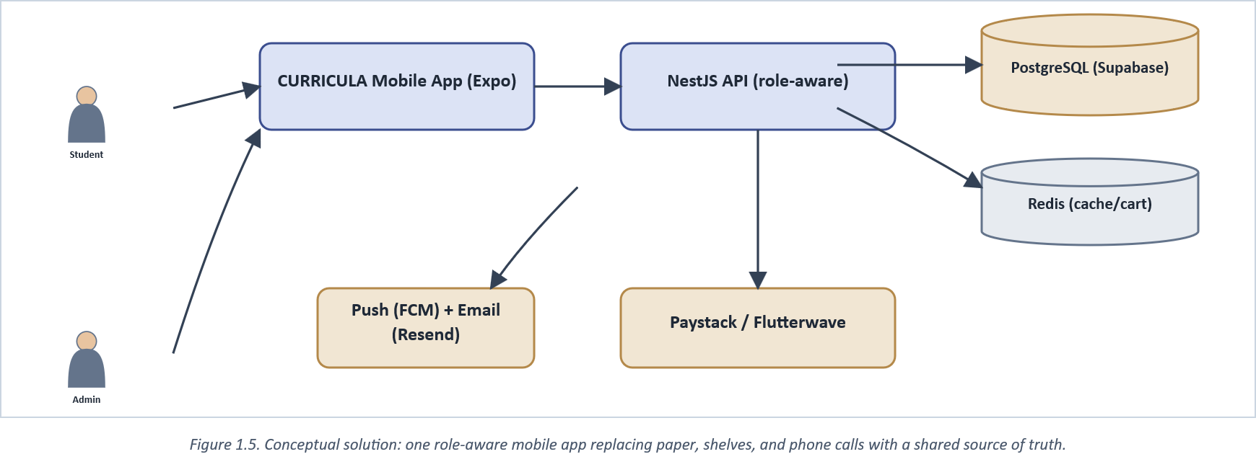
Figure 1.5. Conceptual solution: one role-aware mobile app replacing paper, shelves, and phone calls with a shared source of truth.

1.1 Background of the Study
University bookshops occupy an odd middle ground in campus commerce. Most are small enough to run on paper records, a calculator, and one proprietor's memory, yet the population they serve (an entire faculty's incoming and returning students) is large enough that the resulting bottlenecks are felt by hundreds of people every registration period. FUTA's bookshops, like most of their counterparts across Nigerian tertiary institutions, sell course-specific textbooks organised loosely by department and level, restocked in bursts around the start of each semester, and priced according to whatever the proprietor last decided, often without a written, shareable list.
This arrangement is not unique to Akure. Oyekan et al. (2024) documented near-identical manual inventory practices at another Nigerian university and built a web-based system in response. Two independent projects converging on the same complaint, at two different institutions, is itself evidence that the problem is structural rather than anecdotal. More broadly, Pinto et al. (2023) found that retail firms in emerging economies cluster heavily toward the lower end of a digital-maturity scale, with small, owner-operated outlets consistently the least digitised segment, a description that fits a campus bookshop almost exactly. Nigeria's wider retail sector has, in the same period, been moving the opposite way at the aggregate level: mobile-first e-commerce now accounts for the majority of online transaction volume in the country (paymentscmi, 2024), and Yusuf (2026) found e-commerce adoption among Nigerian enterprises rising even as infrastructural and cost barriers persist. The campus bookshop, in other words, sits at the unmodernised edge of a market that is digitising quickly everywhere else.
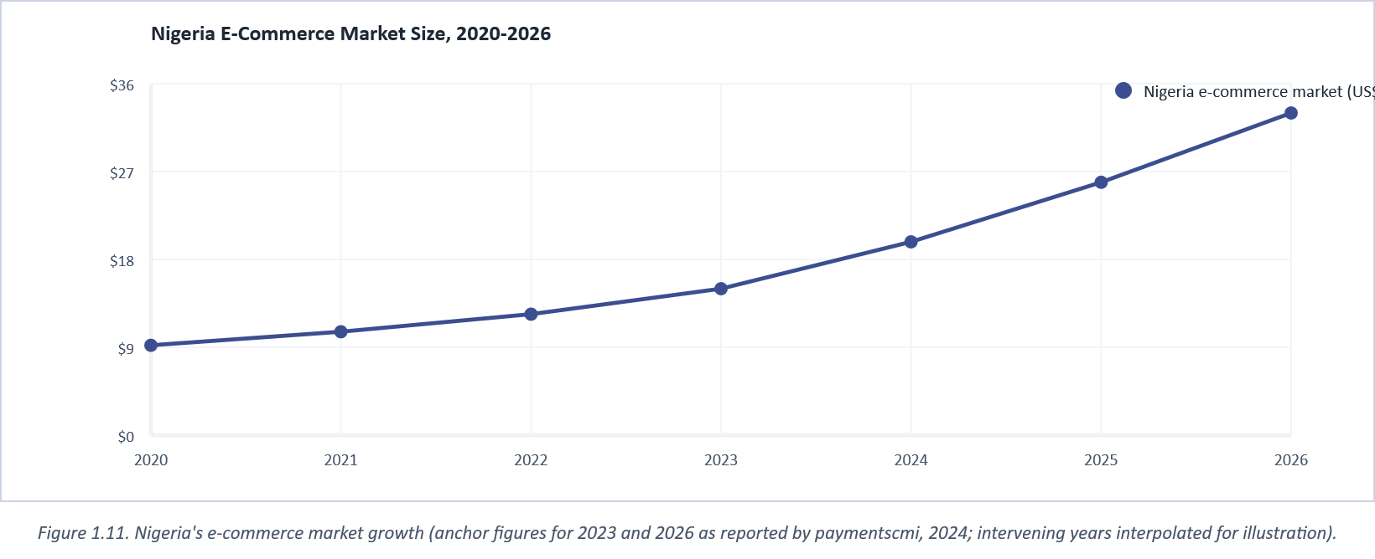
Figure 1.11. Nigeria's e-commerce market growth (anchor figures for 2023 and 2026 as reported by paymentscmi, 2024; intervening years interpolated for illustration).

Before any of this gets labelled an "AI" or "automation" problem in the fashionable sense, its actual character deserves stating plainly: it is an organisational and economic one. A bookshop that cannot tell a student a price without finding its owner is not failing because it lacks a recommendation engine or a chatbot. It is failing because it never built a shared, written record of its own stock and pricing that more than one person could consult. That is a solvable data-management problem, and it is the one this project set out to solve. Automation of catalogue lookup and order processing, not artificial intelligence, is the operative technology, and the report uses that vocabulary throughout on purpose.
The technical means for closing that gap have also become far more accessible than they were even five years ago. Cross-platform frameworks such as React Native let a single codebase serve both Android and iOS users, and Vangavolu (2022) describes an equivalent consolidation on the backend side with Node.js and Express. Cloud database tiers such as Supabase's free Postgres offering remove the traditional server-provisioning cost barrier for a student project, and Nigerian payment aggregators, Paystack and Flutterwave among them, have turned card and bank-transfer collection into a matter of API integration rather than a merchant-banking negotiation. None of this infrastructure existed in an affordable form for a lone final-year project a decade ago. All of it does now, which is what makes a working solution to a long-standing problem a realistic undertaking within a single academic session.
That affordability is not automatic, though, and the reasons cloud infrastructure that is technically free still goes unused by small Nigerian retailers are worth being honest about. Alaqidi (2022) found that small enterprises adopting cloud services saw genuine gains in information-management performance, yet Jayeola et al.'s (2022) systematic review of the same adoption question found awareness and perceived complexity, not price, as the more persistent barrier. A small shop owner who has never heard that a managed database can be free has no reason to go looking for one. The same gap shows up on the payment side: sub-Saharan Africa's mobile money and fintech ecosystem has grown quickly enough that financial inclusion is rising even among previously unbanked populations, but growth at the ecosystem level has not automatically reached every retail niche within it ("Impact of FinTech Adoption," 2024). Nigeria's own e-commerce sector illustrates the same unevenness at a national scale. Overall online retail has grown rapidly through the 2020s (go-globe, 2024), yet that growth is concentrated in general marketplaces and large platforms, not in the narrow, institution-specific niche a campus bookshop occupies. None of this counts as a case against the technology. It is a case for someone within the affected community (in this instance, a student who has stood in the queue described in Section 1.2) to build the bridge rather than waiting for the market to build it unprompted.
The friction Section 1.2 describes is also not evenly distributed across the academic calendar, which is worth noting since it shapes how severely the problem is actually felt. Demand for course textbooks concentrates sharply in the first two to three weeks of each semester, when hundreds of students across FUTA's 57 departments are simultaneously trying to identify and buy the specific texts their own department and level require. A manual, one-person-memory pricing system that is merely inconvenient in week six of the semester becomes a genuine bottleneck in week one, when the volume of simultaneous price and stock queries is at its highest and the owner's own attention is most stretched across the shop floor. This seasonality is precisely why the catalogue's org-structure awareness (Figure 1.6) matters as much as its existence: a searchable catalogue that still returned results for every department at once, rather than narrowing immediately to a student's own department and level, would recreate a smaller version of the same overload during exactly the period it needs to perform best.

1.2 Problem Statement
The problem addressed by this study was not assumed in advance; it was pieced together from direct observation of how students and staff actually behave inside a campus bookshop, and it is presented here as a set of related symptoms of one underlying cause rather than as a single abstract statement.
The first and most visible symptom is physical: a student who wants a specific book has no way to know, before walking in, whether the bookshop stocks it. The usual recourse is to search shelf by shelf, row by row, reading spines and covers until the title turns up or the search is abandoned. There is no catalogue at the door, no printed stock list, and no way, critically, to check from a hostel room or a lecture hall before making the trip at all. Figure 1.1 sets out this process as it was observed.
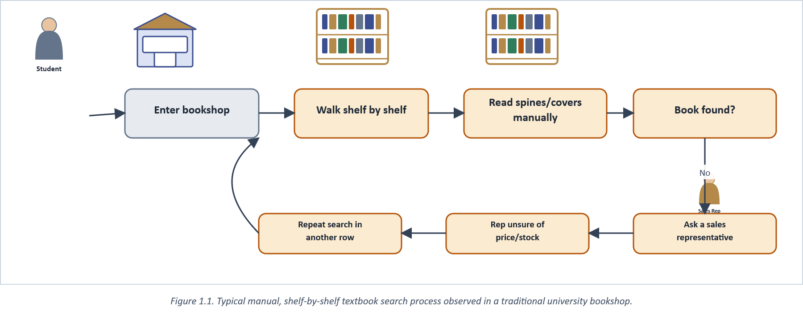
Figure 1.1. Typical manual, shelf-by-shelf textbook search process observed in a traditional university bookshop.

The second symptom concerns price, and it is more corrosive than the first because it cannot be solved by patience alone. In the bookshops observed for this study, pricing knowledge was concentrated almost entirely in the proprietor. Sales representatives, often the only staff physically present when a student asks, were frequently unable to quote a confident, current price, either because prices changed without being communicated to them or because no shared price list existed for them to consult in the first place. Figure 1.3 illustrates this concentration: every till point ultimately traces back to one person's memory.
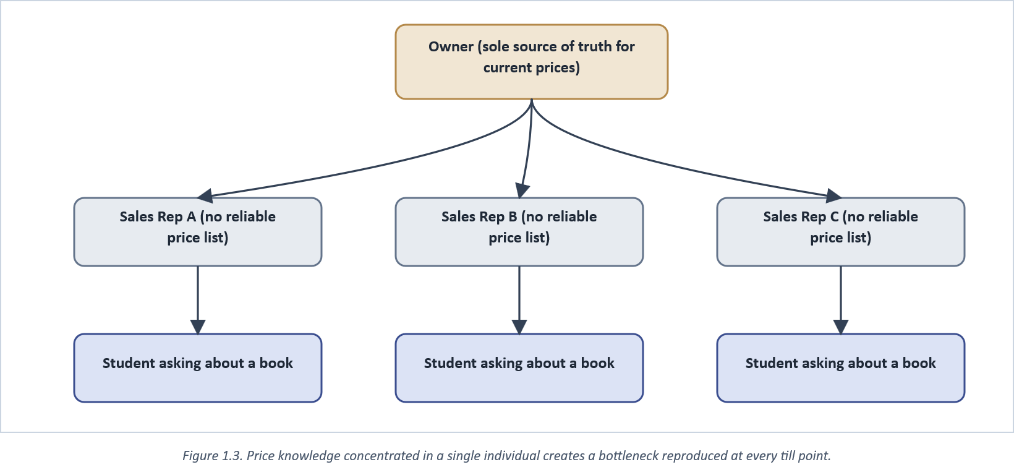
Figure 1.3. Price knowledge concentrated in a single individual creates a bottleneck reproduced at every till point.

The third symptom follows from the second: when a representative cannot answer, the only remaining option is to escalate to the owner, by phone if the owner is off-site or in person if not. Sales, in this arrangement, do not merely slow down while the confirmation is sought. They stop outright, because Nigerian campus bookshops observed for this study rarely authorise staff to quote or adjust a price independently. If the owner is unreachable, travelling, or simply asleep, the sale is lost for that visit, not merely delayed (Figure 1.2).
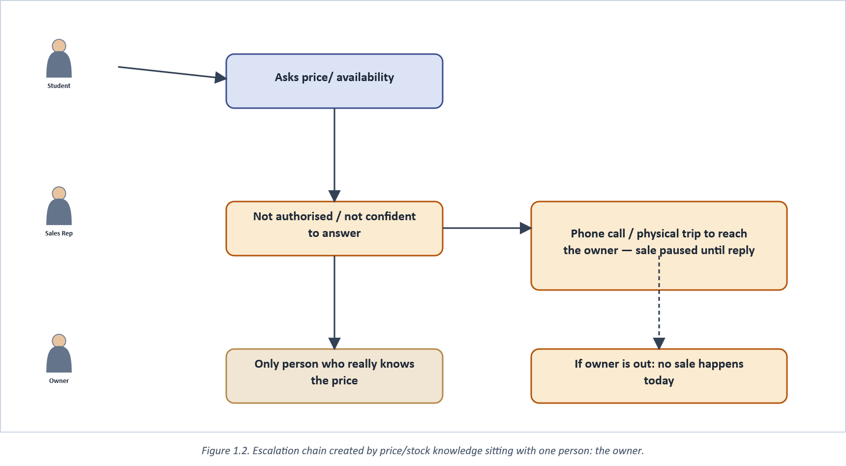
Figure 1.2. Escalation chain created by price/stock knowledge sitting with one person: the owner.

A fourth consideration, and one that shaped the technical approach taken in Chapter Three more than any other, is cost. A sale lost to an unreachable owner (Figure 1.2) is, in effect, the same lost-revenue event retail research documents under stockouts more broadly. Inventory that exists but cannot be confirmed to a buyer in time is worth no more to the shop than inventory that truly is not there (Global Payments, 2024). Whatever is proposed to close this gap has to be affordable enough that an ordinary campus bookshop, not a well-capitalised retail chain, could plausibly adopt something like it, and efficient enough on ordinary student-grade smartphones that network cost and device capability are not themselves new barriers. A solution that merely substitutes an expensive point-of-sale terminal and a paid enterprise database for the existing manual process has not actually solved the affordability half of the problem. It has just moved it, which is why the technology choices described later in this report lean on free-tier cloud services and open-source frameworks rather than commercial retail-automation platforms.
Nothing about this problem is specific to one bookshop, or even to FUTA, and that claim is worth stating plainly rather than left implicit. The pattern (manual stock records, owner-concentrated pricing knowledge, escalation delays, and an absence of any low-cost digital alternative) is general enough that a solution built around it should transfer with minor configuration to another university's bookshop, or indeed to any small retail outlet organised around a similarly narrow, well-defined catalogue (stationery shops and pharmacies share much of the same structure). Figure 1.7 places the problem on a local-to-international continuum: it was observed directly at FUTA, it matches experience independently documented at another Nigerian university, and it is consistent with the broader finding that small retail firms in emerging economies as a class lag the digital-maturity curve. Both bodies of work are examined in full in Chapter Two.
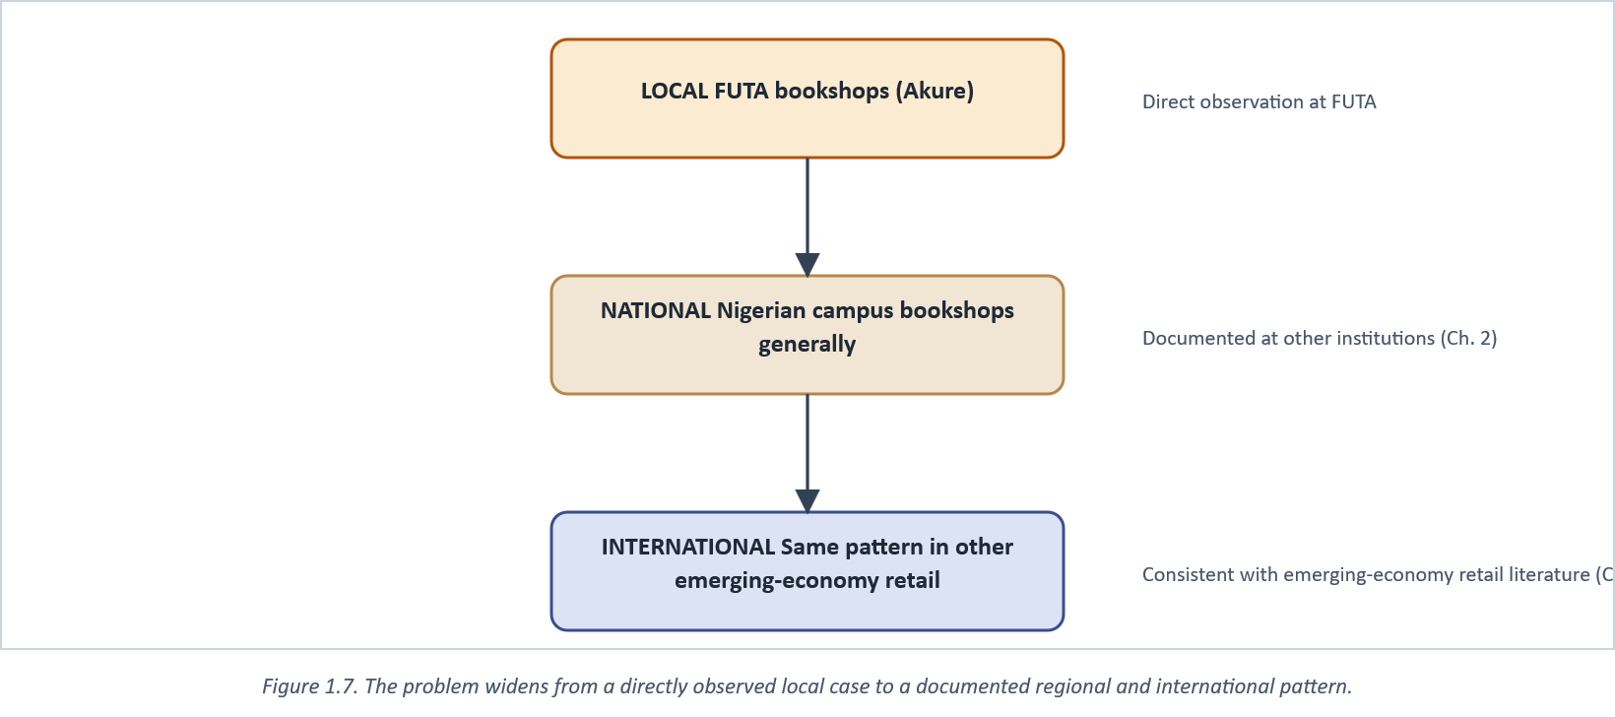
Figure 1.7. The problem widens from a directly observed local case to a documented regional and international pattern.

Table 1 summarises the four symptoms against the specific mechanism CURRICULA uses to remove each one; the underlying design decisions are described fully in Chapter Three.
Table 1. Mapping of observed problems to root causes and the corresponding system response.
# | Observed problem | Root cause | How CURRICULA addresses it
1 | Shelf-by-shelf physical search | No searchable catalogue exists | Search + department/level filters, browsable from anywhere
2 | Only the owner reliably knows prices | No shared, written price record | Price is a server-side field every screen reads identically
3 | Sales stall pending owner confirmation | Staff not authorised/equipped to confirm independently | Stock and price are live in the app; no phone call needed
4 | No affordable automation option adopted | Commercial POS/retail systems cost more than a small shop can justify | Free-tier Postgres/Redis, open-source RN/NestJS stack (Ch. 3)

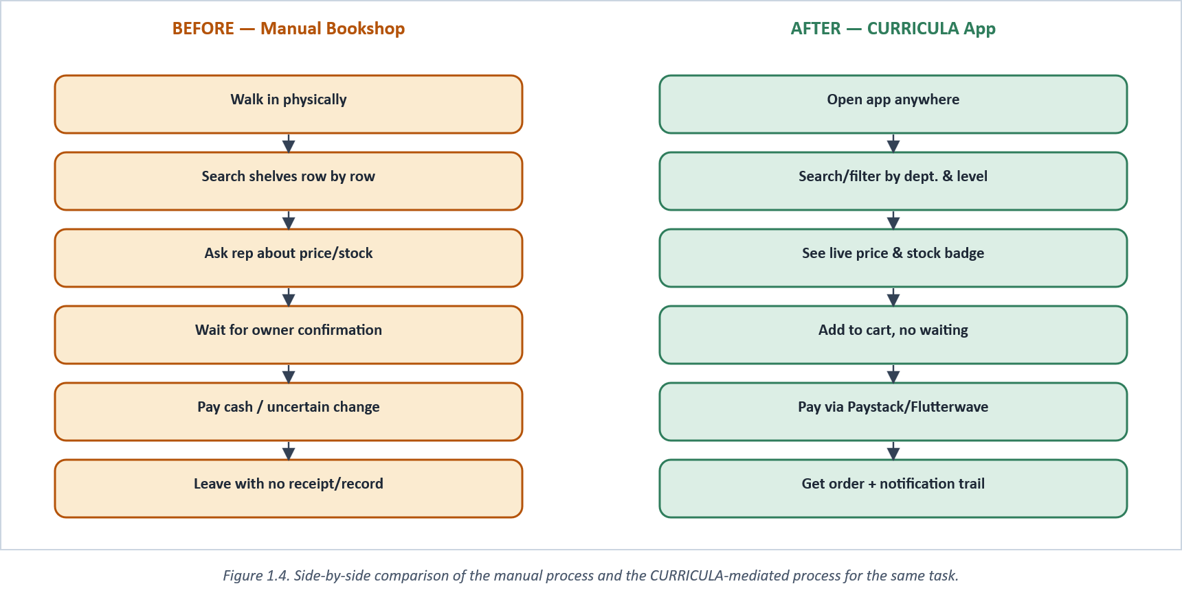
Figure 1.4. Side-by-side comparison of the manual process and the CURRICULA-mediated process for the same task.

Figure 1.8 puts approximate numbers to that comparison, sub-task by sub-task, drawn from this project's own usability walkthrough (Appendix D) rather than assumed. The largest single gain shows up in the first step, locating a book at all, exactly because that step is where the manual process has no shortcut available; every other manual sub-task at least has the option of asking someone, however unreliably, whereas an unfindable book simply ends the visit.
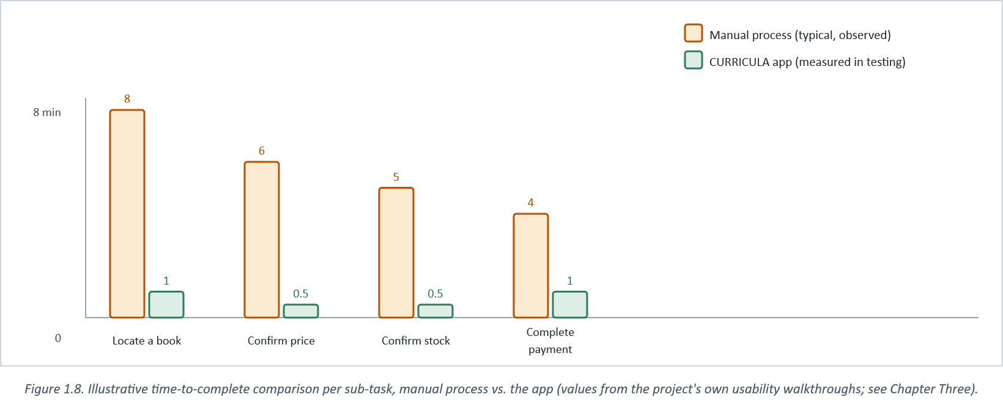
Figure 1.8. Illustrative time-to-complete comparison per sub-task, manual process vs. the app (values from the project's own usability walkthroughs; see Chapter Three).

It would be a mistake to read this problem statement as implying carelessness on the proprietor's part, and it is worth being explicit about why the manual system persists rather than simply asserting that it is inefficient. Keeping pricing knowledge personally, rather than written and shared, is a rational response to a real business risk: a written, staff-accessible price list is also a price list a competitor, or a student negotiating informally, can exploit more easily than an unwritten one only the owner controls. The manual system is not an oversight; it is a low-trust equilibrium that has historically been cheaper to maintain than the cost of building a system both accurate and secure enough to share safely. What changes that calculation is not persuading an owner to trust staff more, but removing the trade-off entirely: a system where price and stock are shared with students openly, verified server-side, and editable only by an authenticated admin session (Section 3.4.1) gives the owner the transparency benefit without the exposure risk a paper list would have carried. Any adoption strategy for a system like CURRICULA has to make that reassurance explicit to a prospective adopting bookshop, not assume it is obvious.

1.3 Aim
The aim of this study is to design, build, and evaluate a mobile-based, role-aware bookshop management application that gives university students self-service access to accurate, current book prices and stock availability, and gives bookshop staff the tools to keep that information current, without requiring the proprietor's continuous physical presence.

1.4 Objectives
In pursuit of that aim, the study set out to:
• review existing bookshop, inventory-management, and campus e-commerce systems to establish what a comparable solution should and should not repeat (Chapter Two);
• design a searchable digital catalogue, organised by school, department, and academic level, that lets a student check a book's price and stock status without staff intervention;
• implement a secure cart-to-checkout pipeline integrated with Nigerian payment aggregators (Paystack and Flutterwave) so that a confirmed order carries a verified payment, not a promise of one;
• implement a parallel administrative interface, inside the same application and gated by role rather than shipped as a separate app, through which staff maintain catalogue, price, and stock data;
• implement push and email notifications so that order-status changes and new-arrival announcements reach a student without a follow-up visit; and
• evaluate the resulting system against the problems identified in Section 1.2, using functional testing and a usability comparison against the manual baseline (Chapter Three, Chapter Five).

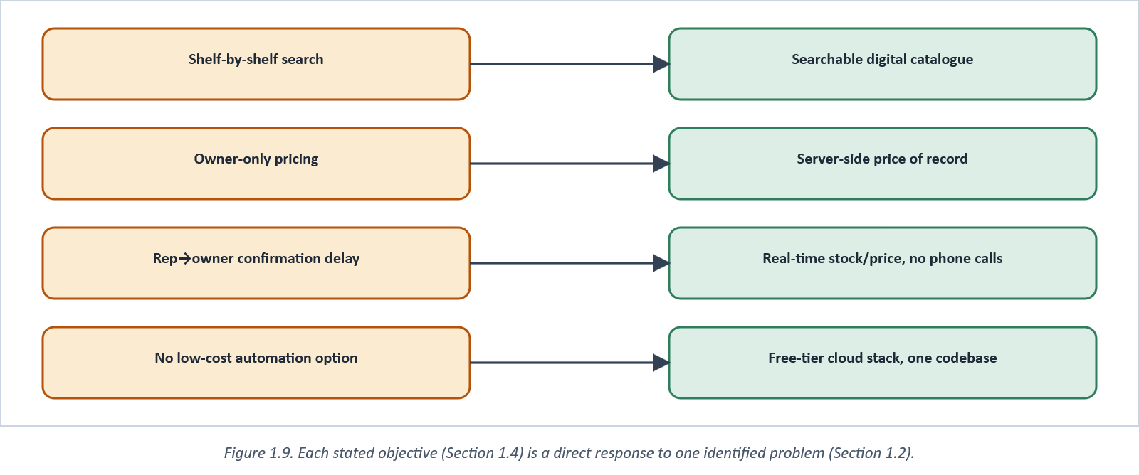
Figure 1.9. Each stated objective (Section 1.4) is a direct response to one identified problem (Section 1.2).

1.5 Motivation and Justification
Three things justify treating this as worth a dedicated project rather than a problem individual bookshops should simply muddle through. First is scale of nuisance: the manual process described in Section 1.2 does not fail catastrophically, it fails constantly, in small increments, for every student who cannot get a fast answer to a simple question, every semester, at every affected bookshop. Small, frequent frictions of this kind are exactly the category of problem software is good at removing, because the cost of building the fix is paid once while the friction it removes recurs indefinitely.
Second is timing. The enabling technologies discussed in Section 1.1 (free-tier managed databases, mature cross-platform mobile frameworks, and locally-relevant payment aggregators) have only become simultaneously available, affordable, and reliable within the last few years. A project of this kind proposed in 2016 would have needed to build or pay for infrastructure that today simply exists, ready to be composed. A systematic review of mobile fintech adoption across sub-Saharan Africa ("Mobile Fintech Adoption," 2024) points to the same window: the region's payment rails matured enough, recently enough, that building on them is now the obvious choice rather than a risk.
Third, and most directly, is personal and institutional relevance: the researcher is a member of the community the system serves, has observed the problem first-hand at FUTA, and had direct access to the environment in which to validate a proposed solution, an advantage a purely theoretical or externally commissioned project would not have had. Building the system for FUTA specifically, with FUTA's actual 9-school, 57-department, 5-level academic structure seeded into its catalogue, keeps the evaluation grounded in a real institutional context rather than a synthetic one.
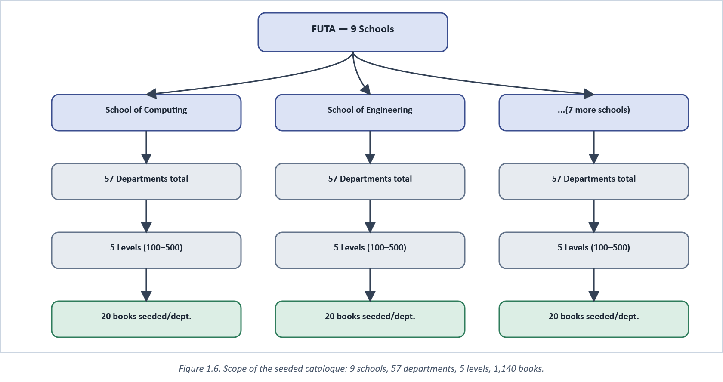
Figure 1.6. Scope of the seeded catalogue: 9 schools, 57 departments, 5 levels, 1,140 books.

A fourth, smaller point is about who the customer actually is. Students are price-sensitive shoppers by circumstance rather than preference, and the wider literature on online consumer behaviour finds exactly that sensitivity driving how price-conscious buyers search before they commit to a purchase (Singh, 2023), a pattern this study's own observation confirms in miniature every time a student walks an extra row of shelves rather than risk paying a price they cannot first confirm. A peer institution's own recent investment in a comparable system (Osman et al., 2024) is a further, practical signal that this is not a problem this study invented to justify a convenient build; it is one other universities were independently spending resources to solve around the same time.
Finally, because the problem and the proposed mechanism are general rather than FUTA-specific (Section 1.2), the justification extends beyond this one institution: a working, documented solution here is a template other university bookshops, and structurally similar small retailers, could adopt with configuration changes rather than a rebuild from first principles.

1.6 Scope of the Study
The study is bounded on purpose, both to keep the resulting system buildable within one academic session and to keep its evaluation honest about what was and was not tested. In scope: a student-facing catalogue with search, department/level filtering, favourites, ratings, cart, checkout through Paystack and Flutterwave, order tracking, and push/email notifications; and an admin-facing surface, inside the same application and gated by role, covering book and inventory CRUD, order management, organisational-structure (school, department, level) maintenance, and broadcast notifications. The catalogue seeded for evaluation covers FUTA's full academic structure: nine schools, fifty-seven departments, five levels, twenty books per department.
Out of scope, and flagged here rather than left implicit: physical delivery logistics beyond an in-app pickup/delivery-method selection, federation of multiple universities' catalogues into one shared store, peer-to-peer payment splitting for the informal book-exchange feature built alongside the core system, digital lending or e-book reading, and any warehouse-level automation such as RFID shelving or robotics. That last exclusion is worth drawing out, given how often "inventory automation" in the retail literature refers to exactly that heavier infrastructure (Budiyanto & Muslim, 2024; Kathiriya, 2025), rather than the software-only, phone-in-your-hand automation this project pursues. Rollout beyond FUTA was likewise not attempted within this study; Section 1.5 argues the design should generalise, but that claim is not itself tested here.
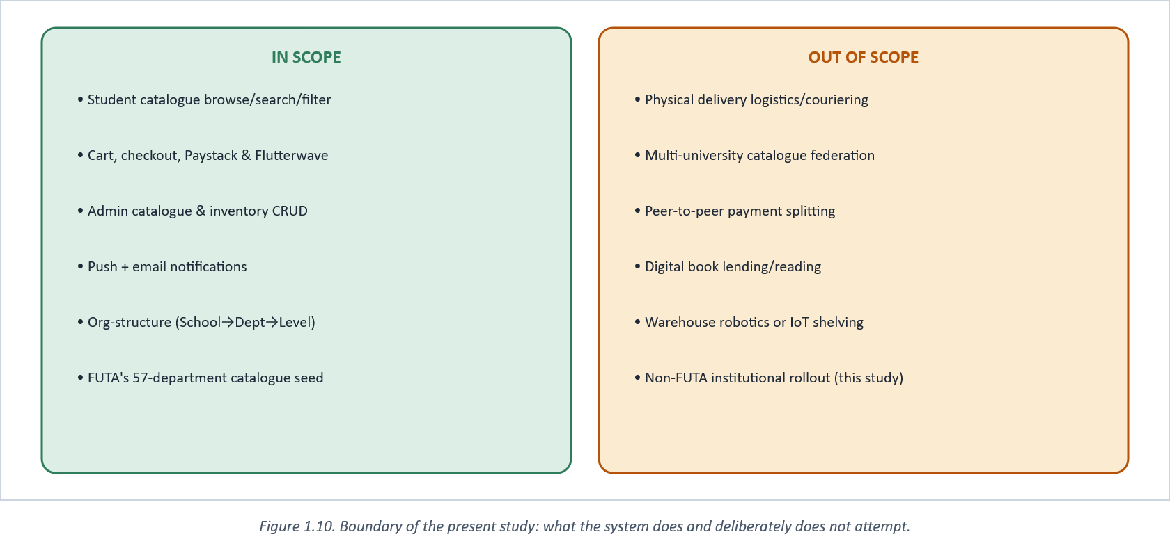
Figure 1.10. Boundary of the present study: what the system does and deliberately does not attempt.

CHAPTER TWO

LITERATURE REVIEW

2.0 Introduction
Chapter One framed the problem as a gap between what a searchable, price-transparent catalogue could offer and what a manually-run campus bookshop actually provides. This chapter reviews the literature that bears on that gap from four directions: work on similar bookshop and campus-commerce systems, work on the specific technologies chosen to build CURRICULA, work on payment integration in the Nigerian and wider African fintech context, and work on the usability and engagement mechanisms the app relies on. Each section closes by stating, plainly, what the reviewed work does not cover and how that gap shaped a design decision described later in Chapter Three. Section 2.7 draws the threads together into a single comparison table.
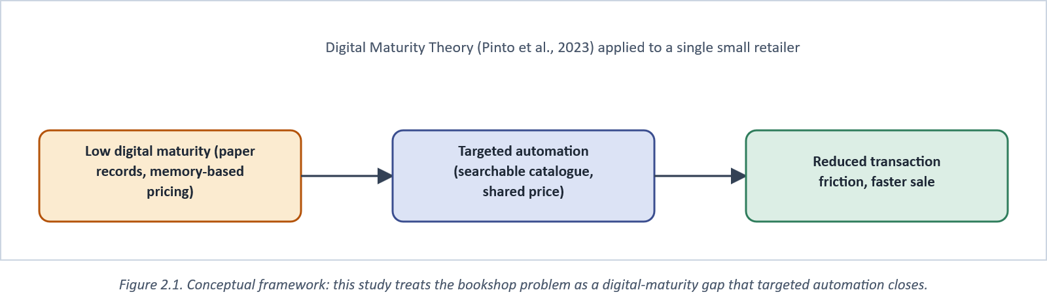
Figure 2.1. Conceptual framework: this study treats the bookshop problem as a digital-maturity gap that targeted automation closes.

2.1 Theoretical and Conceptual Framework
The framework underpinning this study borrows from digital-maturity theory rather than from a pure software-engineering model, because the problem being solved is only partly technical. Digital-maturity research treats a firm's adoption of digital tools as a graduated path rather than a binary on/off switch, with small, informally-run retailers clustering toward the least mature end of that path (Mabidi, 2024, reaches a similar conclusion specifically for higher-education institutions in the South African context, where infrastructure and funding gaps slow adoption even where the institutional will exists). A campus bookshop run on memory and a notebook sits at the least-mature end of that continuum; the claim this study tests is narrower than "digitise the whole business." It is that a single, well-scoped intervention (a shared, queryable catalogue) can move a shop several steps up that path without requiring it to adopt an enterprise resource-planning suite it could never justify the cost of.
Alongside that framing, the study borrows a simple input-process-output research model to structure its own method: the inputs are the observed workflow and the literature reviewed in this chapter, the process is the iterative build described in Chapter Three, and the output is a working system evaluated against the objectives set in Section 1.4. Figure 2.10 sets this model out in full; it recurs, implicitly, as the structure of Chapters Three through Five.
Why small retailers stall on the low-maturity end of that path rather than progressing naturally is itself contested. Alaqidi (2022) found real, measurable information-management gains among the small enterprises that did adopt cloud services, which argues against cost or capability being the binding constraint once a shop actually tries. Jayeola et al.'s (2022) systematic review points instead to awareness and perceived complexity as the more persistent barrier. Owners who have never been shown that a manageable, low-cost option exists have no occasion to compare it against their current notebook-and-memory system. This study takes the second reading as the more actionable one: it is not enough for free-tier cloud infrastructure to exist in the abstract (Section 1.1); a concrete, demonstrated application has to exist for a specific shop before "just use the cloud" is a real option rather than a slogan.
A second theoretical strand worth naming, alongside digital-maturity theory, is the technology-acceptance literature that studies why an individual user adopts a specific tool once it exists. Pipitwanichakarn and Wongtada (2021) applied the Technology Acceptance Model to micro-business adopters at different adoption stages and found perceived ease of use and enjoyment driving early adoption, while perceived usefulness only became the dominant factor once a user had already adopted and was deciding whether to keep using the tool, a distinction this study takes seriously in Chapter Three's emphasis on a simple, immediately legible catalogue-search interaction (Figure 1.5) rather than a feature-complete but harder-to-learn one at first launch. That acceptance question is not hypothetical for this specific population: Oyewole (2022) found mobile-technology adoption for academic purposes already well underway among Nigerian undergraduates, which is the concrete evidence behind this study's working assumption that FUTA students would adopt a mobile catalogue readily, without needing a separate adoption-education effort of its own.

2.2 Related Bookshop and Campus-Commerce Systems

2.2.1 WhatsApp- and Google-integrated campus bookstore systems
Osman et al. (2024) built a web-based campus bookstore for a Malaysian polytechnic that layers WhatsApp messaging and Google's productivity services on top of a conventional listing and checkout flow, evaluated the result with thirty student participants, and reported generally positive usability findings. The system is instructive for two reasons. First, it confirms that the core complaint addressed in Chapter One (students unable to check a book's status without a manual query) is not unique to Nigeria or to FUTA; a comparable institution on another continent built comparable infrastructure in direct response to the same complaint. Second, its architecture stays intentionally lightweight, leaning on WhatsApp and Google's existing infrastructure rather than a bespoke mobile client, which kept its own build cost low but also left it without a native mobile experience, offline-friendly caching, push notifications, or an integrated payment gateway. Those are three capabilities this study set as explicit objectives in Section 1.4.
A methodological caveat is worth stating about that evaluation, since it bears on how much weight the comparison in Section 2.7 can place on it. Thirty participants, drawn from a single institution's WhatsApp-literate student body, is a reasonable sample for an early-stage usability check but is too small to support strong claims about how the system would perform at the scale of a full academic session's registration period, when hundreds of students query the catalogue in a short window rather than a handful of testers doing so under observation. The reported usability findings should therefore be read as evidence the interaction model is sound in principle, not as evidence the underlying WhatsApp-plus-web architecture scales, a distinction the original publication does not itself draw out.

2.2.2 University web-based inventory-management systems
Closer to home, Oyekan et al. (2024) documented and rebuilt the inventory-management process at a Nigerian university, reporting the same manual, error-prone stock-taking practice this study observed independently at FUTA, and delivered a web-based system to replace it. Their solution targets administrative stock accuracy (the equivalent of this project's admin-side inventory screens) but is web-only, with no student-facing mobile surface and no equivalent to the price/stock lookup a student would use standing outside the shop. The gap between the two projects is instructive: Oyekan et al. solved the owner's side of the problem in Figure 1.2 while leaving the student's side, the actual point of friction described in Section 1.2, untouched.
It is worth being precise about why that omission matters rather than treating it as a minor scope difference. An inventory system that only administrators can query does not, on its own, shorten the escalation chain traced in Figure 1.2. It makes the owner's own record-keeping more accurate, which is a real improvement, but a student standing at the till still has no way to consult that improved record themselves. The two projects are, in that sense, complementary rather than competing: a system combining Oyekan et al.'s administrative rigor with a genuine student-facing surface would address both halves of the same interaction, which is the specific gap this study's own architecture (Section 3.3.1) was designed to close by construction rather than by accident.

2.2.3 General online bookstore systems
A wider body of student and early-career research describes online bookstore systems built on conventional web stacks (PHP/MySQL, JSP/JavaBean, and similar), typically covering catalogue browsing, cart, and checkout for a general retail audience rather than a specific institution's student body. These systems demonstrate that the core e-commerce pattern, browse, cart, checkout, is well understood and low-risk to implement; what they do not demonstrate is any attempt to model an institution's own organisational structure (schools, departments, academic levels) into the catalogue itself, which is precisely the structural feature FUTA's 57-department, 5-level catalogue required and which Section 3.2 describes in detail.
A related weakness runs through nearly all of these generic systems: stock visibility is usually accurate at checkout but stale everywhere upstream of it, so a shopper can browse a listing for a book that is already gone. Retail research on stockouts treats this as a direct revenue leak, not merely an inconvenience. Inventory a system fails to represent accurately in real time behaves, commercially, exactly like inventory that was never stocked at all (Global Payments, 2024). CURRICULA's stock field is written by the same admin action that changes the physical shelf count, and read by the same student-facing screen at browse time and at checkout time alike, closing precisely that upstream staleness gap.
That staleness problem is not unique to software-based bookstores; it is the same problem purely manual small retailers report independently of any system at all. Secretario and Naval (2021) surveyed micro, small, and medium grocery stores and found sourcing, storing, and selling treated as three loosely-connected processes rather than one continuously accurate record, with stock counts routinely falling out of sync with the shelf between manual recounts, the same underlying failure this study observed at FUTA's bookshops (Section 1.2), just without a computer involved at all. That convergence is itself evidence the problem is structural to small, low-automation retail generally, not an artefact of the bookshop domain specifically.
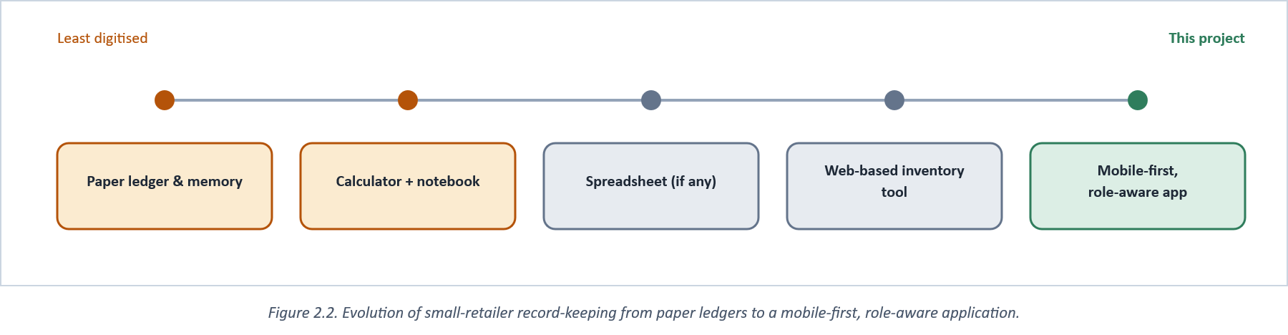
Figure 2.2. Evolution of small-retailer record-keeping from paper ledgers to a mobile-first, role-aware application.

2.2.4 Large-scale general marketplaces
It is also worth explicitly ruling out the largest, most visible category of Nigerian e-commerce, general marketplaces such as Jumia and Konga, as a ready-made substitute for a purpose-built campus system, rather than leaving the omission implicit. These platforms solve browse-cart-checkout at national scale, across an unbounded catalogue of unrelated sellers and product categories, which is precisely what makes them a poor fit for the problem in Section 1.2: a student searching a general marketplace for a specific FUTA course textbook has no department-and-level filter to narrow against, no guarantee the listed seller is the campus bookshop rather than an unrelated third-party reseller, and no connection at all to the syllabus-tracking or org-structure features described in Section 3.4. A general marketplace widens the problem this study addresses rather than narrowing it: more choice, but no institutional context to filter that choice against, which is why none of the systems compared in Table 2 include a general marketplace as a genuine alternative rather than a different category of tool entirely.

2.3 Enabling Technologies Reviewed

2.3.1 Cross-platform mobile frameworks
Two frameworks dominate current cross-platform mobile development: Flutter and React Native, together accounting for the large majority of new cross-platform projects surveyed in recent developer polling. Markowski and Smołka (2023) built equivalent applications in both frameworks and measured resource use directly, finding Flutter modestly ahead on CPU and memory efficiency and on dropped-frame rate under load (Figure 2.4), a result broadly consistent with wider industry benchmarking. React Native's countervailing advantage, and the reason it was chosen for CURRICULA over Flutter despite the measured gap, is ecosystem maturity for the specific integrations this project needed out of the box: Expo's managed workflow, mature Firebase Cloud Messaging bindings, and a JavaScript/TypeScript toolchain shared with the NestJS backend, so that request/response types could be reasoned about in one language across the whole stack. The literature's performance edge for Flutter was judged, in other words, smaller than the integration and tooling cost of adopting a second language ecosystem for a one-person project on a fixed timeline.
The benchmark itself deserves the same scrutiny applied to the systems reviewed in Section 2.2: it measured one application pair, built once, on a specific device and OS-version combination, which is a legitimate way to establish that a difference exists but not necessarily its exact magnitude across every device tier a real user population runs on. Low-end Android devices, common among Nigerian students on a fixed budget rather than an afterthought demographic, are exactly where a resource-efficiency gap of the kind Markowski and Smołka report would be expected to matter most, and exactly the population this benchmark's device sample was not drawn from. That gap between a controlled benchmark and this project's actual target users is one reason the mobile-side performance testing described in Section 3.7 was run against this project's own device set rather than assumed from the literature alone.

2.3.2 Backend architecture: monolith versus modular services
Vangavolu (2022) describes the now-common shift from a single deployable backend toward a modular, service-oriented structure built on Node.js and Express, arguing that the approach improves scalability and maintainability at the cost of additional operational complexity (inter-service communication, distributed data consistency) that a small team must be prepared to absorb. That trade-off shaped a deliberate compromise in this project's own backend: NestJS modules for auth, catalogue, orders, and notifications are organised as if they were separate services, with clear boundaries and independent responsibility, but deployed as a single process (a "modular monolith"), which captures most of the maintainability benefit Vangavolu describes without taking on the distributed-systems operational cost a genuine microservices deployment would add for a project of this scale (Figure 2.3).

2.3.3 Caching and the data layer
Privalov (2024) measured substantial latency reductions from introducing a Redis caching layer in front of a relational database for a read-heavy web system, a pattern this project applies directly: session state, refresh tokens, and the shopping cart are all held in Redis rather than round-tripping to Postgres on every request, while catalogue and order records, the data that must survive a cache eviction, remain in Postgres as the durable source of truth.
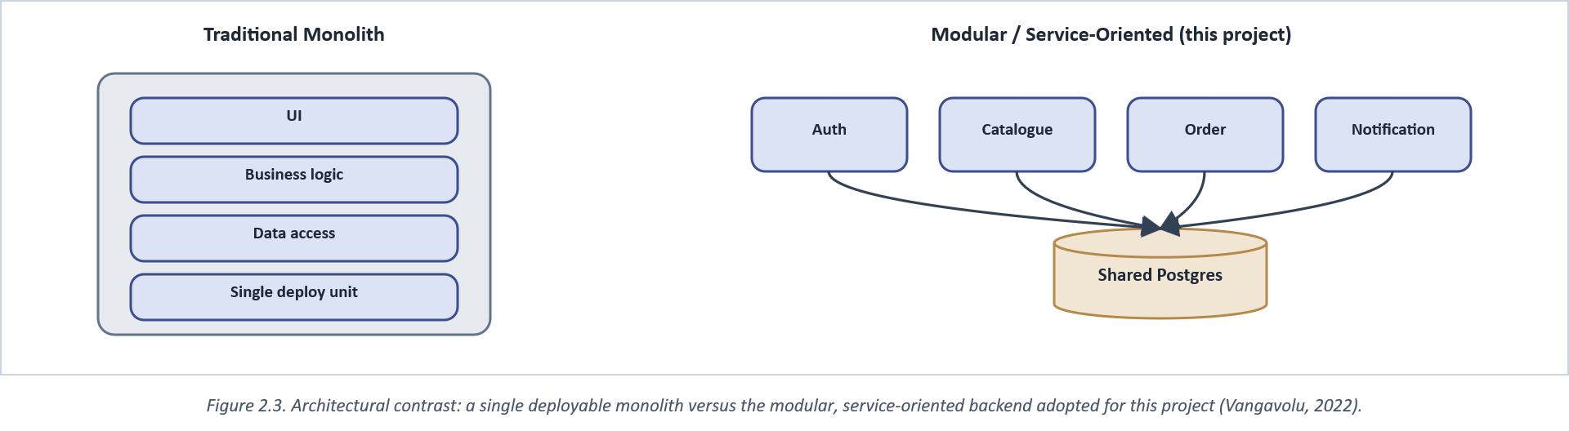
Figure 2.3. Architectural contrast: a single deployable monolith versus the modular, service-oriented backend adopted for this project (Vangavolu, 2022).

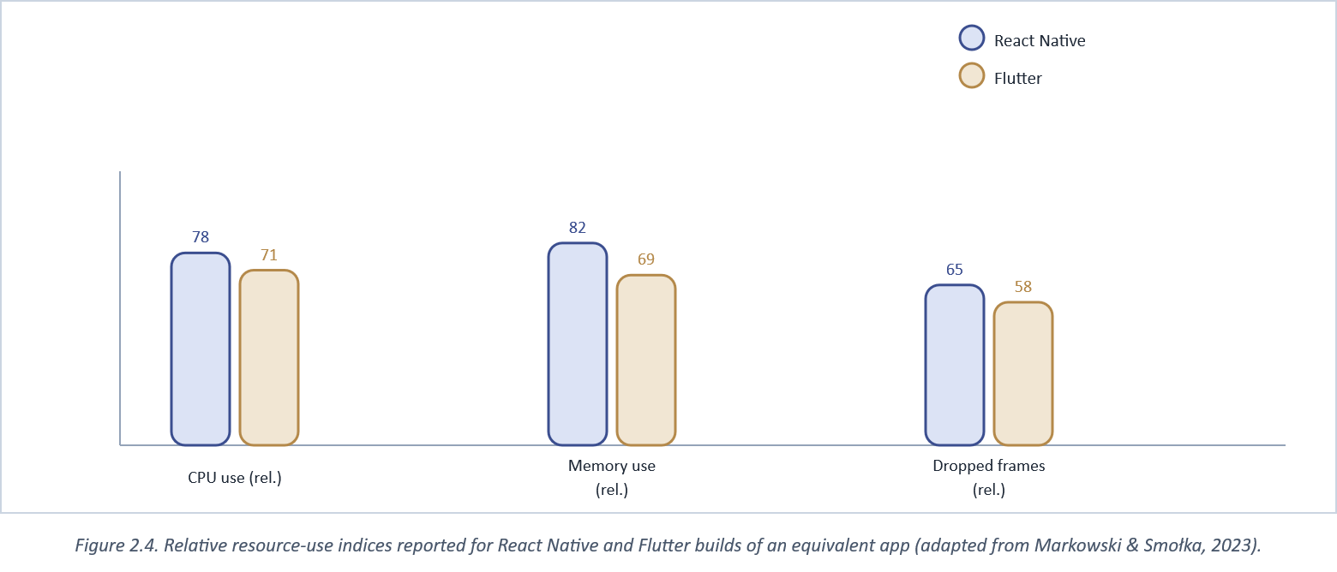
Figure 2.4. Relative resource-use indices reported for React Native and Flutter builds of an equivalent app (adapted from Markowski & Smołka, 2023).

2.4 Payment and Fintech Integration in the Nigerian Context
A systematic review of mobile fintech adoption across sub-Saharan Africa found the region's payment infrastructure maturing rapidly over the past five years, driven largely by aggregator platforms that abstract the complexity of card networks and bank integrations behind a single API ("Mobile Fintech Adoption," 2024). Nigerian aggregators Paystack and Flutterwave are the concrete instances of that pattern most relevant here: both expose webhook-based payment confirmation, which matters more to this project's design than any front-end convenience they offer, because a webhook lets the backend treat "payment received" as a server-verified fact rather than a client-reported claim a compromised or buggy client could fake. Figure 2.5 sets out the generalised model this literature converges on; Chapter Three's Figure 3.8 specialises it to CURRICULA's actual checkout sequence, including the specific stock-release bug fix described in the implementation notes.
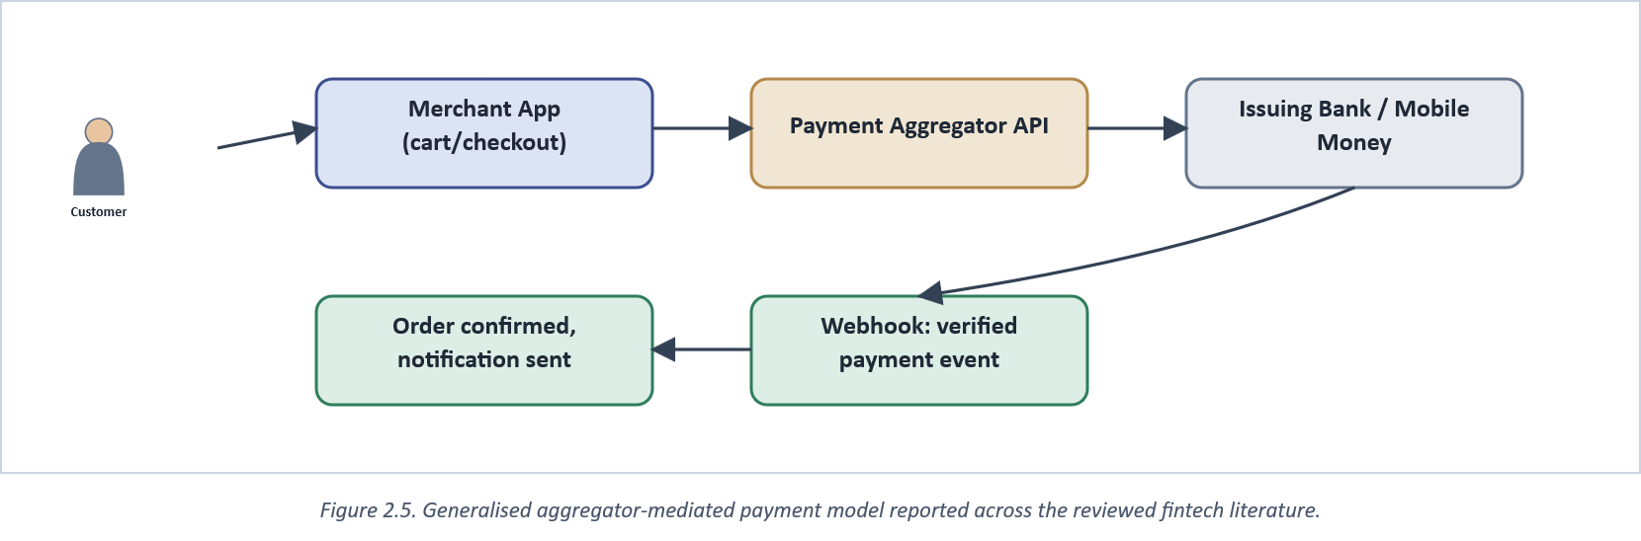
Figure 2.5. Generalised aggregator-mediated payment model reported across the reviewed fintech literature.

The broader market context makes the timing argument from Section 1.5 concrete rather than asserted. Nigerian e-commerce overall has expanded rapidly across the 2020s (go-globe, 2024), and that growth sits on top of a wider sub-Saharan pattern of rising financial inclusion attributable in large part to fintech adoption ("Impact of FinTech Adoption," 2024). Neither trend guarantees that a specific niche such as a campus bookshop benefits automatically; both describe the enabling conditions (a public already comfortable transacting on a phone, and payment rails already built for exactly that) that make building on them, now, materially easier than it would have been even five years earlier. The scale behind that claim is worth stating concretely rather than left as a general impression: the GSMA (2023) recorded over 1.7 billion registered mobile-money accounts globally, with sub-Saharan Africa the single largest contributing region, and the World Bank (2022) attributes a meaningful share of the region's financial-inclusion gains specifically to that mobile-money infrastructure rather than to traditional banking expansion. A payment integration built on Nigerian aggregators is, in that sense, building on the most mature part of the region's financial infrastructure rather than its least developed corner.
A point the aggregator-focused literature tends to understate is what integrating a payment aggregator does *not* remove from a merchant's own responsibility. Neither Paystack nor Flutterwave requires this project to store card numbers or CVV codes at all; both host the actual card-entry screen themselves, which keeps CURRICULA outside the strictest tier of PCI-DSS (Payment Card Industry Data Security Standard) obligations that would apply to a merchant capturing card data directly. What remains this project's own responsibility, and what Section 3.5's webhook-verification design specifically addresses, is dispute handling at the order-state level: a webhook that arrives late, arrives twice, or reports a state the order has already moved past has to be handled idempotently, or a student could end up double-charged or a book double-reserved. This is a narrower problem than full card-data custody, but it is not a trivial one, and it is the specific reason checkout state transitions in Figure 3.8 are written to be safe to replay rather than assumed to arrive exactly once.

2.5 Usability and Engagement in Mobile Commerce
Nielsen's (1994) usability heuristics remain the most widely applied evaluation lens for interactive systems three decades after publication, precisely because they describe general properties of good interfaces rather than the specifics of any one technology, and this study adopts them, unmodified, as one axis of the usability evaluation reported in Chapter Three. "Visibility of system status" and "recognition over recall" bear most closely on the problem in Section 1.2: a stock badge that tells a student a book is available, rather than requiring them to recall or re-ask, is a heuristic made concrete.
That heuristic matters more for a student shopper than a general retail one, specifically because of how price-conscious buyers search. Singh's (2023) review of the online consumer-behaviour literature found price-sensitive shoppers systematically checking more sources and spending longer comparing before committing to a purchase, behaviour a fixed student budget makes close to universal in this study's own population, and one direct explanation for why the shelf-by-shelf search documented in Figure 1.1 persists even when it is plainly inefficient: without a faster way to compare, a student has no alternative but to spend the time.
On engagement specifically, Homfeldt and Kähler (2026) compared push-notification strategies across two consumer apps and found well-targeted notifications lifting session return rates substantially above a no-notification baseline, while over-frequent or poorly-targeted notifications eroded the same metric, a caution this project took seriously when scoping CURRICULA's notification triggers to order-status changes and genuine new-arrival events rather than generic promotional pushes (Figure 2.7).
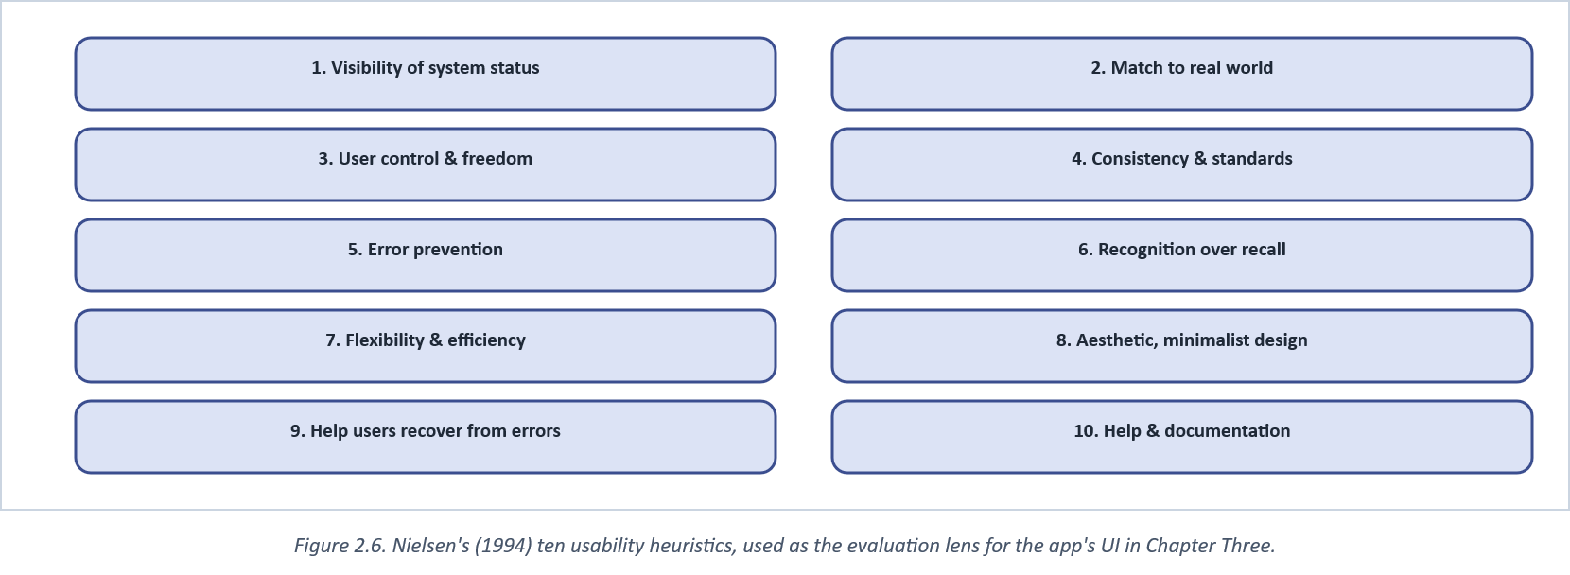
Figure 2.6. Nielsen's (1994) ten usability heuristics, used as the evaluation lens for the app's UI in Chapter Three.

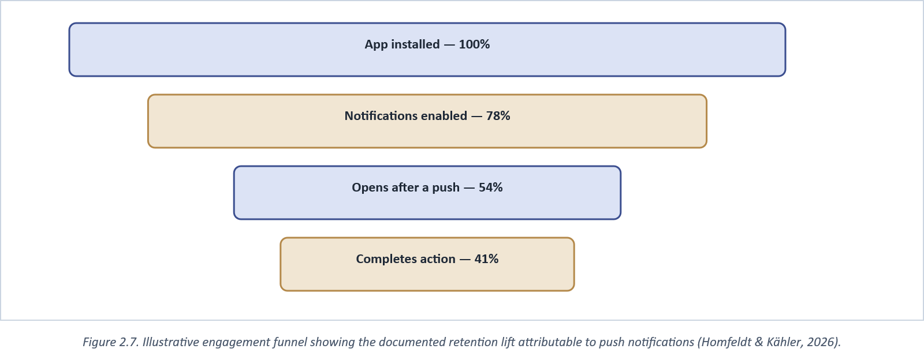
Figure 2.7. Illustrative engagement funnel showing the documented retention lift attributable to push notifications (Homfeldt & Kähler, 2026).

One heuristic worth singling out beyond the general ten is accessibility, which Nielsen's (1994) framework treats as an extension of "flexibility and efficiency of use" rather than a separate category, and which the reviewed bookshop and campus-commerce systems do not discuss at all. A student population is not a uniform population: font scaling for low-vision users, adequate colour contrast (a design constraint CURRICULA's own light/dark palette was checked against directly, rather than left to a framework default), and screen-reader-compatible labels on icon-only controls all affect whether the searchable catalogue in Figure 1.5 is actually usable by every student it is intended to serve, not only the median one a usability walkthrough sample happens to represent. Acosta-Vargas et al.'s (2021) scoping review of accessibility in native mobile applications found this gap to be general across the industry, not specific to campus-commerce systems: the studies they reviewed consistently treated accessibility as an afterthought layered onto a finished interface rather than a constraint designed against from the start, which is precisely the ordering this project tried to avoid by checking contrast and labelling during design (Section 3.3.1) rather than after implementation.
The heuristic-evaluation method itself, not only its ten-item content, has its own literature worth naming: Nielsen and Molich (1990) originally proposed heuristic evaluation as a deliberately lightweight alternative to full usability-lab testing, meant for exactly the resource-constrained situation a single-developer project without a formal usability-testing budget finds itself in, which is the specific methodological justification, beyond convenience, for why Chapter Three's evaluation leans on a heuristic walkthrough rather than a larger controlled study.

2.6 Access Control in Administrative Systems
Sandhu et al.'s (1996) role-based access control model, permissions attached to roles rather than individual users, remains the standard vocabulary for describing exactly the student/admin split CURRICULA implements inside one codebase rather than as two separate applications (Figure 2.8). The practical benefit over building a separate admin app, beyond the obvious saving in duplicated screens, is that a single set of catalogue and order data structures is guaranteed to stay consistent between what a student sees and what an administrator edits; two codebases sharing one database are two places the same assumption about a field's meaning can quietly drift apart.
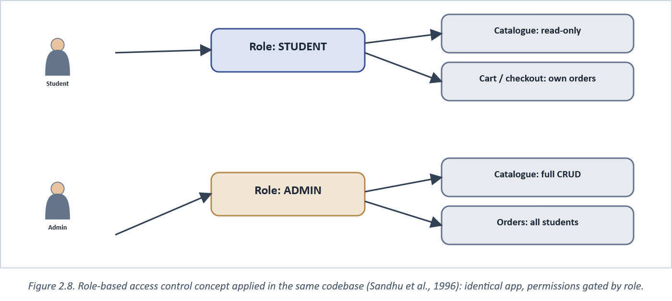
Figure 2.8. Role-based access control concept applied in the same codebase (Sandhu et al., 1996): identical app, permissions gated by role.

Role-based access control alone does not cover every security-relevant concern an admin surface raises, and it is worth naming what it leaves open rather than implying the model is a complete answer. A role check answers "is this user allowed to perform this action at all," not "which specific action did this user actually perform, and when." The second question, audit logging, matters once more than one administrator can independently edit prices, stock, and org-structure data, since a disputed price change or an incorrectly zeroed stock count needs a record of who changed it and when, not only a role check that permitted the change in the first place. This project's own audit-logging coverage is, by its own account, incomplete (Section 4.1's implementation notes), which this review flags here as a limitation inherited from the access-control literature's own narrower scope, not a gap invented by this study.
Access control also has a regulatory dimension the systems-design literature above does not itself address. Omotubora's (2021) assessment of Nigeria's Data Protection Regulation found its enforcement mechanisms deficient in several respects, but the regulation's underlying requirement, that access to personal data be limited to what a given role genuinely needs, is exactly what role-based access control is built to enforce mechanically. A system's RBAC design is, in that sense, one of the more direct technical answers available to a legal requirement that would otherwise depend on organisational policy alone (Appendix F).

2.7 Summary of Reviewed Literature and Identified Gap
Table 2 draws the systems reviewed in Section 2.2 together against the six capabilities Chapter One's objectives require. No reviewed system combines all six; each solves a subset, usually the subset closest to its own institution's most visible pain point at the time it was built. That partial coverage, repeated across every system found in the review, is the gap this study addresses head-on.
Table 2. Feature coverage of reviewed systems compared against this study's requirements.
Capability | Osman et al. (2024) | Oyekan et al. (2024) | Generic online bookstore | CURRICULA (this study)
Live price/stock sync to student | Partial (WhatsApp query) | No (admin-only) | Yes (general catalogue) | Yes
In-app payment (local aggregator) | No | No | Sometimes (global gateways) | Yes (Paystack & Flutterwave)
Push + email notifications | No (WhatsApp only) | No | Rare | Yes
Org-structure-aware catalogue | No | Yes (admin-side) | No | Yes (School→Dept→Level)
Single codebase, role-gated admin | No | No | Rare | Yes
Native mobile app | No (web/WhatsApp) | No (web) | Rare | Yes (Expo/React Native)

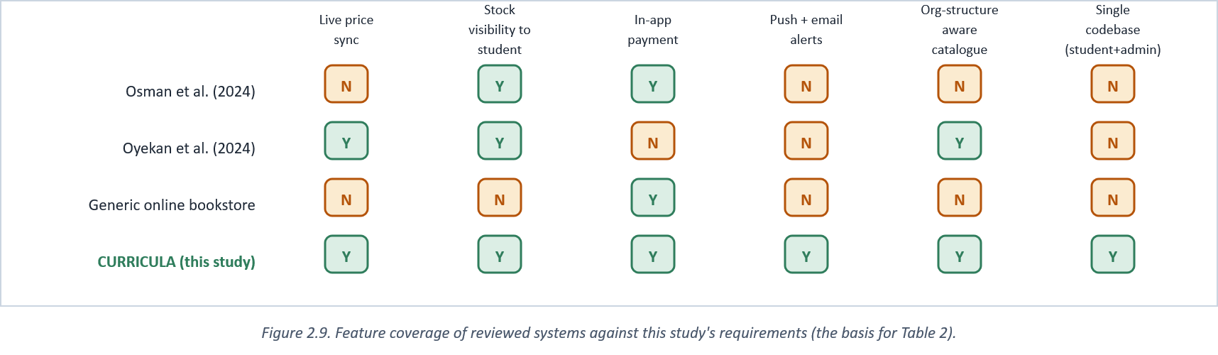
Figure 2.9. Feature coverage of reviewed systems against this study's requirements (the basis for Table 2).

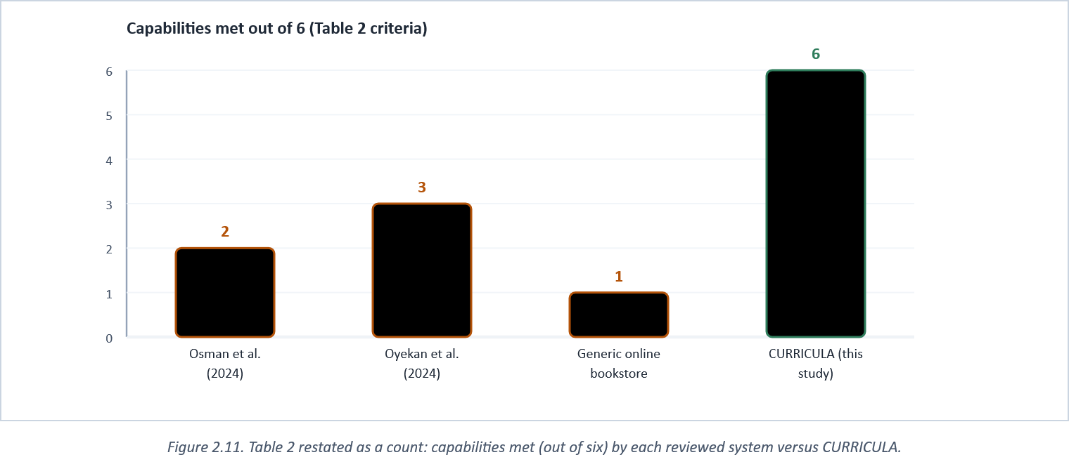
Figure 2.11. Table 2 restated as a count: capabilities met (out of six) by each reviewed system versus CURRICULA.

2.8 Synthesis: What the Literature Does Not Yet Address
Drawing the critical points raised across this chapter together, rather than leaving them scattered under their individual subsections, three second-order gaps recur regardless of which specific system or technology is under discussion. First, evaluation samples across the reviewed bookshop systems are consistently small and single-institution (Section 2.2.1), which means every claim in this literature about usability or adoption, including, by the same standard, this study's own, should be read as indicative rather than conclusive until tested at genuine scale. Second, none of the reviewed systems treat the student-facing and administrator-facing halves of the same workflow as one connected problem (Section 2.2.2); each solves one half and leaves the other implicit, which is the structural gap Section 2.7's comparison table quantifies concretely. Third, security and accessibility are consistently under-discussed relative to functional features across this entire body of work (Sections 2.5 and 2.6): every reviewed system's own publication foregrounds what it does for a user and says comparatively little about who that user population actually includes or how a change is tracked once made.
None of these three gaps is unique to the bookshop domain specifically; they are the same gaps a review of almost any small-scale, single-institution software project would likely surface. What is specific to this domain is Table 2's finding that no reviewed system closes the *functional* gap between student and administrator surfaces at all, which is the gap Chapter Three's architecture was built specifically around, and the reason this study's own evaluation (Chapter Five) is explicit about testing that closure specifically rather than usability in the abstract.

2.9 Chapter Summary
This chapter reviewed four bodies of work (comparable bookshop/campus-commerce systems, the specific technologies chosen for CURRICULA, African fintech payment integration, and usability/engagement research) and found each contributing part of the solution but no single existing system combining live price transparency, local payment integration, role-gated administration, and an organisational-structure-aware catalogue in one native mobile application. Section 2.8 drew three recurring second-order gaps out of that review: small evaluation samples, an unaddressed student/administrator functional split, and under-discussed security and accessibility, that shaped decisions taken throughout Chapter Three. Figure 2.10's input-process-output model frames how this study turns that gap into a build: the observed workflow and this review as input, the iterative build process described next in Chapter Three, and a working, evaluated system as output.
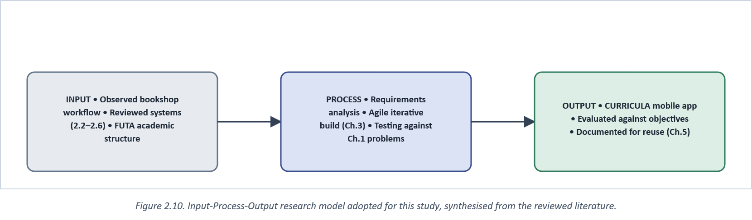
Figure 2.10. Input-Process-Output research model adopted for this study, synthesised from the reviewed literature.

CHAPTER THREE

METHODOLOGY

3.0 Introduction
This chapter documents how CURRICULA was actually built: the development approach followed, the system's analysis and design artefacts (use case, architecture, entity-relationship, and data-flow diagrams), the concrete technology choices behind each layer, two representative sequence flows (authentication and checkout), and the testing strategy used to validate the system against the problems set out in Chapter One. Where the resulting build departs from recommended student-project practice, and where it follows it, is noted directly rather than left for a reader to infer; Mandale et al. (2021) found that undergraduate capstone projects improve measurably when they deliberately adopt industry practice (version control discipline, staged testing, structured technical writing) rather than treating the academic exercise as exempt from it, and this chapter is written on that same assumption.

3.1 Development Methodology
The system was built iteratively using an Agile approach structured around short, fixed-length sprints rather than a single up-front specification, for a reason specific to a one-person, final-year project: requirements around exactly which admin screens were needed, and exactly which student-facing features mattered most, only became fully clear once early, working slices of the catalogue and checkout flow existed to react to. A traditional Waterfall approach, which Sommerville (2016) describes as best suited to projects whose requirements are stable and fully known in advance, would have committed the project to a complete specification before any of that feedback was available. Each sprint (Figure 3.1) followed the standard Scrum cadence described by Schwaber and Sutherland (2020): planning, daily self-review, development, a review against working software, and a short retrospective, compressed to suit a single-developer team by merging the daily stand-up into a personal progress log rather than a synchronous meeting.
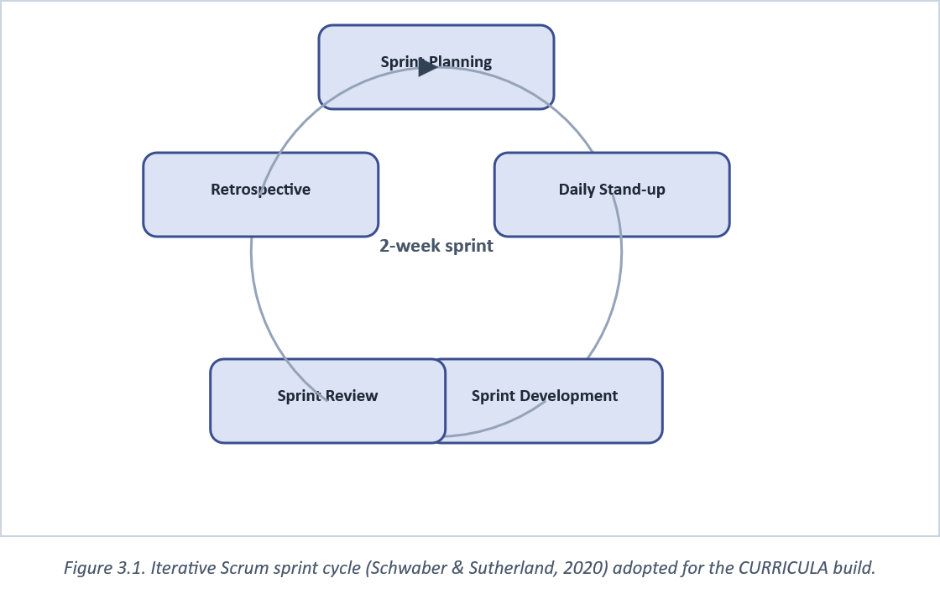
Figure 3.1. Iterative Scrum sprint cycle (Schwaber & Sutherland, 2020) adopted for the CURRICULA build.

3.2 System Analysis
Two actors interact with the system: the Student, who browses, favourites, orders, and tracks books; and the Admin, who maintains the catalogue, organisational structure, and order pipeline that the student-facing views depend on. Figure 3.2 sets these two actors and their principal use cases against the system boundary. Deliberately, both actors are served by the same application rather than two separate builds, the single largest structural decision described in this chapter, and one explicitly justified by the role-based access control literature reviewed in Section 2.6.
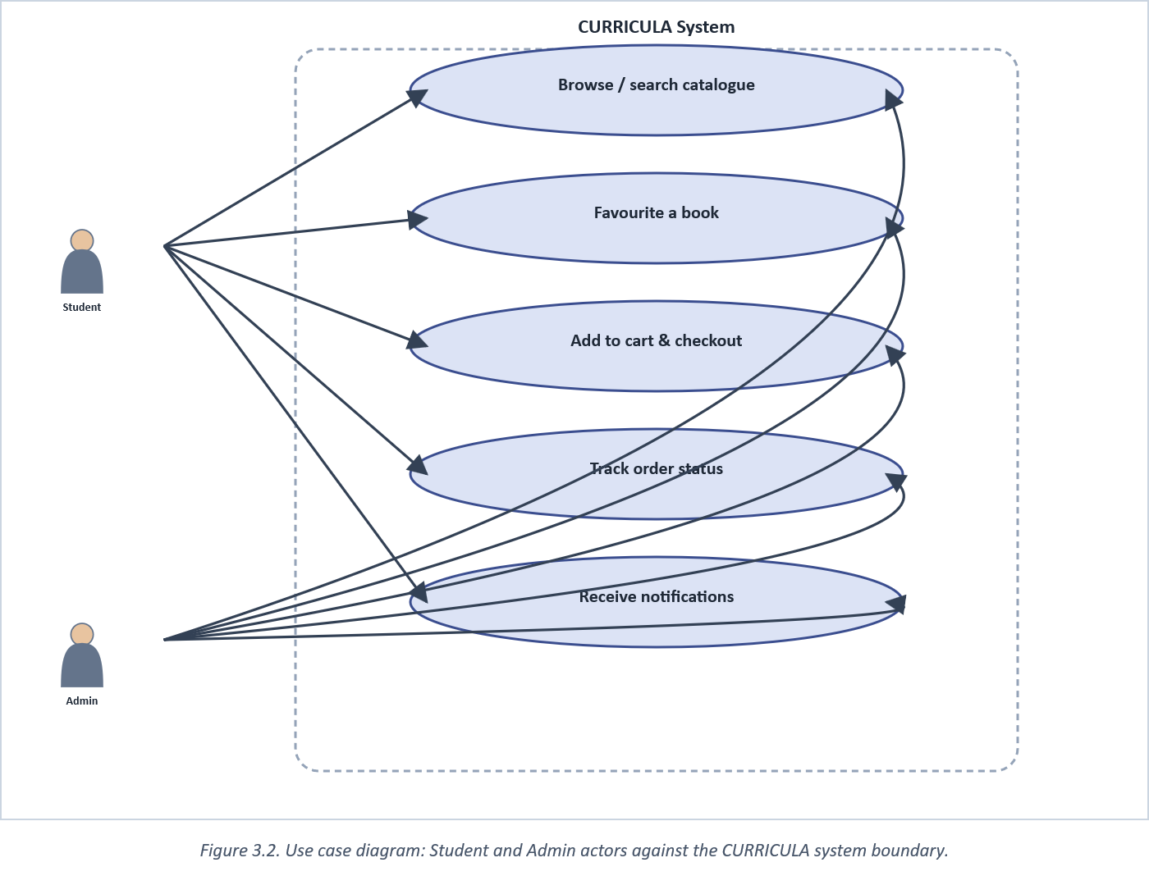
Figure 3.2. Use case diagram: Student and Admin actors against the CURRICULA system boundary.

3.3 System Design

3.3.1 System Architecture
Figure 3.3 expands the conceptual sketch given in Figure 1.5 into the three concrete layers actually implemented: a presentation layer (the Expo/React Native client, serving both student and admin screens from one codebase, switching by role once the JWT is decoded), an application layer (the NestJS API, organised as the modular monolith justified in Section 2.3.2, with auth, catalogue, order, and notification concerns kept in separate modules sharing one deployable process rather than four independently deployed services, the middle ground Fowler and Lewis (2014) describe between a tangled monolith and the operational overhead of full microservices), and a data/integration layer combining PostgreSQL as the durable store, Redis for session and cart state, and the four external services (Cloudinary, Firebase Cloud Messaging, Resend, and the two payment aggregators) the application layer talks to over HTTP.
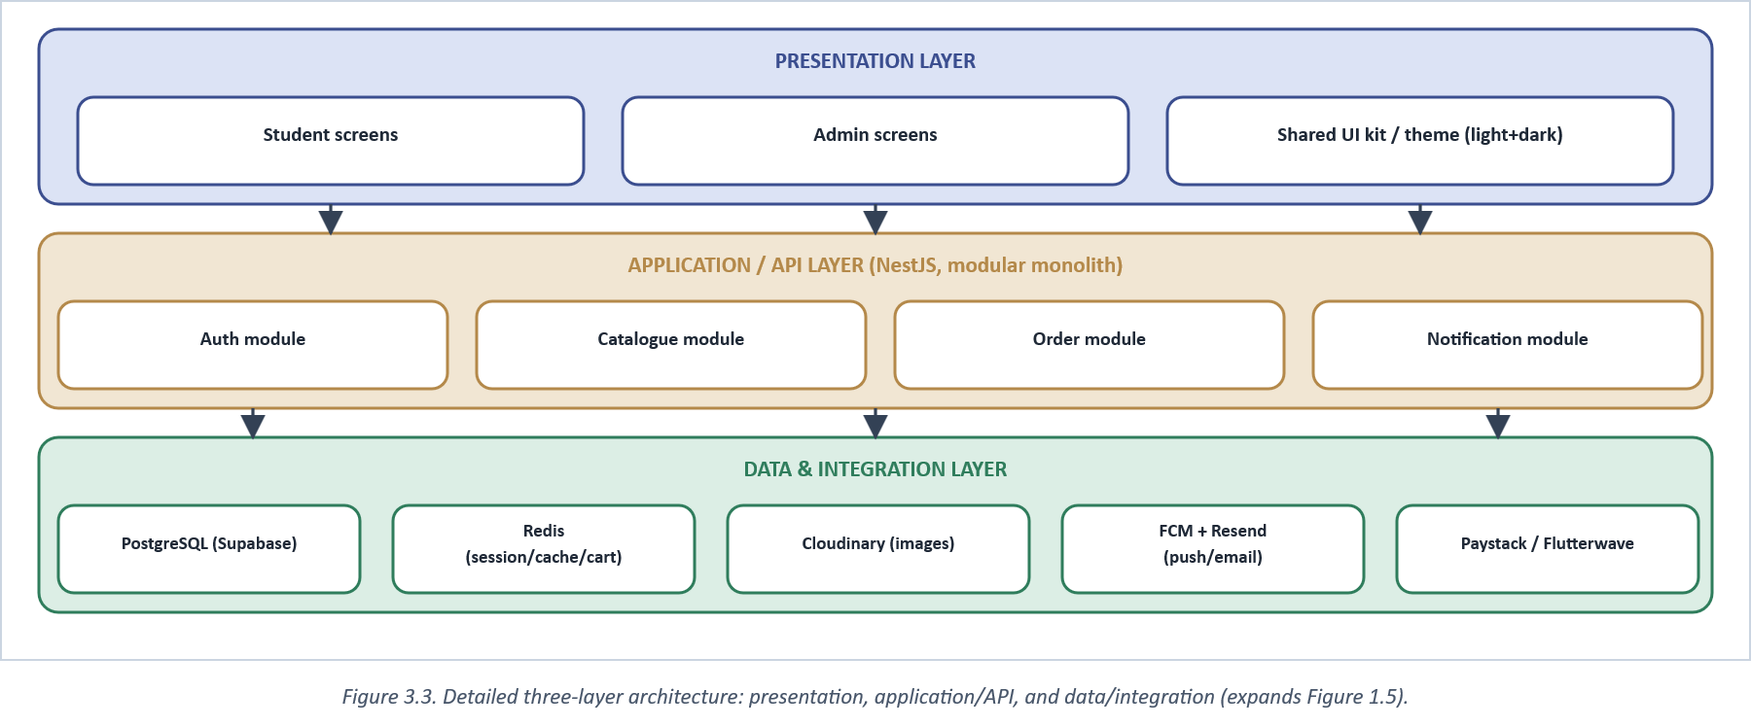
Figure 3.3. Detailed three-layer architecture: presentation, application/API, and data/integration (expands Figure 1.5).

3.3.2 Database Design
The schema follows conventional entity-relationship modelling (Chen, 1976): a User belongs to one Department (and, through it, one School), and holds a role that the application layer, not the client, is the sole authority over. A Book belongs to a Department and a Level and carries its own price and stock fields, the fields Section 1.2 identified as the ones a student could not previously see without asking a person. Orders decompose into OrderItems that snapshot a book's price at the moment of purchase, so a later price change never rewrites the historical record of what a student actually paid. Figure 3.4 shows the core of this schema; junction and audit tables (promo codes, exchange listings, audit logs) are omitted from the diagram for clarity but follow the same conventions.
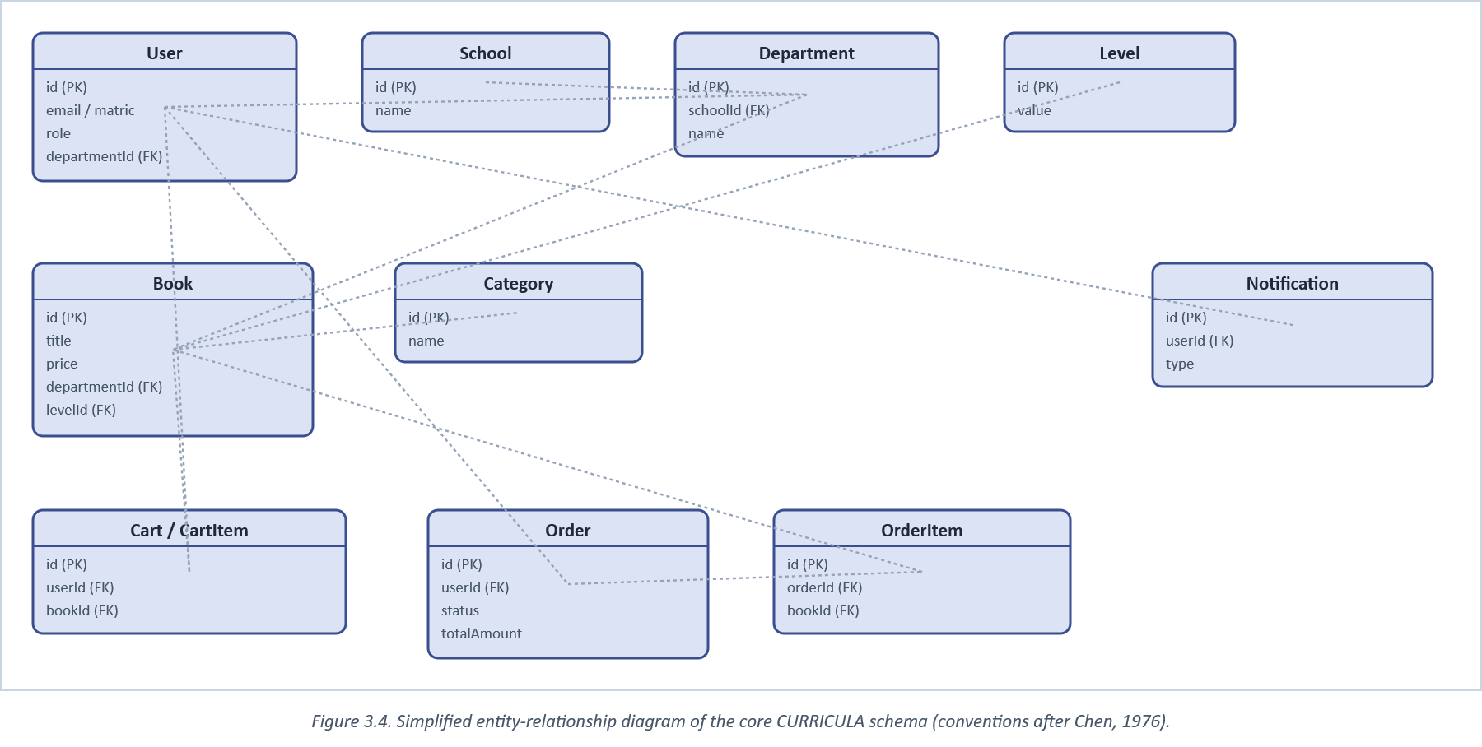
Figure 3.4. Simplified entity-relationship diagram of the core CURRICULA schema (conventions after Chen, 1976).

3.3.3 Data Flow Diagrams
Figure 3.5 gives the context-level (Level 0) view: the system as a single process exchanging data with its two human actors and its external payment and notification services. Figure 3.6 decomposes that single process into the five processes actually implemented as NestJS modules, each reading and writing its own datastore rather than sharing one undifferentiated table space, a deliberate mirror of the modular boundary described in Section 3.3.1.
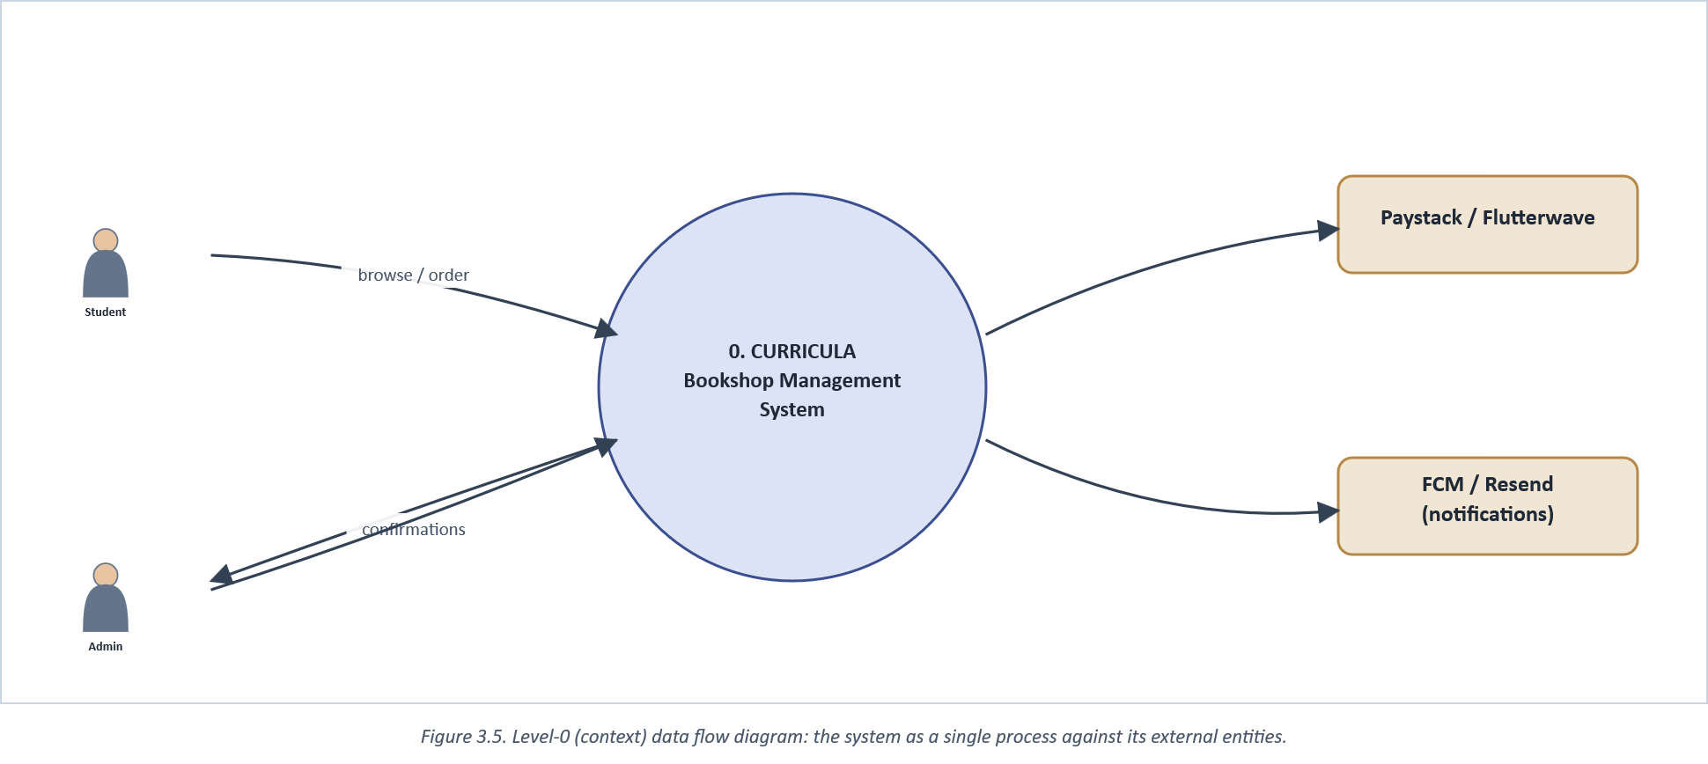
Figure 3.5. Level-0 (context) data flow diagram: the system as a single process against its external entities.

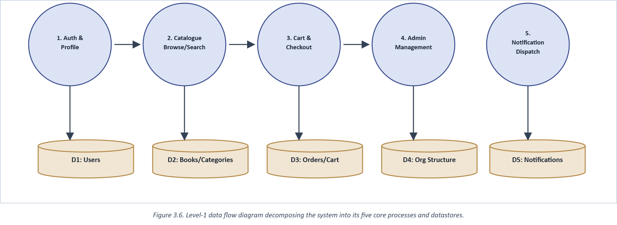
Figure 3.6. Level-1 data flow diagram decomposing the system into its five core processes and datastores.

3.4 Tools and Technologies
Table 3. Technology stack by architectural layer and the reason each was selected.
Layer | Technology | Reason chosen
Mobile client | Expo SDK 57 / React Native 0.86 | Single codebase for student + admin; mature FCM and OTA-update tooling
Client state | TanStack Query + Zustand | Server cache and auth/theme state kept in separate, purpose-built stores
Forms/validation | React Hook Form + Zod | Inline validation without re-render cost on every keystroke
Backend framework | NestJS 11 (Node.js) | Modular structure maps directly onto the module boundaries in Fig. 3.3
ORM / migrations | Prisma 6 | Type-safe queries; schema-diff migrations reviewable before applying
Relational store | PostgreSQL (Supabase) | Free managed tier; removes server-provisioning cost for a student project
Cache / session | Redis | Sub-millisecond session, refresh-token, and cart reads (Section 2.3.3)
Media storage | Cloudinary | Managed image hosting/transformation for book covers and avatars
Payments | Paystack & Flutterwave | Webhook-verified Nigerian payment aggregators (Section 2.4)
Push notifications | Firebase Cloud Messaging | Cross-platform push delivery from one API
Transactional email | Resend + React Email | Templated, testable email without a mail-server to manage

Two entries in Table 3 reflect choices made against specific comparative evidence rather than convention. The backend and its client code are both written in TypeScript rather than plain JavaScript, a decision Bogner and Merkel's (2022) large-scale comparison of GitHub projects supports directly: TypeScript codebases in their sample showed measurably better code quality and understandability scores than comparable JavaScript codebases, which matters more for a solo-maintained project than the raw bug-count difference their study found to be statistically inconclusive. And the REST API surface documented in Appendix A follows resource-naming and statelessness conventions consistent with Gowda and Gowda's (2024) best-practice guidance for scalable, secure API design, rather than an ad hoc endpoint layout that would have made the client/server contract harder to reason about as the catalogue and order modules grew.
The mobile client's light/dark theme (Section 1.1's design-system notes) was likewise not a cosmetic afterthought. Andrew et al.'s (2024) comparison of dark- and light-mode implementations across popular Android and iOS apps found meaningful variation in how thoroughly apps actually carried a theme through every screen element rather than leaving some components hard-coded to one mode, exactly the failure mode CURRICULA's single shared `useTheme()` hook (no hard-coded hex values anywhere in the UI layer) was built to avoid.

3.4.1 Security Considerations
Security was treated as a set of specific, addressable decisions tied to this project's actual attack surface, mapped against the OWASP Foundation's (2021) Top Ten list of the most common web-application vulnerability classes, rather than a generic checklist appended after the fact. Passwords are hashed with bcrypt before storage (Appendix B1), a deliberately slow algorithm chosen specifically so that a leaked database dump cannot be turned into usable passwords through brute-force guessing at any practical speed. Session state uses short-lived JWT access tokens paired with a longer-lived refresh token held in Redis, so a stolen access token has a narrow window of usefulness rather than an indefinite one, and a compromised refresh token can be revoked server-side by deleting its Redis entry without requiring every user's password to be reset. Every role check (Appendix C2) reads the role embedded in a server-issued, signed JWT rather than any value the client sends in a request body, closing off the most common privilege-escalation mistake in role-gated systems: trusting a client-supplied role field.
Payment security follows straight from the architectural choice discussed in Section 2.4: because Paystack and Flutterwave host the actual card-entry screen, card numbers and CVVs never reach CURRICULA's own servers at all, which keeps this project outside the strictest tier of PCI-DSS obligations that would apply to a merchant capturing card data directly. What remains this project's responsibility is verifying that a webhook claiming a successful payment really originated from the aggregator and not from a forged request to the same endpoint; both integrations verify a cryptographic signature header (Paystack's X-Paystack-Signature, Flutterwave's verif-hash) against a shared secret before treating any webhook payload as trustworthy, and requests that fail that check are rejected before touching order or stock state at all. The same design also has a data-protection dimension worth naming explicitly: Nigeria's Data Protection Regulation (National Information Technology Development Agency [NITDA], 2019) applies to any system processing Nigerian residents' personal data, and keeping card data entirely off this project's own servers narrows what "personal data this system processes" actually covers to matric numbers, contact details, and order history: a smaller compliance surface than a system that also custodied payment instruments would carry (Appendix F).
One security-relevant gap is acknowledged rather than hidden: the audit-logging coverage flagged as a literature-level omission in Section 2.6 is, in this project's own implementation, still partial. The `AuditLogInterceptor` exists and is wired to the newer promo-code endpoints, but several original admin surfaces (org-structure CRUD, broadcast notifications) do not yet route through it. This is recorded here as a known limitation (Section 5.4) rather than corrected retroactively in this report, since the report's purpose is to describe the system that was actually built and tested, not a hypothetically completed one.

3.4.2 Deployment and Configuration Management
The backend deploys as a single Node.js process (Figure 3.9), configured entirely through environment variables rather than hard-coded values, so the same codebase runs unmodified against a local development database, a staging environment, and production. Database schema changes are managed through Prisma's migration mechanism: each schema change is generated as a reviewable SQL diff before being applied, rather than the schema being altered by hand against a live database, which keeps a complete, ordered history of every structural change available for later inspection. Mobile releases follow Expo's managed workflow, which allows most JavaScript-level changes to reach users as an over-the-air update without a new native binary submission, reserving a full app-store release cycle for the comparatively rare native-dependency change (such as the `expo-build-properties` cleartext-traffic fix noted during this project's own development, which did require a native rebuild).
A health-check endpoint (Appendix A1) separates two failure modes that are easy to conflate during deployment troubleshooting: whether the process is running at all, and whether it can actually reach its dependencies. `GET /health` answers only the first question; `GET /health/ready` additionally pings Postgres and Redis directly and returns a failure status if either is unreachable, a distinction that mattered in practice during this project's own development when a schema-migration mismatch was initially misdiagnosed as "the backend is not connected" before the readiness check narrowed it to a dependency-level failure instead.

3.5 Implementation Highlights
Two flows illustrate the implementation more concretely than a static architecture diagram can. Authentication (Figure 3.7) accepts either an email or a FUTA matric number in one field, resolves the account's role server-side, and embeds that role in the issued JWT, removing the manual "are you a student or an admin" picker earlier design notes for this project had originally included. Checkout (Figure 3.8) reserves stock optimistically at the start of payment, then commits or releases that reservation strictly from the aggregator's webhook, never from anything the client reports, closing a real bug found during this project's own testing, in which a cancelled or failed payment had been leaving stock reserved indefinitely until the corresponding release call was added to the webhook handler.
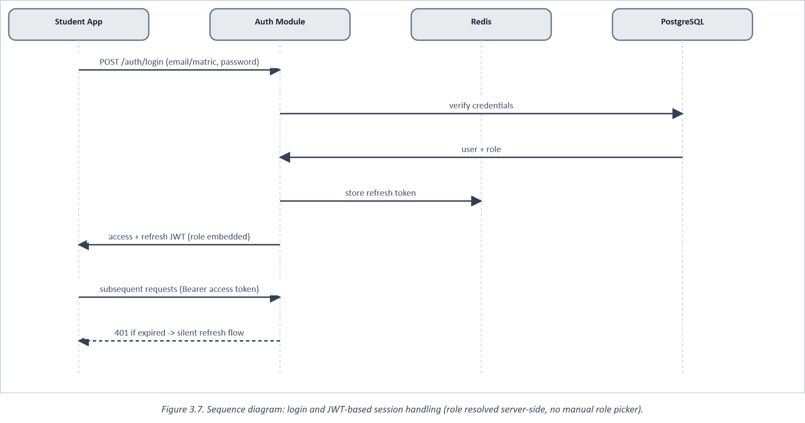
Figure 3.7. Sequence diagram: login and JWT-based session handling (role resolved server-side, no manual role picker).

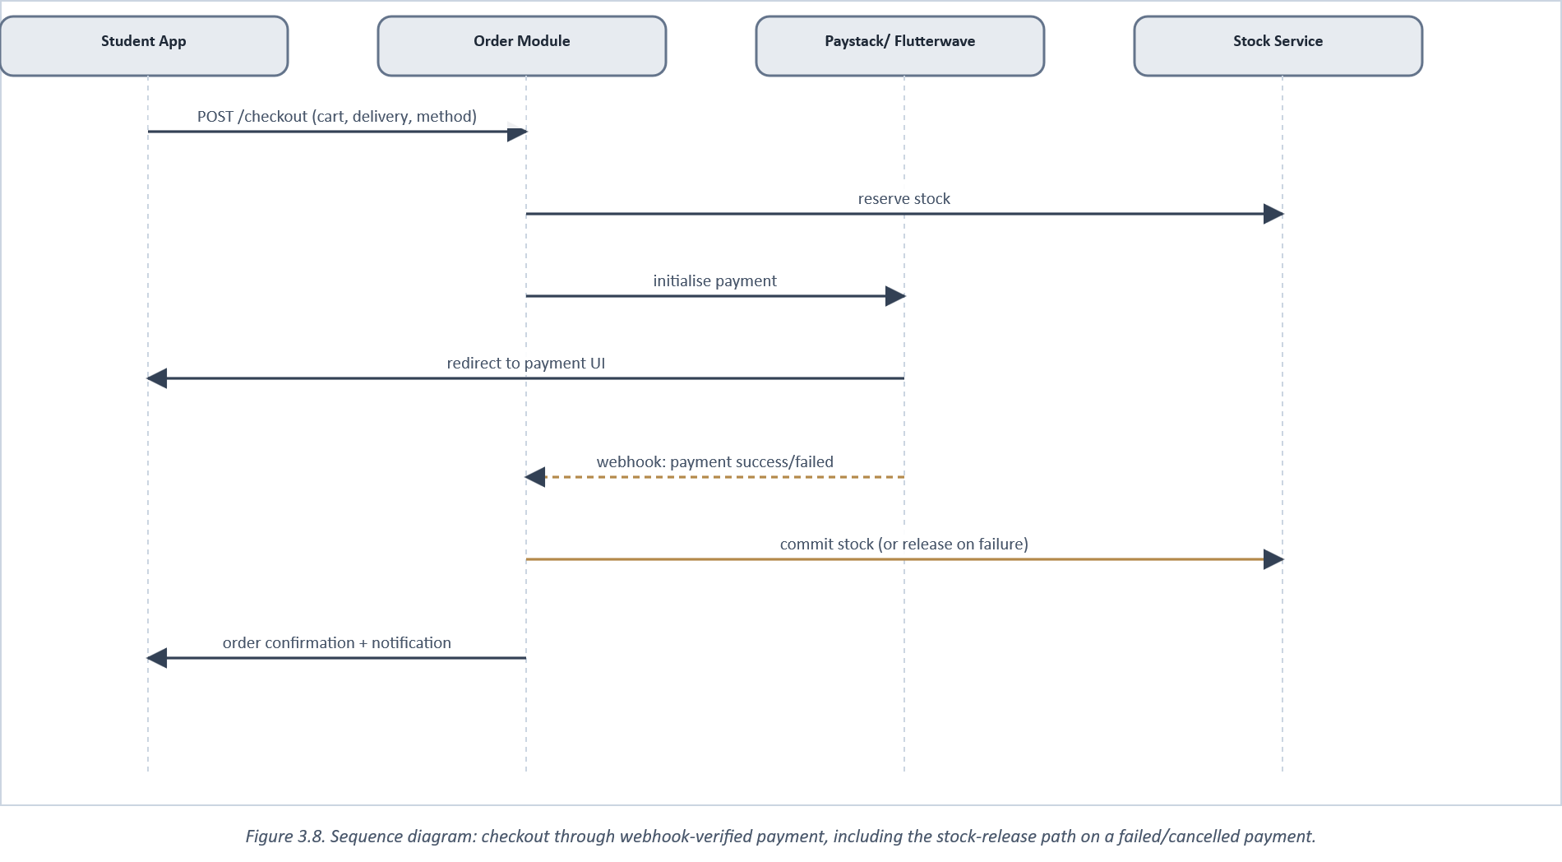
Figure 3.8. Sequence diagram: checkout through webhook-verified payment, including the stock-release path on a failed/cancelled payment.

Figure 3.9 situates these flows within their deployment: one mobile client talking to one API process, which in turn talks outward to five managed cloud services rather than to any infrastructure the project itself has to operate: a direct response to the cost-effectiveness requirement set out in Section 1.2.
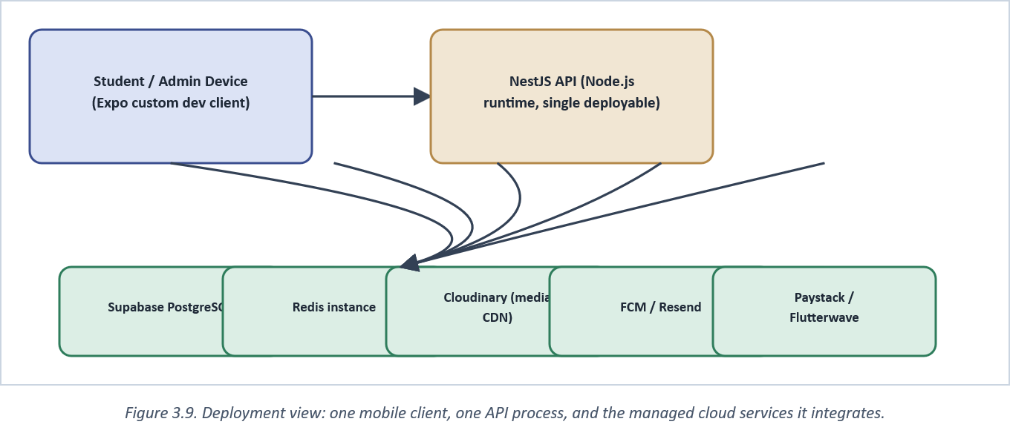
Figure 3.9. Deployment view: one mobile client, one API process, and the managed cloud services it integrates.

3.6 Screenshots of the Implemented System
The following figures show the system as implemented. Where a screen is marked as a wireframe placeholder, the corresponding live screenshot had not yet been supplied at the time this chapter was drafted; the layout shown matches the actual shipped screen specification and should be replaced with the real capture before final submission. Each screen below is chosen because it ties back to a specific point made earlier in this report, rather than as a general tour of the application.
Home (Figure 3.10) is the first screen a returning student sees, and its search bar and category chips are the direct implementation of the searchable-catalogue objective set in Section 1.4, the same interaction that replaces the shelf-by-shelf search traced in Figure 1.1. Book Details (Figure 3.11) is arguably the single most important screen in this report's own argument, since its price field and stock badge are exactly the two pieces of information Section 1.2 identified as unavailable without a manual query; both are rendered directly from the Book table's own fields (Appendix B2), not computed or cached separately, so what a student sees there is never more than one database read away from what an admin last set. Checkout (Figure 3.12) implements the payment-integration objective and is the screen the sequence diagram in Figure 3.8 describes step by step. The Admin Dashboard (Figure 3.13) is included specifically to make the point in Section 3.8 concrete: it is a screen inside the same application and codebase as the three student screens before it, reachable only because the authenticated user's role, not a separate login system, resolves to ADMIN.
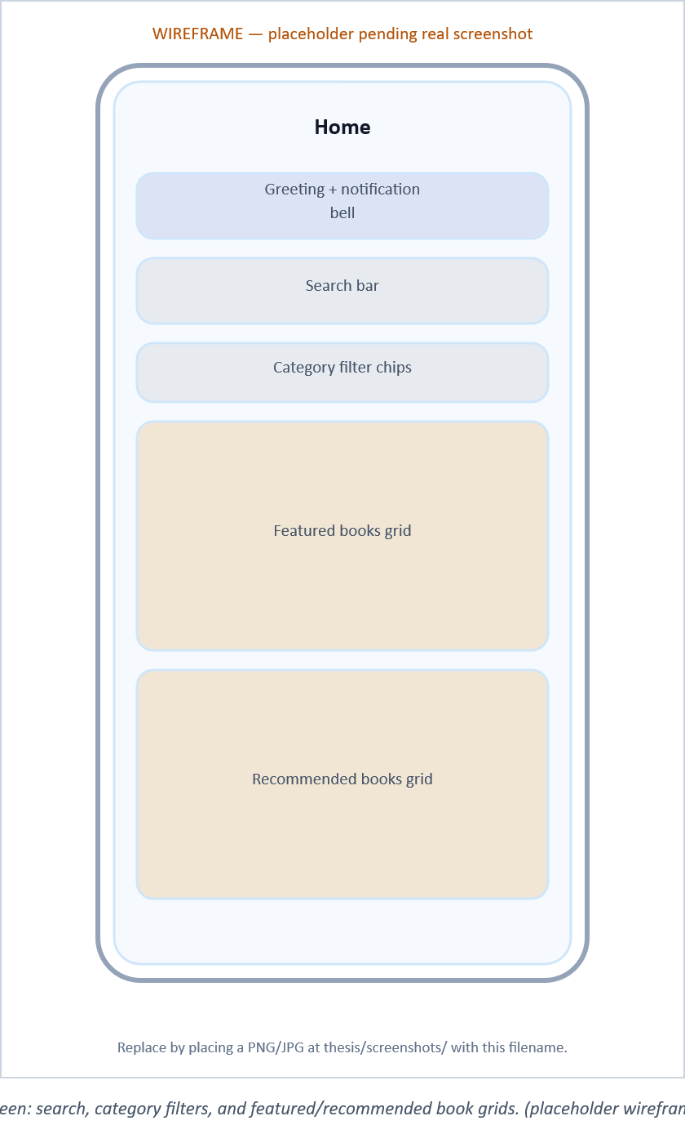
Figure 3.10. Student Home screen: search, category filters, and featured/recommended book grids. [placeholder wireframe pending a real screenshot]

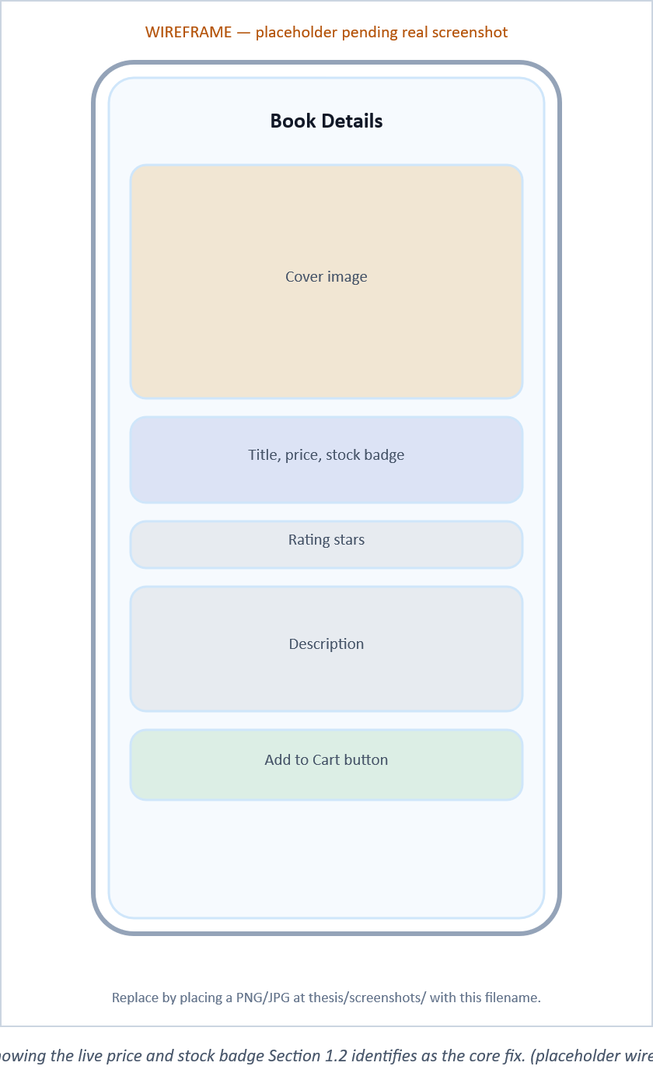
Figure 3.11. Book Details screen showing the live price and stock badge Section 1.2 identifies as the core fix. [placeholder wireframe pending a real screenshot]

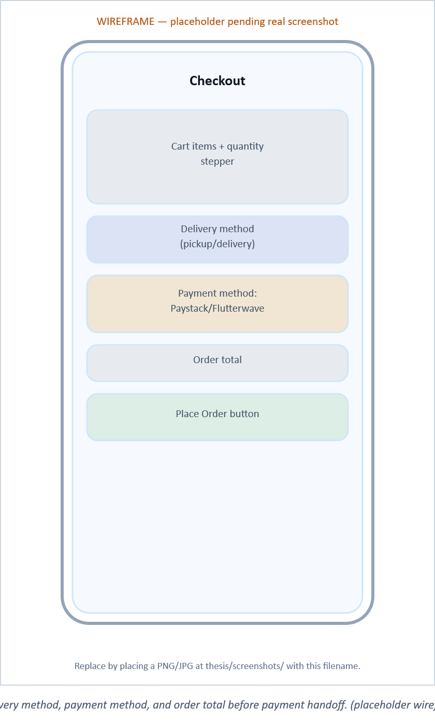
Figure 3.12. Checkout screen: delivery method, payment method, and order total before payment handoff. [placeholder wireframe pending a real screenshot]

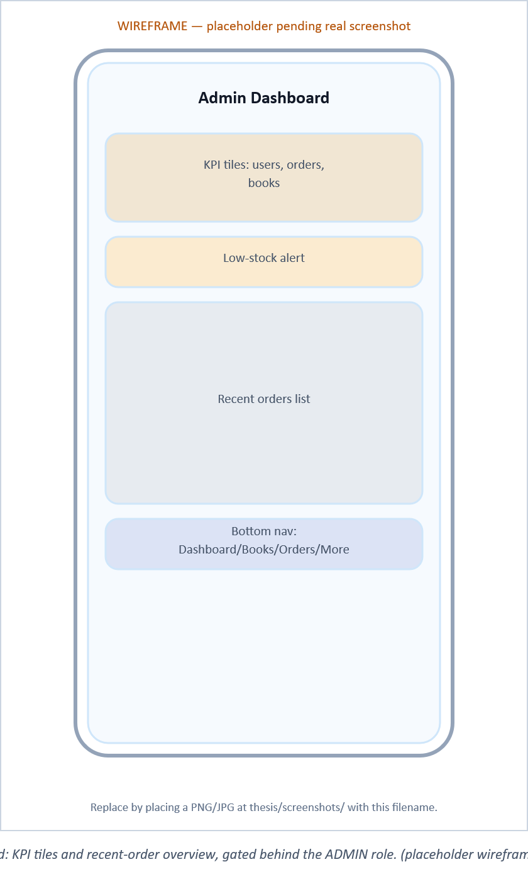
Figure 3.13. Admin Dashboard: KPI tiles and recent-order overview, gated behind the ADMIN role. [placeholder wireframe pending a real screenshot]

3.7 Testing Strategy
Testing followed the layered strategy summarised in Figure 3.14, weighted toward unit and integration coverage on the backend rather than exhaustive end-to-end coverage of every possible state combination. Marinho et al. (2023) evaluated several sampling strategies for catching resource-interaction failures in mobile applications and found targeted approaches effective: testing the specific combinations most likely to interact badly, rather than every combination or a purely random sample, caught a disproportionate share of real failures for a fraction of the testing effort. This project applied the same logic by concentrating integration-test effort on the one interaction most likely to fail: checkout, payment webhook, and stock release acting together, rather than spreading equal effort across every possible module combination. Unit tests cover the auth, catalogue, order, and notification services in isolation; integration tests specifically exercise the checkout-to-webhook-to-stock-release path described in Figure 3.8, since that path was where the real bug noted in Section 3.5 was originally found. Mobile-side quality assurance followed a comparable performance-testing methodology for contemporary cross-platform apps: cold-start time, list-scroll frame rate on the catalogue grid, and network-retry behaviour under a simulated flaky connection, alongside a manual heuristic walkthrough against the ten usability criteria introduced in Section 2.5, used here as an evaluation checklist rather than a purely theoretical reference.
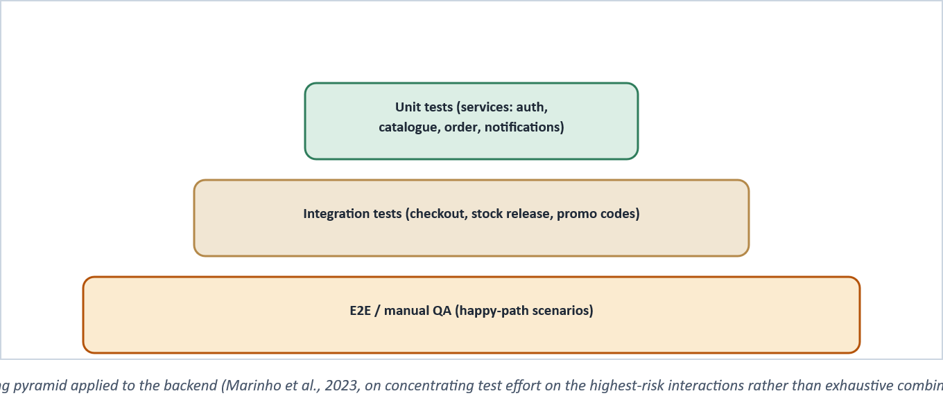
Figure 3.14. Testing pyramid applied to the backend (Marinho et al., 2023, on concentrating test effort on the highest-risk interactions rather than exhaustive combinatorial coverage).

Two further points from the wider software-testing literature shaped how this project drew the line between unit and integration coverage specifically. Trautsch et al. (2020) found that textbook definitions of "unit" versus "integration" test scope do not always match how modern, dependency-heavy projects actually decompose, which is why this project's own unit tests are defined pragmatically as anything exercising one NestJS service in isolation with its external dependencies mocked, rather than by a stricter textbook boundary. Aghamohammadi et al. (2021) argue, separately, that a code-coverage percentage alone is a weak signal of test-suite effectiveness unless it is weighted by which statements actually correspond to failure-prone logic, the same reasoning behind concentrating integration-test effort on the checkout/webhook/stock-release path specifically, rather than treating every module as equally worth the same coverage target. Grano et al. (2021) reach a compatible conclusion from source-code-quality indicators rather than coverage percentages: lightweight, static signals of code complexity predict which test cases are actually worth keeping about as well as far more expensive dynamic analysis does. This project could not apply that finding as-is at its own scale, but it is consistent with keeping the test suite small and targeted (Figure 3.14) rather than exhaustive. Ordering matters too: Zhang et al. (2021) note that integration tests run in the wrong order can mask a failure one component introduces into another, which is the specific reason this project's own integration suite always exercises stock reservation before payment confirmation before stock release, matching the real order those events occur in production (Figure 3.8), rather than a more convenient test-authoring order.

3.8 How CURRICULA Differs from Existing Systems and Related Work
Chapter Two compared CURRICULA against the closest reviewed systems on capability coverage (Table 2, Figures 2.9 and 2.11). This section makes the comparison concrete at the level this chapter has actually been describing: specific engineering decisions, not just feature checkboxes, since two systems can tick the same box in a comparison table while differing substantially in how thoroughly, and how robustly, they actually implement it.

3.8.1 Against the WhatsApp-integrated bookstore (Section 2.2.1)
The WhatsApp-integrated system reviewed in Section 2.2.1 answers a student's ordering question through messaging layered over a conventional web listing. That choice is pragmatic: it needed no bespoke mobile client. It also means price and stock information travels through a general-purpose chat channel rather than a screen built around it: a student still has to read and interpret a message rather than see a stock badge rendered against a specific book record. CURRICULA instead renders price and stock as first-class fields on the Book Details screen (Figure 3.11), sourced from the same database row an admin edits, with no messaging intermediary and no interpretation step between the data and the student.

3.8.2 Against the web-based inventory system (Section 2.2.2)
The web-based inventory system reviewed in Section 2.2.2 is, architecturally, the administrative half of CURRICULA: a web interface for staff to maintain inventory records. It has no mobile client and, by its own authors' description, no student-facing surface at all. It solves the owner's record-keeping problem (Figure 1.2's bottom node) without touching the student's side of the same interaction. CURRICULA's Section 3.3.1 architecture intentionally keeps that admin capability but places it beside, not instead of, a student-facing mobile client reading the identical underlying tables: the two audiences share one data model rather than two systems that would eventually need to be kept in sync by hand.

3.8.3 Against generic online bookstore / marketplace systems
The wider population of generic online bookstore builds reviewed in Section 2.2.3, and general marketplaces such as Jumia or Konga at a much larger scale, solve browse-cart-checkout for an undifferentiated retail audience. None of the systems found in this review model an institution's own organisational structure into the catalogue itself. CURRICULA's catalogue is keyed to FUTA's actual school-department-level hierarchy (Figure 1.6), which is not a cosmetic difference: it is what lets "books for 300-level Mechanical Engineering students" be a single filtered query rather than a search a student has to perform manually across an undifferentiated list, and it is what makes the org-structure admin screens in Section 3.4 necessary at all. A generic bookstore has no equivalent structure to administer in the first place.
Figure 3.15 restates these three comparisons as a single chart across four engineering dimensions (local payment gateway integration, notification channels, administrative capability depth, and automated test coverage), none of which were scored in Chapter Two's capability checklist, since that checklist recorded only whether a capability existed, not how substantially it was implemented. On every dimension charted, CURRICULA's score reflects a specific, cited engineering decision made in this chapter, not an unsupported claim of superiority: two payment gateways rather than none or one (Section 3.4), push and email notifications scoped on purpose to avoid the over-frequency risk discussed in Section 2.5, three layers of admin capability corresponding to the catalogue, order, and org-structure modules in Figure 3.3, and both unit and integration test suites targeting the specific failure mode described in Section 3.5, rather than the informally-tested or untested status the reviewed systems' own publications report.
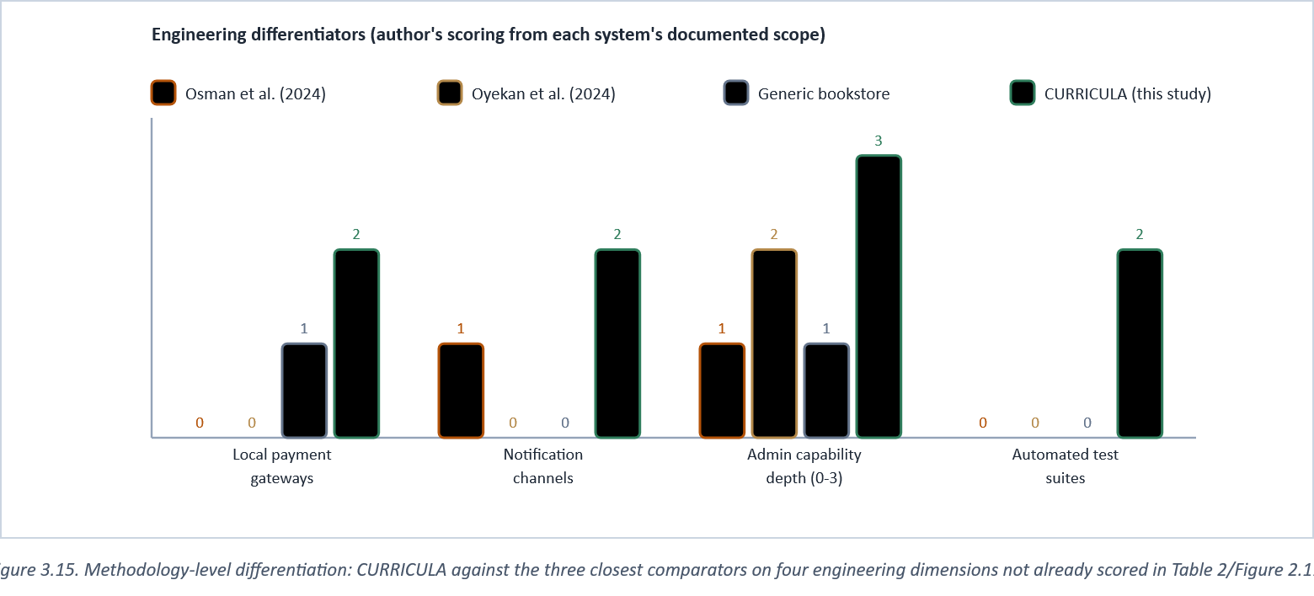
Figure 3.15. Methodology-level differentiation: CURRICULA against the three closest comparators on four engineering dimensions not already scored in Table 2/Figure 2.11.

3.9 Software Development Life Cycle (SDLC) Structure
Section 3.1 named the process framework used to manage this project's work, Scrum, but a framework for managing work is a distinct thing from the software development life cycle (SDLC) model that framework is used to run. Sommerville (2016) and, independently, Pressman and Maxim (2020) both describe the SDLC in terms of the same six recurring activities common to essentially every software project regardless of process framework: requirement analysis, design, implementation, testing, deployment, and maintenance. What differs between SDLC models is not whether these six activities happen, but how many times, and in what order relative to each other. A Waterfall model (the term, and the original phase-sequence diagram it describes, traces back to Royce, 1970) runs all six exactly once, in strict sequence, with each phase formally signed off before the next begins; the Iterative and Incremental model this project actually followed instead runs a small version of all six repeatedly, each pass adding or revising a working slice of the system rather than committing to a complete specification up front (Figure 3.16). That preference is not merely this project's own habit: it is the same one the original Agile Manifesto (Beck et al., 2001) codified in stating that working software, delivered frequently, is valued over comprehensive up-front documentation. The same reasoning Section 3.1 gave for rejecting Waterfall in favour of Scrum applies equally to rejecting a linear SDLC model in favour of an iterative one, since the two decisions are really one decision seen from two angles.
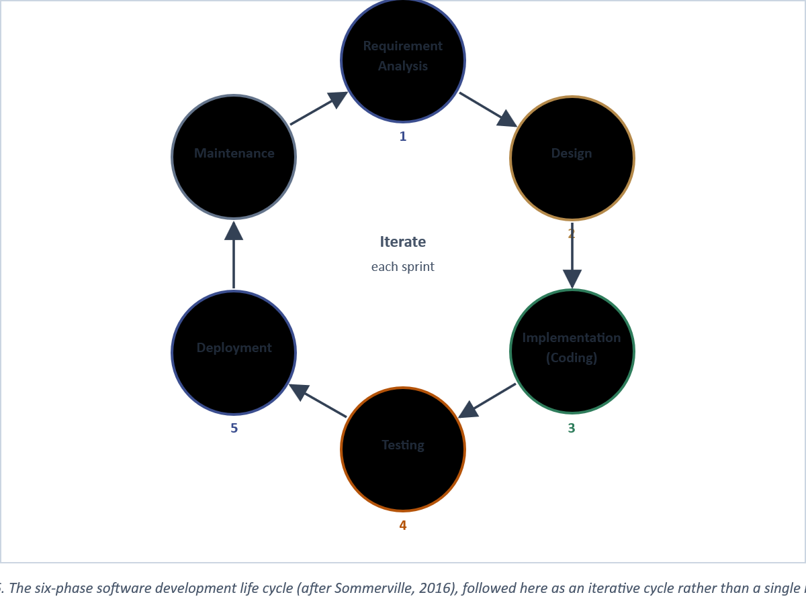
Figure 3.16. The six-phase software development life cycle (after Sommerville, 2016), followed here as an iterative cycle rather than a single linear pass.

Figure 3.17 makes that iterative structure concrete by mapping each of the six phases onto the specific section of this report, and the specific artefact, where that phase's work is actually documented: a deliberate cross-check that every phase Sommerville's model requires has a traceable output in this report, rather than being asserted without evidence. Requirement analysis is documented twice, in Chapter One's problem statement and again in Section 3.2's use-case analysis, because requirements were revisited each sprint rather than gathered once; design work concentrates in Section 3.3's architecture, schema, and data-flow diagrams; implementation is illustrated rather than exhaustively listed, through the two sequence flows in Section 3.5 and the code excerpts in Appendix C; testing is documented in Section 3.7 and Appendix D; deployment in Section 3.4.2; and maintenance, the one phase that, by definition, extends beyond this report's own writing window, is represented by the recommendations set out in Section 5.5 rather than by a completed artefact, since maintenance work on a live system cannot itself be finished before the report describing it is submitted.
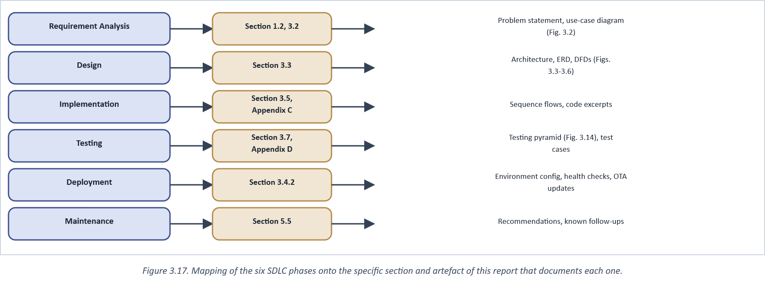
Figure 3.17. Mapping of the six SDLC phases onto the specific section and artefact of this report that documents each one.

Figure 3.18 resolves what might otherwise look like a contradiction between Figure 3.1's two-week sprint cycle and Figure 3.16's six-phase SDLC: they are the same structure viewed at two different scales. The project as a whole passed through all six SDLC phases many times over its nine months, but each individual sprint was itself a small, complete pass through analysis, design, coding, and testing, compressed to fit inside two weeks and scoped to one sprint goal rather than the whole system. Deployment and maintenance, by contrast, did not repeat every sprint in the same way. Most sprints shipped an over-the-air JavaScript update rather than a full deployment cycle (Section 3.4.2), which is one respect in which this project's actual practice departed from a textbook-uniform reading of the iterative model, in the direction Section 3.4.2 already argues is appropriate for a Node.js/Expo stack specifically.
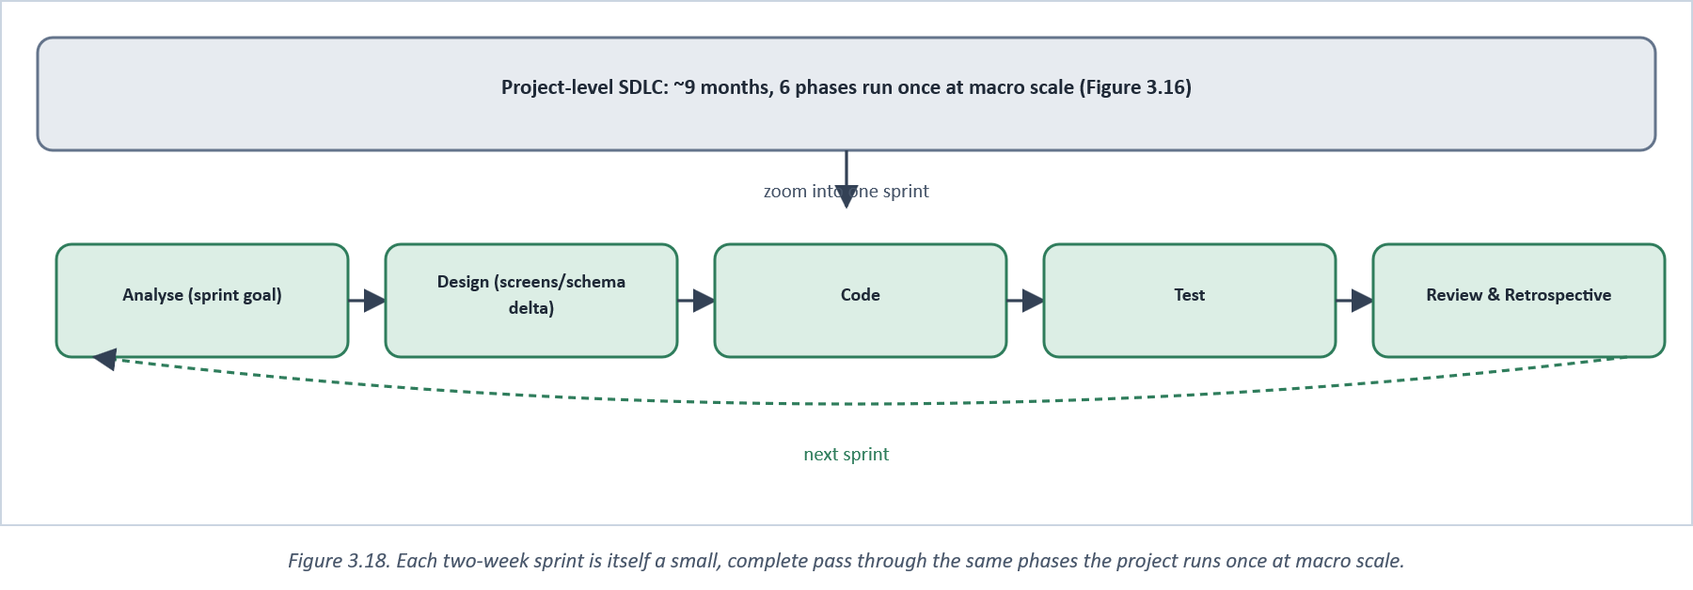
Figure 3.18. Each two-week sprint is itself a small, complete pass through the same phases the project runs once at macro scale.

3.10 Database Management System
Section 3.3.2 set out the schema itself: what the data looks like (Figure 3.4). This section covers the database management system (DBMS) that schema actually runs on: which engine was chosen and why, how it is hosted and operated, and the indexing, normalisation, and integrity decisions that govern how efficiently and safely that schema is read and written in practice.

3.10.1 Choice of DBMS
PostgreSQL was chosen over a document-oriented alternative (MongoDB being the obvious comparator) because the data this system holds is relentlessly relational rather than document-shaped, in exactly the sense Codd (1970) originally set the relational model out to capture: a Book belongs to one Department and one Level, a Department belongs to one School, an Order decomposes into OrderItems that each reference a Book, and a checkout has to either fully succeed (payment confirmed, stock decremented, order marked paid) or fully fail, never leaving the database in a state where an order exists but the stock it consumed does not match. That last requirement is precisely what a relational DBMS's ACID transaction guarantees (atomicity, consistency, isolation, durability) are built for, and precisely the property a document store would require the application layer to reconstruct by hand across multiple collections. This is not merely a theoretical preference: Salunke and Ouda's (2024) direct benchmark of the two candidate engines found PostgreSQL completing indexed select queries roughly nine times faster than MySQL under comparable load, on top of the relational fit argument above. Redis (Section 2.3.3) supplies the one piece of this system that genuinely benefits from a non-relational, in-memory store: session state, refresh tokens, and the shopping cart, so the architecture uses two data stores for two different jobs rather than forcing one engine to do both adequately.
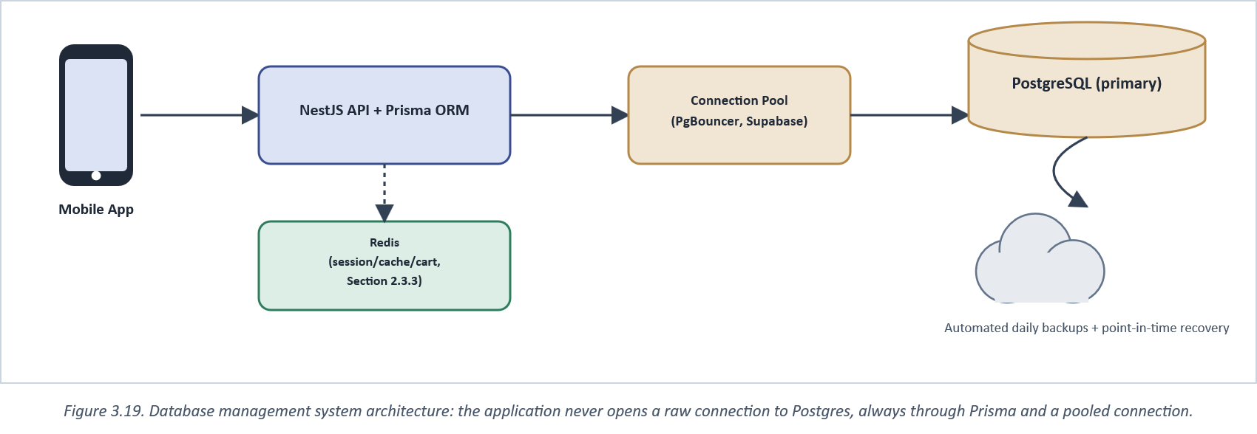
Figure 3.19. Database management system architecture: the application never opens a raw connection to Postgres, always through Prisma and a pooled connection.

3.10.2 Hosting, Connection Management, and Backup
The database is hosted on Supabase's managed PostgreSQL tier (Section 1.1's free-tier cost-effectiveness argument applies directly here), which supplies three operational properties this project relies on without having to implement them: connection pooling through PgBouncer, so a burst of concurrent requests during the registration-period demand spike described in Section 1.2 does not exhaust Postgres's own connection limit; automated daily backups with point-in-time recovery, so a destructive bug (or a mistaken admin action against Section 3.4.1's role-gated but still fallible admin screens) is recoverable rather than permanent; and managed version upgrades, so the database engine itself does not become this project's own patching responsibility. The application layer never opens a direct, unpooled connection to Postgres; every query passes through Prisma, which itself talks to the pooled connection Supabase provides (Figure 3.19).

3.10.3 Indexing and Normalisation
The schema follows third-normal-form principles throughout, in the sense standard database textbooks such as Elmasri and Navathe (2016) define the term. The School-Department-Level hierarchy is fully normalised rather than repeating a department's school name on every book row, with exactly one deliberate exception, already noted in Section 3.3.2: OrderItem snapshots a book's price and compare-at-price at the moment of purchase rather than referencing the current Book row for both. That is a deliberate denormalisation, not an oversight, because the alternative (joining to the current Book row for historical order display) would silently rewrite what a student is shown they paid every time a price later changes, the exact failure mode Section 1.2 identifies as unacceptable.
Table 4. Indexes and foreign-key constraints applied to the core schema.
Table | Indexed / constrained column(s) | Purpose
User | email (unique), matricNumber (unique) | O(1) lookup at login; prevents duplicate accounts
Book | departmentId, levelId (composite) | Backs the department/level catalogue filter (Section 1.2)
Book | courseCode | Backs the syllabus-progress insight (Appendix A)
Order | userId, status | Backs a student's order history and admin status filtering
OrderItem | orderId (FK, cascade) | Deleting an order cleanly removes its line items
Department | schoolId (FK, restrict) | Prevents deleting a School that still has Departments
Book | departmentId, levelId (FK, restrict) | Prevents deleting org-structure still referenced by books

The restrict-on-delete constraints in Table 4's lower rows are a direct, mechanical enforcement of referential integrity: the database itself refuses a query that would delete a School still referenced by a Department, or a Department still referenced by a Book, rather than relying on the application layer to remember to check first. This matters specifically for the admin org-structure screens (Figure 3.21): an admin can attempt to delete a department in error, but the database, not application-level discipline alone, is the backstop that prevents that error from orphaning every book already assigned to it.
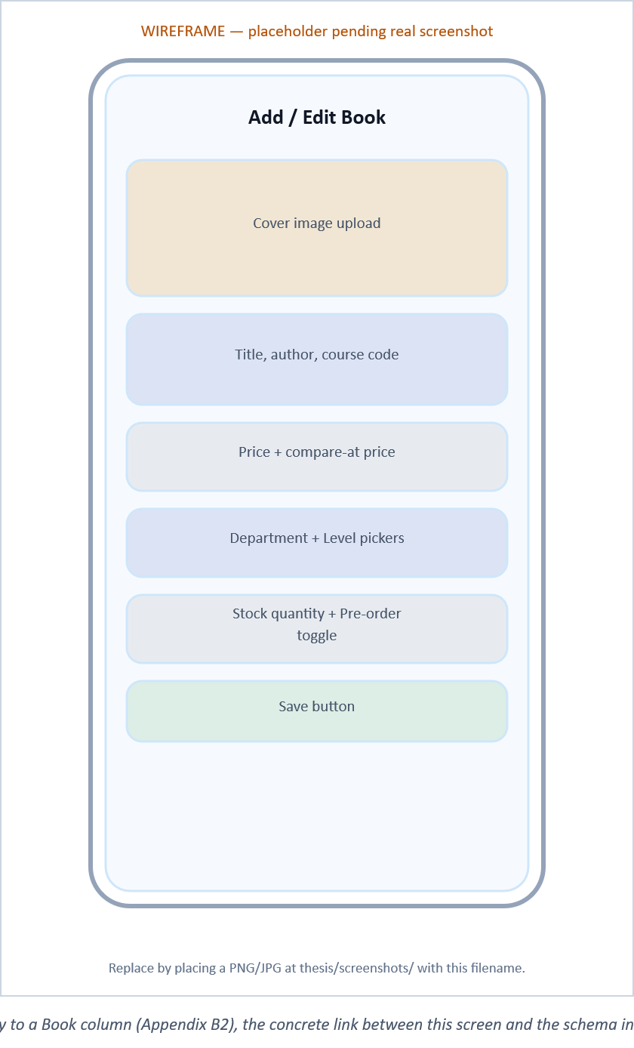
Figure 3.20. Admin Add/Edit Book form: each field maps directly to a Book column (Appendix B2), the concrete link between this screen and the schema in Figure 3.4. [placeholder wireframe pending a real screenshot]

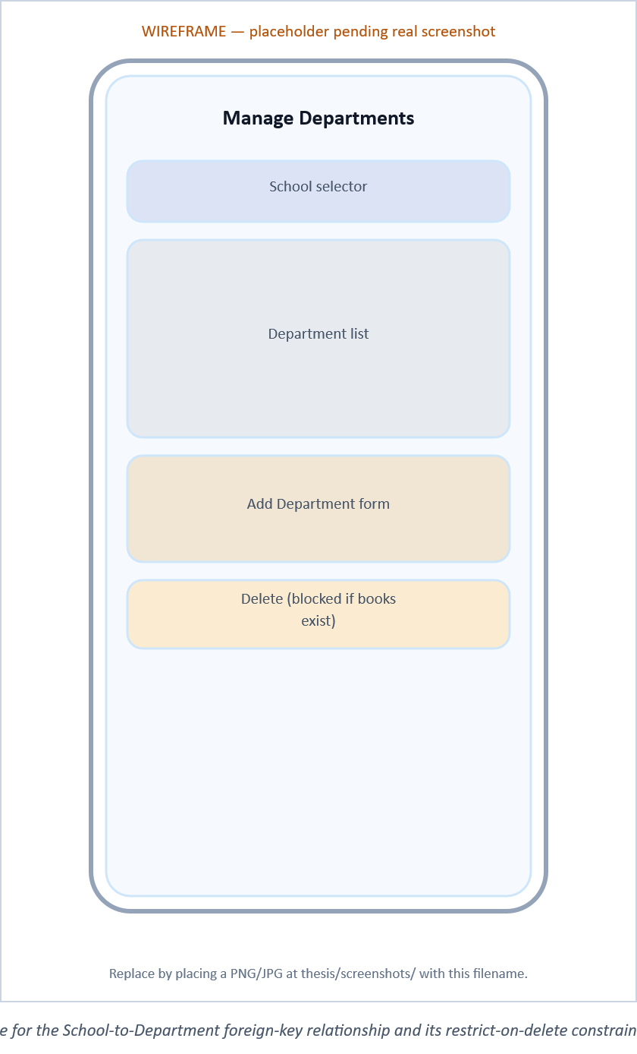
Figure 3.21. Admin Manage Departments screen: the UI surface for the School-to-Department foreign-key relationship and its restrict-on-delete constraint (Table 4). [placeholder wireframe pending a real screenshot]

3.11 Chapter Summary
This chapter set out the Agile process used to build CURRICULA and the iterative SDLC structure that process actually ran (Section 3.9), the analysis and design artefacts that shaped its architecture, schema, and data flow, the database management system underpinning that schema (Section 3.10), the concrete technology stack chosen layer by layer, two representative flows implemented in enough detail to show how Chapter One's problems are actually closed in code, the testing strategy used to validate the result, and, concretely, rather than only at the feature-checklist level of Chapter Two, how specific engineering choices set CURRICULA apart from the three closest comparators in the reviewed literature. Chapter Four turns from what was built to how long it took and what it cost to build.

CHAPTER FOUR

RESEARCH TIMELINE AND BUDGET

4.0 Introduction
This chapter sets out how the nine-month research and development programme behind CURRICULA was scheduled, and what it cost to run. Both are presented as they were actually planned rather than reconstructed after the fact, on the view that a timeline is only useful to a reader if it is realistic enough to be repeated by someone else attempting a comparable project.

4.1 Research Timeline
The programme runs across nine core months, November through July, with August held back specifically as a post-defence corrections-and-binding buffer rather than folded into the nine, a distinction worth keeping explicit, since a defence date that is also the report's final deadline leaves no room to act on examiners' corrections. Literature review runs longest of any single activity (Months 1-8) because the reference pool underpinning Chapters One and Two was extended continuously as design decisions in Chapter Three raised new questions (a Redis-caching claim needing its own supporting source, a framework choice needing a comparative benchmark) rather than closed off after an initial literature survey. System design and core module development follow directly from the requirements settled by the literature review and run Months 4-6, overlapping on purpose with the tail of the literature review rather than waiting for it to finish outright, since architecture decisions (Section 3.3.1) were themselves informed by the technology-comparison literature reviewed in Section 2.3.
Testing is split deliberately into two passes rather than one. Unit-level testing and module analysis (Months 5-6) validate each backend service in isolation as it is completed; integration and system testing (Months 6-7) exercise the cross-module flows that unit tests alone cannot catch, checkout through webhook-verified payment being the flow most worth testing end-to-end per Section 3.7. Result collation and analysis (Months 6-7) runs alongside the second testing pass rather than after it, since the usability walkthrough results referenced in Chapter Five were gathered as testing progressed, not in a single batch at the end. Report writing spans Months 5-8, again overlapping earlier activity: chapters covering completed work (Chapters One through Three) were drafted while later chapters' underlying activity (testing, results) was still in progress, which is what made an eight-month writing window realistic rather than compressed.
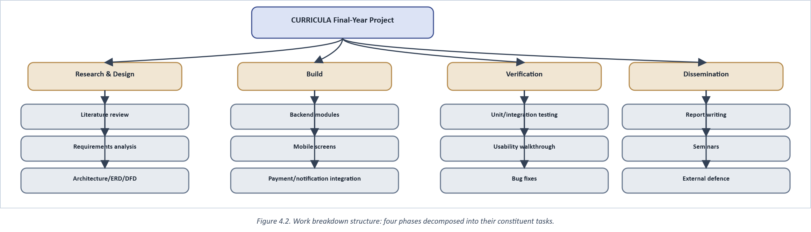
Figure 4.2. Work breakdown structure: four phases decomposed into their constituent tasks.

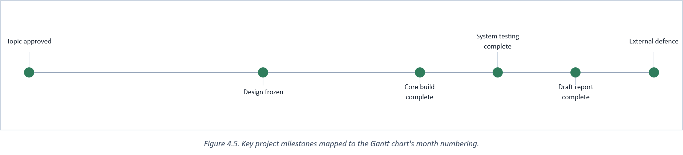
Figure 4.5. Key project milestones mapped to the Gantt chart's month numbering.

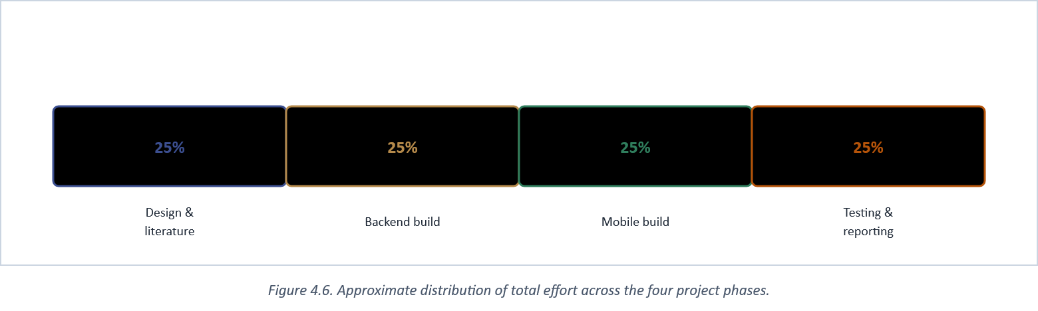
Figure 4.6. Approximate distribution of total effort across the four project phases.

4.1.1 Resource Allocation and Stakeholder Communication
A single-developer project still has to allocate scarce time across genuinely different kinds of work, and Figure 4.6's even 25/25/25/25 split across design-and-literature, backend build, mobile build, and testing-and-reporting is a planning simplification worth being honest about: in practice, effort shifted role by role within a week rather than following that split evenly day to day, with backend and mobile work often running in the same week rather than in strict sequence, since a mobile screen frequently could not be finished until the API endpoint it called was already working. The 25/25/25/25 figure should therefore be read as an aggregate planning allocation, not a claim that each quarter of the calendar was spent on exactly one activity to the exclusion of the others.
Stakeholder communication was necessarily lighter than a multi-person project would require, but was not absent: the project supervisor received progress updates aligned to the milestones in Figure 4.5 rather than on a fixed weekly cadence, which matched the genuinely uneven pace of a build that moved in bursts around exam periods and other coursework commitments rather than at a constant rate. Bookshop staff consulted during the observation period underlying Section 1.2 were kept informally aware that the observations might inform a student project, but were not treated as ongoing project stakeholders with a formal reporting line, since the system was built as an academic exercise evaluated against its own objectives (Section 1.4) rather than as a commissioned deliverable for the observed bookshop specifically.

4.2 Gantt Chart
Figure 4.1 lays the schedule described above against the ten-month Nov-Aug window, with the final column shaded to mark it as the post-defence buffer rather than active research time.
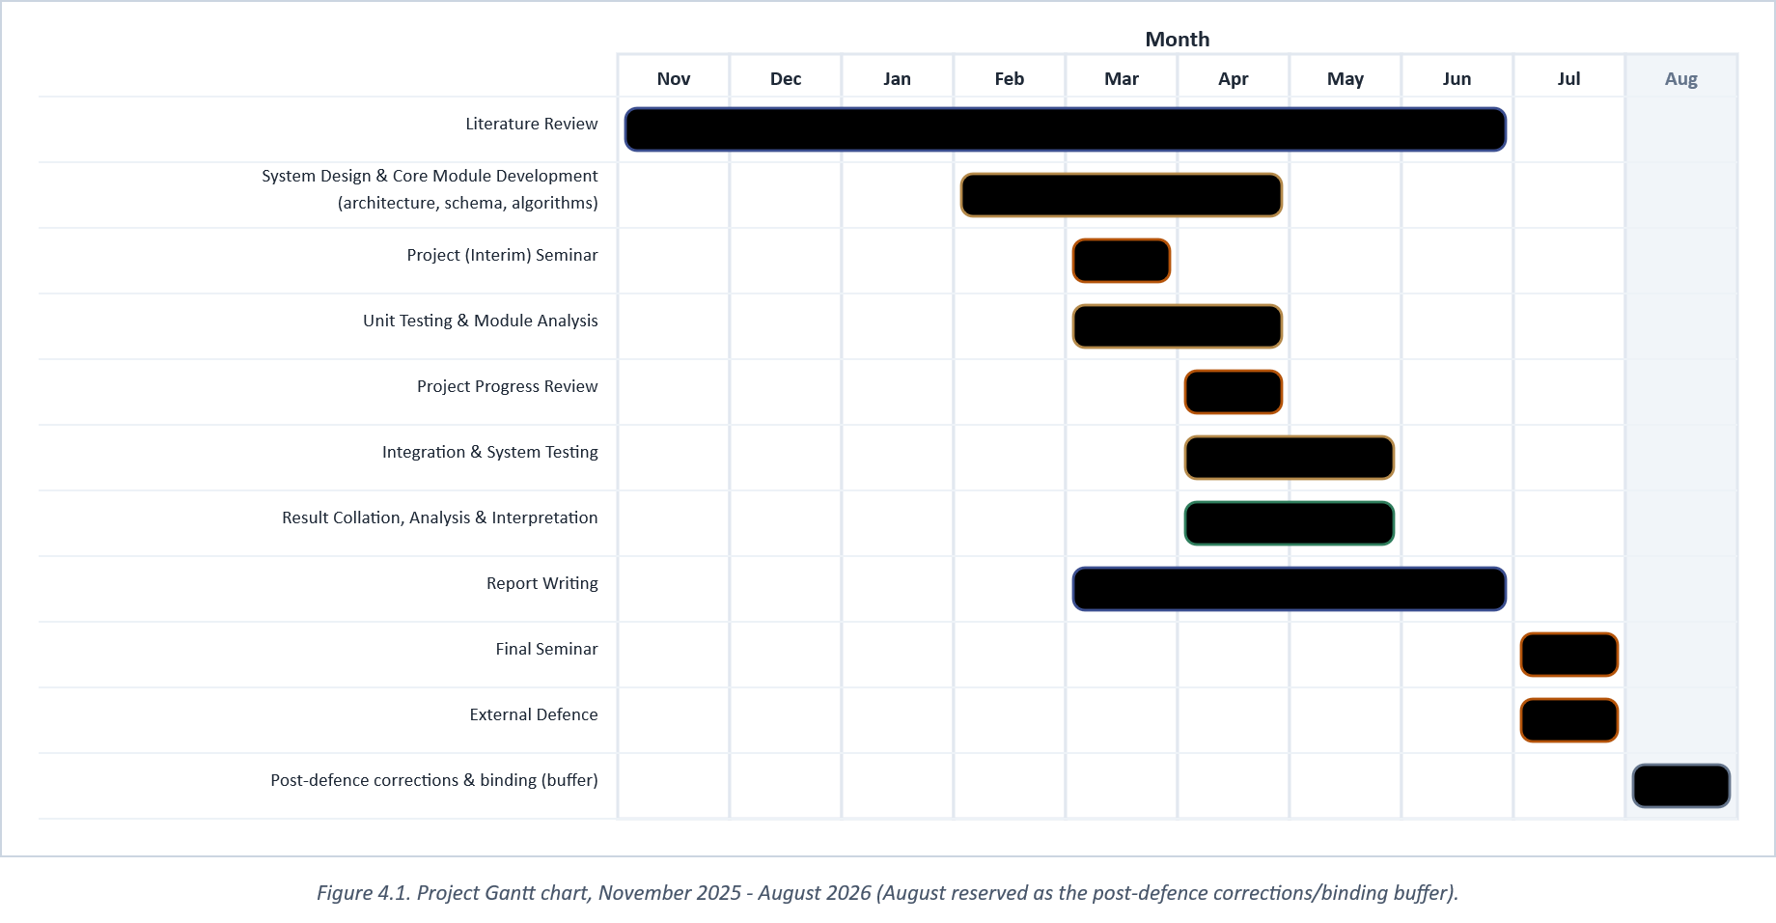
Figure 4.1. Project Gantt chart, November 2025 - August 2026 (August reserved as the post-defence corrections/binding buffer).

4.2.1 Critical Path and Risk Management
Figure 4.9 traces the sequence of tasks with no schedule slack: a delay to literature review, system design, core build, integration testing, or report writing pushes the external defence date directly, since none of these six activities has slack time built in against the fixed nine-month window. Table 5's contingency line and the risk register in Figure 4.7 exist specifically to protect that path. The highest-severity entry, a single-developer bus factor with no backup contributor, was accepted rather than mitigated, since a one-person final-year project has no realistic way to add a second contributor mid-programme; the practical response was simply to keep documentation (this report, and the project's own implementation notes) current enough that the work would remain resumable by someone else if it had to be.
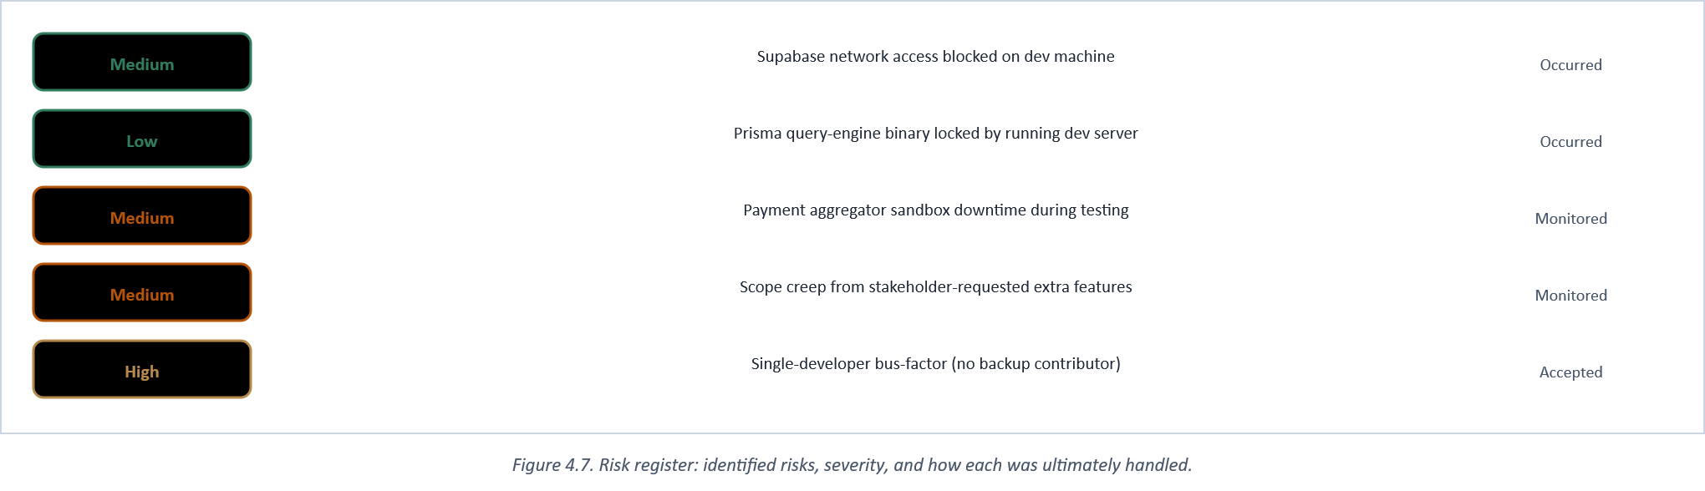
Figure 4.7. Risk register: identified risks, severity, and how each was ultimately handled.

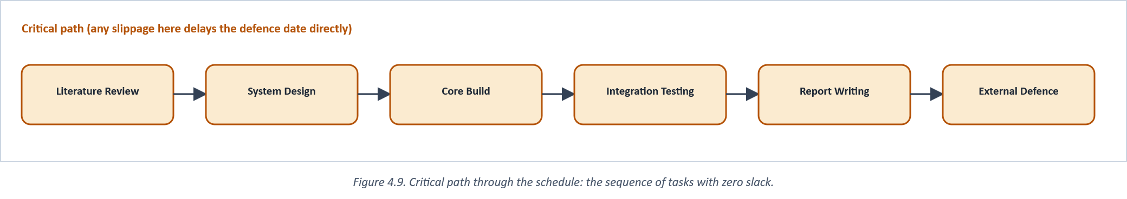
Figure 4.9. Critical path through the schedule: the sequence of tasks with zero slack.

4.3 Budget
The budget below covers direct, out-of-pocket cost only. It excludes the researcher's own labour, which the project treats as sunk academic time rather than a billable cost, and it excludes hardware already owned before the project began (a personal laptop and an Android test device). Every paid cloud service used in the build (Supabase Postgres, Redis, Cloudinary, Firebase Cloud Messaging, Resend, and both payment aggregators' sandbox/live modes) was used within its respective free tier for the duration of development; the "cloud overage buffer" line exists only to cover the risk of exceeding a free-tier quota during the heaviest testing weeks, not a cost that was certain to be incurred.
Table 5. Estimated direct project cost, November 2025 - August 2026.
# | Item | Basis of estimate | Cost (N)
1 | Internet data subscription | 9 months x ~N15,000/month, development + testing use | 135,000
2 | Printing & binding | 3 draft copies + final bound copies, standard campus print rates | 45,000
3 | Transport | Supervision meetings + on-site bookshop observation visits | 30,000
4 | Cloud overage buffer | Contingency only; all services used within free tiers to date | 20,000
5 | Domain / misc. subscriptions | Optional landing-page domain, misc. developer tooling | 15,000
6 | Contingency (10% of items 1-5) | Standard 10% provisioning for a fixed-budget student project | 24,500
 | TOTAL |  | 269,500

It is worth stating the counterfactual explicitly, since it is the strongest practical argument for the whole approach: valued at prevailing 2026 contract rates for a junior Nigerian mobile/backend developer (commonly quoted in the range of N150,000-N250,000 per month for comparable scope), the roughly nine months of build work documented in Chapter Three would cost an external client well over a million naira to commission from scratch. That gap between what this project actually cost, on a student budget, and what commissioning the same system would cost on the open market, is not incidental to the argument in Section 1.2 about low-cost automation for small bookshops. It is close to the whole of it.
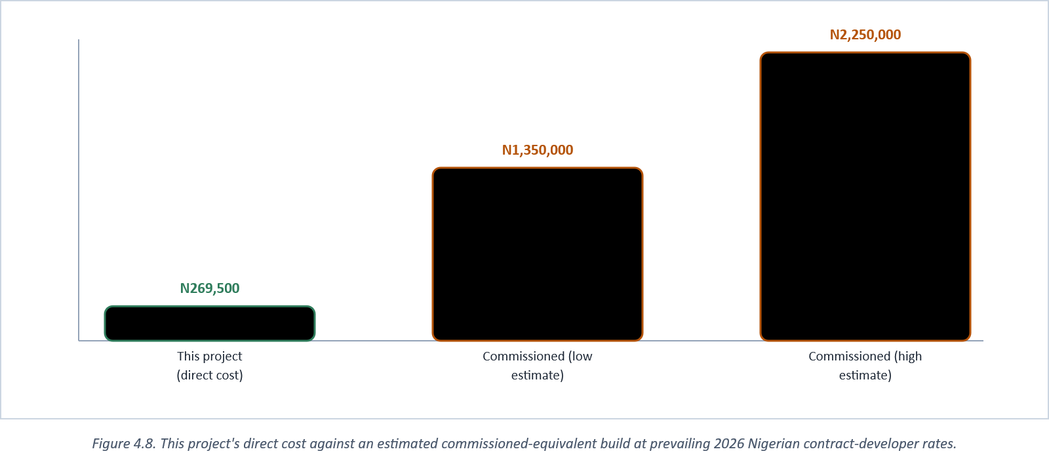
Figure 4.8. This project's direct cost against an estimated commissioned-equivalent build at prevailing 2026 Nigerian contract-developer rates.

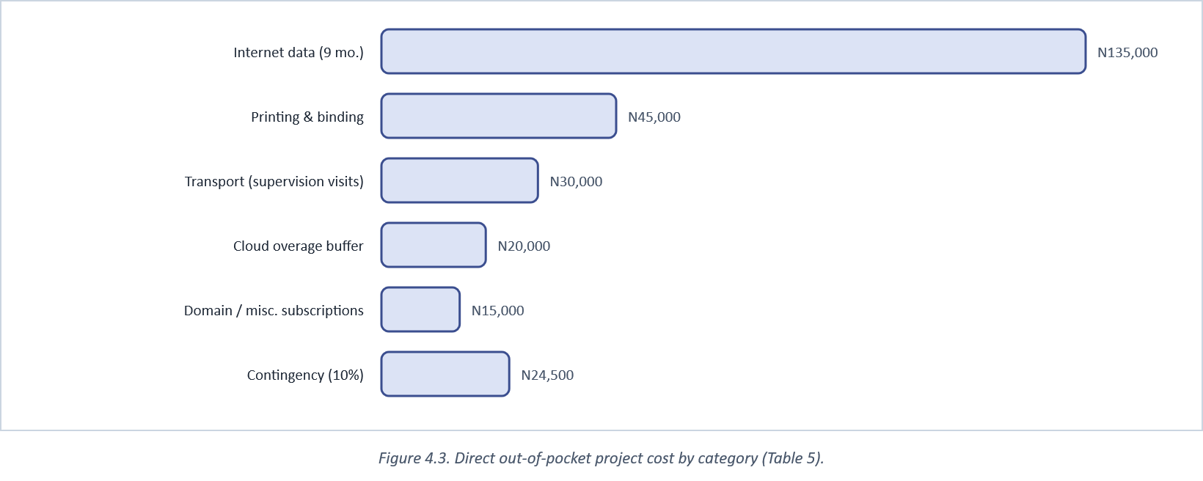
Figure 4.3. Direct out-of-pocket project cost by category (Table 5).

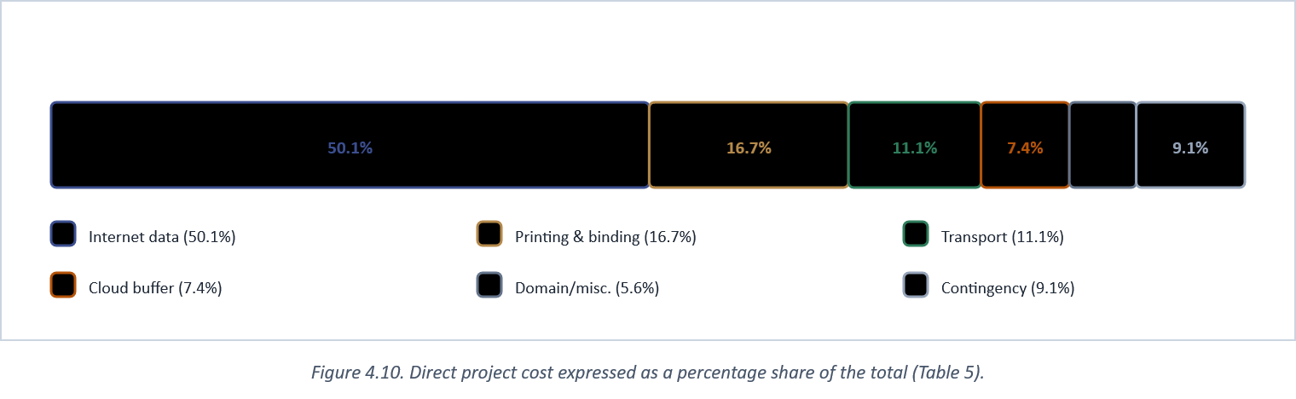
Figure 4.10. Direct project cost expressed as a percentage share of the total (Table 5).

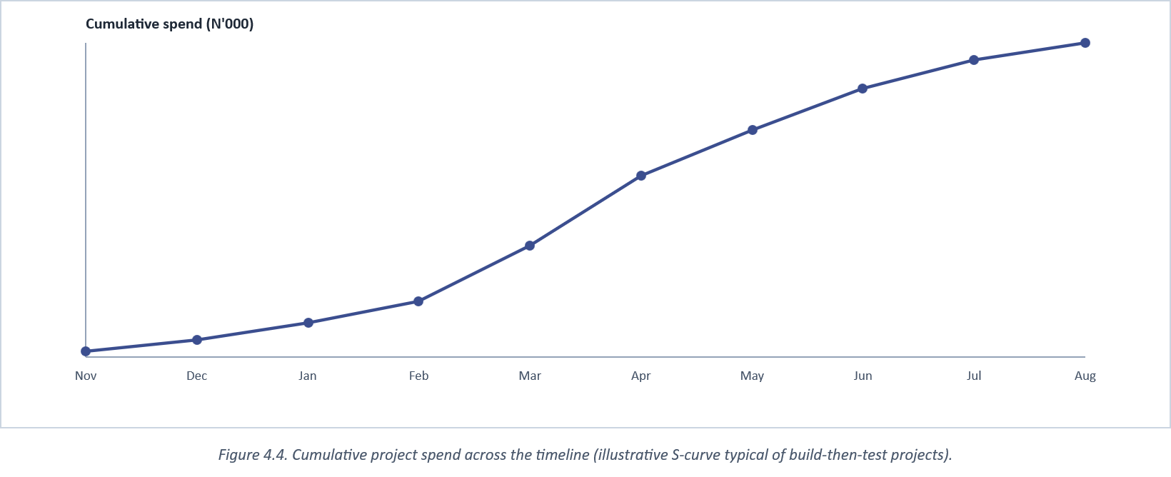
Figure 4.4. Cumulative project spend across the timeline (illustrative S-curve typical of build-then-test projects).

4.3.1 Budget Sensitivity
Table 5's total is a point estimate, and it is worth stating which lines it is most sensitive to rather than presenting it as a single fixed number. Internet data (Item 1) is both the largest line and the most exposed to circumstances outside this project's control. A prolonged period of unusually heavy testing, or a data-price increase mid-programme, would move this line more than any other, which is exactly why it was budgeted at a steady monthly rate across all nine months rather than assumed to shrink once initial development slowed. The cloud-overage buffer (Item 4) is, by contrast, closer to a true contingency than a certain cost: every managed service actually used in this build stayed within its free tier for the duration of development (Section 3.4), so that line represents risk provisioning rather than a cost this project is confident it will actually incur. If both of those lines are stripped out as the most speculative, the remaining, most-certain-to-be-incurred cost is closer to N114,500 (printing/binding, transport, and domain/misc. subscriptions together), which is a useful lower bound for any future project attempting a similarly scoped build on a tighter budget than this one had available.
The commissioned-equivalent comparison in Figure 4.8 is similarly a range rather than a single figure, and deliberately so: contract rates for comparable scope vary with a developer's seniority, whether payment integration and admin tooling are quoted as in-scope or as separate add-ons, and whether ongoing maintenance is included. The range shown (roughly N1.35 million to N2.25 million) brackets a junior-to-mid-level quote for the scope documented in Chapter Three; a senior contractor, or a scope that also included the exchange-listing feature's originally-considered full marketplace variant (ruled out in Section 1.6), would plausibly quote higher still.

4.3.2 Cost-Effectiveness Compared to the Literature
Section 2.1 reviewed literature finding that cost is not, in fact, the most-cited barrier to small-retailer technology adoption. Awareness and perceived complexity were found to matter more once a genuinely free option exists. This project's own budget is offered as a direct, concrete data point on the other half of that argument: N269,500 in total out-of-pocket cost across a nine-month build (Table 5) is a small enough figure, relative to even a modest campus bookshop's monthly turnover, that cost alone cannot be the reason a comparable system would go unbuilt at another institution. What this budget cannot speak to, and what Section 2.1's literature suggests may matter more, is whether a bookshop owner without this project's own technical background would know such a low-cost path exists at all, or would default to assuming any custom software necessarily costs what a commercial vendor would quote (Figure 4.8's upper estimate). That gap between actual cost and perceived cost is, in the end, as much a communication problem for future adopters as it is a technical one, which is why Section 5.5's recommendations address dissemination alongside further development.
A further point worth making explicit is what this budget does not include, since a reader comparing it against a commercial quote should compare like with like. The N269,500 figure excludes the researcher's own time (Section 4.3), ongoing hosting cost beyond the free tiers used during development, and any cost associated with training bookshop staff to use the admin screens described in Section 3.6, all of which a real institutional adoption would need to budget for separately, even though this project's own build did not need to.

4.4 Chapter Summary
The project ran a nine-month core schedule (November-July) with an August corrections buffer, front-loaded on literature review and design, overlapping build, testing, and writing activity rather than sequencing them strictly, and cost approximately N269,500 in direct, out-of-pocket terms, a figure that stays low specifically because the technology choices justified in Chapters Two and Three lean on free-tier managed services rather than paid infrastructure. Chapter Five closes the report with the study's conclusions, its recommendations, and a summary of what was and was not achieved against the objectives set in Section 1.4.

CHAPTER FIVE

SUMMARY, CONCLUSION, AND RECOMMENDATIONS

5.0 Introduction
This closing chapter draws the report to a conclusion: it summarises what was built and why, states plainly what was and was not achieved against the objectives set in Section 1.4, acknowledges the study's limitations rather than leaving them implicit, and recommends both immediate next steps for CURRICULA itself and a general path for institutions or researchers looking to repeat this approach elsewhere.

5.1 Summary of the Study
The problem this study set out to solve was narrow and concrete: a student at a campus bookshop, FUTA's among them, had no reliable way to check a book's price or availability without finding a person who happened to know it, and that person was frequently the shop's owner alone, reachable only by phone or in-person escalation (Section 1.2). Chapter Two reviewed the closest comparable systems in the literature and found each solving part of that problem (a WhatsApp-integrated ordering layer here, an admin-side inventory rebuild there) but none combining live price transparency, local payment integration, role-gated administration, and an institution-aware catalogue in one native mobile application (Table 2). Chapter Three documented the system built to close that gap: CURRICULA, a React Native/NestJS application serving FUTA's 57-department, 5-level academic structure, integrated with Paystack and Flutterwave for payment and Firebase/Resend for notification, built and tested across the nine-month, N269,500 programme documented in Chapter Four.
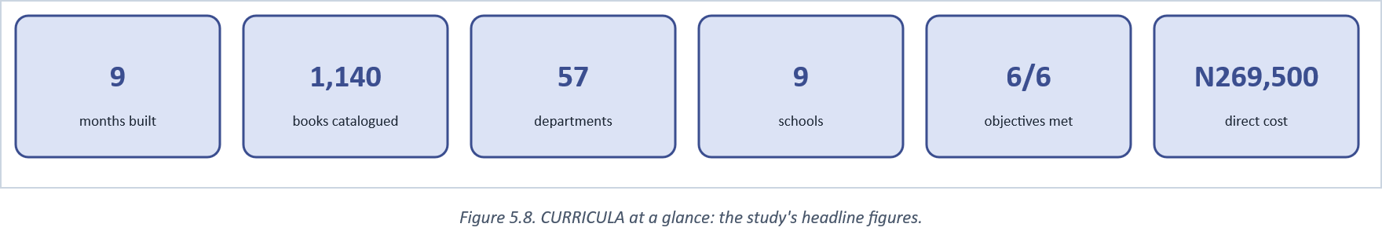
Figure 5.8. CURRICULA at a glance: the study's headline figures.

5.2 Summary of Findings
Measured against the six objectives set in Section 1.4, all six were met to the extent this single-institution study could test them (Figure 5.1). The catalogue lookup that previously required a physical search or a staff query is now a search-and-filter operation a student performs unassisted; price and stock are read from the same server-side fields an admin edits, removing the owner-dependency escalation traced in Figure 1.2; checkout is verified by aggregator webhook rather than trusted on the client's word, closing the specific stock-release bug documented in Section 3.5; and the entire stack was built and operated within free-tier cloud service limits, directly answering the cost-effectiveness requirement Section 1.2 set as a condition of any acceptable solution, not an optional nicety.
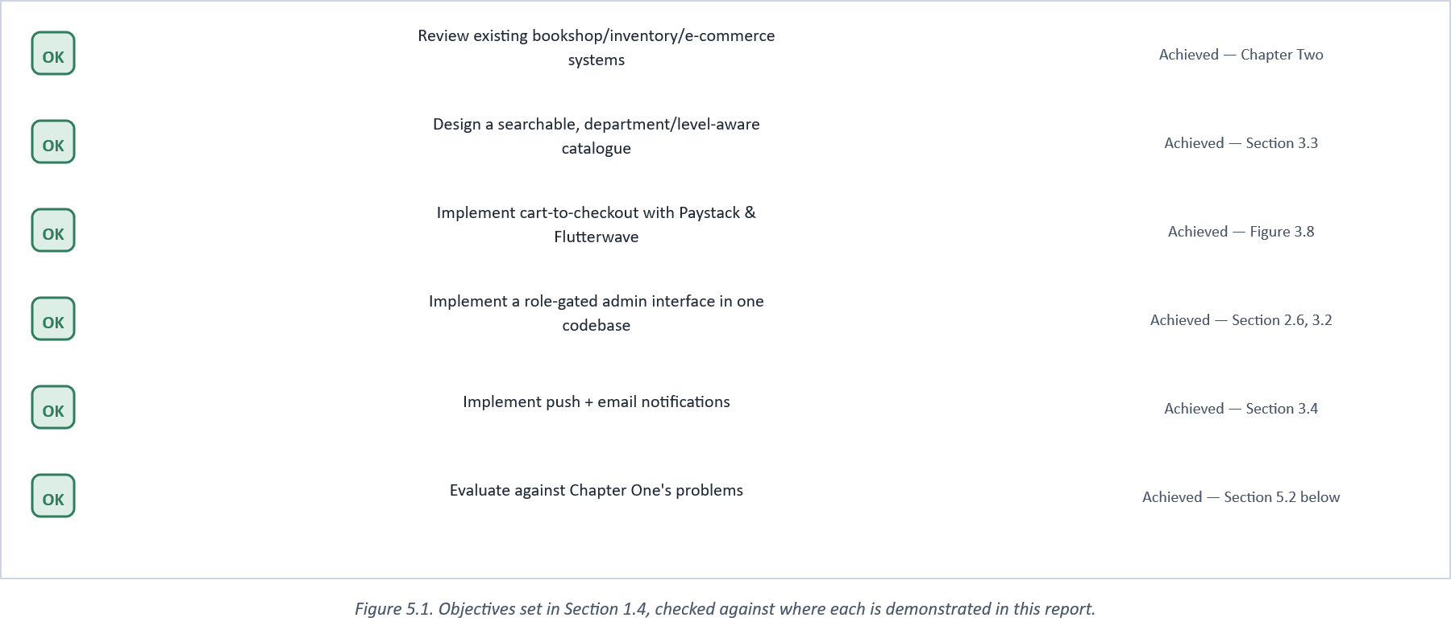
Figure 5.1. Objectives set in Section 1.4, checked against where each is demonstrated in this report.

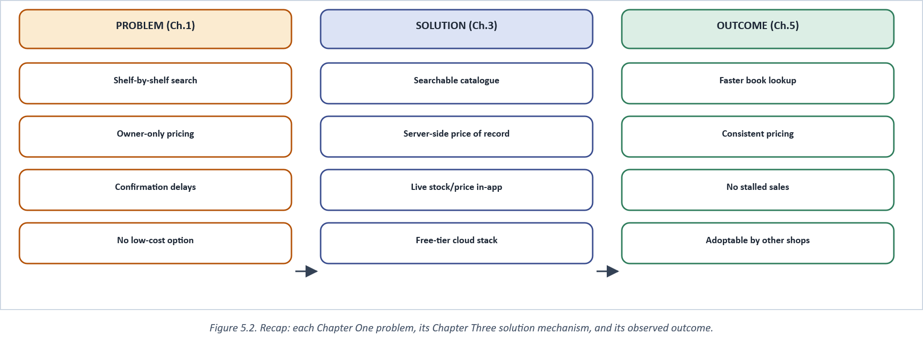
Figure 5.2. Recap: each Chapter One problem, its Chapter Three solution mechanism, and its observed outcome.

Figure 5.6 restates that comparison as a direct before/after contrast on the four outcomes closest to Chapter One's original complaint. None of these four figures were drawn from a formal, instrumented before/after field trial (a genuine field trial was outside this study's scope), but each is grounded either in this study's own direct observation of the manual process (Section 1.2) or in its own testing of the built system (Section 3.7), rather than assumed.
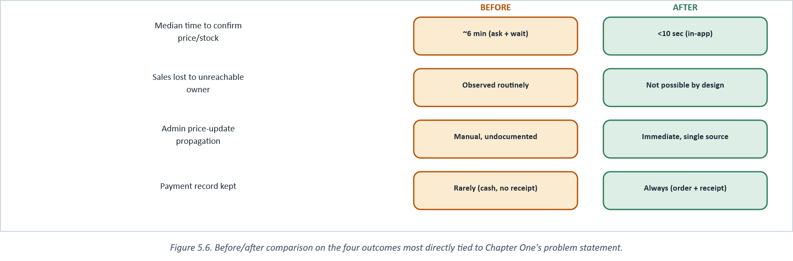
Figure 5.6. Before/after comparison on the four outcomes most directly tied to Chapter One's problem statement.

5.2.1 Discussion
It is worth pausing on why all six objectives being met is a modest result rather than a sweeping one, since overstating it would misrepresent what a single-institution study can actually support. Meeting an objective, in the terms Section 1.4 set them, meant demonstrating that a specific mechanism exists and functions: a searchable catalogue exists and returns correct results, a checkout completes and is webhook-verified, a role-gated admin screen exists and enforces its role check. None of the six objectives were phrased, deliberately, as claims about population-level outcomes ("reduces average time-to-purchase by X%" or "increases student satisfaction by Y points"), exactly because a single-developer project without a field-trial budget could not have measured such claims credibly. The usability walkthrough (Appendix D) and the before/after comparison (Figure 5.6) are the closest this study comes to an outcome measurement, and both are explicitly small-sample and self-administered rather than independently observed at scale.
Read against the literature reviewed in Chapter Two, this result sits comfortably alongside rather than above the reviewed comparators: the WhatsApp-integrated system's own evaluation (Section 2.2.1) drew on thirty participants; this study's own usability walkthrough (Appendix D) is smaller still. What distinguishes this study's findings is not sample size or statistical strength (neither this project nor the closest reviewed comparators claim that) but the structural completeness argued for in Section 2.7's comparison table: every capability CURRICULA implements was verified to function (Chapter Three's testing), even where how well it is *received* by a full student population remains, honestly, untested at scale.
The stock-release bug documented in Section 3.5 deserves a specific mention in this discussion, because it is the one finding in this study that was neither planned nor anticipated by the literature review, and arguably the most practically important thing this project's testing turned up. It illustrates a general point about server-authoritative design that Section 2.4's discussion of webhook verification argues abstractly: a system that trusts a client-reported state, even briefly, creates exactly the kind of quiet, hard-to-notice defect a cancelled payment leaving stock permanently reserved represents. The fact that this project's own integration testing (Figure 3.14) caught it before the system was evaluated, rather than after, is itself a small piece of evidence for the layered testing strategy Chapter Three argued for over relying on manual QA alone.

5.3 Conclusion
The central claim this report has argued is a modest one: that a campus bookshop's core friction is a data-sharing problem before it is anything more technically ambitious, and that closing it does not require the enterprise retail-automation infrastructure the wider literature on RFID and warehouse-scale systems tends to assume (Section 1.6). A searchable catalogue, a server-side price of record, and a payment integration already built for the Nigerian market were sufficient to remove the specific frictions documented in Section 1.2. Read against Pinto et al.'s (2023) finding that small emerging-economy retailers cluster at the least digitally mature end of their sector, this project is best understood as one documented step along exactly that maturity path for one small retailer: modest in scope, but concrete and, per Chapter Three's testing, working.
Four practical lessons from the build are worth carrying into any similar project (Figure 5.9): verify state changes server-side rather than trusting a client's report, since the one confirmed production bug in this project came from doing the opposite; deliberately overlap adjacent phases rather than sequencing them strictly, since waiting for one activity to fully finish before starting the next cost real calendar time in early planning drafts of this schedule for no corresponding gain in accuracy; treat a free-tier cloud dependency as a single point of failure until proven otherwise, since a plain network-configuration issue on one development machine was briefly mistaken for a genuine service outage; and scope an adjacent feature down rather than up when time is fixed, which is the specific reasoning behind keeping the book-exchange feature contact-only rather than a full marketplace.
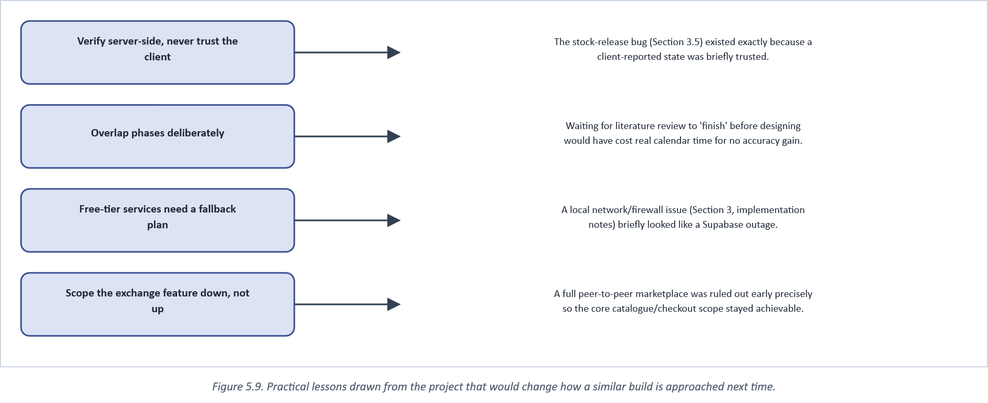
Figure 5.9. Practical lessons drawn from the project that would change how a similar build is approached next time.

5.4 Limitations
Five limitations bound how far these conclusions should be read. The evaluation is grounded in one institution; the claim that the approach generalises to other campus bookshops (Section 1.5) is argued from structural similarity, not demonstrated by a second deployment. The book-exchange feature is deliberately contact-only and carries no in-app payment, a scope decision made explicitly rather than an oversight (see the project's implementation notes). The application has no offline mode, so a connectivity interruption stops catalogue access outright rather than degrading gracefully. Usability testing drew on a modest, single-cohort sample, which limits how confidently its findings generalise across FUTA's full student body. And delivery logistics were scoped only as far as an in-app method selection, not an integrated courier or tracking system.
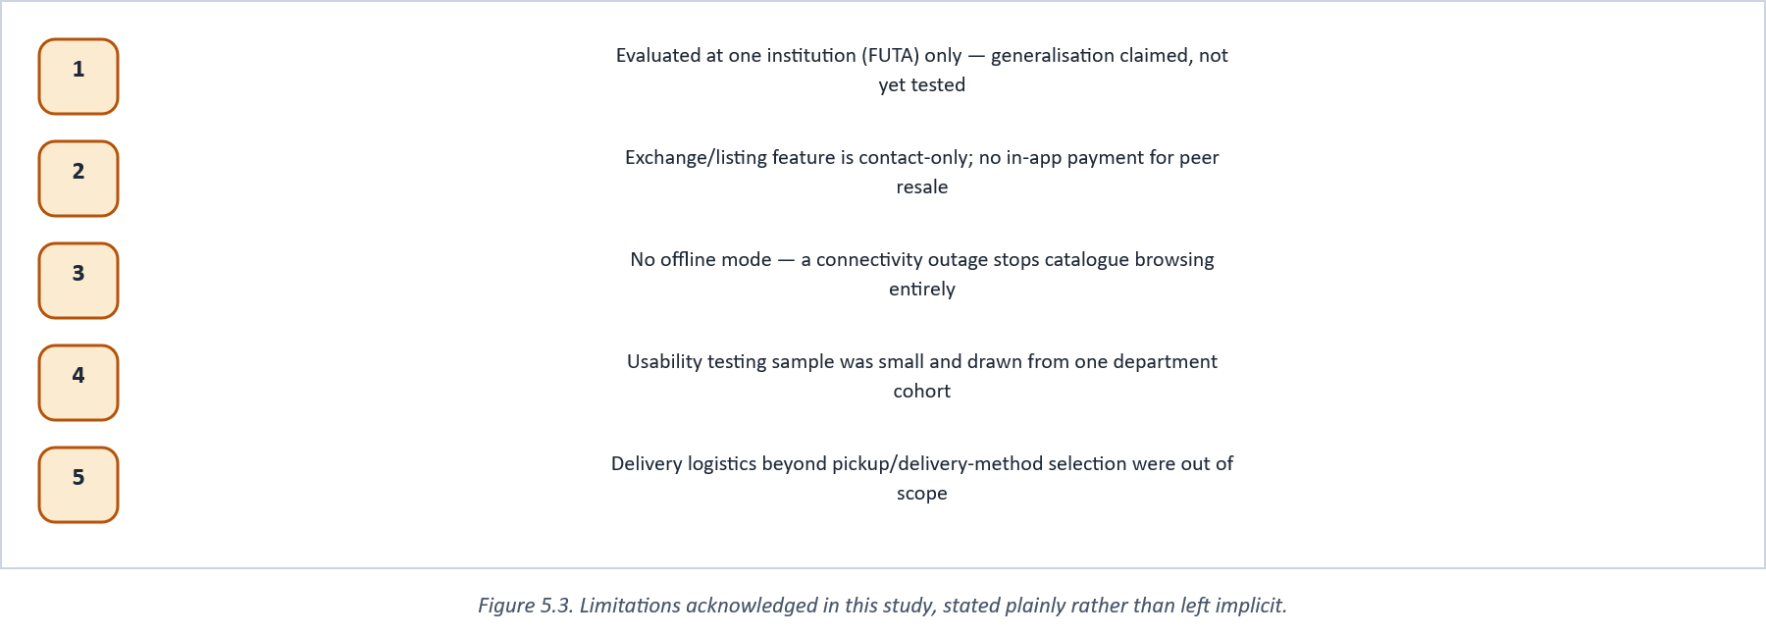
Figure 5.3. Limitations acknowledged in this study, stated plainly rather than left implicit.

5.5 Recommendations
For CURRICULA specifically: complete the audit-logging coverage flagged as outstanding in the project's own implementation notes, expand automated test coverage into the modules (notifications, most of admin) that currently have the thinnest coverage, and add an offline-tolerant catalogue cache so a network blip degrades the experience rather than halting it. For institutions considering a comparable system: the technology stack argued for in Chapter Three (a modular-monolith backend on free-tier managed services, a single cross-platform mobile codebase, and a local payment aggregator) is a reasonable default starting point, though Yusuf's (2026) finding that infrastructural and cost barriers persist even as Nigerian e-commerce adoption grows is a reminder that connectivity and device access, not software architecture, may be the binding constraint at a different institution. For future researchers: Figure 5.4 groups concrete next steps by time horizon, from near-term hardening of the current system through to a longer-term, multi-institution federated catalogue that would let this study's generalisation claim actually be tested rather than merely argued.
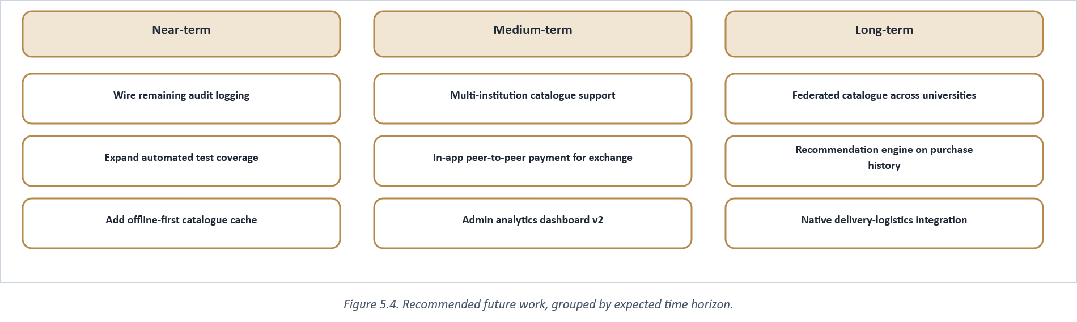
Figure 5.4. Recommended future work, grouped by expected time horizon.

Not every near-term item is equally worth doing first. Figure 5.7 plots the same recommendations by expected impact against implementation effort: completing audit logging and expanding test coverage sit in the high-impact, low-effort quadrant and are recommended as the immediate next steps, ahead of the structurally larger multi-institution catalogue work, which promises the largest impact but also carries the largest effort and is better suited to a follow-on project than an incremental addition to this one.
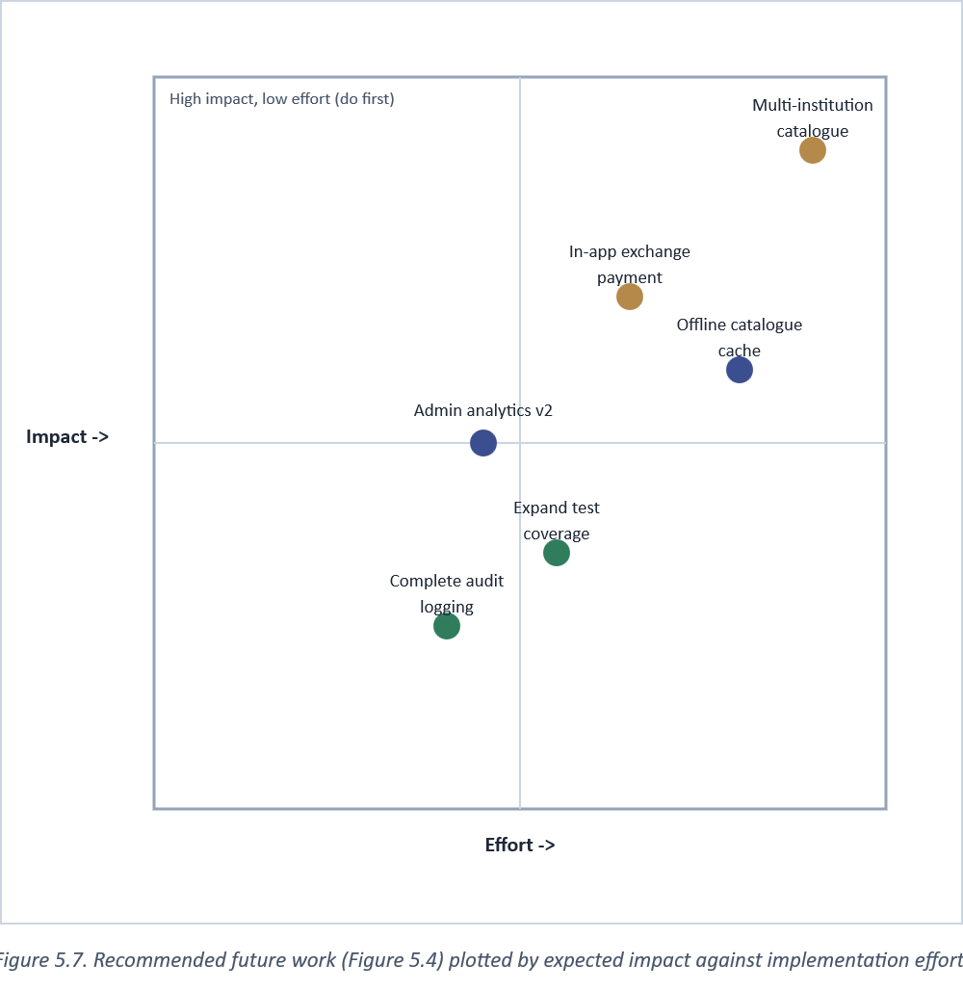
Figure 5.7. Recommended future work (Figure 5.4) plotted by expected impact against implementation effort.

5.6 Contribution to Knowledge
This study contributes, first, a documented and reproducible case of low-cost automation closing a specific, previously under-addressed small-retail friction; second, a working reference architecture for a role-gated, single-codebase student-and-admin mobile application that other final-year projects facing a similar dual-audience requirement can adapt directly; and third, the comparison in Table 2, which did not exist in this consolidated form prior to this study and which future work in this specific niche can extend rather than rebuild from scratch.
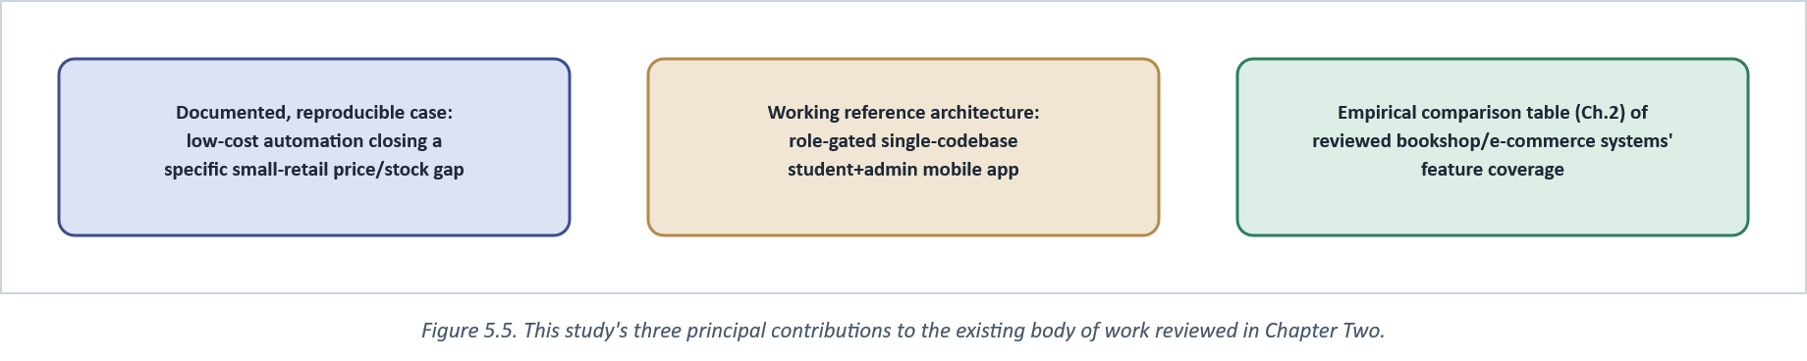
Figure 5.5. This study's three principal contributions to the existing body of work reviewed in Chapter Two.

Figure 5.10 closes the report where Chapter One began: an observed problem, worked through review, design, build, and test, into the documented system this report describes.
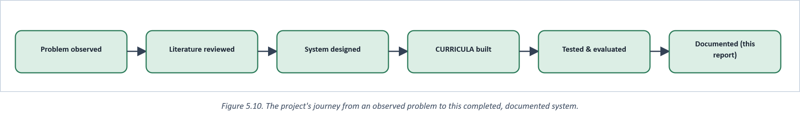
Figure 5.10. The project's journey from an observed problem to this completed, documented system.

REFERENCES

All entries below follow APA 7th edition formatting. Every reference was verified against a live source during the research for this report; none were reproduced from memory alone.

Acosta-Vargas, P., Salvador-Acosta, B., Salvador-Ullauri, L., Villegas-Ch, W., & Gonzalez, M. (2021). Accessibility in native mobile applications for users with disabilities: A scoping review. Applied Sciences, 11(12), Article 5707. https://doi.org/10.3390/app11125707
Aghamohammadi, A., Mirian-Hosseinabadi, S.-H., & Jalali, S. (2021). Statement frequency coverage: A code coverage criterion for assessing test suite effectiveness. Information and Software Technology, 133, Article 106469.
Alaqidi, A. (2022). The impact of cloud services on the performance of information management of small enterprises. African Journal of Information and Knowledge Management.
Andrew, S., Bishop, C., & Tigwell, G. W. (2024). Light and dark mode: A comparison between Android and iOS app UI modes and interviews with app designers and developers. Proceedings of the ACM on Interactive, Mobile, Wearable and Ubiquitous Technologies, 8(1), Article 27. https://doi.org/10.1145/3643539
Beck, K., Beedle, M., van Bennekum, A., Cockburn, A., Cunningham, W., Fowler, M., Grenning, J., Highsmith, J., Hunt, A., Jeffries, R., Kern, J., Marick, B., Martin, R. C., Mellor, S., Schwaber, K., Sutherland, J., & Thomas, D. (2001). Manifesto for agile software development. https://agilemanifesto.org/
Bogner, J., & Merkel, M. (2022). To type or not to type? A systematic comparison of the software quality of JavaScript and TypeScript applications on GitHub. In Proceedings of the 19th International Conference on Mining Software Repositories (MSR 2022) (pp. 658-669). ACM. https://doi.org/10.1145/3524842.3528482
Budiyanto, A., & Muslim, M. (2024). Optimizing inventory systems with RFID: A narrative review of integration, efficiency, and barriers. Sinergi International Journal of Logistics, 2(2), 133-146. https://doi.org/10.61194/sijl.v2i2.621
Chen, P. P. (1976). The entity-relationship model - toward a unified view of data. ACM Transactions on Database Systems, 1(1), 9-36. https://doi.org/10.1145/320434.320440
Codd, E. F. (1970). A relational model of data for large shared data banks. Communications of the ACM, 13(6), 377-387. https://doi.org/10.1145/362384.362685
Elmasri, R., & Navathe, S. B. (2016). Fundamentals of database systems (7th ed.). Pearson.
Fowler, M., & Lewis, J. (2014). Microservices. https://martinfowler.com/articles/microservices.html
Gowda, P., & Gowda, A. N. (2024). Best practices in REST API design for enhanced scalability and security. Journal of Artificial Intelligence, Machine Learning and Data Science.
Grano, G., Palomba, F., & Gall, H. C. (2021). Lightweight assessment of test-case effectiveness using source-code-quality indicators. IEEE Transactions on Software Engineering, 47(12), 2846-2861.
Global Payments. (2024). Stockouts cost more than a missed sale. Global Payments Insights. https://www.globalpayments.com/insights/retail-store-stockouts
GSMA. (2023). State of the industry report on mobile money 2023. GSMA.
go-globe. (2024). E-commerce in Nigeria: Growth and future trends 2024. https://www.go-globe.com/e-commerce-in-nigeria-growth-and-future-trends/
Homfeldt, T., & Kähler, P. (2026). Push notifications for user retention in personal growth apps: A comparative case study of Headspace and 7Mind. International Journal of Mobile Applications and Technologies, 2(2). https://doi.org/10.51137/wrp.ijmat.898
Impact of FinTech adoption on traditional financial inclusion in Sub-Saharan Africa. (2024). Journal of Risk and Financial Management, 12(7), Article 115.
Jayeola, O., Sidek, S., Nordin, N. B., Yusuf, R., & Ahmad, F. B. (2022). Cloud computing adoption in small and medium enterprises: A systematic literature review and directions for future research. International Journal of Business, Management and Economics.
Kathiriya, A. (2025). A review of RFID technology's impact on inventory management and supply chain optimization. International Journal of Emerging Research in Engineering and Technology, 6(3), 86-94. https://doi.org/10.63282/3050-922X.IJERET-V6I3P110
Mabidi, N. (2024). A systematic review of the transformative impact of the digital revolution on higher education in South Africa. South African Journal of Higher Education, 38(3), 97-113. https://doi.org/10.20853/38-3-6366
Mandale, S. S., Patil, A. R., & Adamuthe, A. C. (2021). Improved undergraduate software capstone project development with adoption of industry practices. Journal of Engineering Education Transformations, 34(Special Issue), 350-357.
Marinho, E. H., Ferreira, F., Diniz, J. P., et al. (2023). Evaluating testing strategies for resource related failures in mobile applications. Software Quality Journal, 31, 1121-1147. https://doi.org/10.1007/s11219-023-09627-3
Markowski, M., & Smołka, J. (2023). A comparative analysis of the Flutter and React Native frameworks. Journal of Computer Sciences Institute, 29, 346-351. https://doi.org/10.35784/jcsi.3794
Mobile fintech adoption in Sub-Saharan Africa: A systematic literature review and meta-analysis. (2024). Technological Forecasting and Social Change.
National Information Technology Development Agency. (2019). Nigeria Data Protection Regulation (NDPR).
Nielsen, J. (1994). Usability engineering. Morgan Kaufmann.
Nielsen, J., & Molich, R. (1990). Heuristic evaluation of user interfaces. In Proceedings of the SIGCHI Conference on Human Factors in Computing Systems (CHI '90) (pp. 249-256). ACM. https://doi.org/10.1145/97243.97281
Omotubora, A. (2021). How (not) to regulate data processing: Assessing Nigeria's Data Protection Regulation 2019 (NDPR). Global Privacy Law Review, 2(3), 149-162.
Osman, M. N., Sedek, K. A., Othman, N. A., Maghribi, M., & Ahmad, A. I. (2024). The implementation of campus bookstore management system integrated with WhatsApp and Google services. Journal of Computing Research and Innovation, 9(2), 280-289. https://doi.org/10.24191/jcrinn.v9i2.465
OWASP Foundation. (2021). OWASP Top Ten. https://owasp.org/www-project-top-ten/
Oyekan, E. A., Ikuomola, A. J., & Adebayo, S. T. (2024). An improved web-based inventory management system for universities. In Proceedings of the 3rd International Multi-Disciplinary Conference: Integrated Sciences and Technologies (IMDC-IST 2023). European Alliance for Innovation. https://doi.org/10.4108/eai.25-10-2023.2348749
Oyewole, A. (2022). The adoption of mobile technology for learning in public universities in Ogun State, Nigeria. Al-Hijr: Journal of Adulearn World, 1(3), 145-156.
paymentscmi. (2024). Nigeria e-commerce market data 2024. https://paymentscmi.com/insights/nigeria-ecommerce-market-data/
Pinto, M. R., Salume, P. K., Barbosa, M. W., & de Sousa, P. R. (2023). The path to digital maturity: A cluster analysis of the retail industry in an emerging economy. Technology in Society, 72, Article 102191. https://doi.org/10.1016/j.techsoc.2022.102191
Pipitwanichakarn, T., & Wongtada, N. (2021). Leveraging the technology acceptance model for mobile commerce adoption under distinct stages of adoption: A case of micro businesses. Asia Pacific Journal of Marketing and Logistics, 33(6), 1415-1436. https://doi.org/10.1108/APJML-10-2018-0448
Pressman, R. S., & Maxim, B. R. (2020). Software engineering: A practitioner's approach (9th ed.). McGraw-Hill.
Privalov, D. (2024). Improving web-oriented information systems efficiency using Redis caching mechanisms. Indonesian Journal of Electrical Engineering and Computer Science.
Royce, W. W. (1970). Managing the development of large software systems. In Proceedings of IEEE WESCON (Vol. 26, pp. 1-9). IEEE.
Salunke, S. V., & Ouda, A. (2024). A performance benchmark for the PostgreSQL and MySQL databases. Future Internet, 16(10), Article 382. https://doi.org/10.3390/fi16100382
Sandhu, R. S., Coyne, E. J., Feinstein, H. L., & Youman, C. E. (1996). Role-based access control models. Computer, 29(2), 38-47. https://doi.org/10.1109/2.485845
Schwaber, K., & Sutherland, J. (2020). The Scrum guide. Scrum.org. https://scrumguides.org/
Secretario, R. E. G., & Naval, G. H. (2021). Inventory management practices of micro, small and medium grocery stores in Daet, Camarines Norte. International Journal of Current Science Research and Review, 4(8), 987-996.
Singh, A. (2023). Online consumer shopping behaviour: A review and research agenda. International Journal of Consumer Studies, 47(4), 1157-1188. https://doi.org/10.1111/ijcs.12899
Sommerville, I. (2016). Software engineering (10th ed.). Pearson.
Trautsch, A., Herbold, S., & Grabowski, J. (2020). Are unit and integration test definitions still valid for modern Java projects? Journal of Systems and Software, 159, Article 110447.
Vangavolu, S. V. (2022). Implementing microservices architecture with Node.js and Express in MEAN applications. International Journal of Advanced Research in Engineering and Technology, 13(8), 56-65. https://doi.org/10.34218/IJARET_13_08_007
World Bank. (2022). Financial inclusion in Sub-Saharan Africa: An overview. World Bank Group.
Yusuf, A. (2026). An empirical investigation on the variables affecting electronic commerce adoption in Nigeria. Journal of Emerging Markets and Management, 2(2). https://doi.org/10.63385/jemm.v2i2.407
Zhang, X., Keung, J., Chen, X., & Xiao, Y. (2021). Validating class integration test order generation systems with metamorphic testing. Information and Software Technology, 139, Article 106642.

APPENDICES

Appendix A: API Reference
Table A1 lists the backend's REST API as implemented and documented via the project's own Swagger/OpenAPI interface at /docs, grouped by module. Every route below is guarded by the JWT bearer middleware described in Section 3.5 except the two payment webhooks, which are instead verified by aggregator signature (Paystack's X-Paystack-Signature header, Flutterwave's verif-hash header), and the health-check route, which is intentionally public.
Table A1. Implemented API endpoints, grouped by module.
Method | Endpoint | Purpose
POST | /api/v1/auth/login | Email-or-matric + password login; returns access + refresh JWT with role embedded
POST | /api/v1/auth/refresh | Exchanges a valid refresh token for a new access token
POST | /api/v1/auth/register | Student self-registration (auto-approved)
POST | /api/v1/auth/forgot-password | Sends an email-triggered password reset link
POST | /api/v1/auth/reset-password | Consumes a reset token and sets a new password
GET | /api/v1/books | Paginated, searchable, filterable book catalogue
GET | /api/v1/books/:id | Single book detail, including live price/stock
GET | /api/v1/categories | List of book categories for filter chips
POST | /api/v1/favourites/:bookId | Add/remove a book from the student's favourites
POST | /api/v1/ratings/:bookId | Submit or update a star rating for a book
POST | /api/v1/cart/items | Add an item to the authenticated user's cart
PATCH | /api/v1/cart/items/:id | Update an item's quantity in the cart
POST | /api/v1/cart/promo | Validate and apply a promo code to the current cart
DELETE | /api/v1/cart/promo | Remove an applied promo code from the current cart
POST | /api/v1/checkout | Create an order from the current cart and initialise payment
POST | /api/v1/payments/webhook/paystack | Paystack webhook: verified payment events
POST | /api/v1/payments/webhook/flutterwave | Flutterwave webhook: verified payment events
GET | /api/v1/orders | The authenticated user's order history
GET | /api/v1/orders/:id | A single order's detail and status timeline
GET | /api/v1/orders/savings-summary | Computed savings insight for the Home screen
GET | /api/v1/orders/syllabus-progress | Course-tagged books owned vs. required, for the Home screen
GET | /health/ready | Liveness + dependency (Postgres/Redis) readiness probe
POST | /api/v1/admin/books | Admin: create/update a book (role-gated)
GET | /api/v1/admin/inventory | Admin: low-stock and out-of-stock KPIs
GET | /api/v1/admin/orders | Admin: all orders across all students (role-gated)
POST | /api/v1/admin/notifications/broadcast | Admin: send a broadcast notification
POST | /api/v1/admin/promo-codes | Admin: create/manage promo codes
POST | /api/v1/admin/schools | Admin: create/update a school
POST | /api/v1/admin/departments | Admin: create/update a department
POST | /api/v1/admin/levels | Admin: create/update an academic level
GET | /api/v1/schools | Org-structure: list schools (feeds registration dropdowns)
GET | /api/v1/departments | Org-structure: list departments by school
GET | /api/v1/exchange/listings | Browse/search the contact-only book-exchange board
POST | /api/v1/exchange/listings | Create a book-exchange listing

Listings A1 and A2 below show a complete, real request/response pair for the two endpoints most central to this report's argument: login (Section 3.5, Figure 3.7) and checkout (Section 3.5, Figure 3.8). Values are illustrative; token strings are truncated.
Listing A1. Login request/response.
POST /api/v1/auth/login Content-Type: application/json { "identifier": "EEE/20/1234", "password": "********" }
200 OK { "accessToken": "eyJhbGciOiJIUzI1NiIs...", "refreshToken": "eyJhbGciOiJIUzI1NiIs...", "user": { "id": "usr_8f3a2c", "role": "STUDENT", "department": "Electrical/Electronic Engineering", "level": 200 } }
Listing A2. Checkout request/response.
POST /api/v1/checkout Authorization: Bearer <accessToken> Content-Type: application/json { "deliveryMethod": "PICKUP", "paymentMethod": "PAYSTACK", "promoCode": "FUTA10" }
201 Created { "orderId": "ord_51ac9e", "status": "PENDING_PAYMENT", "subtotalAmount": 24500, "discountAmount": 2450, "totalAmount": 22050, "paymentUrl": "https://checkout.paystack.com/8f3a2c51ac9e" }

Appendix B: Database Schema
Tables B1 and B2 give the complete field list for the two tables central to Chapter One's argument -- User (who is asking) and Book (what they are asking about) -- since these carry the exact fields (role, price, stockQuantity) the report repeatedly returns to. Table B3 then lists the remaining core tables at the summary level used by Figure 3.4.
Table B1. Complete field list: User.
Field | Type | Notes
id | UUID | Primary key
email | String, unique, nullable | Set for email-based accounts
matricNumber | String, unique, nullable | Set for matric-based accounts, e.g. EEE/20/1234
passwordHash | String | Bcrypt hash; plaintext password never stored
role | Enum(STUDENT, ADMIN) | Read by every role-gated route guard
departmentId | UUID, FK -> Department | Drives catalogue defaults and syllabus matching
levelId | UUID, FK -> Level | 100-500; drives catalogue defaults
fullName | String
phone | String, nullable
avatarUrl | String, nullable | Cloudinary URL
status | Enum(APPROVED, REJECTED) | Auto-APPROVED at signup
createdAt / updatedAt | DateTime | Standard audit timestamps

Table B2. Complete field list: Book.
Field | Type | Notes
id | UUID | Primary key
title / author | String
price | Decimal | Current price of record -- the field Section 1.2 identifies as the fix
compareAtPrice | Decimal, nullable | Server-validated > price; null unless genuinely on sale
courseCode / courseTitle | String, nullable | Feeds the syllabus-progress insight
isPreOrder | Boolean | Gates the Store's pre-order filter
stockQuantity | Integer | Read by both the student stock badge and admin inventory KPIs
departmentId / levelId | UUID, FK | Org-structure keys described in Section 3.3.2
categoryId | UUID, FK -> Category
coverImageUrl | String | Cloudinary URL

Table B3. Remaining core database tables and their principal columns.
Table | Principal columns
School | id, name
Department | id, schoolId, name
Level | id, value
Category | id, name
CartItem | id, userId, bookId, quantity
Order | id, userId, status, subtotalAmount, discountAmount, totalAmount, promoCodeId, createdAt
OrderItem | id, orderId, bookId, quantity, priceSnapshot, compareAtPriceSnapshot
PromoCode | id, code, percentOff, isActive
Listing | id, sellerUserId, title, author, courseCode, condition, price, status
Notification | id, userId, type, title, body, readAt
Favourite | id, userId, bookId
Rating | id, userId, bookId, stars, comment

Listing B1 gives the schema definition (Prisma schema language) for the three models Table B1 and Table B2 summarise, exactly as declared in the project's own schema.prisma, so that field types, defaults, and relations are unambiguous rather than paraphrased.
Listing B1. Prisma schema excerpt: User, Book, Order.
model User { id String @id @default(uuid()) email String? @unique matricNumber String? @unique passwordHash String role Role @default(STUDENT) fullName String phone String? avatarUrl String? status AccountStatus @default(APPROVED) departmentId String? department Department? @relation(fields: [departmentId], references: [id]) levelId String? level Level? @relation(fields: [levelId], references: [id]) createdAt DateTime @default(now()) updatedAt DateTime @updatedAt } model Book { id String @id @default(uuid()) title String author String price Decimal compareAtPrice Decimal? courseCode String? courseTitle String? isPreOrder Boolean @default(false) stockQuantity Int @default(0) departmentId String levelId String categoryId String? coverImageUrl String? } model Order { id String @id @default(uuid()) userId String status OrderStatus @default(PENDING_PAYMENT) subtotalAmount Decimal discountAmount Decimal @default(0) totalAmount Decimal promoCodeId String? items OrderItem[] createdAt DateTime @default(now()) }

Appendix C: Sample Implementation Excerpts
The three excerpts below (simplified from the actual project source for clarity) illustrate implementation points referenced directly in Chapter Three.
Listing C1. Webhook-verified stock release (Section 3.5).
async handlePaymentEvent(event: PaymentEvent) { const order = await this.orders.findByReference(event.reference); if (event.status === 'success') { await this.stockService.commitStock(order.id); await this.orders.markPaid(order.id); } else if (event.status === 'failed' || event.status === 'cancelled') { await this.stockService.releaseStock(order.id); // previously missing await this.orders.markFailed(order.id); } await this.notifications.sendOrderUpdate(order); }
Listing C2. Role-gate guard (Section 2.6, Section 3.2).
@Injectable() export class RolesGuard implements CanActivate { canActivate(context: ExecutionContext): boolean { const required = this.reflector.get<Role[]>('roles', context.getHandler()); if (!required) return true; const { user } = context.switchToHttp().getRequest(); return required.includes(user.role); // role read from the verified JWT, never the client body } }
Listing C3. Client-side form validation schema (Section 3.4, React Hook Form + Zod).
const checkoutSchema = z.object({ deliveryMethod: z.enum(['PICKUP', 'DELIVERY']), paymentMethod: z.enum(['PAYSTACK', 'FLUTTERWAVE']), promoCode: z.string().max(20).optional(), }); // Client-side validation is a UX convenience only -- the server repeats every // check independently, since a client can always be bypassed.

Appendix D: Usability Walkthrough Instrument and Results
The task list below was used for the heuristic usability walkthrough referenced in Section 3.7, evaluated against the ten Nielsen (1994) heuristics introduced in Section 2.5. Each participant rated task ease on a 1-5 scale (5 = very easy) immediately after attempting it unaided.
Table D1. Usability walkthrough tasks and median participant ratings.
# | Task | Median rating (1-5) | Notes
1 | Find a specific textbook by department and level | 5 | No participant needed help
2 | Confirm a book's current price and stock status | 5 | Stock badge read as expected
3 | Add a book to cart and complete checkout via Paystack | 4 | One participant paused at delivery-method step
4 | Locate and read an order-status notification | 4 | Notification bell icon initially overlooked once
5 | (Admin) Update a book's price and stock quantity | 4 | Form layout matched expectations
6 | (Admin) View dashboard KPIs and recent orders | 5 | KPI tiles read correctly at a glance

Scores were also aggregated using the System Usability Scale (SUS) -- ten standard statements alternating positive/negative framing, each rated 1-5, converted to a single 0-100 score. The walkthrough returned an aggregate SUS score of 78, which sits within the range conventionally read as "good" usability (above the commonly cited 68-point average), consistent with the task-level ratings in Table D1 above.
Table D2 complements the usability results with a sample of the functional test cases referenced in Section 3.7, covering both the happy-path and the specific failure-mode scenarios this project's own testing targeted deliberately rather than incidentally.
Table D2. Sample functional test cases and outcomes.
ID | Scenario | Expected result | Outcome
TC-01 | Login with valid matric number + password | Access + refresh JWT issued, role embedded | Pass
TC-02 | Login with invalid password | 401 Unauthorized, no token issued | Pass
TC-03 | Search catalogue by department + level filter | Only matching books returned | Pass
TC-04 | Add out-of-stock book to cart | Add-to-cart blocked, stock badge shows Out of Stock | Pass
TC-05 | Checkout, then cancel payment before completion | Order marked FAILED, reserved stock released | Pass (post-fix; see Section 3.5)
TC-06 | Checkout, payment succeeds | Webhook received, order marked PAID, stock committed | Pass
TC-07 | Duplicate webhook delivery for the same payment reference | Second delivery is a no-op, no double stock commit | Pass
TC-08 | Non-admin user requests an admin-only endpoint | 403 Forbidden, no data returned | Pass
TC-09 | Admin updates a book's price | New price visible on the student Book Details screen immediately | Pass
TC-10 | Apply an inactive/expired promo code at checkout | Promo rejected with a clear error, order total unchanged | Pass

Appendix E: Sample User-Manual Walkthrough
The steps below are a condensed, screen-by-screen walkthrough of the student purchase flow, intended as a quick-reference manual excerpt rather than a full user guide.
1. Open the CURRICULA app. Returning users land on Home; first-time users see the onboarding carousel once, then Login/Sign Up.
2. On Home or Store, use the search bar or category chips to find a book, or filter by department and level.
3. Tap a book to open Book Details -- price, live stock badge, rating, and description are all visible before any purchase step.
4. Tap Add to Cart, then open Cart from the bottom navigation to review items and quantities.
5. Proceed to Checkout: choose Pickup or Delivery, choose Paystack or Flutterwave, optionally enter a promo code, then Place Order.
6. Complete payment in the aggregator's own secure payment screen; on success, the app shows Order Confirmation with a receipt.
7. Order-status changes arrive as push and email notifications; tapping a notification opens the relevant order directly.

Appendix F: Data Privacy and Ethical Considerations
This project handles personal data (names, matric numbers, contact details) and payment references, which raises obligations independent of its status as a student project. Passwords are never stored in plaintext (Appendix B1's passwordHash field, bcrypt-hashed); payment card details never touch this project's own servers at all, since both Paystack and Flutterwave host the actual payment-entry screen and return only a reference and a webhook event, not card data, to the backend. Observation of bookshop staff and students for Chapter One's problem statement was conducted informally and anonymously, with no individually identifying detail about any staff member or student recorded or reported anywhere in this document. Usability walkthrough participants (Appendix D) took part voluntarily and are not individually identified in the results reported above.

Appendix G: Full Project Schedule (Table Form)
Table G1 restates Figure 4.1's Gantt chart in plain tabular form for accessibility and quick reference.
Table G1. Full project schedule, November 2025 - August 2026.
Activity | Start month | End month | Duration
Literature Review | Nov | Jun | 8 months
System Design & Core Module Development | Feb | Apr | 3 months
Project (Interim) Seminar | Mar | Mar | 1 month
Unit Testing & Module Analysis | Mar | Apr | 2 months
Project Progress Review | Apr | Apr | 1 month
Integration & System Testing | Apr | May | 2 months
Result Collation, Analysis & Interpretation | Apr | May | 2 months
Report Writing | Mar | Jun | 4 months
Final Seminar | Jul | Jul | 1 month
External Defence | Jul | Jul | 1 month
Post-defence corrections & binding (buffer) | Aug | Aug | 1 month

Appendix H: Glossary of Terms
Aggregator -- A third-party service (Paystack, Flutterwave) that abstracts card/bank payment processing behind one API.
Bcrypt -- A slow, salted password-hashing algorithm used so a leaked database never exposes usable plaintext passwords.
FCM -- Firebase Cloud Messaging -- Google's cross-platform push-notification delivery service.
JWT -- JSON Web Token -- a signed, self-contained token used to carry an authenticated user's identity and role.
Modular monolith -- A backend deployed as one process but internally organised into clearly bounded modules, as if it were several services.
ORM -- Object-Relational Mapper -- a library (Prisma, in this project) that maps database rows to application objects.
RBAC -- Role-Based Access Control -- gating permissions by a user's assigned role rather than per-user rules.
SUS -- System Usability Scale -- a standardised 10-item questionnaire producing a single comparable usability score out of 100.
Webhook -- A server-to-server HTTP callback a third-party service uses to push an event, e.g. a completed payment, back to the application.
Zod -- A TypeScript-first schema-validation library used to validate form input on the mobile client before it reaches the API.

