Project Title
Tactical Crime Analysis Dashboard Using Power BI

Problem Statement:
Law enforcement agencies often struggle to:
- Identify crime hotspots in the city
- Understand when crimes peak (hour, day, month)
- Analyse crime patterns across types and locations
- Examine victim/offender demographics
- Measure case resolution efficiency
Due to raw, unstructured crime data (with only Crime ID, Date, Latitude, Longitude, and People/Role details), departments lack a unified system to convert this data into actionable insights.

Objective:
The objective of this Power BI project is to:
- Build an interactive dashboard to analyse crime trends, hotspots, and patterns
- Identify high-risk areas, time windows, and crime types
- Track resolution performance and solve–unsolved trends
- Provide victim/offender demographic profiles

Dataset Description:
Primary Tables:
- Crimes: Crime ID, Date, Time, Latitude, Longitude, Crime Type ID, Resolved, People Involved
- Crime Types: Names of crime categories
- Crime Person: Linking table between Crime and People
- People: Age, Gender, Demographics
- Crime Roles: Victim, Offender, Witness
- Calendar Table (Created using DAX)

Analysis Steps:
Step 1 — Data Cleaning
- Datatype check
- Extracted Time from Date-time column.
- Created Calender_table using DAX.
(Calender_table = CALENDAR (MIN (Crimes[Crime Date]), MAX (Crimes[Crime Date]))
- Created Day name, Weekday-Weekend, Start of Month column.
- Extracted Age column from People table.
- Rounded latitude-longitude to group areas
- Created “Location Zone” using grouped coordinates
Step 2 — Data Modelling
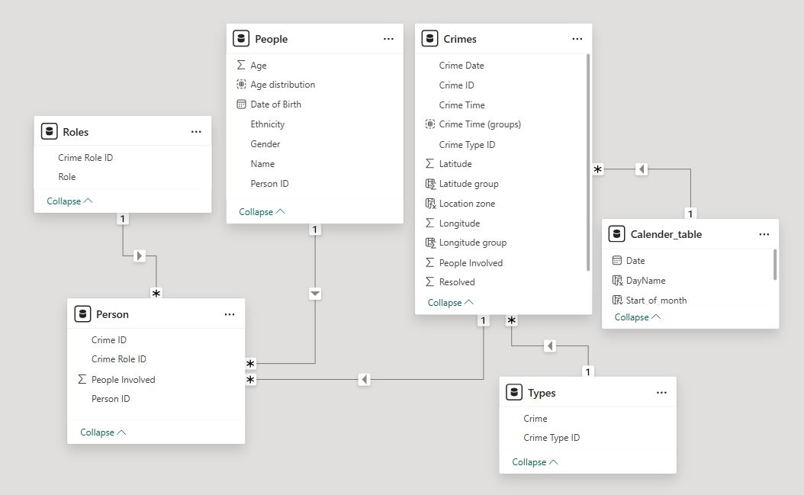

Step 3 — DAX Measures Created

- Total crime, Resolved crime, Unresolved crime, Resolved%
- Total People, Male% & Female%
- Crime by role, Total crime type
- Previous month, YOY, MOM measures

Dashboard Pages:
Page 1 — Crime Overview
Purpose: Get a high-level view of crime volume, resolution, and trend.
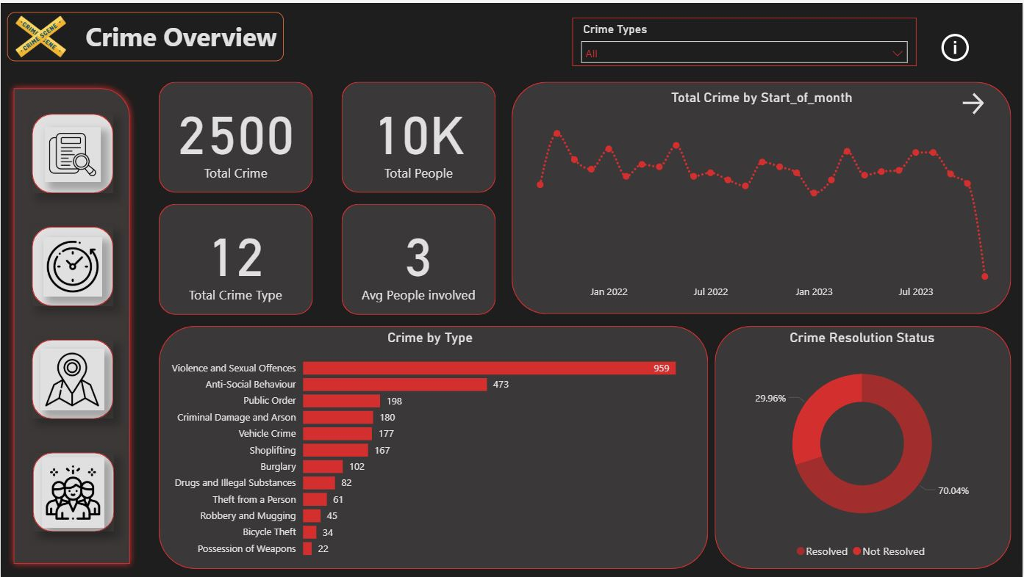
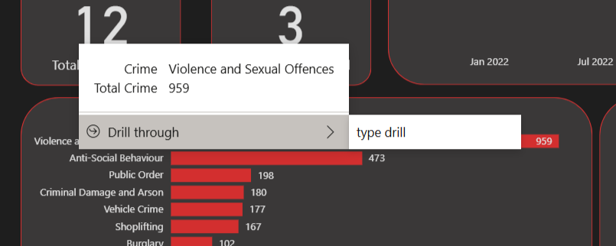 Drill through to get a better understanding on Crime type.
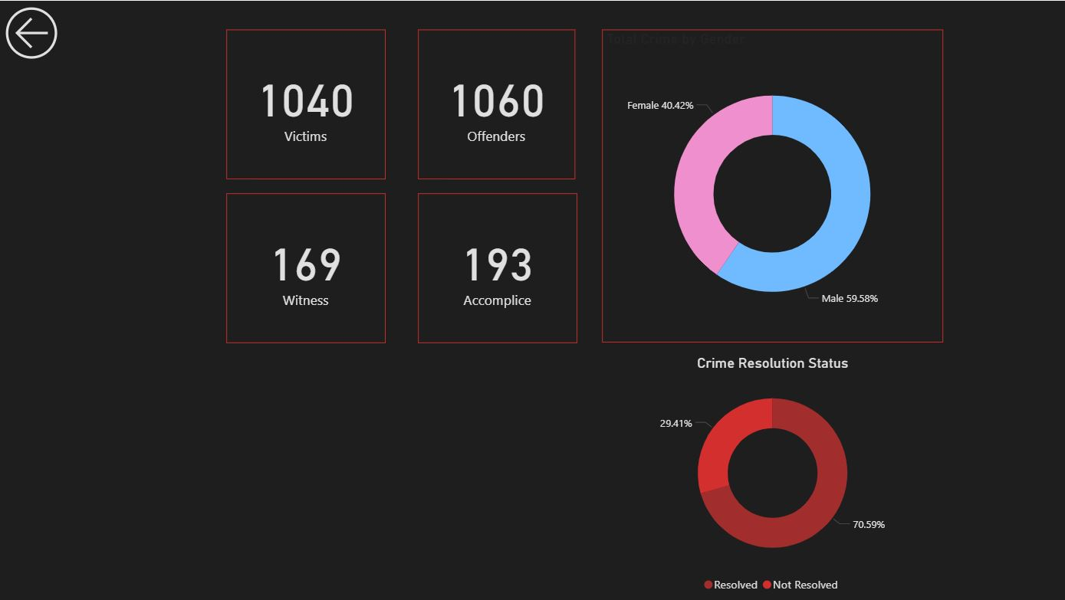

Page 2 — Temporal Analysis
Purpose: Understand when crimes occur most frequently.
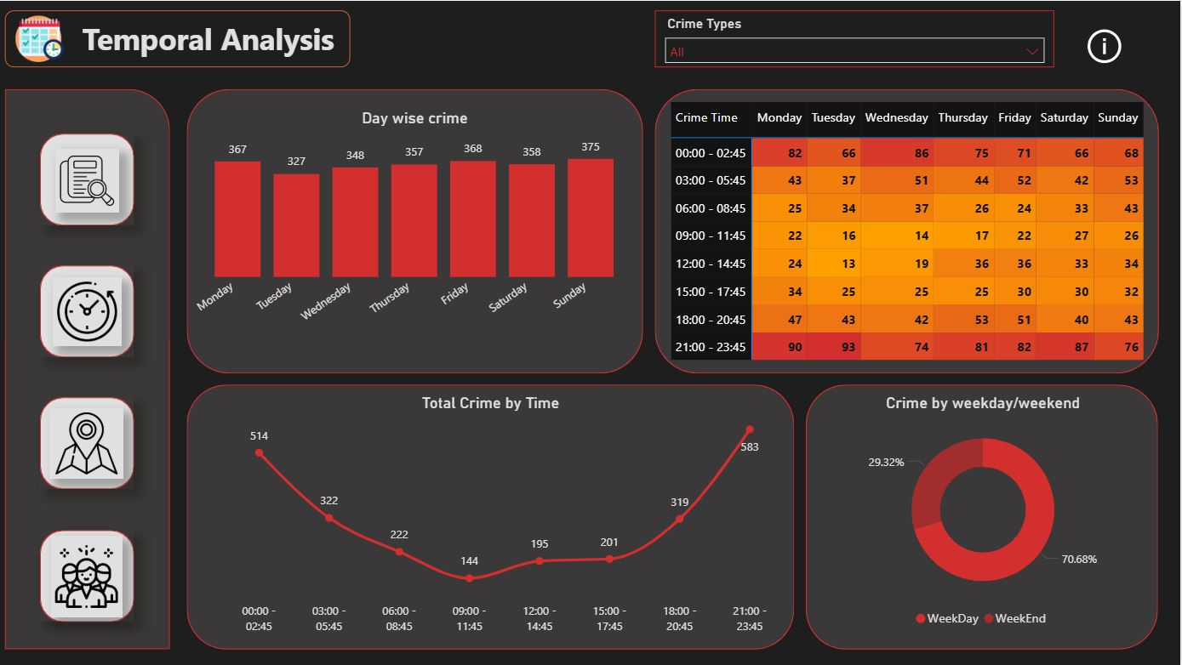
Page 3 — Crime Hotspot Analysis (Azure Map)
Purpose: Identify geographic crime clusters.
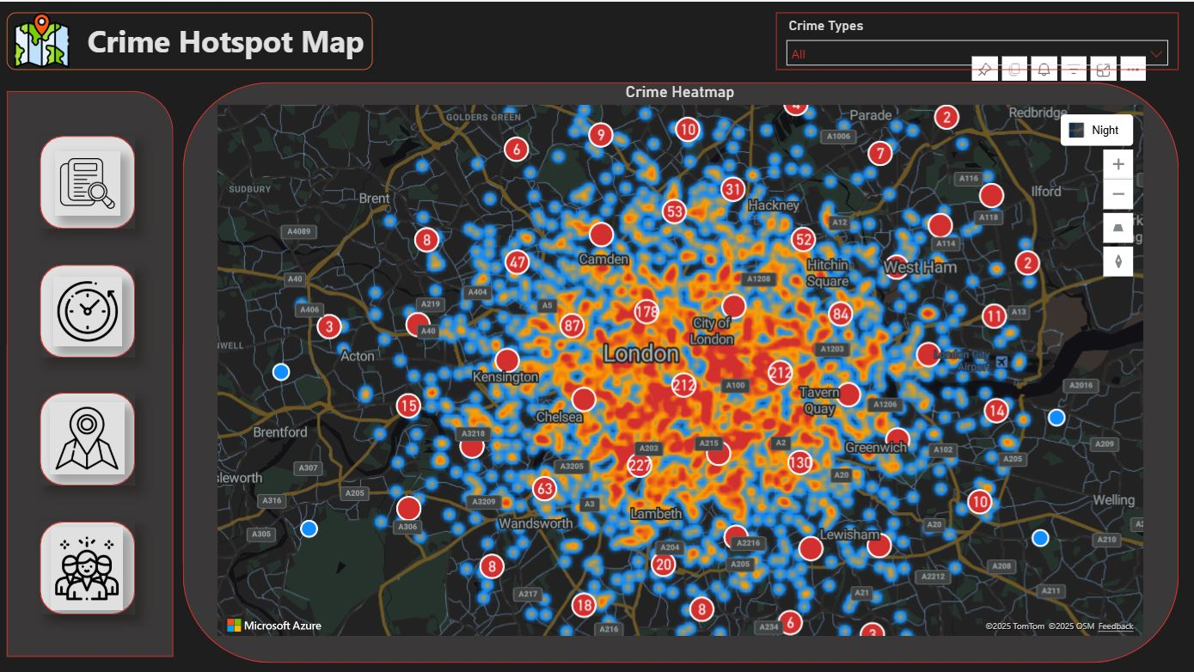

Page 4 — Victim & Offender Analysis
Purpose: Analyse demographic patterns.
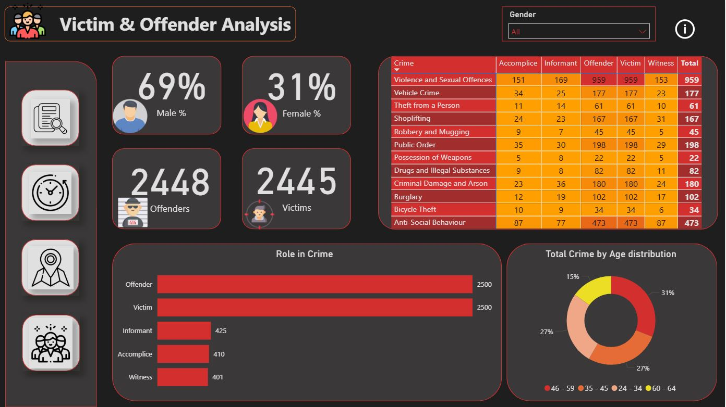

Key Findings:
Finding 1: Crime Types
- Violence & Sexual offences are the highest categories.
- Violent crimes are less resolved compared to property crimes.
Finding 2: Time-Based Patterns
- Crimes peak between 9 PM – 2:45 AM and lowest between 9 AM – 11:45 AM.
- Weekdays show higher activity.
- Seasonal spikes especially in summer months.
Finding 3: Crime Hotspots
- A few zones contribute to the majority of crimes.
- Hotspots remain consistent across months.
Finding 4: Demographics
- Offenders are mostly males aged 46 – 59.
- Victims vary by crime type.

