 | 
Faculty of Technology and Engineering
Chandubhai S. Patel Institute of Technology (CSPIT)
Department of Computer Science & Engineering
Date: / /
Laboratory Manual
Academic Year | : | 2024-25 | Semester | : | 4
Course code | : | CSE206 | Course name | : | DATABASE MANAGEMENT SYSTEM

Practical - 12
Aim: - Your task is to design and implement database functionalities for managing product information in an e-commerce system. The system should allow users to create, retrieve, update, and delete product data, compute discounts on products using a function, and maintain an audit trail for product updates using a trigger.

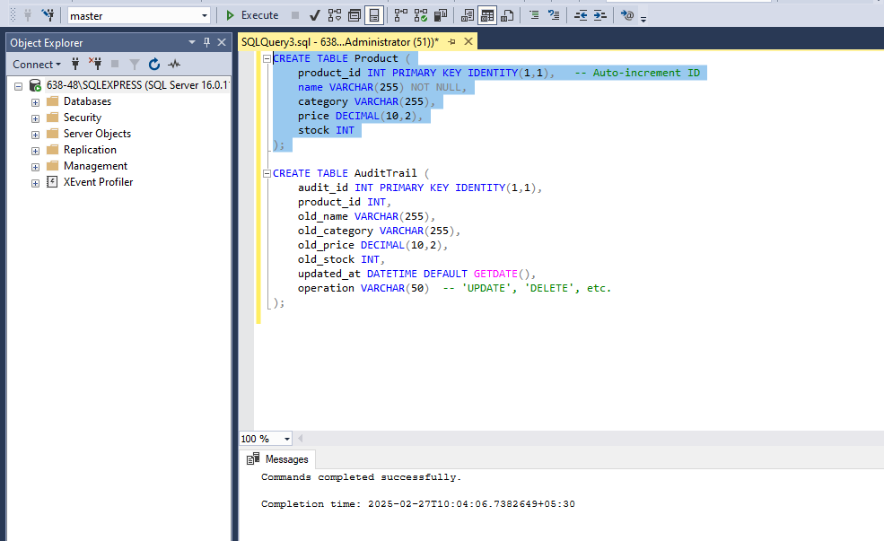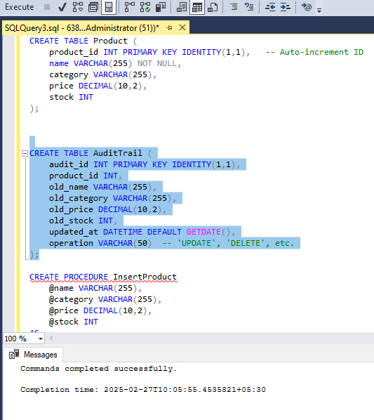
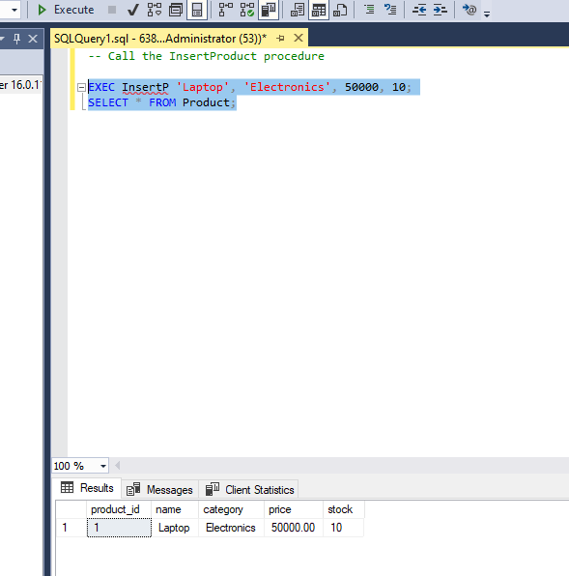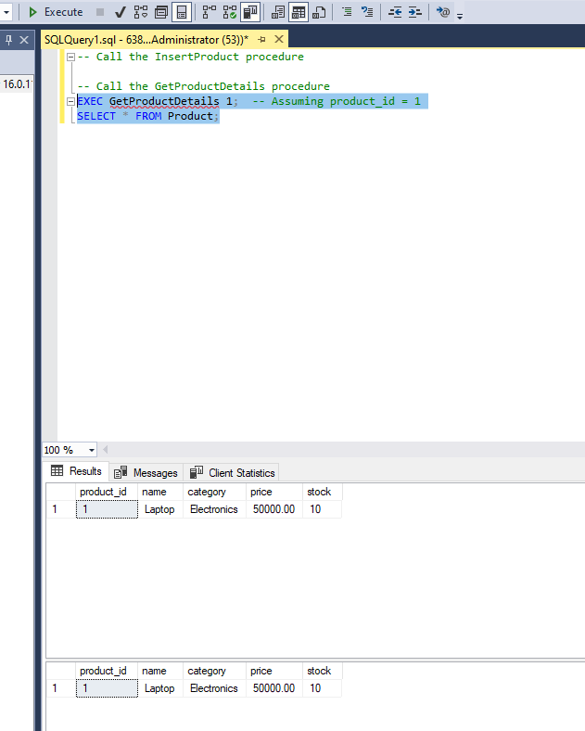

Task:
- Create a stored procedure to insert a new product into the Product table.
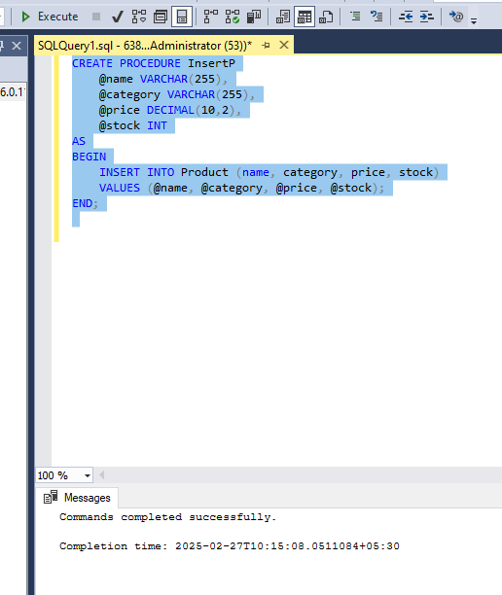
- Create a stored procedure to retrieve product details by product_id.
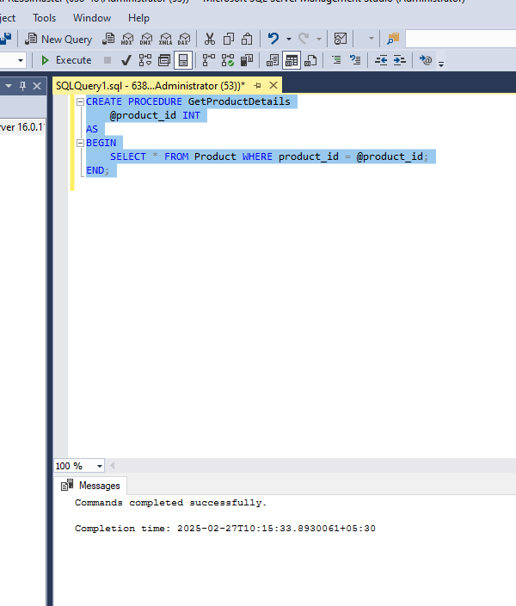
- Create a stored procedure to update the stock of a product.
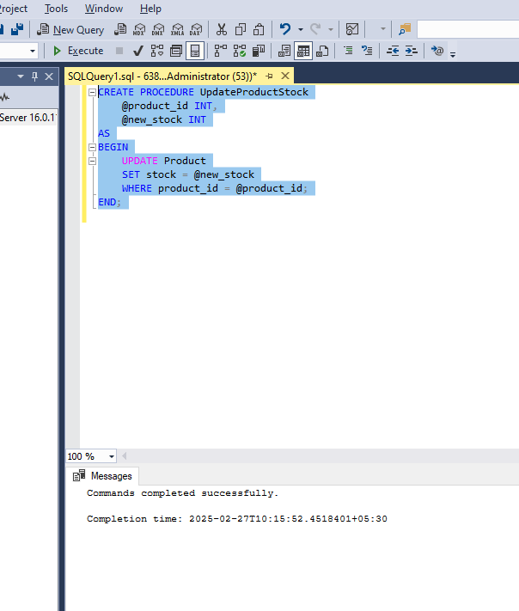
- Create a stored procedure to delete a product by product_id.
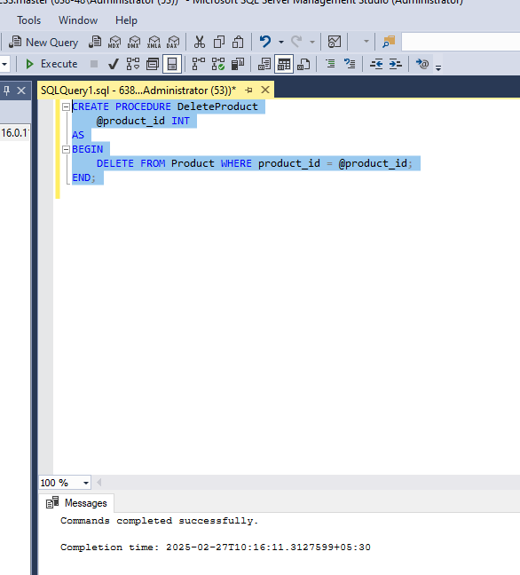
- Create a function to calculate the discounted price of a product.
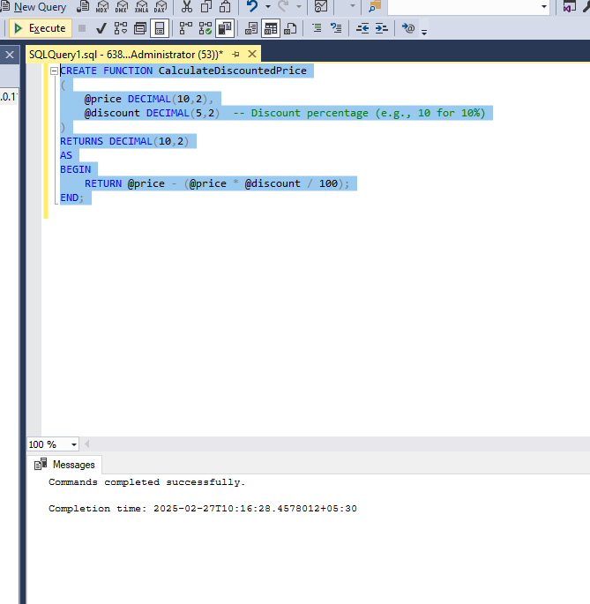
- Implement a trigger to maintain an audit trail of updates made to the Product table. Before any update, the trigger should insert a record into an AuditTrail table, storing the old product details along with the update timestamp.
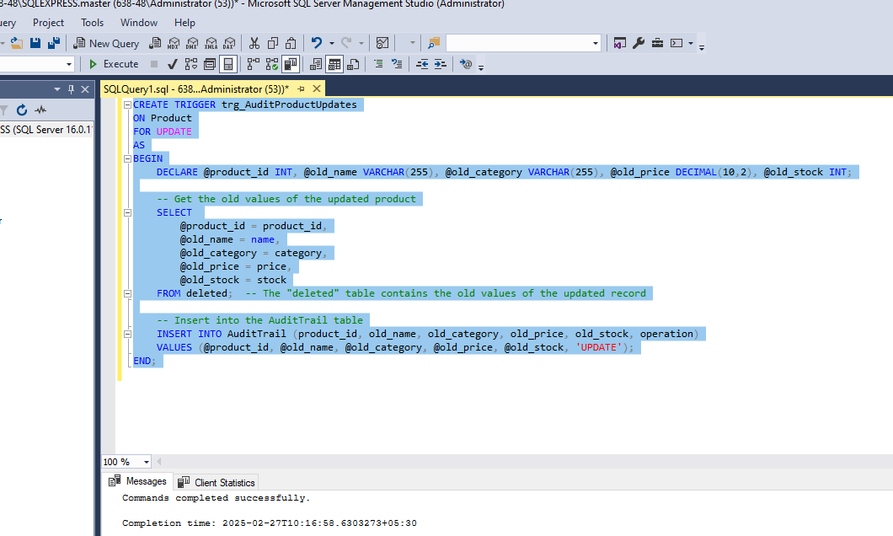

Tasks for test:
