By:251253766

Word Count:2214

deep learning ASSIGNMENT

FM9528A Banking Analytics

**Objective**

With this coursework, we aim to use LiDAR images of several neighborhoods in London, UK and try to predict the deprivation indices of those localities based on these images. The deprivation indices are 7:

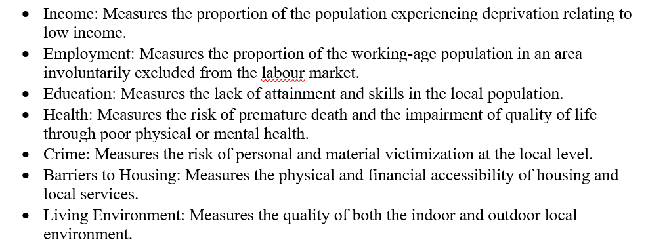

**Approach**

We have been provided with two sets of data

1. A dataset (csv format) that contains the geographic details of the neighborhoods
2. The corresponding LiDAR images of each of these neighborhoods

We will examine a couple of Deep Learning Models, viz, VGG16 and Renet50v2 to understand how well these images can predict deprivation indices. The index we will be exploring is ‘**Living Environment’.**

**Hypothesis**

LiDAR is a method for determining [ranges](https://en.wikipedia.org/wiki/Ranging) (variable distance) by targeting an object with a [laser](https://en.wikipedia.org/wiki/Laser) and measuring the time for the reflected light to return to the receiver. LiDAR images are a freely available resource with multiple applications in various fields including but not limited to Agriculture, Archaeology, Geology and Climate Science, Remote Sensing, where it has been very successfully used with great results. While other forms of remote sensing and related imagery has been used in the domain of socio-economic analysis, LiDAR has not been explored in this domain before this research 1

We use the Transfer Learning approach on models pre-trained on Imagenet weights. The images used in Imagenet are of a different type than aerial laser images, but we hope that our models will learn the pattern using the large number of images we are providing and will be able to predict the index to some degree of accuracy.

I am especially hopeful that we will have a decently low prediction error for Living Environment in comparison to the other indices because Living Environment can almost always be directly interpreted using the images of a particular area. LiDAR also captures some relevant information like the availability of green space, urban density which help in predicting the Living Environment. Previous work (Jean et al., Block et al.) on successfully predicting poverty using satellite imagery has been done 4 5 so it is possible to extend this work with LiDAR images.

My understanding is that the model prediction accuracy can be improved further if we use background geo-demographic information as input in addition to the images.

**Deep Learning**

This section describes the steps taken to predict the ‘Living condition’ of an area using the corresponding LiDAR image as input. We choose two pre-trained Convolutional Neural Network (CNN)from different families, viz. the VGG16 and the Resnet50 Version2.

**Data:**

We combine the CSV dataset and the LiDAR images into one single Pandas dataframe, and we split the dataframe into train and test set in a 70:30 ratio.

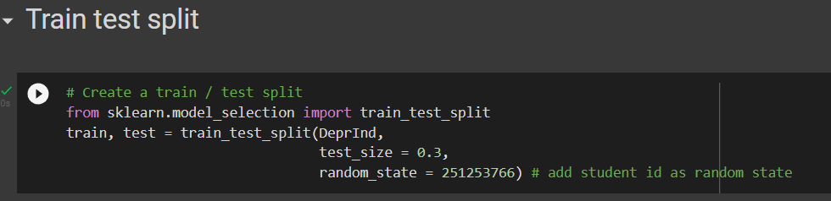

**Model Architecture**

**A. VGG16**

VGG16 is a simple and widely used CNN Architecture used for ImageNet, a large visual database project used in visual object recognition software research 2 . VGG16 abbreviation for Visual Geometry Group, the group of researchers that developed this architecture, is named as such because it has 16 CNN layers. Below is the layer structure for VGG16.

VGG16 is a sequential model that has 16 stacked layers. Unlike earlier CNN models like AlexNet, VGG16 uses 3x3 sized kernels throughout the architecture. The final max-pooling layer is followed by 3 fully connected layers or dense layers and a final output layer with an activation function. This model was pre-trained on ImageNet data, and for this coursework, we will leverage these already trained weights and we follow the following steps to generate our model object:

1. We import the model VGG16 on the fly, but we do not want to include the top layers, so we set the option ‘include_top = False’
2. We use the Imagenet weights as the weights for our model, but at this point the whole model is trainable. We do not want to train the whole model and will just customize the final few layers, so we copy our model object to a new model object and set everything to untrainable in this cloned copy.
3. We set the last two CNN layers as trainable, using the following code:

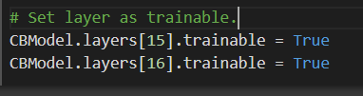

1. We then add 2 dense layers with 64 neurons each and a final output layer with 1 neuron. The activation function added to each of these layers is **‘relu’**.
2. We add 50% dropout in the dense layers to avoid overfitting, which neural networks are quite prone to do. The output layer also has Relu activation function, which sets all negative values to 0 which suits our needs because Living Environment has no negative values

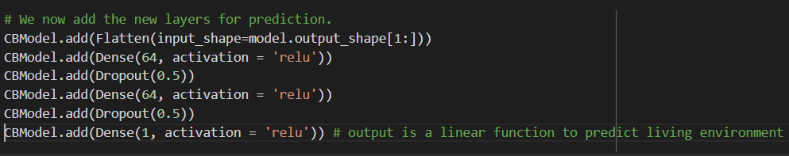

1. With this architecture in place, we compile the model. We choose ‘**Adam’** as our optimizer, as it is an efficient, general-purpose optimizer that can be used for different applications. We set the learning rate low, at 1e-5, as we are using pre-trained models for the training to converge. Since we are predicting continuous variables (‘living condition index’), we use **Mean Squared Error** as our loss function.

**B. RESNET50V2**

ResNet-50 model is a convolutional neural network (CNN) that is 50 layers deep. Resnet stacks residual blocks on top of each other to form a network. ResNet tackles two primary challenges faced by very deep neural nets- the problem of overfitting (and model complexity) and the problem of vanishing gradients. The vanishing gradient problem occurs when the backpropagation algorithm moves back through all the neurons of the neural net to update their weights 3. The residual model is created by using skip connections, where the output of a particular layer (say layer A) is fed forward to a layer (say layer D) which is a few layers ahead of the current layer, skipping the layers in between (layers B and C). Layer D, therefore, gets input from layer C as well as layer A.

**Residual layer:**

**Architecture:**

Resnet comes with built-in batch normalization layers after every few CNN layers to avoid the data getting scaled up too much.

Resnet50 was pre-trained on Imagenet data, and we will use the Imagenet weights to train the model. We follow these steps:

1. The model is downloaded on the fly and saved as a base model, freezing all the weights and setting it as untrainable.
2. We then build the top layer by adding two dense layers with 64 neurons each and one output layer with one neuron. Each layer has the activation function **‘relu’**.

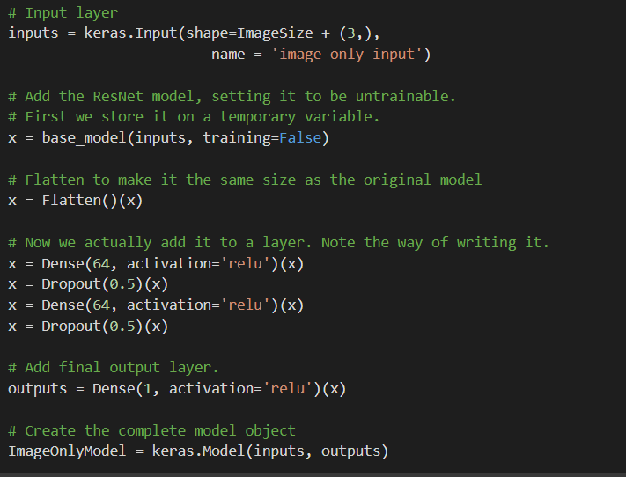

Model summary:

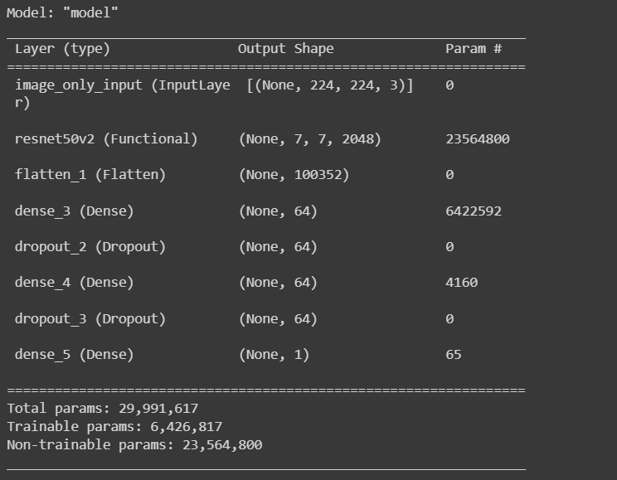

1. We now compile the model and as before, choose ‘**Adam’** as our optimizer, and set the learning rate at 1e-5. We choose **Mean Squared Error** as our loss function.
2. We create an Image Data Generator object (described in the next section) to add the images to the model in batches,
3. We do a warm start with two epochs.
4. Next, we set the base model as trainable. This way all its layers except the batch normalization layers will be set to trainable.

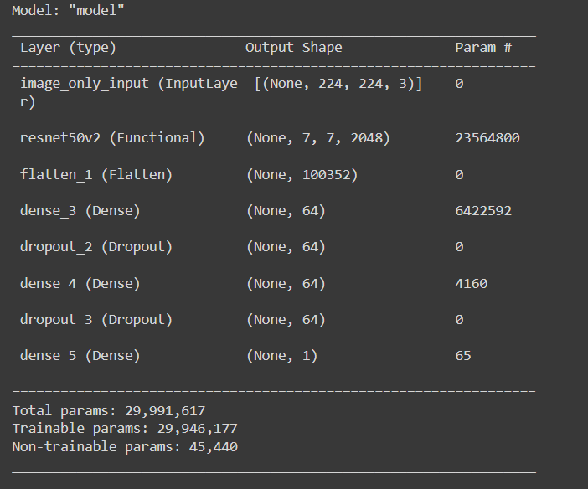

1. We now add two callbacks and train the model.

**EarlyStopping**: This monitors the training and validation losses and automatically stops training the model once the validation error stays within 0.00001(tolerance) of the previous epoch flat for 3 epochs(patience).

**Modelcheckpoint**: Saves the weights of the best performing models. In case we need to retrain our model- we can always start by calling the last saved model and not have to start from scratch.

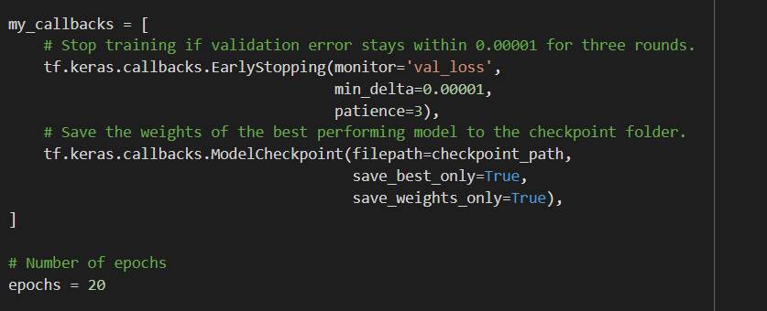

**Image Data Generation:**

We will create Image Data Generators to be used for both our models, which take images from a directory, and feed them to the model as needed. The input size is always set to 224X224.

We do data augmentation to improve the accuracy of prediction by making the models search more complex patterns. For VGG16, the generator has been set to rescale = 1./255 to normalize the inputs. For Resnet, the preprocessor normalizes the inputs, so we don’t rescale. For both models, we choose not to do any shearing, choose to zoom about 80-120%, as we think it might be beneficial to look more closely considering it is an aerial image and do both horizontal and vertical flips. We create a validation subset using 20% data from the train set.

The number of images in each set is:

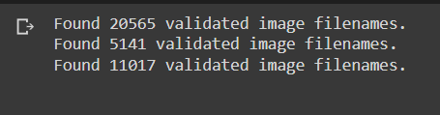

**VGG16:**

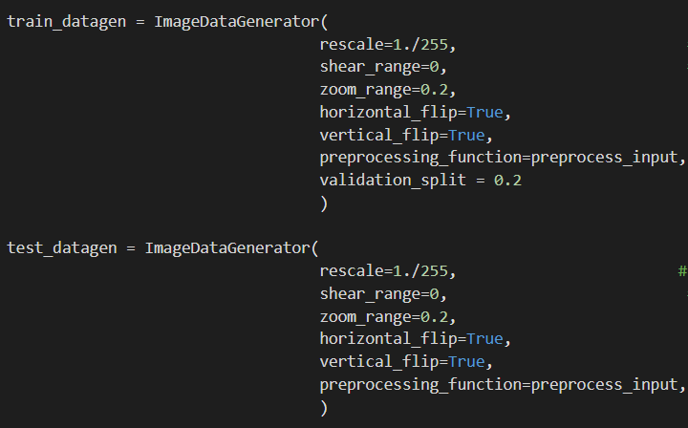

**Resnet:**

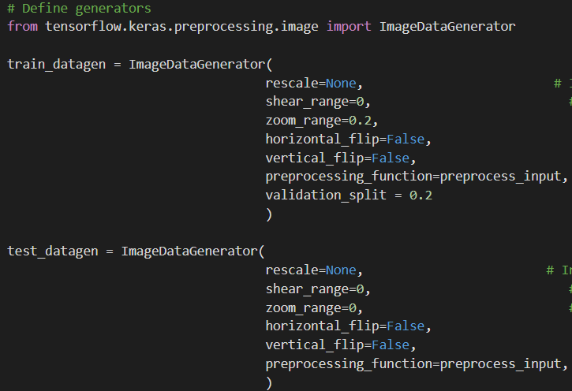

**Training:**

**VGG16:**

Here are the parameters chosen for training VGG:

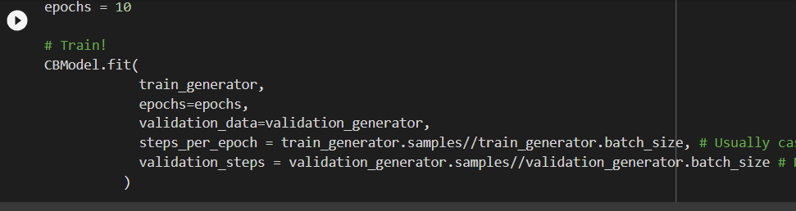

We trained in batches of 5 epochs. The validation loss started to stabilize after about 18 epochs. We saw that it stayed steady for around 3 epochs, and we decided that this was the point where the model converged. The figure below shows the last 10 epochs.

**ResNet50:**

Here, we kept the batch size 128, because Resnet is more memory intensive than VGG. Here are the parameters:

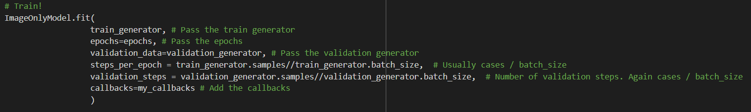

We started out wanting to train the model for 20 epochs. After the 12th epoch, however, the Callback terminated training since the model converged. We found that validation loss was the lowest for the 9th epoch, so we chose that as our optimum model.

**Testing:**

We tested our best performing models on the test set to predict the ‘Living_Environment’. We use **Mean Squared Error**, **Root Mean Squared Error** and **Normalized Mean Squared Error** as our metrics to measure performance because we are tackling a regression problem. The latter will be helpful to compare the performance of the model for different indices (e.g, crime, education) and understand which index is best predicted using these models.



We conclude that for our data, Resnet50V2 is performing marginally better than VGG and is giving us lower test errors.

**Interpretation using GradCAM**

GradCAM(Gradient Class Activation Mapping) is a technique to introduce explainability in our NN models. It allows us to understand where our models are focusing and how they are interpreting the information in the images.

We clone the last convolutional layer of our model and add the top layers from our model and let’s say we name it regression model. We then calculate the gradient of the output of the regression model (predicted value of deprivation index) with respect to the feature map of our last convolutional layer. We take the mean intensity of the gradient over a specific feature map channel, multiply each channel with that weight, and then take the channel wise mean to derive the final heatmap.

The heatmap tells us exactly which features or areas of the image the model gives the highest weights to and considers important.

Following are 10 images from the overall range of the index ‘Living Environment’. We have provided below the original LiDAR image, the heatmap generated by GradCam and the heatmap superimposed on the actual image to understand what parts of the images the model has focused on. The GradCAM was run on Resnet, our better performing model on that model, focusing on the final convolutional layer.

Index = 5.45

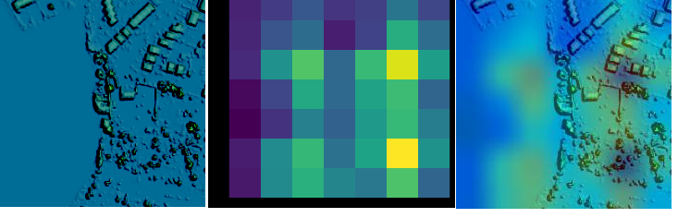

Index = 16.13

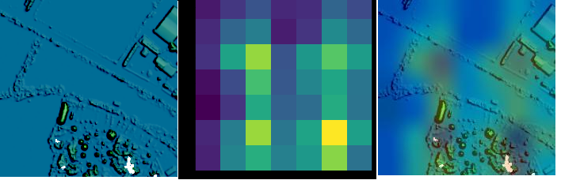

Index = 30.172

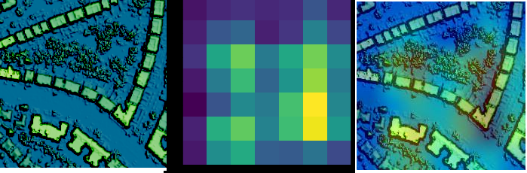

Index = 42.624

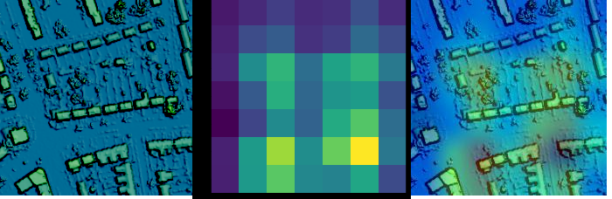

Index = 47.933

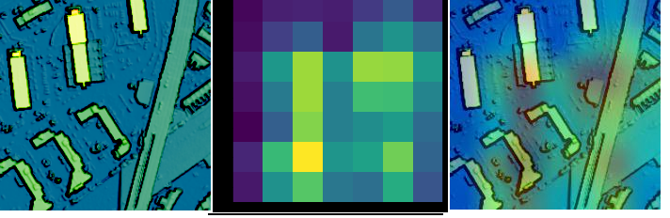

Index = 52.091

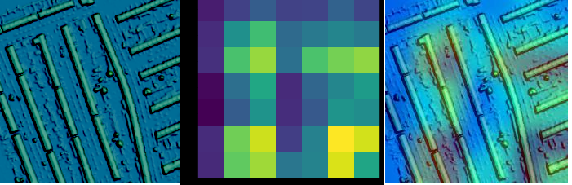

Index = 56.7

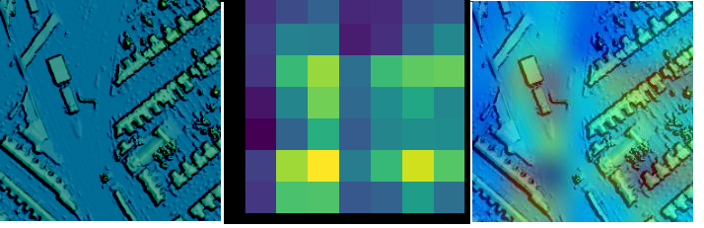

Index = 66.334

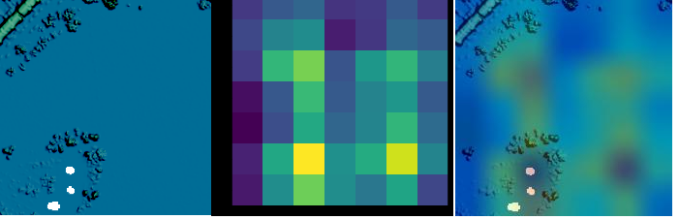

Index = 79.648

Index = 91.602

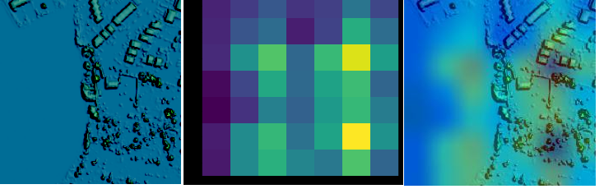

The model appears to focus on areas with higher building concentration, and images with high building density have been predicted to have a higher value of Living environment, which means lower quality of the said index.

The conclusion is not too off base, considering higher building density means less availability of open space. The caveat here is, these pictures are captured aerially, from a considerable height, so it is difficult to capture the indoor living environment. To achieve higher accuracy and lesser bias, the models should consider taking the background geo-demographic information as input in addition to the LiDAR images.

**Ethical implications of using LiDAR images in socio-economic predictions**

When we talk about ethical considerations, we often think about privacy, security, bias and fairness amongst others. Aerial LiDAR does not collect PII data 8, so individual privacy might not be the biggest concern here. There is however some concern regarding the models learning the bias based on the data collected unless the models are trained with data that fit the socio-demographic context of a particular area.

While some interpretations can be correct based on the images, some, for example, crime rates can be biased interpretation based on the diversity and representation of the sample. For example- are all densely populated areas crime-prone? This is where we need to be mindful of data collection bias.

For example, in many studies about predicting poverty, ownership of cars is one of the predictor variables. While this information might be able to correctly predict the living condition of a community in the suburb of an industrialized nation, it is hardly a good predictor when it comes to heavily urban communities or comparatively less industrialized economies.

LiDAR images find wide usage in various disciplines including but not limited to geology, archaeology, climate sciences, and as we saw above in the coursework can be a quite promising tool to predict deprivation indices. Considering that it is open data, we need to start thinking about who might use the data and to what end.

I think we can all agree that data, especially big data, is an incredibly powerful tool, and in the wrong hands can turn into a weapon of destruction. We need to think about implementing changes that give more agency to the individual, enforce the practice of informed consent, minimize the collection of personal information while still collecting overall community information, and bring transparency in every step of the process, from data collection, to use to storage policies.

**References:**

# Bravo, C et al.,2021.Deep residential representations: Using unsupervised learning to unlock elevation data for geo-demographic prediction

# Tinsy John Perumanoor.What is VGG16? Introduction to VGG16” <https://medium.com/@mygreatlearning/what-is-vgg16-introduction-to-vgg16-f2d63849f615>

# Nick McCullum.The Vanishing Gradient Problem in Recurrent Neural Networks <https://nickmccullum.com/python-deep-learning/vanishing-gradient-problem/#what-is-the-vanishing-gradient-problem>

# Jean, N., Burke, M., Xie, M., Davis, W.M., Lobell, D.B., Ermon, S., 2016. Combining satellite imagery and machine learning to predict poverty.

# J. Block et al., "An Unsupervised Deep Learning Approach for Satellite Image Analysis with Applications in Demographic Analysis," 2017 IEEE 13th International Conference on e-Science (e-Science), 2017, pp. 9-18, doi: 10.1109/eScience.2017.13.

# Panchal, Shubham,2021. Grad-CAM: A Camera For Your Model’s Decision

# “ English indices of deprivation” <https://www.gov.uk/government/collections/english-indices-of-deprivation>

# <https://www.thefastmode.com/expert-opinion/19182-lidar-is-playing-a-leading-role-in-the-development-of-smart-cities>

**Appendix:**

1. Link to Collab Notebook:

<https://colab.research.google.com/drive/1zKzROi17Y0kkfzcBEOkWa-I9UoK_w44E#scrollTo=K24odNK20iqJ>

1. Code for the coursework: