**AMITY UNIVERSITY, MAHARASHTRA**





**Java Programming Lab**

Master in Computer Application

SEMESTER 1

Submitted to:

Submitted By:

Debesh Das

A710145022009

MCA (AIIT)

Ms. Roshani Mali

Professor

|  |  |
| --- | --- |
| **Sr. No.** | **Title** |
| 1 | 1. WAP to find fibonacci upto given number using for loop. 2. WAP to print prime numbers using while loop. 3. WAP whether a given string is palindrome or not? 4. WAP to perform arithmetic operations(menu driven). |
| 2 | 1. WAP to sort the elements of array in ascending order. 2. WAP for calculating Matrix multiplication operation. 3. WAP for sorting given list of names in ascending order. |
| 3 | 1. WAP to demonstrate the working of banking- system where we deposit and withdraw amount from our account. 2. WAP using class and object for calculating area of circle, rectangle, triangle using menu driven. 3. WAP to create a room class, the attributes of this class is roomno, roomtype, roomarea, and acmachine. In this class the member functions are setdata and displaydata. |
| 4 | 1. WAP for employee class using constructors. 2. WAP to illustrate constructor overloading using "this" keyword. |
| 5 | 1. WAP to calculate total salary of faculty of college including hra, da, bonus using multilevel inheritance. 2. WAP to illustrate use of hierarchical inheritance. 3. WAP to illustrate use of super keyword. |
| 6 | 1. WAP to illustrate use of abstract class that has abstract and non abstract methods. 2. WAP to illustrate use of interface. |
| 7 | WAP for null pointer exception and illustrate finally block and throws keyword. |
| 8 | 1. WAP to read text from text file. 2. WAP to write text in text file. |
| 9 | Write a java program for calculator operation using AWT controls |
| 10 | Write a java program for student registration using swing |
| 11 | 1. WAP to demonstrate LinkedList and it's methods. 2. WAP to demonstrate HashSet and it's methods. |

# Practical 1

Program1:- Write a java program to find Fibonacci series up to given number using for loop

import java.util.*;

import java.io.*;

class fibonacci

{

public static void main(String args[])

{

Scanner sc=new Scanner(System.in);

System.out.println("Enter a number ");

int k=sc.nextInt();

int n1=0,n2=1;

int n3=0;

System.out.println("Fibonacci series of "+k+" number is :");

System.out.print(n1 +" , "+n2);

for(int i=2;i<k;i++)

{

n3=n2+n1;

System.out.print(" , "+n3);

n1=n2;

n2=n3;

}

}



}

OUTPUT: -

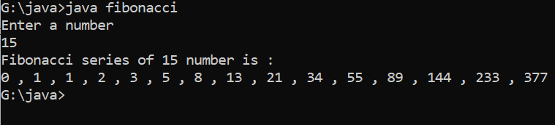

Program 2: - Write a java program to print prime numbers using while loop

import java.util.*;

import java.io.*;

class primeno

{

public static void main(String args[])

{

Scanner sc=new Scanner(System.in);

System.out.println( "Enter a number ");

int k=sc.nextInt();

int i =2,n,j;

while(i<=k){

j=2;

n=0;

while(j<=(i/2)){

if(i%j==0){

n=1;

}

j++;

}

if(n==0){

System.out.print(i+", ");}

i++;

}

}

}

OUTPUT: -

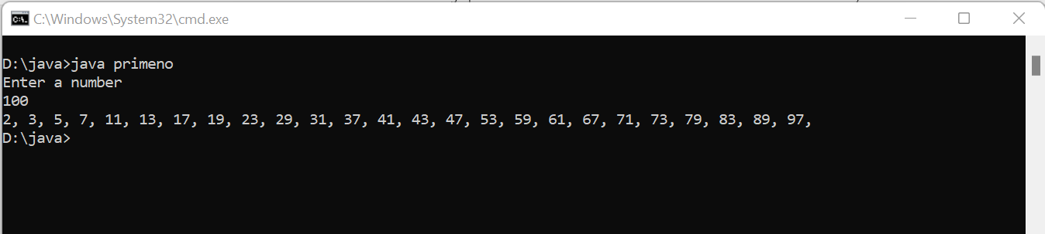

Program 3: - Write a java program whether a given string is palindrome or not

import java.util.*;

import java.io.*;

class palindrome

{

public static void main(String args[])

{

Scanner sc=new Scanner(System.in);

System.out.println( "Enter a String ");

String k=sc.nextLine();

int l = k.length();

System.out.println( "Length of string is "+l);

String k2="";

for(int i=0;i<l;i++)

{

k2=k.charAt(i)+k2;

}

System.out.println(k2);

if(k2.equals(k))

System.out.println("String is Palindrome ");

else

System.out.println("String is not Palindrome");

}

}

OUTPUT: -

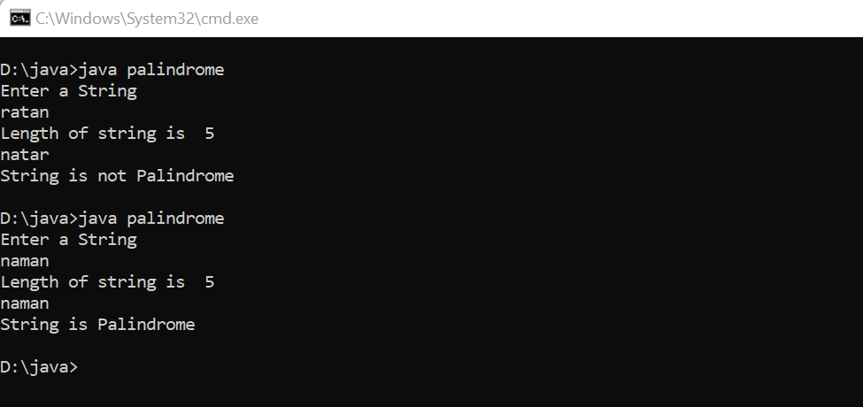

Program 4: - Write a java program to perform arithmetic operations (MENU DRIVEN)

import java.util.*;

import java.io.*;

class arith

{

public static void main(String args[])

{

Scanner sc=new Scanner(System.in);

System.out.println("MENU \n 1.Addition\n2.Subtract\n3.Multiply\n4.Divide");

System.out.print("Enter your choice :- ");

int n=sc.nextInt();

int a,b;

switch(n)

{

case 1:

System.out.println("Enter first number");

a=sc.nextInt();

System.out.println("Enter second Number");

b=sc.nextInt();

System.out.println("Sum of two number is "+(a+b));

break;

case 2:

System.out.println("Enter first number");

a=sc.nextInt();

System.out.println("Enter second Number");

b=sc.nextInt();

System.out.println("Subtraction of two number is "+(a-b));

break;

case 3:

System.out.println("Enter first number");

a=sc.nextInt();

System.out.println("Enter second Number");

b=sc.nextInt();

System.out.println("Multiplication of two number is "+(a*b));

break;

case 4:

System.out.println("Enter first number");

a=sc.nextInt();

System.out.println("Enter second Number");

b=sc.nextInt();

System.out.println("Division of two number is "+(a/b));

break;

default:

System.out.println("Invalid Choice");

}

}

}

OUTPUT: -

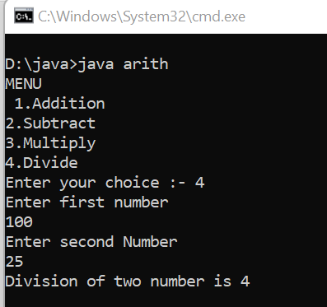 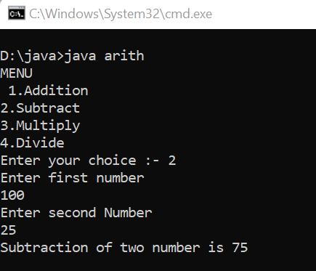 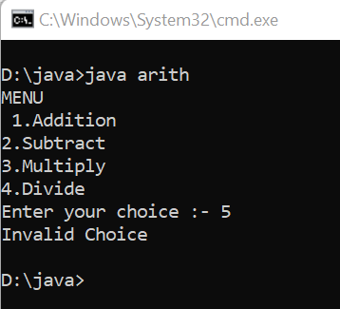

# Practical 2

Program 5: - Write a java program to sort the element of an array in ascending order

import java.util.*;

import java.io.*;

class sort_num

{

public static void main(String args[])

{

Scanner sc=new Scanner (System.in);

int n;

int i,j;

System.out.println("Enter no of elements ");

n=sc.nextInt();

int a[]=new int[n];

System.out.println("Enter "+n+" Elements");

for(i=0;i<n;i++)

a[i]=sc.nextInt();

int t;

for(i=0;i<n;i++)

{

for(j=i+1;j<n;j++)

{

if(a[i]>a[j])

{

t=a[j];

a[j]=a[i];

a[i]=t;

}

}

}

System.out.print("Sorted Array is = ");

for(i=0;i<n;i++)

System.out.print(a[i]+" ");

}

}

Output:-

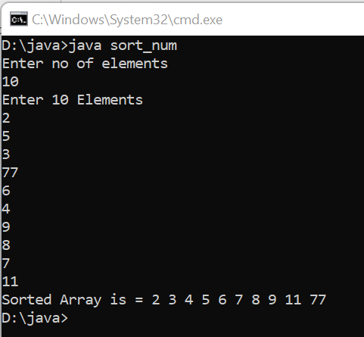

Program 6: Write a java program for calculating matrix multiplication operation

import java.util.*;

import java.io.*;

class matrix

{

public static void main(String args[])

{

int i,j,k;

Scanner sc=new Scanner(System.in);

System.out.println("Enter size of first matrix");

int a1n1=sc.nextInt();

int a1n2=sc.nextInt();

int a1[][]=new int[a1n1][a1n2];

System.out.println("Enter elements of first matrix");

for(i=0;i<a1n1;i++)

for(j=0;j<a1n2;j++)

a1[i][j]=sc.nextInt();

System.out.println("Enter size of matrix");

int a2n1=sc.nextInt();

int a2n2=sc.nextInt();

int a2[][]=new int[a2n1][a2n2];

System.out.println("Enter elements of first matrix");

for(i=0;i<a2n1;i++)

for(j=0;j<a2n2;j++)

a2[i][j]=sc.nextInt();

int r[][]=new int[a1n1][a2n2];

for(i=0;i<a1n1;i++)

{

for(j=0;j<a2n2;j++)

{

for(k=0;k<a1n2;k++)

{

r[i][j]+=a1[i][k]*a2[k][j];

}

}

}

System.out.println("Matrix 1 =");

for(i=0;i<a1n1;i++){

for(j=0;j<a1n2;j++)

System.out.print(a1[i][j]+" ");

System.out.println();

}

System.out.println("Result ");

for(i=0;i<a2n1;i++){

for(j=0;j<a2n2;j++)

System.out.print(a2[i][j]+" ");

System.out.println();

}

System.out.println("Result ");

for(i=0;i<a1n1;i++){

for(j=0;j<a2n2;j++)

System.out.print(r[i][j]+" ");

System.out.println();

}

}

}

Output:

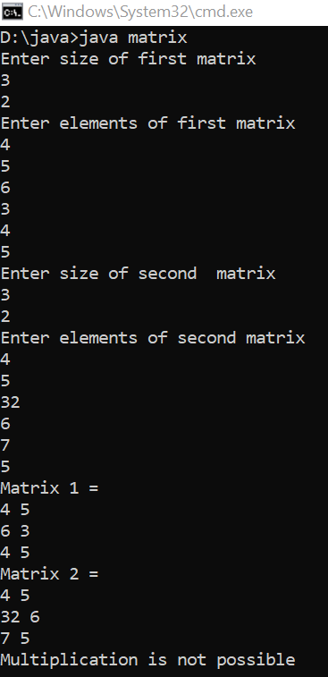 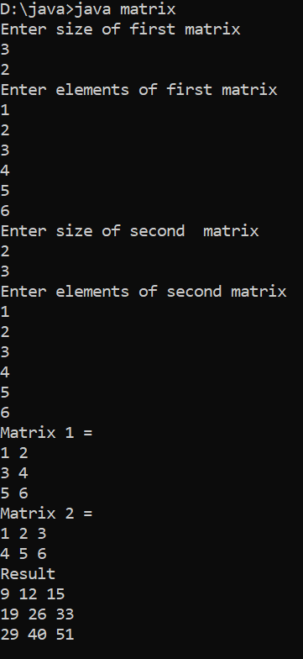

Program 7: Write a program for sorting a given list of names in ascending order

import java.util.*;

import java.io.*;

class sort_string

{

public static void main(String args[])

{

Scanner sc=new Scanner (System.in);

int i,j;

String t;

System.out.println("Enter no of elements");

int n=sc.nextInt();

String name[]=new String[n];

System.out.println("Enter "+n+" names");

for(i=0;i<name.length;i++)

{

name[i]=sc.next();

}

for(i=0;i<n;i++)

{

for(j=i+1;j<n;j++)

{

if(name[i].compareTo(name[j])>0)

{

t=name[j];

name[j]=name[i];

name[i]=t;

}

}

}

System.out.println("Names in ascending order");

for(i=0;i<n;i++)

{

System.out.println(name[i]);

}

}

}

Output:

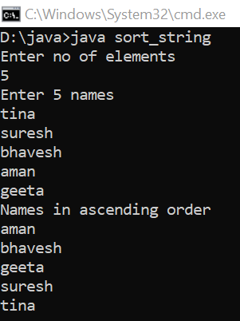

# Practical 3

Program 8 : Write a program to demonstrate the working of a banking system where we deposit and withdraw amount from our account.

import java.util.*;

import java.io.*;

class bank

{

int accno[]={33401,33402,33405,33406,33407};

String name[]={"Debesh","Tina","Karan","Suresh","Danish"};

int amount[]={200,250,100,1000,555};

int d;

public void deposit(int n)

{

Scanner sc= new Scanner(System.in);

System.out.println("Enter the amount to be deposit");

d=sc.nextInt();

amount[n]+=d;

System.out.println("Balance after desposit = "+amount[n]);

}

public void withdraw(int n)

{

Scanner sc= new Scanner(System.in);

System.out.println("Enter the amount to be Withdraw");

d=sc.nextInt();

if(d<amount[n]){

amount[n]-=d;

System.out.println("Balance after withdraw= "+amount[n]);}

else

System.out.println("Insufficient Balance");

}

}

class banking

{

public static void main(String args[])

{

int o=0;

bank bk=new bank();

Scanner sc= new Scanner(System.in);

do

{

int i,ko=0;

for(i=0;i<5;i++)

System.out.println(bk.accno[i]+" "+bk.name[i]+" Balance= "+bk.amount[i]);

System.out.print("Enter account number ");

int no=sc.nextInt();

for(i=0;i<5;i++)

{

if(bk.accno[i]==no)

ko=i;

}

System.out.println("Account number "+bk.accno[ko]+" is selected\nHello "+bk.name[ko]+" Welcome to Internet Banking");

System.out.println("Balance = "+bk.amount[ko]);

System.out.println("1.Deposit\n2.Withdraw\nEnter one option");

int op=sc.nextInt();

switch (op)

{

case 1:

bk.deposit(ko);

break;

case 2:

bk.withdraw(ko);

break;

default:

System.out.println("Enter a valid option");

}

System.out.println("Press 1 to continue internet banking or press 0");

o=sc.nextInt();

}while(o==1);

}

}

Output:

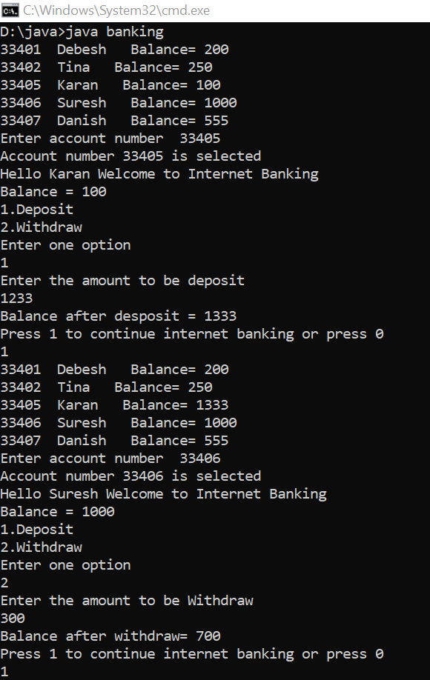 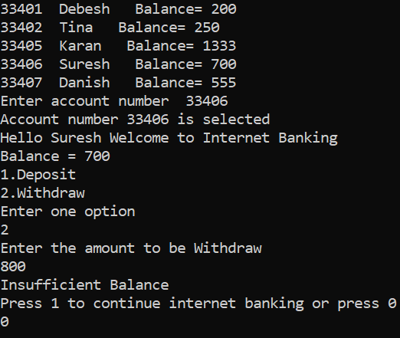

Program 9: Write a java program using class and object for calculating area of circle, rectangle, area of triangle using menu driven

import java.util.*;

import java.io.*;

class areaobject

{

final double pi=3.14;

public double circle(double pi,int r)

{

return (pi*r*r);

}

public int rectangle(int a,int b)

{

return (a*b);

}

public double triangle(int h,int b)

{

return (h*(double)b/2.0);

}

public double square(int a)

{

return (a*a);

}

public static void main(String args[])

{

int op;

areaobject ao=new areaobject();

Scanner sc=new Scanner(System.in);

System.out.println("1.Area of Circle\n2.Area of Rectangle\n3. Area of triangle\n4. Area of Square");

System.out.println("Choose an option");

op=sc.nextInt();

switch (op)

{

case 1:

System.out.println("Enter the radius of circle ");

int r=sc.nextInt();

System.out.println("Area of circle is = "+ao.circle(ao.pi,r));

break;

case 2:

System.out.println("Enter the length and breath of the rectangle ");

int l=sc.nextInt();

int h=sc.nextInt();

System.out.println("Area of rectangle is = "+ao.rectangle(l,h));

break;

case 3:

System.out.println("Enter the base and height of the triangle");

l=sc.nextInt();

h=sc.nextInt();

System.out.println("Area of rectangle is = "+ao.triangle(l,h));

break;

case 4:

System.out.println("Enter the side of sqaure");

l=sc.nextInt();

System.out.println("Area of sqaure is = "+ao.square(l));

break;

default:

System.out.println("Enter a valid option");

}

}

}

Output:

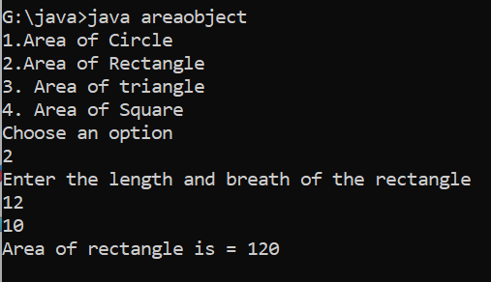 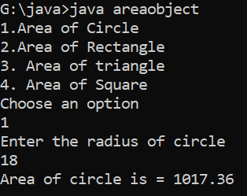

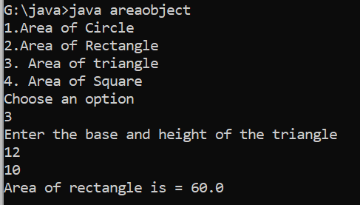 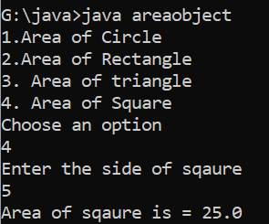

Program 10: Write a java program to create a room class , the attributes of this class is roomno , roomtype , roomarea and ac machine. In this class the member functions are set data and display data.

import java.io.*;

import java.util.*;

class room

{

int roomno;

String roomtype,acmachine;

double roomarea;

room()

{

roomno=0;

roomtype="";

acmachine="";

roomarea=0.0;

}

public void setdata()

{

Scanner sc=new Scanner(System.in);

System.out.println("Enter the details of the room :-");

System.out.print("Room No: - ");

roomno=sc.nextInt();

System.out.print("Room type: - ");

roomtype=sc.next();

System.out.print("Do room have AC (Yes/No) : - ");

acmachine=sc.next();

System.out.print("Room Area in sq.metre - ");

roomarea=sc.nextDouble();

}

public void displaydata()

{

System.out.println("Room Number= "+roomno);

System.out.println("Room Type= "+roomtype);

System.out.println("Availability of AC = "+acmachine);

System.out.println("Room Area= "+roomarea+" square metre");

}

public static void main(String args[])

{

Scanner sc=new Scanner(System.in);

room r=new room();

int i=0;

do{

System.out.println("* * * * * * * * * * * * * * * * * * * * * * * ");

System.out.println("1.Set Data\n2.Display Data");

System.out.println("Enter the option");

int ch=sc.nextInt();

System.out.println("* * * * * * * * * * * * * * * * * * * * * * * ");

switch(ch)

{

case 1:

r.setdata();

break;

case 2:

r.displaydata();

break;

default:

System.out.println("Enter the correct option");

break;

}

System.out.println("* * * * * * * * * * * * * * * * * * * * * * * ");

System.out.println("Do you want to exit\n1.Yes\n2.No");

i=sc.nextInt();

}while(i==2);

}

}

Output :

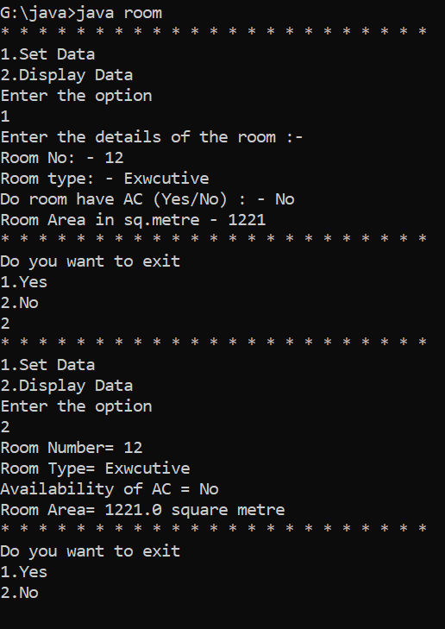

# Practical 4

Program 11: Write a java program for employee class, the attributes of this class is id,name,department and salary. In this class the member functions are display data

import java.util.*;

import java.io.*;

class data

{

int id,salary;

String name,dept;

data(int i,String n,int s,String d)

{

id=i;

salary=s;

name=n;

dept=d;

}

void display()

{

System.out.println("Employee ID = "+id);

System.out.println("Name = "+name);

System.out.println("Salary = "+salary);

System.out.println("Department = "+dept);

}

}

class employee{

public static void main(String args[])

{

Scanner sc=new Scanner (System.in);

System.out.println("Enter Details : ");

System.out.print("ID = ");

int i=Integer.parseInt(sc.nextLine());

System.out.print("Name = ");

String n=sc.nextLine();

System.out.print("Salary = ");

int s=Integer.parseInt(sc.nextLine());

System.out.print("Department = ");

String d=sc.nextLine();

data e=new data(i,n,s,d);

System.out.println("---------xxxxxxx-----------");

e.display();

}

}

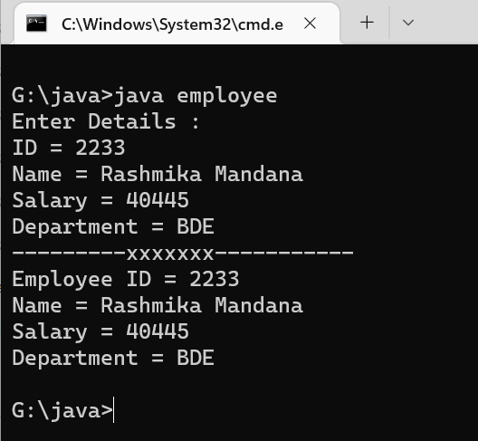

Program 12:Write a java program to illustrate constructor overloading using this keyword

import java.util.*;

import java.io.*;

class dem

{

int a;

dem(){

a=10;

System.out.println("This is default constructor\n Value of A="+a);

}

dem(int a)

{

this.a=a;

System.out.println("This is parameterized constructor\nValue of A ="+this.a);

}

}

public class overl

{

public static void main(String[] args){

Scanner sc=new Scanner(System.in);

System.out.println("Enter value of A");

int a=Integer.parseInt(sc.nextLine());

dem d=new dem();

dem k=new dem(a);

}

}

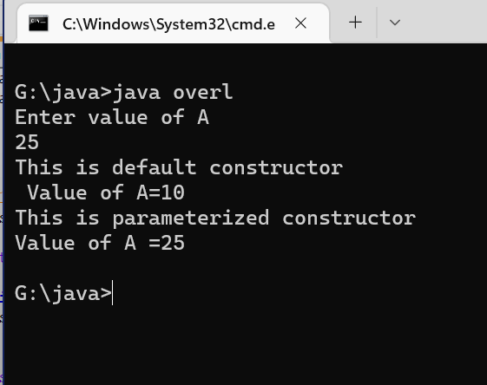

Program 13: Wrie a java program to illustrate single level inheritance

import java.util.*;

import java.io.*;

class student

{

int id;

String name;

void get(int i,String n){

id=i;

name=n;

}

void show(){

System.out.println("ID : "+id);

System.out.println("Name : "+name);

}

}

class aiit extends student

{

int fee;

String course_name;

void get_aiit(int f,String c){

fee=f;

course_name=c;

}

void display(){

System.out.println("Course Name : "+course_name);

System.out.println("Fees : "+fee);

}

}

public class details

{

public static void main(String args[]){

Scanner sc=new Scanner(System.in);

System.out.print("Enter Student name : ");

String na=sc.nextLine();

System.out.print("Enter Student ID : ");

int i=Integer.parseInt(sc.nextLine());

System.out.print("Enter Course Name : ");

String cn=sc.nextLine();

System.out.print("Enter Course Fee : ");

int fe=Integer.parseInt(sc.nextLine());

aiit a=new aiit();

a.get(i,na);

a.show();

a.get_aiit(fe,cn);

a.display();

}

}

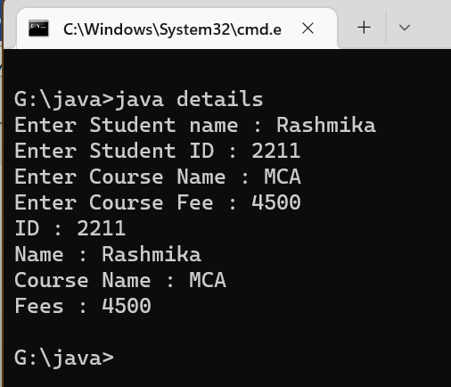

# Practical 5

Program 13: WAP to calculate total salary of faculty of college including hra, da, bonus using multilevel inheritance.

import java.util.*;

import java.io.*;

class salary

{

int sal;

void salar(int k)

{

sal=k;

}

}

class hra extends salary

{

public void calculate1()

{

Scanner sc=new Scanner(System.in);

System.out.print("Enter House Rent Allowance : ");

int hra= sc.nextInt();

sal+=hra;

}

}

class da extends hra

{

public void calculate2()

{

Scanner sc=new Scanner(System.in);

System.out.print("Enter Dearness Allowance : ");

int da=sc.nextInt();

sal+=da;

}

}

class bonus extends da

{

public void calculate3()

{

Scanner sc=new Scanner(System.in);

System.out.print("Enter Bonus : ");

int b=sc.nextInt();

sal+=b;

}

}

public class multilevel

{

public static void main(String[] args){

Scanner sc=new Scanner(System.in);

System.out.print("Enter Salary of the Faculty : ");

int s=sc.nextInt();

bonus b=new bonus();

b.salar(s);

b.calculate1();

b.calculate2();

b.calculate3();

System.out.println("Gross Salary of Faculty is : "+b.sal);

}

}

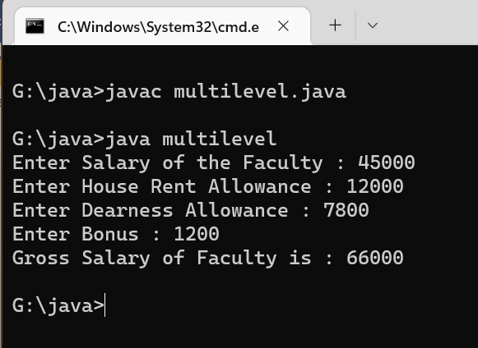

Program 14: WAP to illustrate use of hierarchical inheritance.

import java.util.*;

import java.io.*;

class employeeSalary{

int salary=45000;

}

class permanentEmployee extends employeeSalary{

double hike=0.15;

double grossSalary(){

return (salary+salary*hike);

}

}

class temporaryEmployee extends employeeSalary{

double hike=0.05;

double grossSalary(){

return (salary+salary*hike);

}

}

class hiemployee{

public static void main(String[] args){

permanentEmployee p=new permanentEmployee();

temporaryEmployee t=new temporaryEmployee();

System.out.println("Salary of permanentEmployee = " +p.salary);

System.out.println("Salary after hike of permanentEmployee = " +p.grossSalary());

System.out.println("Salary of temporaryEmployee = " +t.salary);

System.out.println("Salary after hike of temporaryEmployee = " +t.grossSalary());

}

}

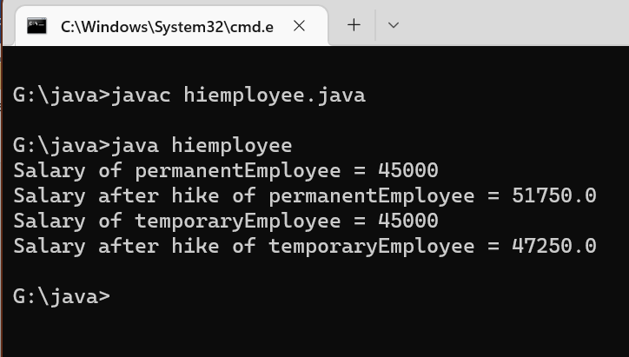

Program 15: Write a java program to illustrate use of super keyword.

import java.util.*;

import java.io.*;

class detail{

String fname,sname;

int age;

detail(String f, String s, int a){

fname=f;

sname=s;

age=a;

}

}

class student extends detail{

String course,semester;

int fees;

student(String f,String s,int a,String ce, String se,int fe){

super(f,s,a);

course=ce;

semester=se;

fees=fe;

}

void display(){

System.out.println("Name of Student: "+fname+" "+sname);

System.out.println("Age : "+age);

System.out.println("Course : "+course+" "+semester+" sem");

System.out.println("Fees : "+fees);

}

}

class faculty extends detail{

String department;

int salary;

faculty(String f,String s,int a,String de,int se){

super(f,s,a);

department=de;

salary=se;

}

void display(){

System.out.println("Name of Faculty : "+fname+" "+sname);

System.out.println("Age : "+age);

System.out.println("Department : "+department);

System.out.println("Salary : "+salary);

}

}

class university{

public static void main(String[] args){

Scanner sc=new Scanner (System.in);

System.out.print("1.Faculty Details\n2.Student Details\nEnter your choice :");

int ch=sc.nextInt();

switch (ch){

case 2:

student s= new student("Rashmika","Madana",23,"MCA","1",86000);

s.display();

break;

case 1:

faculty f=new faculty("Alia","Bhatt",29,"AIIT",45000);

f.display();

break;

default:

System.out.println("Incorrect Option");

}

}

}

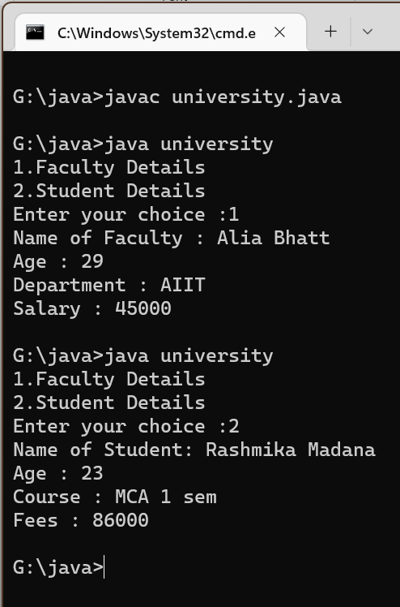

# Practical 6

Program 16: WAP to illustrate use of abstract class that has abstract and non abstract methods.

import java.util.*;

import java.io.*;

abstract class shape{

abstract void area(); //abstract method

public void display(){ //non-abstract method

System.out.println("This is a Program to find out Area");

}

}

class triangle extends shape{

void area(){

Scanner sc=new Scanner(System.in);

System.out.println("Enter height and base of triangle: ");

int h=sc.nextInt();

int b=sc.nextInt();

System.out.println("Area of Triangle is = "+(0.5*h*b)+"\n");}

}

class rectangle extends shape{

void area(){

Scanner sc=new Scanner(System.in);

System.out.println("Enter length and breadth of rectangle: ");

int l=sc.nextInt();

int b=sc.nextInt();

System.out.println("Area of rectangle is = "+(l*b)+"\n");}

}

class circle extends shape{

void area(){

Scanner sc=new Scanner(System.in);

System.out.println("Enter radius of circle: ");

int r=sc.nextInt();

System.out.println("Area of circle is = "+(3.14*r*r)+"\n");}

}

class ar{

public static void main(String[] args){

shape c=new circle();

shape r=new rectangle();

shape t=new triangle();

t.display();

c.area();

r.area();

t.area();

}

}

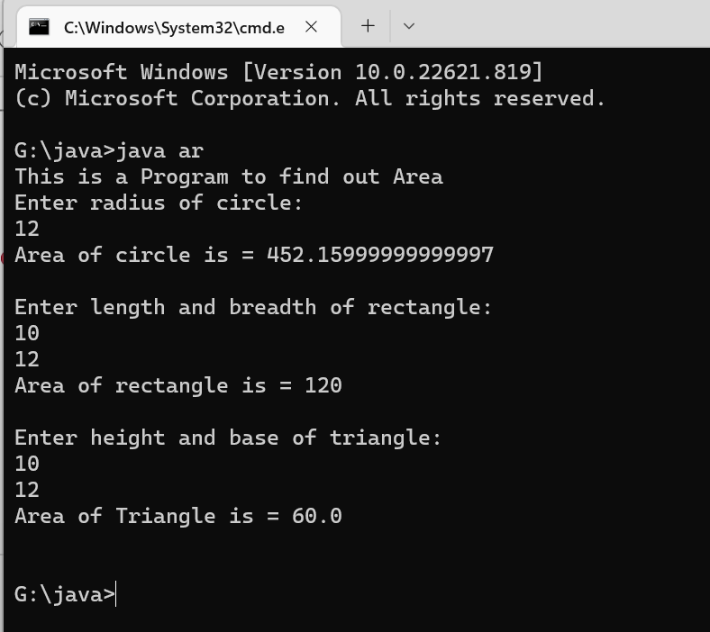

Program 17: WAP to illustrate use of interface.

interface abc

{

void display();

}

class pqr implements abc

{

public void display(){System.out.print("This is a display method");}

public static void main(String[] args){

pqr p=new pqr();

p.display();

}

}

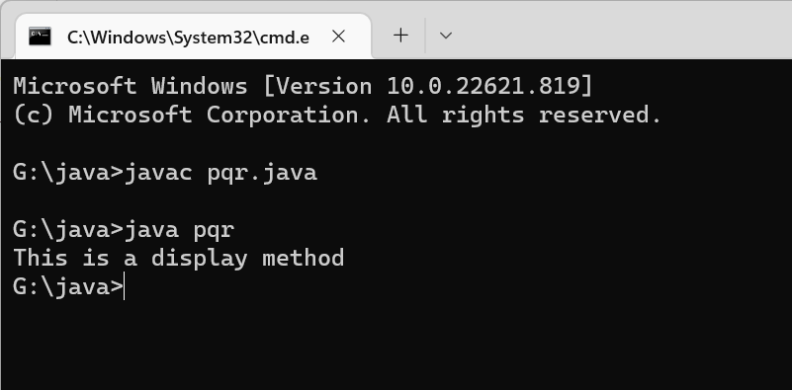

# Practical 7

Program 17: Write a java program for null pointer exception and illustrate finally block and throws keyword.

import java.io.*;

import java.util.*;

class nulldemo{

public static void main(String[] args){

Scanner sc=new Scanner(System.in);

String str=null;

String str2=null;

System.out.println("Enter Yes or No");

str=sc.nextLine();

System.out.println(" * * * * * * * * ");

try{

if (str.equals("Yes")&& str2.equals("Yes"))

System.out.println("Yes");

else

System.out.println("No");

}

catch(NullPointerException e){

System.out.println("Value is Null // Exception occurs");

}

finally{

System.out.println("Hello World //finally statement");

}

System.out.println(" * * * * * * * * ");

}

}

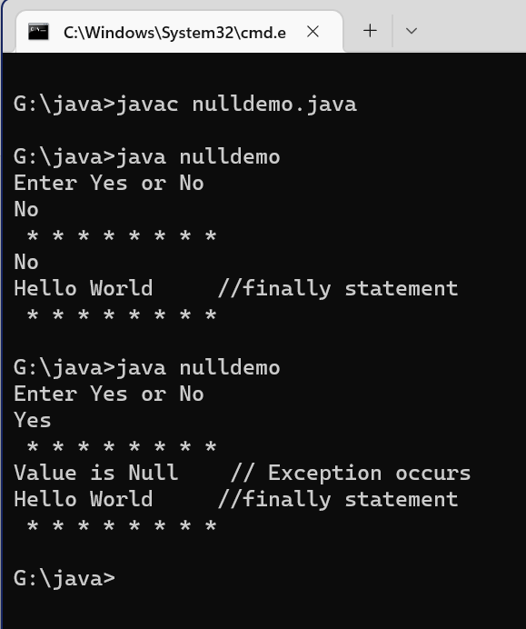

# Practical 8

Program 18: Write a java program to write text in a file

import java.io.*;

class filewriting

{

public static void main(String[] args){

try{

FileWriter r=new FileWriter("demo.txt");

try{

r.write("Hello World! My Name is Debesh Das");

}

finally{

r.close();

}

System.out.println("Successfully data is entered in fie...!");

}

catch(IOException i){

System.out.println(i);

}

}

}

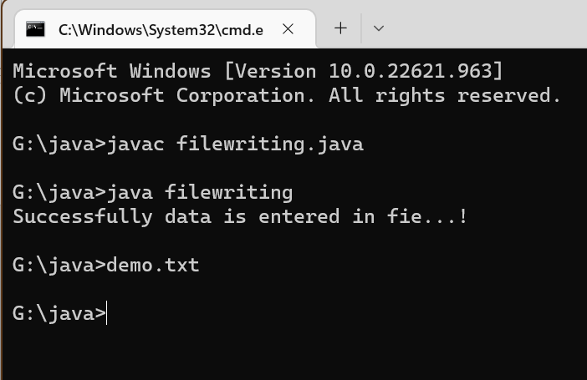

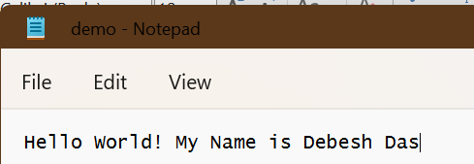

Program 19: Write a java program to read text from the file

import java.io.*;

class filereading{

public static void main(String[] args){

try{

FileReader r=new FileReader("demo.txt");

try{

int i;

while((i=r.read())!=-1){

System.out.print((char)i);

}

}

finally{

r.close();

}

}

catch(IOException e){

System.out.println("Exception Occured");

}

}

}

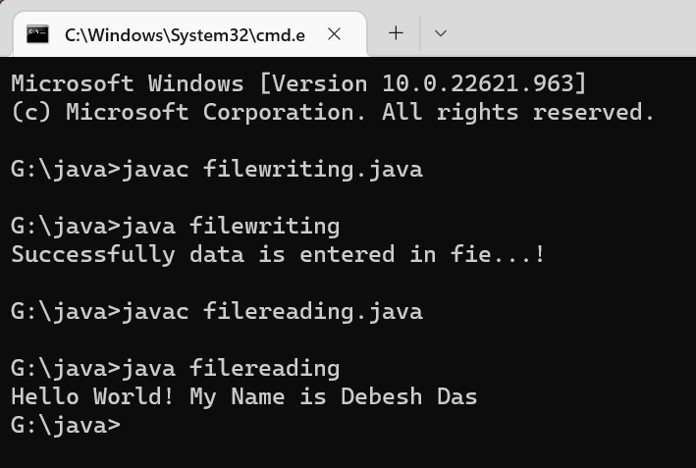

# Practical 9

Program 20: Write a java program for calculator using AWT controls

import java.awt.*;

import java.awt.event.*;

public class calculator implements ActionListener

{

int c,n;

String s1,s2,s3,s4,s5;

Frame f;

Button b1,b2,b3,b4,b5,b6,b7,b8,b9,b10,b11,b12,b13,b14,b15,b16,b17;

Panel p;

TextField tf;

GridLayout g;

calculator()

{

f = new Frame("My calculator");

p = new Panel();

f.setLayout(new FlowLayout());

b1 = new Button("0");

b1.addActionListener(this);

b2 = new Button("1");

b2.addActionListener(this);

b3 = new Button("2");

b3.addActionListener(this);

b4 = new Button("3");

b4.addActionListener(this);

b5 = new Button("4");

b5.addActionListener(this);

b6 = new Button("5");

b6.addActionListener(this);

b7 = new Button("6");

b7.addActionListener(this);

b8 = new Button("7");

b8.addActionListener(this);

b9 = new Button("8");

b9.addActionListener(this);

b10 = new Button("9");

b10.addActionListener(this);

b11 = new Button("+");

b11.addActionListener(this);

b12 = new Button("-");

b12.addActionListener(this);

b13 = new Button("*");

b13.addActionListener(this);

b14 = new Button("/");

b14.addActionListener(this);

b15 = new Button("%");

b15.addActionListener(this);

b16 = new Button("=");

b16.addActionListener(this);

b17 = new Button("C");

b17.addActionListener(this);

tf = new TextField(20);

f.add(tf);

g = new GridLayout(4,4,10,20);

p.setLayout(g);

p.add(b1);p.add(b2);p.add(b3);p.add(b4);p.add(b5);p.add(b6);p.add(b7);p.add(b8);p.add(b9);

p.add(b10);p.add(b11);p.add(b12);p.add(b13);p.add(b14);p.add(b15);p.add(b16);p.add(b17);

f.add(p);

f.setSize(300,300);

f.setVisible(true);

}

public void actionPerformed(ActionEvent e)

{

if(e.getSource()==b1)

{

s3 = tf.getText();

s4 = "0";

s5 = s3+s4;

tf.setText(s5);

}

if(e.getSource()==b2)

{

s3 = tf.getText();

s4 = "1";

s5 = s3+s4;

tf.setText(s5);

}

if(e.getSource()==b3)

{

s3 = tf.getText();

s4 = "2";

s5 = s3+s4;

tf.setText(s5);

}if(e.getSource()==b4)

{

s3 = tf.getText();

s4 = "3";

s5 = s3+s4;

tf.setText(s5);

}

if(e.getSource()==b5)

{

s3 = tf.getText();

s4 = "4";

s5 = s3+s4;

tf.setText(s5);

}

if(e.getSource()==b6)

{

s3 = tf.getText();

s4 = "5";

s5 = s3+s4;

tf.setText(s5);

}

if(e.getSource()==b7)

{

s3 = tf.getText();

s4 = "6";

s5 = s3+s4;

tf.setText(s5);

}

if(e.getSource()==b8)

{

s3 = tf.getText();

s4 = "7";

s5 = s3+s4;

tf.setText(s5);

}

if(e.getSource()==b9)

{

s3 = tf.getText();

s4 = "8";

s5 = s3+s4;

tf.setText(s5);

}

if(e.getSource()==b10)

{

s3 = tf.getText();

s4 = "9";

s5 = s3+s4;

tf.setText(s5);

}

if(e.getSource()==b11)

{

s1 = tf.getText();

tf.setText("");

c=1;

}

if(e.getSource()==b12)

{

s1 = tf.getText();

tf.setText("");

c=2;

}

if(e.getSource()==b13)

{

s1 = tf.getText();

tf.setText("");

c=3;

}

if(e.getSource()==b14)

{

s1 = tf.getText();

tf.setText("");

c=4;

}

if(e.getSource()==b15)

{

s1 = tf.getText();

tf.setText("");

c=5;

}

if(e.getSource()==b16)

{

s2 = tf.getText();

if(c==1)

{

n = Integer.parseInt(s1)+Integer.parseInt(s2);

tf.setText(String.valueOf(n));

}

else

if(c==2)

{

n = Integer.parseInt(s1)-Integer.parseInt(s2);

tf.setText(String.valueOf(n));

}

else

if(c==3)

{

n = Integer.parseInt(s1)*Integer.parseInt(s2);

tf.setText(String.valueOf(n));

}

if(c==4)

{

try

{

int p=Integer.parseInt(s2);

if(p!=0)

{

n = Integer.parseInt(s1)/Integer.parseInt(s2);

tf.setText(String.valueOf(n));

}

else

tf.setText("infinite");

}

catch(Exception i){}

}

if(c==5)

{

n = Integer.parseInt(s1)%Integer.parseInt(s2);

tf.setText(String.valueOf(n));

}

}

if(e.getSource()==b17)

{

tf.setText("");

}

}

public static void main(String[] abc)

{

calculator v = new calculator();

}

}

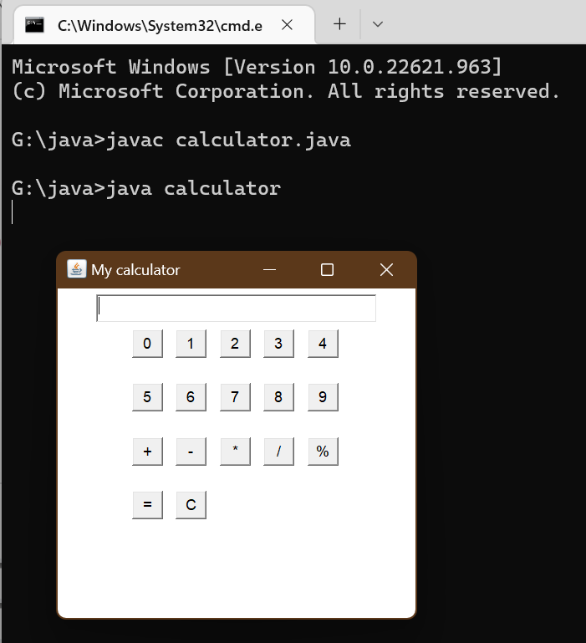

# Practical 10

Program 21: Write a java program for student registration form using jswing

// Java program to implement

// a Simple Registration Form

// using Java Swing

import javax.swing.*;

import java.awt.*;

import java.awt.event.*;

class MyFrame

extends JFrame

implements ActionListener {

// Components of the Form

private Container c;

private JLabel title;

private JLabel name;

private JTextField tname;

private JLabel mno;

private JTextField tmno;

private JLabel gender;

private JRadioButton male;

private JRadioButton female;

private ButtonGroup gengp;

private JLabel dob;

private JComboBox date;

private JComboBox month;

private JComboBox year;

private JLabel add;

private JTextArea tadd;

private JCheckBox term;

private JButton sub;

private JButton reset;

private JTextArea tout;

private JLabel res;

private JTextArea resadd;

private String dates[]

= { "1", "2", "3", "4", "5",

"6", "7", "8", "9", "10",

"11", "12", "13", "14", "15",

"16", "17", "18", "19", "20",

"21", "22", "23", "24", "25",

"26", "27", "28", "29", "30",

"31" };

private String months[]

= { "Jan", "feb", "Mar", "Apr",

"May", "Jun", "July", "Aug",

"Sup", "Oct", "Nov", "Dec" };

private String years[]

= { "1995", "1996", "1997", "1998",

"1999", "2000", "2001", "2002",

"2003", "2004", "2005", "2006",

"2007", "2008", "2009", "2010",

"2011", "2012", "2013", "2014",

"2015", "2016", "2017", "2018",

"2019" };

// constructor, to initialize the components

// with default values.

public MyFrame()

{

setTitle("Registration Form");

setBounds(300, 90, 900, 600);

setDefaultCloseOperation(EXIT_ON_CLOSE);

setResizable(false);

c = getContentPane();

c.setLayout(null);

title = new JLabel("Registration Form");

title.setFont(new Font("Arial", Font.PLAIN, 30));

title.setSize(300, 30);

title.setLocation(300, 30);

c.add(title);

name = new JLabel("Name");

name.setFont(new Font("Arial", Font.PLAIN, 20));

name.setSize(100, 20);

name.setLocation(100, 100);

c.add(name);

tname = new JTextField();

tname.setFont(new Font("Arial", Font.PLAIN, 15));

tname.setSize(190, 20);

tname.setLocation(200, 100);

c.add(tname);

mno = new JLabel("Mobile");

mno.setFont(new Font("Arial", Font.PLAIN, 20));

mno.setSize(100, 20);

mno.setLocation(100, 150);

c.add(mno);

tmno = new JTextField();

tmno.setFont(new Font("Arial", Font.PLAIN, 15));

tmno.setSize(150, 20);

tmno.setLocation(200, 150);

c.add(tmno);

gender = new JLabel("Gender");

gender.setFont(new Font("Arial", Font.PLAIN, 20));

gender.setSize(100, 20);

gender.setLocation(100, 200);

c.add(gender);

male = new JRadioButton("Male");

male.setFont(new Font("Arial", Font.PLAIN, 15));

male.setSelected(true);

male.setSize(75, 20);

male.setLocation(200, 200);

c.add(male);

female = new JRadioButton("Female");

female.setFont(new Font("Arial", Font.PLAIN, 15));

female.setSelected(false);

female.setSize(80, 20);

female.setLocation(275, 200);

c.add(female);

gengp = new ButtonGroup();

gengp.add(male);

gengp.add(female);

dob = new JLabel("DOB");

dob.setFont(new Font("Arial", Font.PLAIN, 20));

dob.setSize(100, 20);

dob.setLocation(100, 250);

c.add(dob);

date = new JComboBox(dates);

date.setFont(new Font("Arial", Font.PLAIN, 15));

date.setSize(50, 20);

date.setLocation(200, 250);

c.add(date);

month = new JComboBox(months);

month.setFont(new Font("Arial", Font.PLAIN, 15));

month.setSize(60, 20);

month.setLocation(250, 250);

c.add(month);

year = new JComboBox(years);

year.setFont(new Font("Arial", Font.PLAIN, 15));

year.setSize(60, 20);

year.setLocation(320, 250);

c.add(year);

add = new JLabel("Address");

add.setFont(new Font("Arial", Font.PLAIN, 20));

add.setSize(100, 20);

add.setLocation(100, 300);

c.add(add);

tadd = new JTextArea();

tadd.setFont(new Font("Arial", Font.PLAIN, 15));

tadd.setSize(200, 75);

tadd.setLocation(200, 300);

tadd.setLineWrap(true);

c.add(tadd);

term = new JCheckBox("Accept Terms And Conditions.");

term.setFont(new Font("Arial", Font.PLAIN, 15));

term.setSize(250, 20);

term.setLocation(150, 400);

c.add(term);

sub = new JButton("Submit");

sub.setFont(new Font("Arial", Font.PLAIN, 15));

sub.setSize(100, 20);

sub.setLocation(150, 450);

sub.addActionListener(this);

c.add(sub);

reset = new JButton("Reset");

reset.setFont(new Font("Arial", Font.PLAIN, 15));

reset.setSize(100, 20);

reset.setLocation(270, 450);

reset.addActionListener(this);

c.add(reset);

tout = new JTextArea();

tout.setFont(new Font("Arial", Font.PLAIN, 15));

tout.setSize(300, 400);

tout.setLocation(500, 100);

tout.setLineWrap(true);

tout.setEditable(false);

c.add(tout);

res = new JLabel("");

res.setFont(new Font("Arial", Font.PLAIN, 20));

res.setSize(500, 25);

res.setLocation(100, 500);

c.add(res);

resadd = new JTextArea();

resadd.setFont(new Font("Arial", Font.PLAIN, 15));

resadd.setSize(200, 75);

resadd.setLocation(580, 175);

resadd.setLineWrap(true);

c.add(resadd);

setVisible(true);

}

// method actionPerformed()

// to get the action performed

// by the user and act accordingly

public void actionPerformed(ActionEvent e)

{

if (e.getSource() == sub) {

if (term.isSelected()) {

String data1;

String data

= "Name : "

+ tname.getText() + "\n"

+ "Mobile : "

+ tmno.getText() + "\n";

if (male.isSelected())

data1 = "Gender : Male"

+ "\n";

else

data1 = "Gender : Female"

+ "\n";

String data2

= "DOB : "

+ (String)date.getSelectedItem()

+ "/" + (String)month.getSelectedItem()

+ "/" + (String)year.getSelectedItem()

+ "\n";

String data3 = "Address : " + tadd.getText();

tout.setText(data + data1 + data2 + data3);

tout.setEditable(false);

res.setText("Registration Successfully..");

}

else {

tout.setText("");

resadd.setText("");

res.setText("Please accept the"

+ " terms & conditions..");

}

}

else if (e.getSource() == reset) {

String def = "";

tname.setText(def);

tadd.setText(def);

tmno.setText(def);

res.setText(def);

tout.setText(def);

term.setSelected(false);

date.setSelectedIndex(0);

month.setSelectedIndex(0);

year.setSelectedIndex(0);

resadd.setText(def);

}

}

}

// Driver Code

class Registration {

public static void main(String[] args) throws Exception

{

MyFrame f = new MyFrame();

}

}

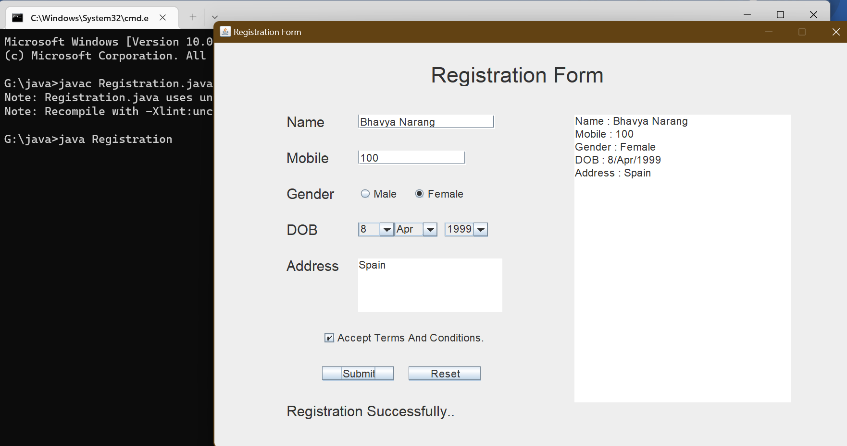

# Practical 11

Program 22: WAP to demonstrate LinkedList and it's methods

import java.util.LinkedList;

class ll

{

public static void main(String[] args)

{

LinkedList<String> car = new LinkedList<>();

car.add("BMW");

car.add("AUDI");

car.add("FERRARI");

System.out.println("LinkedList: " + car);

}

}

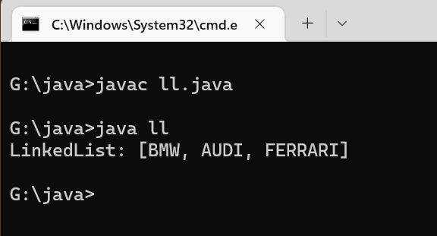

Program 23: WAP to demonstrate HashSet and it’s method

import java.io.*;

import java.util.*;

class hsdem

{

public static void main(String[] args)

{

HashSet<String> hs = new HashSet<String>();

hs.add("Bhavya");

hs.add("Shruti");

hs.add("Vaishali");

System.out.println("HashSet elements : " + hs);

}

}

