1. Project Overview
This project automates appointment scheduling for a clinic using an N8N workflow and the WhatsApp Cloud API. It validates user information, checks availability, books appointments, and automatically sends reminders and promotional announcement messages on WhatsApp.

2. Objectives
The objective of this project is to build an automated WhatsApp-based clinic assistant that streamlines patient communication and appointment management. It handles bookings, sends reminders, provides service menus, and answers FAQs using N8N and the WhatsApp Cloud API. The system also captures leads, syncs data to Google Sheets, and sends promotional announcements automatically.

3. Features Implemented
- Integrated WhatsApp Cloud API to receive and send messages
- AI Agent handles full booking flow using Google Gemini Chat Model
- Google Sheets CRM Integration
- Google Calendar Appointment Sync
- AI-Driven RAG (Retrieval-Augmented Generation) for FAQs
- Ensures 24/7 patient support
- Sends structured list of services and pricing.
- Sends personalized reminder messages
- Memory-Based Conversation Handling

4. Technology Stack
Component | Technology Used
Automation Engine | N8N
Database | Google Sheets / Supabase vector store/N8N Simple memory
APIs | WhatsApp Cloud API, Google Gemini API, Google Sheets API, Google Calendar API
Additional Services | Webhooks, Apps Script, Google Gemini embeddings for RAG

5. Workflow Architecture
Include a diagram or explanation:
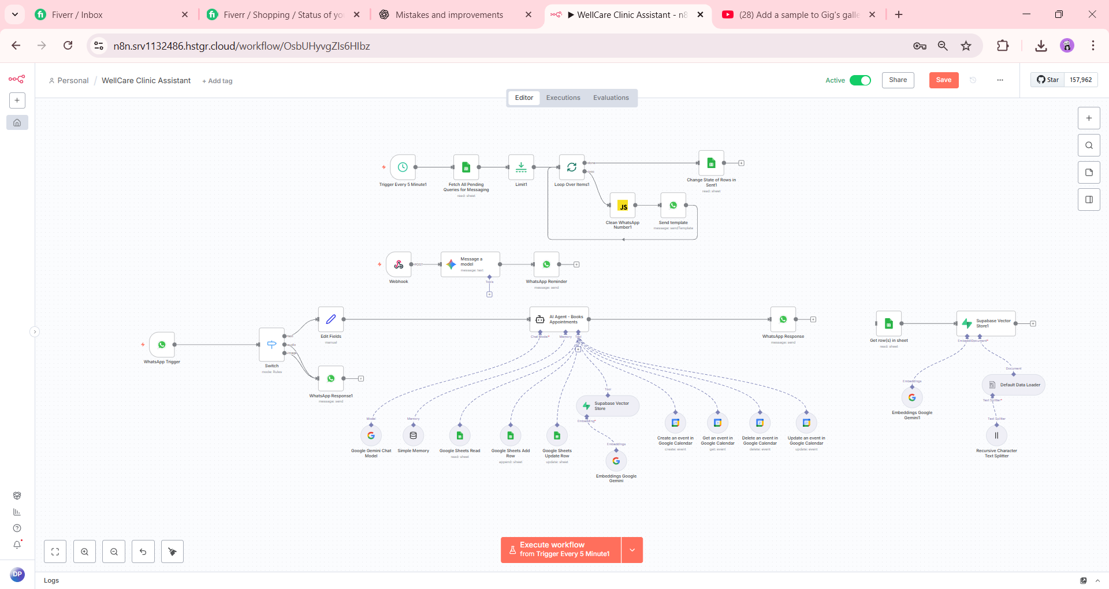

6. Testing
- Booking, Reschedule and Cancellation
- Date & Time validation testing
- Sending Reminder
- API response testing
- Reduced bugs
- Success/failure scenarios tested

7. Final Deliverables
- Documentation
- Google Sheet
- Google Calendar
- N8n Json workflow
8. WhatsApp Cloud API Overview
The WhatsApp Cloud API is Meta’s official API that allows businesses to send and receive WhatsApp messages programmatically. It acts as a bridge between your application (like N8N workflows) and WhatsApp. Key features include:
- Sending text, images, documents, and templates.
- Receiving incoming messages from users.
- Managing conversations in real time.

9. Role of N8N
N8N is a workflow automation tool. In a WhatsApp chatbot setup, N8N:
- Receives incoming WhatsApp messages.
- Processes the message to detect intent or trigger workflows.
- Sends responses back to the user via the WhatsApp Cloud API.
Essentially, N8N acts as the middleware between the user and your chatbot logic.

How the WhatsApp Cloud API Works in N8N?
- Incoming Messages:
  - When a user sends a message on WhatsApp, the WhatsApp Cloud API sends a webhook request to N8N with the message content, sender info, and message type.
  - In N8N, this is handled using a Webhook node configured to receive incoming WhatsApp messages.
- Processing in N8N:
After receiving the webhook, N8N can:
    - Extract the user’s message.
    - Check user details (phone number, previous messages).
    - Decide which workflow or chatbot response to trigger.
This can include reading/writing data to Google Sheets, checking appointments, or sending dynamic replies.
- Sending Messages via API:
N8N uses the HTTP Request node (or a dedicated WhatsApp Cloud API node if available) to send messages back to the user.
Example actions include:
    - Sending a text message: “Your appointment is confirmed.”
    - Sending a file or image: e.g., PDF receipt.
    - Using message templates for structured messages.
- Authentication:
WhatsApp Cloud API requires a Bearer token for authentication.
N8N stores this token securely in the workflow to authorize each outgoing message request.

10. How WhatsApp Cloud Was Implemented in Your Chatbot?
I used your Facebook portfolio to create an App ID in the Meta for Developers account. Then, I added your WhatsApp number and obtained the following credentials:
- Client ID
- Client Secret
- Access Token
- Business Account ID
These credentials were used in N8N to activate and integrate the WhatsApp Cloud API with your chatbot.

11. Setup Instruction
To test the chatbot’s functionality with Google Calendar and Google Sheets, please use the following credentials:
- Email ID:
- Password:
- ⚠️ For security reasons, please do not share these credentials with anyone.
After logging in, you can verify:
- Appointments and booking flow on Google Calendar
- Patient and lead data on Google Sheets
If you face any issues while accessing or testing, please let me know—I’ll be happy to assist.
Note:
To send promotional messages to users through the WhatsApp Cloud API, your WhatsApp Business Account must have a valid payment method registered. This is required by Meta for billing and compliance purposes. Without payment information, sending promotional or marketing messages is not allowed.
To continue using Google Gemini AI or OpenAI APIs in the future, especially with a large number of users, a valid billing/payment method must be registered with the respective service. Currently, the Google Gemini Chat Model in this chatbot is running on the free tier, which has usage limits. For scaling to more users or heavy usage, a paid plan with billing enabled will be required.

12. Screenshot

