1. Executive Summary
This report analyzes the effectiveness of application execution policies (AppLocker) configured on a Windows 11 host. While the default rules successfully restricted unauthorized software execution from standard user directories (such as Downloads), a critical configuration discrepancy regarding Windows directory permissions allowed for a complete bypass of the security perimeter.
- Target System: Windows 11 Virtual Machine
- Attack Technique: MITRE ATT&CK T1218 (System Binary Proxy Execution) / AppLocker Bypass
- Risk Rating: High

2. Technical Analysis & Proof of Concept (PoC)

Step 1: Weak Directory Permissions Discovery (Reconnaissance)
Operating under a standard, non-administrative user context, a reconnaissance phase was initiated to identify any directories under C:\Windows that grant write access to ordinary users. Utilizing the built-in Windows icacls utility, it was discovered that the C:\Windows\Tasks directory grants Modify (M) / Write rights to the standard BUILTIN\Users group.
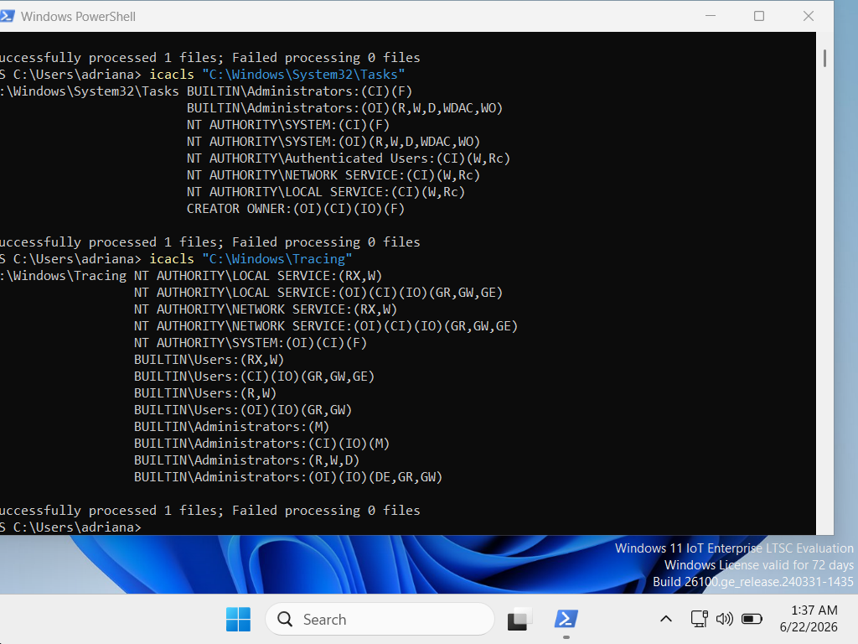

Step 2: Execution Attempt in Disallowed Directory (Downloads)
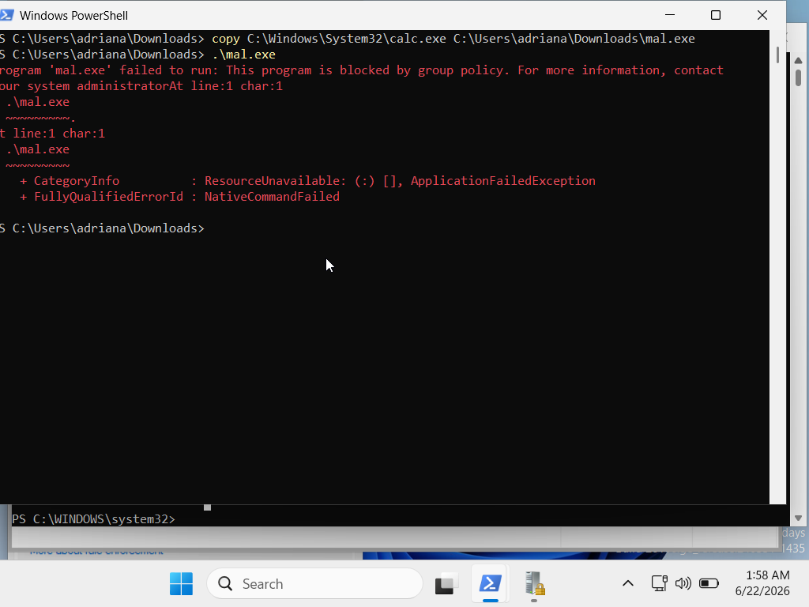
To simulate a malicious execution attempt, a legitimate system binary (calc.exe) was duplicated into the user's Downloads directory and renamed to malicious.exe. When execution was attempted from this directory, the AppLocker enforcement rule correctly intervened and blocked the process.

Step 3: Successful AppLocker Policy Bypass (Execution)
Taking advantage of the trusted path configuration, the blocked binary was copied into the weakly secured C:\Windows\Tasks folder. Since AppLocker inherently trusts the C:\Windows\* path prefix, initiating the binary from this subfolder completely bypassed the security restriction, resulting in an unrestricted process launch.

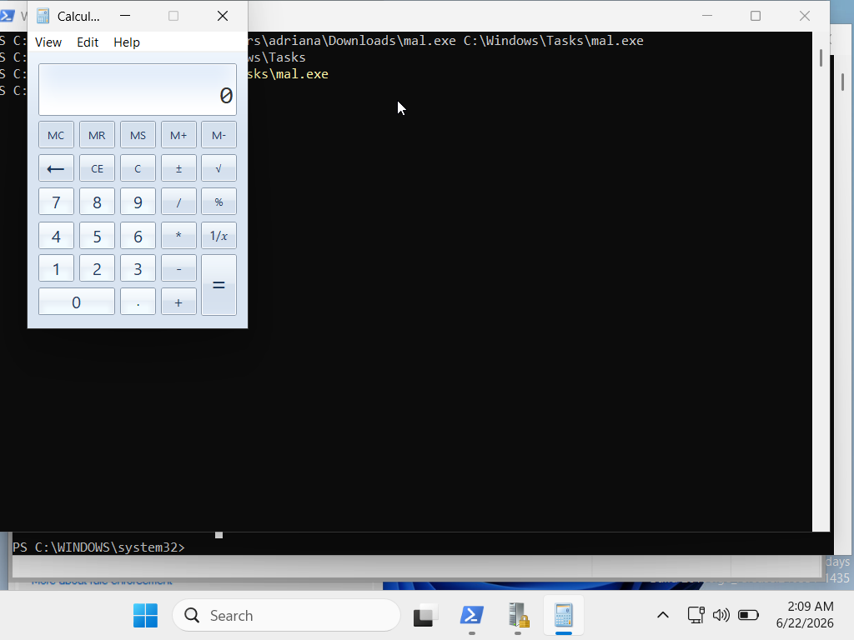
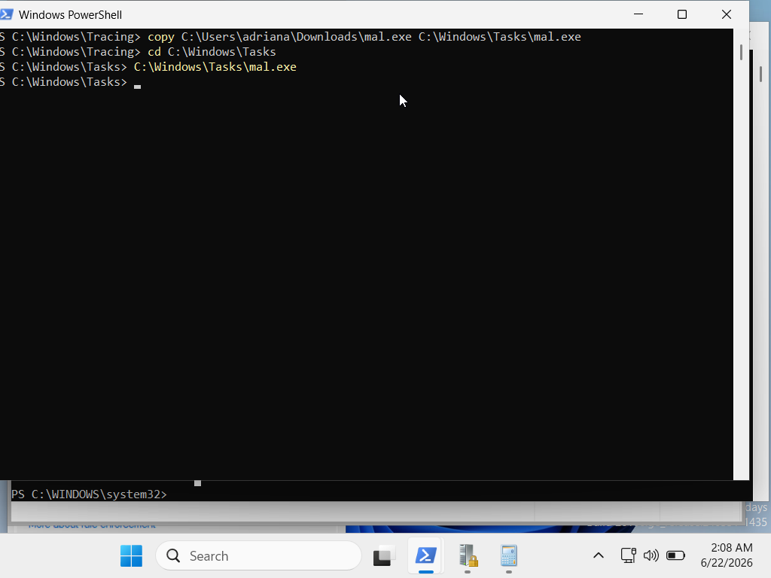

3. Root Cause Analysis
The core vulnerability stems from an implicit trust model. The default AppLocker rules white-list the entire C:\Windows\* directory tree under the assumption that only administrative accounts can modify its contents. However, native Windows architecture leaves specific folders—such as Tasks, System32\Tasks, and Tracing—writable by standard users to facilitate local background services. This path-trust contradiction allows an adversary to drop and execute arbitrary files within an approved path.

4. Remediation & Hardening (Blue Team Recommendations)
To secure the enterprise environment against this specific Living-off-the-Land (LotL) path bypass, the following mitigation strategy must be deployed:

1. Implementation of AppLocker Path Exceptions
The local security policy (secpol.msc) or Centralized Group Policy Objects (GPO) must be updated. The default rule allowing execution from C:\Windows\* must be configured with explicit Exceptions for user-writable folders:
- C:\Windows\Tasks\*
- C:\Windows\System32\Tasks\*
- C:\Windows\Tracing\*

2. Security Monitoring and Auditing (SIEM/EDR)
Security operations should actively monitor Windows Event Logs under Microsoft-Windows-AppLocker/EXE and DLL. Focus on tracking Event ID 8002 (Allowed) and Event ID 8004 (Blocked). Standard users initiating script or binary executions originating from system infrastructure paths like \Tasks\ should trigger an immediate high-priority alert.

