1. Executive Summary
This report documents a post-exploitation security assessment focused on Windows PowerShell restriction mechanisms. In high-security environments, administrators enforce Constrained Language Mode (CLM) via AppLocker to prevent attackers from executing advanced .NET objects or reverse shells. This assessment demonstrates two distinct technical methodologies to completely bypass CLM constraints and restore full scripting capabilities without administrative privileges.
- Target System: Windows 11 Virtual Machine
- Attack Technique: MITRE ATT&CK T1059.001 (Command and Scripting Interpreter: PowerShell) / Defense Evasion
- Risk Rating: High

2. Technical Analysis & Proof of Concept (PoC)

Step 1: Initial Language Mode Verification (Baseline)
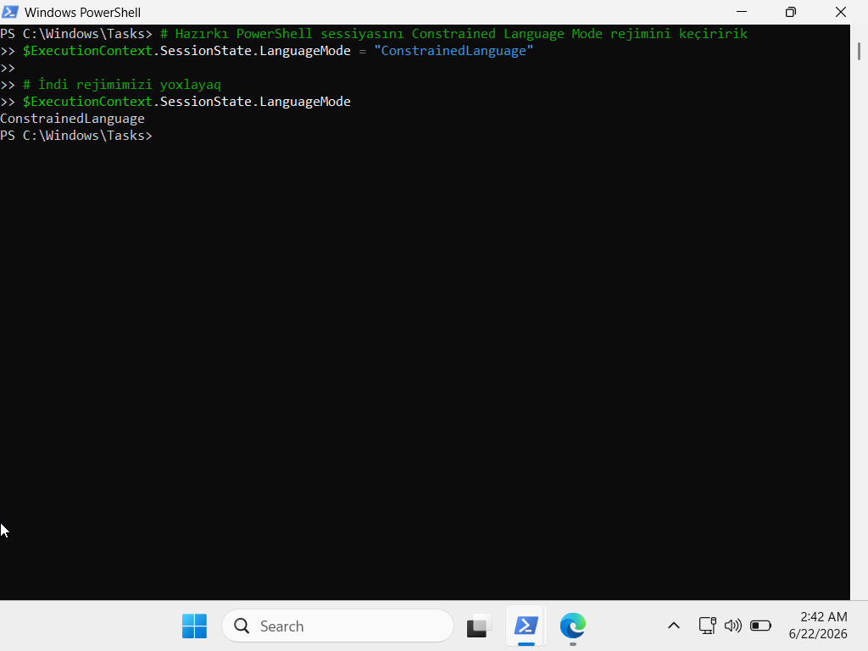
An initial verification check was performed in a standard, non-administrative PowerShell session to confirm that the security restriction was active. The environment successfully restricted advanced execution, operating under the constrained profile.

Step 2: Bypass Methodology v1 – Downgrade Attack (PowerShell V2)
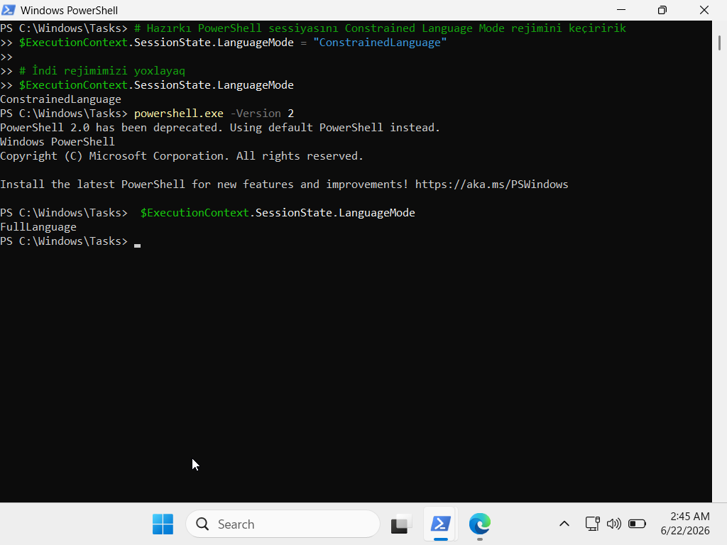
The first bypass utilizes a version downgrade technique. While modern PowerShell engines enforce CLM strictly, legacy engines such as PowerShell Version 2.0 do not possess an inherent understanding of AppLocker's language constraints. By explicitly invoking the legacy engine, the restriction was immediately neutralized.

Step 3: Bypass Methodology v2 – Environment Variable Manipulation (__PSLockdownPolicy)
To simulate an environment where legacy components (PowerShell V2) are disabled, a second, more advanced process-level bypass was performed. AppLocker signals CLM to PowerShell using a hidden system environment variable named __PSLockdownPolicy (where a value of 4 enforces strict mode).
By spawning a standard Command Prompt (CMD), temporarily overwriting this environment variable to 0 (disabled) within the local process scope, and spawning a new PowerShell instance from that exact session, the engine was deceived into disabling all language restrictions.

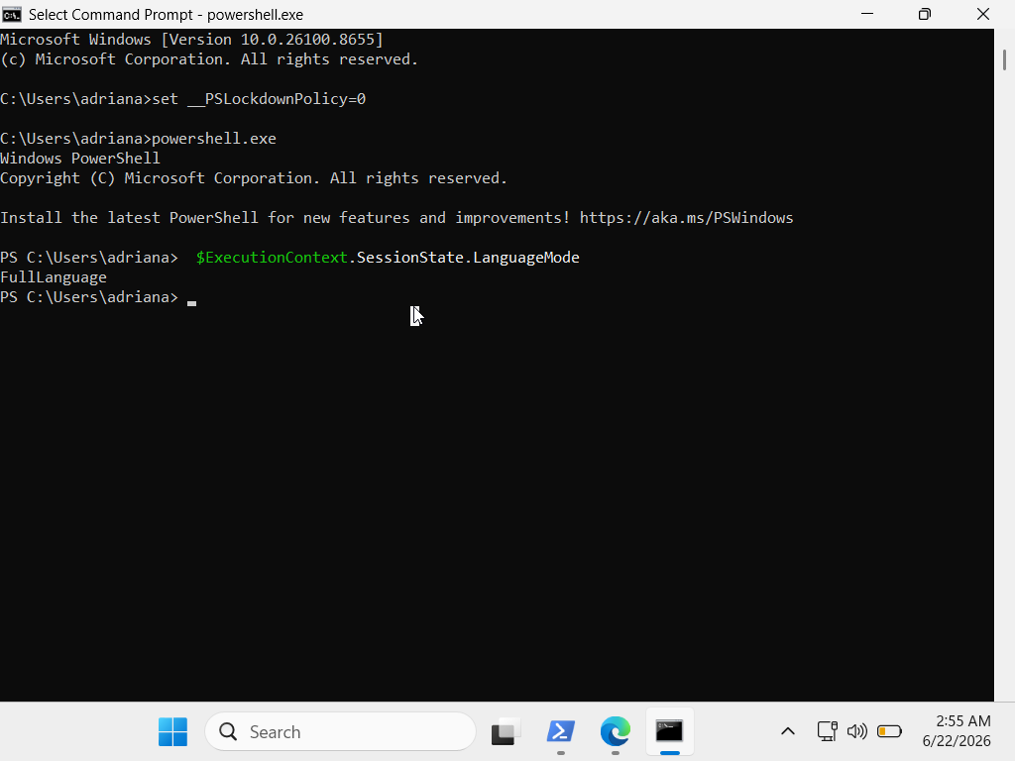
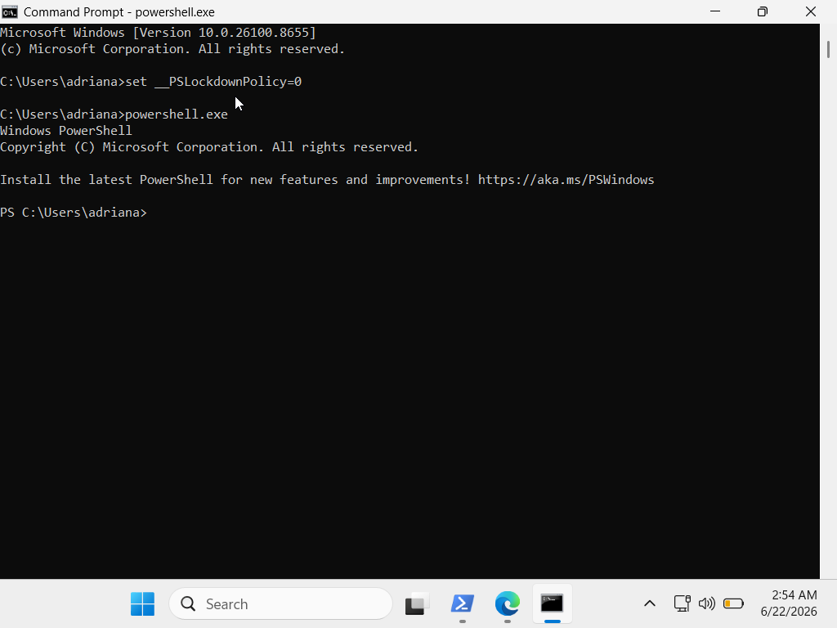

3. Root Cause Analysis
The vulnerability exists due to two primary oversight issues in standard operating environment blueprints:
- Backward Compatibility Overhead: Leaving legacy sub-components like PowerShell v2 active presents an immediate avenue for downgrade attacks.
- Process-Level Trust Boundaries: PowerShell heavily relies on environment variables (__PSLockdownPolicy) inherited from the parent process to determine enforcement levels. If an attacker can manipulate the environment block before the shell initializes, the security controls can be systematically blinded.

4. Remediation & Hardening (Blue Team Recommendations)
To effectively seal these bypass vectors across corporate endpoints, the following defensive configurations must be enforced:

1. Complete Removal of PowerShell v2 Engines
Legacy engines must be completely uninstalled from the operating system image rather than just restricted.
Configure the __PSLockdownPolicy registry setting at the Machine level rather than the User level, preventing non-administrative user processes from modifying or nullifying the lockdown status during process spawning.

