CYBERSECURITY LAB REPORT: Credential Harvesting via Port Forwarding
Objective: Educational and defensive analysis of Phishing attacks and modern Port Forwarding (tunneling) mechanisms. Attacker Platform: Kali Linux v2026 Backend Technologies: PHP (Built-in Server) Tunneling Service: Ngrok

Step 1: Frontend Design (index.html)
A clean, non-suspicious, and minimal user authentication form was created using standard HTML and CSS. The purpose of this form is to capture user inputs and securely relay them to the backend server using the HTTP POST method.
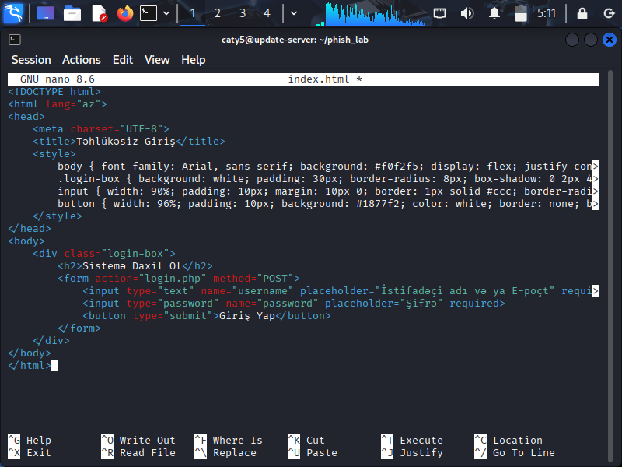

Step 2: Backend Mechanism Design (login.php)
A custom PHP backend script was implemented to orchestrate the post-exploitation process. The script captures the incoming variables (username and password), writes them silently into a persistent flat-text file named sifreler.txt, and seamlessly redirects the unsuspecting victim to the official Google landing page to evade detection.
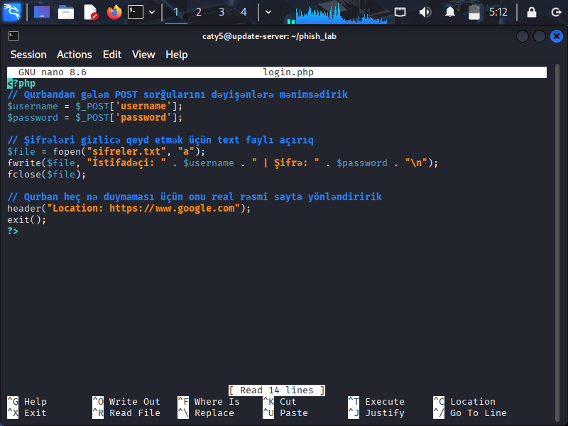

Step 3: Launching the Local PHP Web Server
Since the target platform requires server-side processing for PHP scripts, a local runtime environment was initialized directly on Kali Linux. A built-in PHP development web server was successfully launched on port 8080
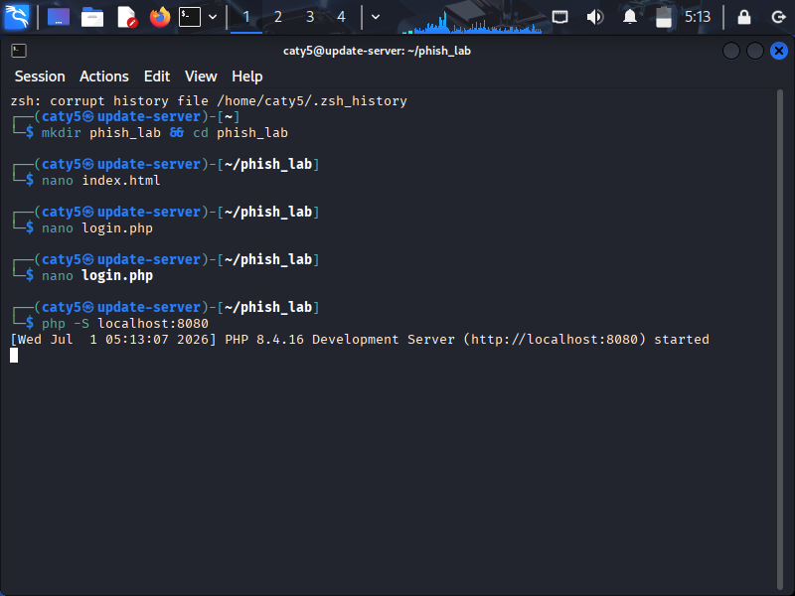

Step 4: Port Forwarding via Ngrok (Bypassing NAT/Firewall)
Because the local environment sits securely behind a residential NAT router and an inbound firewall, a local host configuration is unreachable from the public internet. To bypass this restriction, an active secure tunnel was established via ngrok, exposing local port 8080 to a globally accessible public URL.
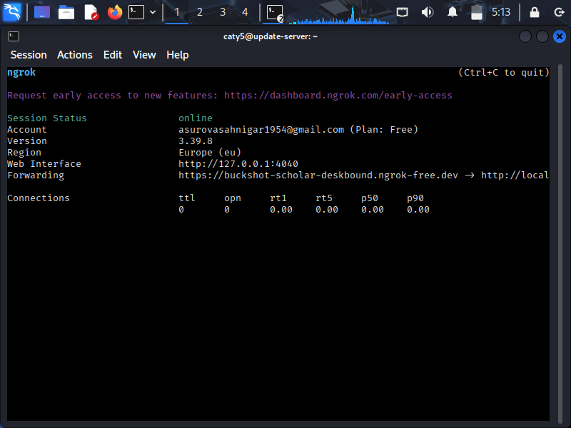

Step 5: Execution & Victim Perspective (Real-Time Deployment)
The generated public Ngrok URL (https://buckshot-scholar-deskbound.ngrok-free.dev) was navigated to from an external target device (e.g., a smartphone on a different network). The router restrictions were completely circumvented, and the custom login portal was displayed seamlessly to the user.

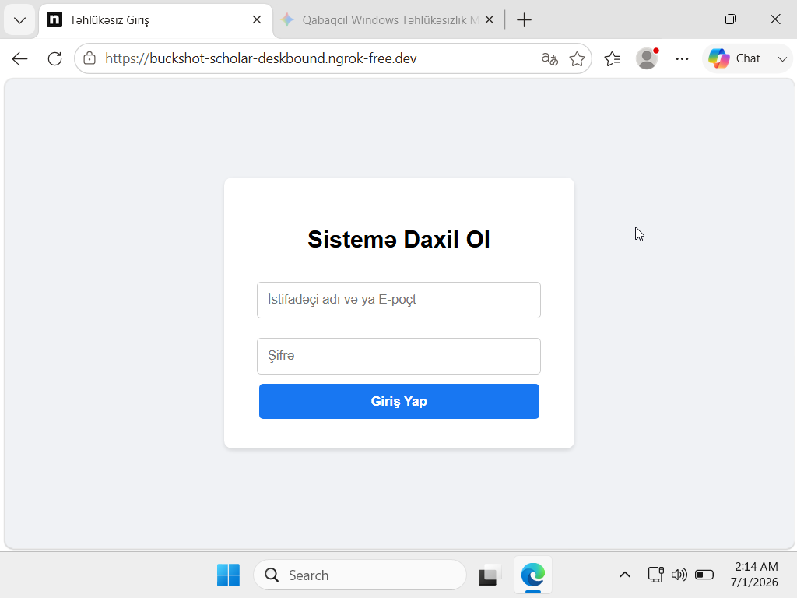

Step 6: Credential Harvesting (Simulated Trap Engagement)
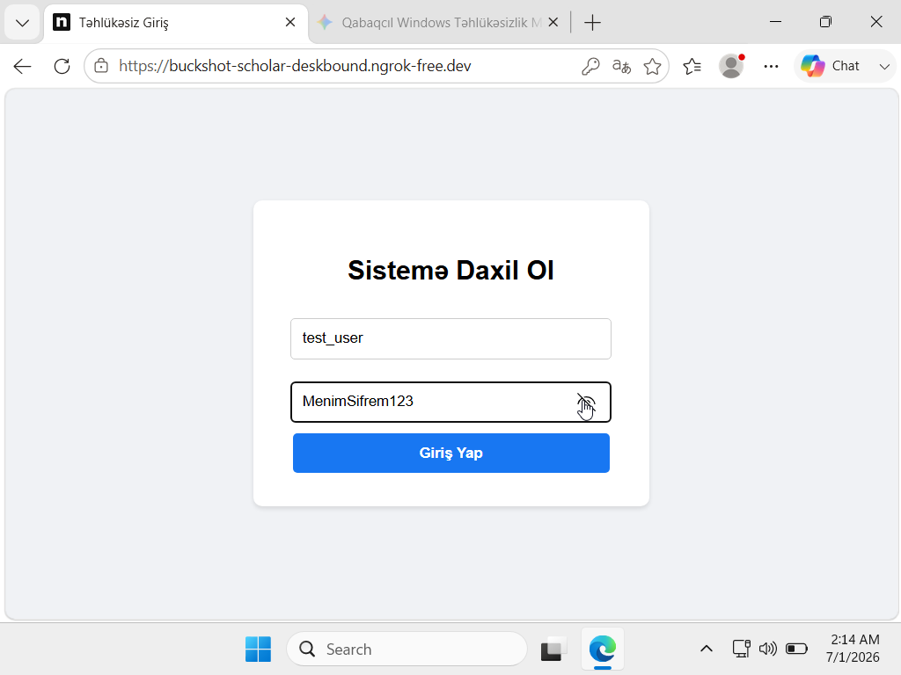
To test the active operational capabilities of the setup, arbitrary credentials (e.g., username: test_user, password: MySecurePassword123) were filled into the required fields, and the "Giriş" action button was pressed. The application intercepted the data stream and safely redirected the client to Google's official website.

Step 7: Exfiltration Success (Data Verification)
Returning to the local terminal on Kali Linux, an examination of the target environment directory was executed. Using the cat utility, the contents of the sifreler.txt file were analyzed, confirming that the harvested credentials had been successfully exfiltrated in clear text.
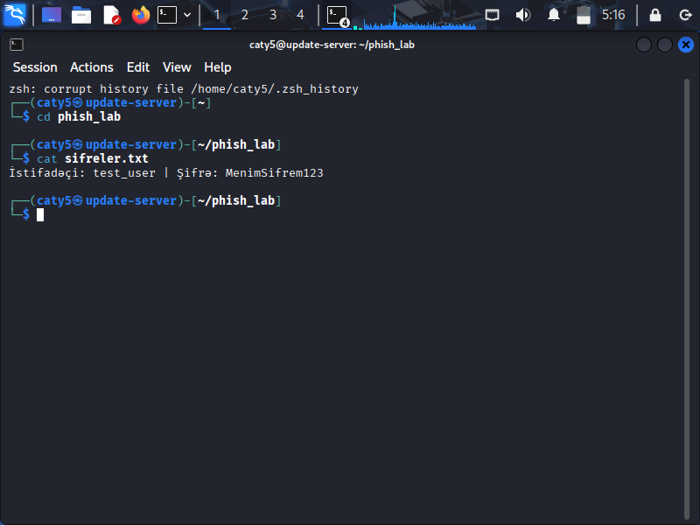

🛡️ Conclusion & Mitigation Strategies
This laboratory experiment highlights how firewalls and traditional perimeter routers inherently trust outbound connections. Port forwarding and reverse tunneling solutions (like Ngrok) exploit this design behavior to punch holes through firewalls without any prior network configuration access.
Mitigation Policies:
- Domain Security Awareness: Users must always inspect URL strings and domain extensions before entering operational or financial metadata. (e.g., recognizing that .ngrok-free.dev is not an authentic enterprise domain).
- Endpoint Protection: Implementing behavior-based Endpoint Detection and Response (EDR) agents capable of flagging unauthorized outbound tunnel connections at the system layer.

