1. Executive Summary
This investigative laboratory project simulates a high-privileged adversary's behavior regarding Log Injection (forging forensic trails) and Anti-Forensics (clearing logs to evade detection). As a Blue Team defense mechanism, the objective was to analyze how the Windows Kernel responds to administrative log tampering and to prove that even when logs are completely wiped, an indelible cryptographic and behavioral trail is left behind in the Security and System event logs.
2. Phase 1: Adverse Log Injection (Adversary Simulation)
Tactic: MITRE ATT&CK T1036 (Masquerading) / T1059 (Command and Scripting Interpreter)
Objective: Inject a deceptive, high-severity error message into the official Windows event stream to mislead incident responders.
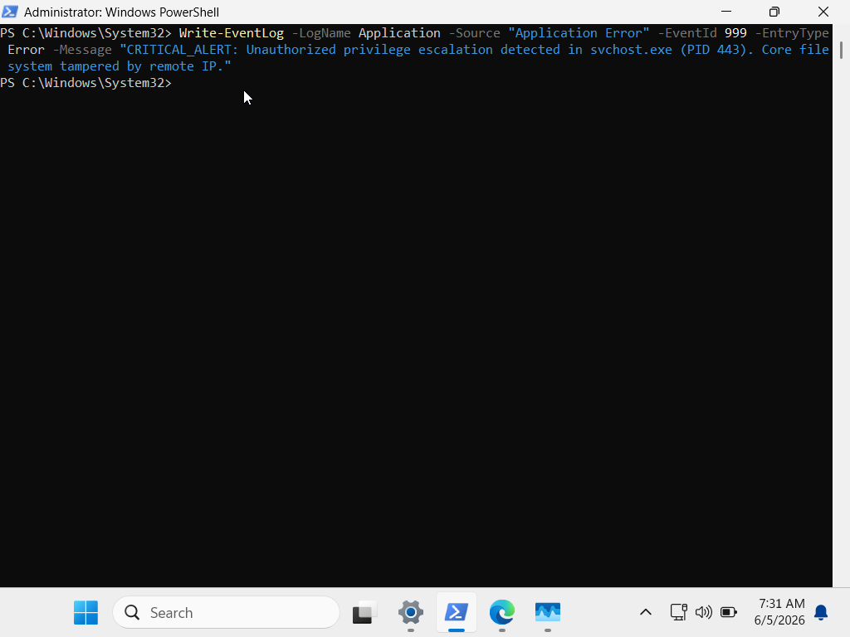
Execution: An administrative PowerShell session was utilized to forcefully inject a custom, malicious event entry into the Application log channel under the guise of a native system crash:
Forensic Proof & Verification:
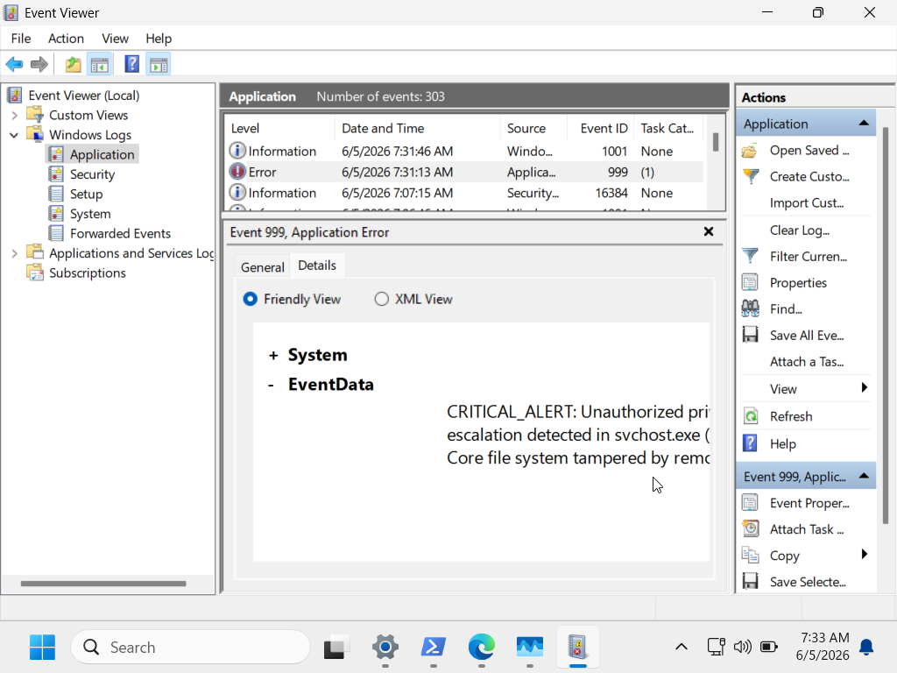
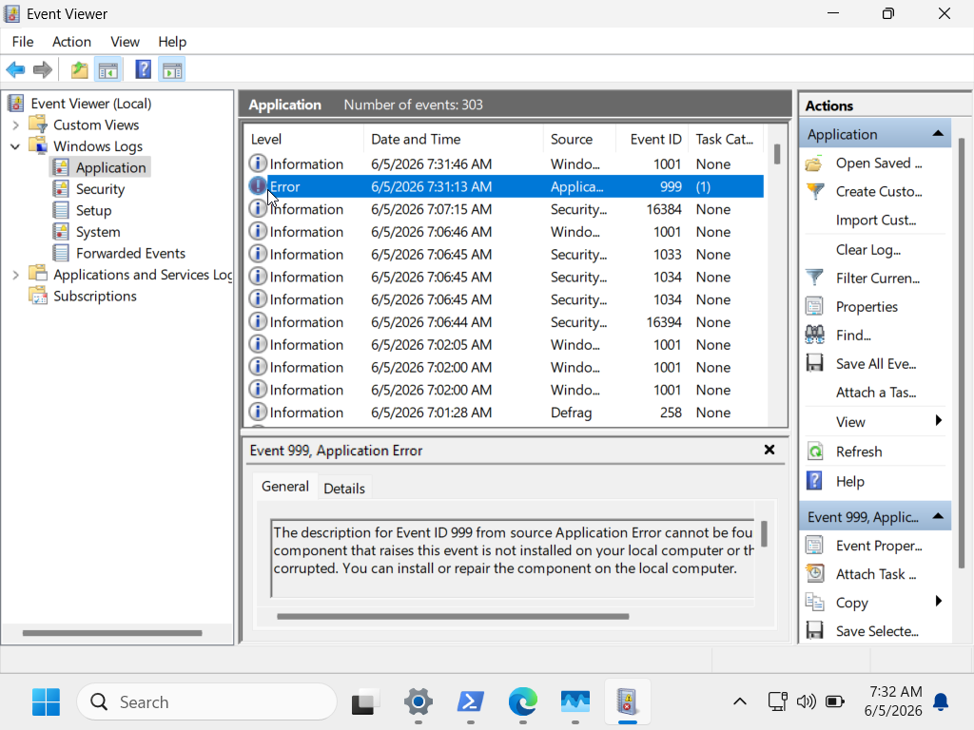
The Windows Subsystem successfully committed the entry. Using Event Viewer (eventvwr.msc), the artifact was localized within the Application logs under Event ID 999, proving that administrative access allows attackers to write arbitrary data into system logs.
3. Phase 2: Anti-Forensics & Wiping Trails (Log Purging)
Tactic: MITRE ATT&CK T1070.001 - Indicator Removal: Clear Windows Event Logs
Objective: Wipe the Application and Security log databases entirely to cover up the malicious presence and the previously injected log.
Execution:
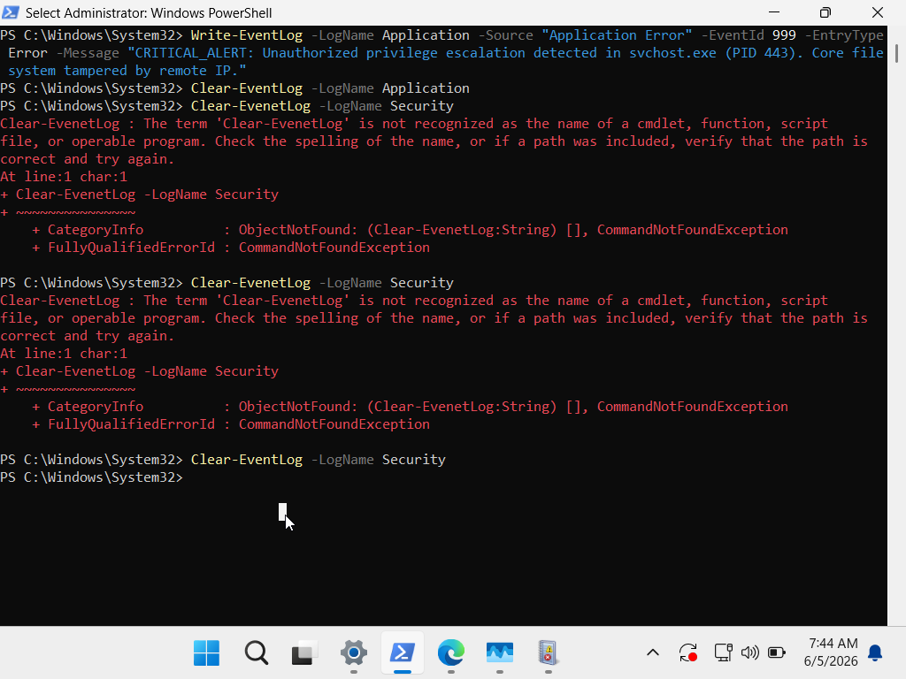
The adversary attempted a full anti-forensic sweep using native PowerShell management commands to destroy the event history:

4. Phase 3: Blue Team Detection & Verification (The Indelible Trail)
Defense Mechanism Analyzed: Security Audit Log Integrity Check
Analysis: While the attacker successfully cleared past historical logs, the Windows security architecture dictates that the act of clearing logs is itself an un-deletable event. Upon inspecting the freshly wiped log channels, the following critical forensic artifacts were discovered and documented:
Artifact A: Security Log Cleared (Event ID 1102)
Channel: Security
Event ID: 1102

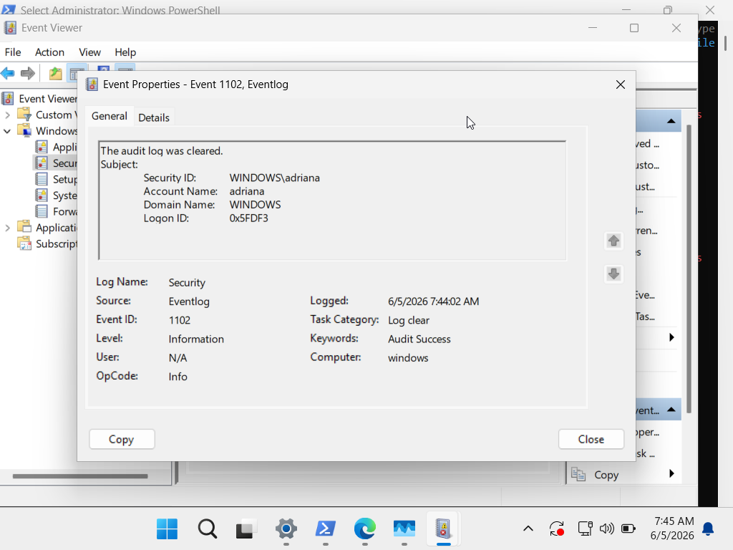
Description: "The audit log was cleared." * Forensic Value: This log captures the exact timestamp of the destruction and explicitly logs the Subject/User Account (Security ID) that initiated the purge. This is an irrefutable proof of inside tampering or compromised administrative credentials.

Artifact B: System Log Cleared (Event ID 104)
Channel: System
Event ID: 104
Description: "Log file was cleared." * Forensic Value: Validates the parallel destruction of the Application/System log tracks, reinforcing the timeline of the anti-forensic activity.
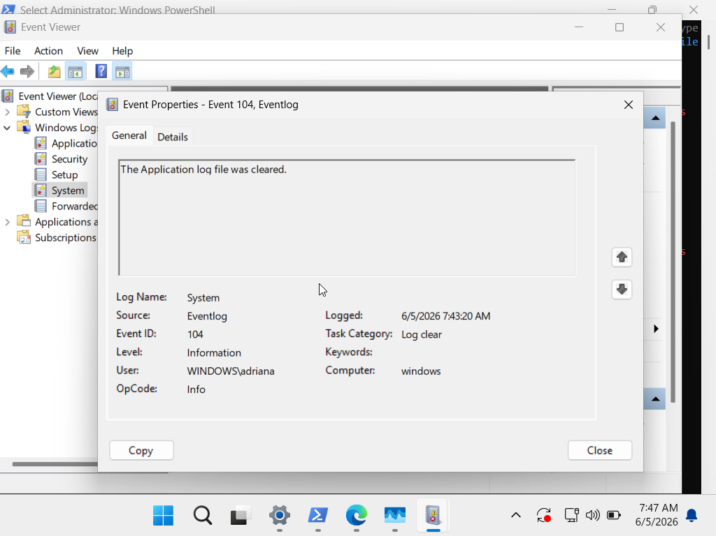
5. Mitigation & Enterprise Recommendations
To prevent high-privileged adversaries from manipulating or clearing local event tracks, the following enterprise-grade Blue Team controls must be enforced:
SIEM / Centralized Log Forwarding: Implement immediate, real-time log forwarding using Windows Event Forwarding (WEF) or Syslog to a centralized SIEM (e.g., Splunk, Microsoft Sentinel). Once logs are forwarded to an Append-Only repository, local clearing (Event ID 1102) becomes ineffective as the historical data remains intact on the SIEM.
High-Priority Alerting Rules: Configure the Security Operations Center (SOC) SIEM to trigger an Immediate P1 Critical Alert the moment Event ID 1102 or Event ID 104 is detected across any endpoint. Log clearing should never occur during normal operations.
Restricting Administrative Auditing Controls: Leverage Group Policy Objects (GPO) to strictly limit which accounts possess the SeSecurityPrivilege (Manage auditing and security log), separating the duties of standard Domain Admins from Forensic Auditors

