Category: Red Team Methodology / Defense Evasion / LotL (Living Off the Land)

1. Executive Summary
This technical report documents the successful simulation of an AppDomain Manager Injection attack within a controlled Windows 11 virtual environment. The objective of this research is to analyze how the Microsoft .NET Common Language Runtime (CLR) processes environmental variables and to demonstrate how a digitally signed Microsoft binary can be manipulated to execute untrusted code without altering its binary structure on disk.
The attack successfully bypassed local endpoint telemetry by shifting execution scope entirely into user-mode process memory, resolving intermediate runtime constraints such as assembly probing errors and safety attribute validation.

2. Technical Concepts & Context

2.1 What is an AppDomain?
In the Microsoft .NET architecture, an Application Domain (AppDomain) acts as an isolated, lightweight execution environment within a single Windows process. Multiple AppDomains can coexist inside one process memory space, sharing resources while remaining logically isolated from one another to prevent mutual interference or crashes.

2.2 The AppDomainManager Subsystem
Every time a .NET application initializes, the CLR instantiates a default AppDomain controlled by a supervisor class known as the AppDomainManager. Microsoft allows developers to subclass this manager to enforce custom security structures or loading policies.

2.3 The Environment Weaponization Vector
Before running any managed assembly, the CLR checks the environment block of the current session for two specific variables:
- APPDOMAIN_MANAGER_ASM: Specifies the assembly (DLL) file name that contains the custom manager.
- APPDOMAIN_MANAGER_TYPE: Specifies the exact class name within that DLL to be instantiated.
If these variables are present, the CLR initializes the custom manager before passing control to the target application's main entry point, enabling early-stage arbitrary code execution within a trusted process context.

3. Step-by-Step Lab Execution

Step 3.1: Development of the Custom Provider Assembly
A weaponized C# script (BypassManager.cs) was created. To satisfy modern Windows 11 CLR security baselines and avoid architectural loading exceptions, the class was explicitly decorated with the [SecurityCritical] attribute, and the overall assembly was exposed via [assembly: ComVisible(true)].
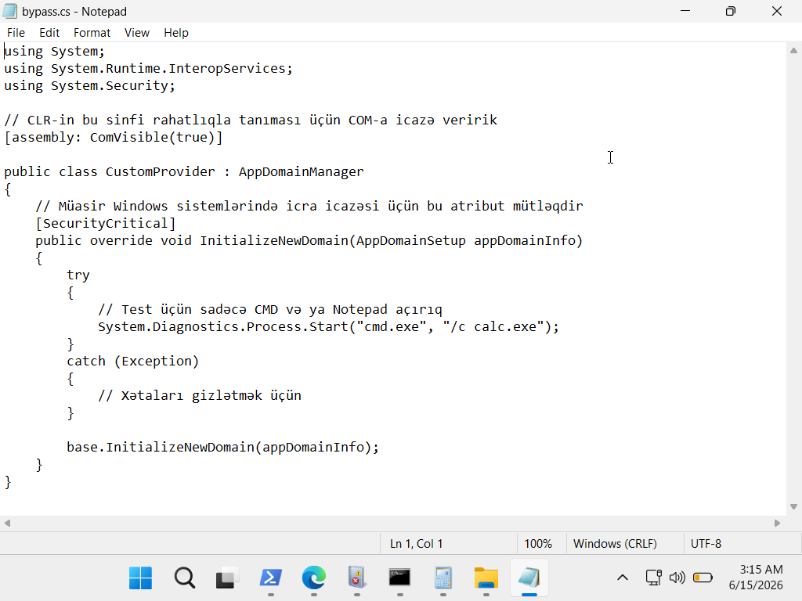
The core logic overrides the InitializeNewDomain method to spawn a demonstration payload (calc.exe) via cmd.exe.

Step 3.2: In-Memory Compilation via PowerShell
Using an administrative PowerShell terminal, the native .NET Framework compiler (csc.exe) was called to compile the C# source code directly into a portable Dynamic Link Library (.dll) format. No heavy IDEs (e.g., Visual Studio) were introduced to simulate realistic restricted post-exploitation conditions.

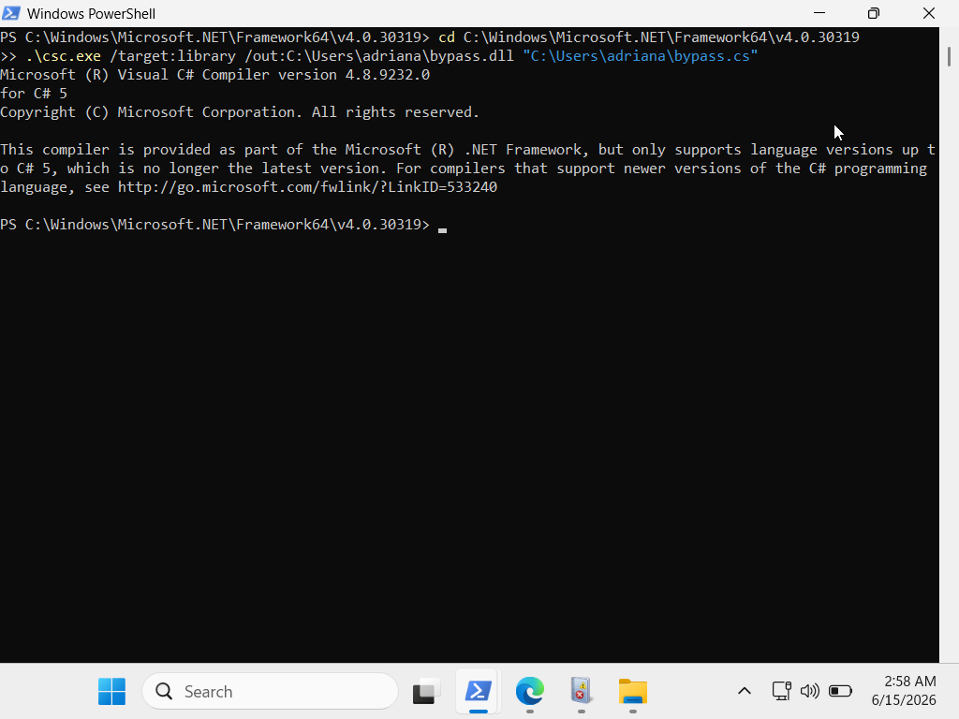

Step 3.3: Overcoming Assembly Probing Restrictions
Initial execution attempts triggered a CLR Error: 80131522 (TypeLoadException) and a subsequent Could not load file or assembly failure. This occurred because the CLR enforces an Assembly Probing Policy, restricting its lookup scope to the Global Assembly Cache (GAC) or the target application’s base execution directory.
To overcome this constraint without modifying system directories, a local workspace was staged on the Desktop. The legitimate Microsoft utility AddInProcess.exe was copied into the same directory containing our compiled bypass.dll.
The target variables were then defined inside a new Command Prompt (CMD) session:

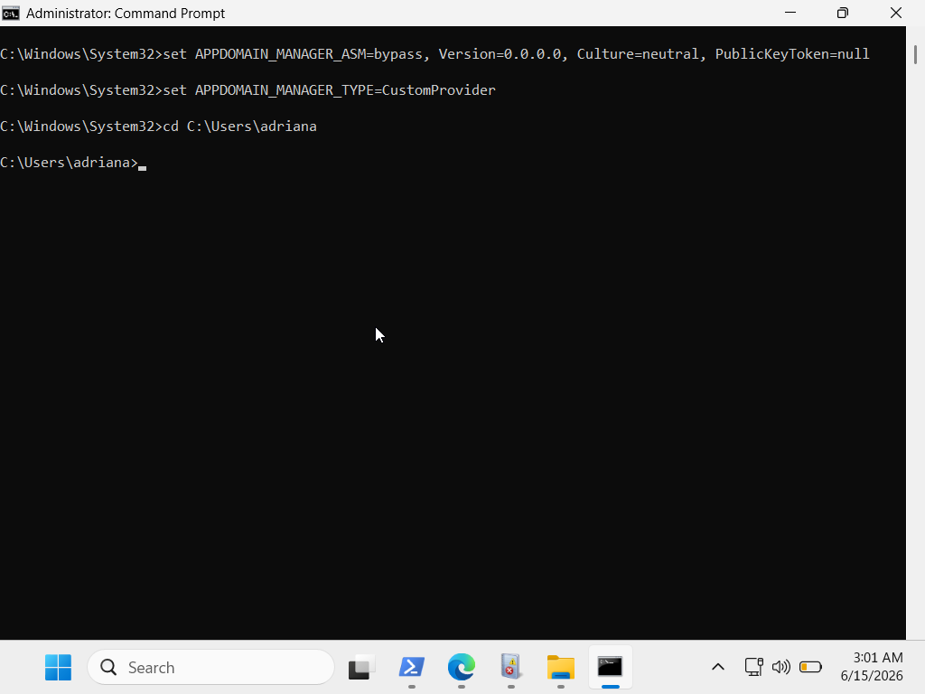

Step 3.4: Final Execution & Behavioral Verification
The trusted binary was launched directly from the poisoned terminal interface:

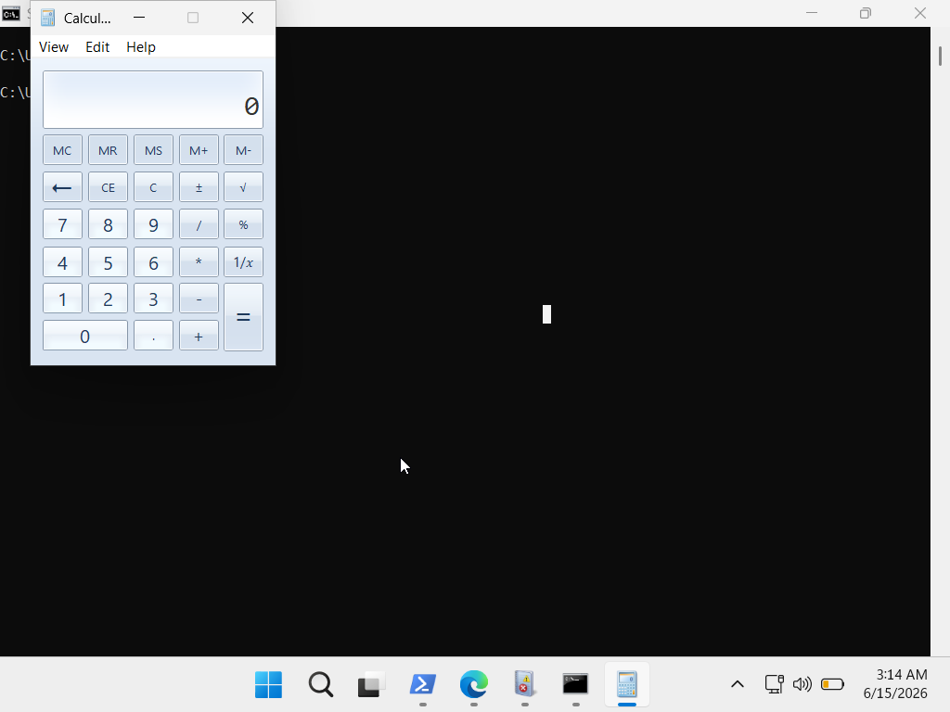
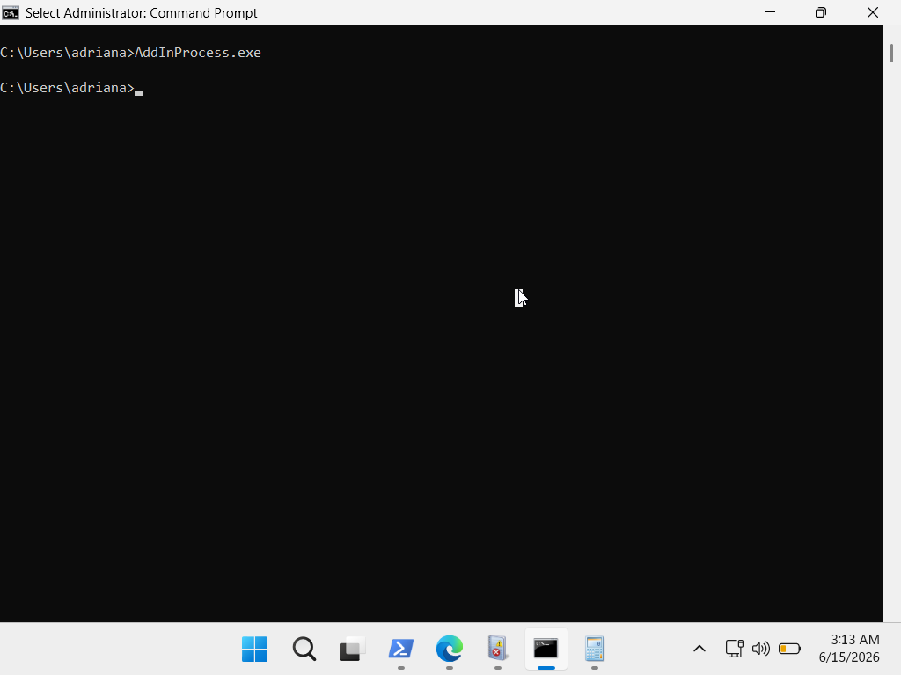
Result: The CLR successfully parsed the custom environment blocks, mapped BypassManager.dll into the trusted AddInProcess.exe thread space, and executed the overridden initialization subroutine. The payload spawned successfully under a completely legitimate parent process tree.

4. Defensive Analysis & Mitigation
From a defensive (Blue Team) perspective, this technique poses a severe threat because it utilizes "dual-use" binaries that are inherently trusted by application whitelisting solutions (like AppLocker or WDAC).

4.1 Detection Vectors
- Process Lineage Anomalies: Monitor native .NET processes (such as AddInProcess.exe, unregmp2.exe, or MSBuild.exe) spawning highly abnormal child processes like cmd.exe, powershell.exe, or non-standard binaries.
- Environment Block Auditing: Deploy EDR rules or configure Sysmon (Event ID 1) to audit process creation events that contain APPDOMAIN_MANAGER_ASM or APPDOMAIN_MANAGER_TYPE within their environment parameters.

4.2 Mitigation Strategies
- Implement strict path-based restrictions to ensure native .NET utilities are blocked from executing if they are triggered from user-writable directories such as \Desktop\ or \AppData\Local\Temp\.

