Experiment-6

Name-Debjit Bhattacharya

Sap_id-500119047

Batch-2

Questions: -

1. **Create the following two tables (EMP and DEPT)**

**EMP TABLE**

     EMPNO      ENAME       JOB                MGR          HIREDATE          SAL         COMM           DEPTNO

       ----------      ----------      ---------            ----------        --------- ---------- ---------- ----------

      7369           SMITH       CLERK             7902            17-DEC-80            500           800                  20

      7499          ALLEN       SALESMAN     7698            20-FEB-81           1600           300                 30

      7521          WARD        SALESMAN      7698           22-FEB-81           1250          500                  30

      7566           JONES       MANAGER        7839           02-APR-81          2975                                  20

      7654          MARTIN     SALESMAN      7698           28-SEP-81           1250          1400                30

      7698          BLAKE       MANAGER        7839          01-MAY-81         2850                                  30

      7782          CLARK       MANAGER        7839          09-JUN-81          2450                                   10

       7788       SCOTT        ANALYST         7566              09-DEC-82       3000                                    20

       7839       KING           PRESIDENT                           17-NOV-81       5000                                    10

       7844       TURNER     SALESMAN       7698            08-SEP-81         1500            0                      30

       7876       ADAMS       CLERK               7788            12-JAN-83         1100                                   20

       7900       JAMES         CLERK               7698            03-DEC-81        950                                     30

       7902       FORD           ANALYST         7566            03-DEC-81        3000                                   20

       7934      MILLER        CLERK              7782             23-JAN-82        1300                                   10

**DEPT TABLE**

      DEPTNO                  DNAME                   LOC

       ----------                  --------------                -------------

         10                      ACCOUNTING            NEW YORK

         20                      RESEARCH                 DALLAS

         30                      SALES                          CHICAGO

         40                      OPERATIONS             BOSTON

Write the Queries for the following using In-built functions.

1. Retrieve average salary of all employees.
2. Retrieve the number of employees.
3. Retrieve distinct number of employees.
4. Retrieve total salary of employee group by job.
5. Display the employee information with maximum salary.
6. Find the highest paid employee in department 10.
7. List the emps whose salary is equal to the average of max and minimum.
8. List the emps who joined in the company on the same date.
9. Display the employee names in upper and lower case.
10. find the date of 3 days later from hire date.
11. Solution: -
12. Creation && insertion on both the tables: -
13. Screenshot:
14. 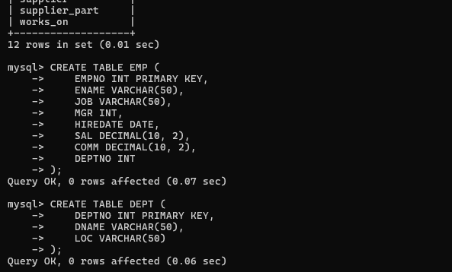
15. 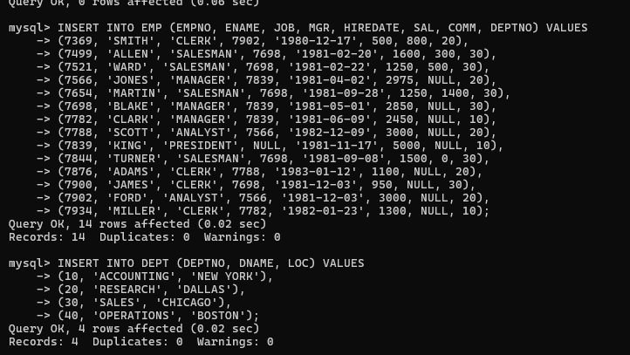
16. Retrieve average salary of all employees.
17. 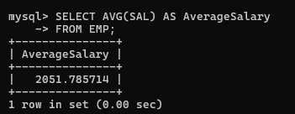
18. Retrieve the number of employees.
19. 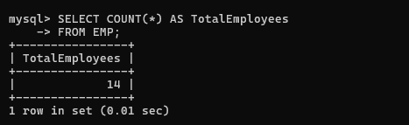
20. Retrieve distinct number of employees.
    1. 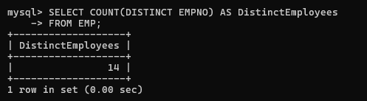
21. Retrieve total salary of employee group by job.
    1. 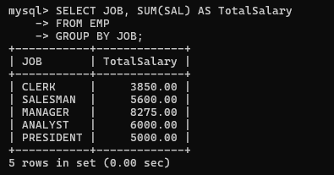
22. Find the highest paid employee in department 10.
    1. 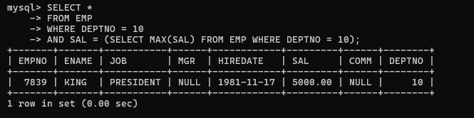
23. List the emps whose salary is equal to the average of max and minimum.
24. 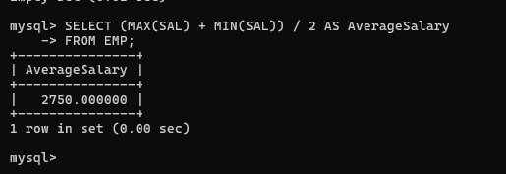
25. List the emps who joined in the company on the same date.
    1. 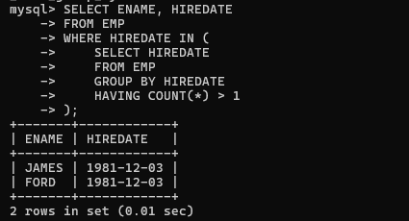
26. 9.Display the employee information with maximum salary.
27. 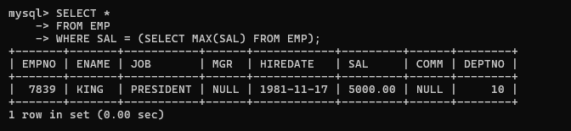
28. Display the employee names in upper and lower case.
29. 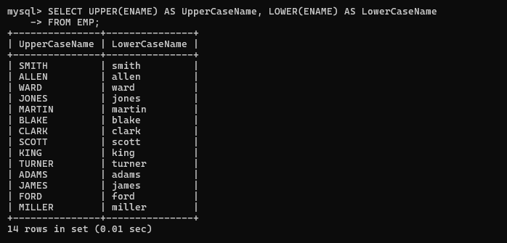
30. find the date of 3 days later from hiredate.
31. 