NAME-DEBJIT Bhattacharya

Rollno.: -R2142230043

Sap-500119047

Lab - 4

1. **Exercise on retrieving records from a table.**   
   a. Find out the names of all the clients.

select name from CLIENT_MASTER;

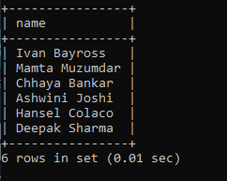  
b. Retrieve the entire contents of the Client_Master table.

select * from CLIENT_MASTER;

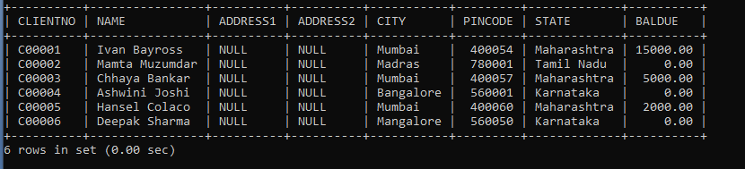  
c. Retrieve the list of names, city and the state of all the clients.

select name, city, state from CLIENT_MASTER;

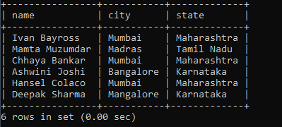

d. List the various products available from the Product_Master table.

select description from PRODUCT_MASTER;

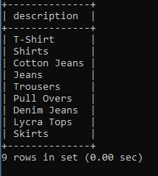  
e. List all the clients who are located in Mumbai.

select name from CLIENT_MASTER where city = 'Mumbai';

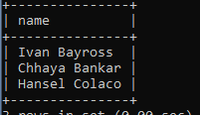

f. Find the names of salesman who have a salary equal to Rs.3000.

select salesmanname from SALESMAN_MASTER where SALAMT = 3000;

6.PNG

1. **Exercise on updating records in a table**   
   a. Change the city of ClientNo ‘C00005’ to ‘Bangalore’.

UPDATE CLIENT_MASTER SET CITY = 'Bangalore' WHERE CLIENTNO = 'C00005';

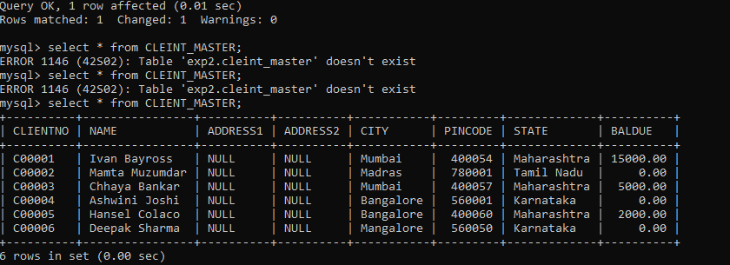  
b. Change the BalDue of ClientNo ‘C00001’ to Rs.1000.

UPDATE CLIENT_MASTER SET BALDUE = 1000 WHERE CLIENTNO = 'C00001';

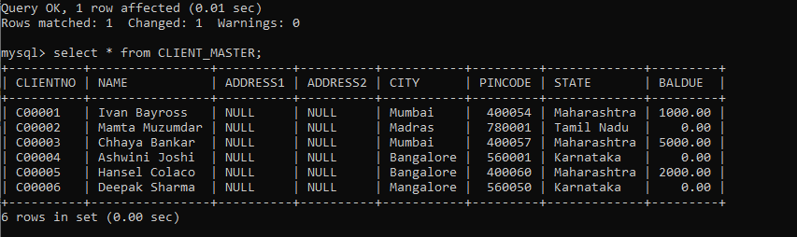  
c. Change the cost price of ‘Trousers’ to rs.950.00.

UPDATE PRODUCT_MASTER SET COSTPRICE = 950.00 WHERE DESCRIPTION = 'Trousers';

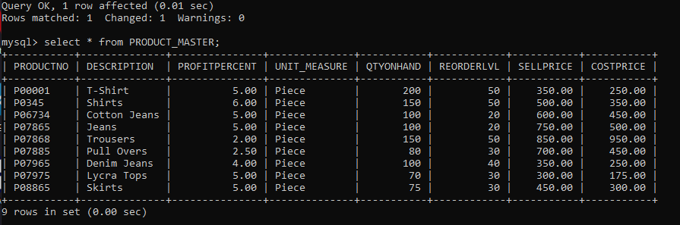  
d. Change the city of the salesman to Pune.

UPDATE SALESMAN_MASTER SET CITY = 'Pune';

9.PNG

1. **Exercise on deleting records in a table**   
   a. Delete all salesman from the Salesman_Master whose salaries are equal to Rs.3500.

**DELETE FROM SALESMAN_MASTER WHERE SALAMT = 3500;**



b. Delete all products from Product_Master where the quantity on hand is equal to 100.

DELETE FROM PRODUCT_MASTER WHERE QTYONHAND = 100;

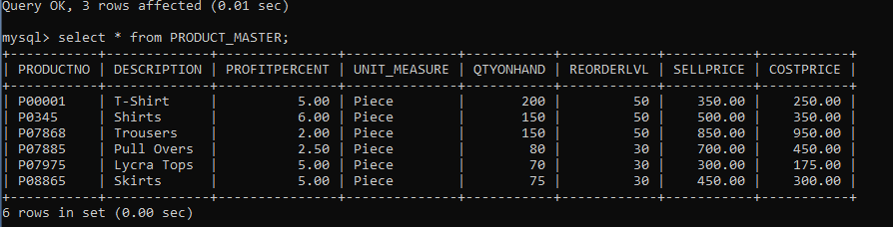

c. Delete from Client_Master where the column state holds the value ‘Tamil Nadu’.

DELETE FROM CLIENT_MASTER WHERE STATE = 'Tamil Nadu';

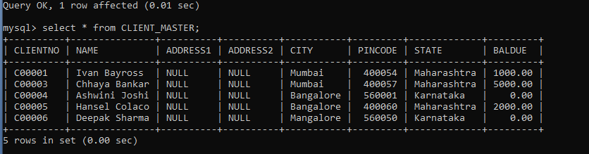

1. **Exercise on altering the table structure**   
   a. Add a column called ‘Telephone’ of data type integer to the Client_Master table.

ALTER TABLE CLIENT_MASTER ADD COLUMN TELEPHONE INTEGER;

13.PNG  
b. Change the size off SellPrice column in Product _Master to 10, 2.

ALTER TABLE PRODUCT_MASTER MODIFY COLUMN SELLPRICE DECIMAL(10, 2);

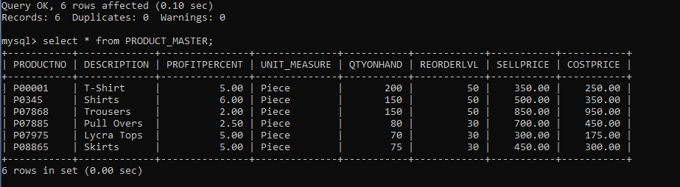

1. **Exercise on deleting the table structure along with the data**   
   a. Destroy the table Client_Master along with its data.

DROP TABLE CLIENT_MASTER;

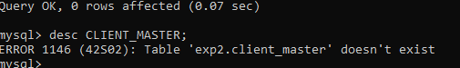

**EXPERIMENT-5**

**Title:  To understand and use SQL Sub-Query**

**Objective:** To understand the use of sql subquery.

**1. Create the following table.**

Supplier-(scode,sname,scity,turnover)

Part-(pcode,weigh,color,cost,sellingprice)

Supplier_Part-(scode,pcode,qty)

ANSWER:-  
-- Creating the Supplier table

create table supplier (

scode int primary key,

sname varchar(50),

scity varchar(50),

turnover int

);

-- Creating the Part table

create table part (

pcode int primary key,

weigh int,

color varchar(20),

cost int,

sellingprice int

);

-- Creating the Supplier_Part table

create table supplier_part (

scode int,

pcode int,

qty int,

foreign key (scode) references supplier(scode),

foreign key (pcode) references part(pcode)

);

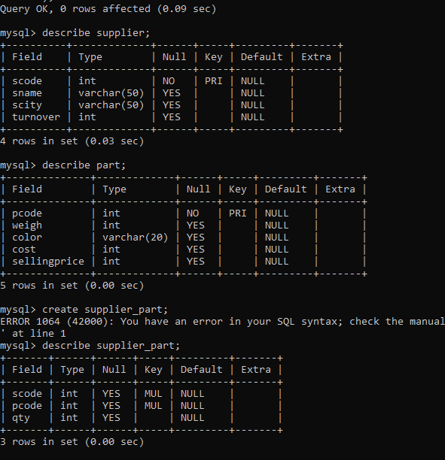

1. **Populate the table**

-- Populating the Supplier table

insert into supplier (scode, sname, scity, turnover) values

(1, 'supplier1', 'bombay', 50),

(2, 'supplier2', 'delhi', 100),

(3, 'supplier3', 'bangalore', null);

-- Populating the Part table

insert into part (pcode, weigh, color, cost, sellingprice) values

(1, 20, 'red', 20, 30),

(2, 30, 'blue', 40, 60),

(3, 25, 'green', 30, 50);

-- Populating the Supplier_Part table

insert into supplier_part (scode, pcode, qty) values

(1, 2, 10),

(2, 1, 20),

(3, 2, 30);

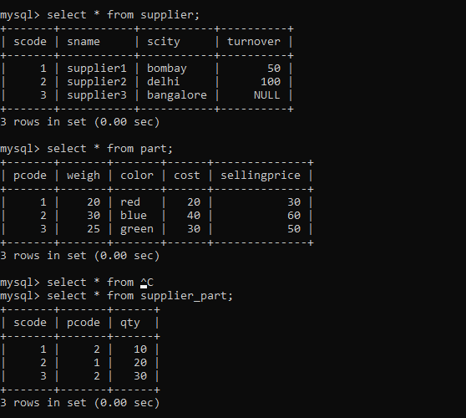

**3. Write appropriate SQL Statement for the following:**

1. Get the supplier number and part number in ascending order of supplier number.

select scode, pcode from supplier_part order by scode;

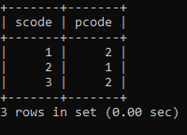

1. Get the details of supplier who operate from Bombay with turnover 50.

select * from supplier where scity = 'bombay' and turnover = 50;

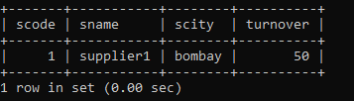

1. Get the total number of supplier.

select count(*) as total_suppliers from supplier;

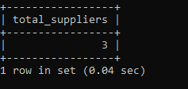

1. Get the part number weighing between 25 and 35.

select pcode from part where weigh between 25 and 35;

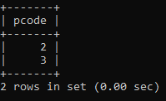

1. Get the supplier number whose turnover is null.

select scode from supplier where turnover is null;

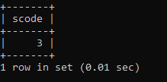

1. Get the part number that cost 20, 30 or 40 rupees.

select pcode from part where cost in (20, 30, 40);

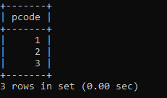

1. Get the total quantity of part 2 that is supplied.

select sum(qty) as total_qty from supplier_part where pcode = 2;

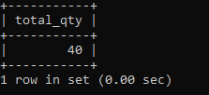

1. Get the name of supplier who supply part 2.

select sname from supplier where scode in (select scode from supplier_part where pcode = 2);

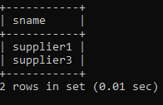

1. Get the part number whose cost is greater than the average cost.

select pcode from part where cost > (select avg(cost) from part);

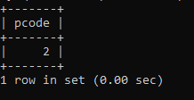

10. Get the supplier number and turnover in descending order of turnover.

select scode, turnover from supplier order by turnover desc;

