DBMS-LAB-3

**EXPERIMENT 3**

1. **Create the tables for** Company database as per ER diagram of Exp 2.

TABLE 1: EMPLOYEE

[ Fname VARCHAR(15) NOT NULL,

Minit CHAR,

Lname VARCHAR(15) NOT NULL,

Ssn CHAR(9) NOT NULL,

Bdate DATE,

Address VARCHAR(30),

Sex CHAR,

Salary DECIMAL(10,2),

Super_ssn CHAR(9),

Dno INT NOT NULL,

PRIMARY KEY (Ssn),

FOREIGN KEY (Super_ssn) REFERENCES EMPLOYEE(Ssn),

FOREIGN KEY (Dno) REFERENCES DEPARTMENT(Dnumber)

]

TABLE 2: DEPARTMENT

[Dname VARCHAR(15) NOT NULL,

Dnumber INT NOT NULL,

Mgr_ssn CHAR(9) NOT NULL,

Mgr_start_date DATE,

PRIMARY KEY (Dnumber),

UNIQUE (Dname),

FOREIGN KEY (Mgr_ssn) REFERENCES EMPLOYEE(Ssn) );

]

 TABLE 3: DEPT_LOCATIONS

( Dnumber INT NOT NULL,

Dlocation VARCHAR(15) NOT NULL,

PRIMARY KEY (Dnumber, Dlocation),

FOREIGN KEY (Dnumber) REFERENCES DEPARTMENT(Dnumber) );

TABLE 4: PROJECT

( Pname VARCHAR(15) NOT NULL,

Pnumber INT NOT NULL,

Plocation VARCHAR(15),

Dnum INT NOT NULL,

PRIMARY KEY (Pnumber),

UNIQUE (Pname),

FOREIGN KEY (Dnum) REFERENCES DEPARTMENT(Dnumber) );

TABLE 5: WORKS_ON

( Essn CHAR(9) NOT NULL,

Pno INT NOT NULL,

Hours DECIMAL(3,1) NOT NULL,

PRIMARY KEY (Essn, Pno),

FOREIGN KEY (Essn) REFERENCES EMPLOYEE(Ssn),

FOREIGN KEY (Pno) REFERENCES PROJECT(Pnumber) );

TABLE 6:  DEPENDENT

( Essn CHAR(9) NOT NULL,

Dependent_name VARCHAR(15) NOT NULL,

Sex CHAR,

Bdate DATE,

Relationship VARCHAR(8),

PRIMARY KEY (Essn, Dependent_name),

FOREIGN KEY (Essn) REFERENCES EMPLOYEE(Ssn) );

1. **Insert the following data into their respective tables of Company database.**

|  |  |  |  |
| --- | --- | --- | --- |
| DEPARTMENT | | | |
| DNAME | DNUMBER | MGRSSN | MGRSTARTDATE |
| Research | 5 | 333445555 | 1988-05-22 |
| Administration | 4 | 987654321 | 1995-01-01 |
| Headquarters | 1 | 888665555 | 1981-06-19 |

|  |  |  |  |  |  |  |  |  |
| --- | --- | --- | --- | --- | --- | --- | --- | --- |
| EMPLOYEE | | | | | | | | |
| FNAME | LNAME | SSN | BDATE | ADDRESS | SEX | SALARY | SUPERSSN | DNO |
| John | Smith | 123456789 | 1965-01-09 | 731 Fondren, Houston TX | M | 30000 | 333445555 | 5 |
| Franklin | Wong | 333445555 | 1965-12-08 | 638 Voss, Houston TX | M | 40000 | 888665555 | 5 |
| Alicia | Zelaya | 999887777 | 1968-01-19 | 3321 Castle, Spring TX | F | 25000 | 987654321 | 4 |
| Jennifer | Wallace | 987654321 | 1941-06-20 | 291 Berry, Bellaire TX | F | 43000 | 888665555 | 4 |
| Ramesh | Narayan | 666884444 | 1962-09-15 | 975 Fire Oak, Humble TX | M | 38000 | 333445555 | 5 |
| Joyce | English | 453453453 | 1972-07-31 | 5631 Rice, Houston TX | F | 25000 | 333445555 | 5 |
| Ahmad | Jabbar | 987987987 | 1969-03-29 | 980 Dallas, Houston TX | M | 25000 | 987654321 | 4 |
| James | Borg | 888665555 | 1937-11-10 | 450 Stone, Houston TX | M | 55000 | null | 1 |

|  |  |  |  |
| --- | --- | --- | --- |
| PROJECT | | | |
| PNAME | PNUMBER | PLOCATION | DNUM |
| ProductX | 1 | Bellaire | 5 |
| ProductY | 2 | Sugarland | 5 |
| ProductZ | 3 | Houston | 5 |
| Computerization | 10 | Stafford | 4 |
| Reorganization | 20 | Houston | 1 |
| Newbenefits | 30 | Stafford | 4 |

|  |  |  |
| --- | --- | --- |
| WORKS_ON | | |
| ESSN | PNO | HOURS |
| 123456789 | 1 | 32.5 |
| 123456789 | 2 | 7.5 |
| 666884444 | 3 | 40.0 |
| 453453453 | 1 | 20.0 |
| 453453453 | 2 | 20.0 |
| 333445555 | 2 | 10.0 |
| 333445555 | 3 | 10.0 |
| 333445555 | 10 | 10.0 |
| 333445555 | 20 | 10.0 |
| 999887777 | 30 | 30.0 |
| 999887777 | 10 | 10.0 |
| 987987987 | 10 | 35.0 |
| 987987987 | 30 | 5.0 |
| 987654321 | 30 | 20.0 |
| 987654321 | 20 | 15.0 |
| 888665555 | 20 | null |

|  |  |  |  |  |
| --- | --- | --- | --- | --- |
| DEPENDENT | | | | |
| ESSN | DEPENDENT_NAME | SEX | BDATE | RELATIONSHIP |
| 333445555 | Alice | F | 1986-04-04 | Daughter |
| 333445555 | Theodore | M | 1983-10-25 | Son |
| 333445555 | Joy | F | 1958-05-03 | Spouse |
| 987654321 | Abner | M | 1942-02-28 | Spouse |
| 123456789 | Michael | M | 1988-01-04 | Son |
| 123456789 | Alice | F | 1988-12-30 | Daughter |
| 123456789 | Elizabeth | F | 1967-05-05 | Spouse |

|  |  |
| --- | --- |
| DEPT_LOCATIONS | |
| DNUMBER | DLOCATION |
| 1 | Houston |
| 4 | Stafford |
| 5 | Bellaire |
| 5 | Houston |
| 5 | Sugarland |

CREATE TABLE EMPLOYEE (

Fname VARCHAR(15) NOT NULL,

Minit CHAR,

Lname VARCHAR(15) NOT NULL,

Ssn CHAR(9) NOT NULL,

Bdate DATE,

Address VARCHAR(30),

Sex CHAR,

Salary DECIMAL(10,2),

Super_ssn CHAR(9),

Dno INT NOT NULL,

PRIMARY KEY (Ssn),

FOREIGN KEY (Super_ssn) REFERENCES EMPLOYEE(Ssn),

FOREIGN KEY (Dno) REFERENCES DEPARTMENT(Dnumber)

);

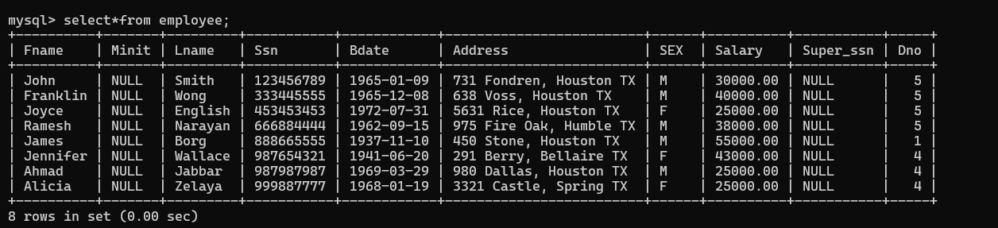

CREATE TABLE DEPARTMENT (

Dnumber INT NOT NULL,

Dname VARCHAR(15) NOT NULL,

Mgr_ssn CHAR(9) NOT NULL,

Mgr_start_date DATE,

PRIMARY KEY (Dnumber),

FOREIGN KEY (Mgr_ssn) REFERENCES EMPLOYEE(Ssn)

);

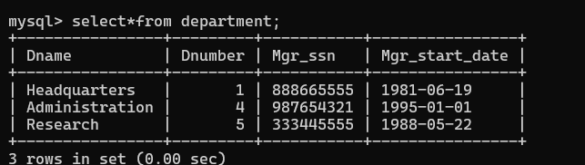

CREATE TABLE DEPENDENT (

Essn CHAR(9) NOT NULL,

Dependent_name VARCHAR(15) NOT NULL,

Sex CHAR,

Bdate DATE,

Relationship VARCHAR(15) NOT NULL,

PRIMARY KEY (Essn, Dependent_name),

FOREIGN KEY (Essn) REFERENCES EMPLOYEE(Ssn)

);

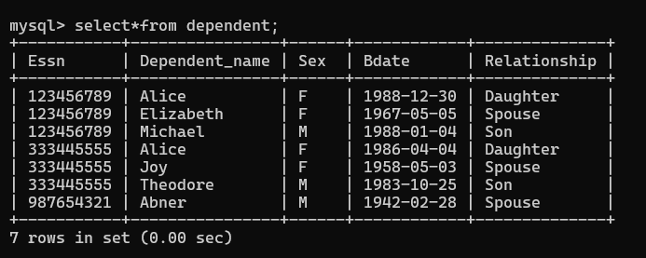

CREATE TABLE PROJECT (

Pnumber INT NOT NULL,

Pname VARCHAR(15) NOT NULL,

Plocation VARCHAR(15) NOT NULL,

Dnum INT NOT NULL,

PRIMARY KEY (Pnumber),

FOREIGN KEY (Dnum) REFERENCES DEPARTMENT(Dnumber)

);

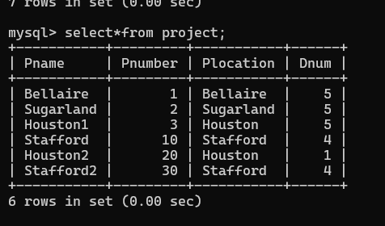

CREATE TABLE WORKS_ON (

Essn CHAR(9) NOT NULL,

Pno INT NOT NULL,

Hours DECIMAL(10,2) NOT NULL,

PRIMARY KEY (Essn, Pno),

FOREIGN KEY (Essn) REFERENCES EMPLOYEE(Ssn),

FOREIGN KEY (Pno) REFERENCES PROJECT(Pnumber)

);

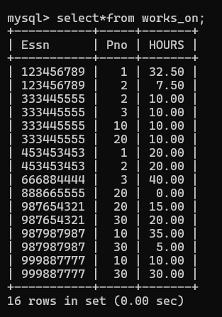

CREATE TABLE DEPT_LOCATION (

Dnumber INT NOT NULL,

Dlocation VARCHAR(15) NOT NULL,

PRIMARY KEY (Dnumber, Dlocation),

FOREIGN KEY (Dnumber) REFERENCES DEPARTMENT(Dnumber)

);

