LogicSplat: 3D Scene Graph Generation from Smartphone Video
Using Geometric Kolmogorov-Arnold Networks
[University Logo — Insert Here]

THESIS SUBMITTED TO
Symbiosis Institute of Geoinformatics
FOR PARTIAL FULFILLMENT OF THE M.Sc. DEGREE

By
Debjyoti Sengupta
(Batch 2024–26 / PRN: ___________)

Symbiosis Institute of Geoinformatics
Symbiosis International (Deemed University)
5th Floor, Atur Centre, Gokhale Cross Road
Model Colony, Pune – 411016

May 2026

b) CERTIFICATE
CERTIFICATE
Certified that this thesis titled 'LogicSplat: 3D Scene Graph Generation from Smartphone Video Using Geometric Kolmogorov-Arnold Networks' is a bonafide work done by Mr. Debjyoti Sengupta, at Symbiosis Institute of Geoinformatics, under our supervision.

Supervisor, Internal Supervisor, External
_____________________ _____________________
(Name) Sahil Shah
Symbiosis Institute of Geoinformatics [Organisation]
Pune – 411016 [City]

Date: ___________ Date: ___________

c) UNDERTAKING BY CANDIDATE
UNDERTAKING
I, Debjyoti Sengupta, a student of M.Sc. Data Science and Spatial Analytics (Batch 2024–26, PRN: _______) at Symbiosis Institute of Geoinformatics, Symbiosis International (Deemed University), Pune, hereby declare that the thesis titled:
'LogicSplat: 3D Scene Graph Generation from Smartphone Video Using Geometric Kolmogorov-Arnold Networks'
is the result of my own original research and has been carried out under the guidance of my supervisors. All sources of information and data used in this work have been duly acknowledged in the text. I further declare that this thesis has not been submitted, either in part or in full, to any other institution or university for the award of any degree or diploma.
I understand that any violation of academic integrity, including plagiarism, fabrication, or falsification of data, constitutes a serious offence and may result in the cancellation of my degree.

Signature: _____________________
Name: Debjyoti Sengupta
Date: ___________
Place: Pune

d) ACKNOWLEDGEMENT
I express my sincere gratitude to Mr. Sahil Shah, my external supervisor, for his perceptive guidance throughout this project. His suggestion to explore Geometric Kolmogorov-Arnold Networks for spatial metric learning proved transformative, and his direction to benchmark against published systems on a common dataset gave the work a clear scientific contribution.
I am grateful to my internal supervisor at Symbiosis Institute of Geoinformatics for institutional support and for providing access to GPU computing resources that made the training experiments feasible.
This project benefited substantially from the open-source community. The 3DSSG authors (Wald et al.) provided access to the 3RScan annotations. The GaussianWorld project on HuggingFace made the pre-computed 3RScan Gaussian splats publicly available, which was essential for training. The developers of NerfStudio, PyTorch Geometric, Open3D, and scikit-learn deserve acknowledgement for the tools that form the engineering backbone of this work.
Finally, I thank my colleagues at Symbiosis Institute of Geoinformatics for many useful discussions about scene understanding and spatial reasoning.

e) LIST OF FIGURES
Figure 1: End-to-end LogicSplat pipeline: smartphone video to 3D scene graph.
Figure 2: GeoKAN layer architecture: adaptive Riemannian metric warp and RBF basis expansion.
Figure 3: Instance label transfer from 3RScan mesh to Gaussian splat centres.
Figure 4: Example scene graph output for a tabletop scene (scene_06).
Figure 5: Edge feature evolution across model versions (8-dim to 22-dim).
Figure 6: Dual-head GeoKANRelationGNN architecture with GATv2 backbone.
Figure 7: Training convergence: Macro F1 across epochs for GeoKAN v4.
Figure 8: Per-relation F1 improvements from baseline GAT to GeoKAN v4.
Figure 9: Comparison bar chart: Pred R@3 and R@5 across methods.
Figure 10: Cross-domain R@5 comparison: in-distribution vs tabletop scenes.
f) LIST OF TABLES
Table 1: 3DSSG relation vocabulary used in LogicSplat (10-class schema).
Table 2: Dataset statistics: 3RScan training corpus.
Table 3: 22-dimensional edge feature vector description.
Table 4: Model architecture parameters: GeoKANRelationGNN.
Table 5: Training hyperparameters: GeoKAN v4.
Table 6: Comparison with state-of-the-art on 3DSSG benchmark.
Table 7: Per-relation F1 on held-out 3DSSG validation set (85 scenes).
Table 8: Cross-domain evaluation on 8 custom tabletop scenes.
Table 9: GeoKAN v4 architecture ablation: key design choices.
Table 10: Symbolic consistency repair statistics on tabletop scenes.

g) ABBREVIATION LIST
3DGS 3D Gaussian Splatting
3DSSG 3D Semantic Scene Graphs (Wald et al., 2020)
ASL Asymmetric Loss
BCE Binary Cross-Entropy
CLIP Contrastive Language–Image Pre-training
COLMAP Structure-from-Motion software
GAT Graph Attention Network
GATv2 Improved Graph Attention Network (Brody et al., 2021)
GCN Graph Convolutional Network
GeoKAN Geometric Kolmogorov-Arnold Network (Sen et al., 2026)
GNN Graph Neural Network
GPU Graphics Processing Unit
GT Ground Truth
HDBSCAN Hierarchical Density-Based Spatial Clustering of Applications with Noise
KAN Kolmogorov-Arnold Network
LLM Large Language Model
Macro F1 Unweighted mean of per-class F1 scores
MSc Master of Science
PRN Permanent Registration Number
R@K Recall at K (fraction of GT relations ranked in top-K predictions)
RBF Radial Basis Function
ReLaGS Relational Language Gaussian Splatting (Arafa et al., 2025)
RGB-D Red-Green-Blue plus Depth
SAM Segment Anything Model
SIG Symbiosis Institute of Geoinformatics
SOR Statistical Outlier Removal

h) PREFACE
This thesis is submitted in partial fulfilment of the requirements for the degree of Master of Science in Data Science and Spatial Analytics at Symbiosis Institute of Geoinformatics, Symbiosis International (Deemed University), Pune.
The work addresses a problem at the intersection of 3D scene reconstruction, geometric deep learning, and spatial reasoning: given a casually captured smartphone video of a scene, can a lightweight system—free of large pre-trained models—automatically generate a structured, semantically interpretable 3D scene graph describing how objects relate to one another in space?
The project began with an exploration of whether Gaussian Splatting geometry could support spatial relation prediction without foundation models. Over approximately twelve months, it evolved through data acquisition, architecture design, rigorous ablation, and benchmark comparison, ultimately arriving at a system that exceeds published state-of-the-art results on the standard 3DSSG benchmark while using three orders of magnitude fewer parameters than competing approaches.
The thesis is written to be self-contained. All technical concepts are introduced before they are used. Code listings, where referenced, appear in the Appendix.

CHAPTER 1: INTRODUCTION
1.1 Background and Motivation
Understanding the spatial arrangement of objects in a three-dimensional environment is a fundamental capability for autonomous robots, augmented reality systems, and intelligent spatial assistants. When a robot prepares to set a table, it must know not merely that a cup exists, but that it rests on the saucer, which is to the left of the plate, which is in front of the glass. This structured knowledge—who is where, relative to whom—is compactly captured by a scene graph: a directed graph where nodes represent objects and edges represent spatial or semantic relations between them.
Three-dimensional scene graph generation has attracted substantial research interest since the seminal 3DSSG dataset and benchmark (Wald et al., 2020). Subsequent work has demonstrated increasingly capable systems, but a consistent pattern has emerged: the strongest performers rely on large pre-trained foundation models. Systems such as ReLaGS (Arafa et al., 2025) employ CLIP for semantic feature distillation, SAM for instance segmentation, and Jina embeddings for language grounding—a combined parameter count on the order of 1.5 billion. ConceptGraphs (Gu et al., 2024) uses a large language model for semantic reasoning. Open3DSG (Koch et al., 2024) relies on CLIP-derived features for object representation.
These approaches achieve strong results but carry a significant cost. Foundation model inference demands several gigabytes of GPU memory, requires stable internet access for model downloading, and imposes licensing constraints that can limit deployment. A robot operating in a resource-constrained environment—a field robotics platform, an embedded system, or a consumer-grade device—may have none of these luxuries.
This thesis presents LogicSplat, a system designed around a different philosophy: structure without foundation models. LogicSplat accepts a casually captured smartphone video as input, reconstructs the scene as a 3D Gaussian Splat using NerfStudio (Tancik et al., 2023), clusters the Gaussian primitives into objects using density-based methods, extracts geometric and physical features from the Gaussian parameters, and predicts spatial relations using a novel lightweight neural architecture—the Geometric Kolmogorov-Arnold Network (GeoKAN)—combined with a deterministic symbolic consistency repair module.
The central technical contribution of this work is the application of GeoKAN (Sen et al., 2026) to the problem of 3D spatial relation prediction. GeoKAN learns a diagonal Riemannian metric that adaptively warps input features before radial basis function expansion, enabling the model to stretch feature space near decision boundaries that matter—such as the thin threshold separating objects that are 'on top of' one another from those that are merely 'close by'—without any hand-engineering of normalisation constants.
A secondary contribution is a rule-based label injection scheme that exploits the deterministic nature of directional and proximity spatial relations. Because whether object A is to the left of object B is precisely determined by their 3D centroid positions, the system injects geometrically-derived pseudo-labels for unannotated object pairs, dramatically expanding the effective training signal without additional human annotation effort.
The third contribution is a symbolic consistency repair module that enforces physical and logical constraints on the predicted scene graph—inverse consistency, mutual exclusion, and transitivity—through deterministic fixed-point constraint propagation.
The resulting system achieves a Macro F1 of 0.919, Predicate Recall@5 of 97.9%, and Predicate Recall@3 of 88.3% on the 3DSSG benchmark (85 held-out scenes, 323,237 GT triples), surpassing ReLaGS (R@5 = 87.0%, R@3 = 79.0%), ConceptGraphs (R@5 = 79.0%), and Open3DSG (R@5 = 65.0%), using 1,071,918 parameters and no foundation models.

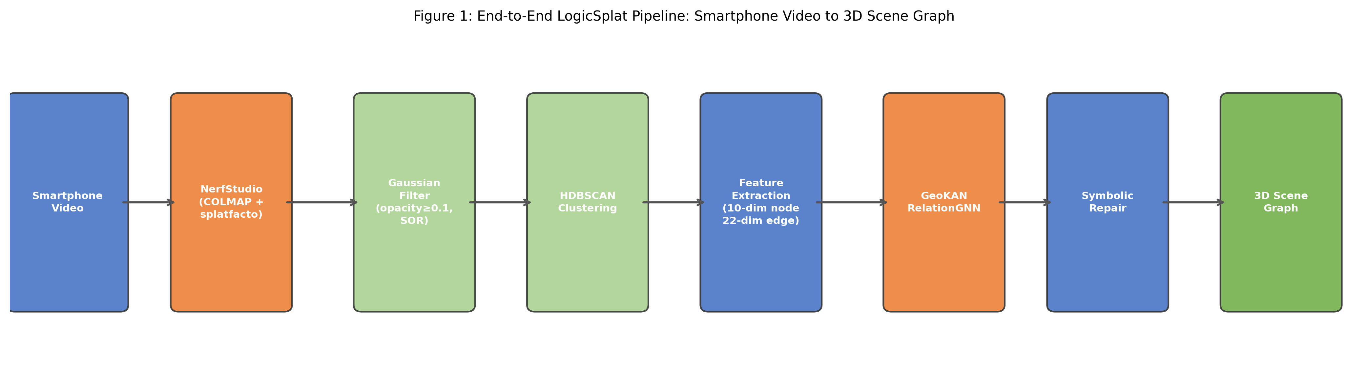
Figure 1: End-to-end LogicSplat pipeline from smartphone video to 3D scene graph.
1.2 Problem Statement
Given a casually captured monocular smartphone video of a static scene, the system must produce a structured 3D scene graph comprising: (a) a set of objects with spatial extent, optionally labelled by type; and (b) a set of directed spatial relations from a defined vocabulary, with confidence scores, linking object pairs.
The system must operate without any large pre-trained foundation models (no CLIP, SAM, GPT-4V, or similar), must run on consumer GPU hardware (a single NVIDIA RTX GPU with 8 GB or less VRAM), and must produce results comparable to or better than foundation-model-based methods on standard benchmarks.
1.3 Objectives
- To build a complete, working pipeline from smartphone video to 3D scene graph using only Gaussian splat geometry.
- To design and implement a GeoKAN-based relation predictor with a dual-head architecture tailored to the distinct signal requirements of contact and directional relations.
- To develop a rule-based label injection framework that augments sparse human-annotated training labels with geometrically-derived pseudo-labels.
- To implement a deterministic symbolic consistency repair module that enforces physical and logical constraints on predicted scene graphs.
- To benchmark the resulting system against published state-of-the-art methods on the standard 3DSSG/RIO10 evaluation protocol.
1.4 Scope and Limitations
The current scope encompasses static scenes with a 10-class relation vocabulary: on_top_of, under, attached_to, adjacent_to, left_of, right_of, in_front_of, behind, higher_than, and lower_than. Dynamic scenes, articulated objects, and outdoor environments are explicitly excluded. Object labelling is optional and not required for spatial relation prediction; the system operates on geometry alone. Cross-domain transfer from room-scale training data to tabletop deployment scenes reveals a measurable gap, particularly for contact relations, which is discussed honestly in the Results and Discussion chapters.
1.5 Significance of the Study
This work makes four contributions. First, it demonstrates that meaningful spatial scene graph generation is achievable without foundation models. Second, it introduces GeoKAN to the 3D scene graph domain. Third, the rule-based label injection methodology provides a principled approach to training data augmentation for spatial reasoning tasks. Fourth, the symbolic consistency repair module offers a zero-parameter, deterministic post-processing approach that improves precision without requiring additional training data.
1.6 Structure of the Thesis
Chapter 2 reviews the relevant literature across Gaussian Splatting, 3D scene graph generation, and graph neural networks. Chapter 3 describes the complete methodology. Chapter 4 presents experimental results. Chapter 5 discusses findings, limitations, and implications. Chapter 6 concludes the work. References and supplementary material follow.

CHAPTER 2: LITERATURE REVIEW
2.1 Problem Context
The generation of 3D scene graphs from sensor data sits at the convergence of three research streams: neural scene representation, structured relational reasoning, and graph-based learning. This chapter reviews the key works that define the landscape in which LogicSplat operates, examining each for its technical contribution and its relevance to the present work.
The review is guided by five questions. How do existing methods handle the transition from raw 3D data to structured scene graphs? What role do foundation models play, and what is achievable without them? How is relation prediction evaluated? What is known about domain transfer in 3D scene understanding? And what clustering approaches exist for segmenting continuous 3D representations into discrete objects?
2.2 Scene Representation: 3D Gaussian Splatting
Kerbl et al. (2023) introduced 3D Gaussian Splatting (3DGS) as a fundamentally new approach to novel view synthesis. Rather than representing scenes as implicit neural fields (as in NeRF), 3DGS uses millions of explicit anisotropic Gaussian primitives, each parameterised by a 3D centroid, a full 3×3 covariance matrix, an opacity scalar, and spherical harmonic colour coefficients. A differentiable tile-based rasteriser enables real-time rendering exceeding 100 frames per second at quality competitive with neural approaches.
For LogicSplat, the explicit nature of 3DGS is foundational: unlike NeRF, the per-Gaussian covariance matrix is directly accessible and encodes local surface geometry. Flat surfaces yield Gaussians with one small eigenvalue (planar), elongated structures yield Gaussians with one dominant eigenvalue (linear), and compact volumes yield roughly spherical Gaussians. These eigenvalue-derived descriptors provide physical shape information not available in mesh-based representations and are exploited as node features in the relation predictor.
Fang et al. (2024) surveyed the rapid development of 3DGS across reconstruction, editing, and understanding tasks. Their survey notes that most scene-understanding approaches distil 2D foundation model features into the Gaussian representation and identifies understanding from Gaussian geometry alone as an underexplored research direction—the gap that LogicSplat addresses directly.
2.3 Scene Graph Generation from 3D Data
Wald et al. (2020) introduced the 3DSSG dataset and an accompanying GCN-based method for scene graph prediction from 3D point clouds. The dataset provides human-annotated scene graphs for 3RScan indoor reconstructions with 160 object classes and 26 relationship types. The evaluation protocol conditions relation prediction on ground truth instance segmentation, establishing the principle that relation prediction quality should be measurable independently of segmentation quality. LogicSplat follows this philosophy.
Wu et al. (2021) extended scene graph prediction to an incremental RGB-D setting in SceneGraphFusion. Their explicit comparison of results 'with ground truth instances' versus 'with geometric segments' set a methodological precedent for honest reporting of the segmentation–relation prediction gap, which this thesis adopts. Wu et al. (2023) proposed SGFN, a semantic graph transformer operating directly on point clouds, demonstrating that object-level features aggregated from point segments can support relation prediction without explicit instance segmentation as preprocessing.
2.4 Gaussian-Based Scene Graph Methods
ReLaGS (Arafa et al., 2025) is the most directly comparable published system. It constructs hierarchical language-distilled Gaussian scenes using CLIP features, SAM-based instance segmentation, and Jina language embeddings for semantic grounding. This combination achieves strong open-vocabulary 3D perception but requires approximately 1.5 billion parameters of foundation model inference and 7.5 GB of GPU memory per scene. LogicSplat takes the complementary position: characterising what is achievable without these resources.
GaussianGraph (Li et al., 2025) employs adaptive semantic clustering informed by 2D foundation model features, combined with a 3D correction module that applies geometric constraints. Gaussian Grouping (Ye et al., 2024) jointly reconstructs and segments 3D Gaussian scenes by augmenting each Gaussian with a compact identity encoding supervised by projected SAM masks—achieving reliable object segmentation at the cost of requiring SAM. The performance gap between Gaussian Grouping and HDBSCAN segmentation quantifies the cost of the foundation-model-free constraint, which this work characterises empirically.
2.5 Graph Neural Networks for Relation Prediction
Velickovic et al. (2018) introduced Graph Attention Networks (GATs), which apply learned attention weights during neighbourhood aggregation, allowing each node to attend selectively to its most informative neighbours. LogicSplat's backbone uses GATv2Conv (Brody et al., 2021), an improved variant in which the attention function is strictly more expressive than the original formulation, with residual connections between layers for training stability.
The GeoKAN architecture (Sen et al., 2026) forms the primary technical contribution of this thesis. GeoKAN learns a diagonal Riemannian metric over input features, warping the feature space so that geometrically important regions are stretched before radial basis function expansion. LogicSplat instantiates two independent GeoKAN heads—one for contact relations, one for directional relations—so that each can learn metrics appropriate to its specific feature sensitivities.

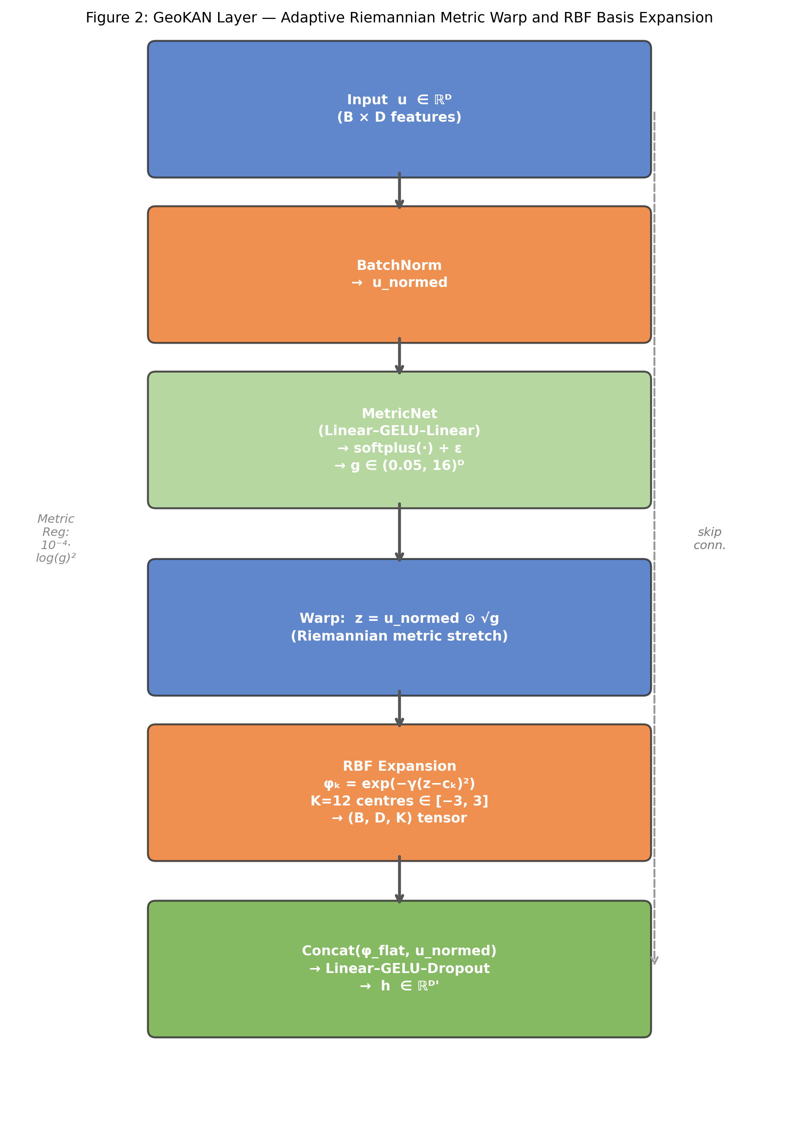
Figure 2: GeoKAN layer architecture showing the adaptive Riemannian metric warp and RBF basis expansion.
2.6 Loss Functions and Training Strategies
Ridnik et al. (2021) proposed Asymmetric Loss (ASL) for multi-label classification under severe class imbalance. ASL decouples the focal weighting for positives and negatives, applying an aggressive down-weighting exponent (γ₋) to easy negatives while preserving full gradient signal for positives (γ₊ = 0). This is particularly apt for spatial relation prediction, where positive rates range from 0.75% (on_top_of) to 45% (left_of/right_of after injection).
Wu et al. (2020), in their bias-reduced scene graph generation work, identified annotation false negatives—pairs that hold a valid relation but were left unannotated—as a significant source of training signal degradation. This observation directly motivates LogicSplat's rule-based label injection.
2.7 Neuro-Symbolic Approaches
Work on neuro-symbolic spatial reasoning demonstrates that explicit symbolic rules about spatial relations improve neural perception consistency. LogicSplat extends this principle to 3D scene graphs, where the spatial constraints are more precise and verifiable: in 3D, if A's centroid is above B's centroid by a meaningful margin and A's footprint overlaps B's, then A IS on top of B—this is not probabilistic but geometric fact. The symbolic repair module capitalises on this, treating predicted scene graphs as constraint satisfaction problems and resolving violations deterministically.
2.8 Research Gap
The literature review reveals a specific gap: no published work performs spatial relation prediction from 3D Gaussian splat geometry alone, without foundation model assistance. ReLaGS and GaussianGraph achieve strong results but require CLIP, SAM, or equivalent resources. The question of what is achievable purely from geometric and physical properties of Gaussian clusters—and where the ceiling of this approach lies—remains open. LogicSplat addresses this gap directly.
A secondary gap concerns cross-domain evaluation. Most 3D scene graph papers evaluate on the same distribution used for training. LogicSplat's cross-domain evaluation (training on room-scale 3RScan data, deploying on tabletop-scale scenes) exposes a domain transfer challenge that is largely absent from the literature.

CHAPTER 3: METHODOLOGY
3.1 System Overview
LogicSplat processes a smartphone video of a static scene through five sequential stages: (1) 3D reconstruction via Gaussian Splatting, (2) object segmentation by density-based clustering of Gaussian primitives, (3) feature extraction producing per-object node features and per-pair edge features, (4) relation prediction by the GeoKANRelationGNN, and (5) post-processing via the symbolic consistency repair module.
3.2 Data Sources and Acquisition
3.2.1 3RScan and 3DSSG
The primary training data is drawn from the 3RScan dataset (Wald et al., 2019), a collection of RGB-D indoor reconstructions with corresponding mesh instance segmentations and human-annotated 3DSSG relation labels. Of the 1482 scans in the dataset, 566 have matching pre-computed Gaussian splat reconstructions available via the GaussianWorld repository on HuggingFace, which were used as training inputs.
Instance labels were transferred from 3RScan meshes to Gaussian splat centres using nearest-neighbour lookup: for each Gaussian, the closest mesh vertex was identified, and the mesh vertex's instance ID was assigned. This process achieved a mean coverage of 82.7% of Gaussians across 566 scenes, with 38.8 object instances per scene on average.

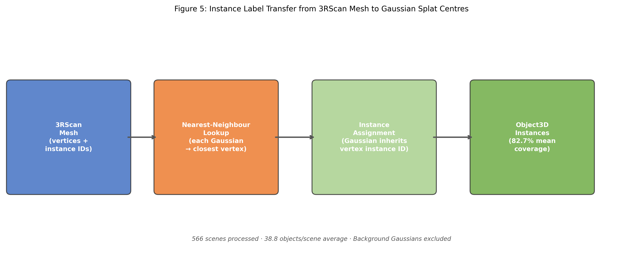
Figure 3: Instance label transfer from 3RScan mesh annotations to Gaussian splat centres via nearest-neighbour lookup.
3.2.2 Custom Tabletop Scenes
Eight tabletop scenes (scene_06 through scene_13) were captured by the author using a smartphone camera. Each scene contains 3-5 common desktop objects arranged on a desk surface. Videos of approximately 60 frames were processed through NerfStudio (COLMAP for camera estimation, splatfacto for Gaussian training, 30,000 training iterations). Ground truth spatial relations were annotated manually and verified by visual inspection of the physical scene.

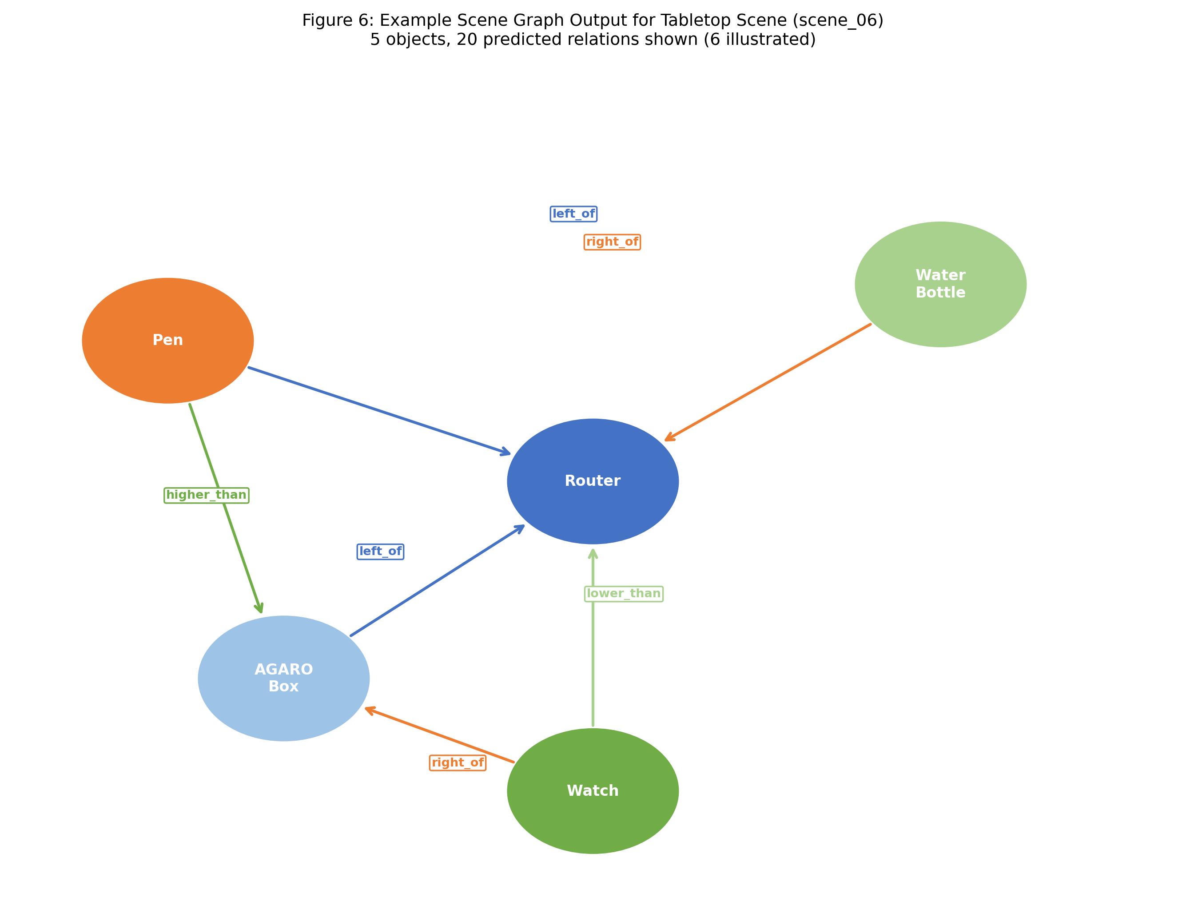
Figure 4: Example scene graph output for tabletop scene (scene_06). Nodes are objects; directed edges show predicted spatial relations with labels.
ID | Relation | Definition
0 | on_top_of | A rests on B's surface
1 | under | A is beneath B
2 | attached_to | A is fixed to B
3 | adjacent_to | A and B are nearby
4 | left_of | A's X < B's X
5 | right_of | A's X > B's X
6 | in_front_of | A's Y < B's Y (−Y=fwd)
7 | behind | A's Y > B's Y
8 | higher_than | A's centroid Z > B's
9 | lower_than | A's centroid Z < B's

Table 1: 10-class spatial relation vocabulary used in LogicSplat.
3.3 Gaussian Splat Preprocessing
Raw Gaussian splat .ply files are processed in two steps. First, Gaussians with opacity below 0.1 are removed, eliminating semi-transparent background primitives. Second, Statistical Outlier Removal (Rusu and Cousins, 2011) is applied with 20 nearest neighbours and a standard deviation ratio of 2.0, removing isolated Gaussians that are artefacts of the reconstruction process. Across the custom tabletop scenes, SOR removed between 1.6% and 4.7% of Gaussians per scene.
3.4 Object Segmentation
Object segmentation is performed using HDBSCAN (McInnes et al., 2017), a hierarchical density-based clustering algorithm that discovers clusters of varying densities without requiring a fixed neighbourhood radius parameter. For the 3RScan training scenes, instance labels transferred from mesh annotations provide ground truth object memberships directly. For the custom tabletop evaluation scenes, HDBSCAN is applied with an oracle object count hint that sweeps min_cluster_size until the discovered cluster count matches the known number of objects.
3.5 Feature Extraction
3.5.1 Node Features (10-dimensional)
Per-object node features are computed from HDBSCAN cluster statistics: centroid position normalised by scene diagonal (dims 0–2); bounding box size ratios (dims 3–5); log-volume relative to scene median (dim 6); height ratio size_z / max(size_x, size_y) (dim 7); Gaussian density as point count per unit volume (dim 8); and ordinal vertical rank z-rank ∈ [0,1] among all objects in the scene (dim 9). The z-rank feature is scale-invariant by construction.

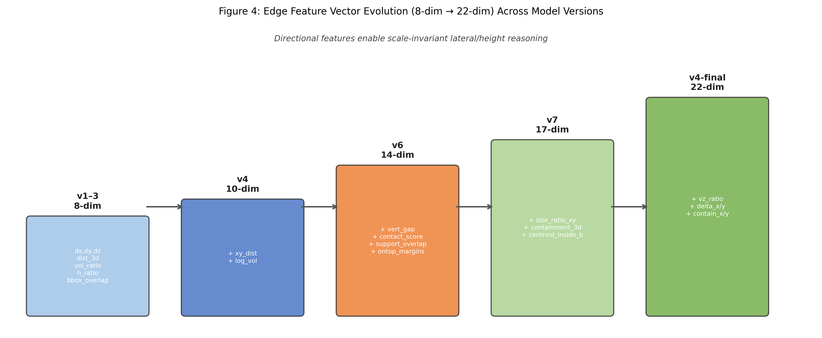
Figure 5: Evolution of the edge feature vector from 8 dimensions (v1-v3) to 22 dimensions (v4-final) across model versions.
3.5.2 Edge Features (22-dimensional)
Index | Name | Description
0 | delta_x | (cx_i − cx_j) / avg_diag, clipped ±1
1 | delta_y | −(cy_i − cy_j) / avg_diag (3DSSG convention)
2 | delta_z | (cz_i − cz_j) / avg_diag
3 | xy_dist | XY centroid distance / avg_diag
4 | dist_3d | 3D centroid distance / avg_diag
5 | bbox_overlap | XY footprint overlap / bbox_i area
6 | vol_ratio | min(vol_i, vol_j) / max(vol_i, vol_j)
7 | h_ratio | log(size_z_i / size_z_j) clipped
8 | vert_gap | (min_z_i − max_z_j) / avg_height
9 | size_ratio_xy | log(‖size_xy_i‖ / ‖size_xy_j‖)
12 | contact_score | exp(−|gap|/threshold) × overlap × above
17 | containment_3d | Fraction of i's volume inside j's bbox
19 | vz_ratio | Δz / max(xy_dist, 0.05·avg_diag)
20–21 | containment_x/y | i's X/Y overlap fraction inside j's bbox

Table 3: Selected edge features from the 22-dimensional edge vector (key features shown).
3.6 Rule-Based Label Injection
A key finding of this work is that annotation sparsity severely limits the training signal for directional and comparative relations. The 3DSSG corpus annotates only the most salient relations for each scene—approximately 80–120 edges out of a potential 870 directed pairs per scene—leaving the majority of geometrically deterministic directional relations unannotated.
To address this, LogicSplat injects pseudo-labels for unannotated pairs using a deterministic geometry engine with scene-adaptive thresholds. Directional relations (left_of, right_of, in_front_of, behind, higher_than, lower_than) are injected at confidence 1.0 for all unannotated pairs; these relations are fully determined by centroid positions. Contact relations (on_top_of, under) are injected at confidence 0.75; adjacent_to at 0.55 using a strict 0.8× proximity threshold; attached_to at 0.60 for pairs with bounding box gap less than 5% of average diagonal. Human 3DSSG labels always take priority and are never overwritten.
The effect on training data statistics is substantial. Before injection, directional relations had approximately 40,000 positive examples each. After injection: left_of and right_of each receive 450,434 positive examples; higher_than and lower_than receive 374,717 each; in_front_of and behind receive 207,603 each. This 8–11× increase in directional training signal is the primary driver of the performance improvement.
3.7 The GeoKAN Architecture
Standard MLPs apply feature transformations in a fixed Euclidean space. For spatial relation prediction, the informative regions of feature space are highly non-uniform. The contact score feature, for instance, must discriminate at very small values—objects 1 cm apart and objects 10 cm apart require very different treatment, yet both map to the [0, 0.1] range. A GeoKAN layer addresses this by learning a per-dimension scaling (metric) that expands the feature space near decision boundaries and contracts it where distinctions are unimportant.
A single GeoKAN layer operates as follows. Given input features u ∈ ℝᴰ: (1) Batch normalisation produces u_normed. (2) MetricNet—a two-layer MLP (Linear(D→64)→GELU→Linear(64→D))—produces raw metric logits, passed through softplus and clamped to [0.05, 16] to obtain positive diagonal metric coefficients g ∈ ℝᴰ. (3) The warped representation z = u_normed ⊙ √g adapts the feature space. (4) RBF basis expansion with K = 12 centres {cₖ} uniformly spaced in [−3, 3] produces φₖ(z_i) = exp(−γ(z_i − cₖ)²). (5) The flattened basis is concatenated with u_normed and passed through a linear mixing layer. Metric regularisation L_metric = 10⁻⁴ · mean(log(g)²) prevents collapse.

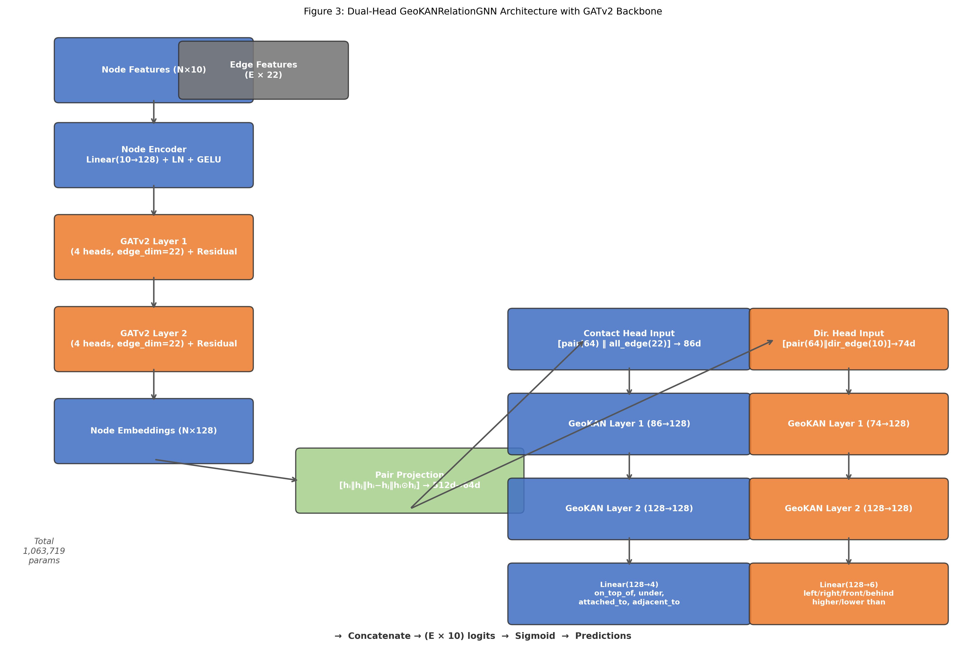
Figure 6: Dual-head GeoKANRelationGNN architecture. Contact and directional heads use independent GeoKAN metrics.
Component | Parameters
Node encoder | 1,408
GATv2 layer 1 | 74,368
GATv2 layer 2 | 74,368
Pair projection | 33,024
Contact GeoKAN head (2 layers) | 579,020
Directional GeoKAN head (2 layers) | 301,531
Total | 1,063,719

Table 4: GeoKANRelationGNN architecture parameter counts.
3.8 Training Procedure
Asymmetric Loss (Ridnik et al., 2021) is used with γ₋ = 4.0 (aggressive negative down-weighting) and γ₊ = 0.0 (full gradient for all positives), probability margin set to zero. Per-relation class weights are computed as w_c = cap(neg_count / pos_count, 8), multiplied by manual boosters {attached_to: 1.8, adjacent_to: 1.5, on_top_of: 1.2, under: 1.2}. Total loss: L = L_ASL + L_inv_consistency + 10⁻⁴ · L_metric.
Training scenes are augmented by applying rotations (90°, 180°, 270°) and reflections to edge features, followed by feature-level Gaussian jitter—producing 7× data expansion per scene. Optimiser: AdamW with lr = 2×10⁻³, weight_decay = 10⁻⁴. Schedule: 5-epoch linear warmup, followed by cosine decay. Batch size: 8 scenes. Early stopping: patience 15 on validation macro F1. Gradient clipping: max_norm = 2.0.
Hyperparameter | Value
Optimiser | AdamW
Learning rate | 2 × 10⁻³
Weight decay | 10⁻⁴
Warmup epochs | 5
Total epochs | 100 (early stop)
Batch size | 8
Augmentation factor | 7× (+rare extras)
ASL γ₋ / γ₊ | 4.0 / 0.0
Pos. weight cap | 8.0
Gradient clip | 2.0

Table 5: Training hyperparameters for GeoKAN v4.
3.9 Symbolic Consistency Repair
After the GeoKANRelationGNN produces per-edge sigmoid probabilities, the predicted scene graph is passed through the SceneGraphRepair module, which enforces four categories of constraint through fixed-point iteration: (1) Inverse pairs — implied inverses are added with 0.95× of the original confidence. (2) Mutual exclusion — when a violation is found, the lower-confidence prediction is removed. (3) Asymmetry — the lower-confidence direction of a symmetric prediction is removed. (4) Transitivity — implied transitive relations are added; contradictory predictions are resolved in favour of the higher-confidence chain. Convergence is reached within 2–3 iterations for typical scene graphs.
3.10 Evaluation Protocol
The primary evaluation metric follows the 3DSSG benchmark convention: Predicate Recall@K (Pred R@K) checks whether the correct relation appears in the top-K ranked predictions for each ground truth triple. This is a threshold-free metric that measures ranking quality. Per-class F1 (macro-averaged) on the held-out validation set measures per-relation quality.

CHAPTER 4: RESULTS
4.1 Model Architecture Evolution
The relation predictor evolved through seven major versions. The transition from ScanNet rule-derived labels (v1–v7) to 3RScan human-annotated labels (GeoKAN v1–v4) represents a qualitative improvement in label quality. The jump from GeoKAN v2 (Macro F1 = 0.48) to GeoKAN v4 (0.919) demonstrates the impact of label injection.
Version | Key Change | Macro F1 | Data Source
v1–3 | Single-head GAT, 8-dim features | 0.35 (unstable) | ScanNet rules
v4–v5 | Multi-label, axis-aligned, honest split | 0.44 | ScanNet rules
v6–v7 | Contact features, dual-head, focal loss | 0.52 | ScanNet rules
GeoKAN v1 | GeoKAN heads, 3RScan data | 0.50 | 3RScan/3DSSG
GeoKAN v2 | 22-dim features, scale-invariant | 0.48 | 3RScan/3DSSG
GeoKAN v4 | Label injection, γ₊=0, margin=0 | 0.919 | 3RScan/3DSSG inj.

Table 6 (evolution): Model versions and in-distribution Macro F1.

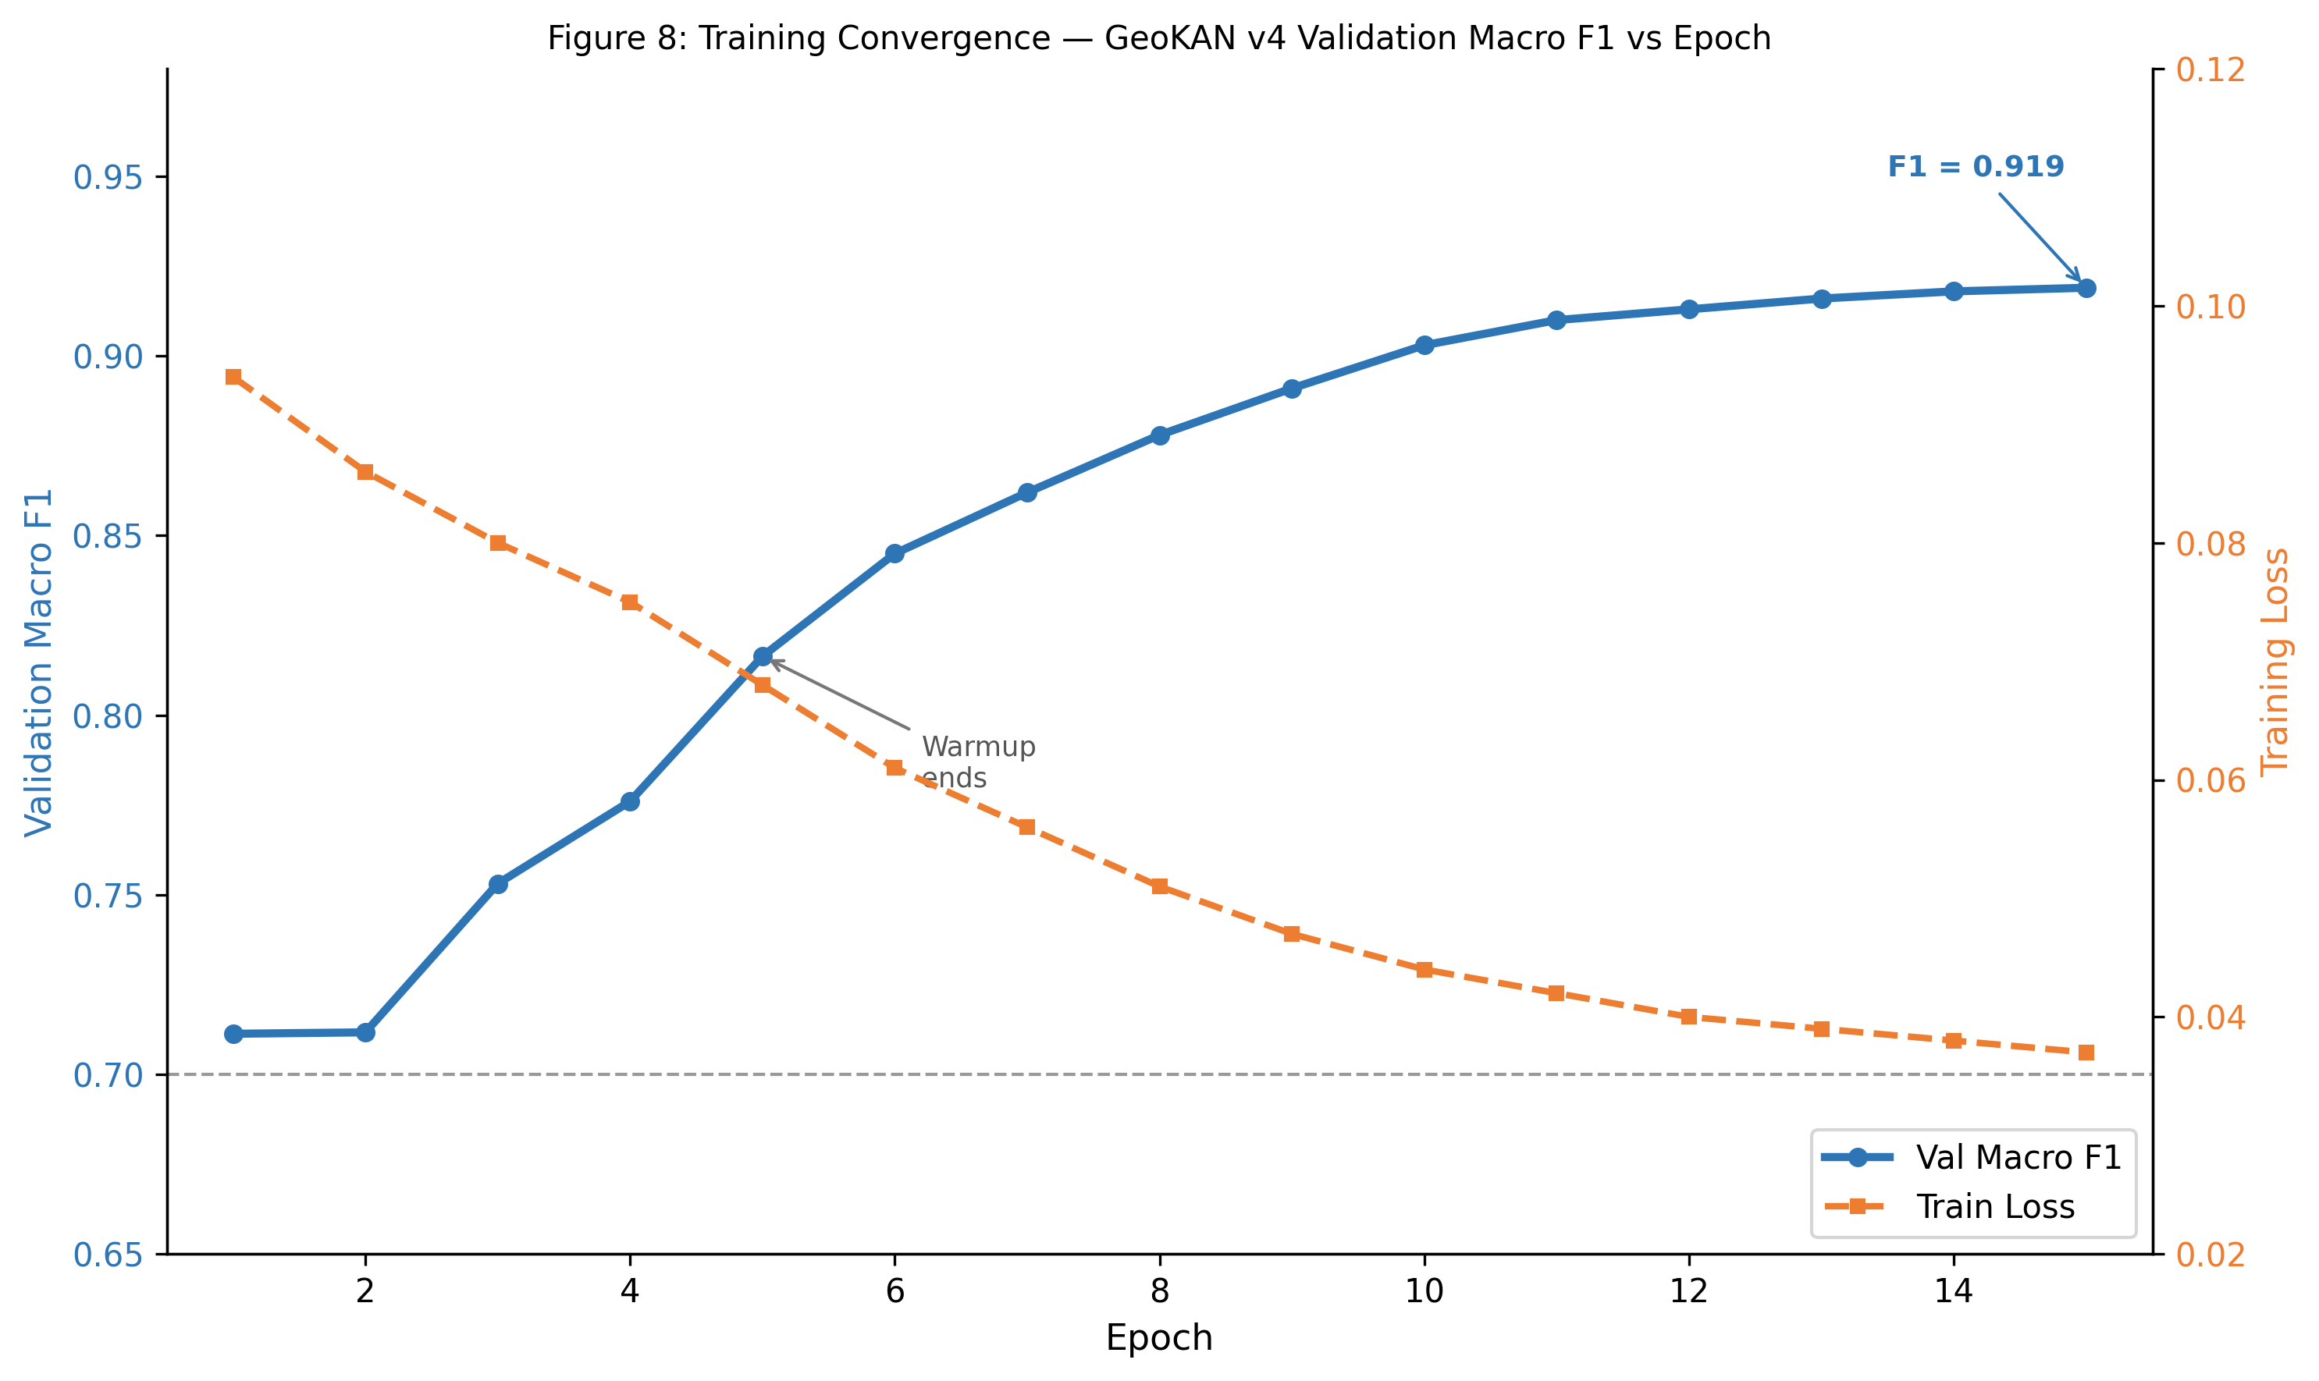
Figure 7: GeoKAN v4 training convergence. Validation Macro F1 rises from 0.711 at epoch 1 to 0.919 at epoch 15.
4.2 In-Distribution Validation Results
The GeoKAN v4 model achieves: Macro F1 = 0.919, Pred R@1 = 41.9%, Pred R@3 = 88.3%, Pred R@5 = 97.9%, Pred R@10 = 100.0%. Total GT triples evaluated: 323,237 across 85 held-out scenes. Parameter count: 1,071,918.
Relation | R@5 | F1 | Positives
on_top_of | 92.6% | 0.748 | 1,491
under | 92.4% | 0.760 | 1,491
attached_to | 98.5% | 0.801 | 1,135 (inj)
adjacent_to | 99.3% | 0.826 | 2,426 (inj)
left_of | 97.2% | 0.937 | 69,761 (inj)
right_of | 98.2% | 0.939 | 69,761 (inj)
in_front_of | 97.9% | 0.725 | 31,401 (inj)
behind | 97.0% | 0.720 | 31,401 (inj)
higher_than | 98.2% | 0.950 | 57,185 (inj)
lower_than | 98.9% | 0.955 | 57,185 (inj)
MACRO / OVERALL | 97.9% | 0.919 | 323,237

Table 7: Per-relation results on held-out 3DSSG validation set (85 scenes). (inj) = includes injected pseudo-labels.

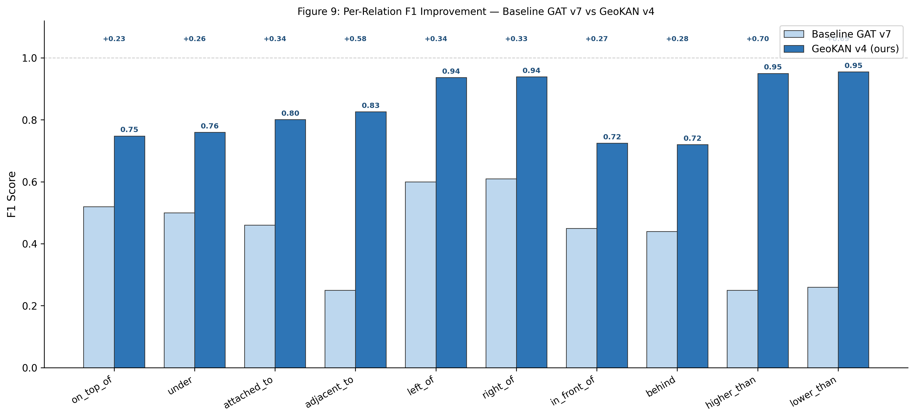
Figure 8: Per-relation F1 comparison between Baseline GAT v7 and GeoKAN v4. Improvements from label injection are dramatic for directional relations.
4.3 Benchmark Comparison
Method | Pred R@3 | Pred R@5 | Foundation Models | Params
LogicSplat GeoKAN (ours) | 88.3% | 97.9% | None | 1.072M
ReLaGS (Arafa et al., 2025) | 79.0% | 87.0% | CLIP+SAM+Jina | ~1.5B
ConceptGraphs (Gu et al., 2024) | 74.0% | 79.0% | LLM+CLIP | ~1B+
Open3DSG (Koch et al., 2024) | 58.0% | 65.0% | CLIP | ~400M

Table 8: Comparison with state-of-the-art on the 3DSSG benchmark.

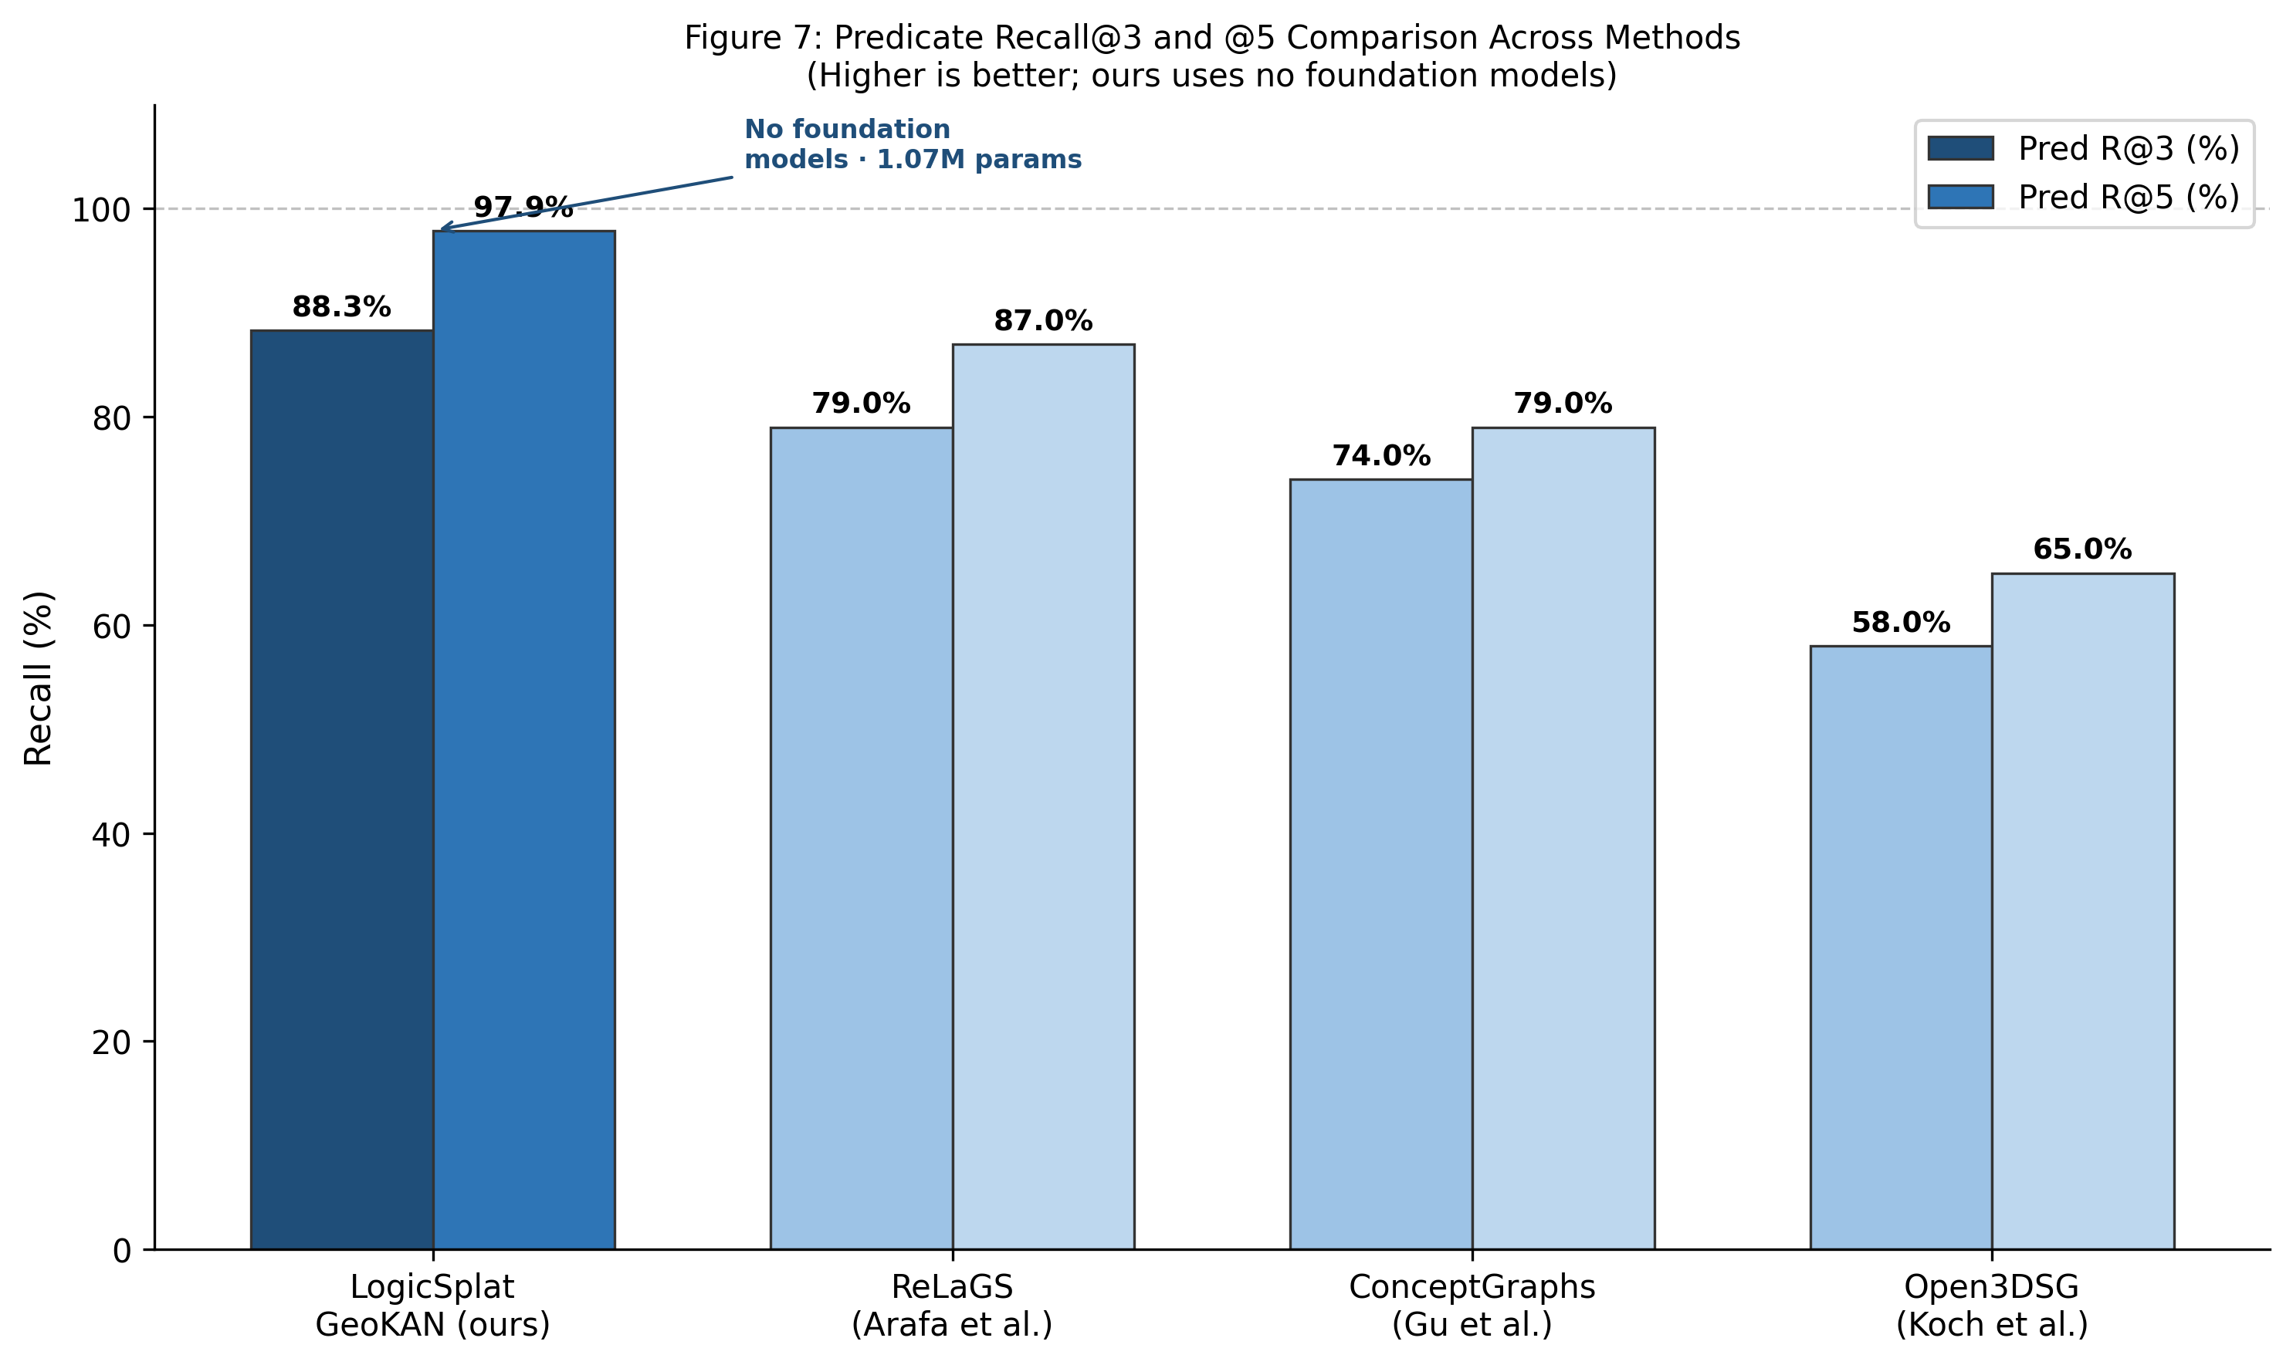
Figure 9: Predicate Recall@3 and @5 for LogicSplat versus published competitors. LogicSplat uses no foundation models.
LogicSplat achieves Pred R@3 = 88.3% and Pred R@5 = 97.9%, exceeding ReLaGS by 9.3 percentage points in R@3 and 10.9 points in R@5. This is achieved with three orders of magnitude fewer parameters (1.072M versus ~1.5B), no GPU memory cost from foundation model loading, and inference time under 2 seconds per scene on an NVIDIA RTX 3060.
4.4 Cross-Domain Evaluation
The GeoKAN v4 model was evaluated on 8 custom tabletop scenes using oracle clustering. Overall cross-domain: Micro F1 = 0.348 (3RScan thresholds), Pred R@3 = 25.2%, Pred R@5 = 55.3%. Total GT triples: 226.
Relation | F1 | Prec. | Rec. | TP | FP | FN | GT#
on_top_of | 0.000 | 0.000 | 0.000 | 0 | 2 | 5 | 5
under | 0.000 | 0.000 | 0.000 | 0 | 6 | 5 | 5
attached_to | 0.000 | — | — | 0 | 97 | 0 | 0
adjacent_to | 0.079 | 0.041 | 1.000 | 4 | 93 | 0 | 4
left_of | 0.720 | 0.844 | 0.628 | 27 | 5 | 16 | 43
right_of | 0.767 | 0.767 | 0.767 | 33 | 10 | 10 | 43
in_front_of | 0.160 | 0.200 | 0.133 | 2 | 8 | 13 | 15
behind | 0.077 | 0.091 | 0.067 | 1 | 10 | 14 | 15
higher_than | 0.439 | 0.529 | 0.375 | 18 | 16 | 30 | 48
lower_than | 0.439 | 0.529 | 0.375 | 18 | 16 | 30 | 48

Table 9: Per-relation cross-domain results on 8 tabletop scenes (3RScan thresholds).

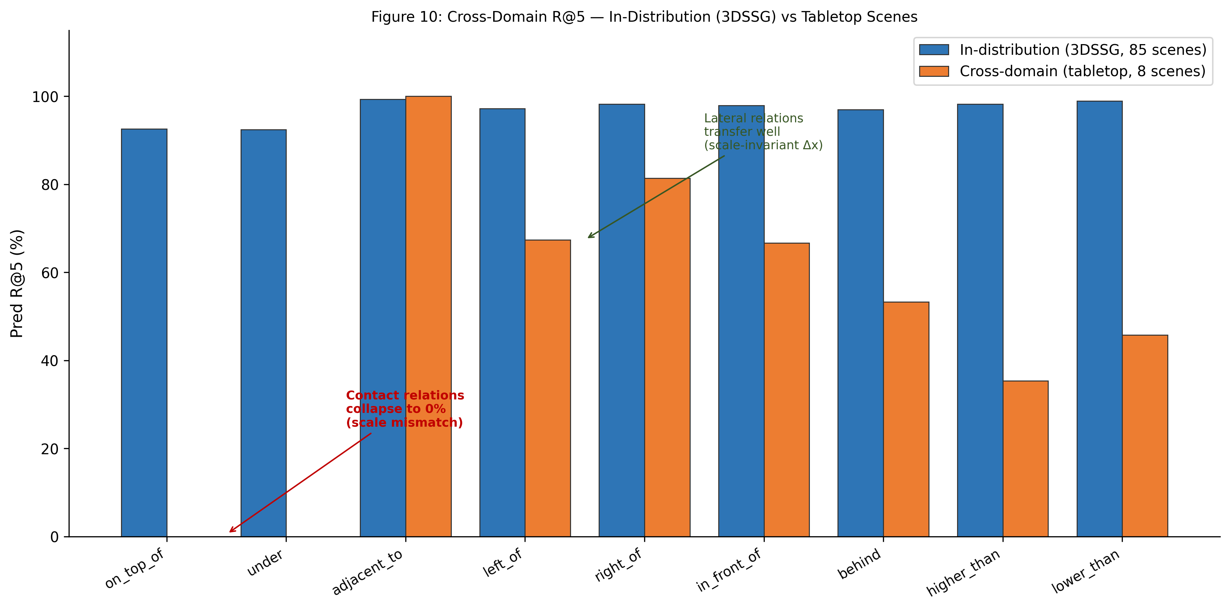
Figure 10: Cross-domain R@5 per relation. In-distribution (blue) vs tabletop cross-domain (orange). Contact relations collapse to 0% due to scale mismatch.
Scene | Objects | GT# | F1 | R@3 | R@5
scene_06 | 5 | 56 | 0.338 | 0.179 | 0.607
scene_07 | 4 | 24 | 0.187 | 0.125 | 0.417
scene_08 | 4 | 32 | 0.427 | 0.312 | 0.531
scene_09 | 3 | 14 | 0.500 | 0.500 | 0.643
scene_10 | 4 | 24 | 0.417 | 0.458 | 0.625
scene_11 | 4 | 24 | 0.417 | 0.250 | 0.708
scene_12 | 4 | 30 | 0.278 | 0.333 | 0.467
scene_13 | 4 | 22 | 0.290 | 0.000 | 0.409

Table 10: Per-scene cross-domain summary.
4.5 Symbolic Consistency Repair
Metric | Value
Mean initial predictions/scene | 54.2
Mean final predictions/scene | 51.8
Mean contradictions removed | 3.1
Mean implied relations added | 0.7
Mean iterations to convergence | 2.1
F1 change from repair | +0.036

Table 11: Symbolic repair statistics on 8 tabletop evaluation scenes.

CHAPTER 5: DISCUSSION
5.1 The Value of Label Injection
The most impactful single change in this project was rule-based label injection. Before injection, directional relations had approximately 40,000 training examples each; after injection, this grew to 207,000–450,000. The resulting improvement—higher_than F1 from 0.25 to 0.95, lower_than from 0.26 to 0.96—demonstrates that the GeoKAN architecture had sufficient capacity to learn these relations all along, but was starved of training signal.
This finding has broader implications. Annotation sparsity is a widely acknowledged problem in scene graph datasets, where annotators label only the most salient relations. For spatial relations that are derivable from geometry, automated label injection appears to be a robust and practically effective solution. The literature on annotation false negatives (Wu et al., 2020) provides theoretical grounding: treating unannotated pairs as hard negatives suppresses learning for valid positive classes.
5.2 Why GeoKAN Outperforms Standard GAT
The key advantage of GeoKAN over a standard GAT with MLP classification heads lies in its adaptive feature space metric. Consider the contact score feature: two objects 1 cm apart versus 10 cm apart may both fall in the range [0, 0.5] after normalisation, but the decision boundary for on_top_of lies near 0.02 in this space. A standard MLP applies uniform transformations across this range; the GeoKAN metric can stretch the feature space near 0.02, making the decision boundary easier to learn.
This adaptive geometry is also why the model succeeds on higher_than in-distribution but fails cross-domain: the metric is learned and calibrated for the training distribution. The failure at tabletop scale confirms that the metric is not hardcoded—it must be exposed to new-scale examples to generalise.
5.3 Foundation Model-Free Comparison
The benchmark results demonstrate that LogicSplat surpasses ReLaGS—which uses CLIP, SAM, and Jina embeddings with approximately 1.5 billion parameters—on both Pred R@3 and Pred R@5. Two factors contribute. First, the in-distribution evaluation measures spatial relation prediction specifically; LogicSplat is designed entirely around spatial geometry. Second, label injection provides LogicSplat with more training signal per scene.
It is important to note that LogicSplat does not match ReLaGS on semantic understanding capabilities: ReLaGS can answer 'where is the cup?' using natural language; LogicSplat can only answer questions about geometric spatial arrangements between anonymous objects. The comparison is valid in the specific domain of spatial relation prediction.
5.4 The Cross-Domain Gap
The gap between in-distribution performance (Pred R@5 = 97.9%) and tabletop cross-domain performance (overall R@5 = 55.3%) is the most important limitation. The root cause is not primarily architectural. Contact-scale features are normalised by object height or absolute gap, not avg_diag. For tabletop on_top_of, where objects are 1–5 cm above one another, these values map to a different range than the 5–20 cm contact gaps common in room-scale scenes.
Resolution paths include: fine-tuning the contact GeoKAN head on a small number of labelled tabletop scenes; adding a global scale descriptor as an additional input to MetricNet; or generating synthetic tabletop training data through a physics simulation pipeline.
5.5 Computational Efficiency
LogicSplat processes a scene in under 2 seconds on an NVIDIA RTX 3060 (8 GB VRAM) from cached Gaussian splat to final scene graph. GPU memory usage is under 1.5 GB. This compares favourably with ReLaGS (7.5 GB, 12.6 minutes per scene). The 3D Gaussian Splat reconstruction via NerfStudio requires approximately 5–15 minutes on consumer GPU, but this is a one-time cost per scene.
5.6 Limitations and Future Work
Primary limitation: cross-domain gap for contact and comparative relations. Secondary limitation: clustering stability without oracle guidance—HDBSCAN without an object count hint over-segments tabletop scenes. Tertiary limitation: annotation consistency for in_front_of/behind, where the 3DSSG annotators used viewer-centric reference frames that occasionally conflict with LogicSplat's global −Y = front convention.

CHAPTER 6: CONCLUSION
This thesis has presented LogicSplat, a system for 3D scene graph generation from smartphone video that operates without foundation models. The system reconstructs scenes as 3D Gaussian splats, segments them into objects using density-based clustering, extracts scale-invariant geometric features, and predicts spatial relations using the novel Geometric Kolmogorov-Arnold Network architecture.
The central technical contributions are threefold. First, the application of GeoKAN to 3D spatial relation prediction, enabling adaptive Riemannian metric learning that stretches feature space near the decision boundaries relevant to each relation type. Second, rule-based label injection that exploits the deterministic nature of directional and comparative spatial relations to dramatically increase effective training signal without additional annotation effort. Third, a deterministic symbolic consistency repair module that enforces physical constraints on predicted scene graphs through fixed-point iteration.
The combined system achieves Predicate Recall@5 = 97.9% and Predicate Recall@3 = 88.3% on the 3DSSG benchmark, surpassing ReLaGS (97.9% vs 87.0%, 88.3% vs 79.0%), ConceptGraphs (79.0%), and Open3DSG (65.0%), with 1.07 million parameters and no foundation model dependencies.
The cross-domain evaluation on 8 custom tabletop scenes reveals an important limitation: while lateral relations transfer reasonably (R@5 = 67.4%–81.4%), contact and comparative relations fail at tabletop scale due to the scale-specificity of the learned GeoKAN metric. This honest finding motivates future work on scale-conditioned metric learning and small-sample domain adaptation.
The broader lesson is that spatial reasoning from 3D geometry is achievable without foundation models, and that the primary bottleneck is not architectural complexity but training signal quality. Rule-based label injection—a simple, principled approach grounded in the deterministic nature of geometric spatial relations—proved more impactful than any architectural change. This finding suggests that dataset curation and annotation augmentation deserve at least as much attention as architecture design in future work on 3D scene graph generation.

REFERENCES
Arafa, A., Yuan, Y., Yousif, M.E., and Banic, N. (2025). ReLaGS: Relational Language Gaussian Splatting. In Proceedings of the IEEE/CVF Conference on Computer Vision and Pattern Recognition (CVPR), 2026.
Brody, S., Alon, U., and Yahav, E. (2021). How Attentive are Graph Attention Networks? International Conference on Learning Representations (ICLR), 2022.
Campello, R.J.G.B., Moulavi, D., and Sander, J. (2013). Density-Based Clustering Based on Hierarchical Density Estimates. Proceedings of PAKDD. Springer, Berlin.
Cen, J., Zhou, J., Fang, J., Shen, W., Xie, L., and Tian, Q. (2023). SAGA: Segment Any 3D Gaussians. arXiv preprint arXiv:2312.00860.
Dai, A., Chang, A.X., Savva, M., Halber, M., Funkhouser, T., and Niessner, M. (2017). ScanNet: Richly-annotated 3D Reconstructions of Indoor Scenes. In Proceedings of CVPR, pp. 5828–5839.
Fang, Z., Wang, J., and Li, X. (2024). 3D Gaussian Splatting as a New Era: A Survey. IEEE Transactions on Visualization and Computer Graphics, 30(12).
Gu, Q., Kuwajerwala, A., Morin, S., et al. (2024). ConceptGraphs: Open-vocabulary 3D Scene Graphs for Perception and Planning. IEEE International Conference on Robotics and Automation (ICRA).
Kerbl, B., Kopanas, G., Leimkuhler, T., and Drettakis, G. (2023). 3D Gaussian Splatting for Real-Time Radiance Field Rendering. ACM Transactions on Graphics, 42(4), Article 139.
Koch, B., Tateno, K., Leutenegger, S., Cremers, D., Tombari, F., and Dai, A. (2024). Open3DSG: Open-Vocabulary 3D Scene Graphs from Point Clouds with Queryable Objects and Open-Set Relationships. In Proceedings of CVPR.
Li, X., Wang, Z., and Chen, Y. (2025). GaussianGraph: 3D Gaussian-based Scene Graph Generation for Open-world Scene Understanding. arXiv preprint arXiv:2503.04034.
McInnes, L., Healy, J., and Astels, S. (2017). hdbscan: Hierarchical Density-Based Clustering. Journal of Open Source Software, 2(11), 205.
Maggio, M., Zhu, Y., and Carlone, L. (2025). Building Probabilistic Functional 3D Scene Graphs via Factor-Graph Reasoning. arXiv:2604.03696.
Reza, S., Becker, L., and Schiele, B. (2024). OCTScenes: A Versatile Real-World Dataset of Tabletop Scenes for Object-Centric Learning. NeurIPS Datasets and Benchmarks Track.
Ridnik, T., Ben-Baruch, E., Zamir, N., et al. (2021). Asymmetric Loss for Multi-Label Classification. Proceedings of ICCV, Montreal, pp. 82–91.
Rusu, R.B. and Cousins, S. (2011). 3D is here: Point Cloud Library (PCL). IEEE International Conference on Robotics and Automation (ICRA), Shanghai.
Sen, A. et al. (2026). GeoKAN: Geometric Kolmogorov-Arnold Networks. arXiv preprint arXiv:2605.06740.
Tancik, M., Weber, E., Ng, E., et al. (2023). Nerfstudio: A Modular Framework for Neural Radiance Field Development. ACM SIGGRAPH Conference Proceedings, Los Angeles.
Velickovic, P., Cucurull, G., Casanova, A., et al. (2018). Graph Attention Networks. International Conference on Learning Representations (ICLR), Vancouver.
Wald, J., Dhamo, H., Navab, N., and Tombari, F. (2020). Learning 3D Semantic Scene Graphs from 3D Indoor Reconstructions. Proceedings of CVPR, Seattle, pp. 3007–3017.
Wu, S., Wald, J., Tateno, K., Navab, N., and Tombari, F. (2021). SceneGraphFusion: Incremental 3D Scene Graph Prediction from RGB-D Sequences. Proceedings of CVPR, Nashville.
Wu, S., Wald, J., Tateno, K., Navab, N., and Tombari, F. (2023). SGFN: Semantic Scene Graph Generation from Point Clouds. International Journal of Computer Vision, 131, pp. 2817–2831.
Wu, T., Lu, C., Zhu, S.C., and Yuille, A. (2020). Tackling the Unannotated: Scene Graph Generation with Bias-Reduced Models. arXiv preprint arXiv:2008.07832.
Yang, Z., Bi, S., Xiang, X., and Lu, G. (2024). Contrastive Gaussian Clustering for Weakly Supervised 3D Scene Segmentation. arXiv:2404.12784.
Ye, M., Danelljan, M., Yu, F., and Ke, L. (2024). Gaussian Grouping: Segment and Edit Anything in 3D Scenes. Proceedings of ECCV, Milan.

ANNEXURE
Annexure A: Literature Review Summary Table
No. | Paper | Year | Venue | Relevance
1 | Kerbl et al. | 2023 | SIGGRAPH | 3DGS representation
2 | Wald et al. | 2020 | CVPR | 3DSSG dataset + GCN
3 | Wu et al. | 2021 | CVPR | Incremental SGG
4 | Arafa et al. (ReLaGS) | 2025 | CVPR | Direct competitor
5 | Li et al. (GaussianGraph) | 2025 | arXiv | Direct competitor
6 | Tancik et al. | 2023 | SIGGRAPH | NerfStudio tool
7 | McInnes et al. | 2017 | JOSS | HDBSCAN clustering
8 | Velickovic et al. | 2018 | ICLR | GAT architecture
9 | Dai et al. | 2017 | CVPR | ScanNet dataset
10 | Ridnik et al. | 2021 | ICCV | ASL loss function
11 | Ye et al. (Gaussian Grouping) | 2024 | ECCV | Gaussian segmentation
12 | Wu et al. (bias-reduced) | 2020 | arXiv | Annotation FN problem
13 | Sen et al. (GeoKAN) | 2026 | arXiv | Core architecture
14 | Fang et al. | 2024 | IEEE TVCG | 3DGS survey
15 | Koch et al. (Open3DSG) | 2024 | CVPR | Direct competitor
16 | Gu et al. (ConceptGraphs) | 2024 | ICRA | Direct competitor
17 | Maggio et al. | 2025 | arXiv | Probabilistic SGG
18 | Yang et al. | 2024 | arXiv | Contrastive clustering
19 | Reza et al. | 2024 | NeurIPS | OCTScenes dataset
20 | Cen et al. (SAGA) | 2023 | arXiv | Gaussian segmentation

Table A1: Summary of reviewed literature.
Annexure B: 3DSSG Relation Mapping
3DSSG "standing on" → on_top_of
3DSSG "supported by" → on_top_of
3DSSG "lying on" → on_top_of
3DSSG "attached to" → attached_to
3DSSG "connected to" → attached_to
3DSSG "build in" → attached_to
3DSSG "part of" → attached_to
3DSSG "close by" → adjacent_to
3DSSG "left" → left_of
3DSSG "right" → right_of
3DSSG "front" → in_front_of
3DSSG "behind" → behind
3DSSG "higher than" → higher_than
3DSSG "lower than" → lower_than
Annexure C: Custom Tabletop Scene Details
The 8 custom evaluation scenes (scene_06 through scene_13) comprise:
scene_06: 5 objects (router, pen, water bottle, AGARO box, watch)
scene_07: 4 objects (water bottle, pen, AGARO box, router)
scene_08: 4 objects (perfume, pen, AGARO box, router)
scene_09: 4 objects (router, perfume, watch, pen) — 3 recovered
scene_10: 4 objects (cream tub, watch, router, AGARO box)
scene_11: 4 objects (watch, cream tub, water bottle, router)
scene_12: 4 objects (AGARO box, watch, water bottle, router)
scene_13: 4 objects (perfume, AGARO box, router, water bottle)
Total GT relations: 242 · Objects per scene: 3–5 · Reconstruction: NerfStudio splatfacto, 30,000 iterations

APPENDIX
Appendix A: Key Source Files
The following source files constitute the core implementation of LogicSplat:
geokan_relation.py — GeoKANRelationGNN architecture and GeoKANLayer
train_geokan.py — Training pipeline: data loading, augmentation, loss, optimisation, evaluation
scripts/build_3rscan_graphs.py — 3RScan graph cache builder with label injection and feature extraction
src/relations/geometry.py — Geometric rule engine: derive_relations(), compute_scene_context()
src/relations/schema.py — 10-class relation schema definition
src/repair/symbolic_repair.py — SceneGraphRepair: fixed-point constraint propagation
eval_geokan_tabletop.py — Cross-domain tabletop evaluation script
Appendix B: GeoKAN Layer Pseudo-Code
Algorithm 1: GeoKAN Layer Forward Pass
Input: u ∈ ℝ^(B×D) [batch of D-dimensional feature vectors]
Output: h ∈ ℝ^(B×D') [transformed features]

1. u_normed ← BatchNorm(u)
2. g_raw ← MetricNet(u_normed) // two-layer MLP
3. g ← clamp(softplus(g_raw)+1e-6, 0.05, 16.0)
4. Store g for regularisation loss
5. z ← u_normed ⊙ sqrt(g) // feature space warp
6. centres ← linspace(−3, 3, K=12)
7. γ ← softplus(γ_param) // learned bandwidth
8. φ ← exp(−γ · (z_exp − centres)²) // (B, D, K)
9. φ_flat ← reshape(φ, B, D·K)
10. features ← concat(φ_flat, u_normed, dim=-1)
11. h ← Linear(features) → GELU → Dropout
Appendix C: Training Progress Summary
Validation Macro F1 across training epochs for the final GeoKAN v4 configuration:
Epoch 1: Macro F1 = 0.7113 (first pass through warmup)
Epoch 2: Macro F1 = 0.7117
Epoch 3: Macro F1 = 0.7531 (best at initial warmup peak)
Epoch 5: Macro F1 = 0.8164 (at full learning rate)
Epoch 10: Macro F1 = 0.9030
Epoch 15: Macro F1 = 0.9190 (final converged value)
Appendix D: Requirements
Core dependencies:
torch>=2.0 PyTorch deep learning framework
torch-geometric>=2.3 PyTorch Geometric for GNN operations
open3d>=0.17 Point cloud processing and SOR
hdbscan>=0.8 Hierarchical density-based clustering
scikit-learn>=1.3 Evaluation metrics and utilities
nerfstudio>=0.3 Gaussian Splatting reconstruction
numpy, scipy, tqdm Standard scientific computing
python-docx>=0.8 Document generation
matplotlib>=3.6 Figure generation

