Consider the following employee-related tables in MySQL.

**Tables:**

* employees_table (contains employee details such as id, name, email, phone, salary, department etc.)
* departments_table (contains department details such as department id, name, location etc.)
* locations_table (contains location information such as street name, city, pin, state, country)
* jobs_table (contains job metadata such as job id, job name etc.)
* regions_table (contains region details such as region id, region name)
* countries_table (contains county details such as country id, country name)

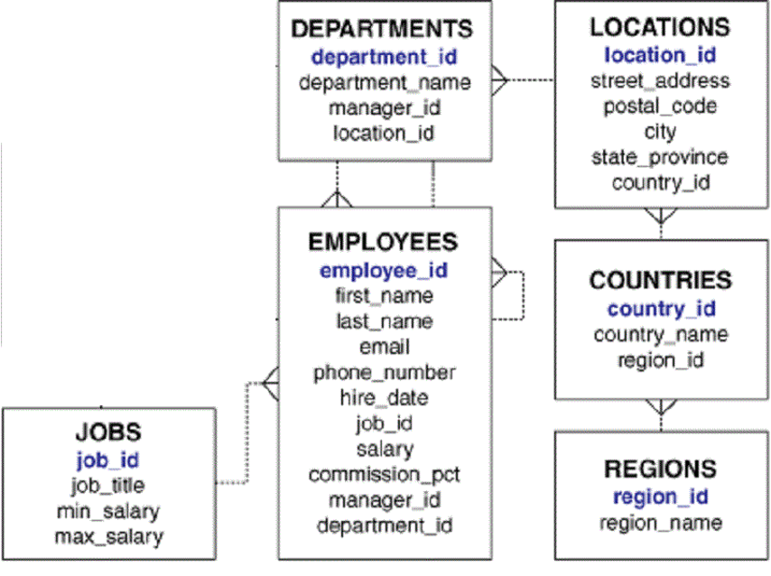

As a Big Data Engineer, you have to perform the following tasks:

* Import all these MySQL tables to Hive tables. Hive DDLs can be inferred from table schemas in MySQL.
* Create a new table (i.e. employee_scd) which implements a slowly changing dimension (type 2) for the employees table.
* SCD table should have additional columns, start_date, end_date, and active_flag.
* Start_date and end_date behave as per the concept of SCD type 2. The active flag can be 0 or 1 depending on which row in the table contains the latest information of the employee.
* There is a delta file present at the HDFS path '**hdfs:///bigdatapgp/common_folder/assignment8/emp_details/Employeedelta.txt**' that contains the changes in employee information till the current date.
* Based on changes present in the delta file (on columns such as email, phone_number, job_id, department_id, manager_id, salary, commission_pct) maintain the change history using start_date, end_date and active flag columns with old information being closed with end_date = (current_date -1).
* Create an updated employee table with the latest information on all the employees.
* Upload the updated employee details to a MySQL table.

**SCD Type 2 Example:**

|  |  |  |  |  |  |  |
| --- | --- | --- | --- | --- | --- | --- |
| **id** | **Name** | **dept_id** | **manager_id** | **start_date** | **end_date** | **active_flag** |
| 1 | Abc | 10 | 111 | 2019-01-01 | 9999-12-31 | 1 |
| 2 | Def | 10 | 111 | 2019-01-01 | 2019-12-08 | 0 |
| 2 | Def | 20 | 111 | 2019-12-09 | 9999-12-31 | 1 |

**For employee 2, the department got changed on 2019-12-09 from 10 to 20, hence in SCD type 2, there will be 2 records for employee id 2.**

**The schema of the output table is mentioned below. The SCD table needs to be present in the Hive whereas the updated employee table needs to be present in MySQL.**

**Output the result as per the schema mentioned in the below tables.**

1. **Employee_scd Output Table in Hive:**

CREATE TABLE edureka_dw.employees_scd

   ( employee_id int

   , first_name VARCHAR(20)

   , last_name VARCHAR(25)

   , email VARCHAR(25)

   , phone_number VARCHAR(20)

   , hire_date varchar(12)

   , job_id VARCHAR(10)

   , salary decimal

   , commission_pct decimal(2,2)

   , manager_id int

   , department_id int

   , start_date string

   , end_date string

   , active_flag char(1)

   , row_insertion_dttm string

   ) ;

1. **Updated Employee Detail Table in MySQL:**

CREATE table edureka_dw.employee_details_latest

   (employee_id int,

   job_id varchar(10),

   manager_id int,

   department_id int,

   location_id int,

   country_id char(2),

   first_name varchar(20),

   last_name varchar(25),

   salary decimal,

   commission_pct decimal(2,2),

   department_name varchar(30),

   job_title varchar(35),

   city varchar(30),

   state_province varchar(25),

   country_name varchar(40),

   region_name varchar(25)

   );

**Output Format:**You need to paste the commands and the code used to solve this problem.

[HTML EditorKeyboard Shortcuts](https://claas-canvas.corestack.io/courses/5/quizzes/119/take)

**ANSWER TO THE ABOVE QUESTION**

