|  |  |
| --- | --- |
| A picture of a winding road and trees  MID tERM pROJECT  Chicago Taxi Data | Abstract  Marketix, a Market Research firm, has hired you as a big data engineer. You are asked to prepare the datafor performing market research on the trends and patterns of Taxi services in Chicago. The report shouldequip to serve the following target audience:• Executives and Leadership team from any of the existing taxi service provider or aggregator thatoperates already in the region.• Executives and Leadership team from any of the taxi service providers operating in otherregions, who are trying to enter the market for the first time.• Any potential Entrepreneur or investor who is trying to invest in the business of taxi service oraggregator service.The outcomes and findings must cater to the needs of diversified target audience, who have differentgoals in their mind.  Debmalya Ray  Project Submission |

**Database Creation for the Mid – Term Project**

create database taxi_trip_database

use taxi_trip_database

**Raw File Location – taxi trip dataset**

http://bdlabs.edureka.co:50003/filebrowser/#/bigdatapgp/common_folder/midproject/taxi_trip_dataset

**RESULT DATA**

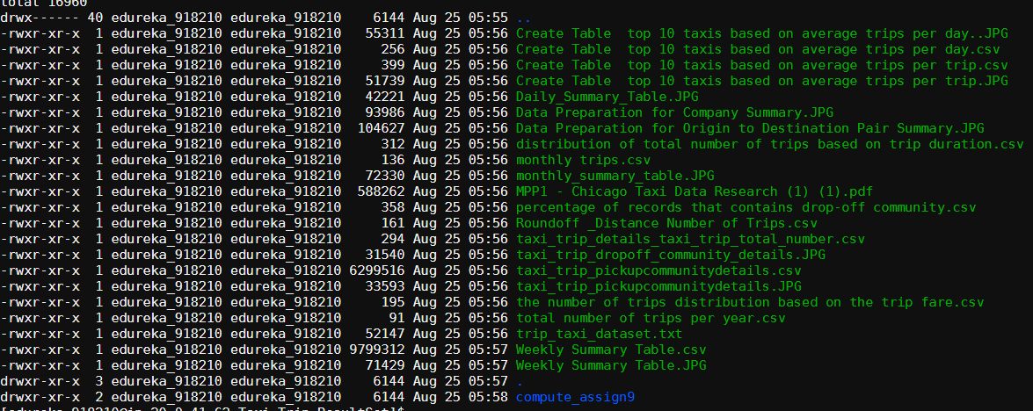

[edureka_918210@ip-20-0-41-164 ~]$ hadoop fs -ls /bigdatapgp/common_folder/midproject/taxi_trip_dataset

Found 1 items

-rw-r--r-- 3 evaluationuser01 supergroup 2589084507 2020-05-17 13:54 /bigdatapgp/common_folder/midproject/taxi_trip_dataset/taxi_trip.csv

[edureka_918210@ip-20-0-41-164 ~]$

hadoop fs -ls /user/edureka_918210

hadoop fs -mkdir /user/edureka_918210/TaxiTrip

hadoop fs -put taxi_trip.csv /user/edureka_918210/TaxiTrip

**Cleaning, Loading and Pre-processing Data**

**1. Creating taxi_details_str table & loading the whole row as a string**

CREATE TABLE IF NOT EXISTS taxi_trip_database.taxi_details_str (

taxi_trip_details_str String)

STORED AS TEXTFILE

tblproperties("skip.header.line.count"="1");

LOAD DATA INPATH '/user/edureka_918210/TaxiTrip/taxi_trip.csv'

OVERWRITE INTO TABLE taxi_trip_database.taxi_details_str;

**Table - taxi_trip_database.taxi_details_str**

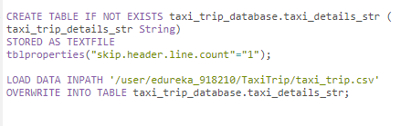

**2. Splitting one column in multiple columns and creating taxi_trip_details table**

CREATE TABLE IF NOT EXISTS taxi_trip_database.taxi_trip_details

AS

select split(taxi_trip_details_str, ",")[0] as trip_id,

split(taxi_trip_details_str, ",")[1] as taxi_id,

split(taxi_trip_details_str, ",")[2] as trip_start_time,

split(taxi_trip_details_str, ",")[3] as trip_end_time,

cast(split(taxi_trip_details_str, ",")[4] as int) as trip_seconds,

cast(split(taxi_trip_details_str, ",")[5] as float) as trip_miles,

cast(split(taxi_trip_details_str, ",")[6] as bigint) as pickup_tract,

cast(split(taxi_trip_details_str, ",")[7] as bigint) as dropoff_tract,

cast(split(taxi_trip_details_str, ",")[8] as tinyint) as pickup_community,

cast(split(taxi_trip_details_str, ",")[9] as tinyint) as dropoff_community,

cast(split(taxi_trip_details_str, ",")[10] as float) as trip_fare,

cast(split(taxi_trip_details_str, ",")[11] as float) as tip_amt,

cast(split(taxi_trip_details_str, ",")[12] as float) as toll_amt,

cast(split(taxi_trip_details_str, ",")[13] as float) as extra_amt,

cast(split(taxi_trip_details_str, ",")[14] as float) as trip_total_amt,

split(taxi_trip_details_str, ",")[15] as payment_type,

split(taxi_trip_details_str, ",")[16] as company,

cast(split(taxi_trip_details_str, ",")[17] as double) as pickup_latitude,

cast(split(taxi_trip_details_str, ",")[18] as double) as pickup_longitude,

split(taxi_trip_details_str, ",")[19] as pickup_location,

cast(split(taxi_trip_details_str, ",")[20] as double) as dropoff_latitude,

cast(split(taxi_trip_details_str, ",")[21] as double) as dropoff_longitude,

split(taxi_trip_details_str, ",")[22] as dropoff_location,

split(taxi_trip_details_str, ",")[23] as community_areas

from

taxi_trip_database.taxi_details_str;

**Table – taxi_trip_details**

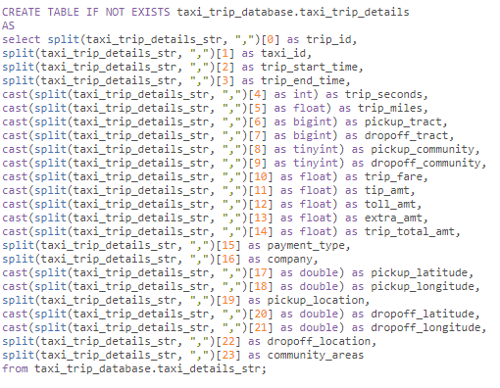

select split(taxi_trip_details_str, ",")[0] as trip_id,

split(taxi_trip_details_str, ",")[1] as taxi_id,

split(taxi_trip_details_str, ",")[2] as trip_start_time,

split(taxi_trip_details_str, ",")[3] as trip_end_time,

cast(split(taxi_trip_details_str, ",")[4] as int) as trip_seconds,

cast(split(taxi_trip_details_str, ",")[12] as float) as toll_amt

from

taxi_trip_database.taxi_details_str limit 5;

**3. Numerical Mapping of taxi_id & trip_id to reduce the data volume**

select count(distinct taxi_id) from taxi_trip_database.taxi_trip_details;

**RESULT :::::::::::::::::::::: 5396**

There are only 8287 distinct values. But as we can see the uuid is a really large:

c1305c4490085b703eed20e95ab0c479c954ae3735a963578627d563fadbf2cc859e12ebcd12c4b8f34b7eb

2d6c4782b17b56ba8ddfe896fff5763105e81e050

Keeping this column would result in significant performance implications.

Hence, we can either

• Drop this field

• Or move it to a separate table and create a numerical mapping of the same into the master table.

This would reduce the data volume significantly as we are going to store only around 8K distinct

values of taxi ids, which are repeating for over 90M trips.

Second option makes sense, as it would help us perform per taxi-wise analysis.

Similarly, we can drop the trip_id, which is a uuid and create a row_number which can be an integer in its

place.

**3.a. Creating a separate table with distinct taxi_id values**

CREATE TABLE IF NOT EXISTS taxi_trip_database.taxi_id_mapping

AS

select distinct taxi_id from taxi_trip_database.taxi_trip_details

describe taxi_trip_database.taxi_id_mapping

select * from taxi_trip_database.taxi_id_mapping limit 5;

CREATE TABLE IF NOT EXISTS taxi_trip_database.taxi_id_mapping_with_id

AS

select row_number() over() as id, taxi_id from taxi_trip_database.taxi_id_mapping

select * from taxi_trip_database.taxi_id_mapping_with_id limit 5;

**Table - taxi_id_mapping_with_id**

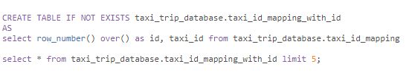

**3.b. Joining taxi_id_mapping_with_id table to master table to replace the current taxi_id i.e uuid with a**

**numerical id.**

CREATE TABLE IF NOT EXISTS taxi_trip_database.taxi_trip_details_taxi_id_removed

AS

SELECT

trip_id,

id as taxi_id_int,

trip_start_time,

trip_end_time,

trip_seconds,

trip_miles,

pickup_tract,

dropoff_tract,

pickup_community,

dropoff_community,

trip_fare,

tip_amt,

toll_amt,

extra_amt,

trip_total_amt,

payment_type,

company,

pickup_latitude,

pickup_longitude,

pickup_location,

dropoff_latitude,

dropoff_longitude,

dropoff_location,

community_areas

from

taxi_trip_database.taxi_trip_details as a

join

taxi_trip_database.taxi_id_mapping_with_id as b

on

a.taxi_id = b.taxi_id

**Table - taxi_trip_database.taxi_trip_details_taxi_id_removed**

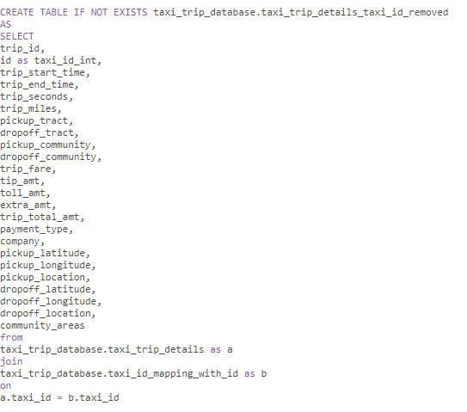

**3.c. Removing trip_id (uuid) and adding an int id instead**

CREATE TABLE IF NOT EXISTS taxi_trip_database.taxi_trip_details_taxi_trip_id_removed

STORED AS ORC

AS

SELECT

row_number() over() as trip_id_int,

taxi_id_int,

trip_start_time,

trip_end_time,

trip_seconds,

trip_miles,

pickup_tract,

dropoff_tract,

pickup_community,

dropoff_community,

trip_fare,

tip_amt,

toll_amt,

extra_amt,

trip_total_amt,

payment_type,

company,

pickup_latitude,

pickup_longitude,

pickup_location,

dropoff_latitude,

dropoff_longitude,

dropoff_location,

community_areas

from

taxi_trip_database.taxi_trip_details_taxi_id_removed

**Table – taxi_trip_database.taxi_trip_details_tai_trip_id_removed**

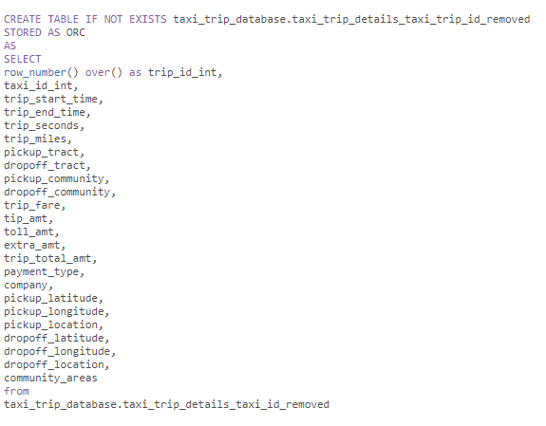

**4. Cleaning up the temp tables**

drop table chicago_taxis.taxi_details_str

drop table chicago_taxis.taxi_trip_details

drop table chicago_taxis.taxi_trip_details_taxi_id_removed

**5. Casting date fields**

CREATE TABLE IF NOT EXISTS taxi_trip_database.taxi_trip_details_taxi_trip_id_removed_ts

STORED AS ORC

AS

SELECT

taxi_id_int,

trip_start_time,

trip_end_time,

to_date(from_unixtime(unix_timestamp(split(trip_start_time, " ")[0], 'MM/dd/yyyy'), 'yyyy-MM-dd')) as

trip_start_date,

to_date(from_unixtime(unix_timestamp(split(trip_end_time, " ")[0], 'MM/dd/yyyy'), 'yyyy-MM-dd')) as

trip_end_date,

trip_seconds,

trip_miles,

pickup_tract,

dropoff_tract,

pickup_community,

dropoff_community,

trip_fare,

tip_amt,

toll_amt,

extra_amt,

trip_total_amt,

payment_type,

company,

pickup_latitude,

pickup_longitude,

pickup_location,

dropoff_latitude,

dropoff_longitude,

dropoff_location,

community_areas

from

taxi_trip_database.taxi_trip_details_taxi_trip_id_removed

select * from taxi_trip_database.taxi_trip_details_taxi_trip_id_removed_ts

**6. Adding two fields for the trip start & end day of the week**

CREATE TABLE IF NOT EXISTS taxi_trip_database.taxi_trip_details_processed_with_dayofweek

AS

SELECT

*,

from_unixtime(unix_timestamp(split(trip_start_time, " ")[0], 'MM/dd/yyyy'), 'u') as start_dayofweek,

from_unixtime(unix_timestamp(split(trip_end_time, " ")[0], 'MM/dd/yyyy'), 'u') as end_dayofweek

from

taxi_trip_database.taxi_trip_details_taxi_trip_id_removed

select * from taxi_trip_database.taxi_trip_details_processed_with_dayofweek limit 5

**7. Adding a weekend field to store whether a day is weekday or weekend**

CREATE TABLE IF NOT EXISTS taxi_trip_database.taxi_trip_details_weekend_encoded

STORED AS ORC

AS

SELECT

*,

CASE

WHEN start_dayofweek in (6,7) THEN 1

WHEN start_dayofweek in (1,2,3,4,5) THEN 0

END AS weekend

from

taxi_trip_database.taxi_trip_details_processed_with_dayofweek

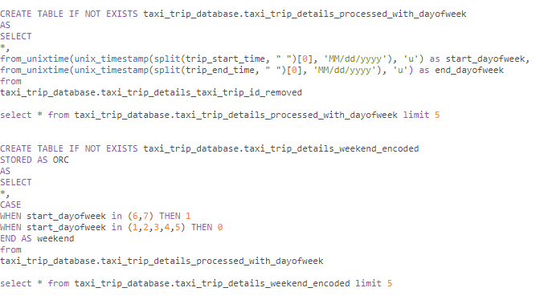

select * from taxi_trip_database.taxi_trip_details_weekend_encoded limit 5

**TABLE DESCRIPTION :**

hive> describe taxi_trip_database.taxi_details_str;

OK

taxi_trip_details_str string

Time taken: 0.493 seconds, Fetched: 1 row(s)

> describe taxi_trip_database.taxi_trip_details;

OK

trip_id string

taxi_id string

trip_start_time string

trip_end_time string

trip_seconds int

trip_miles float

pickup_tract bigint

dropoff_tract bigint

pickup_community tinyint

dropoff_community tinyint

trip_fare float

tip_amt float

toll_amt float

extra_amt float

trip_total_amt float

payment_type string

company string

pickup_latitude double

pickup_longitude double

pickup_location string

dropoff_latitude double

dropoff_longitude double

dropoff_location string

community_areas string

Time taken: 0.068 seconds, Fetched: 24 row(s)

> describe taxi_trip_database.taxi_id_mapping

> ;

OK

taxi_id string

> describe taxi_trip_database.taxi_id_mapping_with_id;

OK

id int

taxi_id string

hive>

> describe taxi_trip_database.taxi_trip_details_taxi_id_removed

> ;

OK

trip_id string

taxi_id_int int

trip_start_time string

trip_end_time string

trip_seconds int

trip_miles float

pickup_tract bigint

dropoff_tract bigint

pickup_community tinyint

dropoff_community tinyint

trip_fare float

tip_amt float

toll_amt float

extra_amt float

trip_total_amt float

payment_type string

company string

pickup_latitude double

pickup_longitude double

pickup_location string

dropoff_latitude double

dropoff_longitude double

dropoff_location string

community_areas string

Time taken: 0.047 seconds, Fetched: 24 row(s)

hive>

> describe taxi_trip_database.taxi_trip_details_taxi_trip_id_removed_ts;

OK

taxi_id_int int

trip_start_time string

trip_end_time string

trip_start_date string

trip_end_date string

trip_seconds int

trip_miles float

pickup_tract bigint

dropoff_tract bigint

pickup_community tinyint

dropoff_community tinyint

trip_fare float

tip_amt float

toll_amt float

extra_amt float

trip_total_amt float

payment_type string

company string

pickup_latitude double

pickup_longitude double

pickup_location string

dropoff_latitude double

dropoff_longitude double

dropoff_location string

community_areas string

Time taken: 0.052 seconds, Fetched: 25 row(s)

hive>

>

> describe taxi_trip_database.taxi_trip_details_processed_with_dayofweek;

OK

trip_id_int int

taxi_id_int int

trip_start_time string

trip_end_time string

trip_seconds int

trip_miles float

pickup_tract bigint

dropoff_tract bigint

pickup_community tinyint

dropoff_community tinyint

trip_fare float

tip_amt float

toll_amt float

extra_amt float

trip_total_amt float

payment_type string

company string

pickup_latitude double

pickup_longitude double

pickup_location string

dropoff_latitude double

dropoff_longitude double

dropoff_location string

community_areas string

start_dayofweek string

end_dayofweek string

Time taken: 0.045 seconds, Fetched: 26 row(s)

hive>

> describe taxi_trip_database.taxi_trip_details_weekend_encoded;

OK

trip_id_int int

taxi_id_int int

trip_start_time string

trip_end_time string

trip_seconds int

trip_miles float

pickup_tract bigint

dropoff_tract bigint

pickup_community tinyint

dropoff_community tinyint

trip_fare float

tip_amt float

toll_amt float

extra_amt float

trip_total_amt float

payment_type string

company string

pickup_latitude double

pickup_longitude double

pickup_location string

dropoff_latitude double

dropoff_longitude double

dropoff_location string

community_areas string

start_dayofweek string

end_dayofweek string

weekend int

Time taken: 0.046 seconds, Fetched: 27 row(s)

hive>

**3.2.1 Data Summary**

**What are the total number of trips per year? Present the findings in the below format**.

select count(trip_id_int), cast(substr(trip_end_time, 7, 4) as int) from taxi_trip_database.taxi_trip_details_weekend_encoded group by cast(substr(trip_end_time, 7, 4) as int)



**Create the same summary for number of trips at monthly level. Present the findings in the below format.**

select count(trip_id_int), cast(substr(trip_end_time, 1, 2) as int) from taxi_trip_database.taxi_trip_details_weekend_encoded group by cast(substr(trip_end_time, 1, 2) as int)



**Calculate the percentage of records that contains drop-off community value. Excluding all the NULL records, find out the top 10 communities, where people travel to, based on the drop-off**

**community field and also find its percentage to the total number of trips. Present the findings in**

**the below format.**

select

sum(case when dropoff_community is not null then 1 else 0 end) dropoff_community,

(sum(case when dropoff_tract is not null then 1 else 0 end)/count(trip_id_int))*100 dropoff_tract,

(sum(case when dropoff_community is not null then 1 else 0 end)/count(dropoff_community))*100 dropoff_community

from

taxi_trip_database.taxi_trip_details_weekend_encoded

group by dropoff_community

order by dropoff_community desc

limit 10;



**Create a table which contains the total number of trips for each drop-off community across each**

**year. Using the above table, find the top 10 records based on number of trips with year and**

**drop_off community. Remove the null record while creating the table to remove inconsistencies.**

CREATE TABLE IF NOT EXISTS taxi_trip_database.taxi_trip_details_taxi_trip_total_number

STORED AS ORC

AS

SELECT

dropoff_community,

cast(substr(trip_end_time, 7, 4) as int) trip_end_time,

sum(case when pickup_location is not null then 1 else 0 end) pickup_location

from

taxi_trip_database.taxi_trip_details_taxi_trip_id_removed

group by cast(substr(trip_end_time, 7, 4) as int) ,dropoff_community

order by cast(substr(trip_end_time, 7, 4) as int) desc

limit 10;

select * from taxi_trip_database.taxi_trip_details_taxi_trip_total_number

**5. Create a table which contains total number of trips for each drop-off communities across**

**weekdays & weekends to check if there is any sort of pattern visible. After creating the table, find**

**the top 10 drop off communities based on number of trips where people travel on weekdays.**

**Find the same for the weekends. Also find the total number of trips taken on weekdays &**

**weekends and their ratio.**

CREATE TABLE IF NOT EXISTS taxi_trip_database.taxi_trip_details_taxi_trip_id_weekend_weekdays

STORED AS ORC

AS

SELECT

dropoff_community,

sum(CASE WHEN start_dayofweek in (6,7) then 1 else 0 end) start_dayofweek,

sum(CASE WHEN start_dayofweek in (1,2,3,4,5) then 1 else 0 end) start_dayofweek,

(sum(CASE WHEN start_dayofweek in (1,2,3,4,5) then 1 else 0 end) start_dayofweek) / (sum(CASE WHEN start_dayofweek in (6,7) then 1 else 0 end) start_dayofweek)

from

taxi_trip_database.taxi_trip_details_processed_with_dayofweek

group by dropoff_community

order by dropoff_community

limit 10;

**6. Find the distribution of total number of trips based on trip duration, like <1 hr, 1 to 2 hr, 2 to 3, …**

**22 to 23 hr. Note that this requires converting trip_seconds into trip_hours as pre-processing.**

**Remove the trips that do not contain trip duration.**

select trip_range, count(*) cnt

from (select

case when (trip_seconds/3600 >=0 and trip_seconds/3600 <1) then '(0-1)'

when (trip_seconds/3600 >=1 and trip_seconds/3600 <2) then '(1-2)'

when (trip_seconds/3600 >=2 and trip_seconds/3600 <3) then '(2-3)'

when (trip_seconds/3600 >=3 and trip_seconds/3600 <4) then '(3-4)'

when (trip_seconds/3600 >=4 and trip_seconds/3600 <5) then '(4-5)'

when (trip_seconds/3600 >=5 and trip_seconds/3600 <6) then '(5-6)'

when (trip_seconds/3600 >=6 and trip_seconds/3600 <7) then '(6-7)'

when (trip_seconds/3600 >=7 and trip_seconds/3600 <8) then '(7-8)'

when (trip_seconds/3600 >=8 and trip_seconds/3600 <9) then '(8-9)'

when (trip_seconds/3600 >=9 and trip_seconds/3600 <10) then '(9-10)'

when (trip_seconds/3600 >=10 and trip_seconds/3600 <11) then '(10-11)'

when (trip_seconds/3600 >=11 and trip_seconds/3600 <12) then '(11-12)'

when (trip_seconds/3600 >=12 and trip_seconds/3600 <13) then '(12-13)'

when (trip_seconds/3600 >=13 and trip_seconds/3600 <14) then '(13-14)'

when (trip_seconds/3600 >=14 and trip_seconds/3600 <15) then '(14-15)'

when (trip_seconds/3600 >=15 and trip_seconds/3600 <16) then '(15-16)'

when (trip_seconds/3600 >=16 and trip_seconds/3600 <17) then '(16-17)'

when (trip_seconds/3600 >=17 and trip_seconds/3600 <18) then '(17-18)'

when (trip_seconds/3600 >=18 and trip_seconds/3600 <19) then '(18-19)'

when (trip_seconds/3600 >=19 and trip_seconds/3600 <20) then '(19-20)'

when (trip_seconds/3600 >=20 and trip_seconds/3600 <21) then '(20-21)'

when (trip_seconds/3600 >=21 and trip_seconds/3600 <22) then '(21-22)'

when (trip_seconds/3600 >=22 and trip_seconds/3600 <23) then '(22-23)' end trip_range

from taxi_trip_database.taxi_trip_details_weekend_encoded) T

group by trip_range

order by cnt desc;



**7. Find the top 10 buckets of the number of trips distribution based on the distance covered. Also**

**round off the trip miles to the nearest integer. Remove the trips that do not contain distance.**

trip_id_int int

taxi_id_int int

trip_start_time string

trip_end_time string

trip_seconds int

trip_miles float

pickup_tract bigint

dropoff_tract bigint

pickup_community tinyint

dropoff_community tinyint

trip_fare float

tip_amt float

toll_amt float

extra_amt float

trip_total_amt float

payment_type string

company string

pickup_latitude double

pickup_longitude double

pickup_location string

dropoff_latitude double

dropoff_longitude double

dropoff_location string

community_areas string

start_dayofweek string

end_dayofweek string

weekend int

Roundoff | Distance Number of Trips

SELECT trip_miles, count(*) AS Total

FROM taxi_trip_database.taxi_trip_details_weekend_encoded

WHERE isnotnull(trip_miles) and trip_miles > 0

GROUP BY trip_miles

ORDER BY trip_miles desc limit 10;



**8. Find top 10 buckets of the number of trips distribution based on the trip fare. Also round off the**

**trip fare to the nearest integer. Remove the trips that do not contain trip fare.**

**Roundoff Fare Number of Trips**

SELECT trip_fare, count(*) AS Total

FROM taxi_trip_database.taxi_trip_details_weekend_encoded

WHERE isnotnull(trip_fare) and trip_fare > 0

GROUP BY trip_fare

ORDER BY trip_fare desc limit 10;



**9. Compute the average trip fare per day. Also compute the average trip fare per trip. Compute the**

**same based on weekdays and weekend days. Find out if there is any substantial difference**

**observed.**

**Normal Days :**

SELECT

cast(substr(trip_end_time, 7, 4) as int) trip_end_time,

avg(trip_fare)

from

taxi_trip_database.taxi_trip_details_taxi_trip_id_removed

group by cast(substr(trip_end_time, 7, 4) as int)

order by cast(substr(trip_end_time, 7, 4) as int) desc

limit 10;



SELECT

dropoff_tract ,

avg(trip_fare)

from

taxi_trip_database.taxi_trip_details_taxi_trip_id_removed

group by dropoff_tract

order by dropoff_tract desc

limit 10;



**Weekend Days :**

SELECT

cast(substr(trip_end_time, 7, 4) as int) trip_end_time,

avg(trip_fare)

from

taxi_trip_database.taxi_trip_details_weekend_encoded

where weekend > 0

group by cast(substr(trip_end_time, 7, 4) as int)

order by cast(substr(trip_end_time, 7, 4) as int) desc

limit 10;



SELECT

dropoff_tract ,

avg(trip_fare)

from

taxi_trip_database.taxi_trip_details_weekend_encoded

where weekend > 0

group by dropoff_tract

order by dropoff_tract desc

limit 10;



**10. Create a table to store the taxi wise total fare & total number of trips for each day. Find the**

**following insights from the table:**

**a. Find the top 10 taxis based on average trips per day.**

**b. Find the top 10 taxis based on average fare per day.**

CREATE TABLE IF NOT EXISTS taxi_trip_database.taxi_trip_details_avg_trip_fare_per_day

STORED AS ORC

AS

SELECT

cast(substr(trip_end_time, 7, 4) as int) trip_end_time,

avg(trip_fare)

from

taxi_trip_database.taxi_trip_details_taxi_trip_id_removed

group by cast(substr(trip_end_time, 7, 4) as int)

order by cast(substr(trip_end_time, 7, 4) as int) desc

limit 10;

describe taxi_trip_database.taxi_trip_details_avg_trip_fare_per_day

CREATE TABLE IF NOT EXISTS taxi_trip_database.taxi_trip_details_avg_trip_fare_per_trip

STORED AS ORC

AS

SELECT

dropoff_tract ,

avg(trip_fare)

from

taxi_trip_database.taxi_trip_details_weekend_encoded

where weekend > 0

group by dropoff_tract

order by dropoff_tract desc

limit 10;

describe taxi_trip_database.taxi_trip_details_avg_trip_fare_per_trip

**3.2.2 Data Preparation for Forecasting**

**DAILY SUMMARY TABLE**

CREATE TABLE IF NOT EXISTS taxi_trip_database.taxi_trip_details_summary

STORED AS ORC

AS

SELECT

*,

day(trip_start_time) AS day,

month(trip_start_time) AS month,

year(trip_start_time) AS year,

CASE

WHEN start_dayofweek in (6,7) THEN 1

WHEN start_dayofweek in (1,2,3,4,5) THEN 0

END AS sat_sun

from taxi_trip_database.taxi_trip_details_weekend_encoded;

CREATE TABLE IF NOT EXISTS taxi_trip_database.taxi_trip_daily_details_summary

STORED AS ORC

AS

SELECT

day

month,

year,

CASE

WHEN start_dayofweek in (6,7) THEN 1

WHEN start_dayofweek in (1,2,3,4,5) THEN 0

END AS satsun,

sum(case when trip_end_time is not null then 1 else 0 end) trip_end_time,

trip_total_amt,

sum(trip_seconds/60),

avg(trip_fare),

avg(trip_miles),

avg(trip_seconds/60)

from

taxi_trip_database.taxi_trip_details_summary

group by day,month,year,start_dayofweek,trip_total_amt

order by day ASC,month ASC,year ASC;

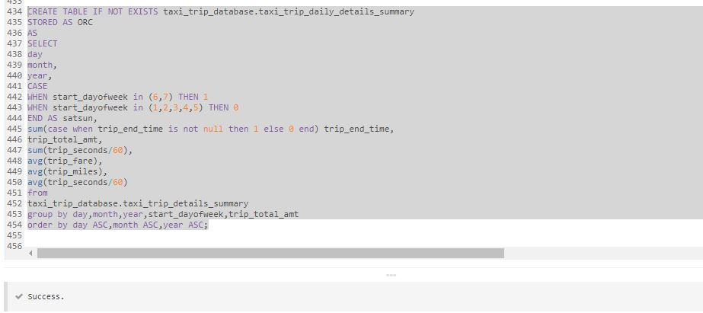

**WEEKLY SUMMARY TABLE**

CREATE TABLE IF NOT EXISTS taxi_trip_database.taxi_trip_weekly_details_summary

STORED AS ORC

AS

SELECT

CASE

WHEN start_dayofweek in (1,2,3,4,5,6,7) THEN 1 ELSE 0 END AS Week_No,

substr(trip_start_time, 1, 11),

substr(trip_end_time, 1, 11),

substr(trip_end_time, 4, 2),

count(trip_id_int),

sum(trip_fare),

sum(trip_miles),

sum(trip_seconds/60),

avg(trip_fare),

avg(trip_miles),

avg(trip_seconds/60)

from

taxi_trip_database.taxi_trip_details_summary

group by start_dayofweek,substr(trip_start_time, 1, 11),substr(trip_end_time, 1, 11),substr(trip_end_time, 4, 2),trip_fare,trip_miles,trip_seconds;

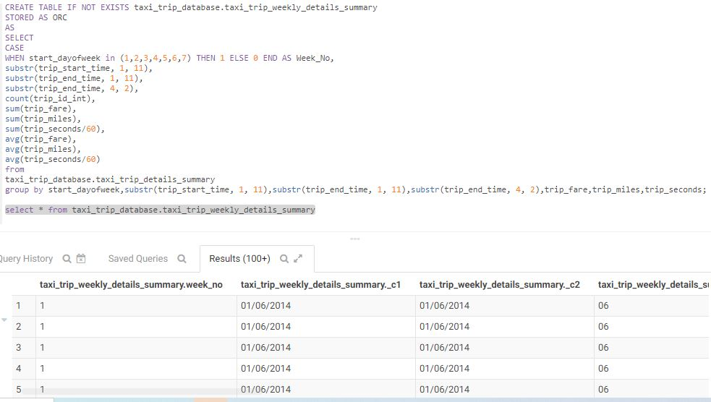

**MONTHLY SUMMARY TABLE**

CREATE TABLE IF NOT EXISTS taxi_trip_database.taxi_trip_monthly_details_summary

STORED AS ORC

AS

SELECT

CASE

WHEN substr(trip_end_time, 4, 2) IS NULL THEN 0 ELSE 1 END AS Month_No,

substr(trip_start_time, 1, 11),

substr(trip_end_time, 1, 11),

cast(substr(trip_end_time, 7, 4) as int) ,

count(trip_id_int),

sum(trip_fare),

sum(trip_miles),

sum(trip_seconds/60),

avg(trip_fare),

avg(trip_miles),

avg(trip_seconds/60)

from

taxi_trip_database.taxi_trip_details_summary

group by substr(trip_end_time, 4, 2),substr(trip_start_time, 1, 11),substr(trip_end_time, 1, 11),cast(substr(trip_end_time, 7, 4) as int),trip_id_int,trip_fare,trip_miles,trip_seconds;

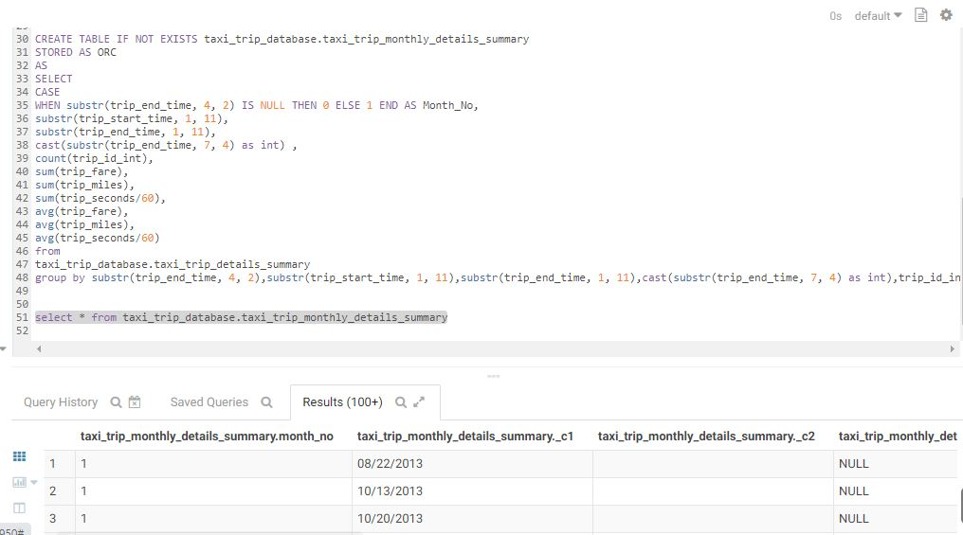

**3.2.3 Data Preparation for Community Summary**

**Pickup Communities**

**Attributes Used by Pickup Communities**

PickupCommunityID,

DailyTripCount,

DailyTotalFare,

DailyTotalDistance,

DailyTotalDuration,

DailyAverageAmount,

DailyAverageDistance,

DailyAverageDuration

CREATE TABLE IF NOT EXISTS taxi_trip_database.taxi_trip_pickupcommunitydetails

STORED AS ORC

AS

SELECT * FROM

(select

CASE

WHEN pickup_community IS NULL THEN 0 ELSE pickup_community END AS pickup_community_id,

CASE

WHEN trip_end_time IS NULL THEN 0 ELSE 1 END AS Trip_Count,

sum(trip_fare),

sum(trip_miles),

sum(trip_seconds/60),

avg(trip_fare),

avg(trip_miles),

avg(trip_seconds/60)

from

taxi_trip_database.taxi_trip_details_weekend_encoded

group by pickup_community,trip_end_time,trip_fare,trip_miles,trip_seconds) b;

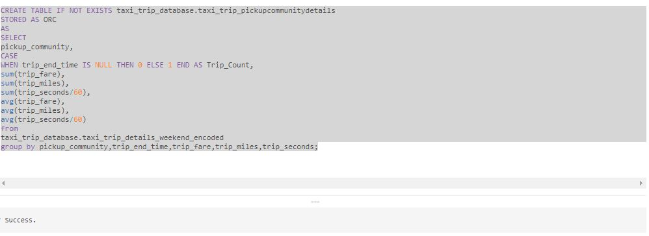

**Dropoff Communities**

**Attributes Used by Dropoff Communities**

DropoffCommunityID,

DailyTripCount,

DailyTotalFare,

DailyTotalDistance,

DailyTotalDuration,

DailyAverageAmount,

DailyAverageDistance,

DailyAverageDuration

CREATE TABLE IF NOT EXISTS taxi_trip_database.taxi_trip_dropoffcommunitydetails

STORED AS ORC

AS

SELECT * FROM

(select dropoff_community,

CASE

WHEN trip_end_time IS NULL THEN 0 ELSE 1 END AS Trip_Count,

sum(trip_fare),

sum(trip_miles),

sum(trip_seconds/60),

avg(trip_fare),

avg(trip_miles),

avg(trip_seconds/60)

from

taxi_trip_database.taxi_trip_details_weekend_encoded

group by dropoff_community,trip_end_time,trip_fare,trip_miles,trip_seconds) b;

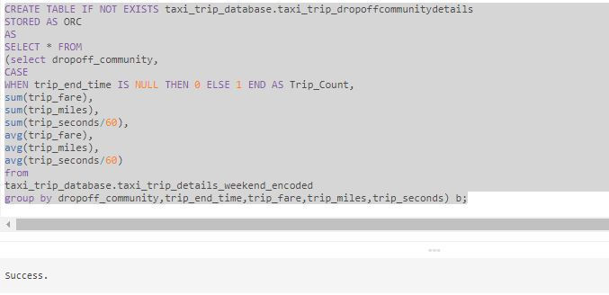

**3.2.4 Data Preparation for Origin to Destination Pair Summary**

IN SPARK

**1) Mapping the Raw Data with RDD(Resilent Distributed Data) and converstion of DF - Single Code**

var myDF_Trip1=spark.read.format("csv").option("delimiter",",").option("header","false").option("inferSchema","true").load("/user/edureka_918210/TaxiTrip/taxi_trip.csv").toDF("Trip_ID","Taxi_ID","Trip_Start_Timestamp","Trip_End_Timestamp","Trip_Seconds","Trip_Miles","Pickup_Census_Tract","Dropoff_Census_Tract","Pickup_Community_Area","Dropoff_Community_Area","Fare","Tips","Tolls","Extras","Trip_Total","Payment_Type","Company","Pickup_Centroid_Latitude","Pickup_Centroid_Longitude","Pickup_Centroid_Location","Dropoff_Centroid_Latitude","Dropoff_Centroid_Longitude","Dropoff_Centroid_Location","Community_Areas")

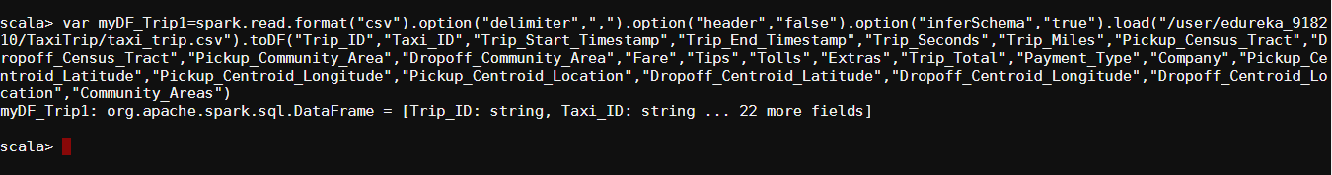

**2) DF definition . Please Note, we used InferSchema Option for automatic conversion in data definition in above command**

myDF_Trip1.show(false)

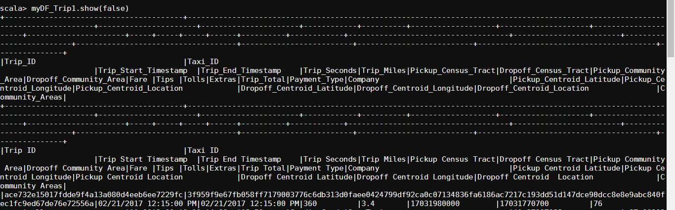

**3) DF data definition**

myDF_Trip1.printSchema

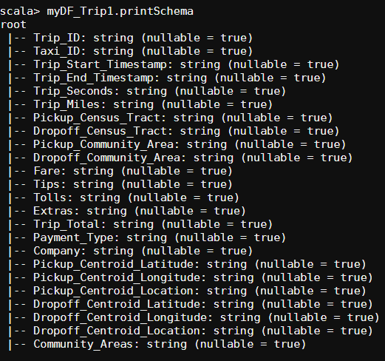

root

|-- Trip_ID: string (nullable = true)

|-- Taxi_ID: string (nullable = true)

|-- Trip_Start_Timestamp: string (nullable = true)

|-- Trip_End_Timestamp: string (nullable = true)

|-- Trip_Seconds: string (nullable = true)

|-- Trip_Miles: string (nullable = true)

|-- Pickup_Census_Tract: string (nullable = true)

|-- Dropoff_Census_Tract: string (nullable = true)

|-- Pickup_Community_Area: string (nullable = true)

|-- Dropoff_Community_Area: string (nullable = true)

|-- Fare: string (nullable = true)

|-- Tips: string (nullable = true)

|-- Tolls: string (nullable = true)

|-- Extras: string (nullable = true)

|-- Trip_Total: string (nullable = true)

|-- Payment_Type: string (nullable = true)

|-- Company: string (nullable = true)

|-- Pickup_Centroid_Latitude: string (nullable = true)

|-- Pickup_Centroid_Longitude: string (nullable = true)

|-- Pickup_Centroid_Location: string (nullable = true)

|-- Dropoff_Centroid_Latitude: string (nullable = true)

|-- Dropoff_Centroid_Longitude: string (nullable = true)

|-- Dropoff_Centroid_Location: string (nullable = true)

|-- Community_Areas: string (nullable = true)

**4) Registering orCreation of Temp View for using Spark SQL**

myDF_Trip1.createOrReplaceTempView("Trip_Details")

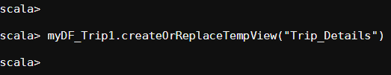

**5) Using Spark SQL**

spark.sql("select Pickup_Community_Area,Dropoff_Community_Area,CASE WHEN Trip_ID IS NULL THEN 0 ELSE 1 END AS Trip_Count,sum(Fare),sum(Trip_Miles),sum(Trip_Seconds/60),avg(Fare),avg(Trip_Miles),avg(Trip_Seconds/60) from Trip_Details group by Pickup_Community_Area,Dropoff_Community_Area,Trip_ID,Fare,Trip_Miles,Trip_Seconds").show

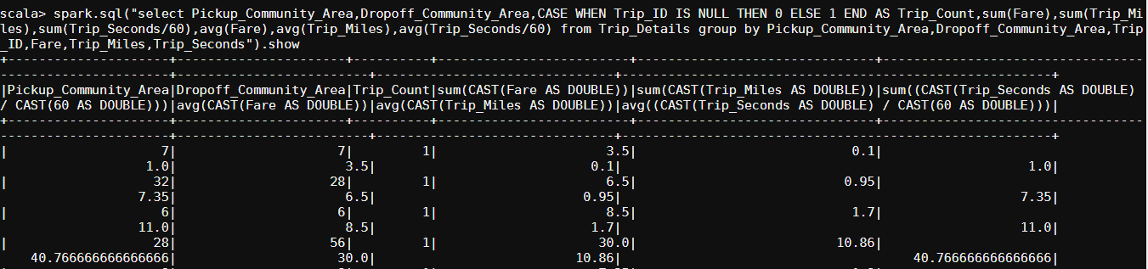

**3.2.5 Data Preparation for Company Summary**

spark.sql("select Company,CASE WHEN Trip_ID IS NULL THEN 0 ELSE 1 END AS Trip_Count,sum(Fare),sum(Trip_Miles),sum(Trip_Seconds/60),avg(Fare),avg(Trip_Miles),avg(Trip_Seconds/60) from Trip_Details group by Company,Dropoff_Community_Area,Trip_ID,Fare,Trip_Miles,Trip_Seconds").show

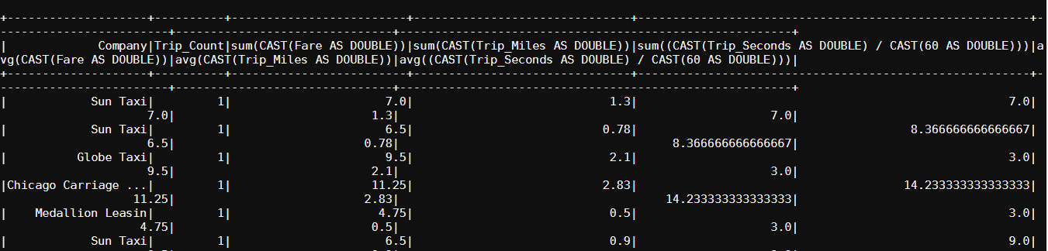

**3.2.6 Data Summary in RDBMS**

CREATE TABLE IF NOT EXISTS taxi_trip_database.taxi_trip_pickupcommunitydetails (

Pickup_community_id TINYINT NOT NULL,

daily_trip_count TINYINT NOT NULL,

total_trip_fare INT AUTO_INCREMENT PRIMARY KEY,

total_trip_miles TINYINT NOT NULL,

total_trip_mins TINYINT NOT NULL,

avg_trip_fare TINYINT NOT NULL,

avg_trip_miles TINYINT NOT NULL,

avg_trip_mins TINYINT NOT NULL

) ENGINE=INNODB;

CREATE TABLE IF NOT EXISTS taxi_trip_database.taxi_trip_dropoffcommunitydetails (

dropoff_community_id TINYINT NOT NULL,

daily_trip_count TINYINT NOT NULL,

total_trip_fare INT AUTO_INCREMENT PRIMARY KEY,

total_trip_miles TINYINT NOT NULL,

total_trip_mins TINYINT NOT NULL,

avg_trip_fare TINYINT NOT NULL,

avg_trip_miles TINYINT NOT NULL,

avg_trip_mins TINYINT NOT NULL

) ENGINE=INNODB;

CREATE TABLE IF NOT EXISTS taxi_trip_database.taxi_trip_companydetails (

company TINYINT NOT NULL,

daily_trip_count TINYINT NOT NULL,

total_trip_fare INT AUTO_INCREMENT PRIMARY KEY,

total_trip_miles TINYINT NOT NULL,

total_trip_mins TINYINT NOT NULL,

avg_trip_fare TINYINT NOT NULL,

avg_trip_miles TINYINT NOT NULL,

avg_trip_mins TINYINT NOT NULL

) ENGINE=INNODB;

**LOADING THE DATA**

LOAD DATA INFILE '/mnt/home/edureka_918210/Taxi_Trip_ResultSet/taxi_trip_pickupcommunitydetails.csv'

INTO TABLE taxi_trip_database.taxi_trip_pickupcommunitydetails

FIELDS TERMINATED BY ','

LINES TERMINATED BY '/n'

IGNORE 1 ROWS;

LOAD DATA INFILE '/mnt/home/edureka_918210/Taxi_Trip_ResultSet/percentageofrecordsthat contains drop-off community.csv'

INTO TABLE taxi_trip_database.taxi_trip_dropoffcommunitydetails

FIELDS TERMINATED BY ','

LINES TERMINATED BY '/n'

IGNORE 1 ROWS;

LOAD DATA INFILE '/mnt/home/edureka_918210/Taxi_Trip_ResultSet/taxi_trip_pickupcommunitydetails.csv'

INTO TABLE taxi_trip_database.taxi_trip_companydetails

FIELDS TERMINATED BY ','

LINES TERMINATED BY '/n'

IGNORE 1 ROWS;

**3.2.7 Summary Data Mart**

CREATING TABLES FROM HIVE TO HBASE :

**PICKUP COMMUNITY DETAILS :**

import java.io.IOException;

import org.apache.hadoop.conf.Configuration;

import org.apache.hadoop.hbase.HBaseConfiguration;

import org.apache.hadoop.hbase.HColumnDescriptor;

import org.apache.hadoop.hbase.HTableDescriptor;

import org.apache.hadoop.hbase.client.HBaseAdmin;

public class CreateHBaseTable

{

public static void main(String[] args) throws IOException

{

HBaseConfiguration hconfig = new HBaseConfiguration(new Configuration());

HTableDescriptor htable = new HTableDescriptor("taxi_trip_pickupcommunitydetails");

htable.addFamily( new HColumnDescriptor("pickup_community_id"));

htable.addFamily( new HColumnDescriptor("Trip_Count"));

htable.addFamily( new HColumnDescriptor("Total_trip_fare"));

htable.addFamily( new HColumnDescriptor("Total_trip_miles"));

htable.addFamily( new HColumnDescriptor("Total_trip_duration_mins"));

htable.addFamily( new HColumnDescriptor("Average_trip_fare"));

htable.addFamily( new HColumnDescriptor("Average_trip_miles"));

htable.addFamily( new HColumnDescriptor("Average_trip_duration_mins"));

System.out.println( "Connecting..." );

HBaseAdmin hbase_admin = new HBaseAdmin( hconfig );

System.out.println( "Creating Table..." );

hbase_admin.createTable( htable );

System.out.println("Done!");

}

}

**DROPOFF COMMUNITY DETAILS :**

import java.io.IOException;

import org.apache.hadoop.conf.Configuration;

import org.apache.hadoop.hbase.HBaseConfiguration;

import org.apache.hadoop.hbase.HColumnDescriptor;

import org.apache.hadoop.hbase.HTableDescriptor;

import org.apache.hadoop.hbase.client.HBaseAdmin;

public class CreateHBaseTable

{

public static void main(String[] args) throws IOException

{

HBaseConfiguration hconfig = new HBaseConfiguration(new Configuration());

HTableDescriptor htable = new HTableDescriptor("taxi_trip_dropoffcommunitydetails");

htable.addFamily( new HColumnDescriptor("dropoff_community_id"));

htable.addFamily( new HColumnDescriptor("Trip_Count"));

htable.addFamily( new HColumnDescriptor("Total_trip_fare"));

htable.addFamily( new HColumnDescriptor("Total_trip_miles"));

htable.addFamily( new HColumnDescriptor("Total_trip_duration_mins"));

htable.addFamily( new HColumnDescriptor("Average_trip_fare"));

htable.addFamily( new HColumnDescriptor("Average_trip_miles"));

htable.addFamily( new HColumnDescriptor("Average_trip_duration_mins"));

System.out.println( "Connecting..." );

HBaseAdmin hbase_admin = new HBaseAdmin( hconfig );

System.out.println( "Creating Table..." );

hbase_admin.createTable( htable );

System.out.println("Done!");

}

}

**COMPANY SUMMARY TABLE**

import java.io.IOException;

import org.apache.hadoop.conf.Configuration;

import org.apache.hadoop.hbase.HBaseConfiguration;

import org.apache.hadoop.hbase.HColumnDescriptor;

import org.apache.hadoop.hbase.HTableDescriptor;

import org.apache.hadoop.hbase.client.HBaseAdmin;

public class CreateHBaseTable

{

public static void main(String[] args) throws IOException

{

HBaseConfiguration hconfig = new HBaseConfiguration(new Configuration());

HTableDescriptor htable = new HTableDescriptor("taxi_trip_dropoffcommunitydetails");

htable.addFamily( new HColumnDescriptor("Company"));

htable.addFamily( new HColumnDescriptor("Trip_Count"));

htable.addFamily( new HColumnDescriptor("Total_trip_fare"));

htable.addFamily( new HColumnDescriptor("Total_trip_miles"));

htable.addFamily( new HColumnDescriptor("Total_trip_duration_mins"));

htable.addFamily( new HColumnDescriptor("Average_trip_fare"));

htable.addFamily( new HColumnDescriptor("Average_trip_miles"));

htable.addFamily( new HColumnDescriptor("Average_trip_duration_mins"));

System.out.println( "Connecting..." );

HBaseAdmin hbase_admin = new HBaseAdmin( hconfig );

System.out.println( "Creating Table..." );

hbase_admin.createTable( htable );

System.out.println("Done!");

}

}

**3.2.7 SUMMARY DATA MART**

package HBASECRUD.HBASE;

import java.io.IOException;

import org.apache.hadoop.conf.Configuration;

import org.apache.hadoop.hbase.Cell;

import org.apache.hadoop.hbase.CellUtil;

import org.apache.hadoop.hbase.HColumnDescriptor;

import org.apache.hadoop.hbase.HTableDescriptor;

import org.apache.hadoop.hbase.TableName;

import org.apache.hadoop.hbase.client.Connection;

import org.apache.hadoop.hbase.client.ConnectionFactory;

import org.apache.hadoop.hbase.client.Delete;

import org.apache.hadoop.hbase.client.HBaseAdmin;

import org.apache.hadoop.hbase.client.Put;

import org.apache.hadoop.hbase.client.Result;

import org.apache.hadoop.hbase.client.ResultScanner;

import org.apache.hadoop.hbase.client.Scan;

import org.apache.hadoop.hbase.client.Table;

import org.apache.hadoop.hbase.util.Bytes;

public class HBaseCustomClient {

private HBaseAdmin admin;

private Connection connection = null;

public HBaseCustomClient(Configuration conf) throws IOException {

connection = ConnectionFactory.createConnection(conf);

admin = (HBaseAdmin) connection.getAdmin();

}

public void createTable(String tableName, String[] CFs) {

try {

if (admin.tableExists(tableName)) {

System.out.println(tableName + "Already Exists");

} else {

HTableDescriptor tableDescriptor = new HTableDescriptor(TableName.valueOf(tableName));

for (String CFName : CFs) {

tableDescriptor.addFamily(new HColumnDescriptor(CFName));

}

admin.createTable(tableDescriptor);

}

} catch (IOException e) {

// TODO Auto-generated catch block

e.printStackTrace();

}

}

public void deleteTable(String tableName) {

try {

if (admin.tableExists(tableName)) {

admin.disableTable(tableName);

admin.deleteTable(tableName);

} else {

System.out.println(tableName + " Doesn't exist");

}

} catch (IOException e) {

// TODO Auto-generated catch block

e.printStackTrace();

}

}

public void insertRecord(String tableName, String rowKey, String family, String qualifier, String value) {

try {

Table table = connection.getTable(TableName.valueOf(tableName));

Put p = new Put(Bytes.toBytes(rowKey));

p.addColumn(Bytes.toBytes(family), Bytes.toBytes(qualifier), Bytes.toBytes(value));

table.put(p);

} catch (IOException e) {

// TODO Auto-generated catch block

e.printStackTrace();

}

}

public void deleteRecord(String tableName, String rowKey) {

try {

Table table = connection.getTable(TableName.valueOf(tableName));

Delete d = new Delete(Bytes.toBytes(rowKey));

table.delete(d);

} catch (IOException e) {

// TODO Auto-generated catch block

e.printStackTrace();

}

}

public void printTable(String tablename) {

ResultScanner rsObj = null;

try {

Table table = connection.getTable(TableName.valueOf(tablename));

Scan s = new Scan();

rsObj = table.getScanner(s);

for (Result result : rsObj) {

System.out.println(Bytes.toString(result.getRow()));

for (Cell c : result.rawCells()) {

System.out.println("Family: " + Bytes.toString(CellUtil.cloneFamily(c)));

System.out.println("Qualifiers: " + Bytes.toString(CellUtil.cloneQualifier(c)));

System.out.println("Values: " + Bytes.toString(CellUtil.cloneValue(c)));

}

}

rsObj.close();

} catch (IOException e) {

// TODO Auto-generated catch block

rsObj.close();

e.printStackTrace();

}

}

}