**Football – Soccer Dataset Analysis**

[edureka_918210@ip-20-0-41-164 ~]$ hadoop fs -ls /bigdatapgp/common_folder/ect3/soccer_dataset

Found 7 items

-rw-r--r-- 3 evaluationuser01 supergroup 171 2019-12-24 14:12 /bigdatapgp/common_folder/ect3/soccer_dataset/Country.csv

-rw-r--r-- 3 evaluationuser01 supergroup 378 2019-12-24 14:12 /bigdatapgp/common_folder/ect3/soccer_dataset/League.csv

-rw-r--r-- 3 evaluationuser01 supergroup 279237963 2019-12-24 14:12 /bigdatapgp/common_folder/ect3/soccer_dataset/Match.csv

-rw-r--r-- 3 evaluationuser01 supergroup 715829 2019-12-24 14:12 /bigdatapgp/common_folder/ect3/soccer_dataset/Player.csv

-rw-r--r-- 3 evaluationuser01 supergroup 29714922 2019-12-24 14:12 /bigdatapgp/common_folder/ect3/soccer_dataset/Player_Attributes.csv

-rw-r--r-- 3 evaluationuser01 supergroup 10153 2019-12-24 14:12 /bigdatapgp/common_folder/ect3/soccer_dataset/Team.csv

-rw-r--r-- 3 evaluationuser01 supergroup 216522 2019-12-24 14:12 /bigdatapgp/common_folder/ect3/soccer_dataset/Team_Attributes.csv

[edureka_918210@ip-20-0-41-164 ~]$

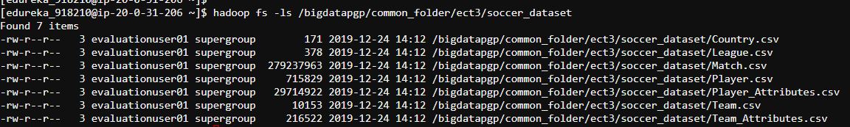

**Downloaded the DataSets from the HDFS to the Local System**

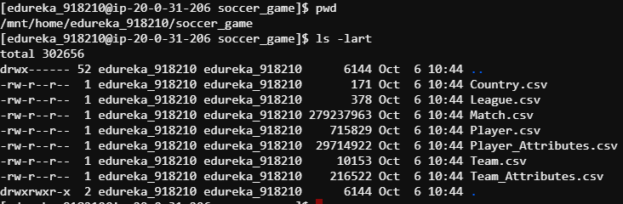

**Spark DF Conversion**

var myDF_Country=spark.read.format("csv").option("delimiter",",").option("header","false").option("inferSchema","true").load("/bigdatapgp/common_folder/ect3/soccer_dataset/Country.csv").toDF("id","name")



var myDF_League=spark.read.format("csv").option("delimiter",",").option("header","false").option("inferSchema","true").load("/bigdatapgp/common_folder/ect3/soccer_dataset/League.csv").toDF("id","country_id","name")



var myDF_Match=spark.read.format("csv").option("delimiter",",").option("header","false").option("inferSchema","true").load("/bigdatapgp/common_folder/ect3/soccer_dataset/Match.csv").toDF(

"id","country_id","league_id","season","stage","date","match_api_id","home_team_api_id","away_team_api_id","home_team_goal","away_team_goal","home_player_X1","home_player_X2","home_player_X3","home_player_X4","home_player_X5","home_player_X6","home_player_X7","home_player_X8","home_player_X9","home_player_X10","home_player_X11","away_player_X1","away_player_X2","away_player_X3","away_player_X4","away_player_X5","away_player_X6","away_player_X7","away_player_X8","away_player_X9","away_player_X10","away_player_X11","home_player_Y1","home_player_Y2","home_player_Y3","home_player_Y4","home_player_Y5","home_player_Y6","home_player_Y7","home_player_Y8","home_player_Y9","home_player_Y10","home_player_Y11","away_player_Y1","away_player_Y2","away_player_Y3","away_player_Y4","away_player_Y5","away_player_Y6","away_player_Y7","away_player_Y8","away_player_Y9","away_player_Y10","away_player_Y11","home_player_1","home_player_2","home_player_3","home_player_4","home_player_5","home_player_6","home_player_7","home_player_8","home_player_9","home_player_10","home_player_11","away_player_1","away_player_2","away_player_3","away_player_4","away_player_5","away_player_6","away_player_7","away_player_8","away_player_9","away_player_10","away_player_11","goal","shoton","shotoff","foulcommit","card","cross","corner","possession","B365H","B365D","B365A","BWH","BWD","BWA","IWH","IWD","IWA","LBH","LBD","LBA","PSH","PSD","PSA","WHH","WHD","WHA","SJH","SJD","SJA","VCH","VCD","VCA","GBH","GBD","GBA","BSH","BSD","BSA")

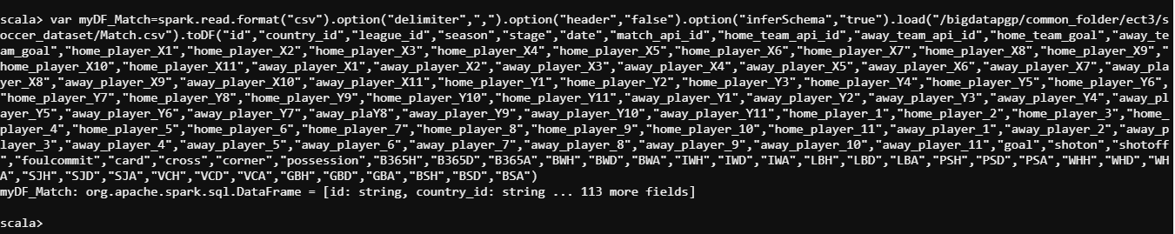

var myDF_Player=spark.read.format("csv").option("delimiter",",").option("header","false").option("inferSchema","true").load("/bigdatapgp/common_folder/ect3/soccer_dataset/Player.csv").toDF("id","player_api_id","player_name","player_fifa_api_id","birthday","height","weight")



var myDF_Player_Attributes=spark.read.format("csv").option("delimiter",",").option("header","false").option("inferSchema","true").load("/bigdatapgp/common_folder/ect3/soccer_dataset/Player_Attributes.csv").toDF("id","player_fifa_api_id","player_api_id","date","overall_rating","potential","preferred_foot","attacking_work_rate","defensive_work_rate","crossing","finishing","heading_accuracy","short_passing,volleys","dribbling","curve","free_kick_accuracy","long_passing","ball_control","acceleration","sprint_speed","agility","reactions","balance","shot_power","jumping","stamina","strength","long_shots","aggression","interceptions","positioning","vision","penalties","marking","standing_tackle","sliding_tackle","gk_diving","gk_handling","gk_kicking","gk_positioning","gk_reflexes")

var myDF_Team=spark.read.format("csv").option("delimiter",",").option("header","false").option("inferSchema","true").load("/bigdatapgp/common_folder/ect3/soccer_dataset/Team.csv").toDF("id","team_api_id","team_fifa_api_id","team_long_name","team_short_name")



var myDF_Team_Attributes=spark.read.format("csv").option("delimiter",",").option("header","false").option("inferSchema","true").load("/bigdatapgp/common_folder/ect3/soccer_dataset/Team_Attributes.csv").toDF("id","team_fifa_api_id","team_api_id","date","buildUpPlaySpeed","buildUpPlaySpeedClass","buildUpPlayDribbling","buildUpPlayDribblingClass","buildUpPlayPassing","buildUpPlayPassingClass","buildUpPlayPositioningClass","chanceCreationPassing","chanceCreationPassingClass","chanceCreationCrossing","chanceCreationCrossingClass","chanceCreationShooting","chanceCreationShootingClass","chanceCreationPositioningClass","defencePressure","defencePressureClass","defenceAggression","defenceAggressionClass","defenceTeamWidth","defenceTeamWidthClass","defenceDefenderLineClass")

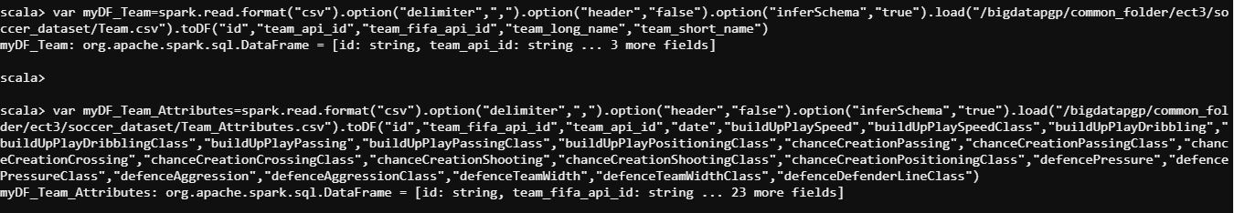

myDF_Country.show(false)

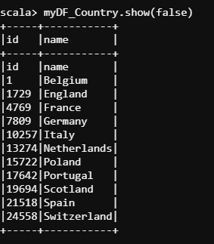

myDF_League.show(false)

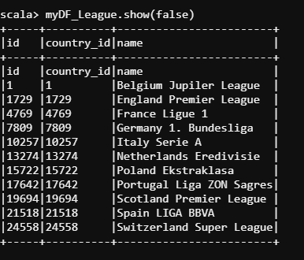

myDF_Match.show(false)

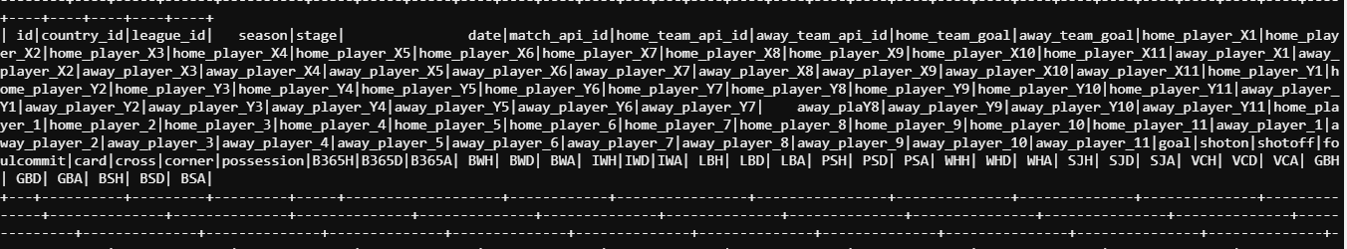

myDF_Player.show(false)

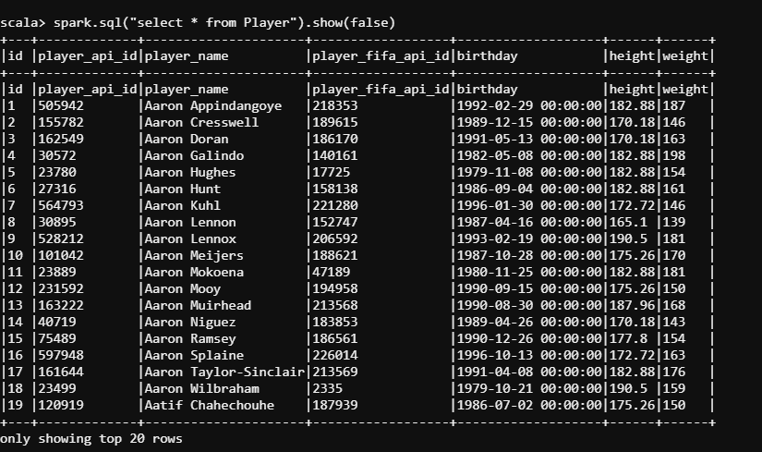

myDF_Player_Attributes.show(false)

myDF_Team.show(false)

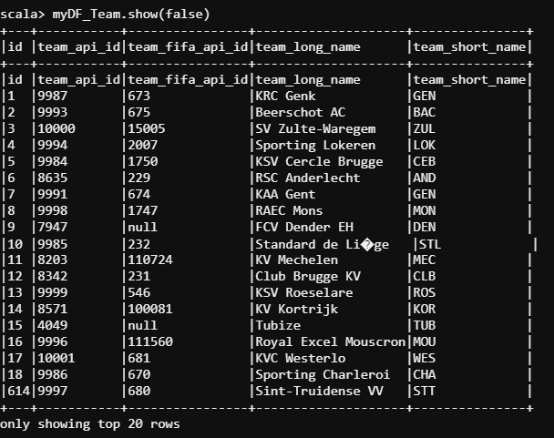

myDF_Team_Attributes.show(false)

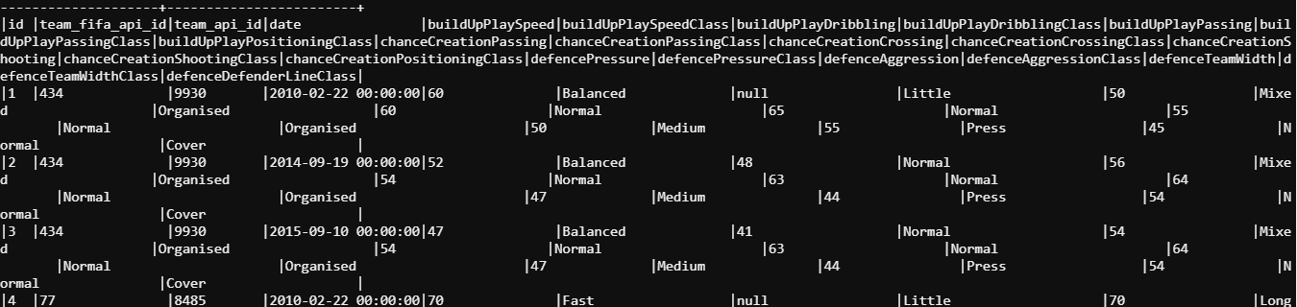

myDF_Country.createOrReplaceTempView("Country")

myDF_League.createOrReplaceTempView("League")

myDF_Match.createOrReplaceTempView("Match")

myDF_Player.createOrReplaceTempView("Player")

myDF_Player_Attributes.createOrReplaceTempView("Player_Attributes")

myDF_Team.createOrReplaceTempView("Team")

myDF_Team_Attributes.createOrReplaceTempView("Team_Attributes")

**SPARK SQL**

spark.sql("SELECT League.id,League.country_id,League.name,Country.name FROM League FULL OUTER JOIN Country ON League.id = Country.id").show(false)

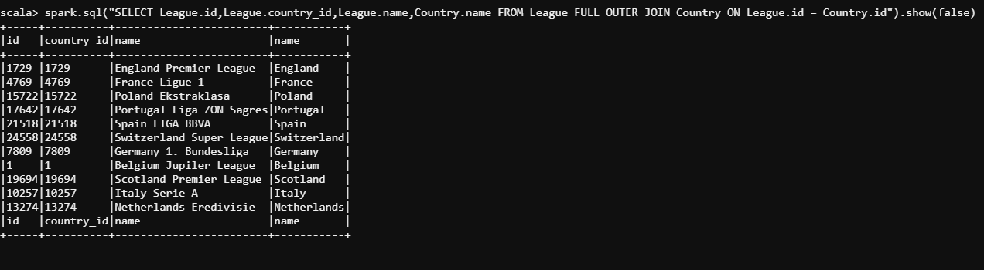

spark.sql("selectPlayer.player_api_id,Player.player_name,Player.player_fifa_api_id,Player.birthday,Player.height,Player.weight,Team.team_api_id,Team.team_fifa_api_id,Team.team_long_name,Team.team_short_name FROM Player LEFT OUTER JOIN Team ON Player.id = Team.id").show(false)

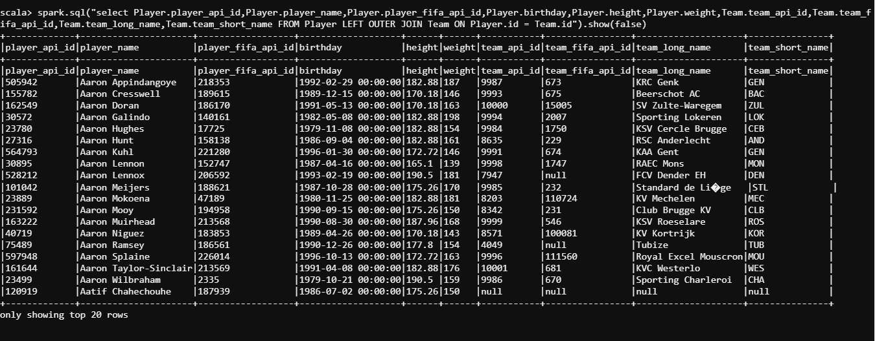

**DF USE**

myDF_Team.select(col("id"),col("team_api_id")).show

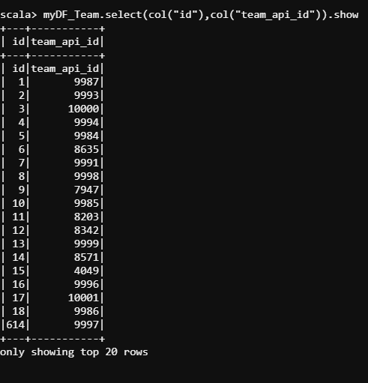

myDF_Team.sort("team_long_name","team_short_name").show(false)

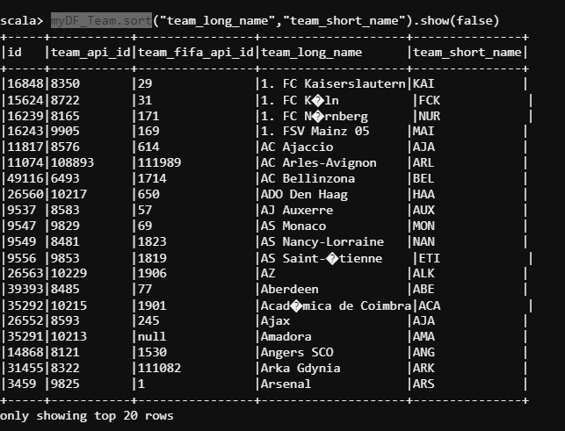

myDF_Team.sort(col("team_long_name"),col("team_short_name")).show(false)

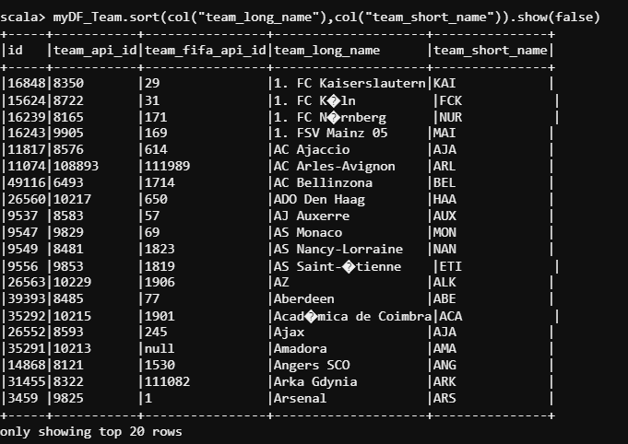

myDF_Team.orderBy("team_long_name","team_short_name").show(false)

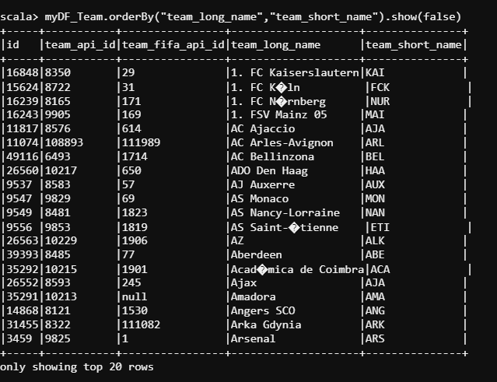

myDF_Team.orderBy(col("team_long_name"),col("team_short_name")).show(false)

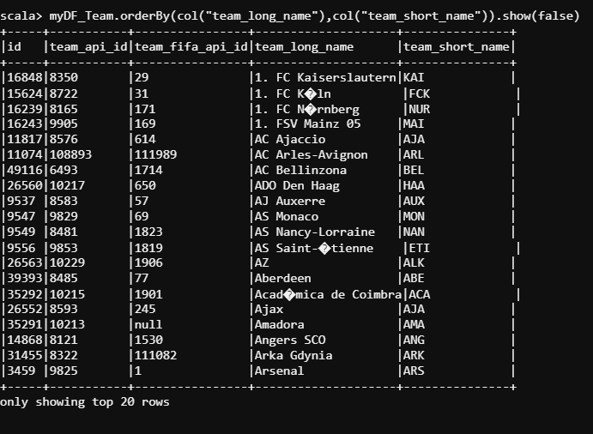

CAST COLUMN NAME TYPE

============================

var myDF_Player=spark.read.format("csv").option("delimiter",",").option("header","false").option("inferSchema","true").load("/bigdatapgp/common_folder/ect3/soccer_dataset/Player.csv").toDF("id","player_api_id","player_name","player_fifa_api_id","birthday","height","weight")



import org.apache.spark.sql.types.{StructType, StructField, StringType, IntegerType, DateType, DoubleType};

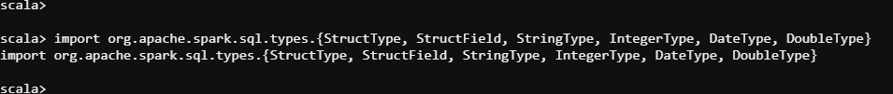

val myDF_Player_Cast = myDF_Player.withColumn("id",col("id").cast(IntegerType)).withColumn("player_api_id",col("player_api_id").cast(IntegerType)).withColumn("player_name",col("player_name").cast(StringType)).withColumn("player_fifa_api_id",col("player_fifa_api_id").cast(IntegerType)).withColumn("birthday",col("birthday").cast(DateType)).withColumn("height",col("height").cast(DoubleType)).withColumn("weight",col("weight").cast(DoubleType))



myDF_Player_Cast.printSchema

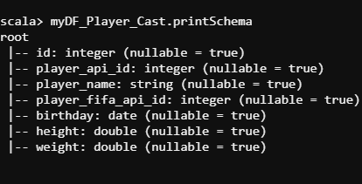

myDF_Player_Cast.createOrReplaceTempView("Player_Cast")

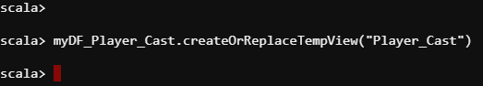

spark.sql("Describe Player_Cast").show(false)

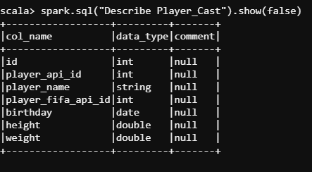

WHERE EXAMPLES IN DF

============================

myDF_Team.show(false)

myDF_Team.where(myDF_Team("team_short_name") === "GEN").show(false)

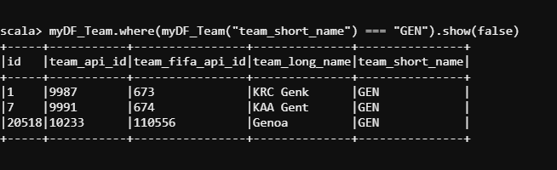

JOINING IN DF

===============

println("Inner join")

myDF_Player.join(myDF_Team,myDF_Player("id") === myDF_Team("id"),"inner").show(false)

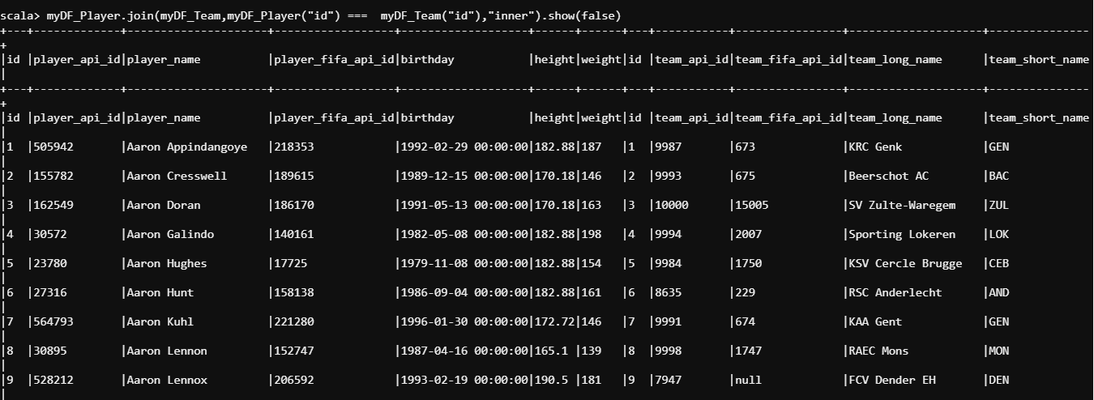

println("Outer join")

myDF_Player.join(myDF_Team,myDF_Player("id") === myDF_Team("id"),"outer").show(false)

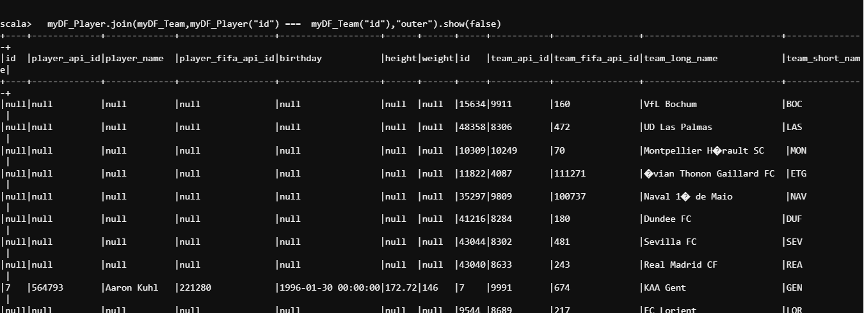

println("full join")

myDF_Player.join(myDF_Team,myDF_Player("id") === myDF_Team("id"),"full").show(false)

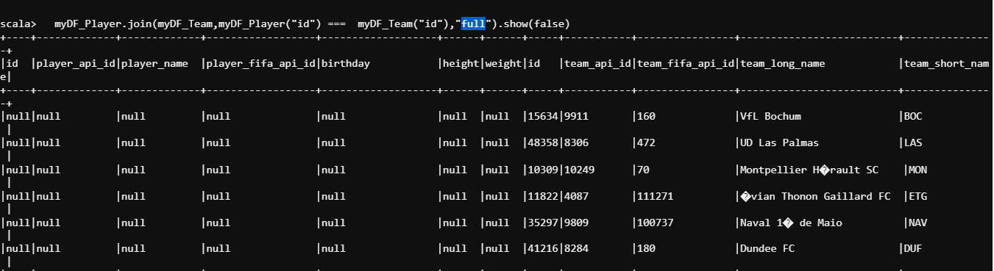

println("fullouter join")

myDF_Player.join(myDF_Team,myDF_Player("id") === myDF_Team("id"),"fullouter") .show(false)

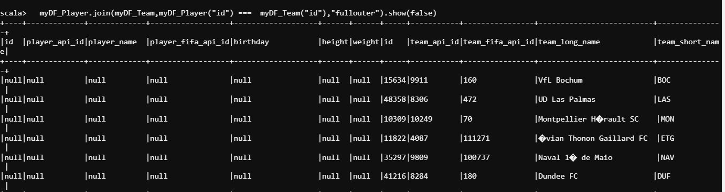

println("right join")

myDF_Player.join(myDF_Team,myDF_Player("id") === myDF_Team("id"),"right") .show(false)

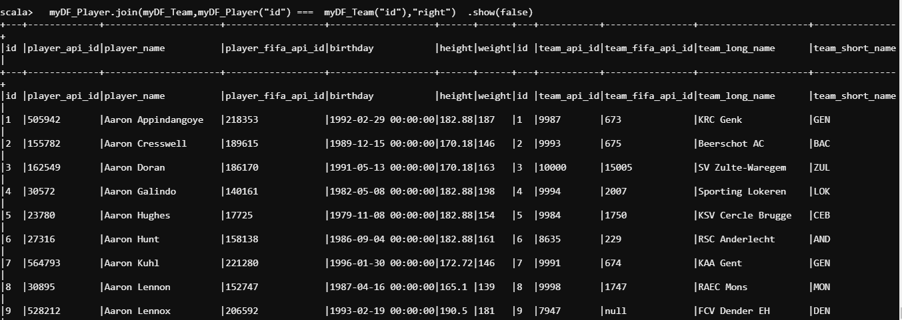

println("rightouter join")

myDF_Player.join(myDF_Team,myDF_Player("id") === myDF_Team("id"),"rightouter") .show(false)

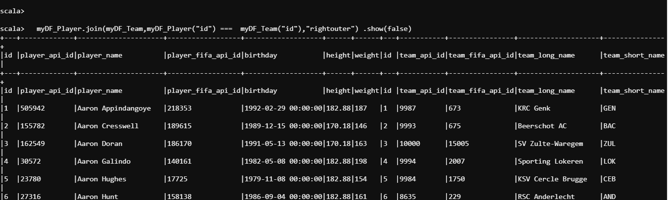

println("left join")

myDF_Player.join(myDF_Team,myDF_Player("id") === myDF_Team("id"),"left").show(false)

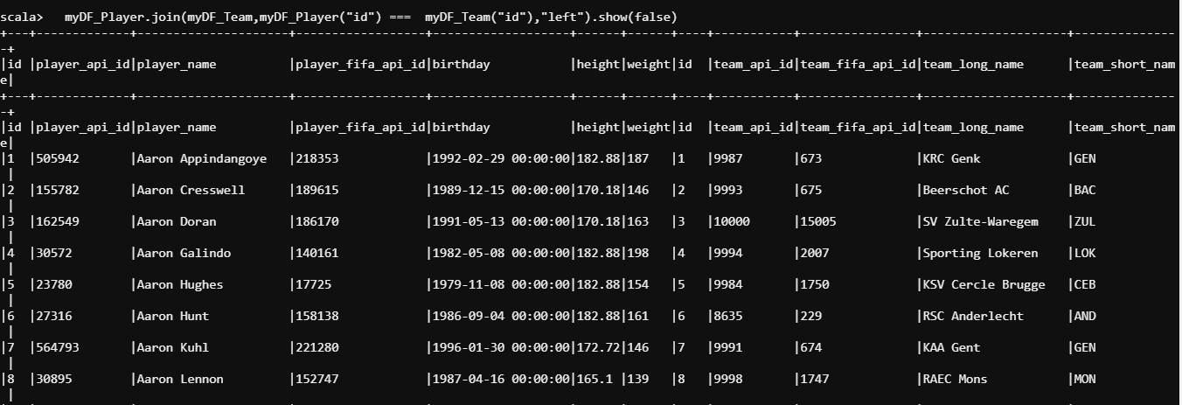

println("leftouter join")

myDF_Player.join(myDF_Team,myDF_Player("id") === myDF_Team("id"),"leftouter") .show(false)

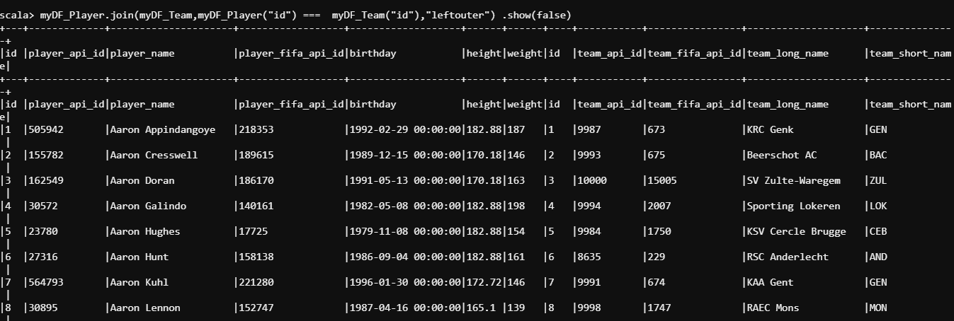

println("leftanti join")

myDF_Player.join(myDF_Team,myDF_Player("id") === myDF_Team("id"),"leftanti").show(false)

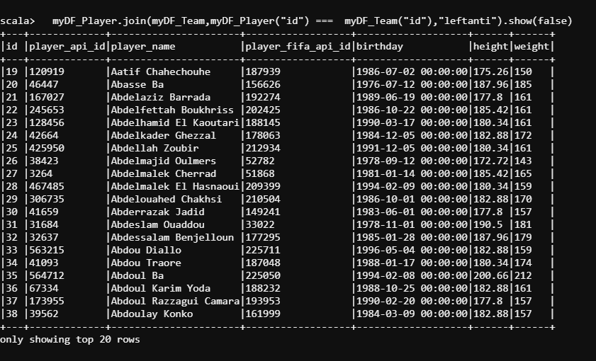

println("leftsemi join")

myDF_Player.join(myDF_Team,myDF_Player("id") === myDF_Team("id"),"leftsemi")

.show(false)

println("cross join")

myDF_Player.join(myDF_Team,myDF_Player("id") === myDF_Team("id"),"cross")

.show(false)

println("Using crossJoin()")

empDF.crossJoin(deptDF).show(false)

//Group By on single column

==============================

myDF_Player_Cast.groupBy("player_api_id").count().show(false)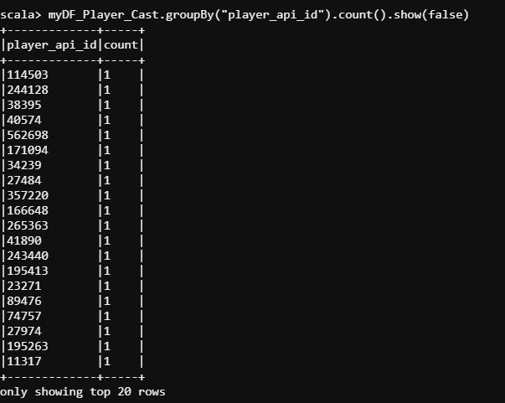

myDF_Player_Cast.groupBy("player_api_id").avg("height").show(false)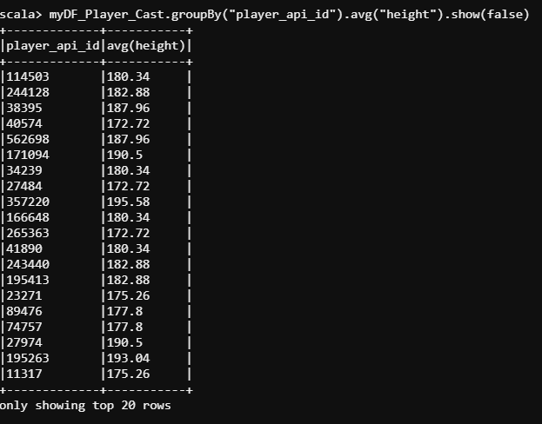

myDF_Player_Cast.groupBy("player_api_id").sum("height").show(false)

myDF_Player_Cast.groupBy("player_api_id").max ("height").show(false)

myDF_Player_Cast.groupBy("player_api_id").min ("height").show(false)