**PLAYING WITH IPL DATA IN SPARK**

IPL DATA DOWNLOADED :

<https://data.world/raghu543/ipl-data-till-2017#:~:text=Overview,-Description&text=This%20data%20set%20has%20the,R%20Script%20%2CSQL%2CSSIS>.

SITE : http : IPL DATASETS

hadoop fs -ls /user/edureka_918210/ipldata

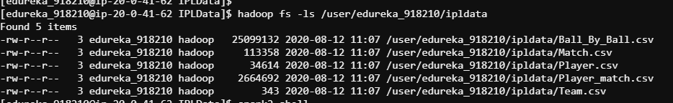

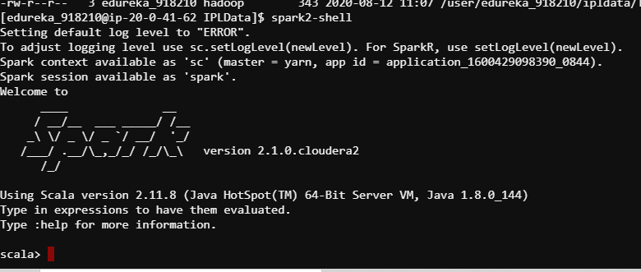

var myDF_BallByBall=spark.read.format("csv").option("delimiter",",").option("header","false").option("inferSchema","true").load("/user/edureka_918210/ipldata/Ball_By_Ball.csv").toDF("MatcH_id","Over_id","Ball_id","Innings_No","Team_Batting","Team_Bowling","Striker_Batting_Position","Extra_Type","Runs_Scored","Extra_runs","Wides","Legbyes","Byes","Noballs","Penalty","Bowler_Extras","Out_type","Caught","Bowled","Run_out","LBW","Retired_hurt","Stumped","caught_and_bowled","hit_wicket","ObstructingFeild","Bowler_Wicket","Match_Date","Season","Striker","Non_Striker","Bowler","Player_Out","Fielders","Striker_match_SK","StrikerSK","NonStriker_match_SK","NONStriker_SK","Fielder_match_SK","Fielder_SK","Bowler_match_SK","BOWLER_SK","PlayerOut_match_SK","BattingTeam_SK","BowlingTeam_SK","Keeper_Catch","Player_out_sk","MatchDateSK")

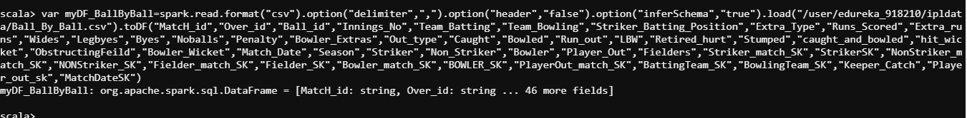

var myDF_Match=spark.read.format("csv").option("delimiter",",").option("header","false").option("inferSchema","true").load("/user/edureka_918210/ipldata/Match.csv").toDF("Match_SK","match_id","Team1","Team2","match_date","Season_Year","Venue_Name","City_Name","Country_Name","Toss_Winner","match_winner","Toss_Name","Win_Type","Outcome_Type","ManOfMach","Win_Margin","Country_id")

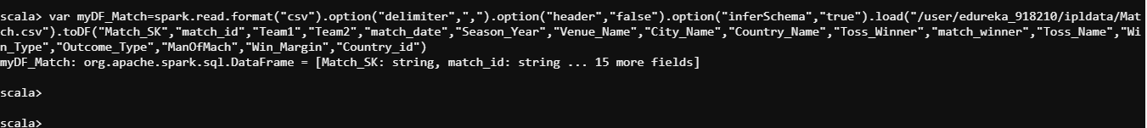

var myDF_Player=spark.read.format("csv").option("delimiter",",").option("header","false").option("inferSchema","true").load("/user/edureka_918210/ipldata/Player.csv").toDF("PLAYER_SK","Player_Id","Player_Name","DOB","Batting_hand","Bowling_skill","Country_Name")



var myDF_Player_match=spark.read.format("csv").option("delimiter",",").option("header","false").option("inferSchema","true").load("/user/edureka_918210/ipldata/Player_match.csv").toDF("Player_match_SK","PlayerMatch_key","Match_Id","Player_Id","Player_Name","DOB","Batting_hand","Bowling_skill","Country_Name","Role_Desc","Player_team","Opposit_Team","Season_year","is_manofThematch","Age_As_on_match","IsPlayers_Team_won","Batting_Status","Bowling_Status","Player_Captain","Opposit_captain","Player_keeper","Opposit_keeper")

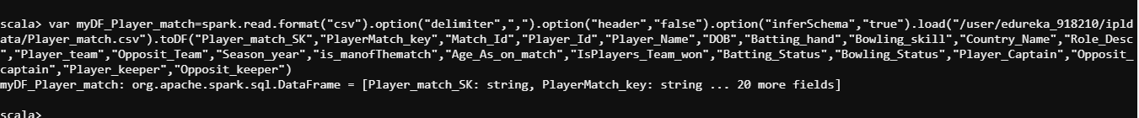

var myDF_Team=spark.read.format("csv").option("delimiter",",").option("header","false").option("inferSchema","true").load("/user/edureka_918210/ipldata/Team.csv").toDF("Team_SK","Team_Id","Team_Name")



myDF_BallByBall.printSchema

myDF_Match.printSchema

myDF_Player.printSchema

myDF_Player_match.printSchema

myDF_Team.printSchema

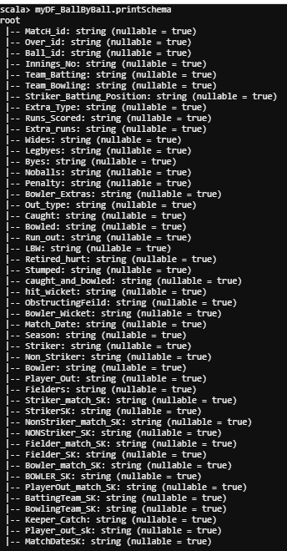

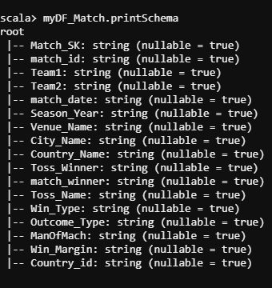

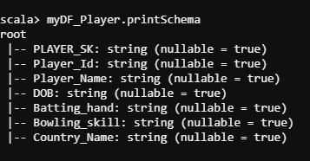

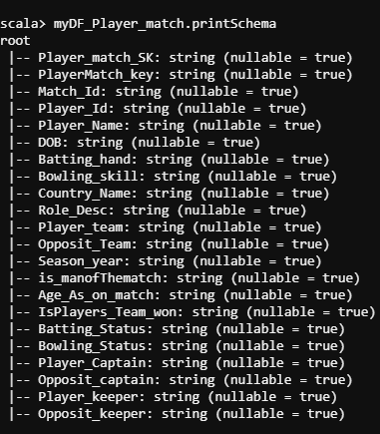

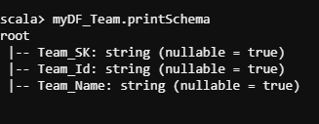

myDF_BallByBall.createOrReplaceTempView("BallByBall")

myDF_Match.createOrReplaceTempView("Match")

myDF_Player.createOrReplaceTempView("Player")

myDF_Player_match.createOrReplaceTempView("Player_match")

myDF_Team.createOrReplaceTempView("Team")

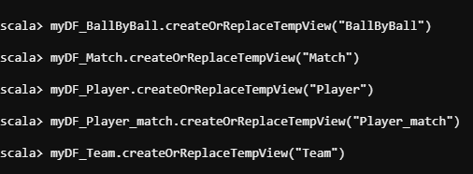

spark.sql("describe Team").show

spark.sql("select * from Team").show

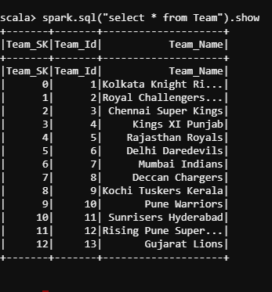

spark.sql("select PLAYER_SK,Player_Id,Player_Name from Player where Country_Name='India'").show

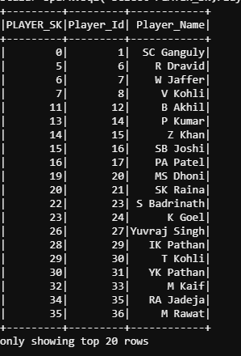

spark.sql("describe Player_match").show

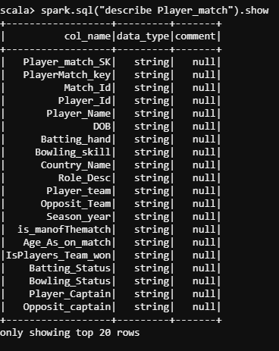

spark.sql("select Player_Name,Player_Id,is_manofThematch,Player_team,Opposit_Team from Player_match").show(false)

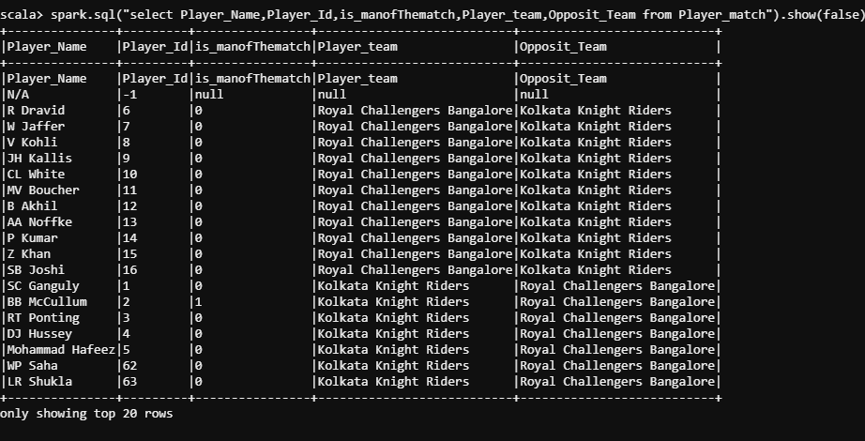

**INNER JOIN**

spark.sql("SELECT Player_match.Batting_hand,Player_match.Player_team,Player_match.Player_Captain,Player.Player_Name,Player.DOB FROM Player INNER JOIN Player_match ON Player.Player_Id = Player_match.Player_Id").show

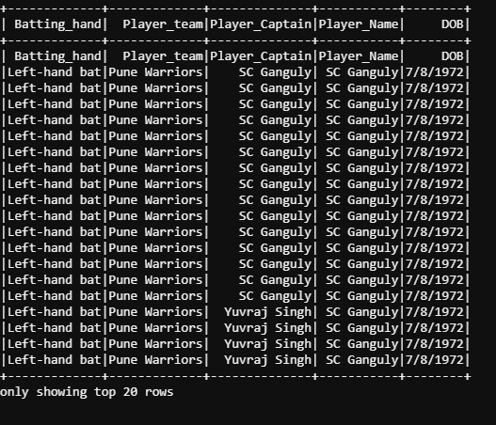

spark.sql("SELECT Player_match.Batting_hand,Player_match.Player_team,Player_match.Player_Captain,Player.Player_Name,Player.DOB FROM Player RIGHT JOIN Player_match ON Player.Player_Id = Player_match.Player_Id").show

