**TITANIC ANALYSIS**

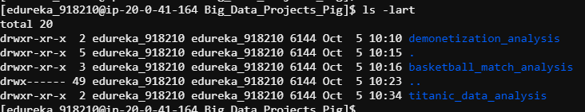

titanic_data = load '/mnt/home/edureka_918210/Big_Data_Projects_Pig/titanic_data_analysis/TitanicData.txt' using PigStorage(',') as (PassengerId:int,Survived:int,Pclass:int,Name:chararray,Sex:chararray,Age:int,SibSp:int,Parch:int,Ticket:chararray,Fare:int,Cabin:chararray,Embarked:chararray);

feature_data = foreach titanic_data generate Survived,Sex,Age;

SPLIT feature_data INTO died_Passanger IF(Survived==0),survived_Passanger IF(Survived==1);

survived_gender_grp = GROUP survived_Passanger by Sex;

died_gender_grp = GROUP died_Passanger by Sex;

sur_avg_age = foreach survived_gender_grp generate CONCAT('Survived_',group) ,AVG(survived_Passanger.Age) as avg_age;

died_avg_age = foreach died_gender_grp generate CONCAT('Died_',group) ,AVG(died_Passanger.Age) as avg_age;

merged_data = UNION sur_avg_age,died_avg_age;

STORE merged_data INTO '/mnt/home/edureka_918210/Big_Data_Projects_Pig/titanic_data_analysis/merged_report.txt' using PigStorage(',');

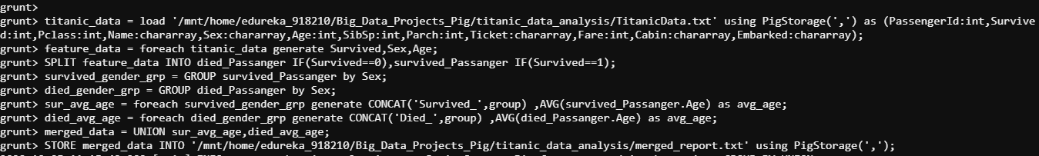

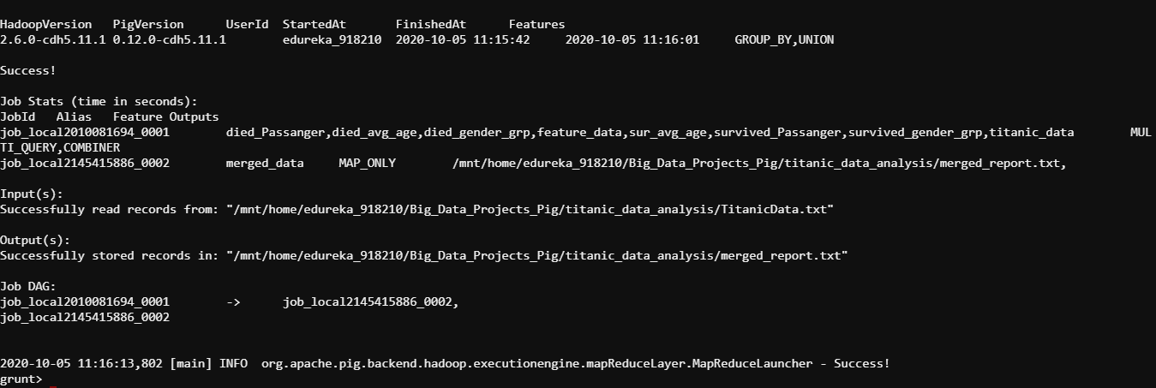

avg_age_report = load '/mnt/home/edureka_918210/Big_Data_Projects_Pig/titanic_data_analysis/merged_report.txt' using PigStorage(',') as (category:chararray,avg_age:int);

dump avg_age_report;



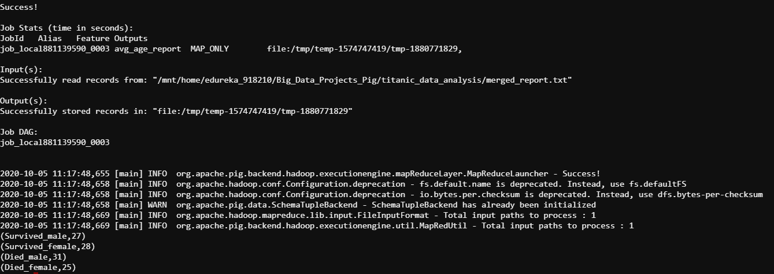

STORE avg_age_report INTO '/mnt/home/edureka_918210/Big_Data_Projects_Pig/titanic_data_analysis/average_report.txt' using PigStorage(',');

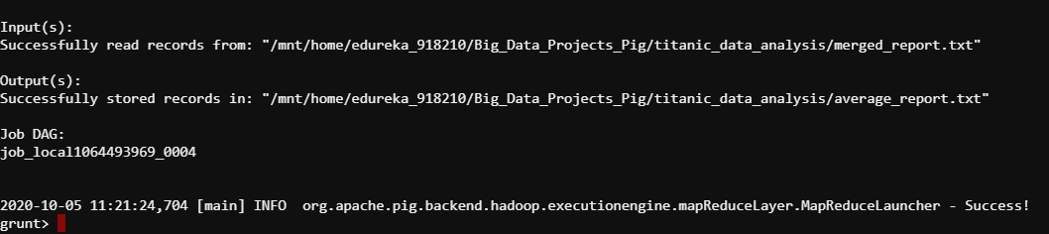

**RESULTS**

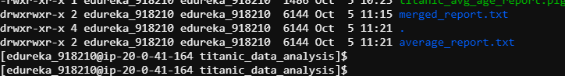

**DEMONITIZATION ANALYSIS**

raw_data = load '/mnt/home/edureka_918210/Big_Data_Projects_Pig/demonetization_analysis/demonetization-tweets.csv' using PigStorage(',');

get_details = foreach raw_data generate $0 as id,$1 as text;

tokens = foreach get_details generate id,text,FLATTEN(TOKENIZE(text)) as words;

dictionary = load '/mnt/home/edureka_918210/Big_Data_Projects_Pig/demonetization_analysis/AFINN.txt' using PigStorage('\t') as (word:chararray,rating:int);

word_ratings = join tokens by words left outer, dictionary by word using 'replicated';

describe word_ratings;

ratings = foreach word_ratings generate tokens::id as id,tokens::text as text,dictionary::rating as rating;

group_words = group ratings by (id,text);

avg_ratings = foreach group_words generate group,AVG(ratings.rating) as tweet_rating;

positive_tweets = filter avg_ratings by tweet_rating > 0;

negative_tweets = filter avg_ratings by tweet_rating < 0;

store positive_tweets INTO '/mnt/home/edureka_918210/Big_Data_Projects_Pig/demonetization_analysis/positive_tweets.txt' using PigStorage(',');

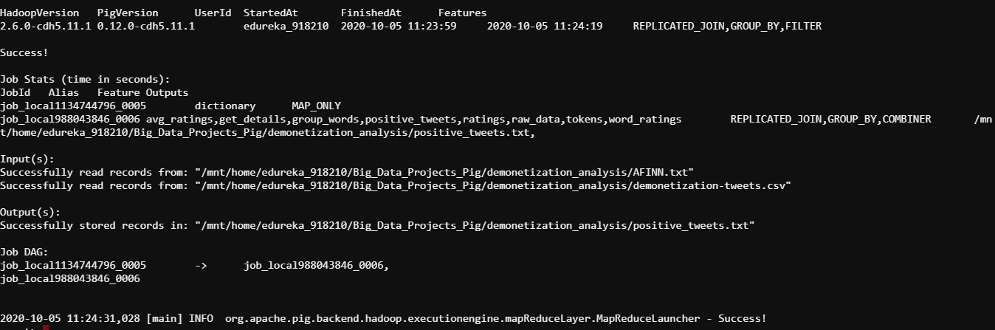

store negative_tweets INTO '/mnt/home/edureka_918210/Big_Data_Projects_Pig/demonetization_analysis/negative_tweets.txt' using PigStorage(',');

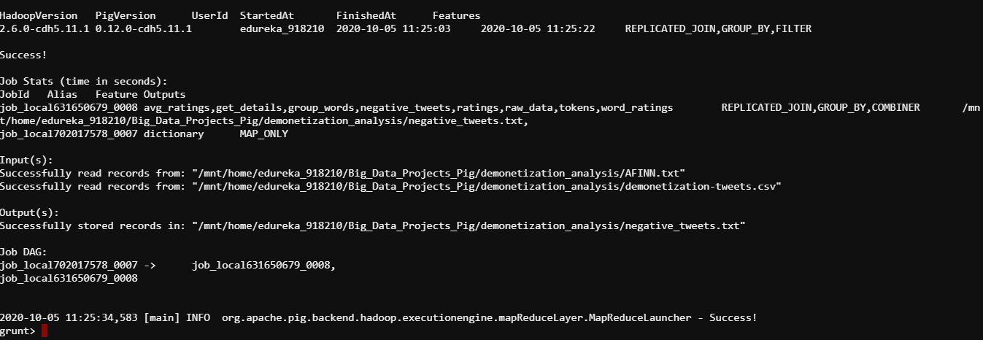

**RESULTS**

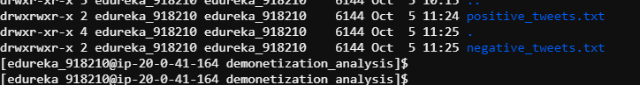

**BASKETBALL ANALYSIS**

**id_to_name**

raw_data = LOAD '/mnt/home/edureka_918210/Big_Data_Projects_Pig/basketball_match_analysis/gamedata/*.EV{A,N}' using PigStorage(',') as (type:chararray,id:chararray,name:chararray);

players_data= filter raw_data by type MATCHES 'start' OR type MATCHES 'sub';

id_name = foreach players_data generate id,name;

distinct_data = DISTINCT id_name;

sorted_data = order distinct_data by id;

store sorted_data INTO '/mnt/home/edureka_918210/Big_Data_Projects_Pig/basketball_match_analysis/id_player_mapping.txt' using PigStorage(',');

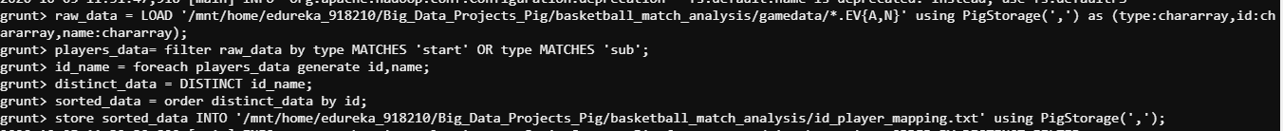

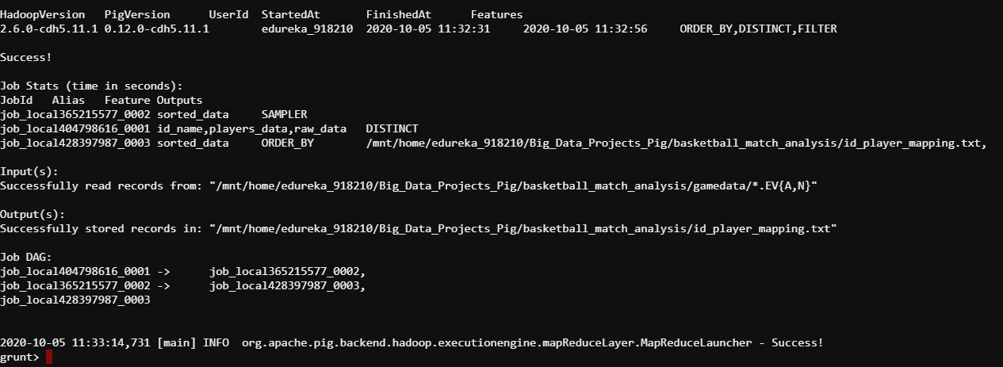

**total_counts**

all_data = load '/mnt/home/edureka_918210/Big_Data_Projects_Pig/basketball_match_analysis/gamedata/*EV{A,N}' using PigStorage(',') as (teams:chararray);

al_data = load '/mnt/home/edureka_918210/Big_Data_Projects_Pig/basketball_match_analysis/gamedata/*EVA' using PigStorage(',') as (team:chararray);

nl_data = load '/mnt/home/edureka_918210/Big_Data_Projects_Pig/basketball_match_analysis/gamedata/*EVN' using PigStorage(',') as (team:chararray);

all_data_ids = filter all_data by teams MATCHES 'id';

al_data_ids = filter al_data by team MATCHES 'id';

nl_data_ids = filter nl_data by team MATCHES 'id';

all_id_grp = group all_data_ids ALL;

al_id_grp = group al_data_ids ALL;

nl_id_grp = group nl_data_ids ALL;

allcount = foreach all_id_grp generate COUNT(all_data_ids) as tmatch;

alcount = foreach al_id_grp generate COUNT(al_data_ids) as talm;

nlcount = foreach nl_id_grp generate COUNT(nl_data_ids) as tnlm;

matchcounttable = foreach allcount generate tmatch,alcount.talm,nlcount.tnlm;

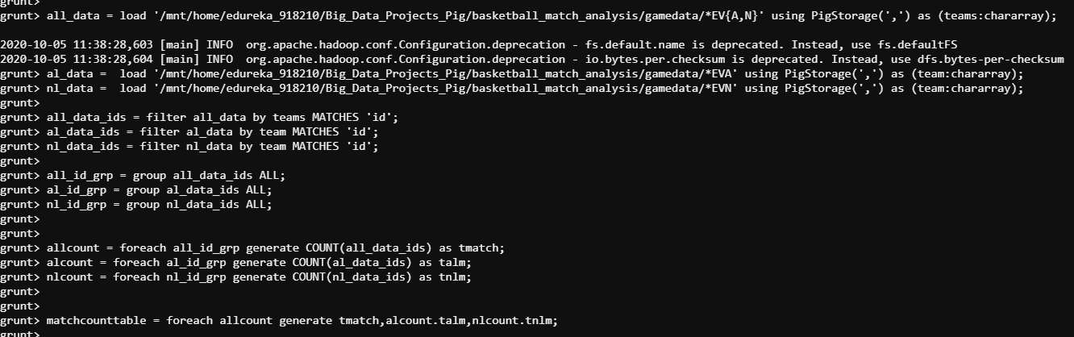

store matchcounttable INTO '/mnt/home/edureka_918210/Big_Data_Projects_Pig/basketball_match_analysis/totalmatches.txt' using PigStorage(',');

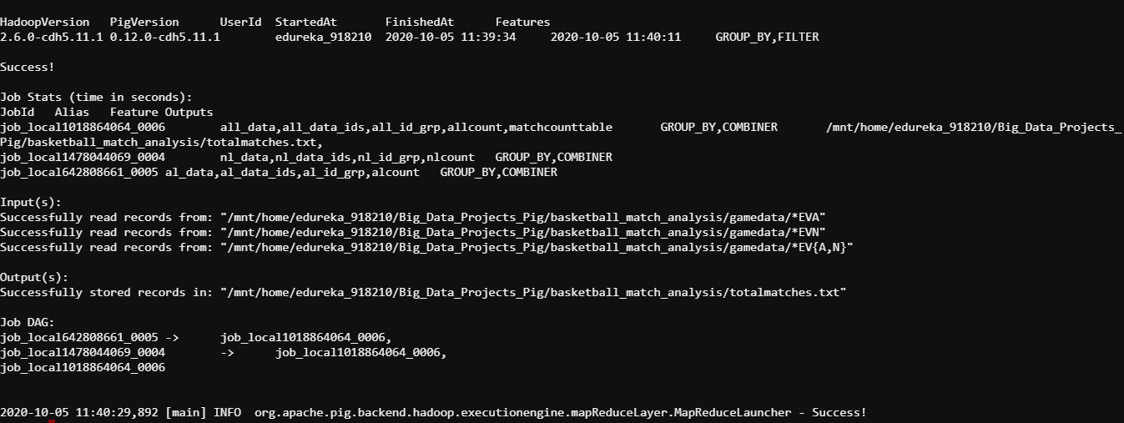

dump matchcounttable;

