Detecting Droplets for Crop Spraying Systems Using Machine Learning

Author - Debmalya Ray

ORCID - 0000-0001-6616-6028

Email – [debmalya.ray9989@gmail.com](mailto:debmalya.ray9989@gmail.com)

Corresponding author email: [debmalya.ray9989@gmail.com](mailto:debmalya.ray9989@gmail.com)

# Abstract:

Agricultural Development combined with technology has made great progress in recent years, making it possible to improve the yield for farmers. This project combines deep learning algorithms with spraying technology to design a machine vision precision real-time targeting spraying system for field scenarios.

Highly efficient mechanized nozzles are used to spray and apply nutrients and pesticides to crops so that farmers can increase production and mitigate the gap between supplies and demands.

We employ high-speed visualization [8] to quantify the impact and evaporation of a droplet on a solid surface. This will also help us to identify the density/area covered by a single spray at a time and correct the delta part left to be covered at first work.

This paper is focused on using image classification techniques with a computer vision algorithm to extract the parameters required from a single image at a time and convert it into structured data so that an unsupervised algorithm can cluster the regions based on density.

## Keywords:

machine vision, image processing methods, unsupervised learning, droplets impact.

# Introduction:

Water droplet recognition technology has been widely used in performance tests and crop production.

Understanding the distribution of pesticide spray on crop fields will be an arduous task as it requires a lot of effort and time. Also, the precision will not be good as it has to be done by human effort.

Here's where computer vision algorithms with machine learning techniques will play a significant role in applying digital image processing techniques to recognize water droplets on the surface and achieve good results. This will help in reducing human efforts and optimize the process to retrieve significant results.

The below flow-chart (Figure-1) explains the entire process in a very simple block diagram.

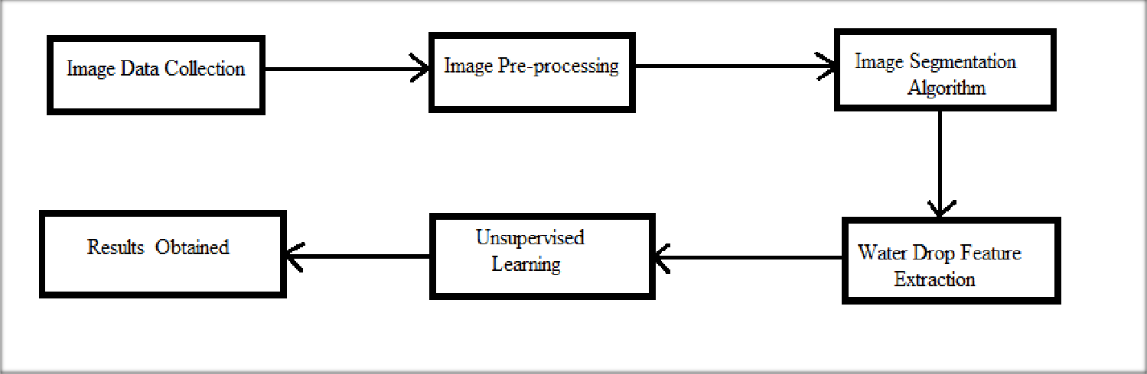

Figure-1 – Entire Process

The difficulties lie in the image segmentation techniques for water droplets. Based on the image being processed the density of water droplets can vary. Hence, computer vision algorithms like open-cv can be used to check if such difficulties can be solved.

Computer vision algorithms are based on threshold segmentation like edge detection, and removal of background noise in an image by smoothening the area and region identification.

# Related Works

Based on the availability of sources, the existing methods for raindrop density segmentation can be categorized as multi-image methods and single-image methods.

## Multi-image methods

When multiple images are considered as input, we should also consider the strong correlation being found among multiple images.

RetinaNet [13], and Mask R-CNN [14]. These techniques have demonstrated superior performance in various benchmarks and have been applied in various applications. Here we focused mainly computer vision library like: open-cv.

OpenCV, short for Open Source Computer Vision Library, is an open-source computer vision [20] and machine learning software library. Originally developed by Intel, it is now maintained by a community of developers under the OpenCV Foundation.

## Single-image methods

For a single image, things will be a little easier as we are considering one image only at a time. However, single image processing for object detection is the foundation stone which led to the development of computer vision techniques.

Region-based convolutional neural network (R-CNN) was first introduced that can successfully segment image objects helping in extracting the required region within an image. However, the advancement in multi-image processing has revolutionized image segmentation problems with better accuracy.

# Methods

The methodology used should be proficient in analyzing high-speed images of droplets and recognizing the area covered. The algorithm must produce reliable results.

## Image Data Collection

The experimental data has been collected from various site like: pixabay as a free source. Each image as been name as: water_droplets1.jpg, water_droplets2.jpg, water_dropletsn.jpg

These images have series of water droplets. We used a single script that can read all the images from a directory and process it for object detection using opencv library.

## Image Pre-processing

Each image has been considered individually and then the images are segmented using `open-cv` to detect contours. Below are the contours rule explaining the same in details. These are:

1. RETR_LIST
2. RETR_EXTERNAL
3. RETR_CCOMP
4. RETR_TREE

To demonstrate the importance of the function **`cv2.findContours() `**, below is the code sniffet represented as block diagram.

contours, hierarchy = cv2.findContours(blending, cv2.RETR_EXTERNAL, cv2.CHAIN_APPROX_SIMPLE) cv2.drawContours(image = blending, contours = contours, contourIdx = -1, color = (0, 0, 255), thickness = 5)

Figure-2 – Object Detection – Finding Contours

## Image Segmentation

Once being processed via library like `open-cv` , the segmented objects derived will help us to obtain the results. Two important results are: count and area-covered.

Here’s an example of the original image and density segmented gray-scale image discussed below:

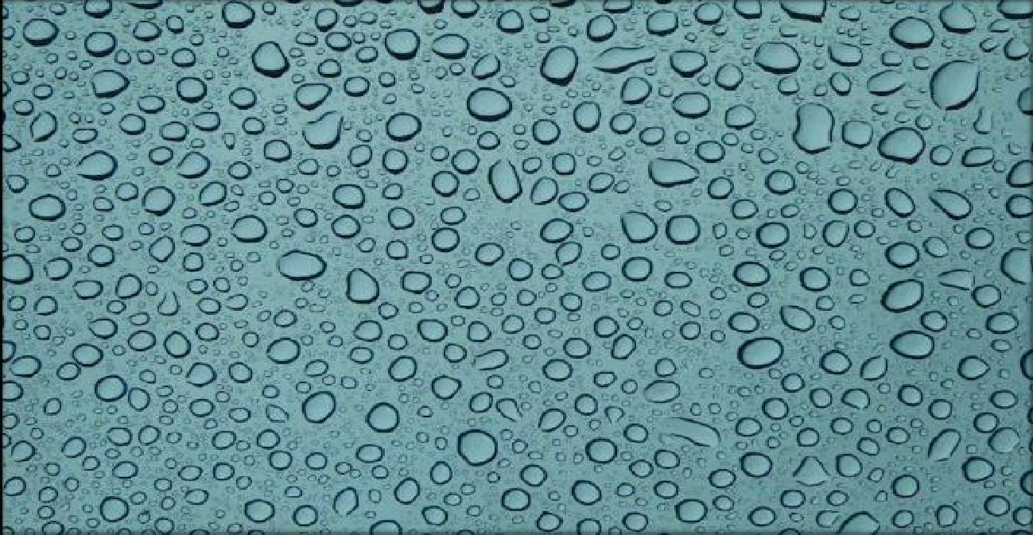

Figure 3: Original Image

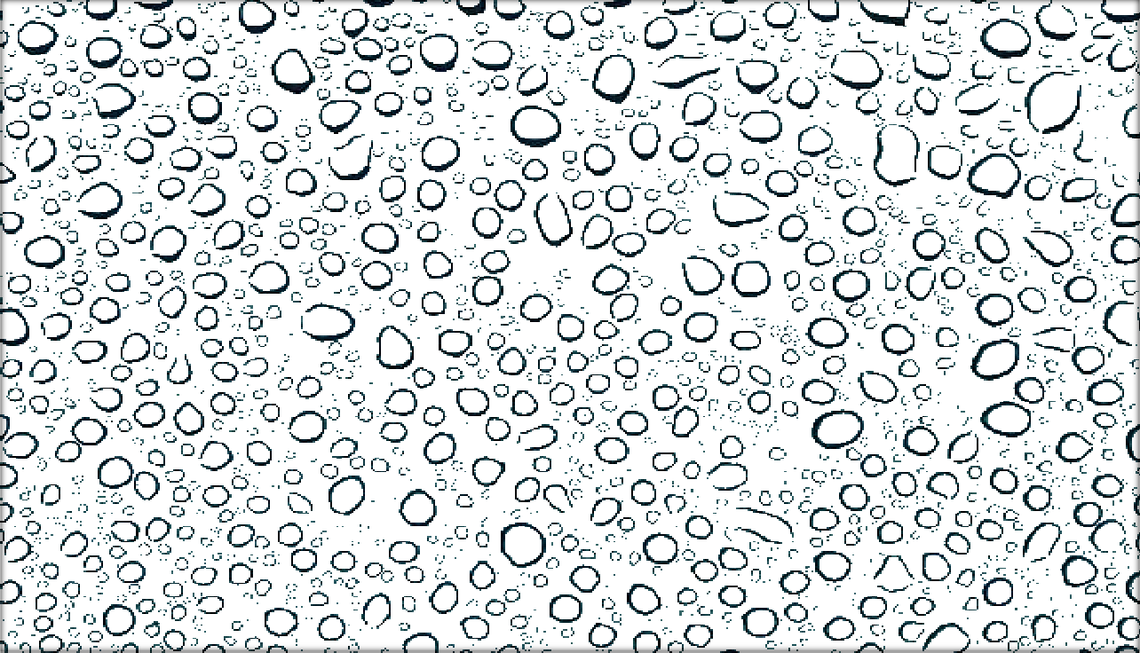

Figure 4: Gray – Scaled Image

## Importance of Grayscaling

1. **Dimension reduction:** For example, In RGB images there are three color channels and three dimensions while grayscale images are single-dimensional.
2. **Reduces model complexity:** Consider training neural articles on RGB images of 10x10x3 pixels. The input layer will have 300 input nodes. On the other hand, the same neural network will need only 100 input nodes for grayscale images.
3. **For other algorithms to work:** Many algorithms are customized to work only on grayscale images e.g. Canny edge detection function pre-implemented in the OpenCV library works on Grayscale images only.

## Unsupervised Learning

Unsupervised learning is a type of machine learning (ML) technique that uses artificial intelligence (AI) algorithms to identify patterns in data sets that are neither classified nor labeled.

# Results and Discussion

To verify the accuracy of the target spraying system in the field and its effectiveness in saving chemicals, the below results are obtained focusing more on "count of water droplets" and "area covered / density".

The results obtained are very satisfactory as we experimented on very difficult and complicated images. The computer vision library like opencv can mostly obtain the results, in case the water droplets are very denser in the images, it will return the results as `1`.

`Please Note` that, density represents area covered within the image represented as pixels accessed by their (x, y)-coordinates. The below code snippets explains the same as block diagram.

total_area = 0 #drops = len(cnts)

smallest = sorted (contours, key=cv2.contourArea) [0] largest = sorted (contours, key=cv2.contourArea) [-1] for c in contours:

area = cv2.contourArea(c) total_area += area

Figure 5: Total Area Covered

The result obtained displayed in the command prompt as:

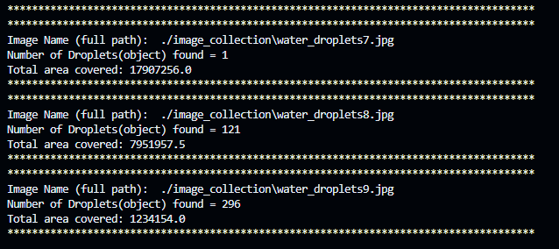

Figure 6: Command Prompt – Result

The result obtained is saved in a structured table as a .csv file.

# Conclusions

This study represents an eminent step in the field of droplet detection, and it exhibits an innovative methodology grounded in deep learning and an architecture laid by Open-CV network. The proposed method and the values obtained by available analytical theories are in good agreement and validate the method to obtain better values.

# References

1. Chen, Z. Y., Wu, R. H., Lin, Y. Y., Li, C. Y., Chen, S. Y., Yuan, Z. E., et al. (2022). Plant disease recognition model based on improved YOLOv5. Agronomy-Basel 12 (2), 14. doi: 10.3390/agronomy12020365
2. Chueca, P., Garcera, C., Molto, E., and Gutierrez, A. (2008). Development of a sensor-controlled sprayer for applying low-volume bait treatments. Crop Prot. 27 (10), 1373–1379. doi: 10.1016/j.cropro.2008.05.004
3. Cooper, J., and Dobson, H. (2007). The benefits of pesticides to mankind and the environment. Crop Prot. 26 (9), 1337–1348. doi: 10.1016/j.cropro.2007.03.022
4. Dammer, K. H. (2016). Real-time variable-rate herbicide application for weed control in carrots. Weed. Res. 56 (3), 237–246. doi: 10.1111/wre.12205
5. Deng, W., He, X. K., Zhang, L. D., Zeng, A. J., Song, J. L., and Zou, J. J. (2008). Target infrared detection in target spray.

Spectrosc. Spectr. Anal. 28 (10), 2285– 2289. doi: 10.3964/j.issn.1000-0593(2008)10-2285-05

1. He, K., Gkioxari, G., Dollár, P., and Girshick, R. (2017). “Mask r-cnn,” in Proceedings of the IEEE international conference on computer vision (USA: IEEE). 2961–2969. doi: 10.1109/ICCV.2017.322
2. Howard, A., Pang, R., Adam, H., Le, Q. V., Sandler, M., Chen, B., et al. (2019). “Searching for MobileNetV3,” in International conference on computer vision (USA: IEEE). 1314–1324. doi: 10.1109/ICCV.2019.00140
3. Lan, Y., Shan, C., Wang, Q., Liu, Q., Yang, C., Xie, Y., et al. (2021). Effects of different spray additives on droplet deposition characteristics during plant protection UAV spraying operations. Transact. Chin. Soc Agric. Eng. 37 (16), 31–

38. doi: 10.11975/j.issn.1002-6819.2021.16.005

1. Liu, W., Anguelov, D., Erhan, D., Szegedy, C., Reed, S., Fu, C.-Y., et al. (2016). “Ssd: Single shot multibox detector,” in European conference on computer vision (Germany: Springer). 21–37. doi: 10.1007/978-3-319-46448-0_2
2. Meshram, A. T., Vanalkar, A. V., Kalambe, K. B., and Badar, A. M. (2022). Pesticide spraying robot for precision agriculture: A categorical literature review and future trends. J. Field Robot. 39 (2), 153–171. doi: 10.1002/rob.22043
3. Song, Y. Y., Sun, H., Li, M. Z., and Zhang, Q. (2015). Technology application of smart spray in agriculture: A review.

Intell. Autom. Soft. Comput. 21 (3), 319–333. doi: 10.1080/10798587.2015.1015781

1. Verger, P. J. P., and Boobis, A. R. (2013). Reevaluate pesticides for food security and safety. Science 341 (6147), 717–718. doi: 10.1126/science.1241572
2. Wang, A. C., Zhang, W., and Wei, X. H. (2019). A review on weed detection using ground-based machine vision and image processing techniques. Comput. Electron. Agric. 158, 226–240. doi: 10.1016/j.compag.2019.02.005
3. Wang, L. L., Zhao, Y. J., Xiong, Z. J., Wang, S. Z., Li, Y. H., and Lan, Y. B. (2022). Fast and precise detection of litchi fruits for yield estimation based on the improved YOLOv5 model. Front. Plant Sci. 13, 16. doi: 10.3389/fpls.2022.965425
4. Redmon, J.; Divvala, S.; Girshick, R.; Farhadi, A. You only look once: Unified, real-time object detection. In Proceedings of the IEEE Conference on Computer Vision and Pattern Recognition, Las Vegas, NV, USA, 27–30 June 2016;

pp. 779–788. 12.

1. Liu, W.; Anguelov, D.; Erhan, D.; Szegedy, C.; Reed, S.; Fu, C.Y.; Berg, A.C. Ssd: Single shot multibox detector. In Proceedings of the Computer Vision—ECCV 2016: 14th European Conference, Amsterdam, The Netherlands, 11–14 October 2016; Proceedings, Part I 14; Springer: Berlin/Heidelberg, Germany, 2016; pp. 21–37. 13.
2. Lin, T.Y.; Goyal, P.; Girshick, R.; He, K.; Dollár, P. Focal loss for dense object detection. In Proceedings of the IEEE International Conference on Computer Vision, Venice, Italy, 22–29 October 2017; pp. 2980–2988. 14.
3. He, K.; Gkioxari, G.; Dollár, P.; Girshick, R. Mask r-cnn. In Proceedings of the IEEE International Conference on Computer Vision, Venice, Italy, 22–29 October 2017; pp. 2961–2969. 15. Sun, R. Optimization for deep learning: Theory and algorithms. arXiv 2019, arXiv:1912.08957.
4. Li, L.; Zhang, S.; Wu, J. Efficient object detection framework and hardware architecture for remote sensing images. Remote Sens. 2019, 11, 2376. [[CrossRef](http://dx.doi.org/10.3390/rs11202376)]
5. Mirani, I.K.; Tianhua, C.; Khan, M.A.A.; Aamir, S.M.; Menhaj, W. Object Recognition in Different Lighting Conditions at Various Angles by Deep Learning Method. arXiv 2022, arXiv:2210.09618.
6. Acharya, P.; Burgers, T.; Nguyen, K.D. AI-enabled droplet detection and tracking for agricultural spraying systems. Comput. Electron. Agric. 2022, 202, 107325. [[CrossRef](http://dx.doi.org/10.1016/j.compag.2022.107325)]
7. De Cock, N.; Massinon, M.; Nuyttens, D.; Dekeyser, D.; Lebeau, F. Measurements of reference ISO nozzles by high- speed imaging. Crop Prot. 2016, 89, 105–115. [[CrossRef](http://dx.doi.org/10.1016/j.cropro.2016.07.016)]
8. Butts, T.R.; Samples, C.A.; Franca, L.X.; Dodds, D.M.; Reynolds, D.B.; Adams, J.W.; Zollinger, R.K.; Howatt, K.A.; Fritz, B.K.; Clint Hoffmann, W.; et al. Spray droplet size and carrier volume effect on dicamba and glufosinate efficacy. Pest Manag. Sci. 2018, 74, 2020–2029. [[CrossRef](http://dx.doi.org/10.1002/ps.4913)] [[PubMed](http://www.ncbi.nlm.nih.gov/pubmed/29536620)]
9. Guan, Q.; Chen, Y.; Wei, Z.; Heidari, A.A.; Hu, H.; Yang, X.H.; Zheng, J.; Zhou, Q.; Chen, H.; Chen, F. Medical image augmentation for lesion detection using a texture-constrained multichannel progressive GAN. Comput. Biol. Med. 2022, 145, 105444. [[CrossRef](http://dx.doi.org/10.1016/j.compbiomed.2022.105444)] [[PubMed](http://www.ncbi.nlm.nih.gov/pubmed/35421795)]
10. Zhu, X.; Lyu, S.; Wang, X.; Zhao, Q. TPH-YOLOv5: Improved YOLOv5 based on transformer prediction head for object detection on drone-captured scenarios. In Proceedings of the IEEE/CVF International Conference on Computer Vision, Montreal, BC, Canada, 11–17 October 2021; pp. 2778–2788.