Render - Deployed on Cloud Platform

<https://ticketsstreamlit.onrender.com/>

Problem Statement

The SR excel contains the mention below columns .

|  |
| --- |
| 1. ticket |
| 1. requestor 2. RequestorSeniority 3. ITOwner 4. FiledAgainst 5. TicketType 6. Severity 7. Priority 8. daysOpen 9. Satisfaction |

Here, **Priority** is your target column and rest of the columns are your feature columns. The Priority columns constructs mentioned below categories ( **0-Unassigned, 1-Low, 2-Medium, 3- High**). Based on the feature variables , we will try to perform perform predictive analysis on the target column.

**Steps Involved:**

1. Upload the datasets.
2. Performing Exploratory Data Analysis on the data based on shape, column feature , plots and graphs
3. Train – Test split. Train for train the model . Test for evaluation purposes.
4. Based on Test data, we will try to predict on the target column.
5. Display of prediction data.

**Drop-Down List in the side bar:**

1. EDA
2. Drop Down List
3. Machine Learning

Github :

<https://github.com/DebmalyaRay9989/tickets-streamlit>

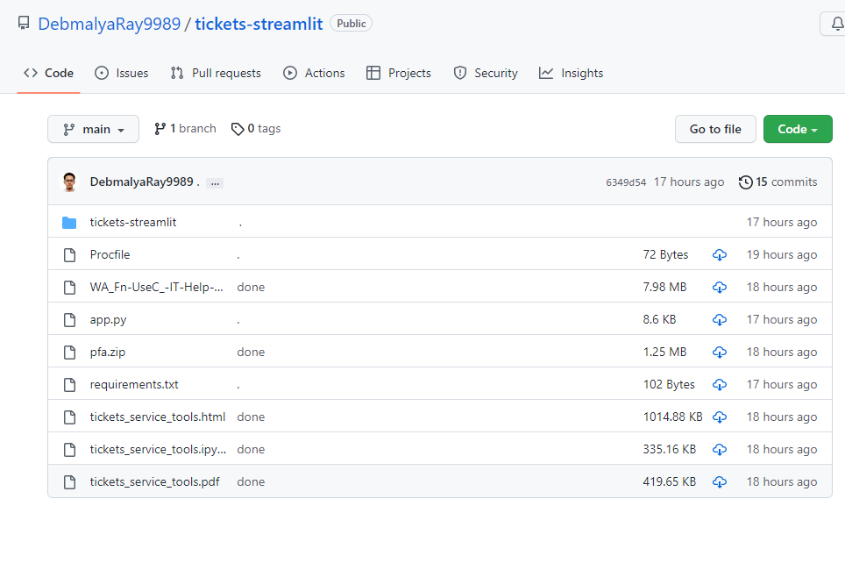

**Application Created :**

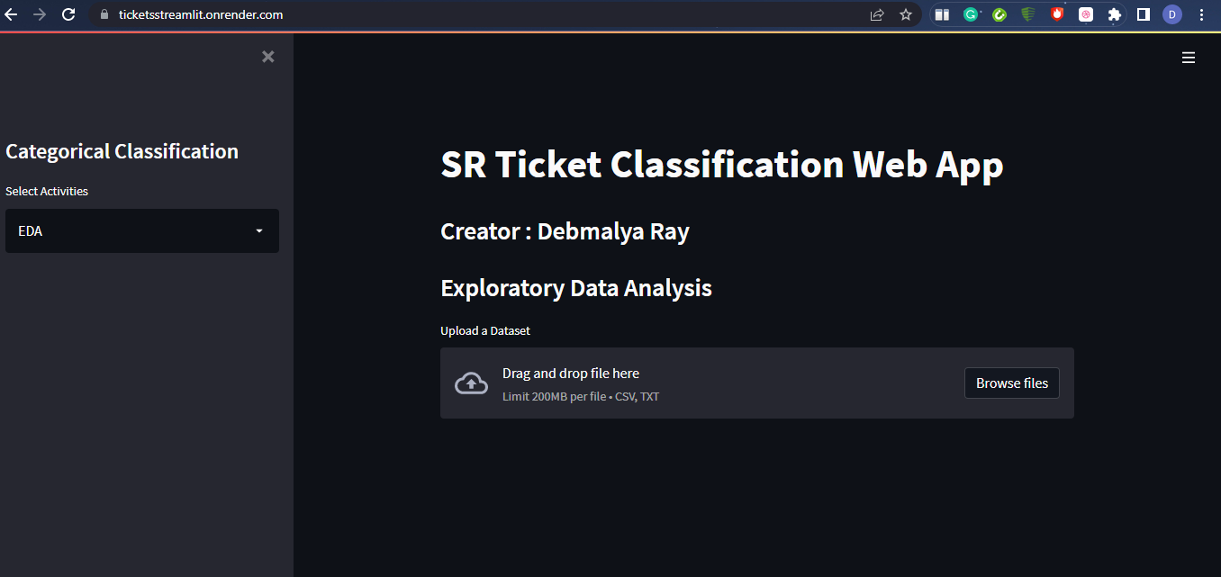

**Display Of Data :**

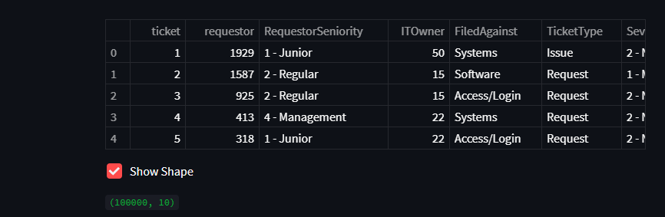

Summary :

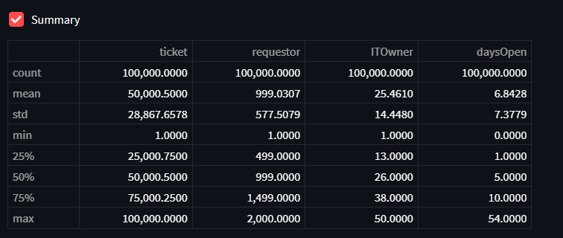

**Show Selected Columns**

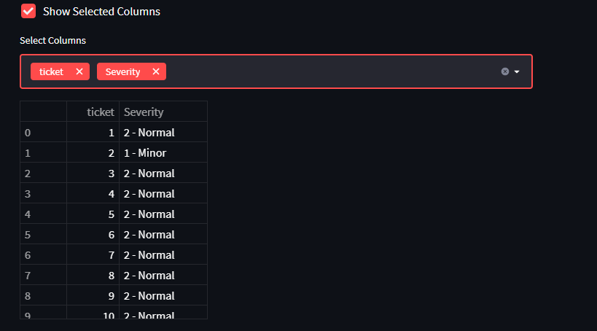

**Show Value Counts :**



**Show Correlation Plot :**

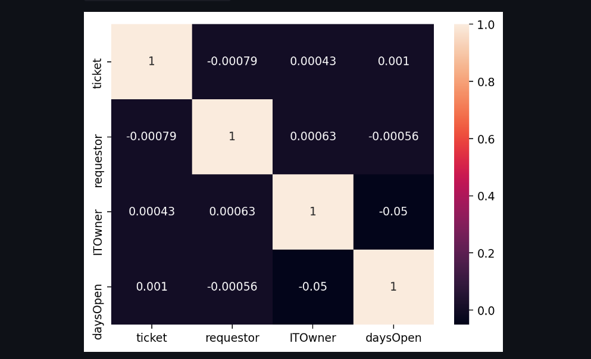

**Machine Learning (ML)**

The Machine Learning algorithm used for prediction: Random Forest , Gradient Boosting , Adaboost Classifiction.

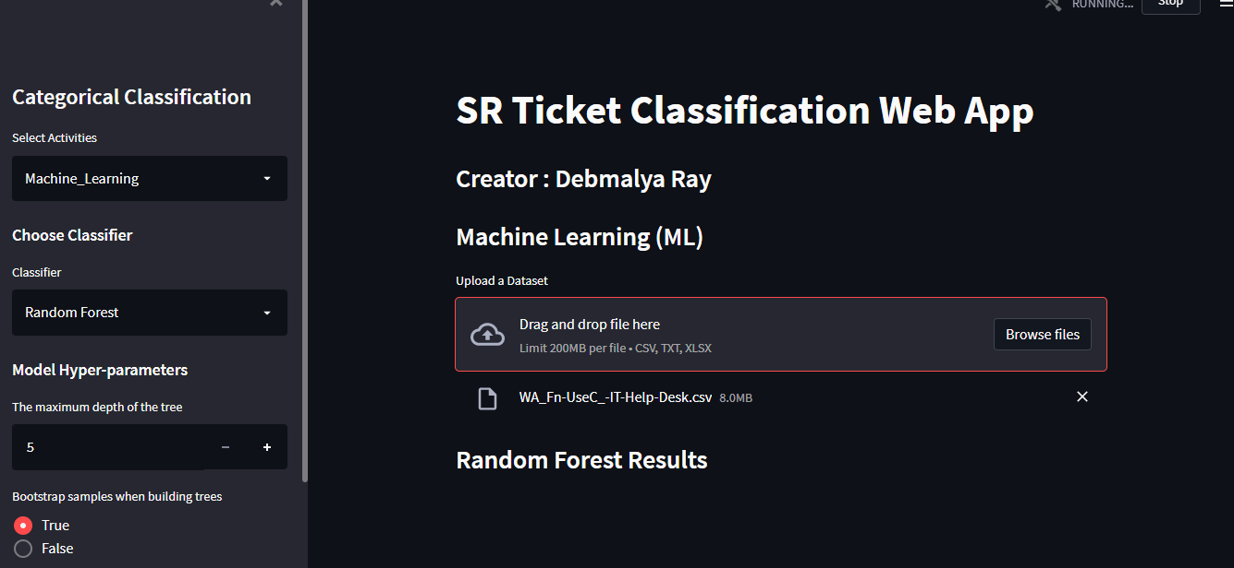

**Prediction Results :**

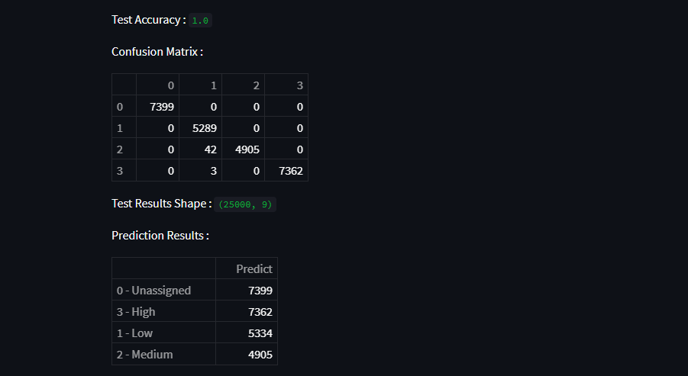

**Bar-Chart Representation :**

