**OFFER PRICE PREDICTION: TELECOM USER**

OBJECTIVE :

The dataset contains all unlimited call plans offered by VI and AIrtel as of 16th July 2022. Based on the input variables , we are trying to predict the

"offer price" that a customer can be suggested.

Here we are trying to customize the offer plans individually based on his/her previous records. Based on the PREDICTED OFFER PRICE , telecom provider can

share plans to the customer and thus individual needs can be taken care off.

The features are as follows:

**SIM_COMPANY :** Specifies VI or Airtel

**OFFER-PRICE(INR) :** Price of the offer

**VALIDITY(DAYS) :** Plan Validity

**DATA-PER-DAY(GB) :** Internet Data provided on daily basis

**ADDITIONAL-DATA(GB) :** Data provided as whole with the pack

**SMS-PER-DAY :** Number of Free SMS on daily basis

**ADDITIONAL-SMS :** Free SMS included with the pack

**DISNEY+HOTSTAR(Months) :** Number of months for Free subscription of Disney/Hotstar

**COST-PER-DAY :** Cost calculation based on plan validity and price offered

**Target:**

**PREDICTED OFFER-PRICE :** Predicted - Price of the offer

**LOGIN CREDENTIALS** - USERNAME / PASSWORD – admin /admin

Login Credentials Implemented : admin / admin - Simple - Deployed on SAAS (render)

Github : **https://github.com/DebmalyaRay9989/mlproject_telecom**

URL : **https://mlprojecttelecom.onrender.com/**

Login Credentials with DB authentication -

Github : https://github.com/DebmalyaRay9989/mlproject_telecom2

URL : running well (local machine) with no issues.

SAAS - need DB service

Login Authentication with HASH algorithm - NEED TIME

**SCREEN SHOT**

<https://mlprojecttelecom.onrender.com/>

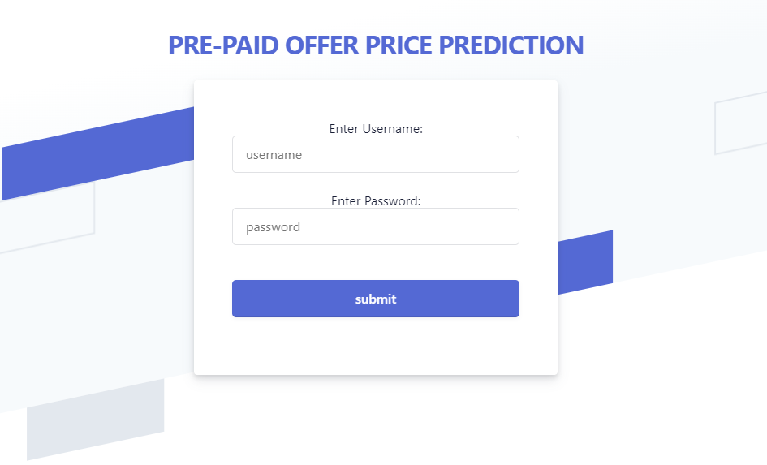

**CREDENTIALS:** admin / admin

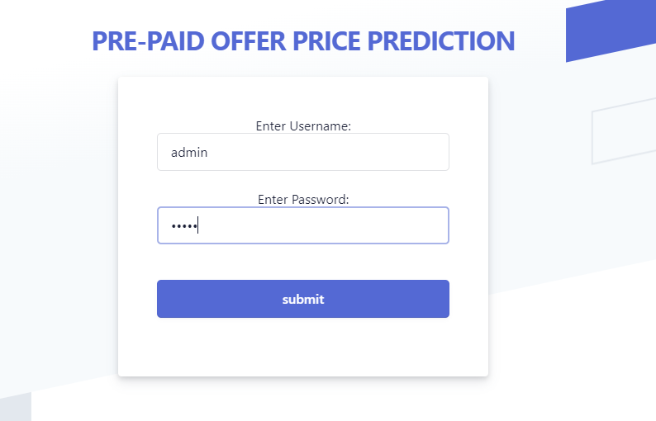

<https://mlprojecttelecom.onrender.com/predictdata>

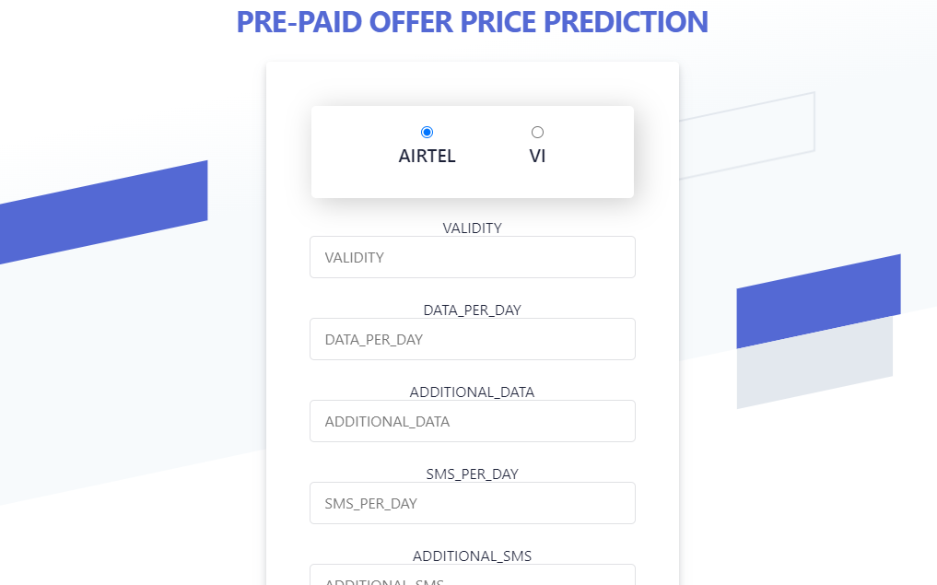

<https://mlprojecttelecom.onrender.com/predictdata>

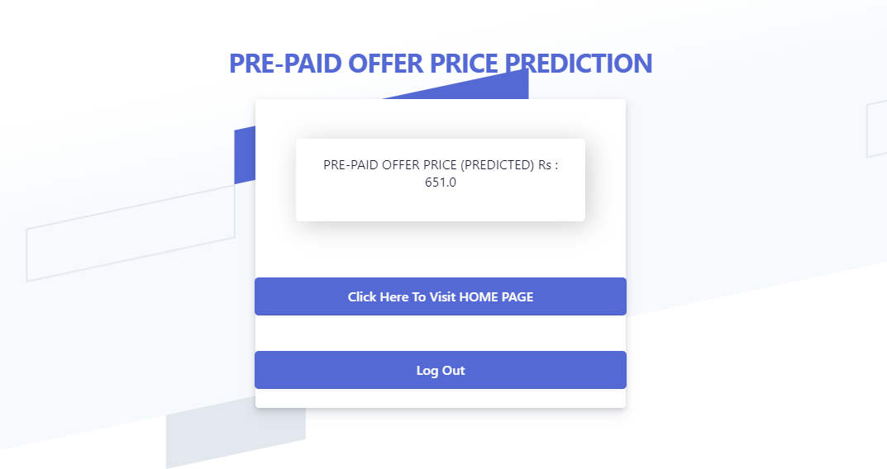

**LOG OUT**

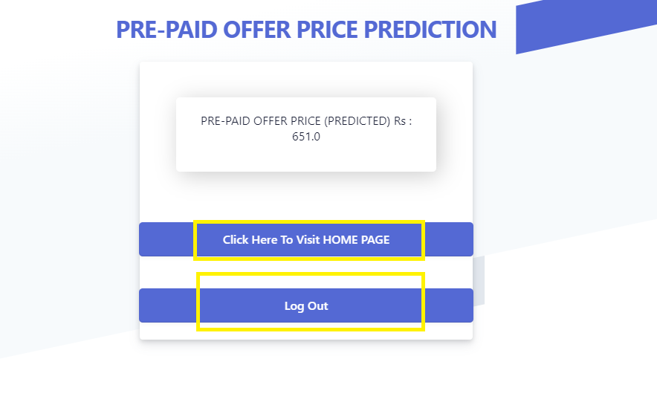

<https://mlprojecttelecom.onrender.com/login>

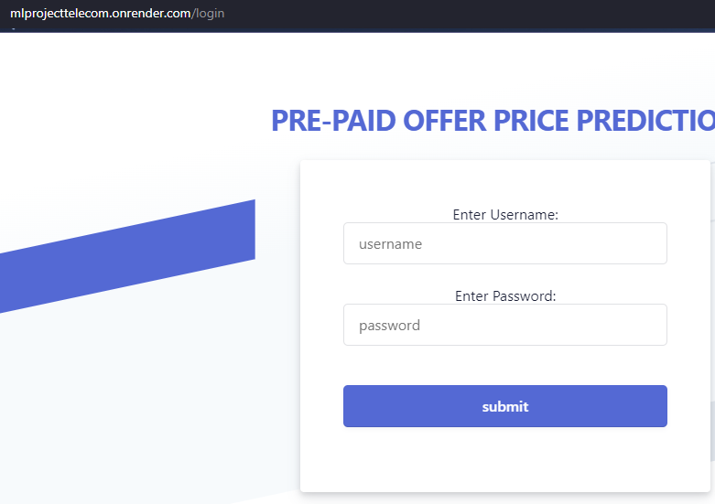

**GITHUB CODES : MLOPS**

<https://github.com/DebmalyaRay9989/mlproject_telecom2>

