Reliable Smartphone-Based Detection of Counterfeit Bangladeshi Banknotes: Multi-View Deep Learning with Out-of-Distribution Rejection and a Benchmark Audit
Debobrato Biswas and Imran Mahmud
D. Biswas and I. Mahmud are with the Department of Software Engineering, Daffodil International University, Dhaka 1207, Bangladesh.
Corresponding author: Debobrato Biswas (e-mail: biswas2305343003@diu.edu.bd).

Abstract
Background: Counterfeit high-value banknotes harm retailers and individuals who cannot afford verification hardware.
Methods: We present a smartphone-based authenticator for Bangladeshi Tk 500 and Tk 1000 notes, evaluated on JaalTaka (1,390 notes: 802 genuine, 588 seized counterfeits; six photographs each). It fine-tunes EfficientNet-B0, fuses up to six photographs per note, returns a genuine, uncertain, or counterfeit verdict, rejects unsupported inputs, and explains decisions with Grad-CAM. We audited the benchmark for duplicates.
Results: On 208 held-out test notes, the system reaches 98.08% accuracy (95% CI 95.16–99.25%) and an ROC-AUC of 0.994 at 37 ms per photograph. However, the 1,390 notes form only 846 distinct photograph sets, 116 test notes have a copy in training, and 12 duplicate groups carry both labels, causing all four test errors. On the 92 test notes without a copy, the system and two simple baselines are error-free.
Conclusion: The benchmark is saturated. We release the duplicate groups and recommend group-aware, counterfeit-family hold-out evaluation.

Index Terms
Banknote authentication, Bangladeshi Taka, counterfeit detection, data leakage, EfficientNet, explainable AI, Grad-CAM, out-of-distribution detection, transfer learning.

Plain Language Summary
Fake Tk 500 and Tk 1000 notes are hard to spot by eye. We built a tool that checks a banknote from one to six phone photographs, answers “genuine”, “counterfeit”, or “uncertain”, refuses pictures of other objects, and highlights the parts of the note behind its answer. It was correct for 98% of the test notes of a public photo collection. That collection, however, contains many repeated photographs, some labelled both genuine and fake, and these explained every mistake. The tool may therefore not catch new kinds of fakes. We share the repeated photographs and suggest fairer tests.

Word Count
2,955 words excluding references (main text: 1,937 words; abstract: 159 words); 9 figures; 4 tables.

I. Introduction
Counterfeit Tk 500 and Tk 1000 notes undermine trust in cash, the main means of payment for small retailers in Bangladesh. Banks use ultraviolet, infrared, and magnetic sorters, but shopkeepers and citizens rely on visual and tactile checks that are slow and unreliable for untrained users. A smartphone camera, carried by almost everyone, makes image-based authentication an attractive complement.
The JaalTaka dataset [1] enabled such work for Bangladeshi notes by releasing smartphone photographs of genuine notes and of counterfeits seized by the Rapid Action Battalion (RAB); its authors reported 97.4–98.9% accuracy for five ImageNet CNNs. High benchmark accuracy is necessary but not sufficient for a tool that people trust with money. It must also (i) handle unsupported inputs, (ii) admit uncertainty, (iii) explain its decisions, and (iv) be evaluated in a way that predicts behaviour on unseen notes. The last point is easy to get wrong: networks exploit shortcuts [2], and duplicates across splits inflate accuracy [3]. Our contributions are:
- an open, CPU-real-time pipeline (Fig. 1) combining EfficientNet-B0 [4], fusion of up to six photographs, a three-way decision with adjustable strictness, an out-of-distribution (OOD) gate, and Grad-CAM [5];
- a note-disjoint evaluation with confidence intervals, threshold and OOD analyses, and frozen-feature baselines; and
- a duplicate audit showing that label conflicts between copied notes cause every test error and that the benchmark is saturated, plus an occlusion test revealing signal outside the note’s centre.
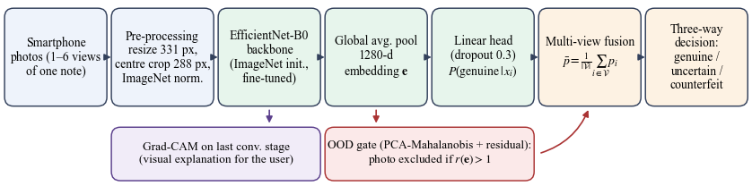
Fig. 1. Overview of the system. Each photograph is classified by a fine-tuned EfficientNet-B0; photographs failing the OOD test are excluded, the remaining genuine probabilities are averaged, and a three-way verdict is returned with Grad-CAM maps.

A. Related Work
Early detectors used hand-crafted features: luminance histograms with multiple-kernel SVMs [6], scanned background printing texture [7], the multispectral response of inks [8], and individual security features of Bangladeshi notes [9]; a mobile application was also proposed [10]. These methods depend on controlled imaging and denomination-specific tuning. Transfer learning from ImageNet [11], [12] lets CNNs learn from few images: Pham et al. detected fake banknotes in smartphone images [13], [14], Bangladeshi denominations were recognised with neural networks and lightweight CNNs [15], [16], JaalTaka was benchmarked [1] with DenseNet121 [17], ResNet50 [18], VGG16 [19], MobileNetV2 [20], and InceptionV3 [21], and transfer learning was also applied in [22]. None of these studies evaluates OOD inputs, uncertainty, or duplicates.
Maximum softmax probability is a weak OOD signal [23]; Mahalanobis distances on network features are stronger [24], and we adapt them to a low-dimensional subspace. Miscalibrated probabilities [25] motivate an explicit “uncertain” outcome, and Grad-CAM [5] shows the regions supporting a class. Shortcut learning [2] and train–test leakage [3] motivate our audit.

II. Materials and Methods

A. Dataset
JaalTaka [1], [26] (CC BY 4.0) contains 1,390 notes: 802 genuine (398 Tk 500, 404 Tk 1000) from three national banks and 588 counterfeit (320 Tk 500, 268 Tk 1000) supplied by RAB. Each note was photographed six times, showing different segments (Fig. 2), with one of four smartphones (Samsung Galaxy A50 and M31, Redmi Note 8 and Note 9 Pro), giving 8,340 images, which we resized to a longer side of 1,024 pixels. According to the dataset description, 649 original notes (502 genuine, 147 counterfeit) were expanded to 1,390 by augmentation.
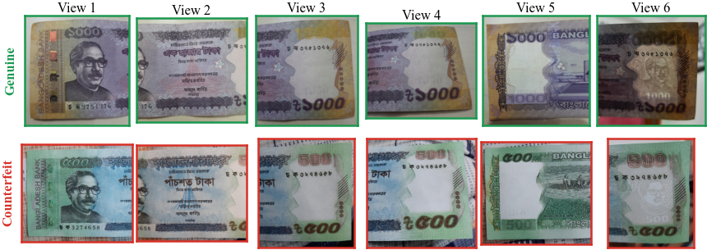
Fig. 2. The six photographs of a genuine Tk 1000 note (top) and a counterfeit Tk 500 note (bottom) from the test split; colour, lighting, and background vary with the phone and session.

B. Evaluation Protocol
Because the photographs of a note are correlated, we split by note: within each class, notes were shuffled (seed 42) and assigned 70/15/15% to training (562 genuine, 412 counterfeit; 5,844 photographs), validation, and test (120 genuine, 88 counterfeit; 1,248 photographs each). Validation serves model selection and OOD calibration; the test split is used once. Section III-F shows that this note-disjoint split is not sufficient, because distinct notes can share photographs. Genuine is the positive class. We report accuracy with a 95% Wilson interval [27], the counterfeit detection rate (specificity), the genuine acceptance rate (recall), and ROC-AUC [28], per photograph ($n=1,248$) and per note ($n=208$), at threshold 0.5 unless stated otherwise.

C. Classifier and Training
EfficientNet-B0 [4], chosen for its accuracy–cost trade-off on CPUs and initialised with ImageNet weights [11], maps a $288×288$ input $x$ to a $1280×9×9$ feature map; global average pooling yields the embedding $e=f(x)∈R^{1280}$. The head is dropout ($p=0.3$) and a linear layer:
$$p(x)=softmax​{\left(We+b\right)}_{\text{genuine}}. (1)$$
The model has 4.01 M parameters. Training uses random resized crops (scale 0.35–1.0, aspect 0.75–1.33), rotations up to $±{10}^{∘}$, colour jitter (brightness and contrast $±0.4$, saturation $±0.3$, hue $±0.04$), and Gaussian blur ($p=0.2$). At evaluation, the shorter side is resized to 331 pixels and the central $288×288$ crop is kept. The stem and first three MBConv stages are frozen with their ImageNet batch-norm statistics; the rest is fine-tuned with the class-weighted, label-smoothed [21] cross-entropy
L=−c∈{0,1}​wc qclogyc, qc=(1−ε) 1[c=y]+ε2, (2)
with $ε=0.05$ and $w_{c}=N/(2N_{c})$. We use AdamW [29] (weight decay ${10}^{−4}$), a one-cycle schedule [30] (peak $3×{10}^{−4}$, 15% warm-up), batch size 12, and six epochs, keeping the epoch with the highest validation accuracy plus AUC; accuracy rose from 98.80% after the first epoch to 99.04% (AUC 0.9976) after the sixth, which was selected. Training took about 55 min on an Intel Core i5-12400 CPU with PyTorch [31].

D. Multi-View Fusion and Three-Way Decision
Let $V$ be the photographs of a note that pass the OOD gate. The note-level probability is the mean, a late-fusion form of multi-view pooling [32],
p=1|V|i∈V​p(xi), (3)
and, for a strictness threshold $τ∈[0.5,1)$ (default 0.7), the verdict is
$$\text{verdict}=\left\{\begin{matrix}\text{not supported} & \text{if }V=∅, \\ \text{genuine} & \text{if }\overset{‾}{p}≥τ, \\ \text{counterfeit} & \text{if }\overset{‾}{p}<0.5, \\ \text{uncertain} & \text{otherwise.}\end{matrix}\right. (4)$$
Averaging needs no extra training and accepts any number of views. The asymmetry reflects costs: accepting a counterfeit causes a loss, whereas “uncertain” only asks the user to check the note by hand or add photographs. Users can choose $τ∈\{0.6,0.7,0.85\}$ or any other value.

E. Out-of-Distribution Gate
Following [24], let $μ$ be the mean training embedding and $U_{k}$ its first $k=64$ principal directions with variances $σ_{j}^{2}$. With $z=U_{k}^{⊤}(e−μ)$, we compute the in-subspace Mahalanobis distance and the out-of-subspace residual
$$m(e)=\sum_{j=1}^{k}{\frac{z_{j}^{2}}{σ_{j}^{2}}}, ρ(e)={∥(e−μ)−U_{k}z∥}_{2}^{2}. (5)$$
Thresholds $θ_{m}$ and $θ_{ρ}$ are the 99.5th validation percentiles. A photograph is accepted when $r(e)=max\{m/θ_{m}, ρ/θ_{ρ}\}≤1$ and its Laplacian variance (a texture measure) is at least 30, which rejects blank and blurred images. The residual catches embeddings that leave the banknote subspace, which the in-subspace distance alone cannot detect.

F. Explanation and Deployment
Grad-CAM [5] is computed on the last feature map $A∈R^{1280×9×9}$ for the predicted class $c$:
αk=181u,v​∂yc∂Auvk, Lc=ReLU​k​αkAk, (6)
where $y^{c}$ is the logit of class $c$; the map is normalised, upsampled, and overlaid on the photograph. The model runs in 37 ms per photograph (median of 30 runs, six CPU threads). The deployed Flask and Streamlit interfaces also average a full-frame crop; all reported results use the central crop only.

III. Results

A. Main Results and Baselines
Per note, the system rejects 86 of 88 counterfeits and accepts 118 of 120 genuine notes (Table I, Fig. 3), and both ROC curves in Fig. 4 rise almost vertically. The per-note confusion matrix equals the per-photograph matrix divided by six, and each view position alone reaches 98.08%: every error comes from all six photographs of one of four notes.
TABLE I
Test Results of the Proposed System (Threshold 0.5)
Metric | Per photograph | Per note (6 views)
Samples (genuine / counterf.) | 1,248 (720 / 528) | 208 (120 / 88)
Accuracy (%) | 98.08 | 98.08
95% Wilson CI (%) | 97.15–98.70 | 95.16–99.25
Counterfeit detection (%) | 97.73 | 97.73 (86/88)
Genuine acceptance (%) | 98.33 | 98.33 (118/120)
Balanced accuracy (%) | 98.03 | 98.03
F1, genuine class | 0.983 | 0.983
ROC-AUC | 0.990 | 0.994
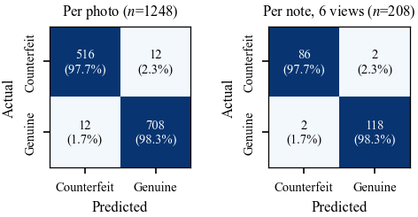
Fig. 3. Test confusion matrices per photograph (left) and per note (right).
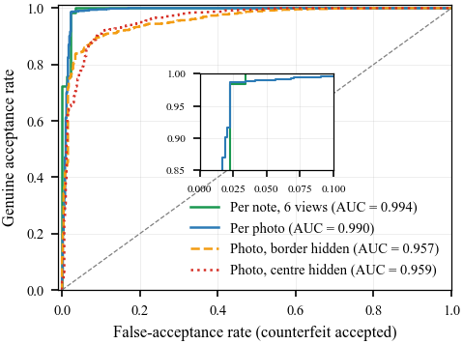
Fig. 4. Test ROC curves for per-note fusion, single photographs, and the occlusion diagnostics of Section III-E.
Table II compares a cosine 1-nearest-neighbour (1-NN) classifier and a logistic-regression probe on frozen ImageNet EfficientNet-B0 embeddings. Fine-tuning adds 1.4–1.6 points of per-photograph accuracy, but at note level the probe matches it and 1-NN errs on only six notes. The JaalTaka authors’ results (97.4–98.9% [1]) used a different split and are not directly comparable.
TABLE II
Comparison With Frozen-Feature Baselines on the Test Split
 | Per photograph |  | Per note
Method | Acc. (%) | AUC | Acc. (%) | AUC
1-NN, frozen ImageNet features | 96.71 | 0.967 | 97.12 | 0.979
Linear probe, frozen features | 96.47 | 0.981 | 98.08 | 0.983
Fine-tuned EfficientNet-B0 (ours) | 98.08 | 0.990 | 98.08 | 0.994

B. Fusion and the Strictness Threshold
Over all $\left({6 \atop k}\right)$ subsets of $k$ views, accuracy stays at 98.08% while the mean AUC rises monotonically from 0.9900 ($k=1$) through 0.9912, 0.9917, 0.9925, and 0.9930 to 0.9939 ($k=6$): fusion makes the ranking of notes more reliable. The fused scores are strongly bimodal (Fig. 5): correctly classified genuine notes have $\overset{‾}{p}>0.86$ and counterfeits $\overset{‾}{p}<0.10$, so outcomes are unchanged for $τ≤0.85$, and at $τ=0.90$ one genuine note (0.8%) becomes “uncertain”. The two accepted counterfeits ($\overset{‾}{p}≈0.95$) would need $τ>0.954$, which would send most genuine notes to manual inspection.
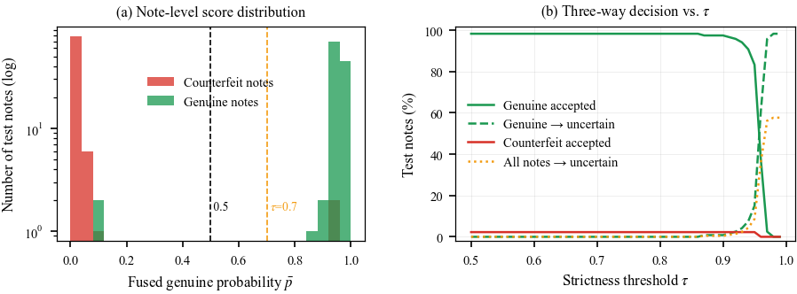
Fig. 5. (a) Fused genuine probability $\overset{‾}{p}$ of the 208 test notes. (b) Share of test notes accepted, “uncertain”, or wrongly accepted versus the threshold $τ$.

C. Out-of-Distribution Gate
The gate rejects 4 of 1,248 test photographs (0.32%) versus 0.72% on validation, with a median test ratio of 0.26 (Fig. 6); no test note was “not supported”. In a preliminary check, it rejected 100 of 105 photographs of other denominations (Tk 2–200) and blank, noise, and unrelated images; a systematic OOD benchmark remains future work.
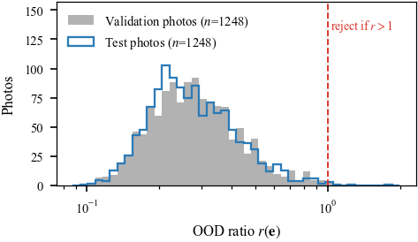
Fig. 6. OOD ratio $r(e)$ of validation and test photographs; the dashed line is the rejection limit.

D. Visual Explanations
In Fig. 7, Grad-CAM concentrates on the portrait and the denomination and ornament panels for correct decisions, and also on the security band for the counterfeit in row (b). The wrongly accepted note in row (c) looks genuine to the model, as expected because an identical copy appears in training labelled genuine (Section III-F).
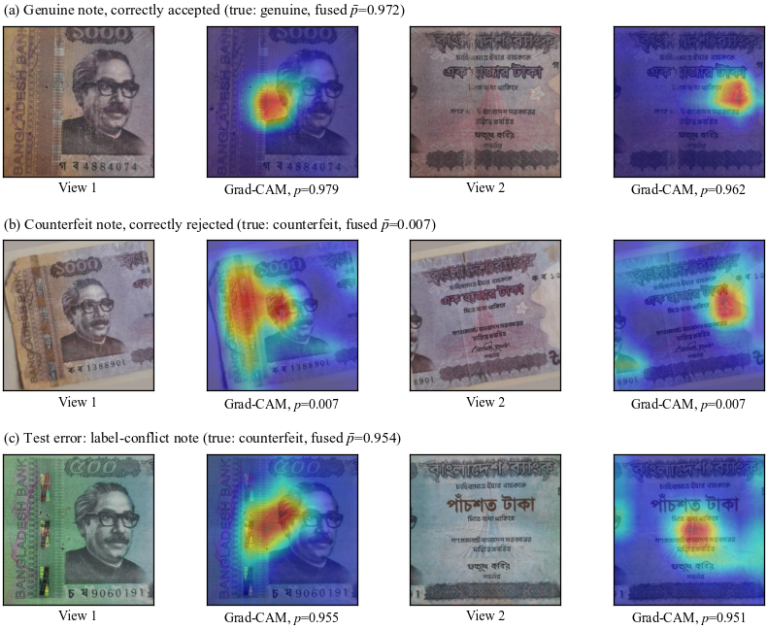
Fig. 7. Grad-CAM on test notes (views 1 and 2). (a) Genuine, accepted. (b) Counterfeit, rejected. (c) Counterfeit, wrongly accepted; its photographs occur in training under the genuine label.

E. Shortcut Diagnostic
As shown in Fig. 8, we blacked out either the centre (keeping a 20% border) or the border of each test input. Hiding the border gives 88.94% accuracy (AUC 0.957). Hiding the centre gives 75.48%, as most genuine photographs are rejected (acceptance 58.47%), yet the AUC remains 0.959 and 98.67% of counterfeits are recognised. The border, which holds the note’s margins but often also the table or hand beneath it, thus suffices to rank most photographs. Because genuine and counterfeit notes came from different sources (banks and RAB), capture conditions may contribute to decisions [2].
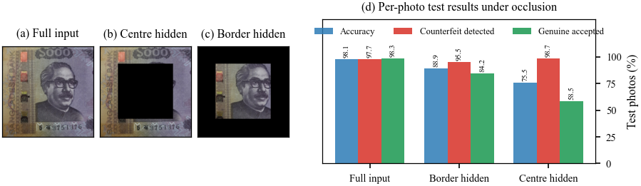
Fig. 8. Occlusion diagnostic. (a)–(c) Inputs with the centre or the 20% border hidden. (d) Per-photograph test results under each condition.

F. Benchmark Audit: Duplicates and Label Conflicts
The perfect agreement between a note’s photographs, the strong frozen baselines, and the documented augmentation led us to search for duplicates. For every pair of notes, we computed the normalised cross-correlation (NCC) of $48×48$ grey-scale thumbnails of corresponding views, averaged over the six views and maximised over flips. The best-match distribution is bimodal (Fig. 9(a)): for validation and test notes, no match lies between 0.963 and 0.997. We therefore grouped notes with NCC $>0.98$ (Table III).
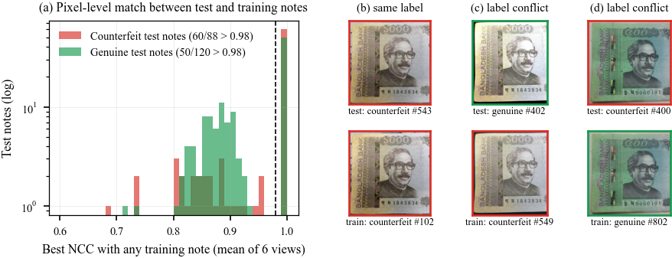
Fig. 9. Duplicate audit. (a) Best NCC match of each test note to any training note; dashed line: threshold 0.98. (b)–(d) A test note (top) and its matching training note (bottom); green frame: genuine, red: counterfeit. (b) Augmented copy, same label. (c), (d) Identical photographs with opposite labels.
TABLE III
Duplicate Audit of JaalTaka (Pixel NCC $>0.98$ Over Six Views)
Quantity | Value
Notes / distinct photograph sets (groups) | 1,390 / 846
Groups of size 1 / 2 / 3 | 449 / 250 / 147
Notes sharing their photographs with another note | 941 (67.7%)
Groups with only counterfeit / only genuine labels | 289 / 545
Groups containing both labels | 12 (31 notes)
Test notes with a copy in training or validation | 116 of 208 (55.8%)
counterfeit / genuine | 60 of 88 / 56 of 120
Test notes in label-conflict groups | 6
Test errors explained by label conflicts | 4 of 4
The augmented copies were thus stored as independent notes, and a note-level split places copies of 55.8% of test notes in training or validation. Twelve groups contain genuine- and counterfeit-labelled copies of the same photographs (e.g., genuine notes 400–406 duplicate counterfeit notes 106–112 and 547–553, and counterfeit notes 400 and 403–406 duplicate genuine notes 802 and 1–4), so at least one label per group is wrong; genuine-labelled notes 402 and 403 carry serial number 1843834, which also appears on counterfeit-labelled notes. All four test errors are notes from these groups, each predicted with the label of its training copy. On the 92 clean test notes, whose group has no member in training or validation, and on the 202 notes outside label-conflict groups, all three methods are error-free (Table IV). The 98.08% accuracy is thus limited by label noise, not by the model, and the task is saturated even for 1-NN on generic features.
TABLE IV
Note-Level Accuracy (%) on Audited Test Subsets
Test subset | All | Without label | Clean
 |  | conflicts | (no copy)
Notes (genuine / counterf.) | 208 (120/88) | 202 (117/85) | 92 (64/28)
1-NN, frozen features | 97.12 | 100.0 | 100.0
Linear probe, frozen | 98.08 | 100.0 | 100.0
Ours (fine-tuned) | 98.08 | 100.0 | 100.0
95% Wilson CI | 95.16–99.25 | 98.13–100 | 95.99–100

IV. Discussion
Within JaalTaka, the system is error-free once label conflicts are removed (lower 95% bound 96.0% on the 92 clean notes), its errors are fully explained, and it runs in real time on a CPU. This does not show that it will detect new counterfeits: the 588 counterfeits collapse into 289 photograph sets, those we inspected share a few serial numbers, and they were collected separately from the genuine notes. A model, even 1-NN, can therefore succeed by recognising known batches or capture sessions, as the occlusion test suggests. The saturated benchmark also cannot rank methods, since differences between published CNNs are smaller than its label noise.
We recommend (i) removing or relabelling the 12 conflict groups; (ii) splitting by duplicate group, for which we release our list; (iii) holding out counterfeit families (e.g., by serial number or seizure batch) and capture devices, to measure generalisation to unseen forgeries and phones; and (iv) reporting confidence intervals and frozen-feature baselines, which immediately reveal saturation.
Limitations: The system covers only Tk 500 and Tk 1000. Visible-light photographs cannot capture ultraviolet, magnetic, or tactile features, so the output is decision support and suspicious notes should be confirmed at a bank. Scans and distant photographs are mostly rejected, the OOD evaluation is preliminary, and probabilities are not calibrated on independent data [25]. Retraining on a group-aware split with a counterfeit-family hold-out is the most important next step.

V. Conclusion
Our smartphone system combines multi-view fusion, a three-way decision, an OOD gate, and Grad-CAM, runs in real time on a CPU, and reaches 98.08% note-level accuracy (AUC 0.994) on JaalTaka. The audit shows that label conflicts among duplicated notes explain every error and that on duplicate-free notes even simple baselines are error-free. Progress now depends on evaluation data that separates counterfeit families, sessions, and devices.

Acknowledgment
The authors thank the Department of Software Engineering, Daffodil International University, for its support and the JaalTaka creators for releasing their data.

Funding
This research received no external funding.

Author Contributions
D. Biswas: conceptualisation, software, experiments, analysis, and original draft. I. Mahmud: supervision, methodology review, and manuscript editing.

Conflict of Interest
The authors declare no conflict of interest.

Ethics Statement
This study involved no human participants, personal data, or animals; it used only banknote photographs from a public CC BY 4.0 dataset [26]. Ethics approval and informed consent were therefore not required.

Generative AI Disclosure
The authors used an AI assistant to help write analysis scripts and edit the text, and checked all code, results, and references.

Data Availability
JaalTaka is available from Mendeley Data [26]. The model, code, and duplicate-group list are available from the corresponding author and will be released publicly upon publication.

References
[1] B. R. C. Piyas, F. J. Tisha, S. Rahman, S. Islam, and B. R. C. Preenon, “JaalTaka: A benchmark dataset for detecting counterfeit Bangladeshi banknotes,” Data in Brief, vol. 64, p. 112377, 2025.
[2] R. Geirhos, J.-H. Jacobsen, C. Michaelis, R. Zemel, W. Brendel, M. Bethge, and F. A. Wichmann, “Shortcut learning in deep neural networks,” Nature Machine Intelligence, vol. 2, no. 11, pp. 665–673, 2020.
[3] S. Kapoor and A. Narayanan, “Leakage and the reproducibility crisis in machine-learning-based science,” Patterns, vol. 4, no. 9, p. 100804, 2023.
[4] M. Tan and Q. V. Le, “EfficientNet: Rethinking model scaling for convolutional neural networks,” in Proc. 36th Int. Conf. Machine Learning (ICML), ser. Proceedings of Machine Learning Research, vol. 97, Long Beach, CA, USA, 2019, pp. 6105–6114.
[5] R. R. Selvaraju, M. Cogswell, A. Das, R. Vedantam, D. Parikh, and D. Batra, “Grad-CAM: Visual explanations from deep networks via gradient-based localization,” in Proc. IEEE Int. Conf. Computer Vision (ICCV), Venice, Italy, 2017, pp. 618–626.
[6] C.-Y. Yeh, W.-P. Su, and S.-J. Lee, “Employing multiple-kernel support vector machines for counterfeit banknote recognition,” Applied Soft Computing, vol. 11, no. 1, pp. 1439–1447, 2011.
[7] A. Berenguel, O. Ramos Terrades, J. Lladós, and C. Cañero, “Banknote counterfeit detection through background texture printing analysis,” in Proc. 12th IAPR Workshop on Document Analysis Systems (DAS), Santorini, Greece, 2016, pp. 66–71.
[8] S. Baek, E. Choi, Y. Baek, and C. Lee, “Detection of counterfeit banknotes using multispectral images,” Digital Signal Processing, vol. 78, pp. 294–304, 2018.
[9] M. S. Uddin, P. P. Das, and M. S. A. Roney, “Image-based approach for the detection of counterfeit banknotes of Bangladesh,” in Proc. 5th Int. Conf. Informatics, Electronics and Vision (ICIEV), Dhaka, Bangladesh, 2016, pp. 1067–1072.
[10] T. V. Dittimi and C. Y. Suen, “Mobile app for detection of counterfeit banknotes,” in Advances in Artificial Intelligence (Canadian AI 2018), ser. Lecture Notes in Computer Science.Cham, Switzerland: Springer, 2018, vol. 10832, pp. 156–168.
[11] J. Deng, W. Dong, R. Socher, L.-J. Li, K. Li, and L. Fei-Fei, “ImageNet: A large-scale hierarchical image database,” in Proc. IEEE Conf. Computer Vision and Pattern Recognition (CVPR), Miami, FL, USA, 2009, pp. 248–255.
[12] J. Yosinski, J. Clune, Y. Bengio, and H. Lipson, “How transferable are features in deep neural networks?” in Advances in Neural Information Processing Systems (NeurIPS), vol. 27, 2014, pp. 3320–3328.
[13] T. D. Pham, C. Park, D. T. Nguyen, G. Batchuluun, and K. R. Park, “Deep learning-based fake-banknote detection for the visually impaired people using visible-light images captured by smartphone cameras,” IEEE Access, vol. 8, pp. 63 144–63 161, 2020.
[14] T. D. Pham, Y. W. Lee, C. Park, and K. R. Park, “Deep learning-based detection of fake multinational banknotes in a cross-dataset environment utilizing smartphone cameras for assisting visually impaired individuals,” Mathematics, vol. 10, no. 9, p. 1616, 2022.
[15] N. Jahangir and A. R. Chowdhury, “Bangladeshi banknote recognition by neural network with axis symmetrical masks,” in Proc. 10th Int. Conf. Computer and Information Technology (ICCIT), Dhaka, Bangladesh, 2007, pp. 1–5.
[16] A. H. M. Linkon, M. M. Labib, F. H. Bappy, S. Sarker, M.-E. Jannat, and M. S. Islam, “Deep learning approach combining lightweight CNN architecture with transfer learning: An automatic approach for the detection and recognition of Bangladeshi banknotes,” in Proc. 11th Int. Conf. Electrical and Computer Engineering (ICECE), Dhaka, Bangladesh, 2020, pp. 214–217.
[17] G. Huang, Z. Liu, L. van der Maaten, and K. Q. Weinberger, “Densely connected convolutional networks,” in Proc. IEEE Conf. Computer Vision and Pattern Recognition (CVPR), Honolulu, HI, USA, 2017, pp. 4700–4708.
[18] K. He, X. Zhang, S. Ren, and J. Sun, “Deep residual learning for image recognition,” in Proc. IEEE Conf. Computer Vision and Pattern Recognition (CVPR), Las Vegas, NV, USA, 2016, pp. 770–778.
[19] K. Simonyan and A. Zisserman, “Very deep convolutional networks for large-scale image recognition,” in Proc. Int. Conf. Learning Representations (ICLR), San Diego, CA, USA, 2015.
[20] M. Sandler, A. Howard, M. Zhu, A. Zhmoginov, and L.-C. Chen, “MobileNetV2: Inverted residuals and linear bottlenecks,” in Proc. IEEE/CVF Conf. Computer Vision and Pattern Recognition (CVPR), Salt Lake City, UT, USA, 2018, pp. 4510–4520.
[21] C. Szegedy, V. Vanhoucke, S. Ioffe, J. Shlens, and Z. Wojna, “Rethinking the Inception architecture for computer vision,” in Proc. IEEE Conf. Computer Vision and Pattern Recognition (CVPR), Las Vegas, NV, USA, 2016, pp. 2818–2826.
[22] B. Tabassum, M. H. Zubayer, A. K. M. Masum, and D. M. Farid, “Counterfeit Bangladeshi banknote detection using transfer learning,” in Proc. 28th Int. Conf. Computer and Information Technology (ICCIT), 2025, pp. 4384–4389.
[23] D. Hendrycks and K. Gimpel, “A baseline for detecting misclassified and out-of-distribution examples in neural networks,” in Proc. Int. Conf. Learning Representations (ICLR), Toulon, France, 2017.
[24] K. Lee, K. Lee, H. Lee, and J. Shin, “A simple unified framework for detecting out-of-distribution samples and adversarial attacks,” in Advances in Neural Information Processing Systems (NeurIPS), vol. 31, 2018, pp. 7167–7177.
[25] C. Guo, G. Pleiss, Y. Sun, and K. Q. Weinberger, “On calibration of modern neural networks,” in Proc. 34th Int. Conf. Machine Learning (ICML), ser. Proceedings of Machine Learning Research, vol. 70, Sydney, Australia, 2017, pp. 1321–1330.
[26] B. R. C. Piyas et al., “JaalTaka: A benchmark dataset for detecting counterfeit Bangladeshi banknotes, version 2,” Mendeley Data, 2025, licensed CC BY 4.0.
[27] E. B. Wilson, “Probable inference, the law of succession, and statistical inference,” Journal of the American Statistical Association, vol. 22, no. 158, pp. 209–212, 1927.
[28] T. Fawcett, “An introduction to ROC analysis,” Pattern Recognition Letters, vol. 27, no. 8, pp. 861–874, 2006.
[29] I. Loshchilov and F. Hutter, “Decoupled weight decay regularization,” in Proc. Int. Conf. Learning Representations (ICLR), New Orleans, LA, USA, 2019.
[30] L. N. Smith and N. Topin, “Super-convergence: Very fast training of neural networks using large learning rates,” in Proc. SPIE Artificial Intelligence and Machine Learning for Multi-Domain Operations Applications, vol. 11006, 2019, p. 1100612.
[31] A. Paszke, S. Gross, F. Massa, A. Lerer, J. Bradbury, G. Chanan, T. Killeen, Z. Lin, N. Gimelshein, L. Antiga et al., “PyTorch: An imperative style, high-performance deep learning library,” in Advances in Neural Information Processing Systems (NeurIPS), vol. 32, 2019, pp. 8024–8035.
[32] H. Su, S. Maji, E. Kalogerakis, and E. Learned-Miller, “Multi-view convolutional neural networks for 3D shape recognition,” in Proc. IEEE Int. Conf. Computer Vision (ICCV), Santiago, Chile, 2015, pp. 945–953.
Debobrato Biswas is with the Department of Software Engineering, Daffodil International University, Dhaka, Bangladesh.
Imran Mahmud is with the Department of Software Engineering, Daffodil International University, Dhaka, Bangladesh.

