**Assignment No: 15**

**Problem Statement: Create a serverless computing service.**

The steps are as follows: -

1. Please access the AWS console and use the search bar to look for "**Lambda**". Then, select the first option that appears in the search results.

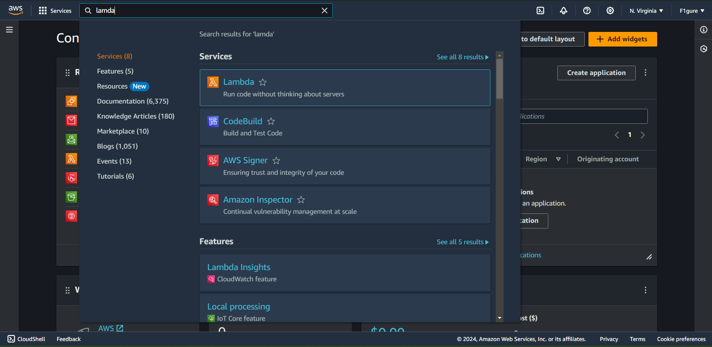

2.To proceed click on “**Create a function**”.

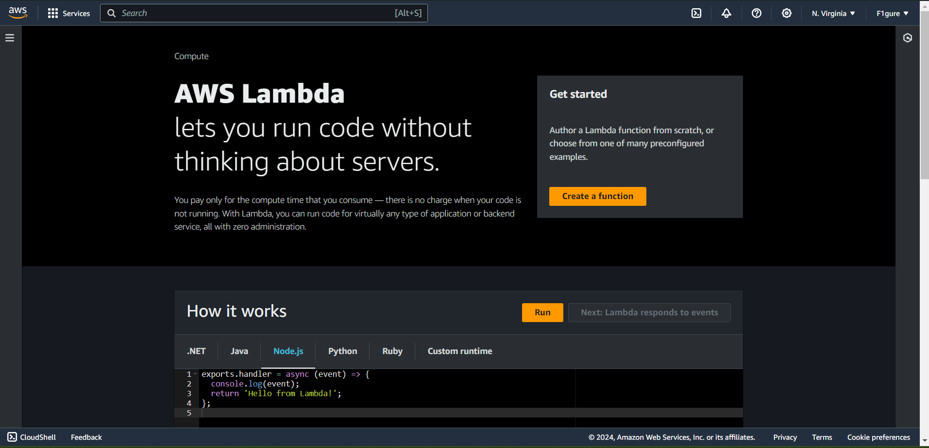

3. Please specify an appropriate function name, as "**func1**" is currently being used.

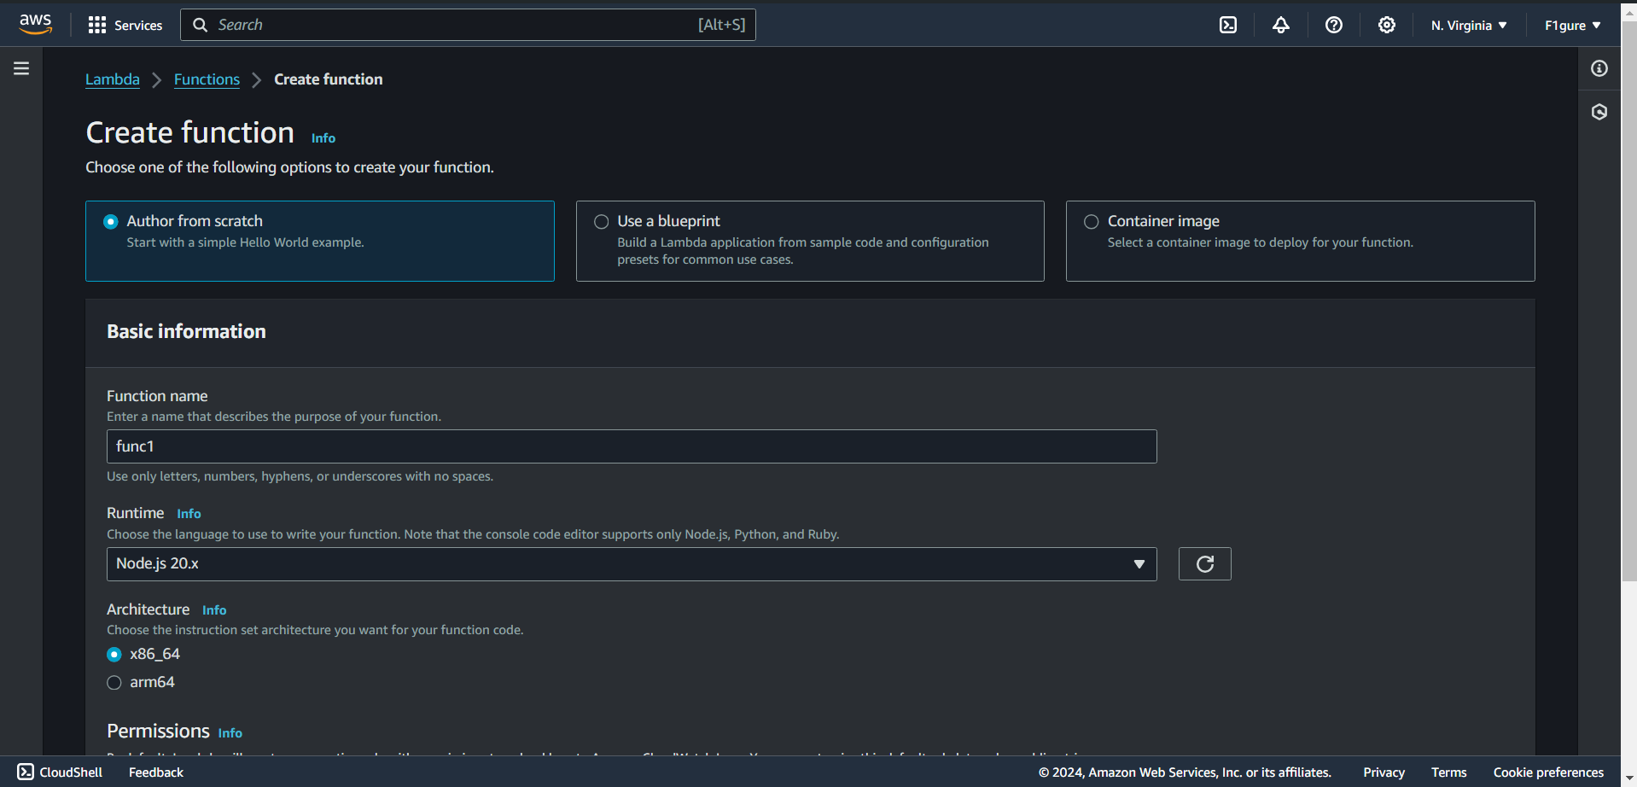

4. Without making any changes, proceed to click on "**Create function**" located at the bottom.

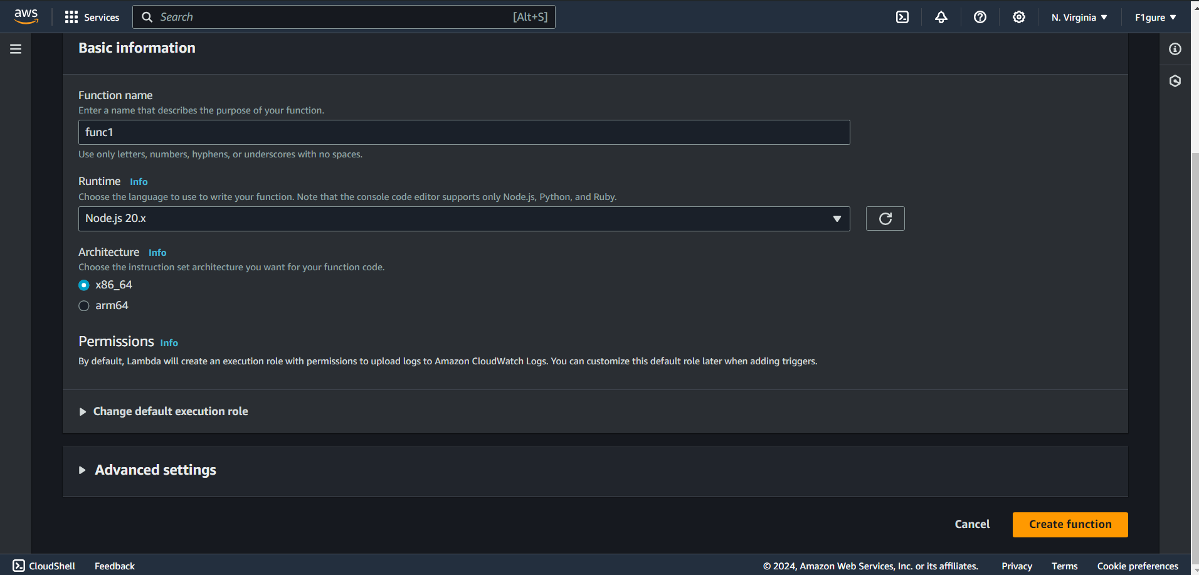

5. The function named "**func1"** has been successfully created.

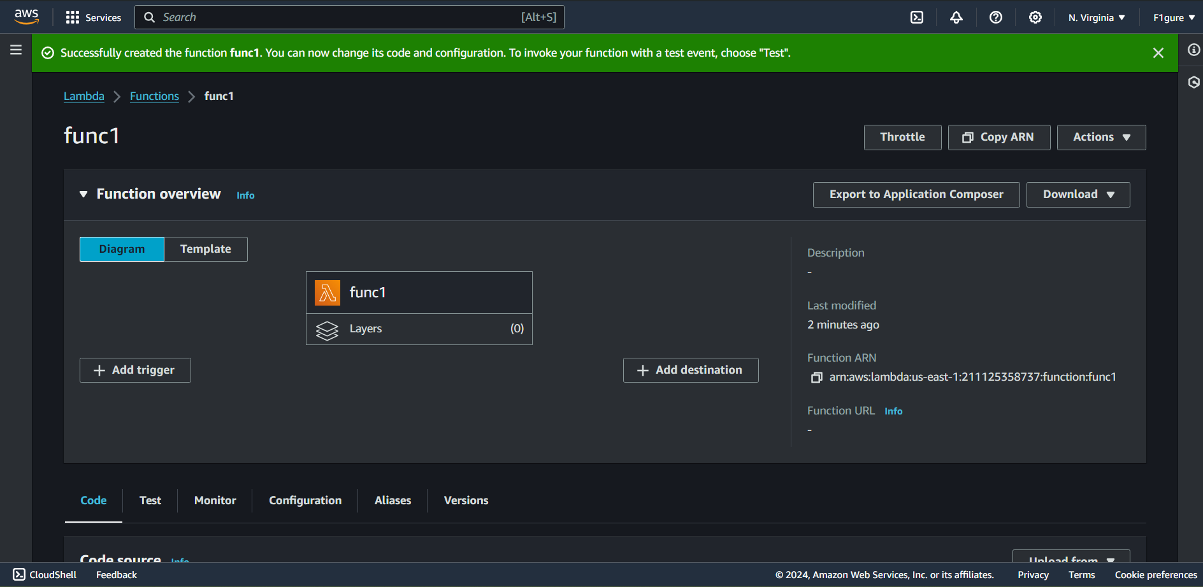

6. Next, scroll down to access the code section. Make the necessary modifications to the code, and then proceed to deploy it in order to save the changes.

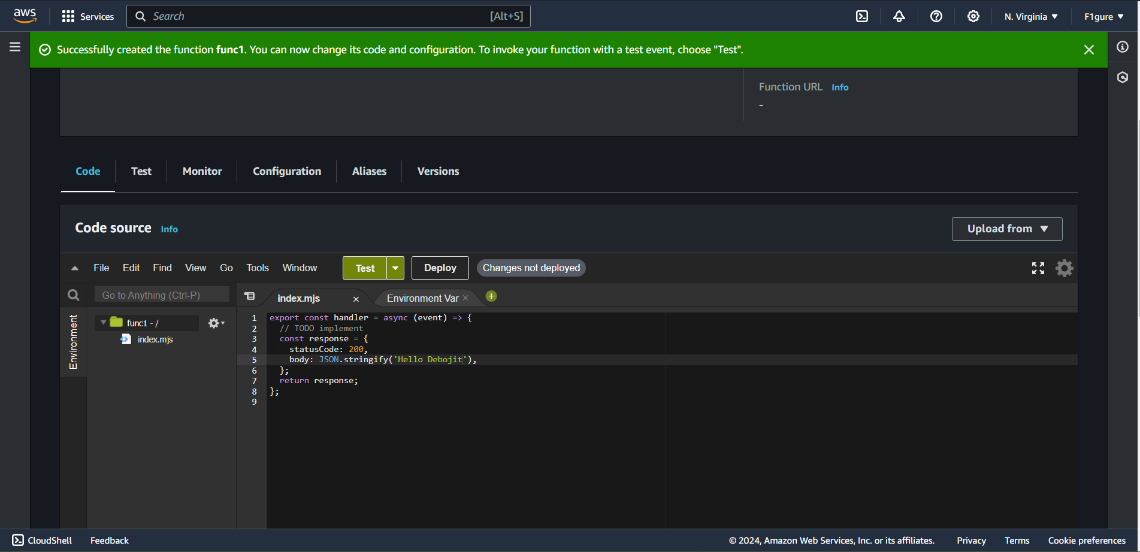

7. Navigate to the Test section, where you'll create an event. Give the event a name (for instance, "event1") and then select "Test" to proceed.

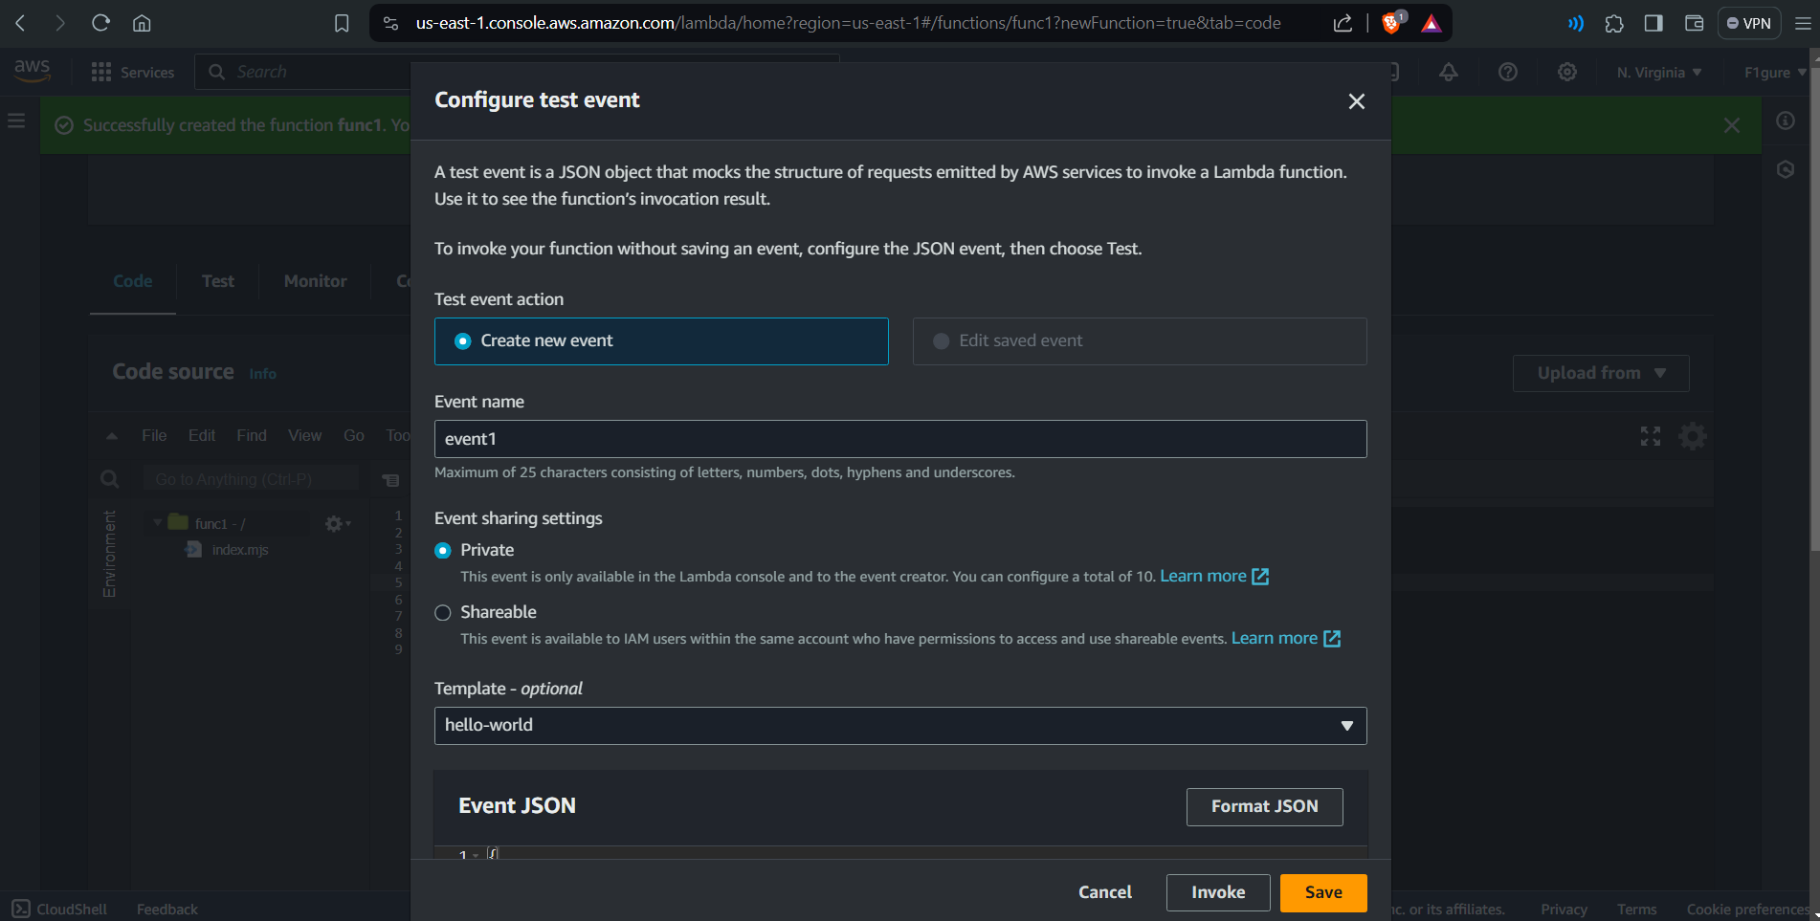

8. Access the configuration settings, and from the left panel, choose "**Function URL**." Proceed by selecting "**Create function URL**."

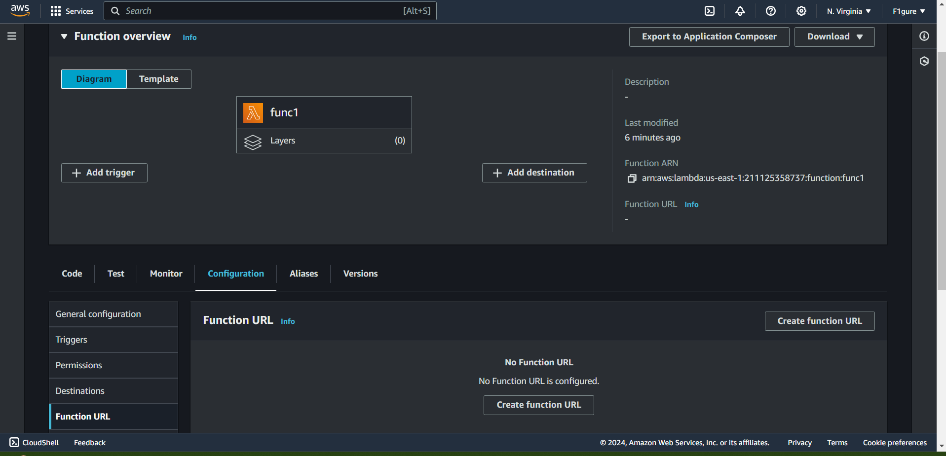

9.Choose “**None**” in the author type.

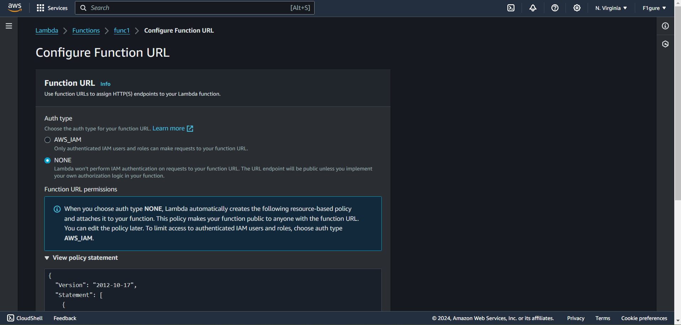

10.Proceed to click on “**Save**” button.

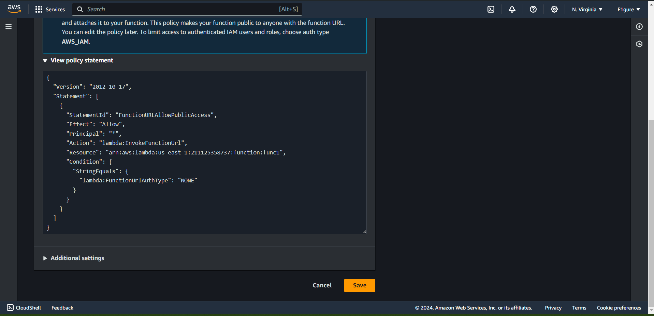

11. Click on the function URL that has been generated in the right pane.

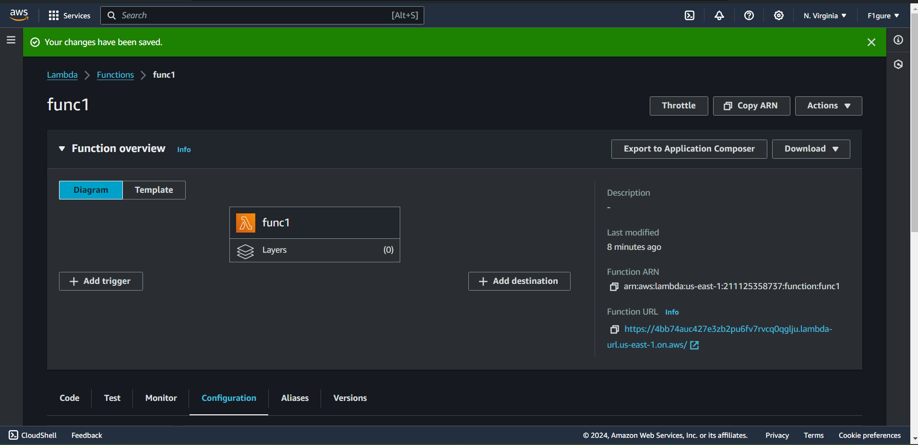

12.The subsequent window shows the output of the modified code.

