**Assignment No:10**

**Problem Statement: Deploy a project from EC2 by using new security group**.

The steps are as follows: -

1. Navigate to AWS and locate the EC2 service. Choose the first option listed under the EC2 services.

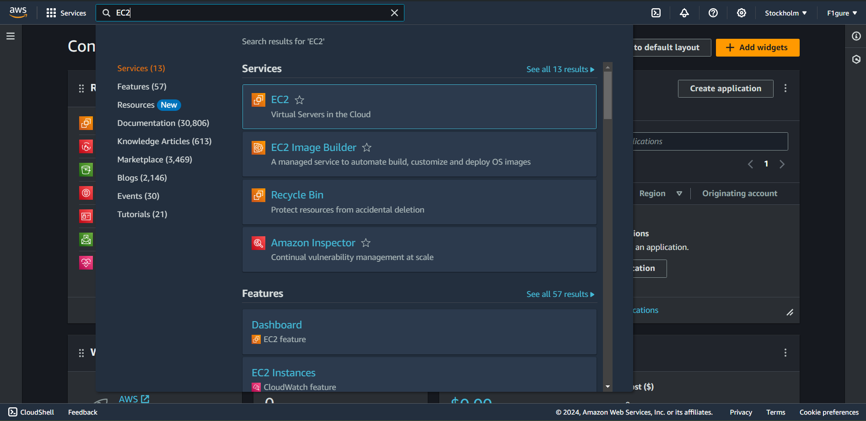

2. Select the "**Security group"** option.

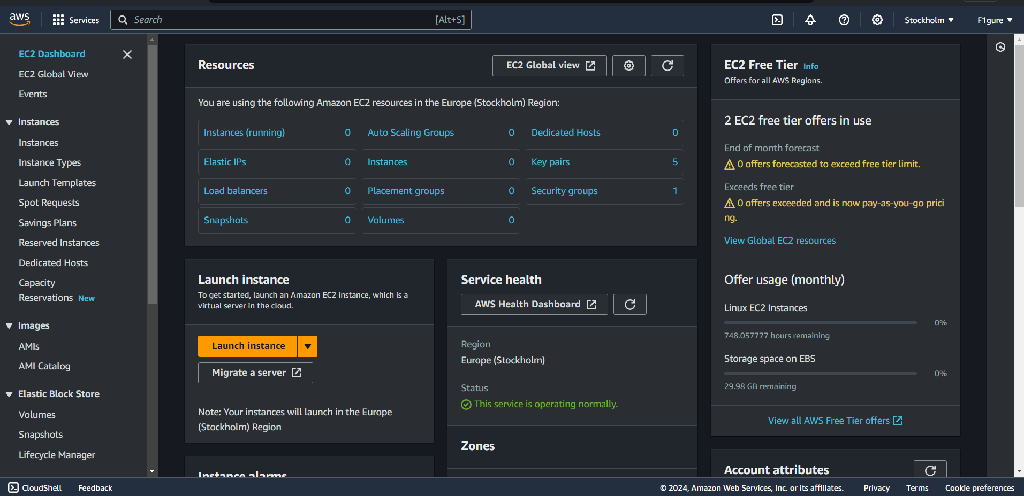

3.If there are any security groups other than the default, please delete them by clicking on **"Actions**" and then selecting "**Delete security group**." Since there are no additional security groups, we can proceed to the next step.

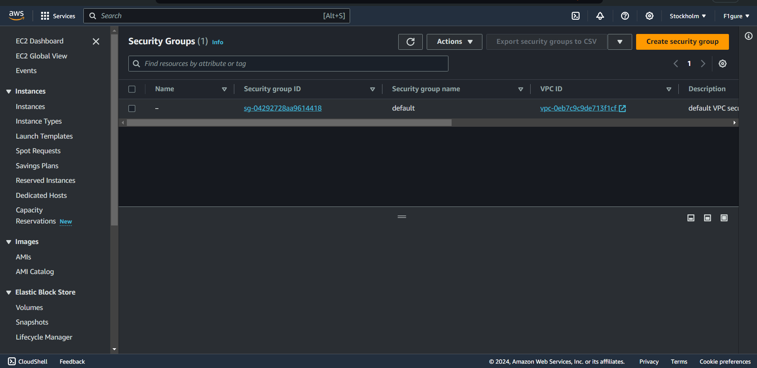

4.Now, select “**create security group”.**

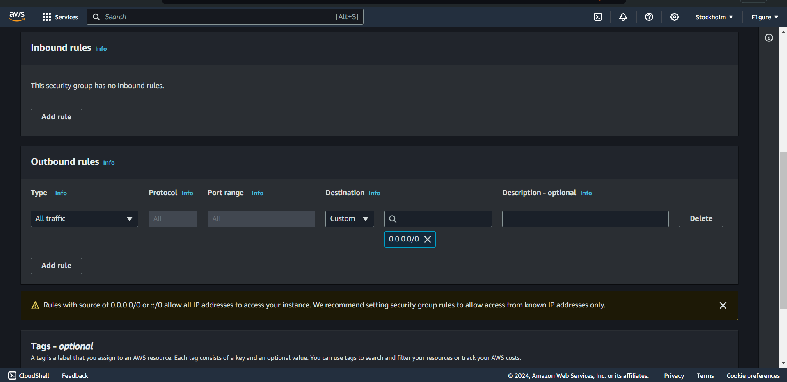

5. Choose an appropriate and valid name for the group (for instance, we've used "**debojitsecurity**" here). You can also copy the same name into the **'Description**' field, or provide any other relevant information.

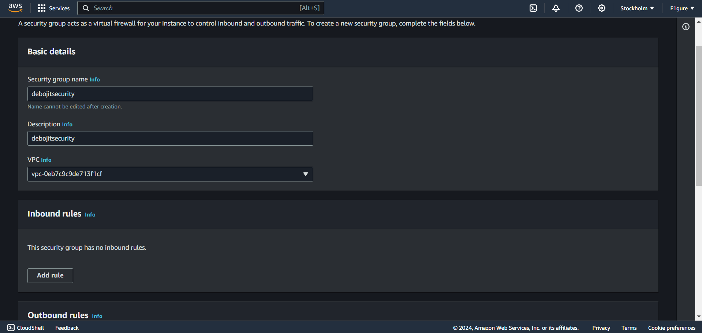

6. Within the **'Inbound rules'** section, select **'Add rule'**.

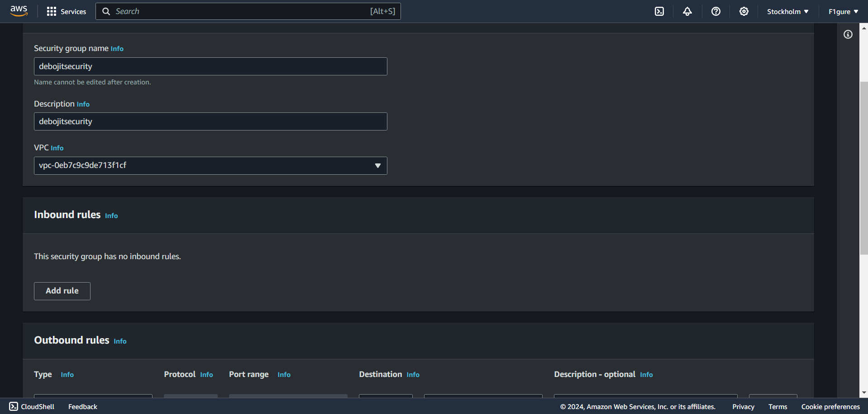

7. Since **'Custom TCP'** protocol is already chosen, input '**4000'** (as specified in the index.js) in the Port range field and select **'0.0.0.0/0'**.

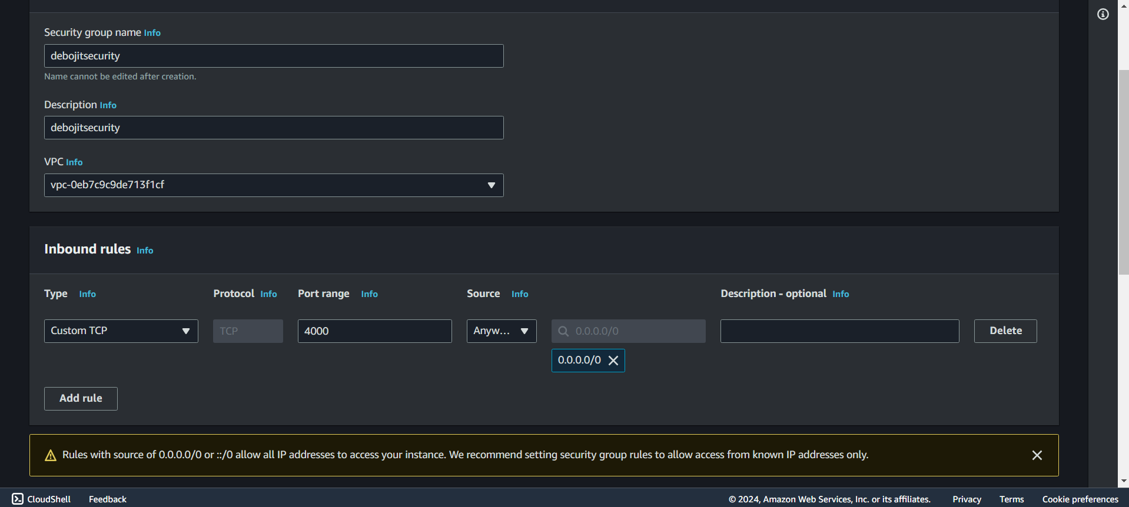

8. Next, include the three protocols **SSH, HTTP, and HTTPS** from the dropdown list. For each protocol, select **'0.0.0.0/0'** and add them as individual rules one by one.

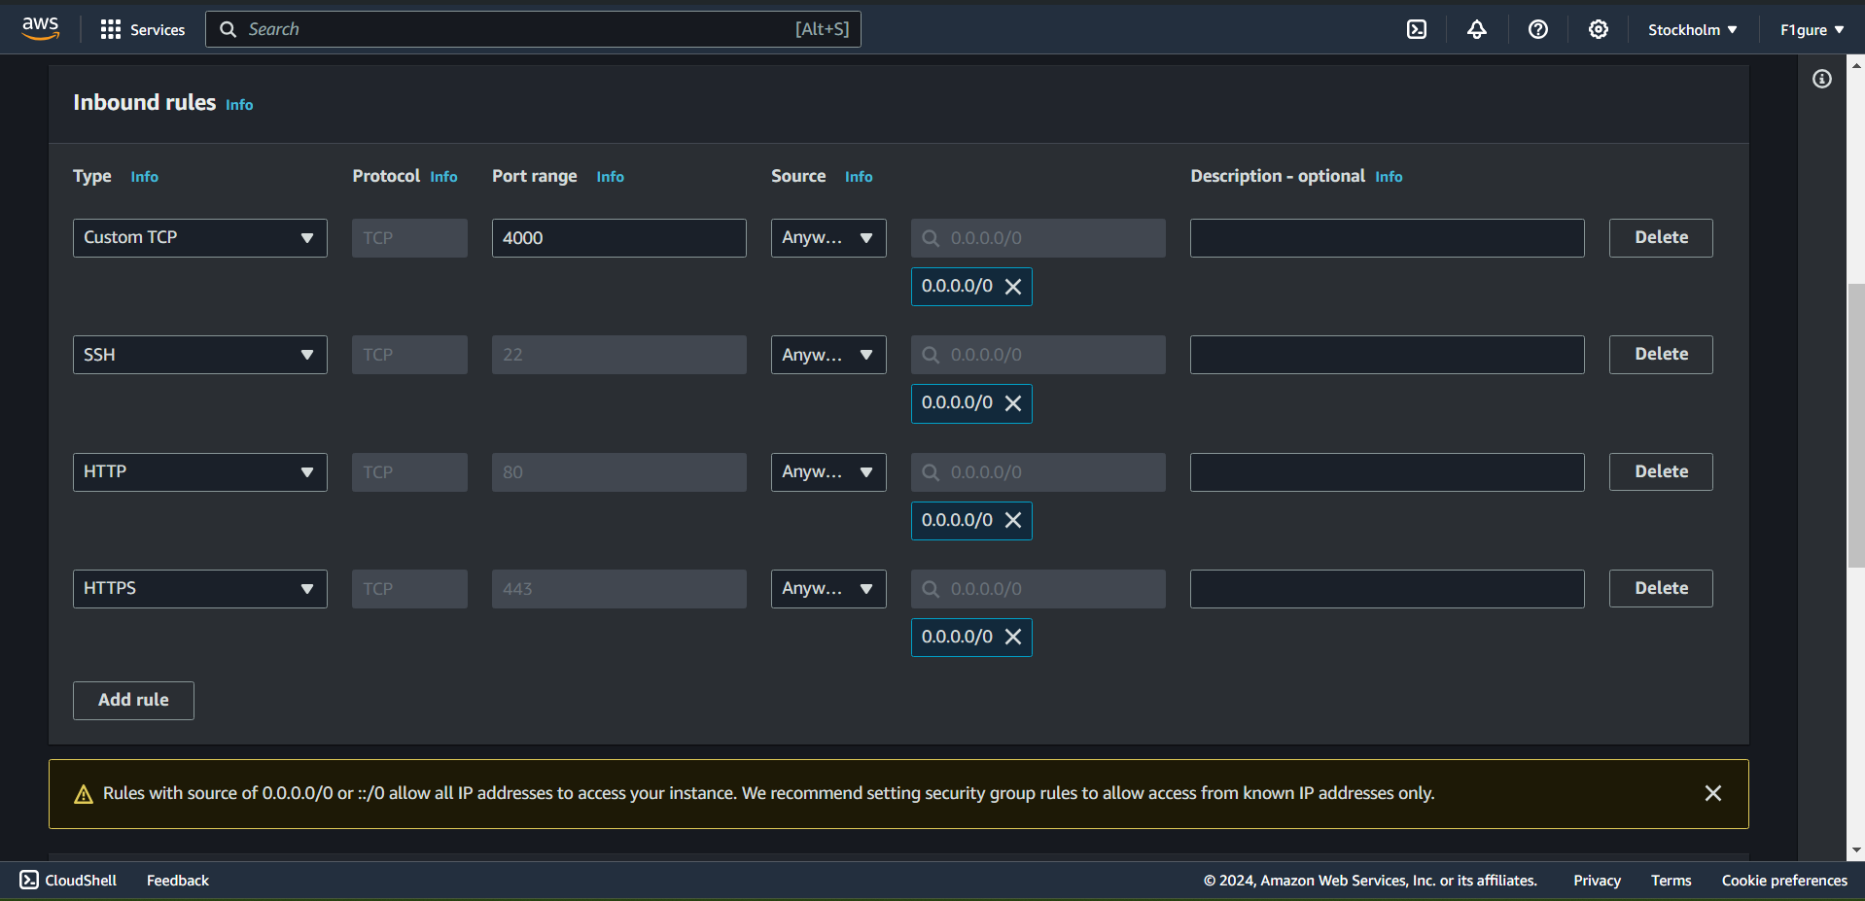

9. Scroll down without making any changes to the Outbound rules, then proceed to click on "**Create security group**".

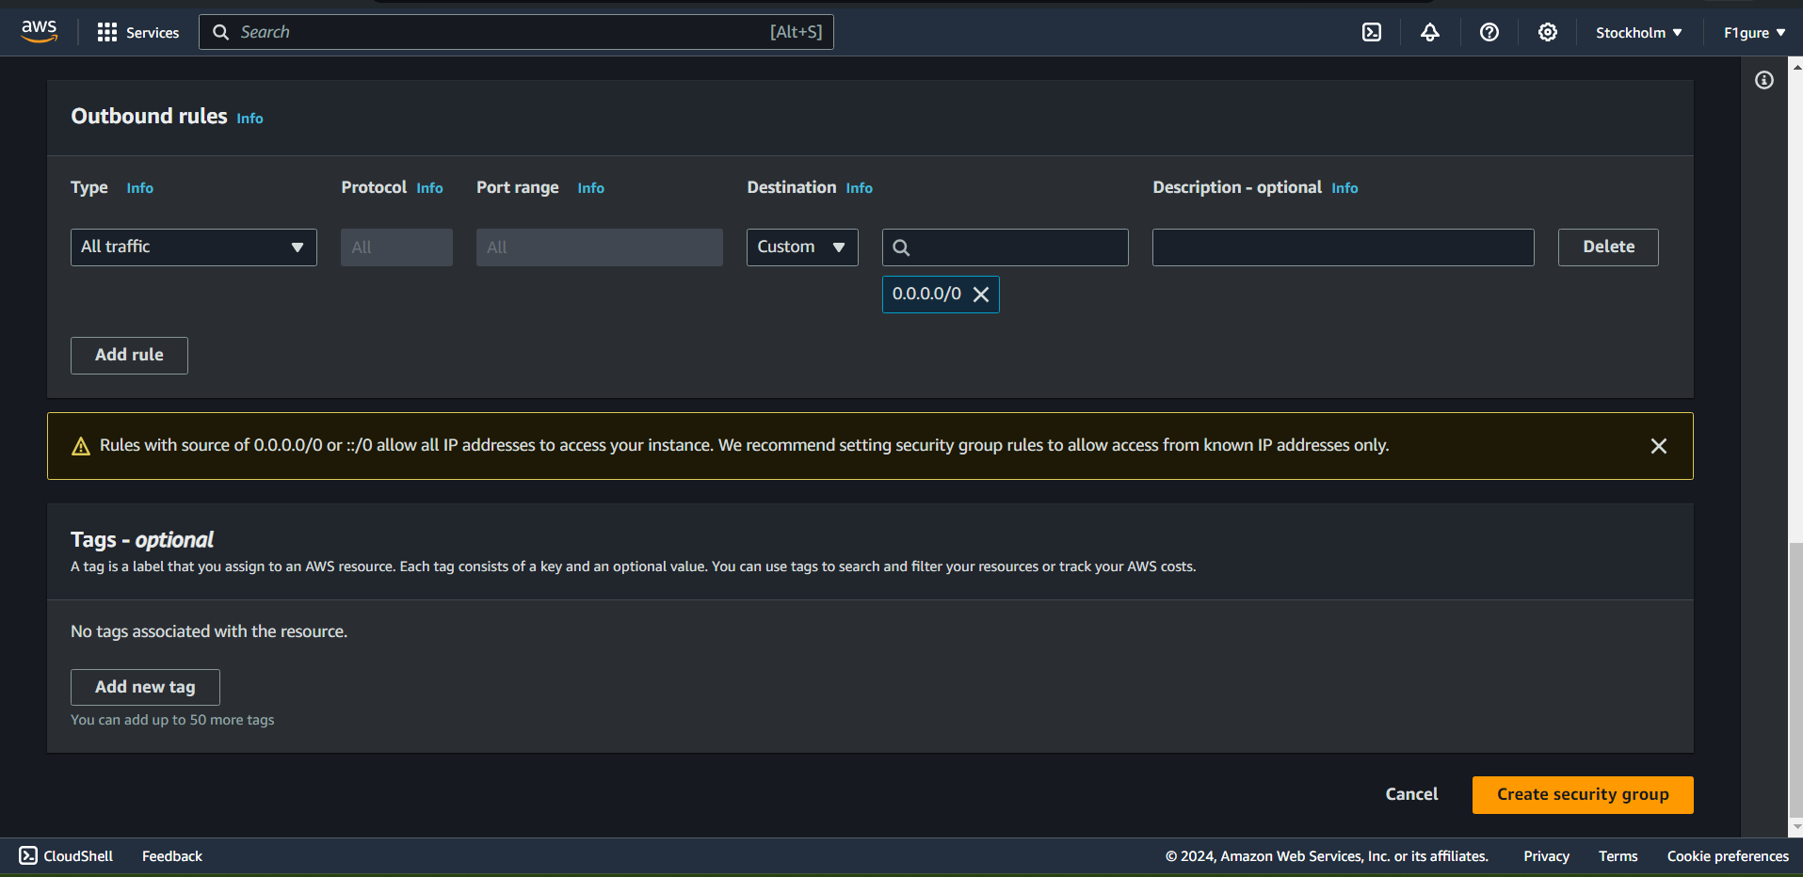

10.The security group is created successfully.

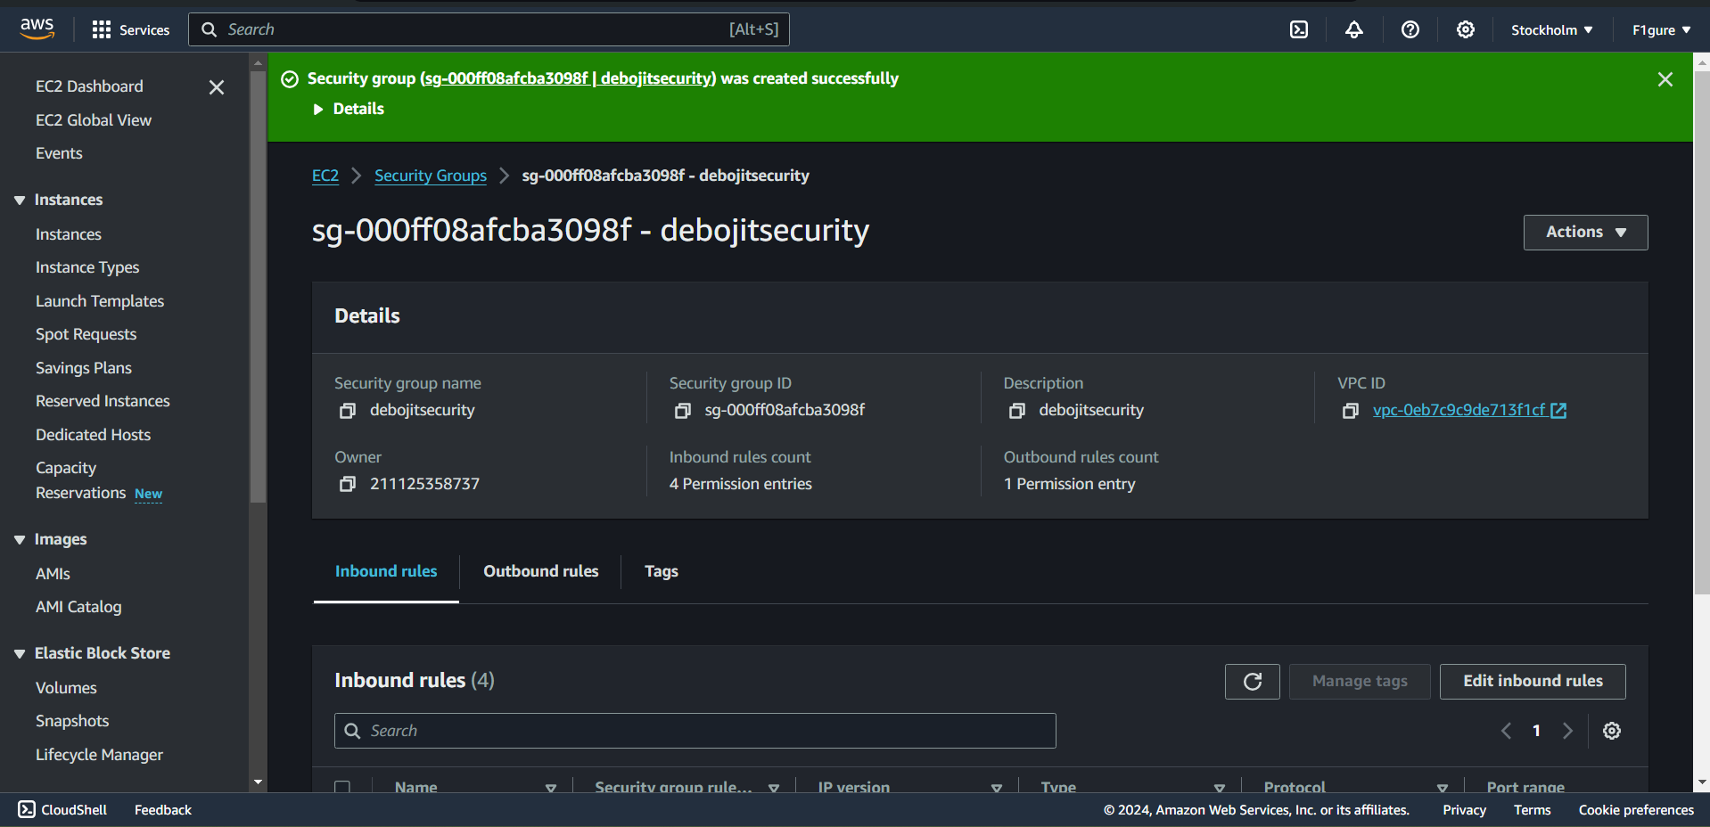

11. Return to the "**EC2 dashboard**" and select "**Launch Instance**".

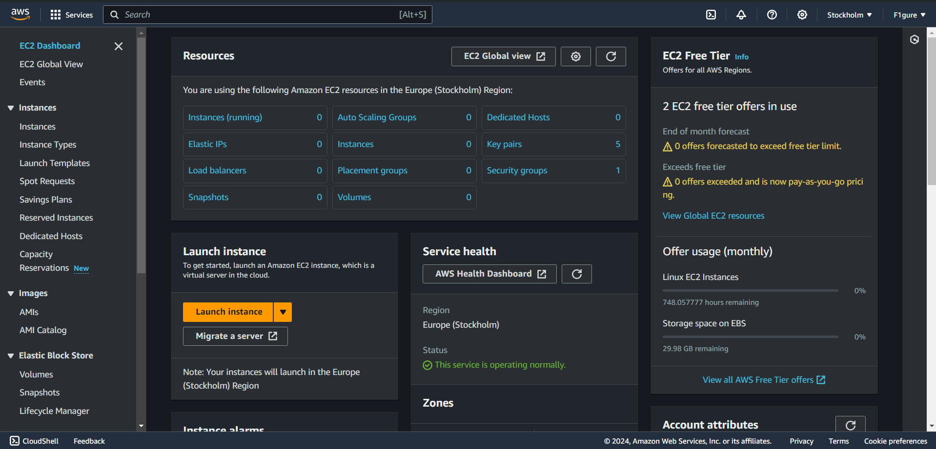

12. Enter a suitable and valid name for the instance (for instance, "**debec2**" in this example).

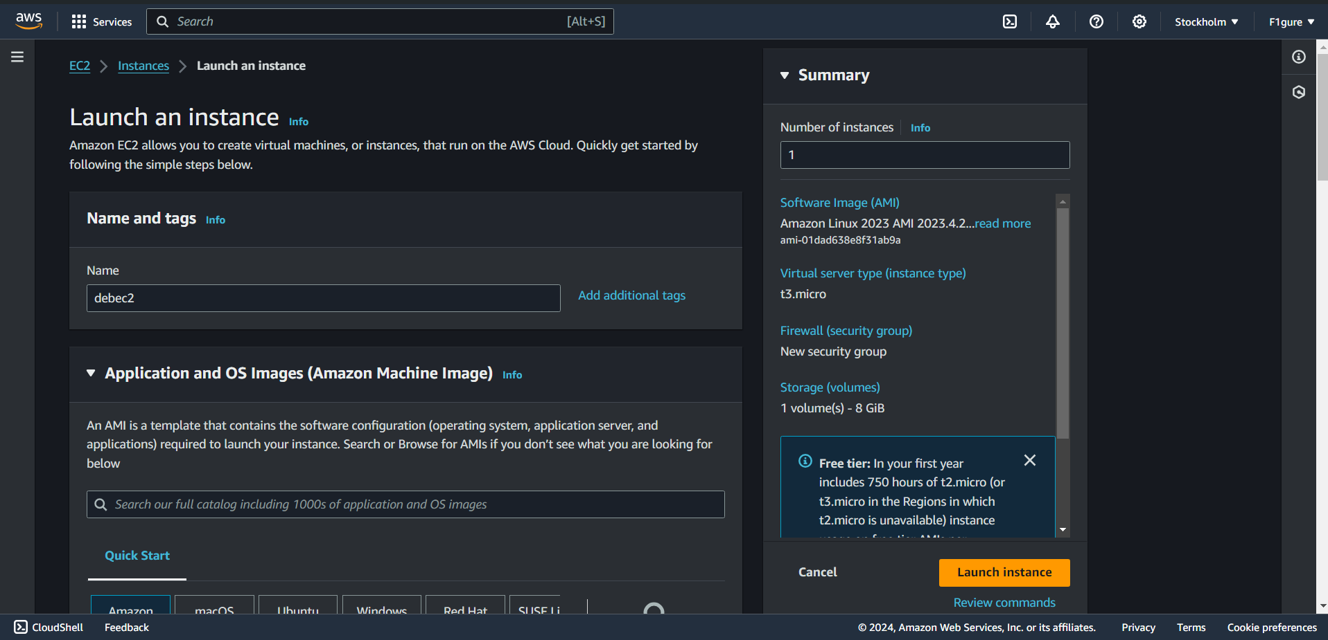

13.Choose "**Ubuntu**" as the AMI from the available options.

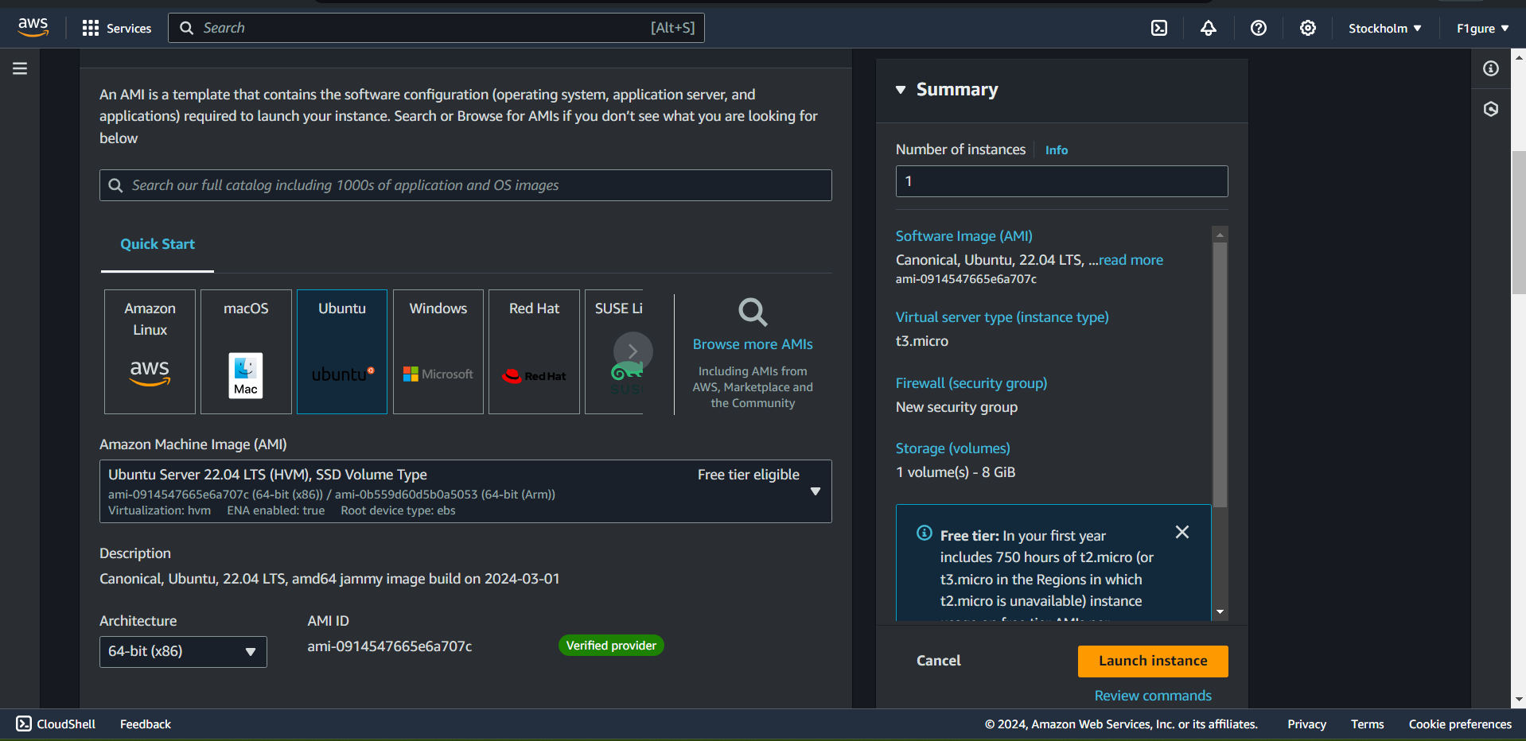

14. Choose an existing key pair, or alternatively, create a new key pair if necessary. In this case, the existing key pair named "**newkey1**" is utilized.

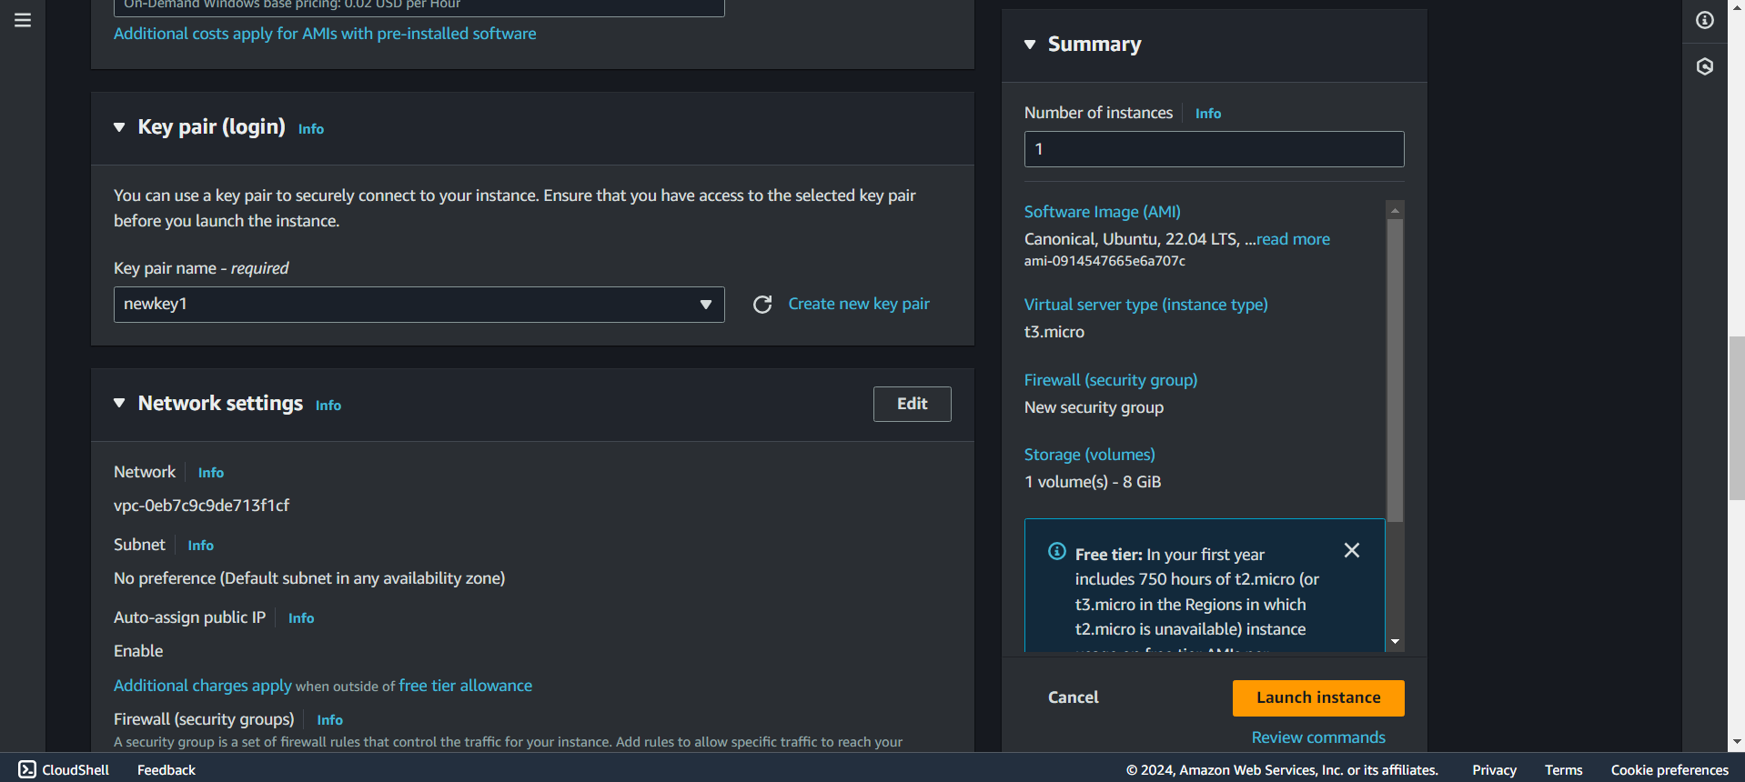

15. Next, click on the "**Select existing security group**" option. From the dropdown menu, choose the existing security group that was created as outlined in the previous steps.

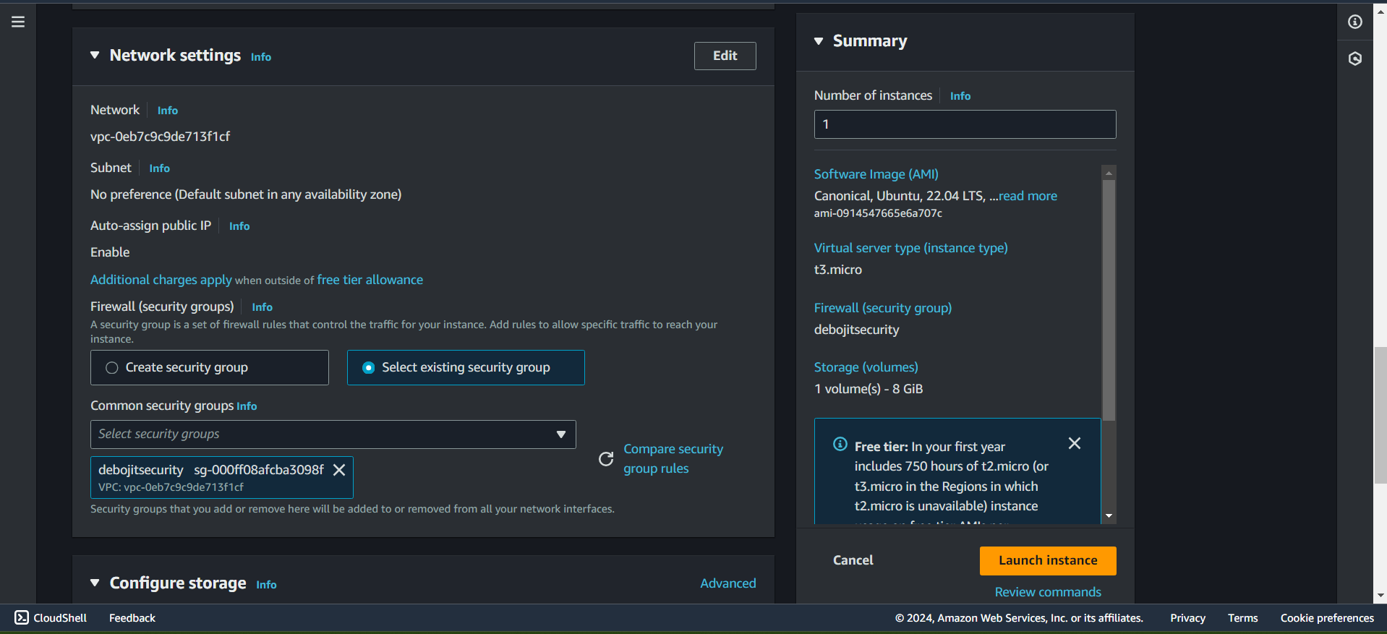

16. Select the dropdown menu for "**Advanced details**".

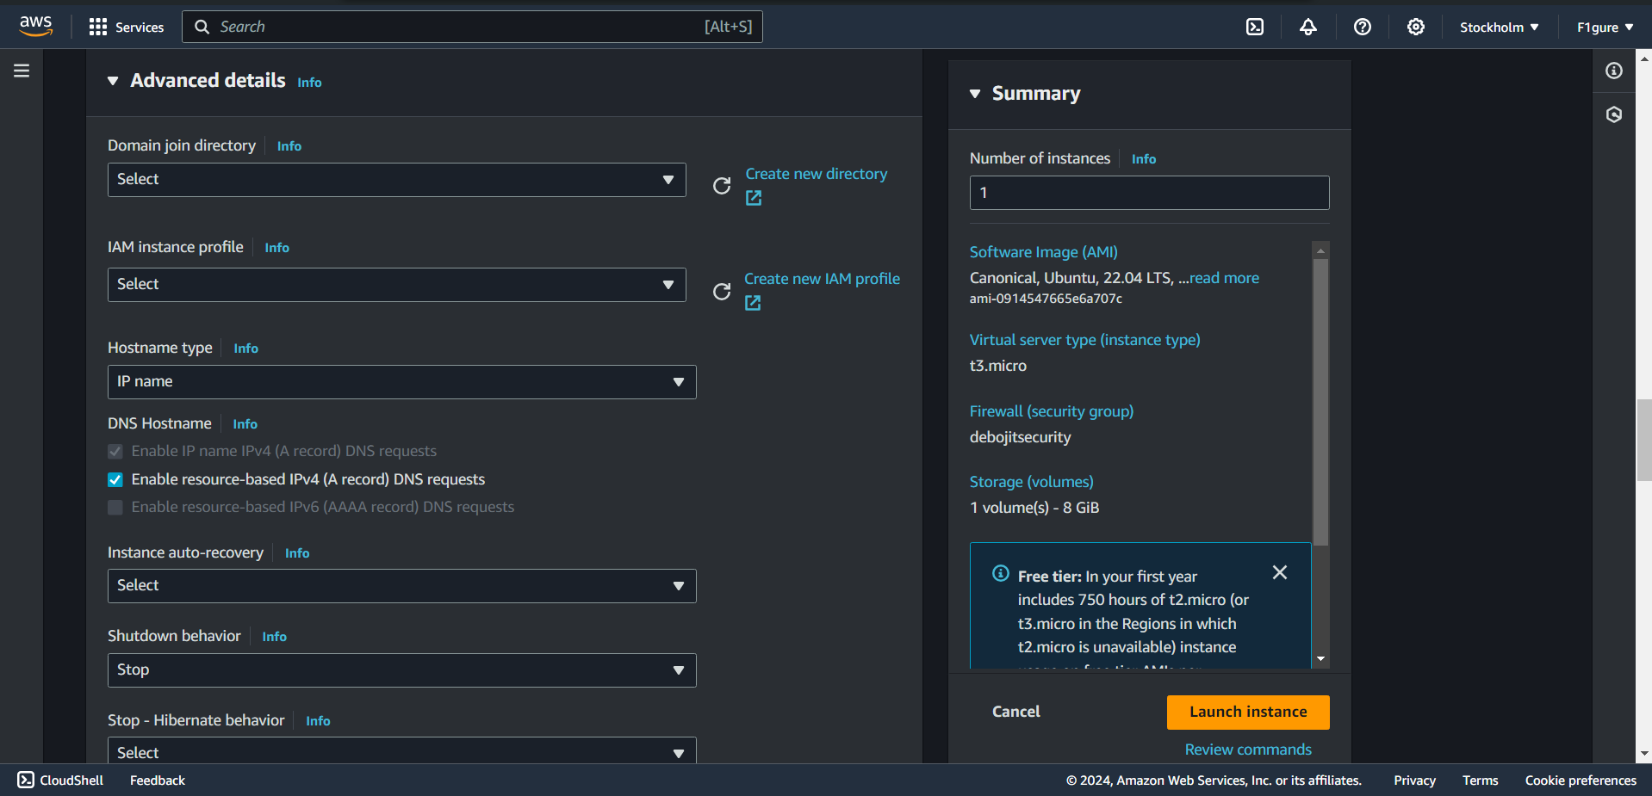

17. Scroll down and navigate to the user-data editor.

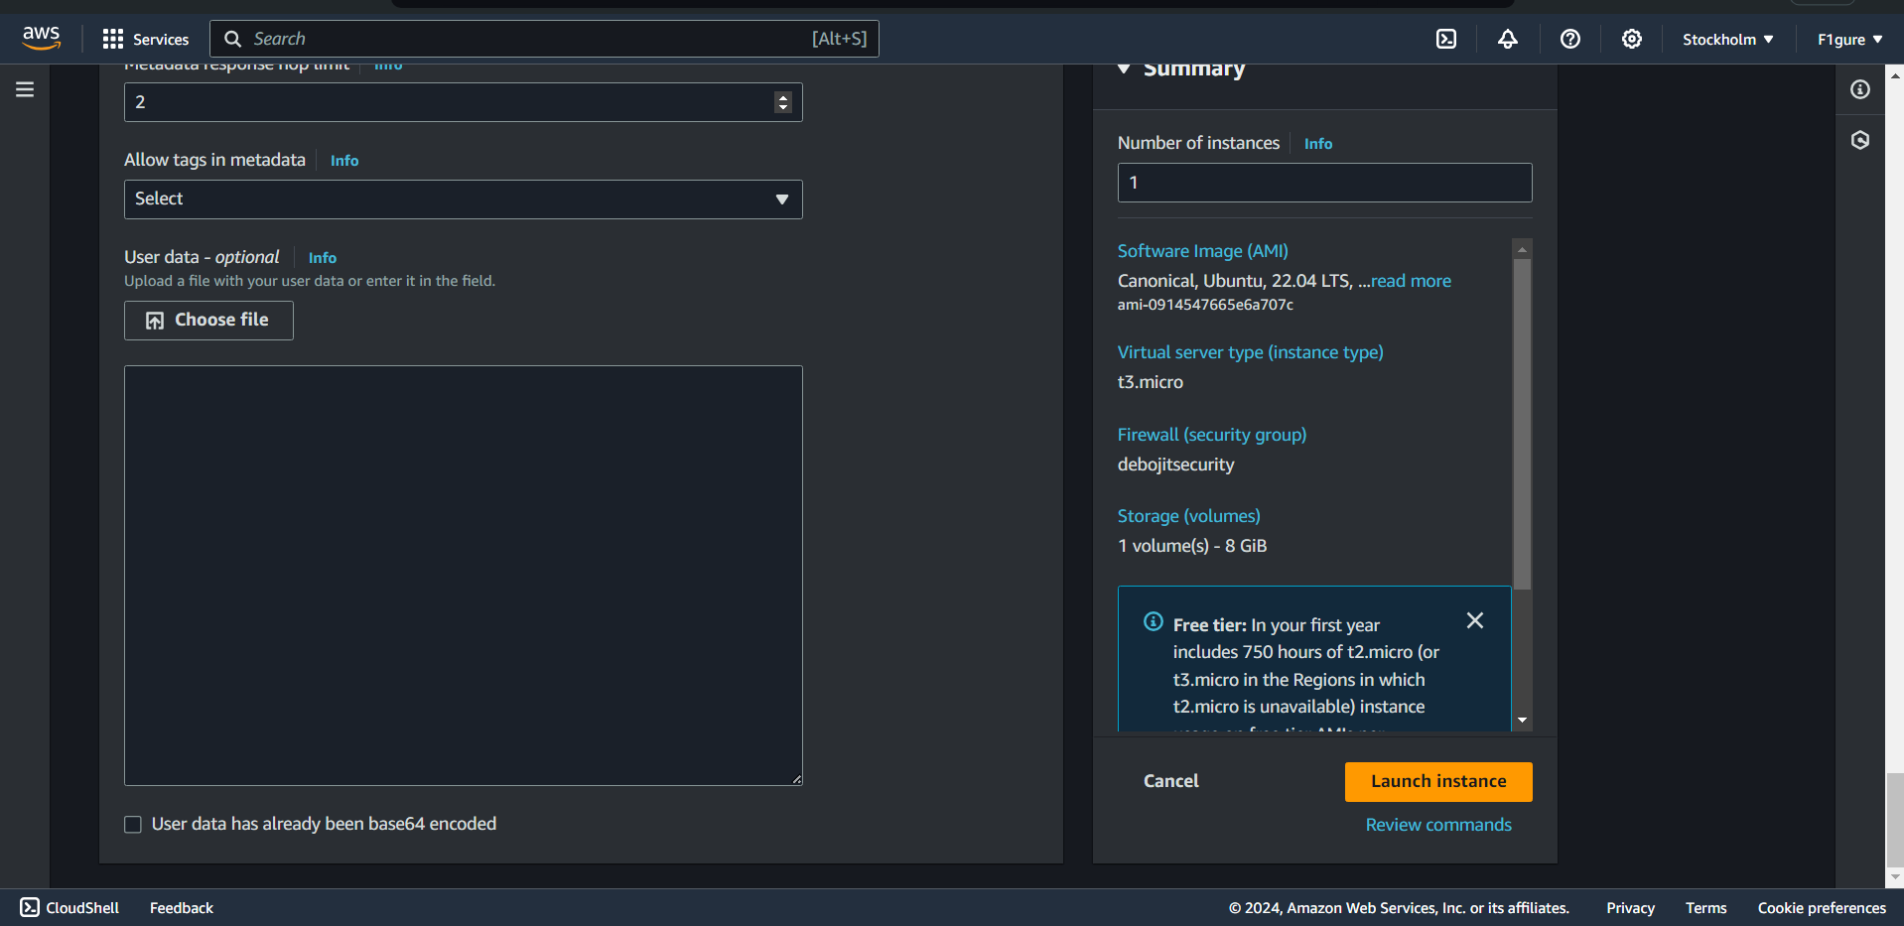

18. Enter the following commands in the editor space as displayed in the subsequent window to establish a connection from the client to the server (without utilizing Bitvise SSH Client). Then, proceed to click on "**launch instance**".

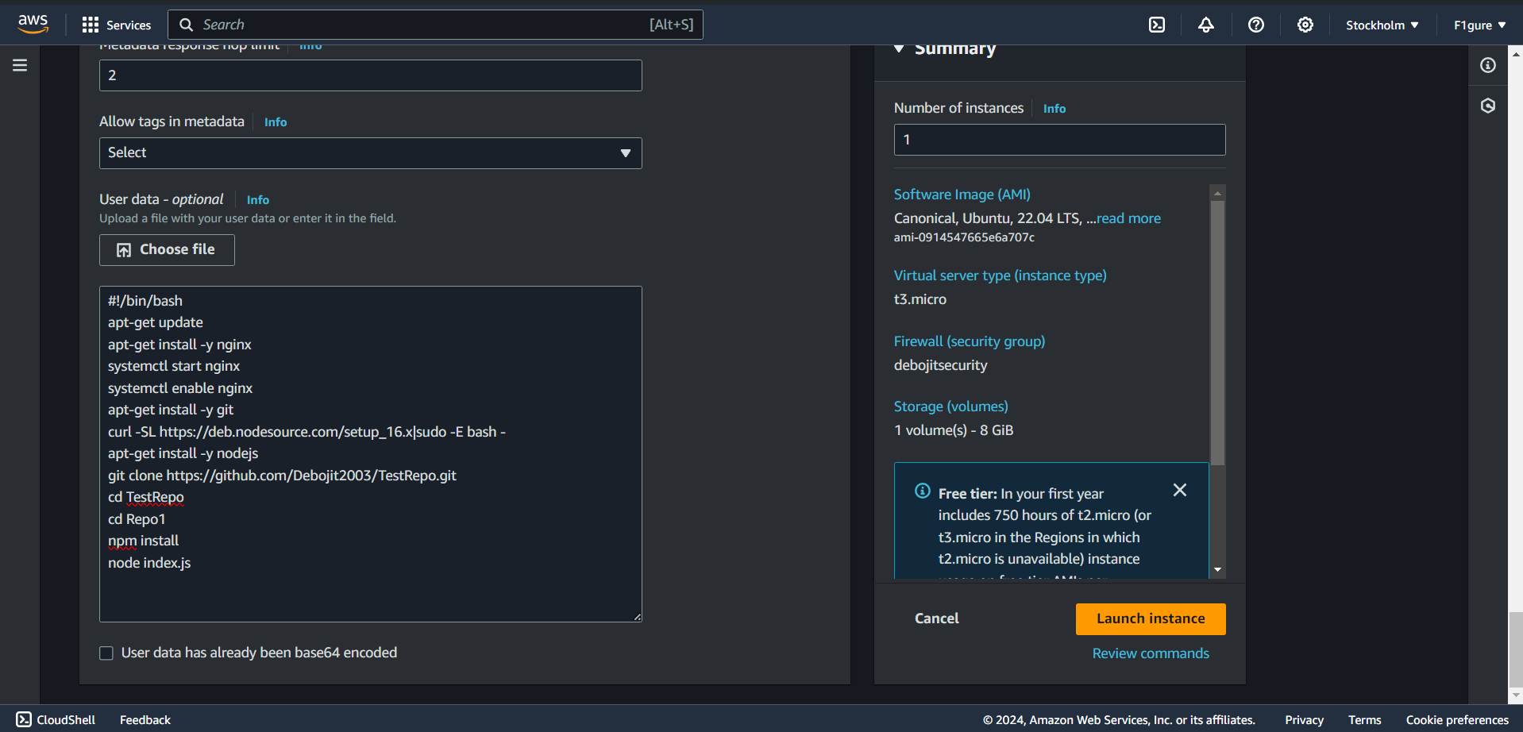

[**Remember: Access your GitHub account and navigate to the repository containing the Index.js file. Copy the repository's path to clone the project.**].

19. The instance has been successfully created utilizing the existing security group.

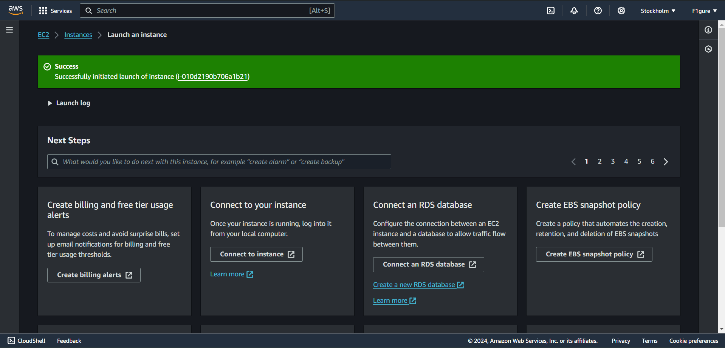

20.Scroll down and click on “**view all instances**”.

21. Select the instance ID of the newly created instance.

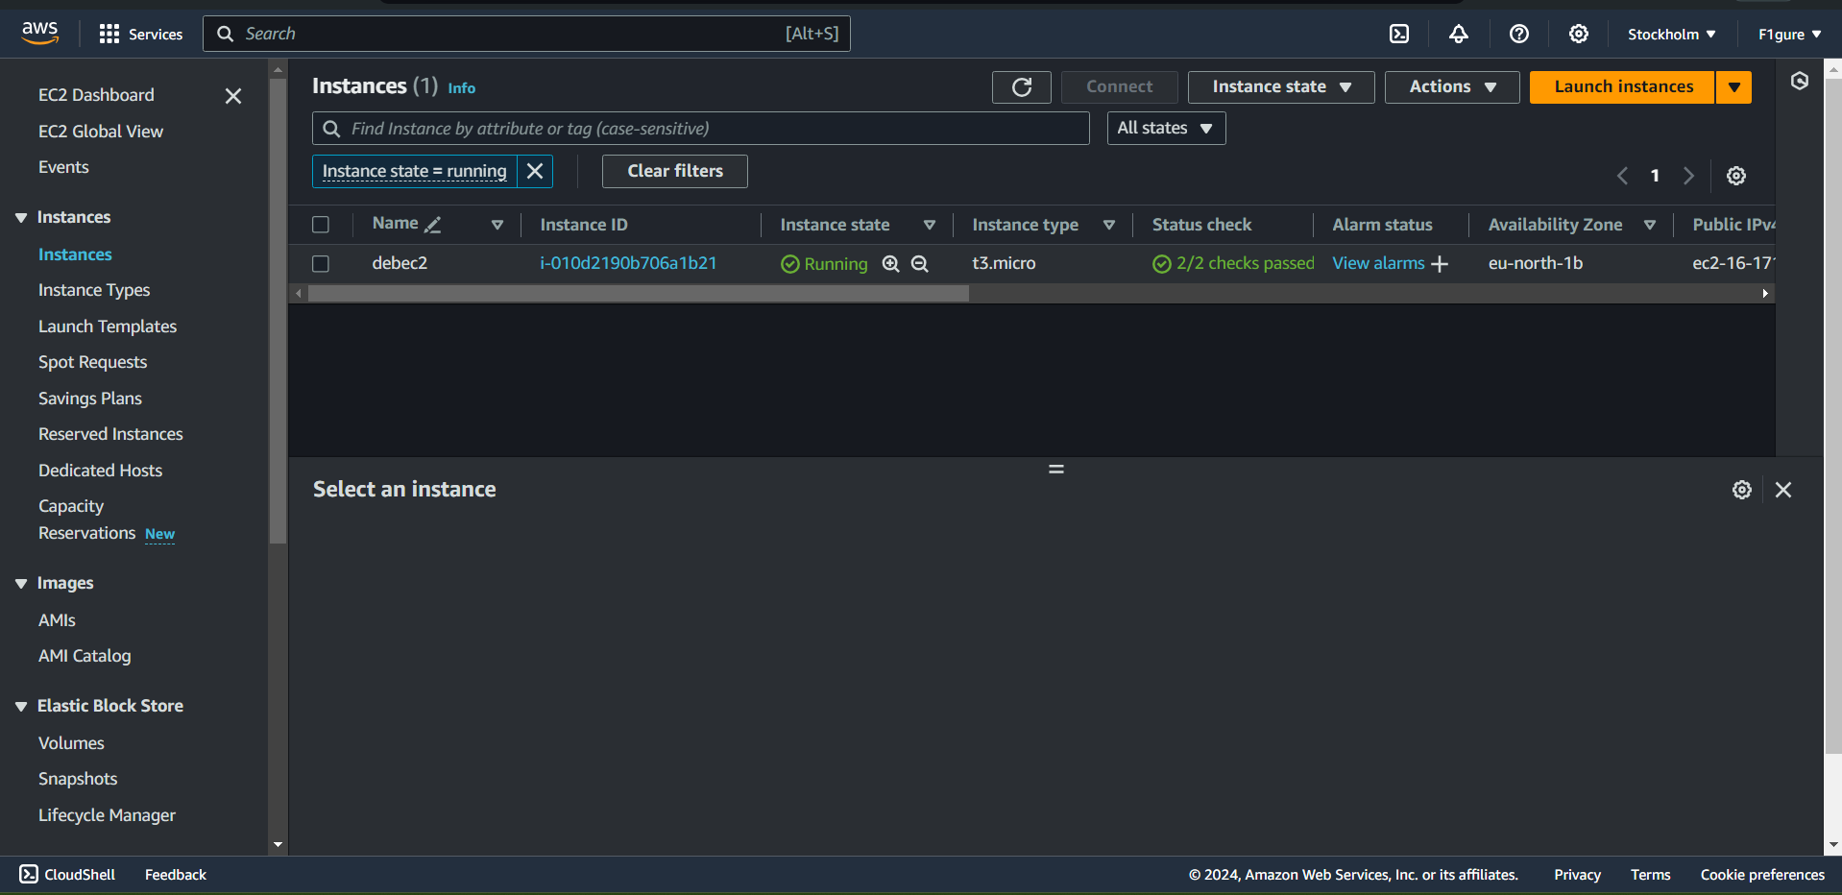

22.Copy the **Public IPv4 address.**

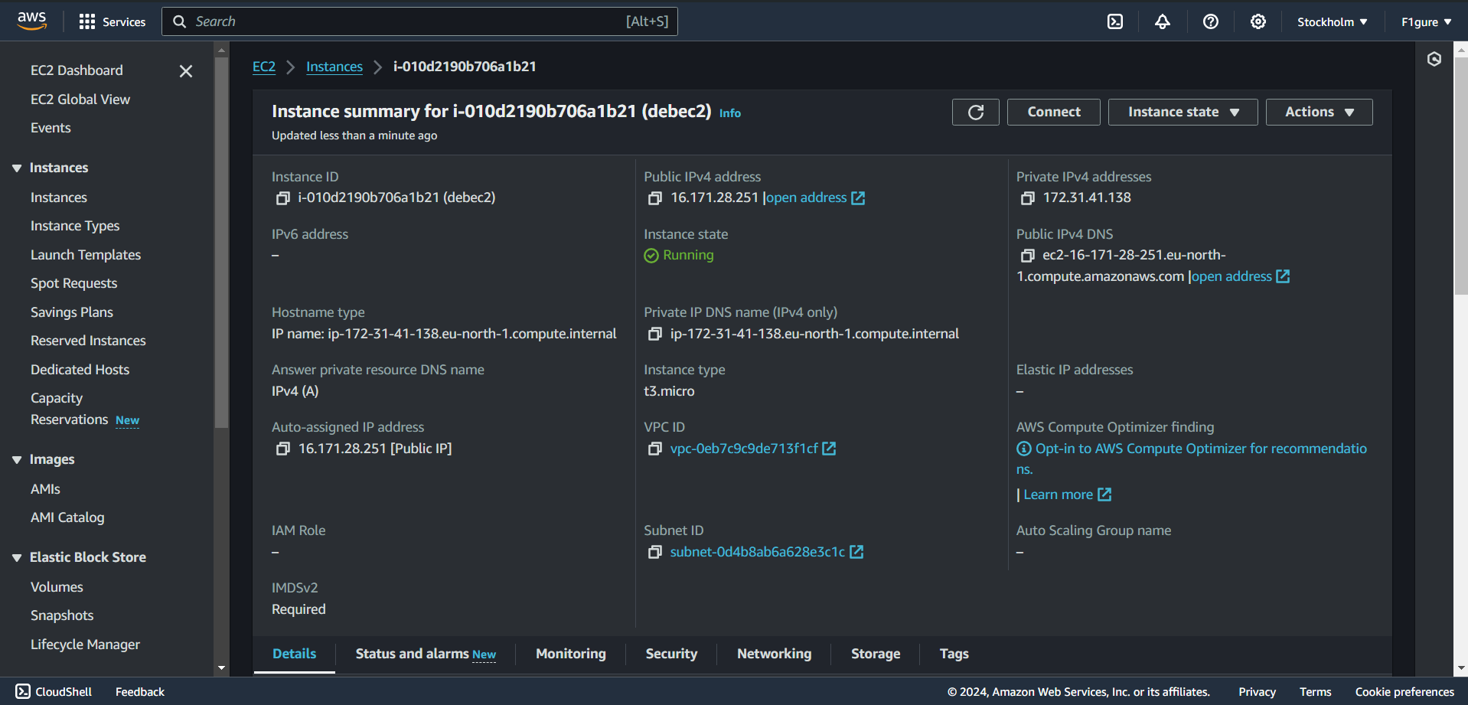

23. Paste the address into a new tab in your browser. The window should display "**Welcome to nginx server**".

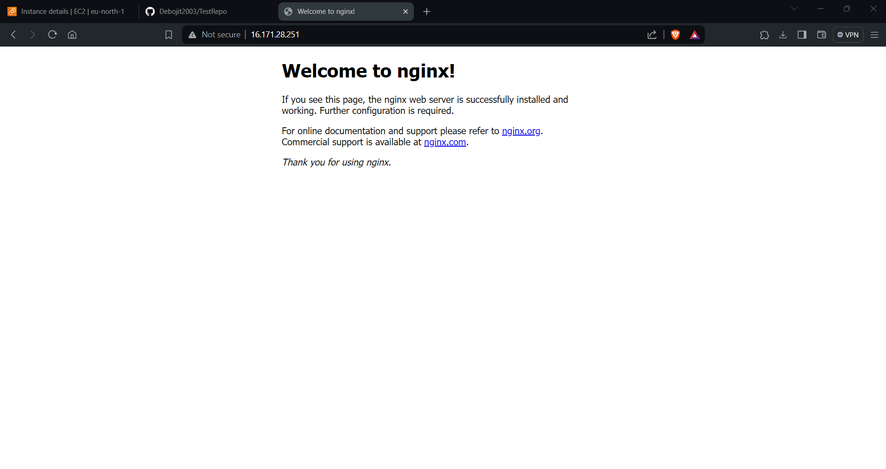

24.Now, append a colon followed by 4000 after the Public IPv4 address.

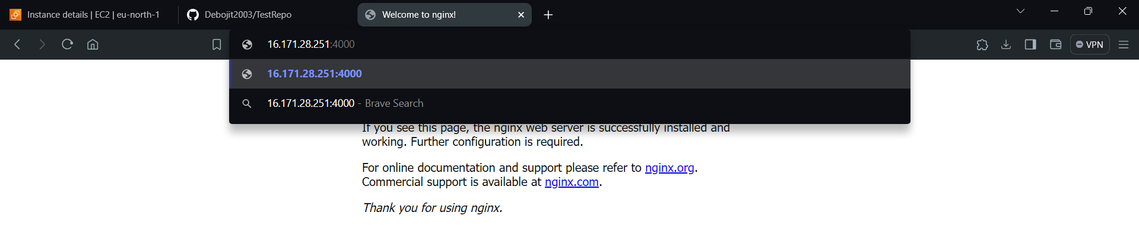

25.The subsequent window shows up.

