**Assignment No: -13**

**Problem statement: Create a workmail for your organization.**

The step are as follows: -

1. Navigate to the AWS console and locate the **"Work Mail**" service. Click on the first option that appears in the search results.

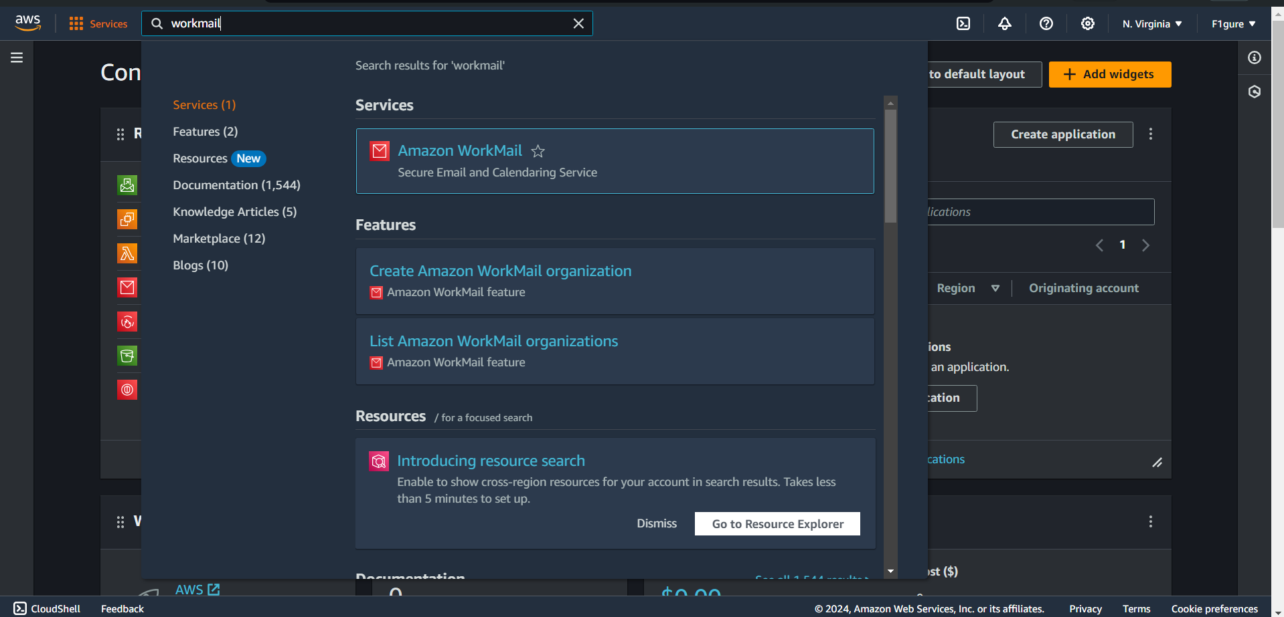

2. Choose a region from the list of supported regions. For this example, select "**US East (N. Virginia)".**

3.Click on “**Create organization**”.

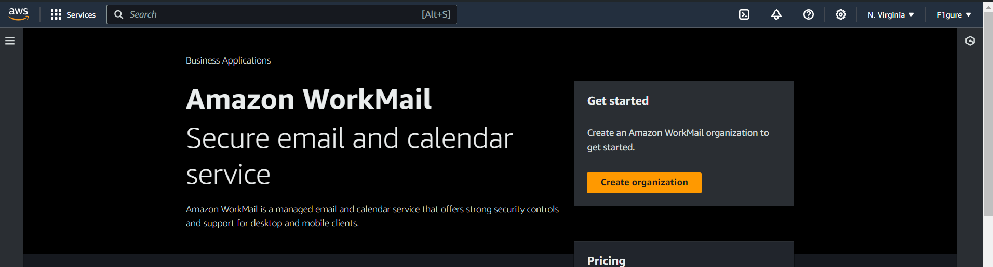

4. Select the "**Free test domain**" option from the available email domains. Then, enter an organization name, such as "**hotdawg**"

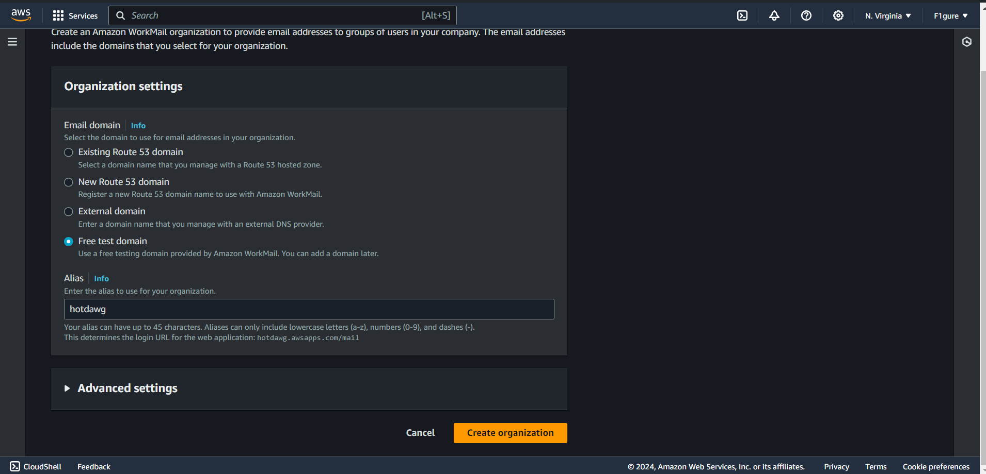

5. Once the organization is successfully created, click on the organization name.

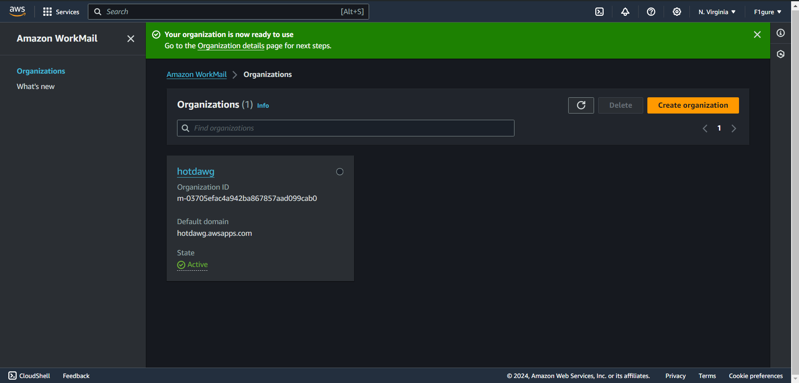

6. From the left pane, navigate to "**Users**" under the Organization category.

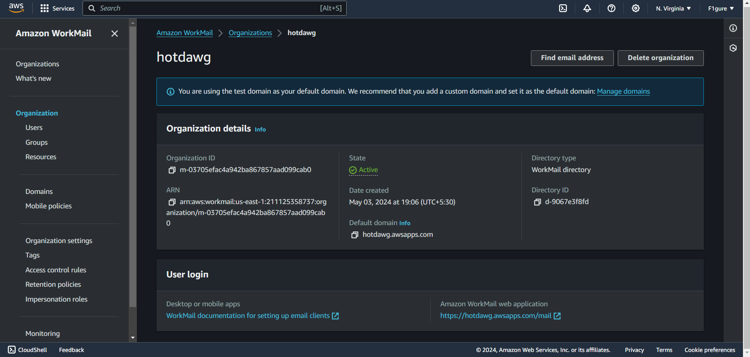

7.Then proceed to click on “**Add user**”.

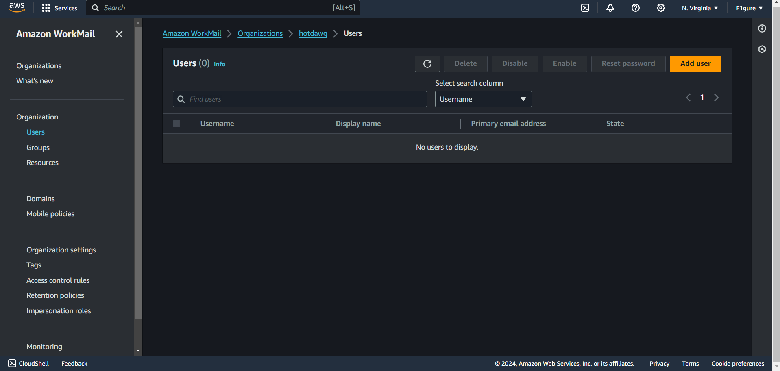

8. Enter the username, first name, and last name in their respective fields. The display name will be generated automatically.

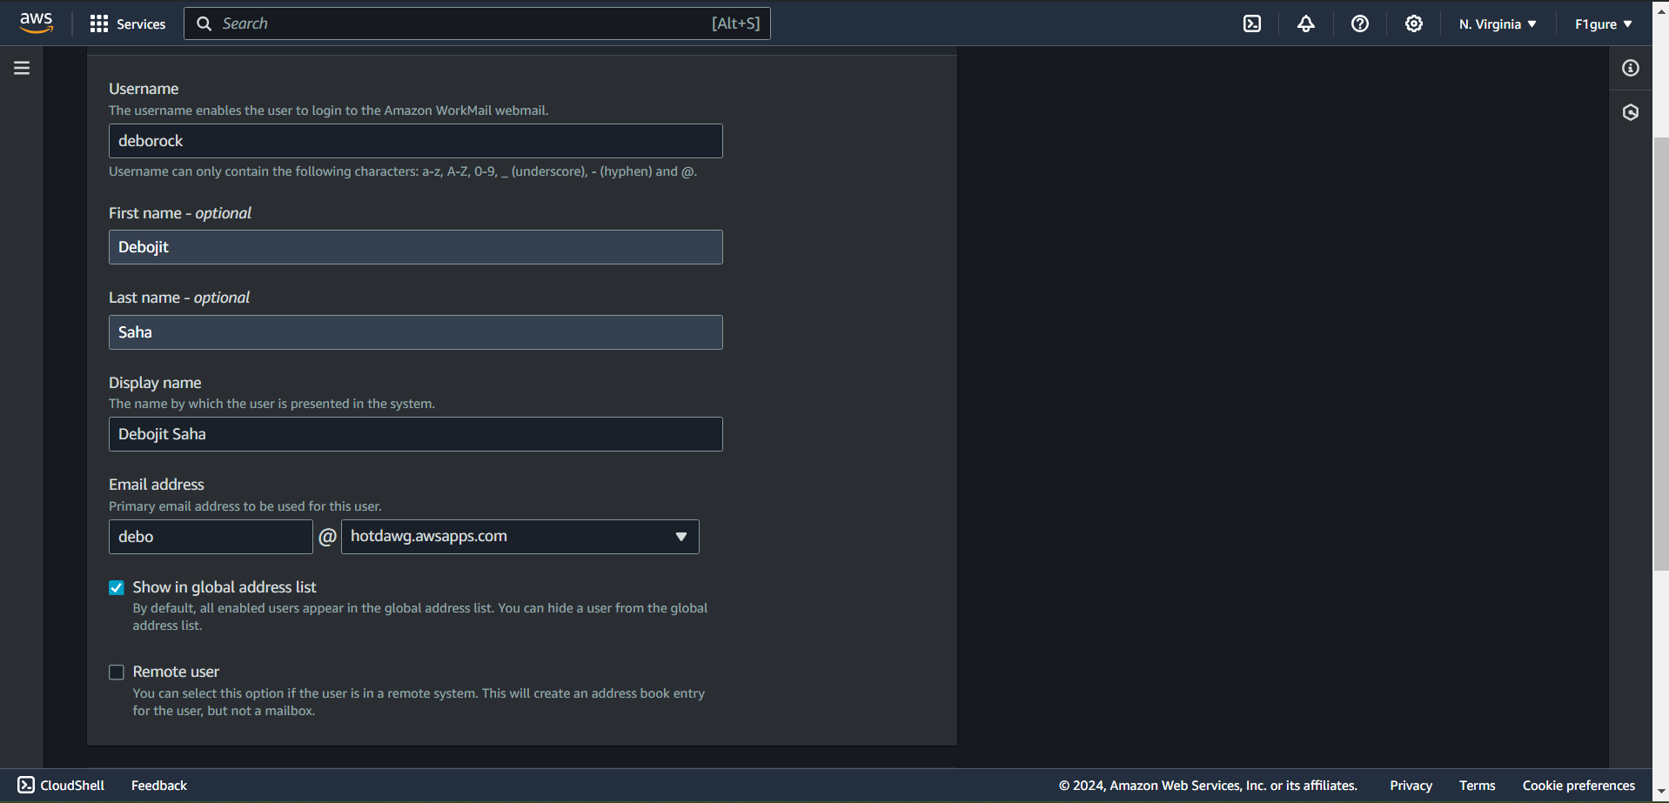

9. Next, set a password for the WorkMail account according to the provided guidelines.

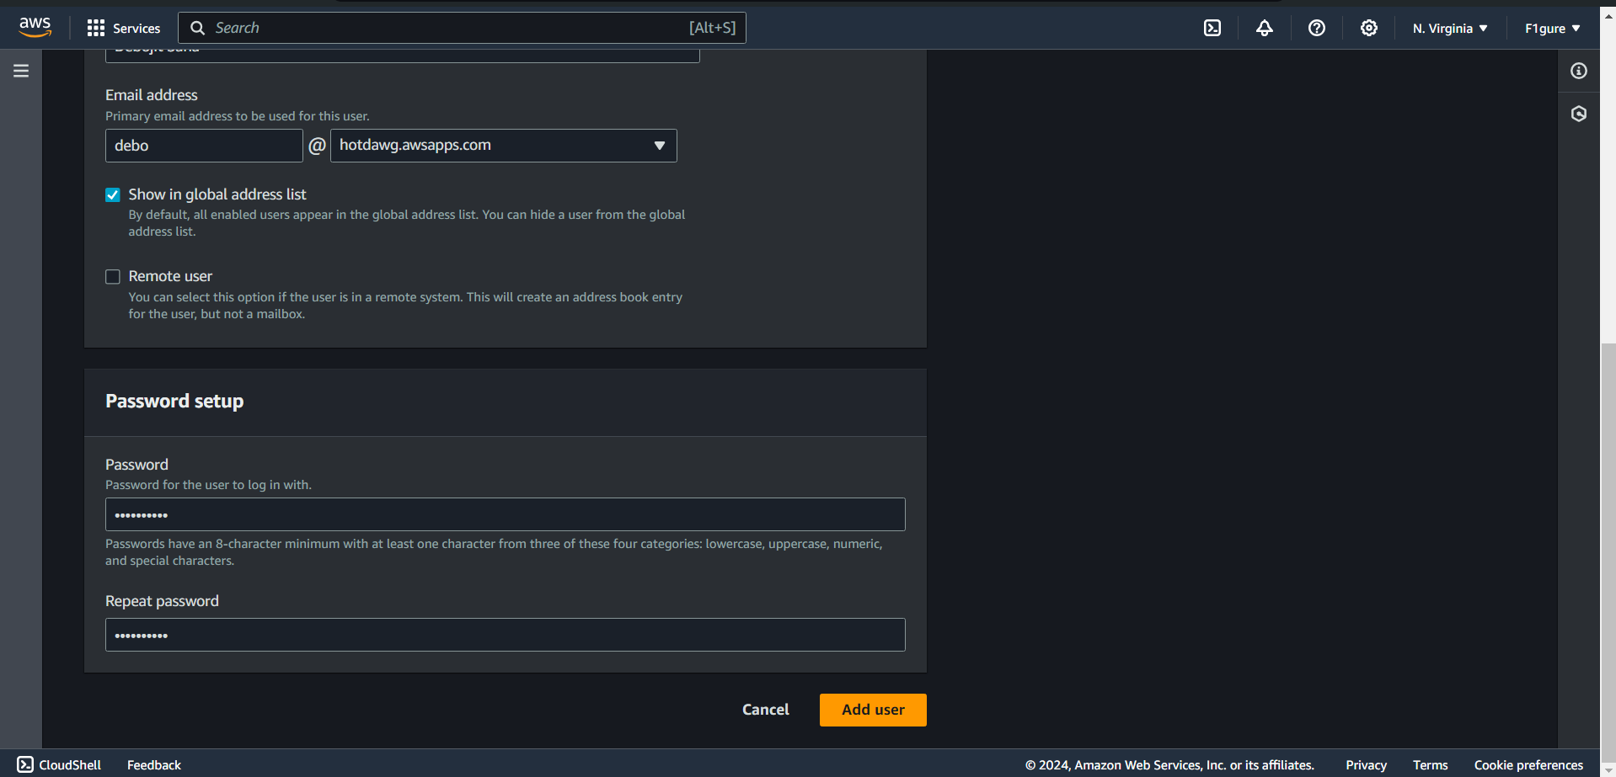

10.Proceed to click on “**Add User**”.



11. After successfully adding the user, return to the organizations page, click on the organization name, and navigate to the “**Amazon WorkMail web application**” link to proceed.

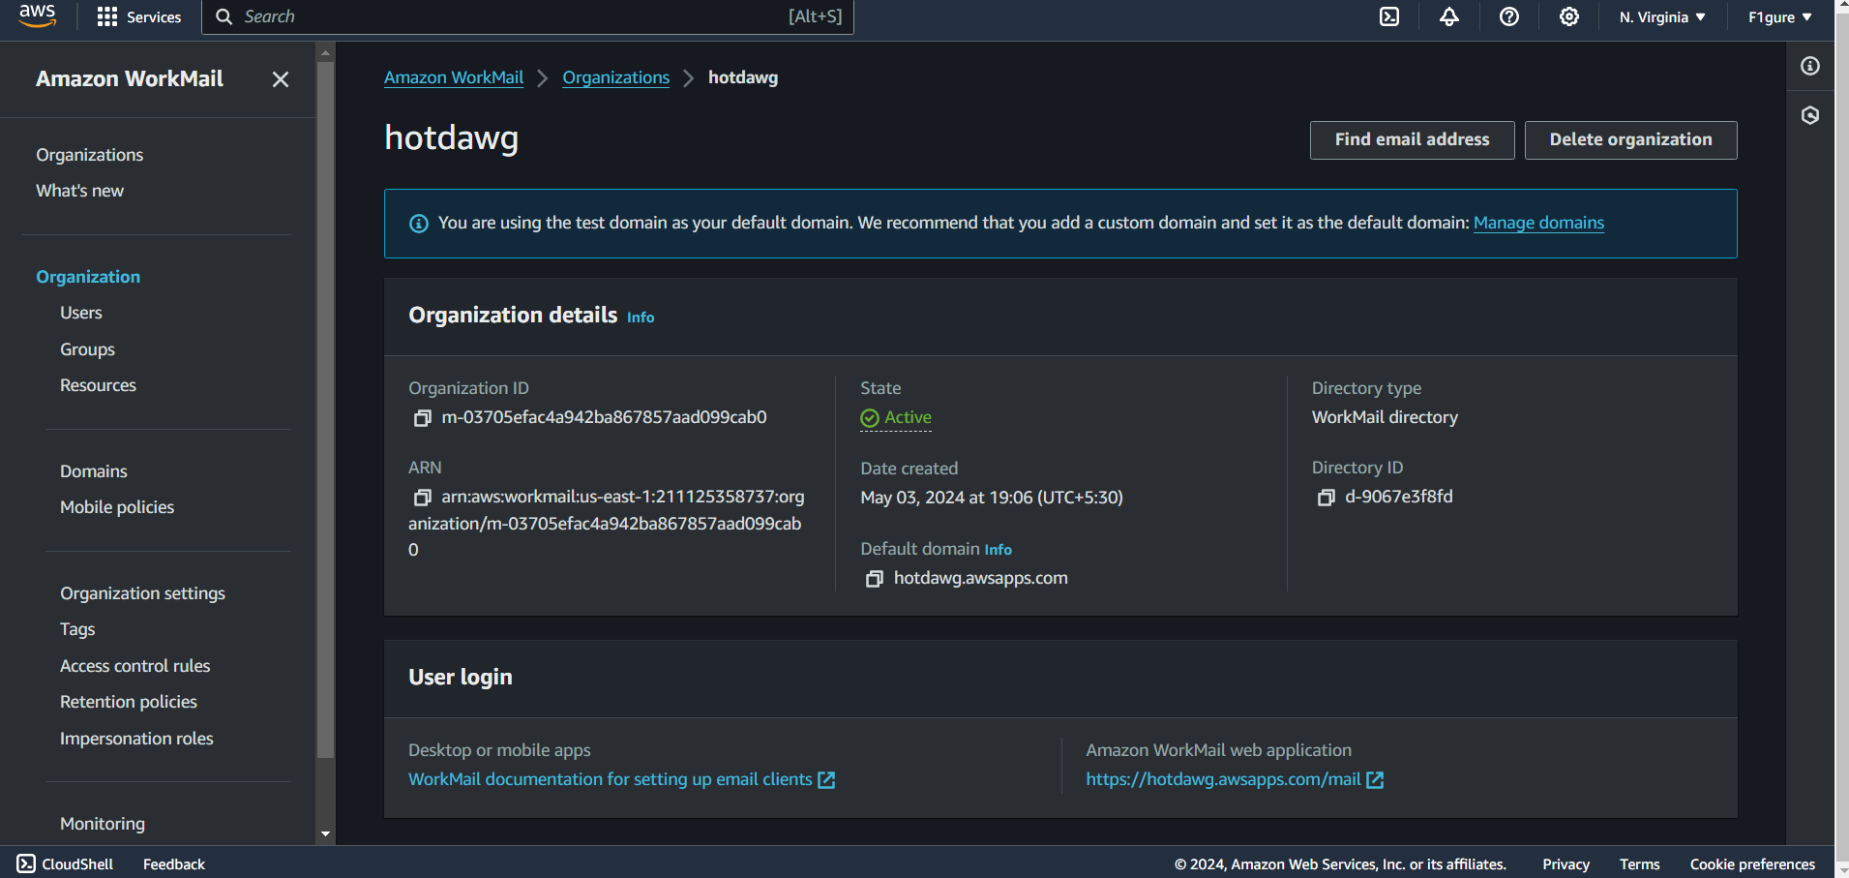

12. Now, enter the username and password to access your WorkMail account.

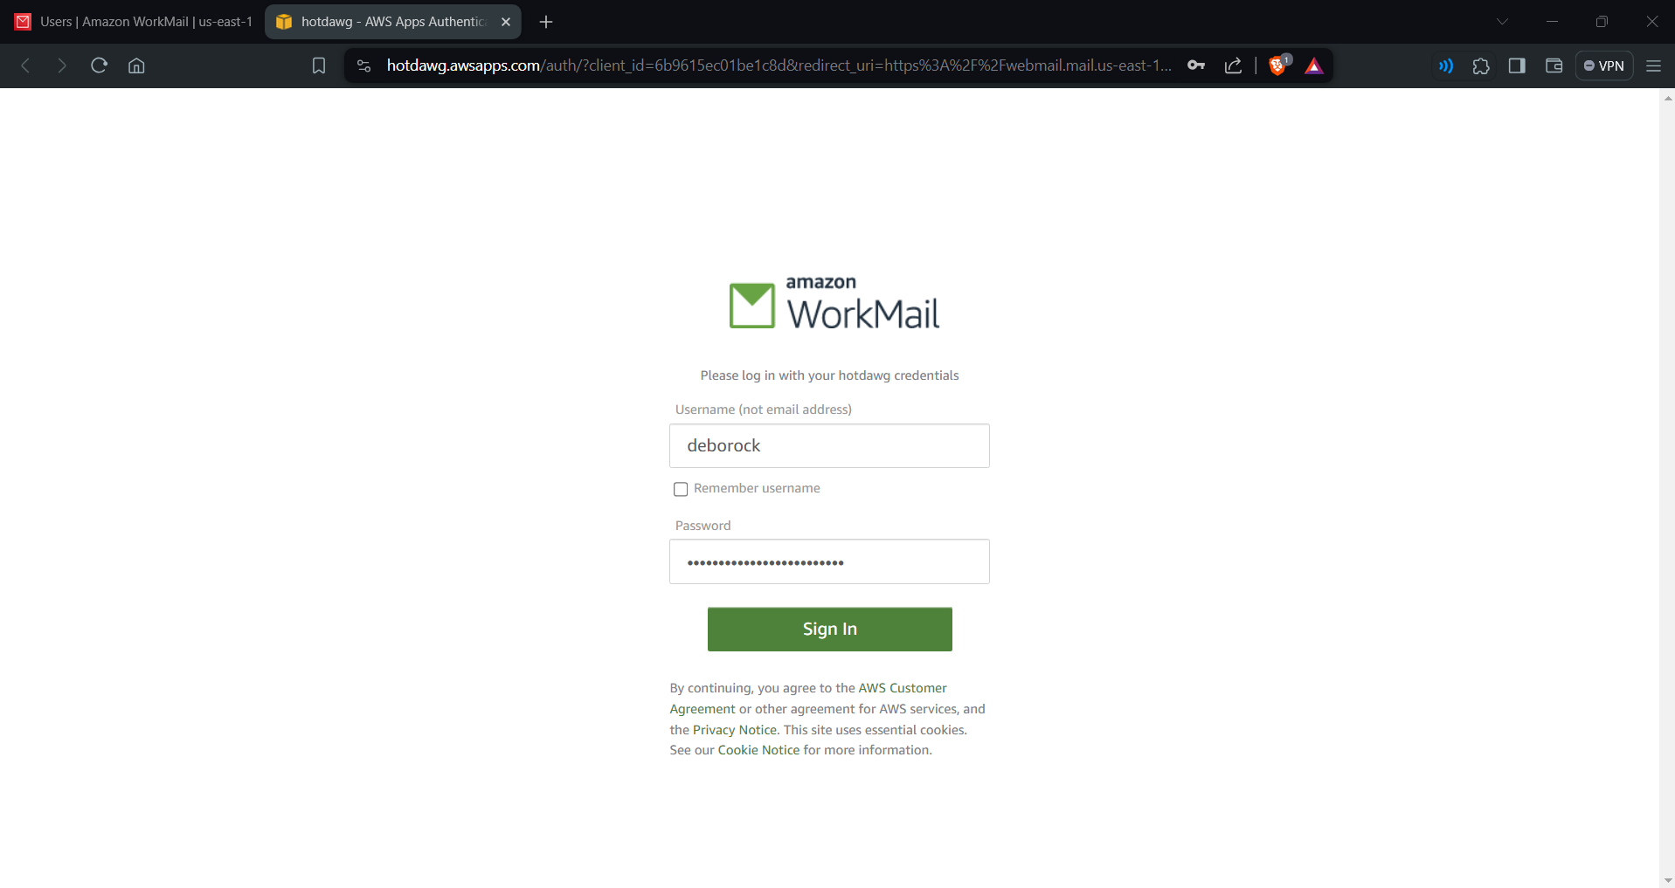

13. From this point, you can send an email to a Gmail account and verify whether it was received in your Gmail inbox to confirm that your WorkMail is functioning properly.

