**Assignment No: 14**

**Problem Statement: Create an Elastic IP for an instance.**

The steps are as follows: -

1. Please open the AWS console, navigate to EC2, and select the first option listed.

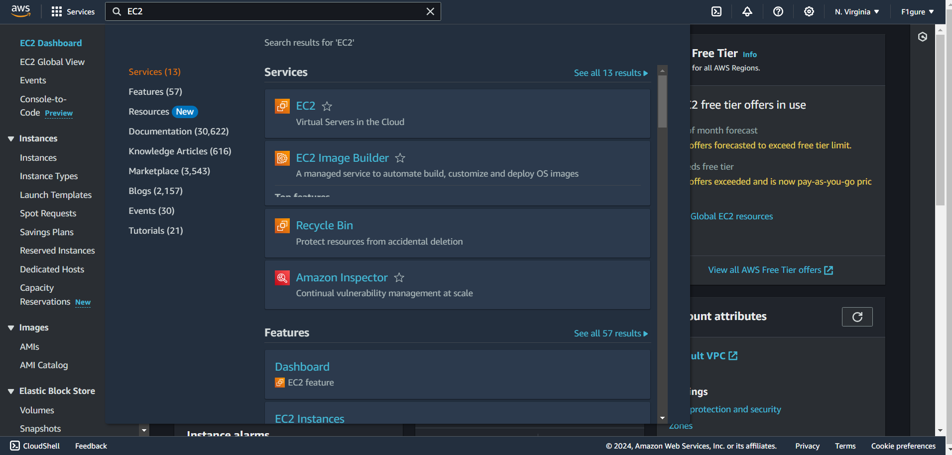

2. Select the "**Launch Instance"** button.

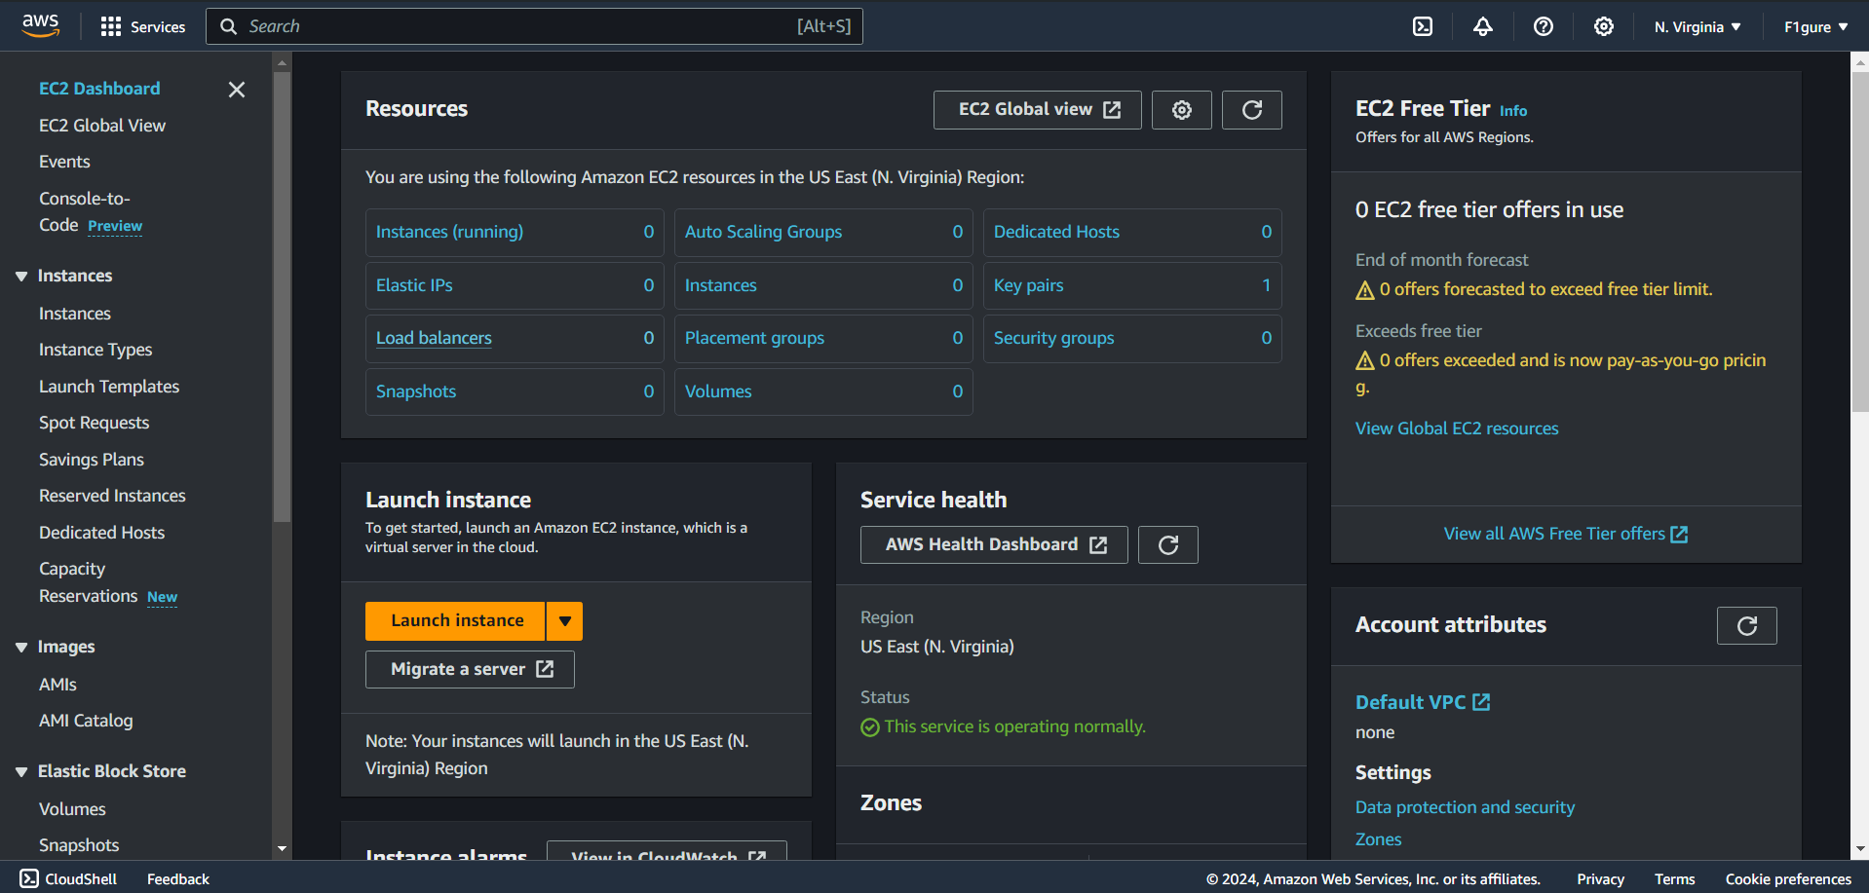

3. Enter a suitable name for your instance. For instance, we have named it **"debec2."**

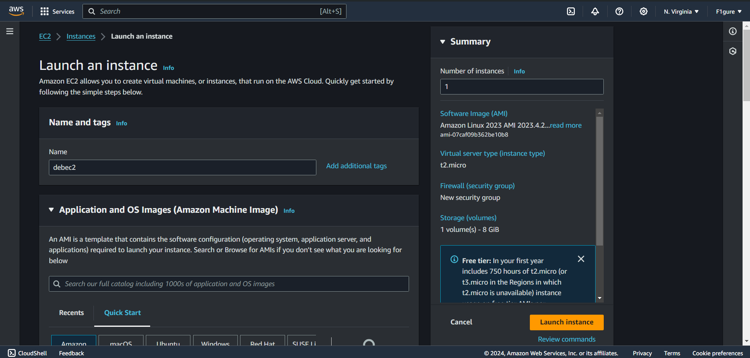

4. Select **Ubuntu** from the list of available AMIs.

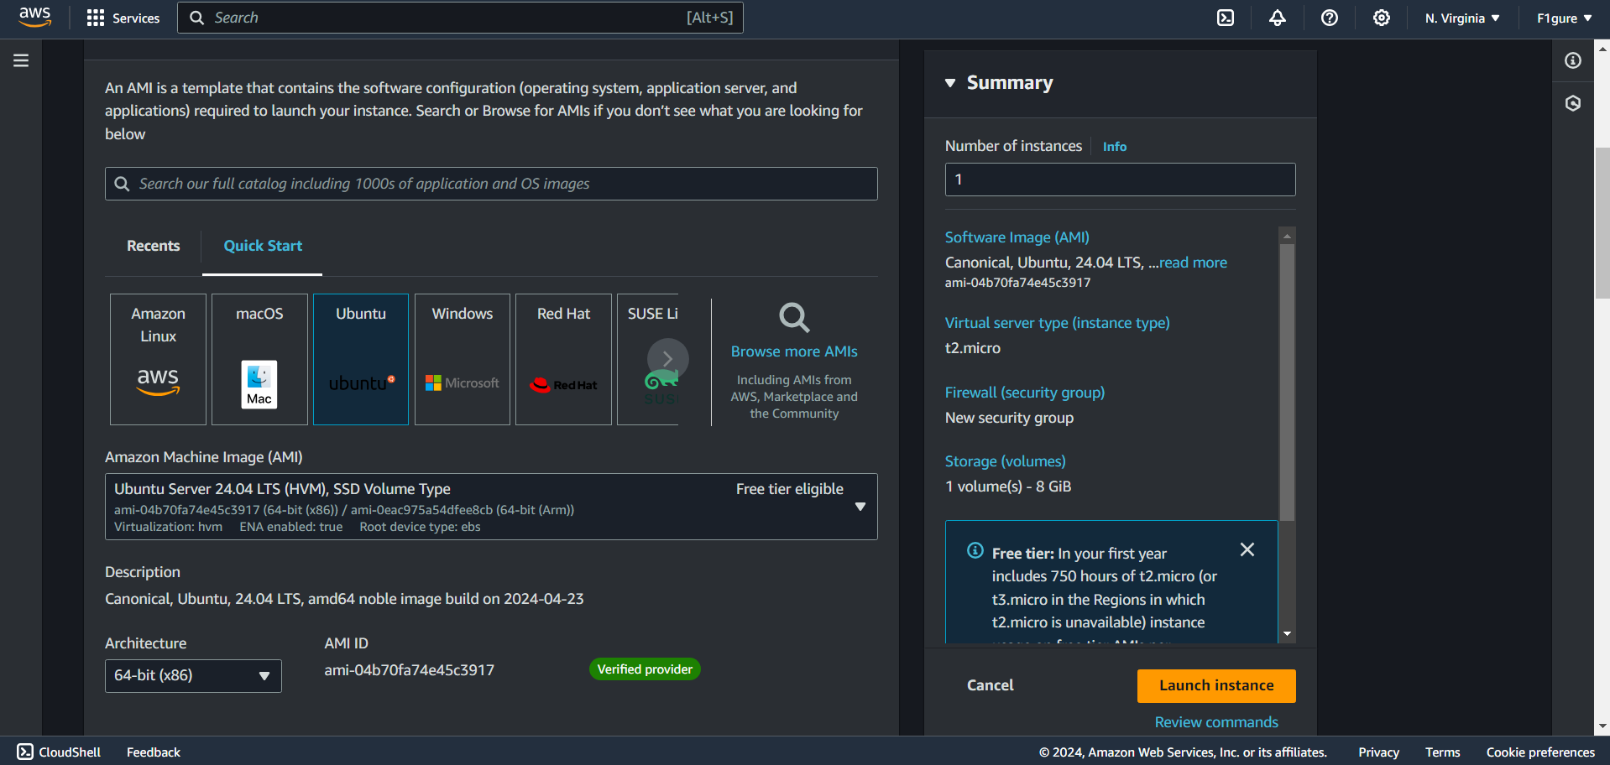

5. Select the checkboxes for SSH, HTTP, and HTTPS protocols. Proceed to click on

“Launch Instance”.

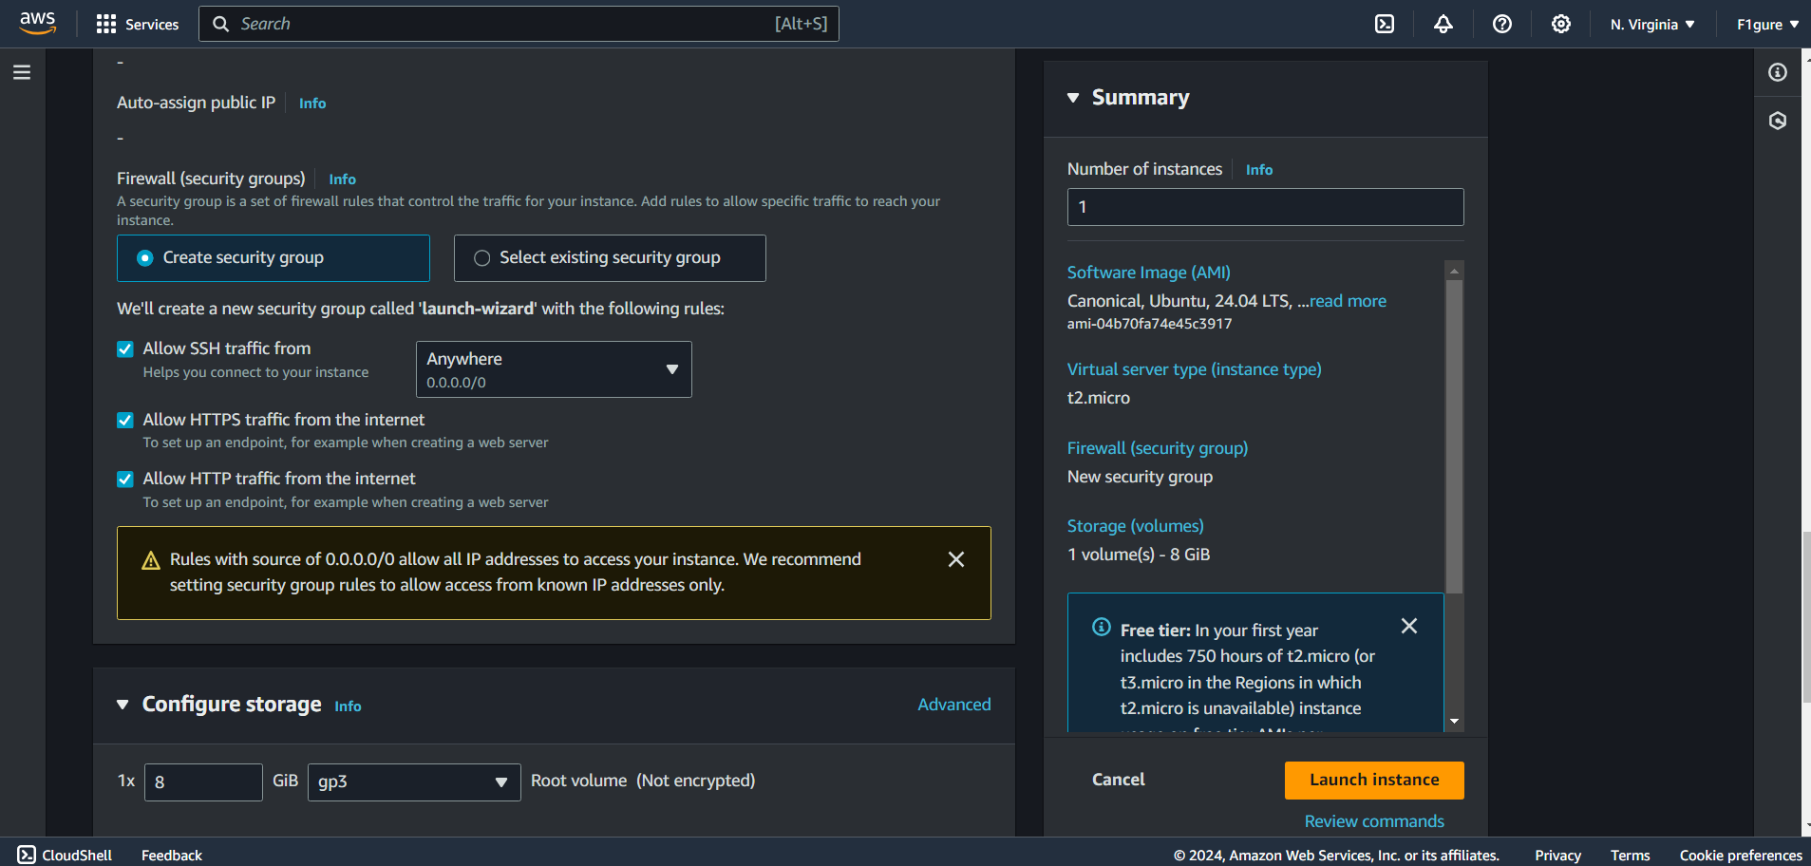

6. The instance has been created successfully.

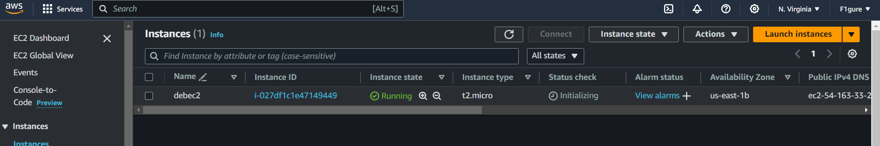

7. To view the public IPv4 address, click on the instance ID.

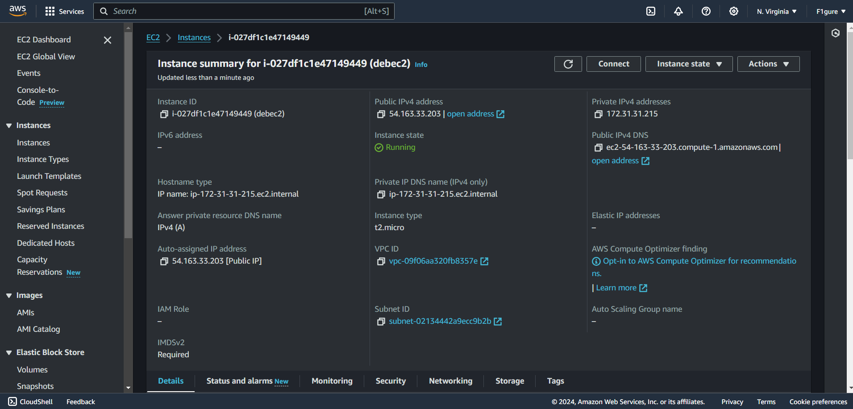

8. Select the instance, go to "Instance State," and choose to stop the instance.

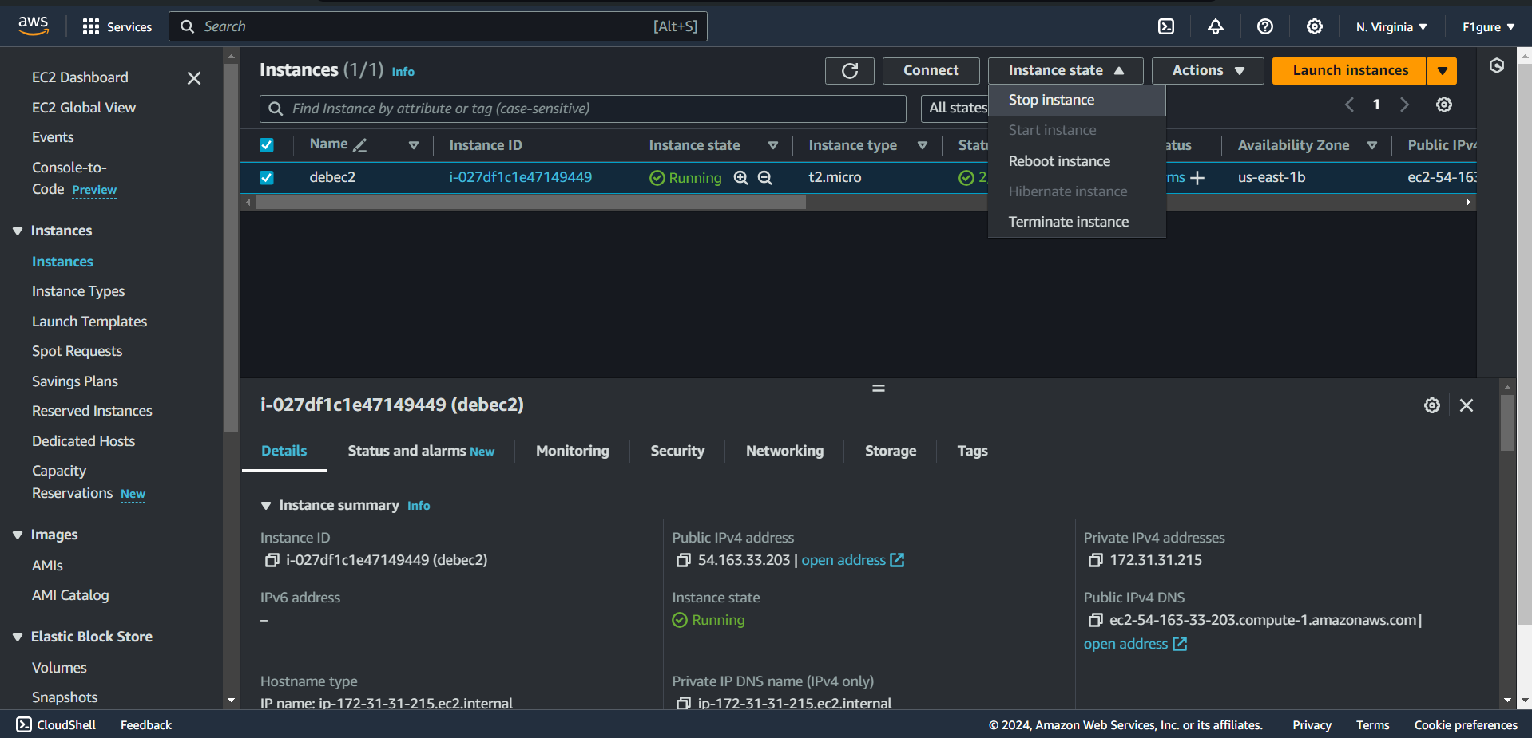

9. Once the instance is stopped, proceed to start the instance again.

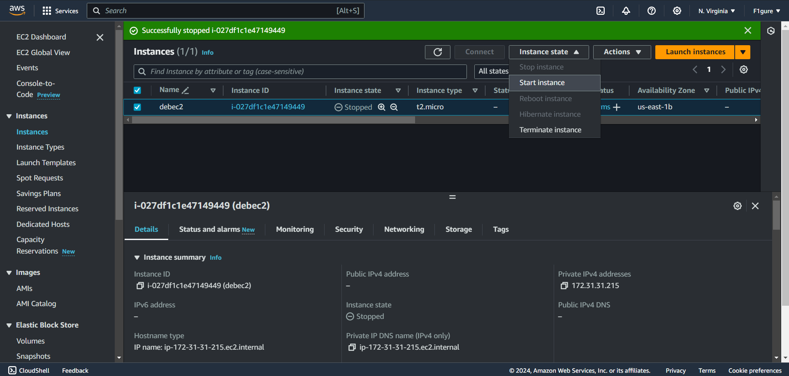

10. After restarting the instance, you will notice that the IPv4 address has changed.

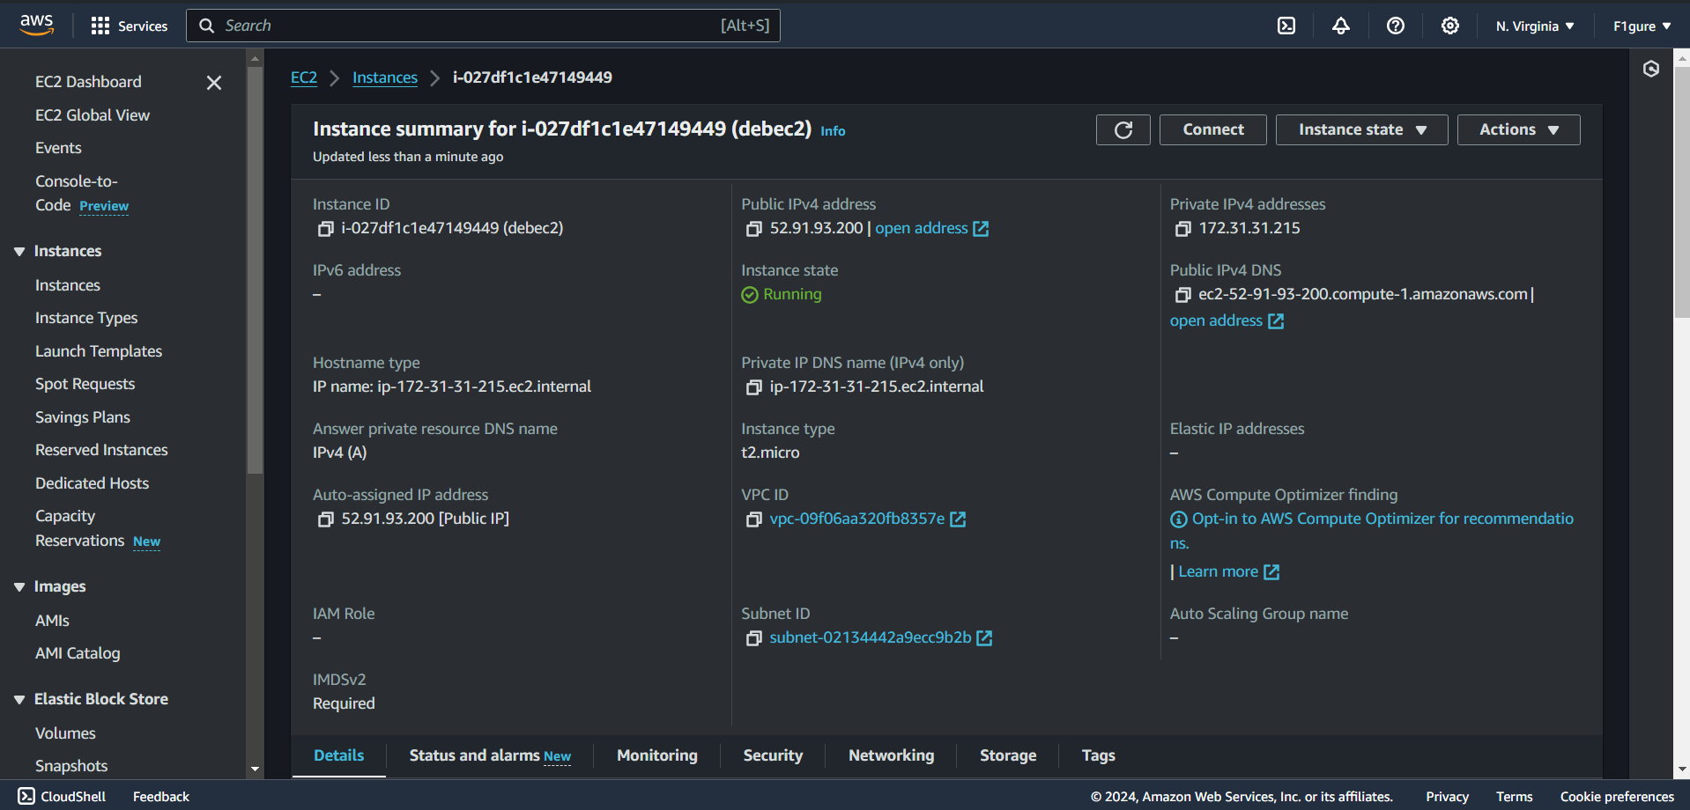

11. Next, we will associate this instance with an Elastic IP.

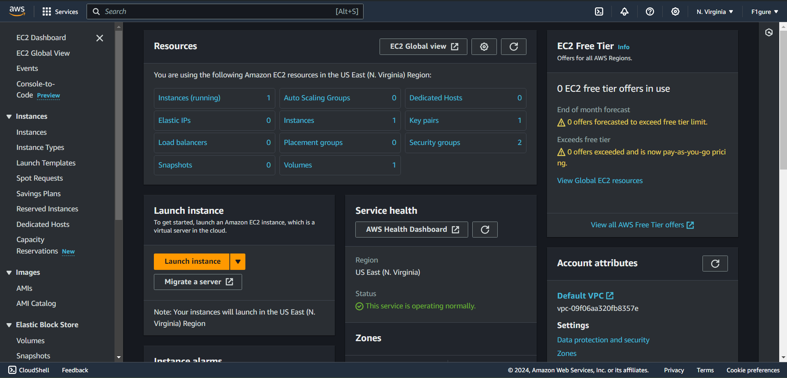

12.Select “**Allocate Elastic IP Address**” button.

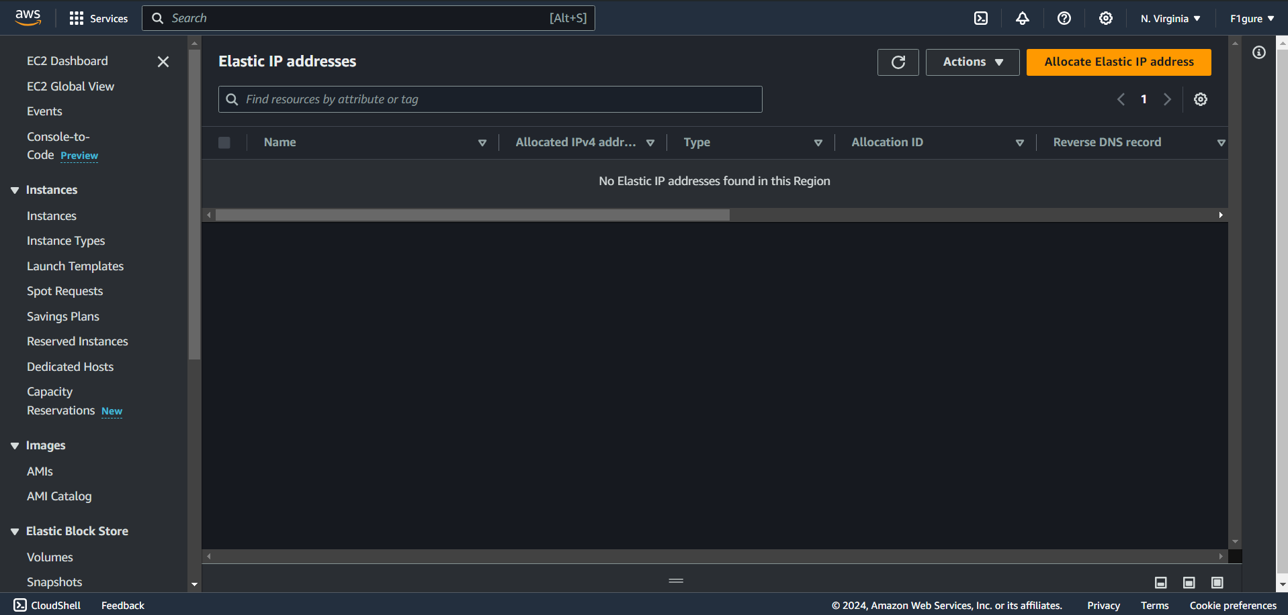

13.The subsequent window appears.

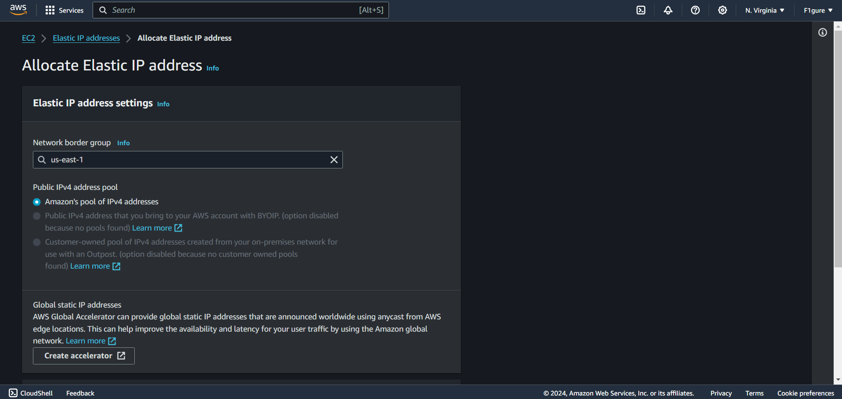

14.Proceed to click on “**Allocate**”.

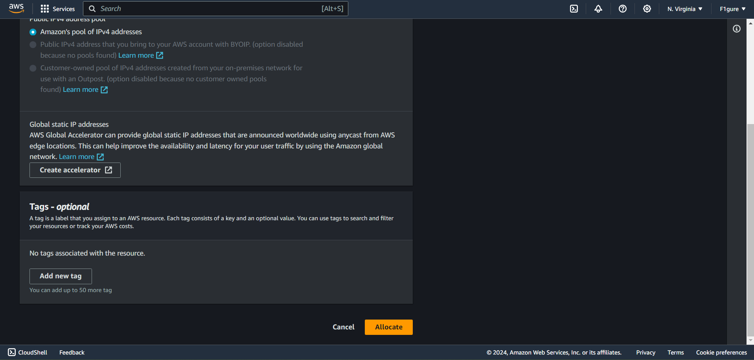

15.Now proceed to click on “**Associate Elastic IP Address**”.

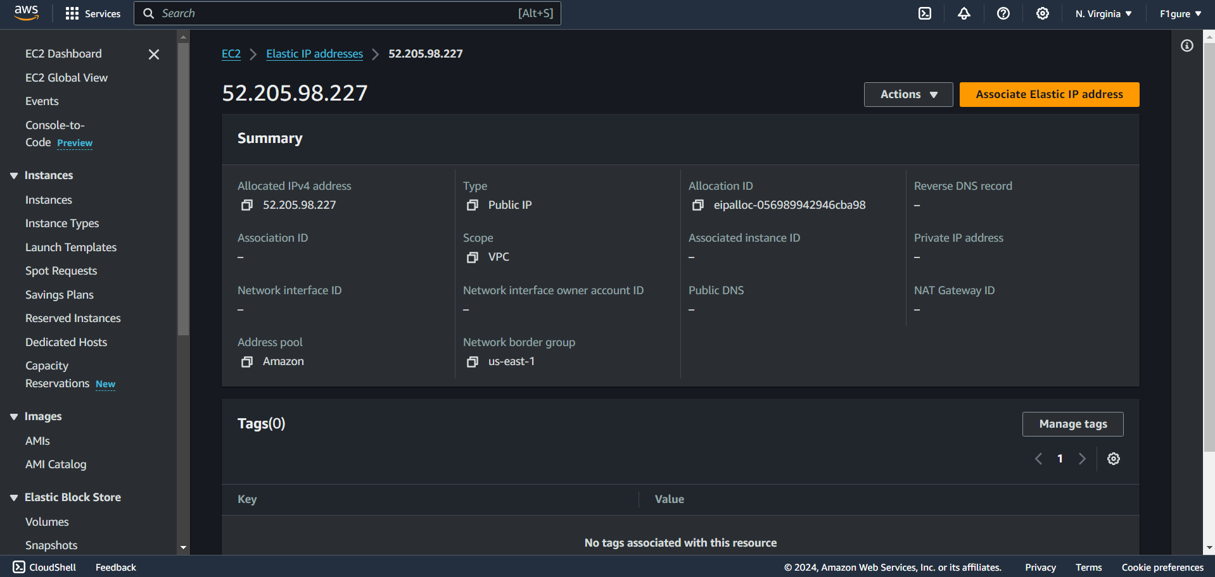

16. Choose the instance, its private IP address, and tick the checkbox below. Then, proceed to click on "**Associate**."

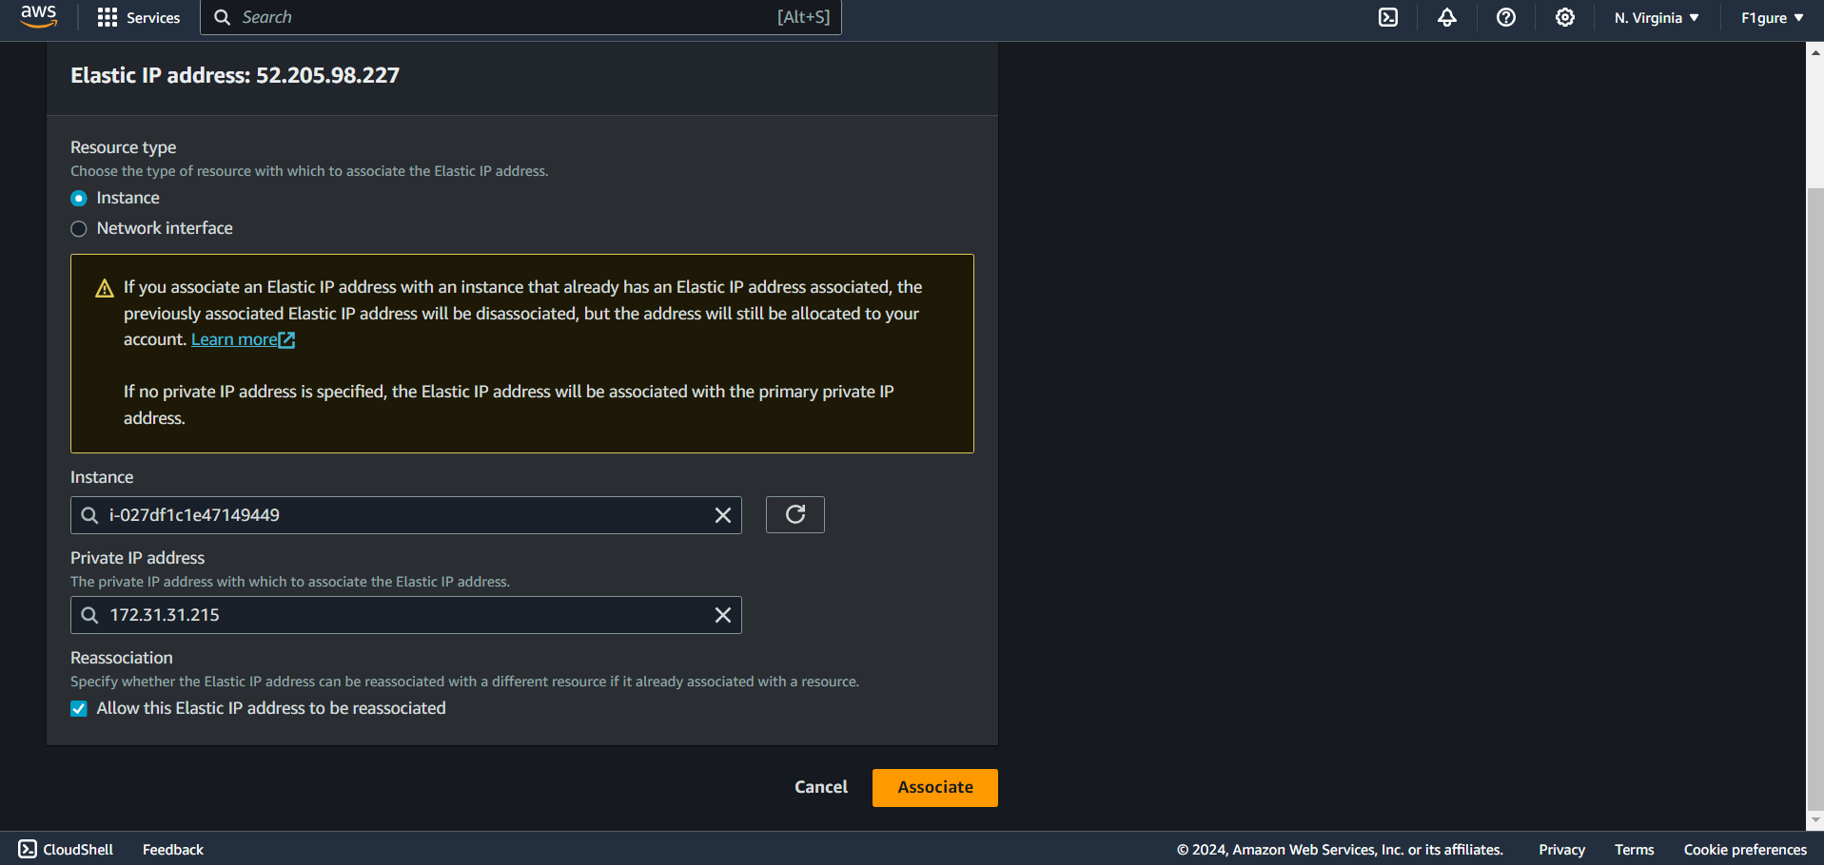

17. After stopping and then restarting the instance, you will observe that the IPv4 address remains unchanged.

