**ASSIGNMENT No: 9**

**Problem Statement**: Deploy a project from GitHub to EC2.

The steps are as follows: -

1. Please confirm whether the `**index.js**` file exists in your GitHub repository. If it's not present, then clone it into a repository if the file already exists on your local machine using the command `**git clone <repository_path>`.**

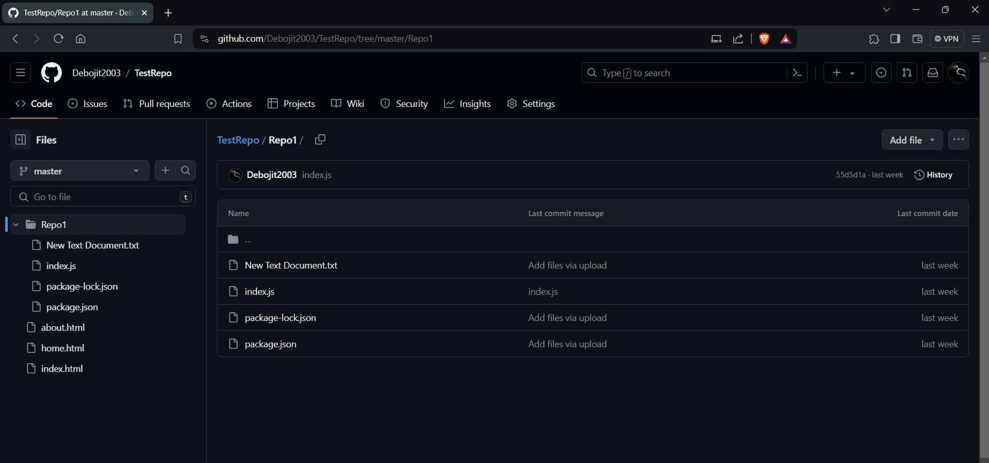

2. Access your AWS account and utilize the search box to look for EC2, then proceed to click on the first option displayed.

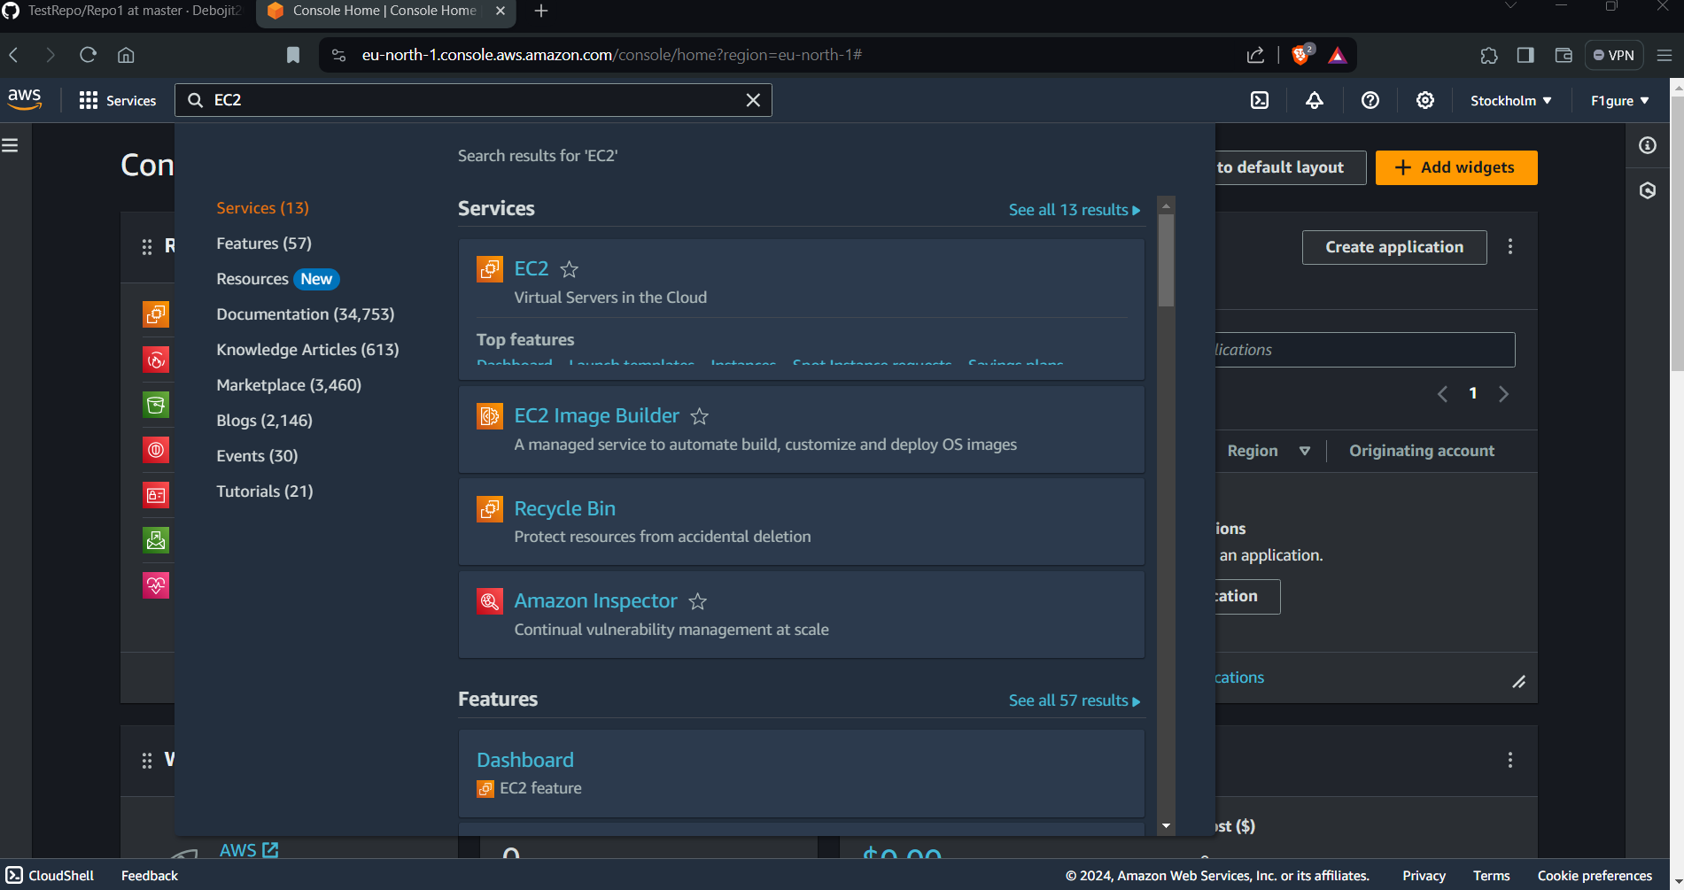

3. Subsequently, select "**Launch Instance**".

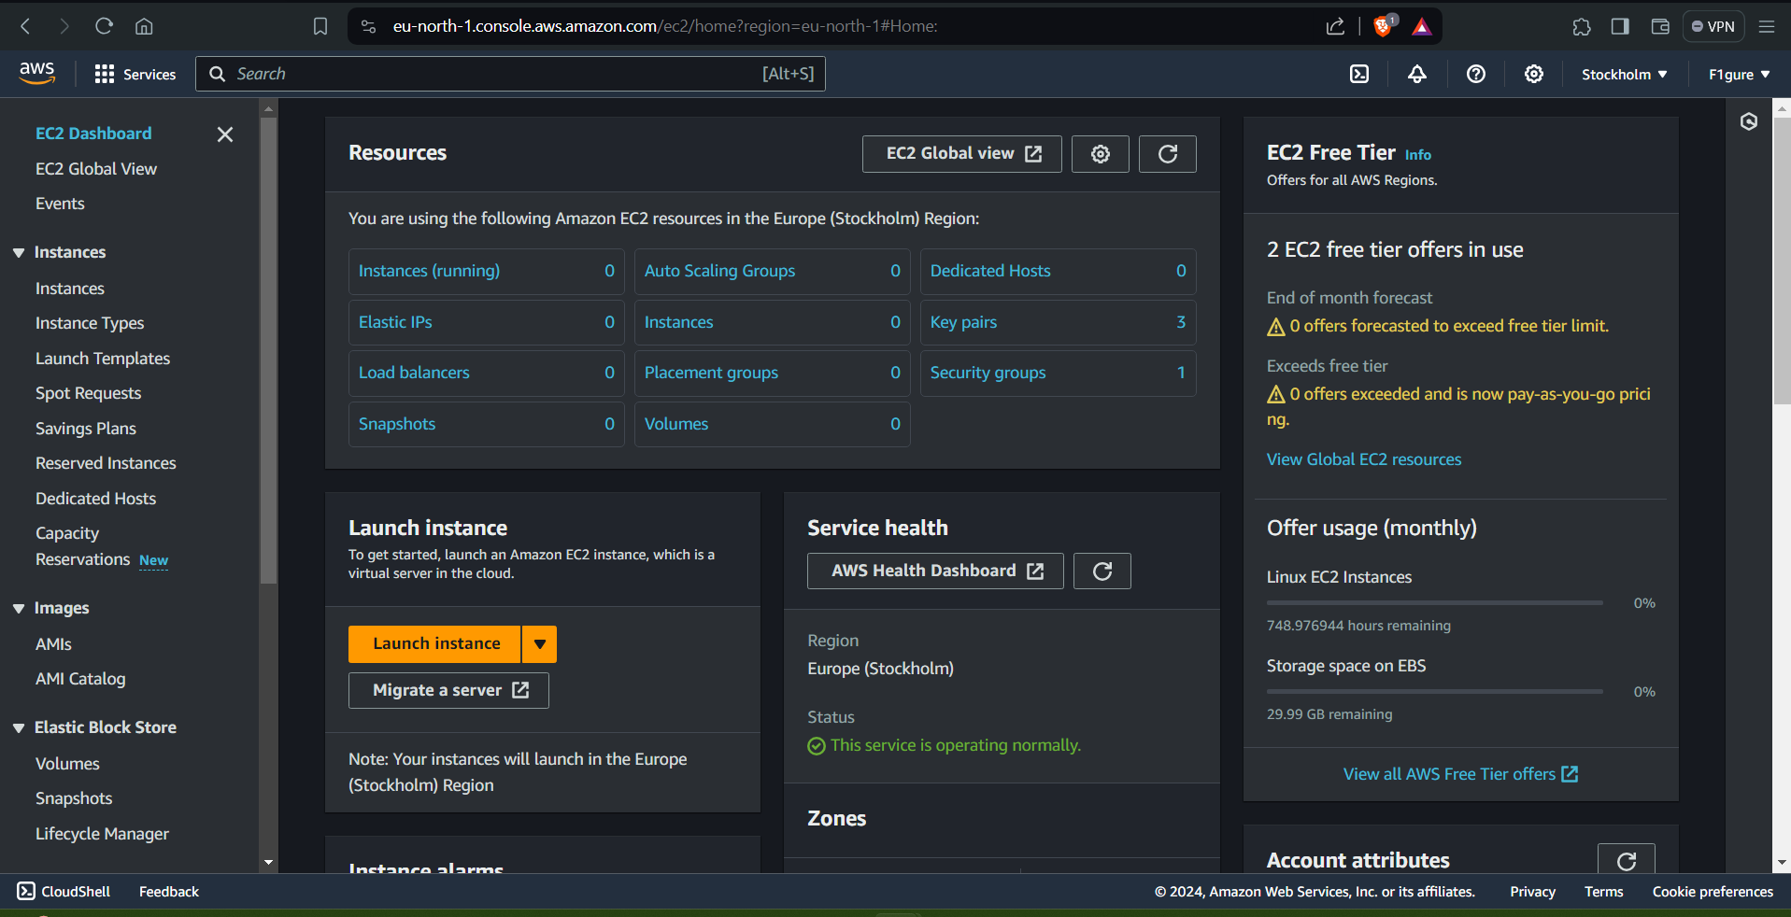

4. For the subsequent step, ensure to assign an appropriate name to the EC2 instance. (For instance, here it is : DebojitEC2)

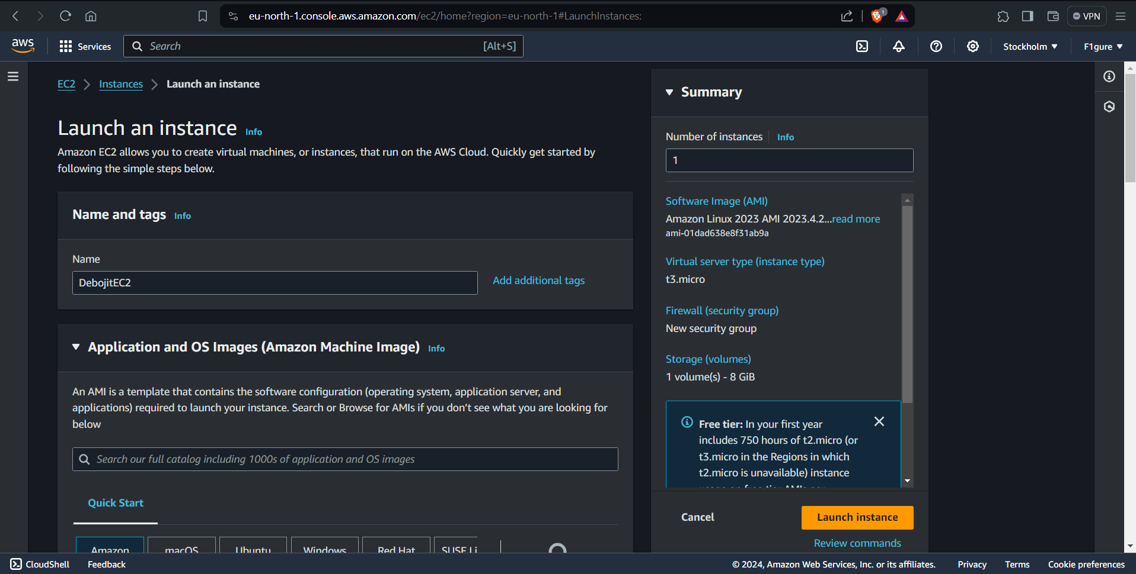

5. Choose **Ubuntu** from the available AMIs.

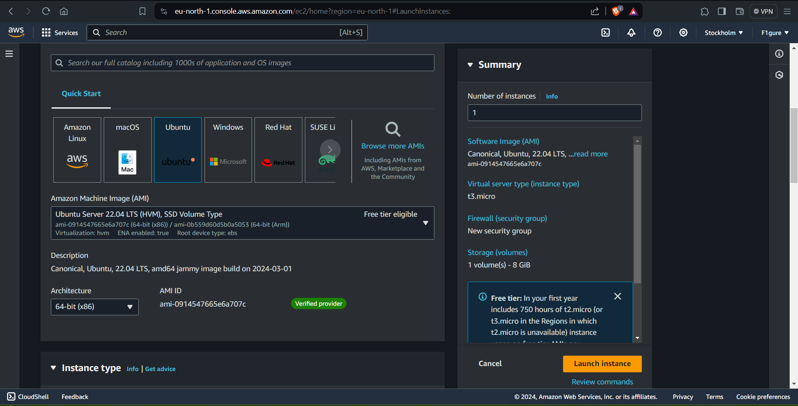

6. Generate a new key pair or alternatively, utilize an existing one. A new key pair is generated by selecting "**Create new key pair**".

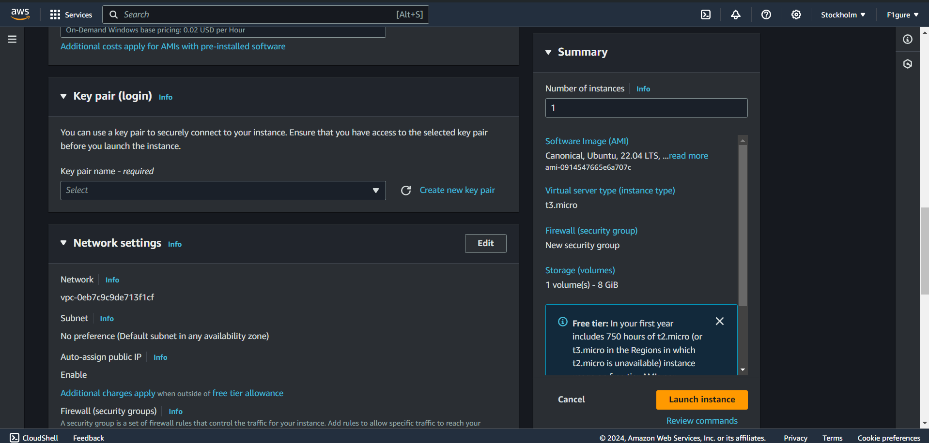

7. In the following window, provide a name for the key pair(here it is- newkey1) and opt for the **.pem** format. Then click on “**create key pair**”.

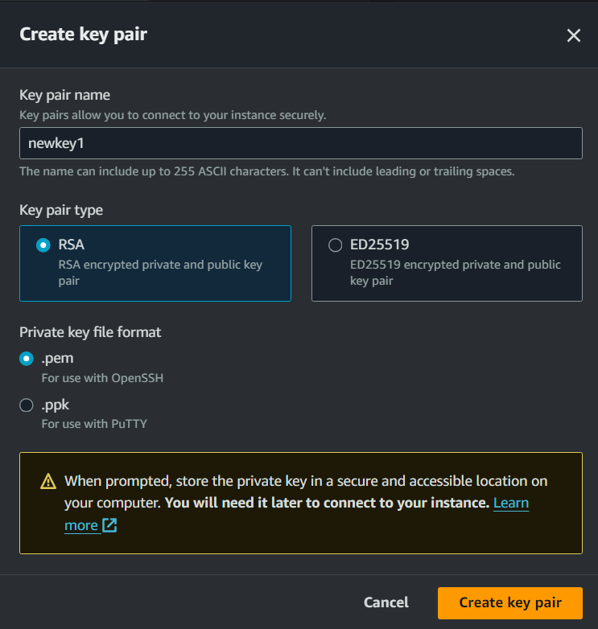

8. Select to create a server and ensure to enable all three protocols: SSH, HTTP, and HTTPS.

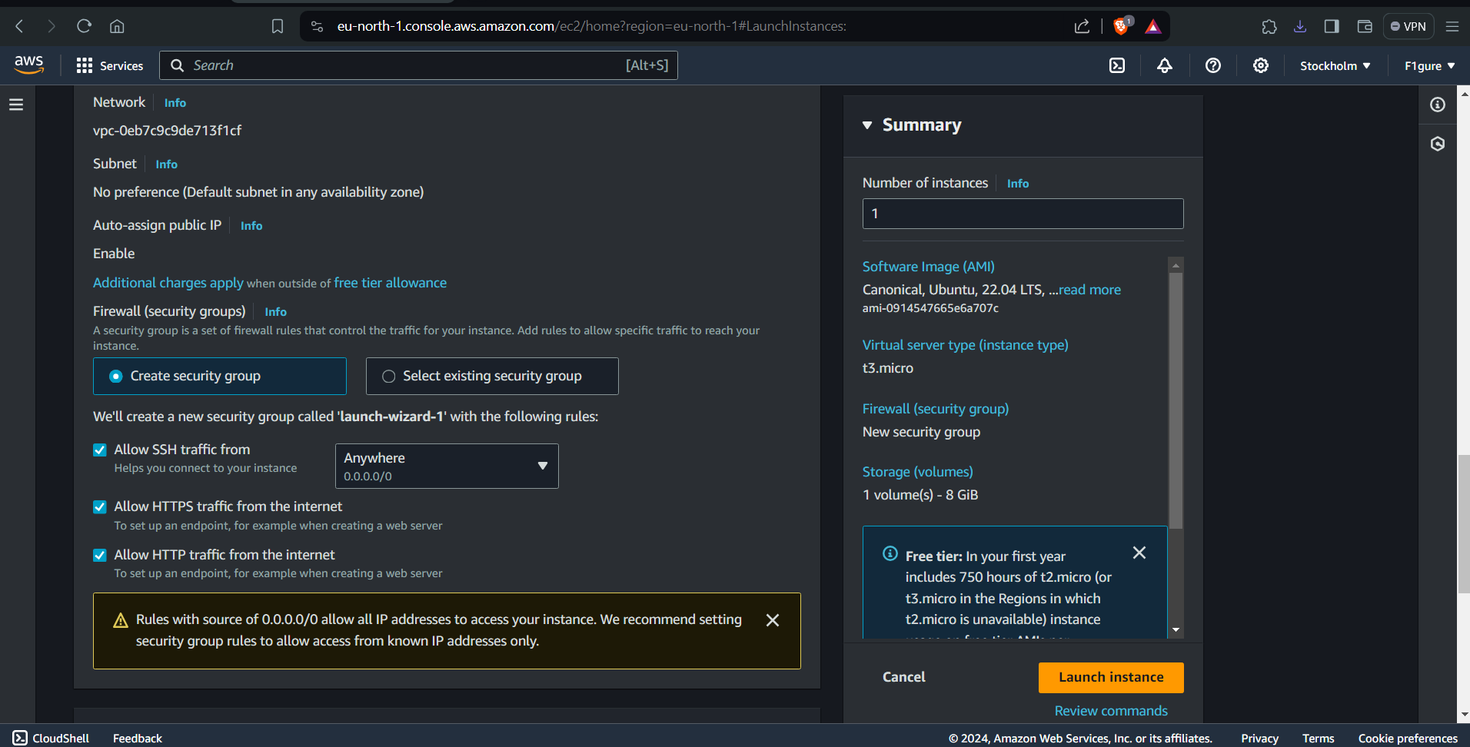

9. Finally, proceed by clicking on "**Launch Instance**".

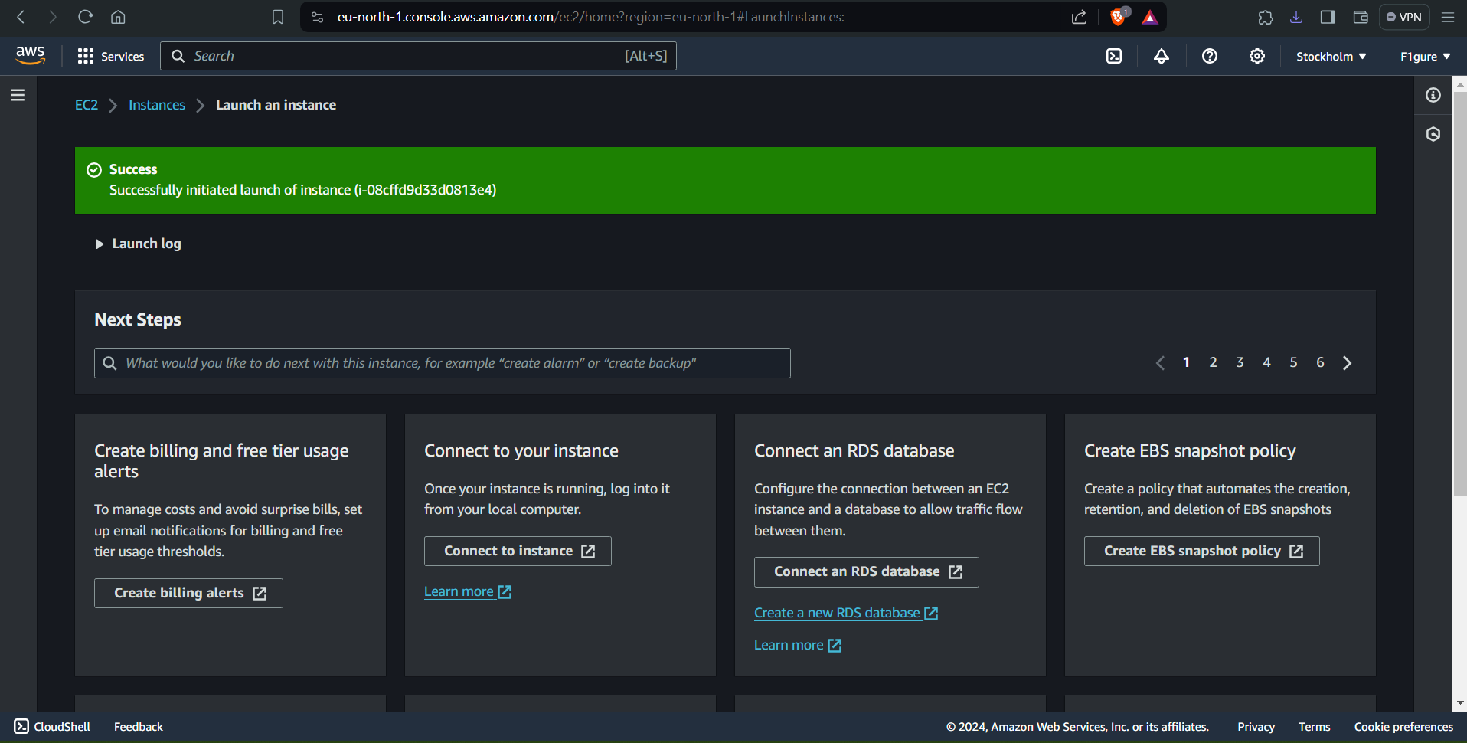

10. Access GitHub and navigate to your repository that is currently being worked on, containing the `**index.js`** file.

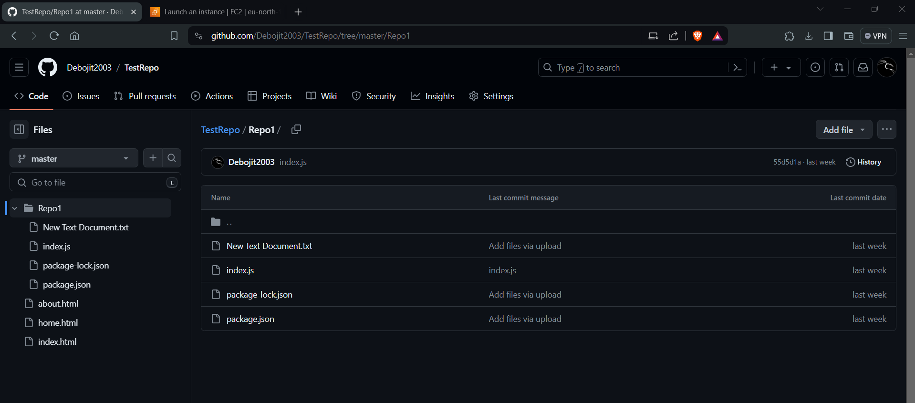

11. Access the "**index.js"** file and modify the code by replacing "**hello students**" with "**hello <your_name>".**

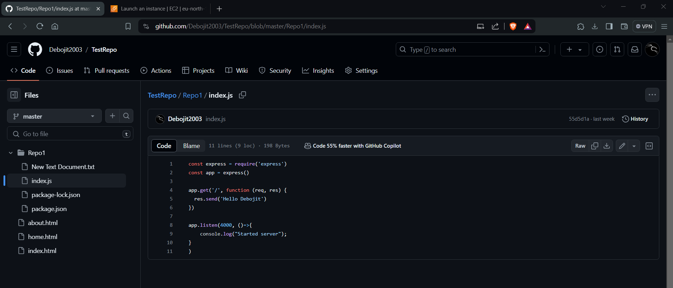

12. Return to the AWS tab currently open in your system, then navigate to **instances** and select **security.**

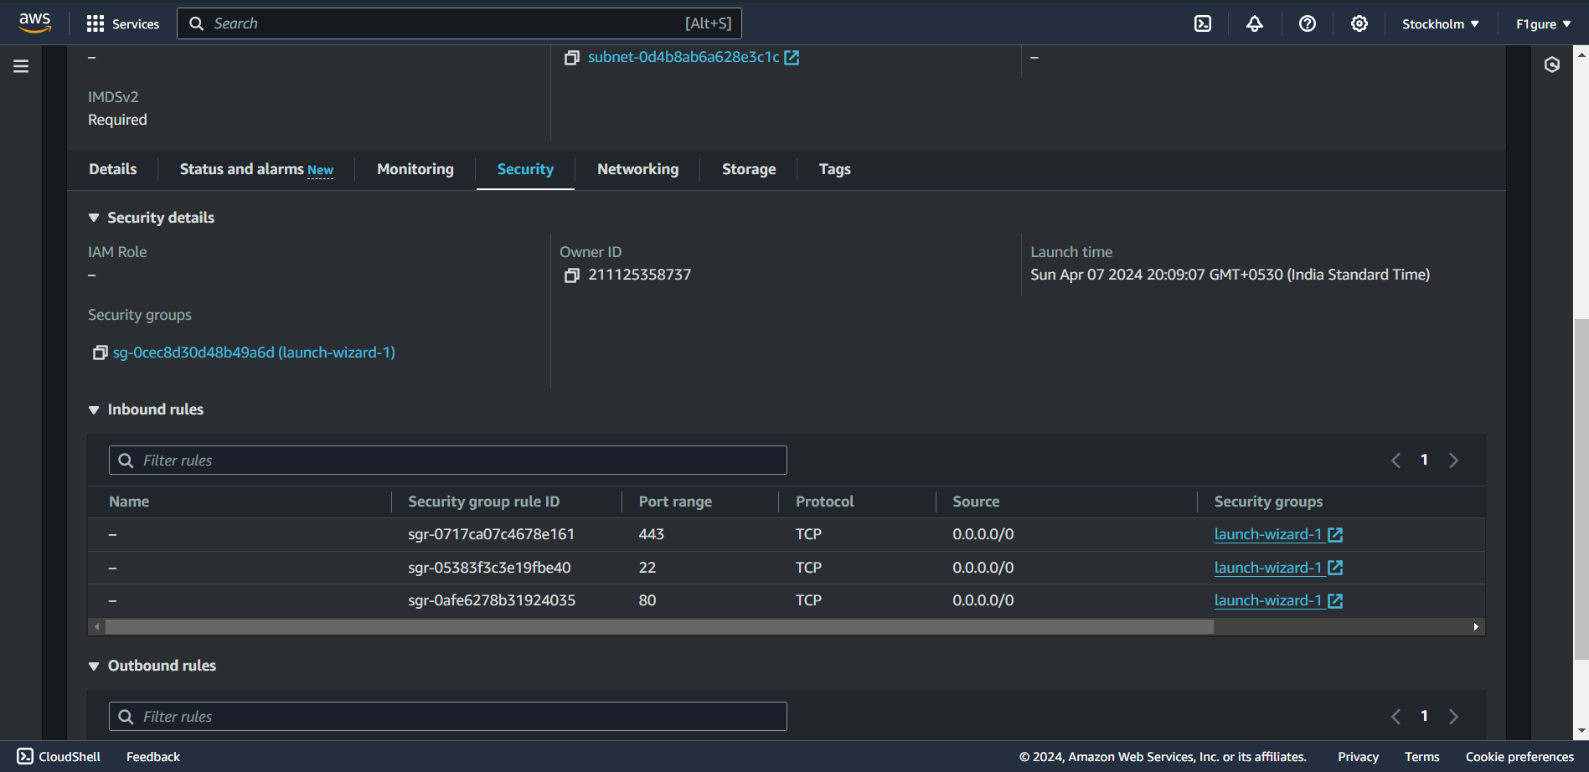

13. Select the security group and observe that three protocols have been chosen.

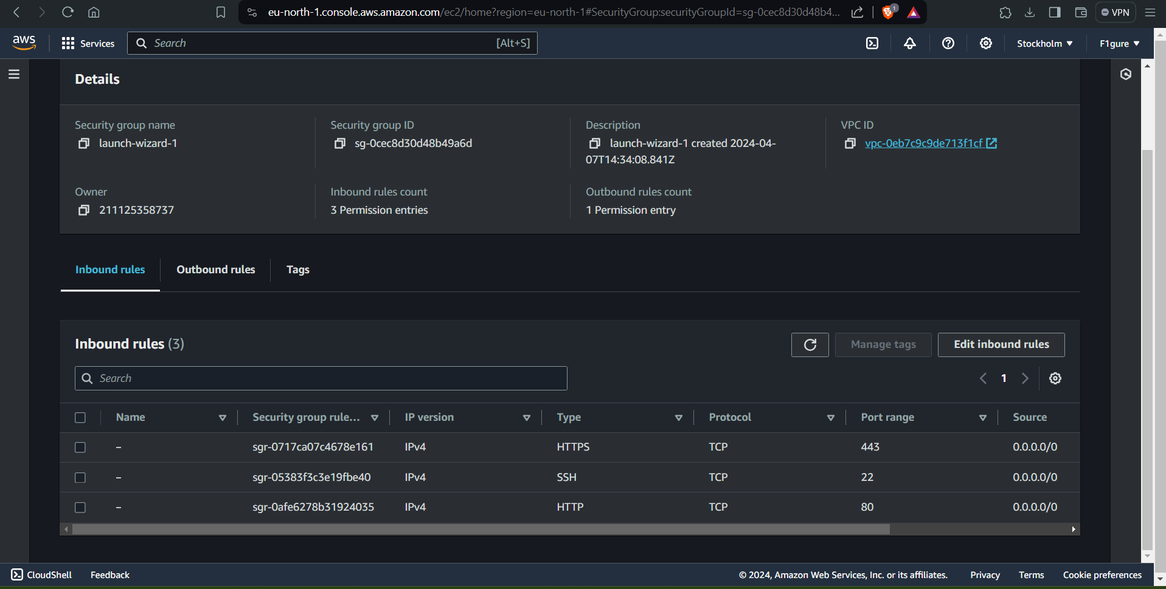

14. Select "**Edit inbound rules.**"

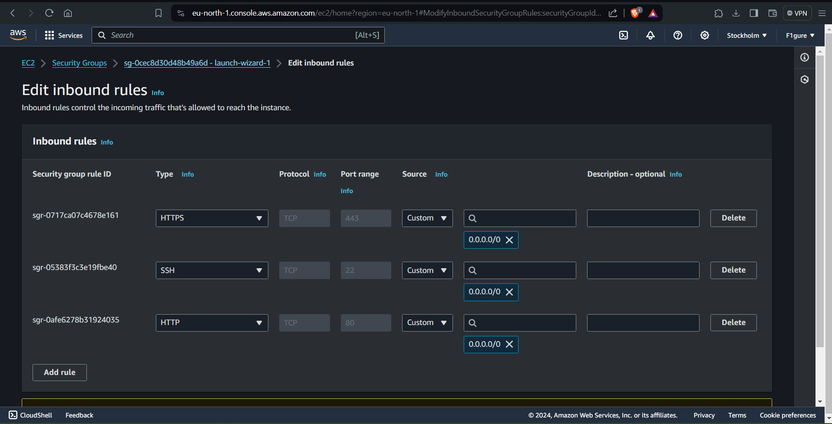

15. Scroll down and select "**Add rule**" to add Custom protocol.



16. Enter 4000 in the port number field, as specified in the `**index.js**` code.

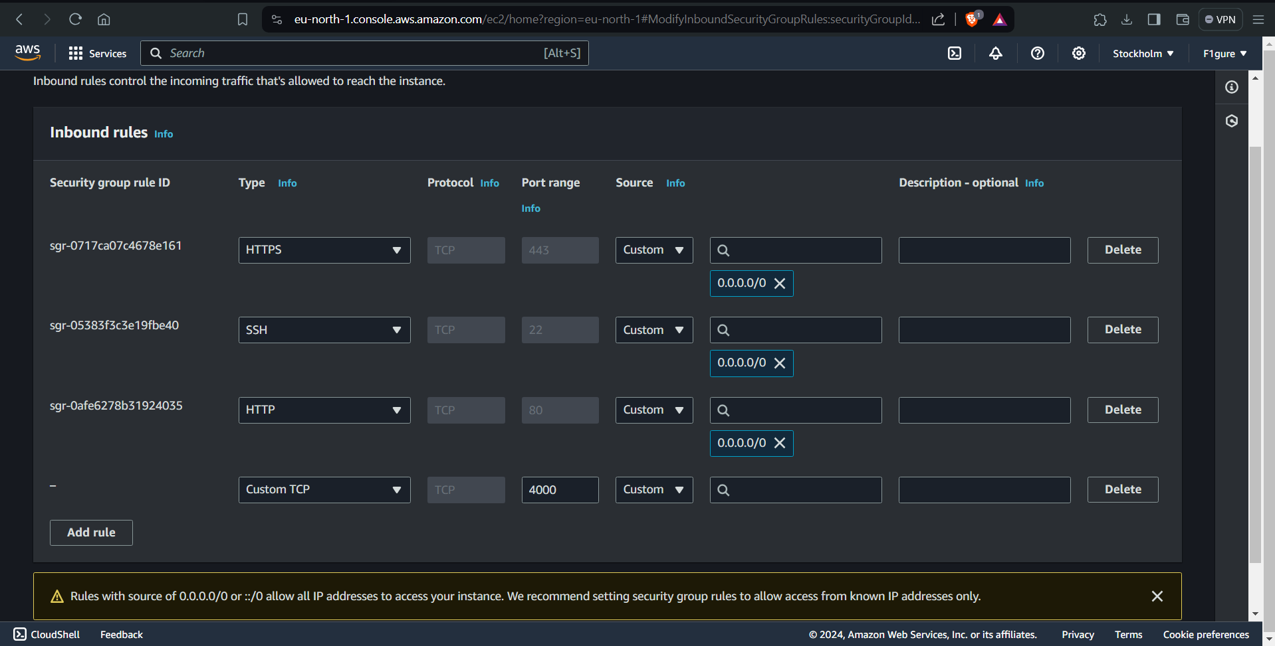

17. Choose the first option available beside it.

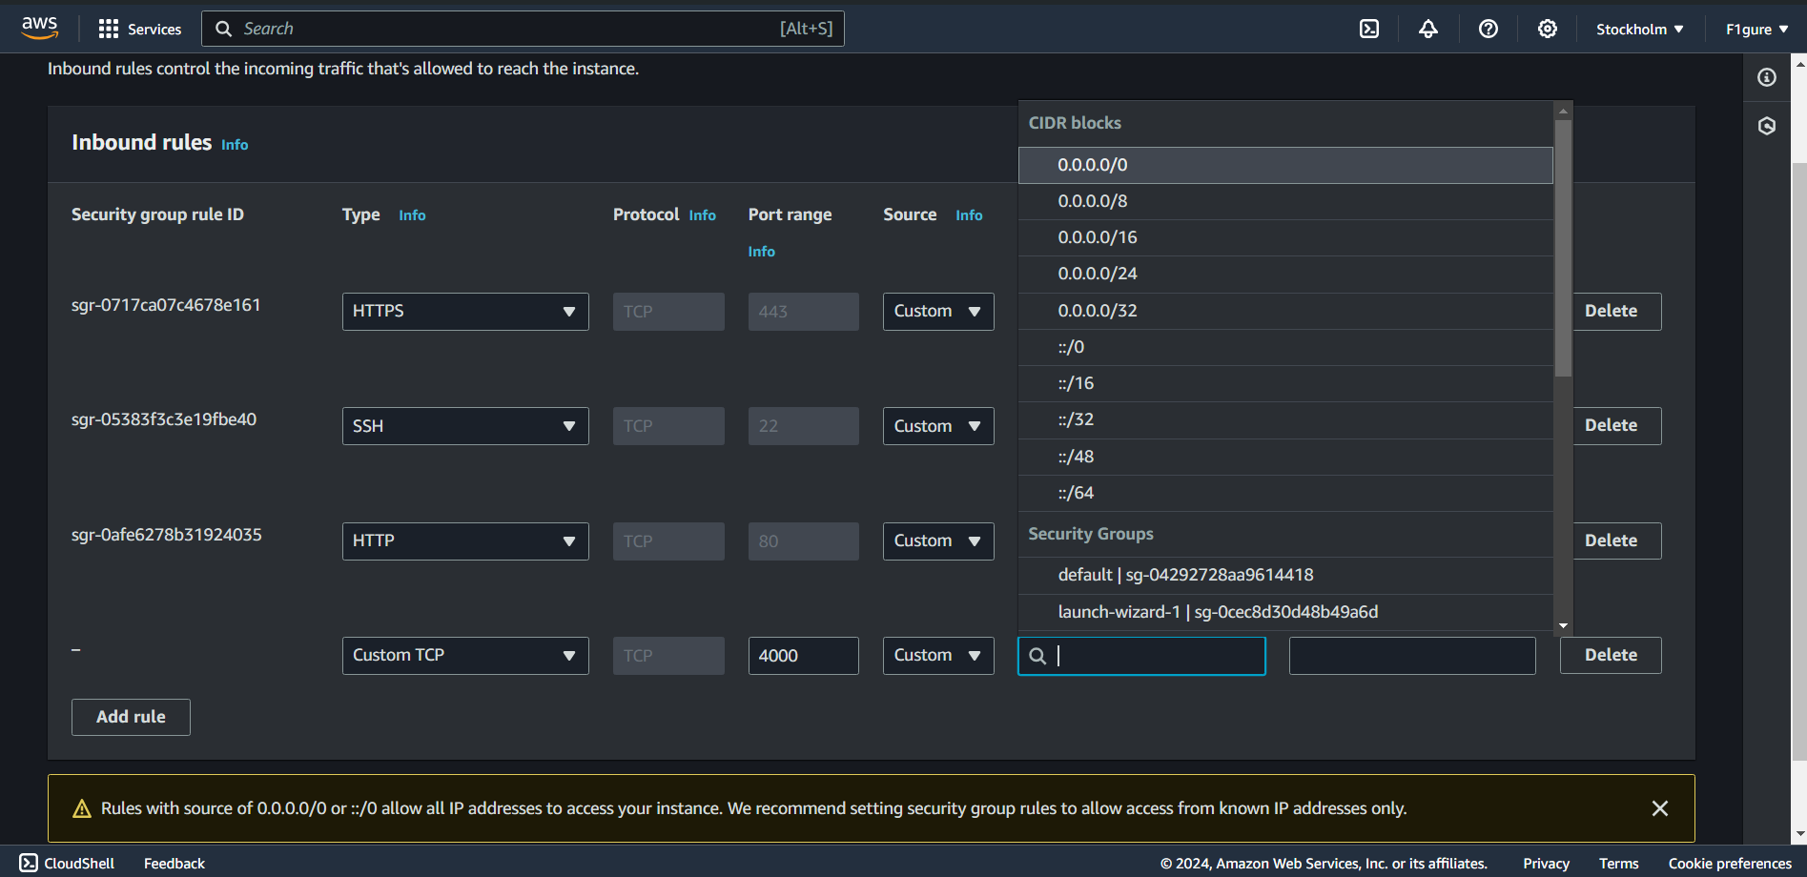

18.Finally click on **Save rules**. Then you will see the following window appears.

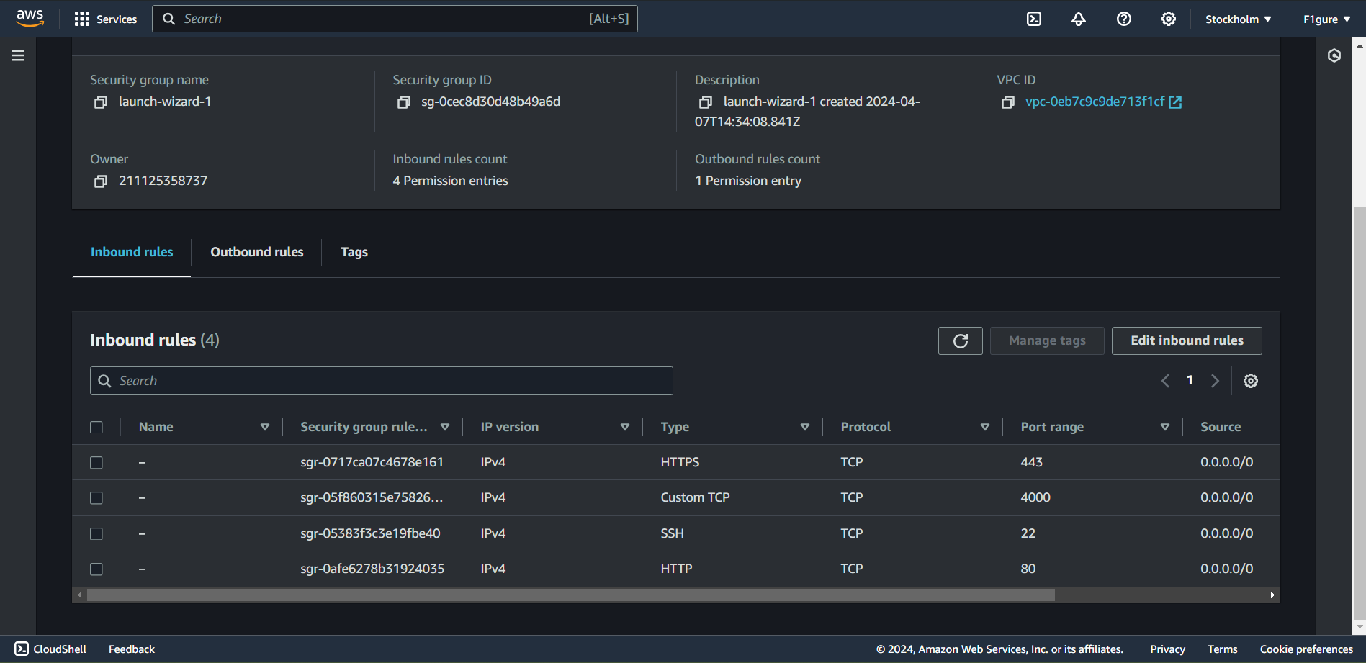19. Navigate to instances and copy the Public IPv4 address.

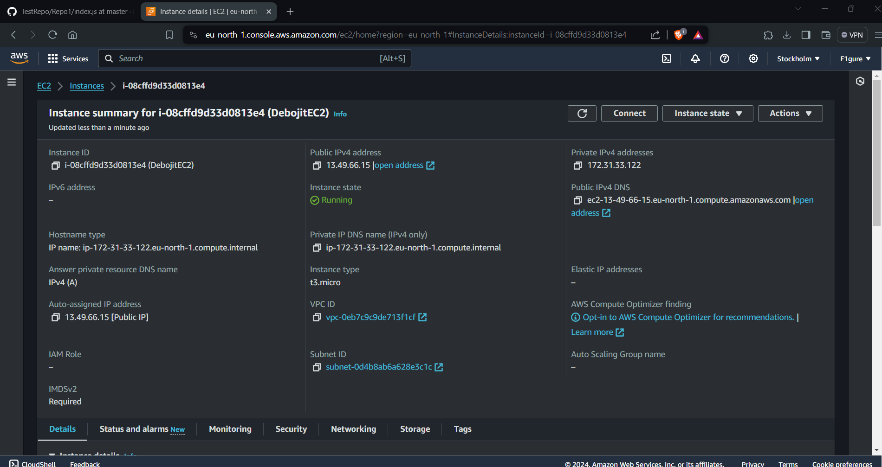

20. Launch Bitvise SSH Client and proceed to click on "**Login**".

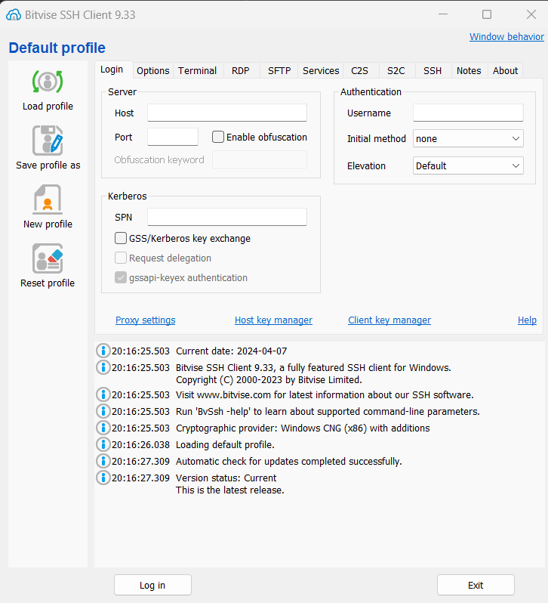

21.Paste the IPv4 address into the host field and enter "ubuntu" as the username. 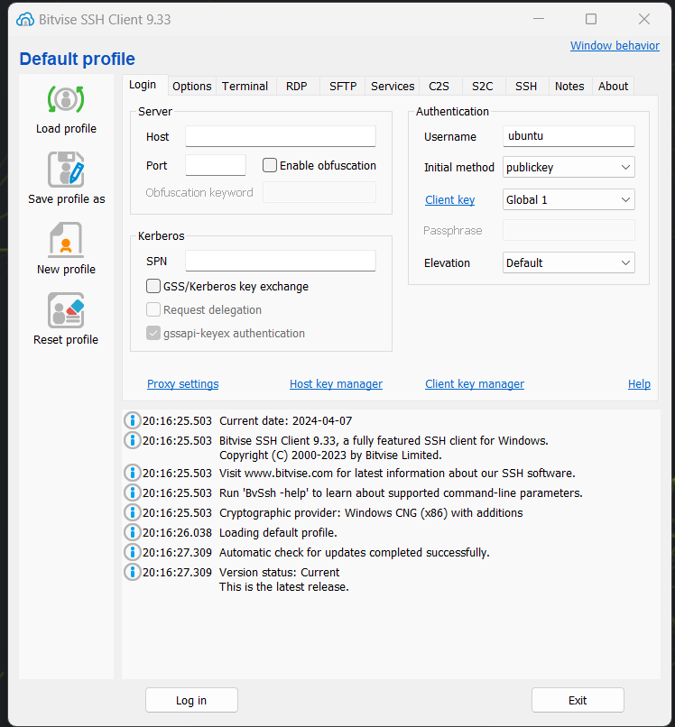

22. Navigate to the client key manager to verify if the correct key is being used. If not, remove the existing key and import the correct one. The steps are: -

i)

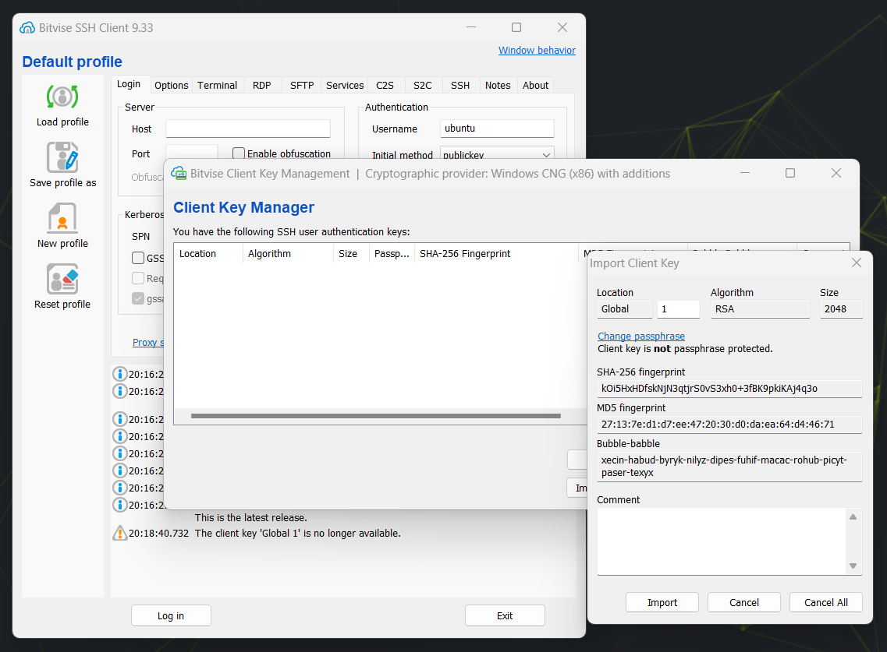

ii)

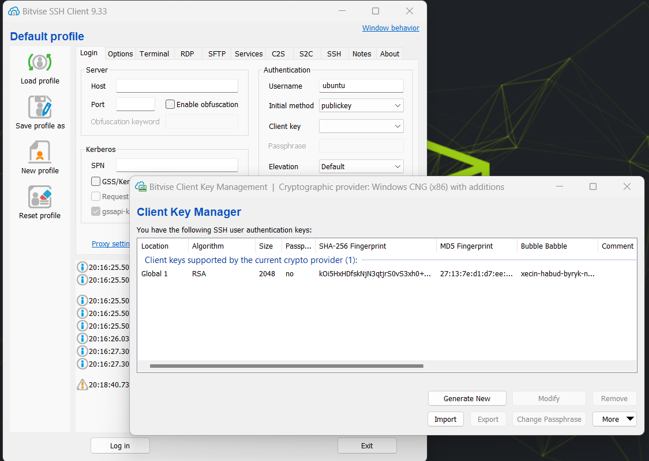

23. Enter the HOST as the public IP of your instance then click on Log in. After logging in, click on "**Accept and Save**". Subsequently, the following window will appear.

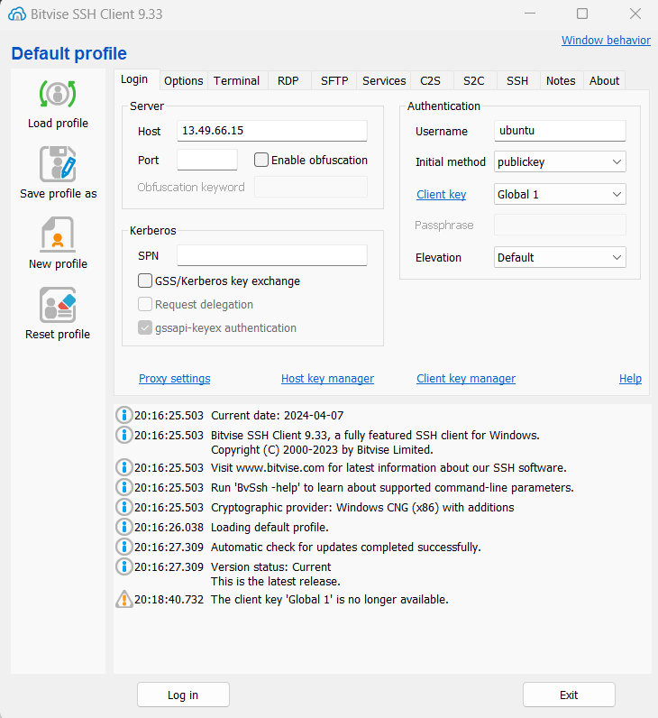

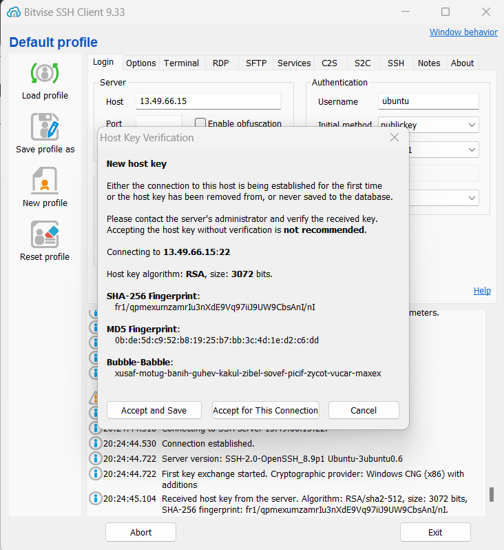

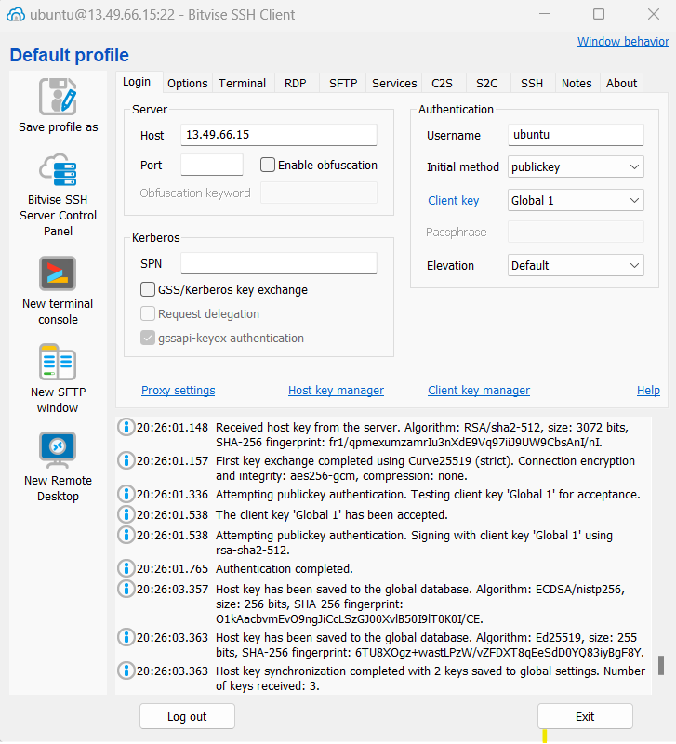

24. Access the terminal console from the provided left pane.

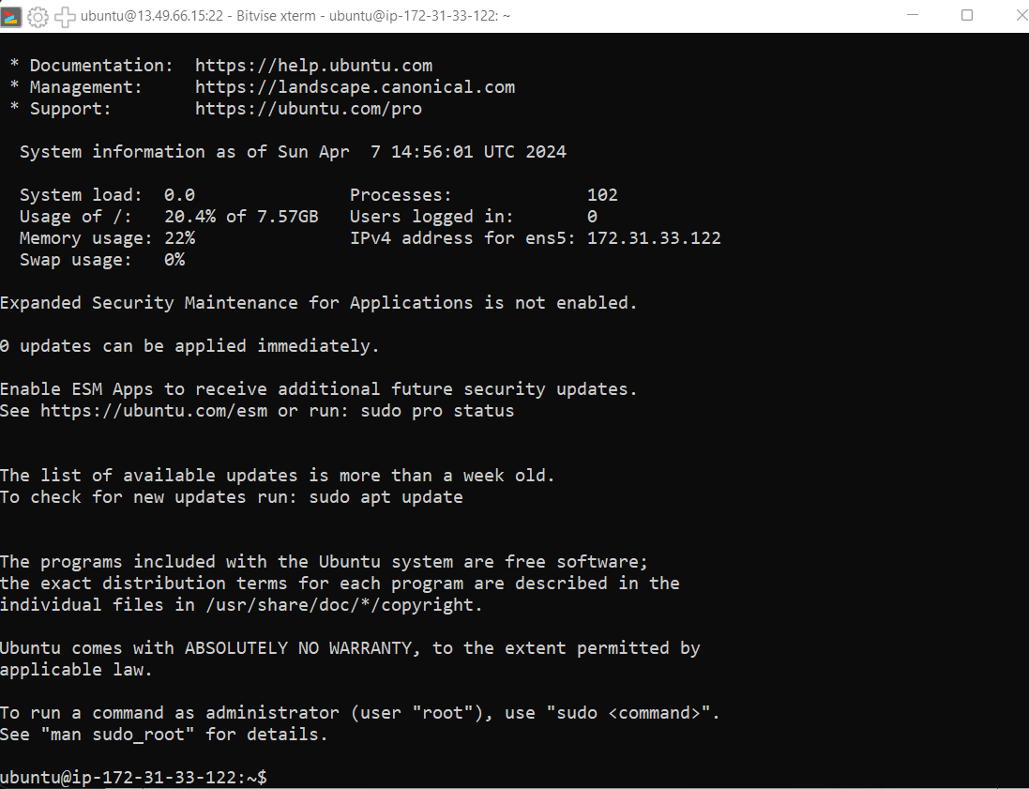

25. Proceed by entering the commands as listed below.

->***pwd***

(When executed in a terminal, it displays the current directory or the full path of the current working directory in the file system.)

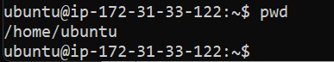

->***sudo apt-get update***

(The `sudo apt-get update` command is used on Ubuntu and other Debian-based systems to update the local package index.)

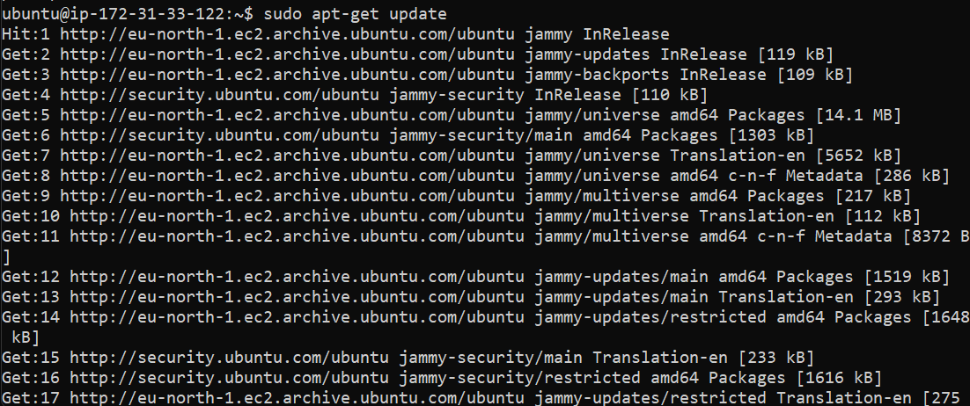

->***sudo apt-get upgrade***

(The `sudo apt-get upgrade` command, when executed on Ubuntu or other Debian-based systems, upgrades all installed packages to their latest available versions)

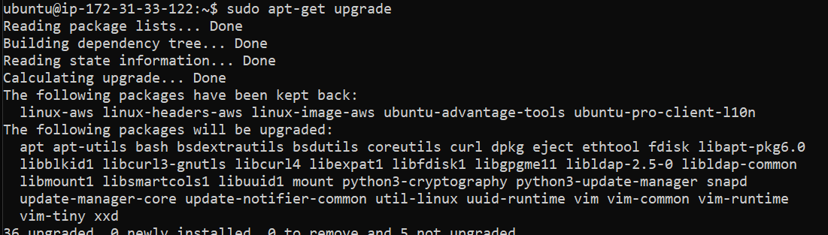

->***sudo apt-get install nginx***

(The `sudo apt-get install nginx` command, when executed on Ubuntu or other Debian-based systems, installs the Nginx web server software.)

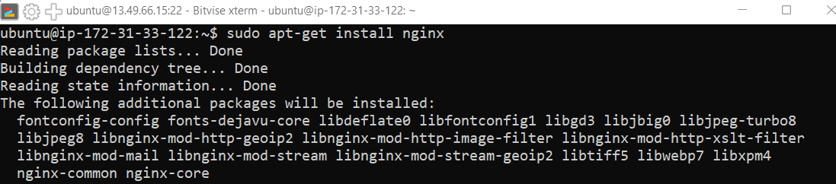

->***curl -SL*** [***https://deb.nodesource.com/setup_16.x|sudo***](https://deb.nodesource.com/setup_16.x|sudo) ***-E bash***



(After execution, your system will be set up to install Node.js version 16.x from the Node Source repository.)

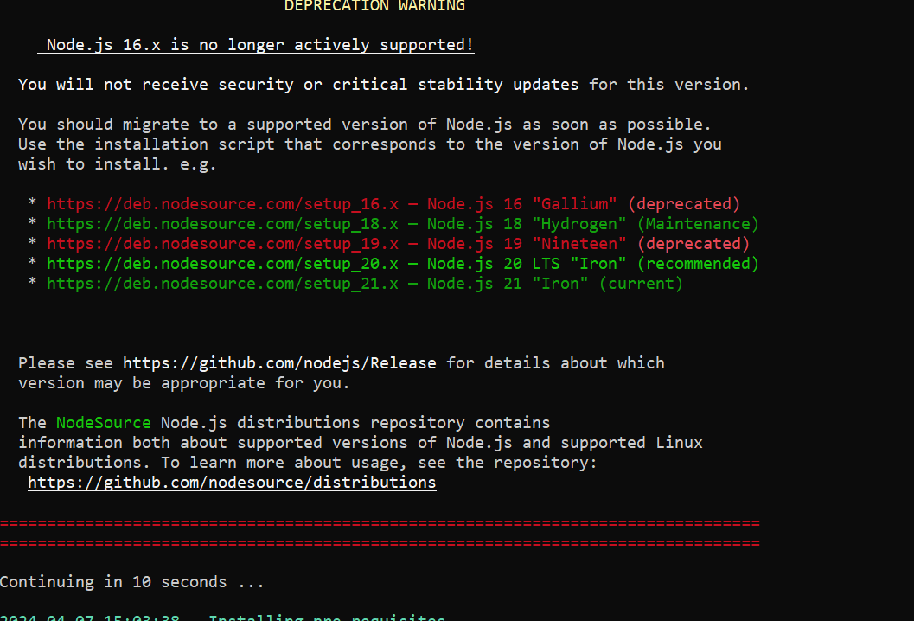

->***sudo apt install nodejs***

(The `sudo apt install NodeJS command, when executed on Ubuntu or other Debian-based systems, installs the Node.js runtime environment along with the npm package manager.)

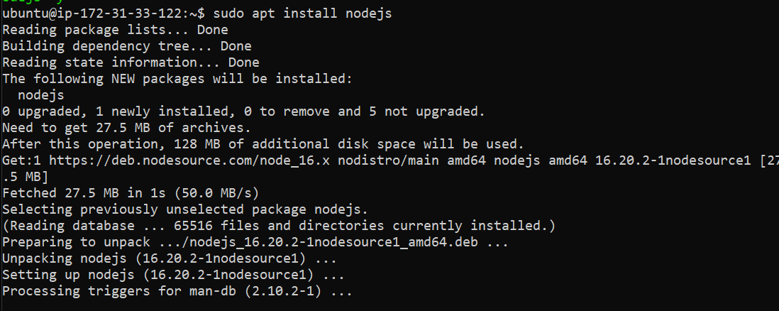

->***node --version***

(Returns the version of nodejs installed.)



->***git clone <your repository path>***

(The `git clone` command is used to create a copy of a Git repository on your local machine.)

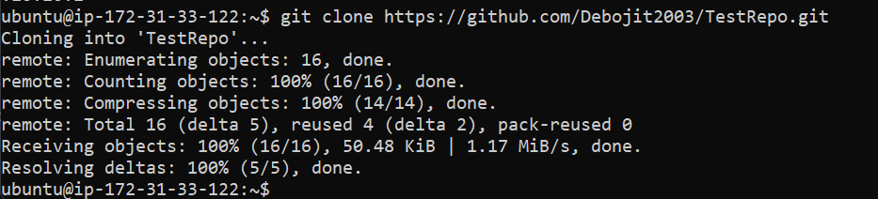

>Now go inside the repository using cd and ls.

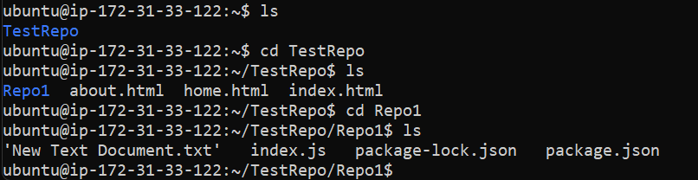

->***npm install***

(The `npm install` command is used in a Node.js project to install dependencies listed in the `package.json` file)

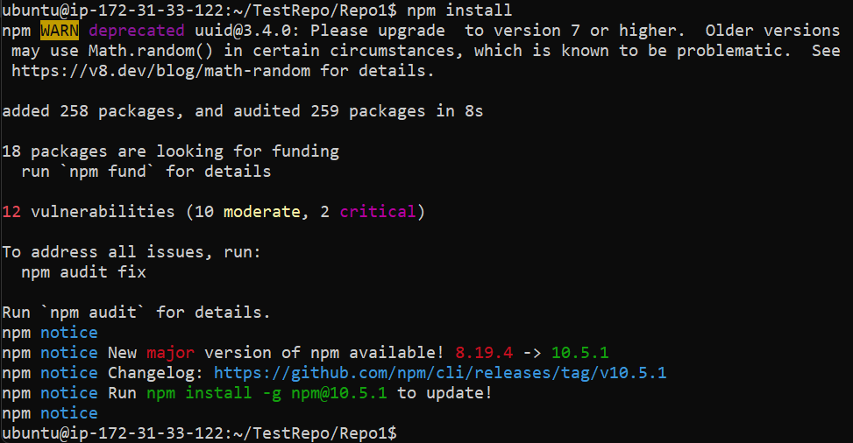

->***node index.js***

(The command `node index.js` is used to execute a JavaScript file named `index.js` using the Node.js runtime environment.)

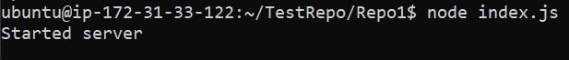

26. Open a new browser window and enter the IPv4 address followed by ":4000", like "IPv4_address:4000".

