Assignment-6

Problem Statement: Upload a static website on S3.

The steps are listed as follows: -

1. Initially, generate three HTML files**: Index, About**, and **Home**, each interlinked with one another.

2.Now sign up for an AWS account, search for ‘**S3**’ then click on it.

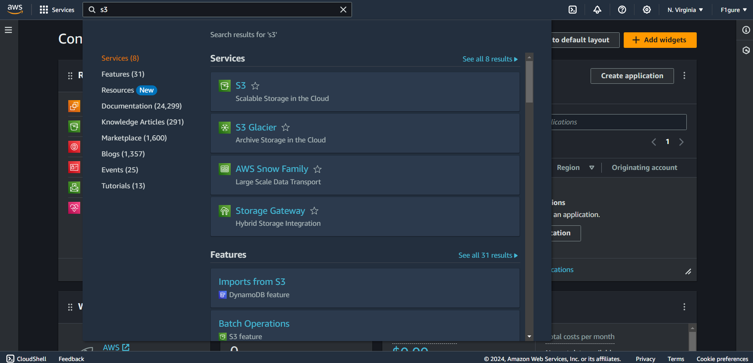

3.Click on ‘**Create bucket’**.

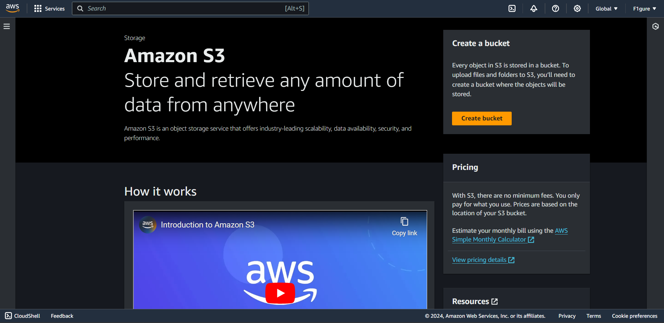

4. The subsequent window appears. From the drop-down menu, select **'Asia Pacific (Mumbai) ap-south-1**' as the AWS Region. Next, specify a bucket name, such as '-debojitbucket'.

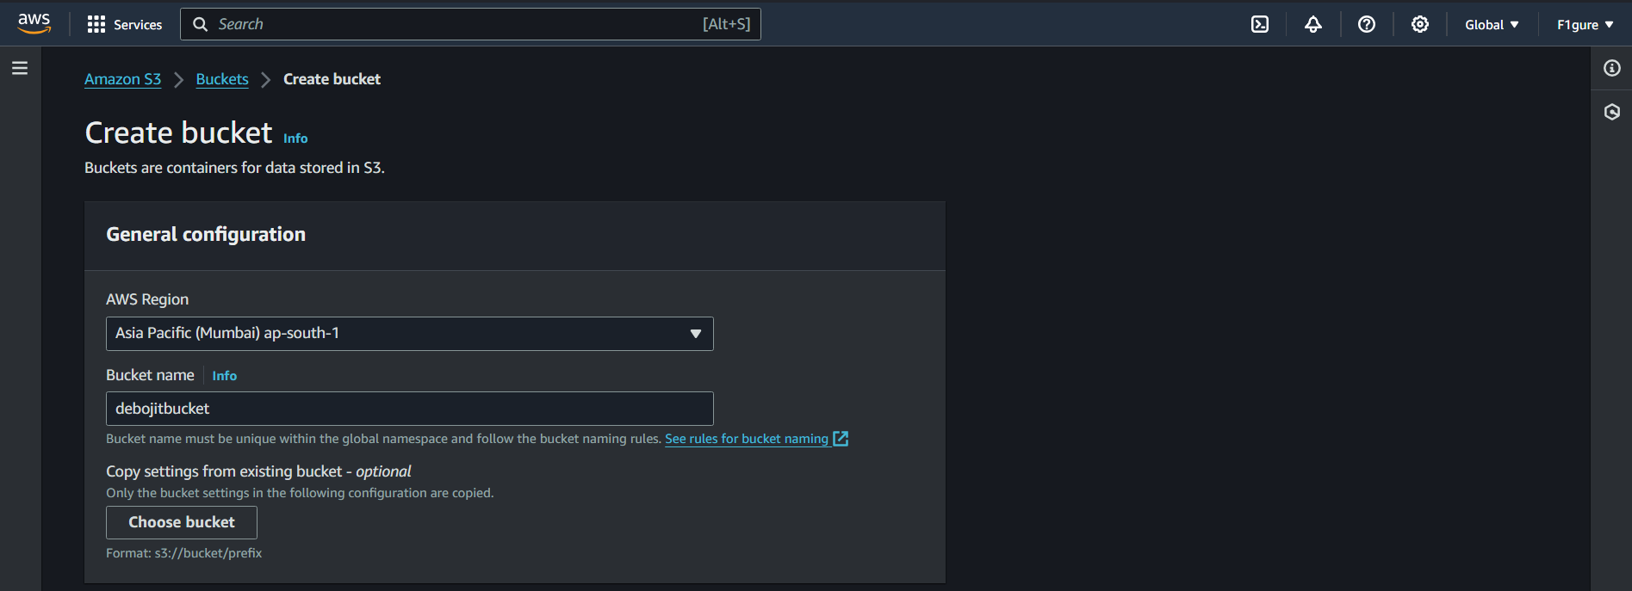

5. By default, the Object Ownership is set to **'ACLs disabled'** in this window. Select **'ACLs enabled'** since we are creating a public bucket for uploading static website.

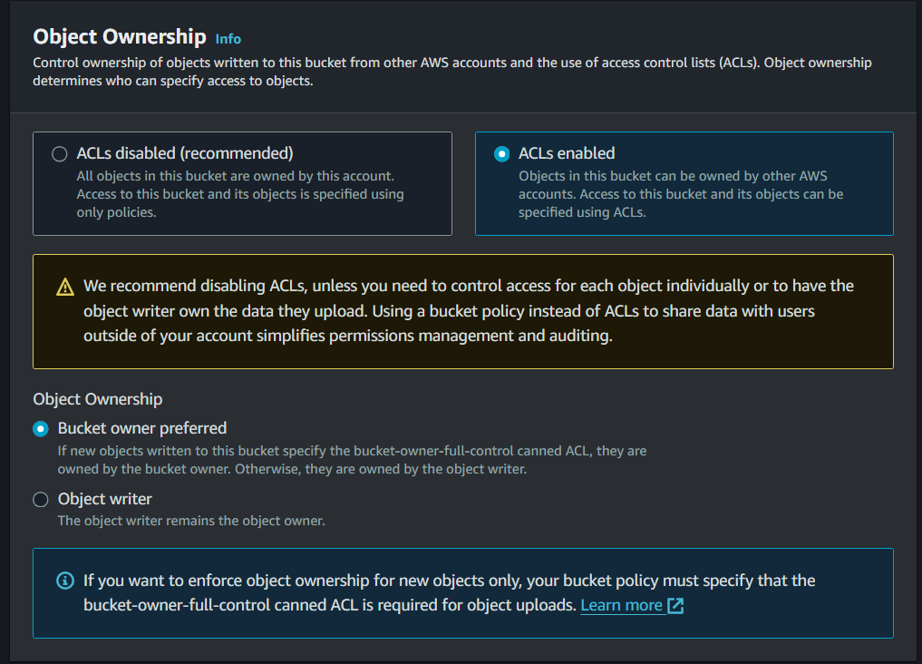

6. Now, uncheck the box for **'block all public access'**. At the bottom of the window, check the box confirming that the current setting changes may result in a public buc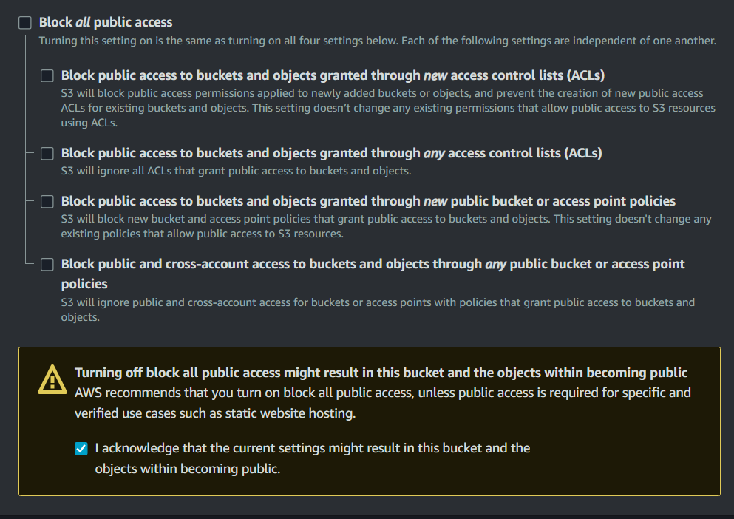

7. Scroll down without any further modifications and proceed to click on **'Create Bucket'.**

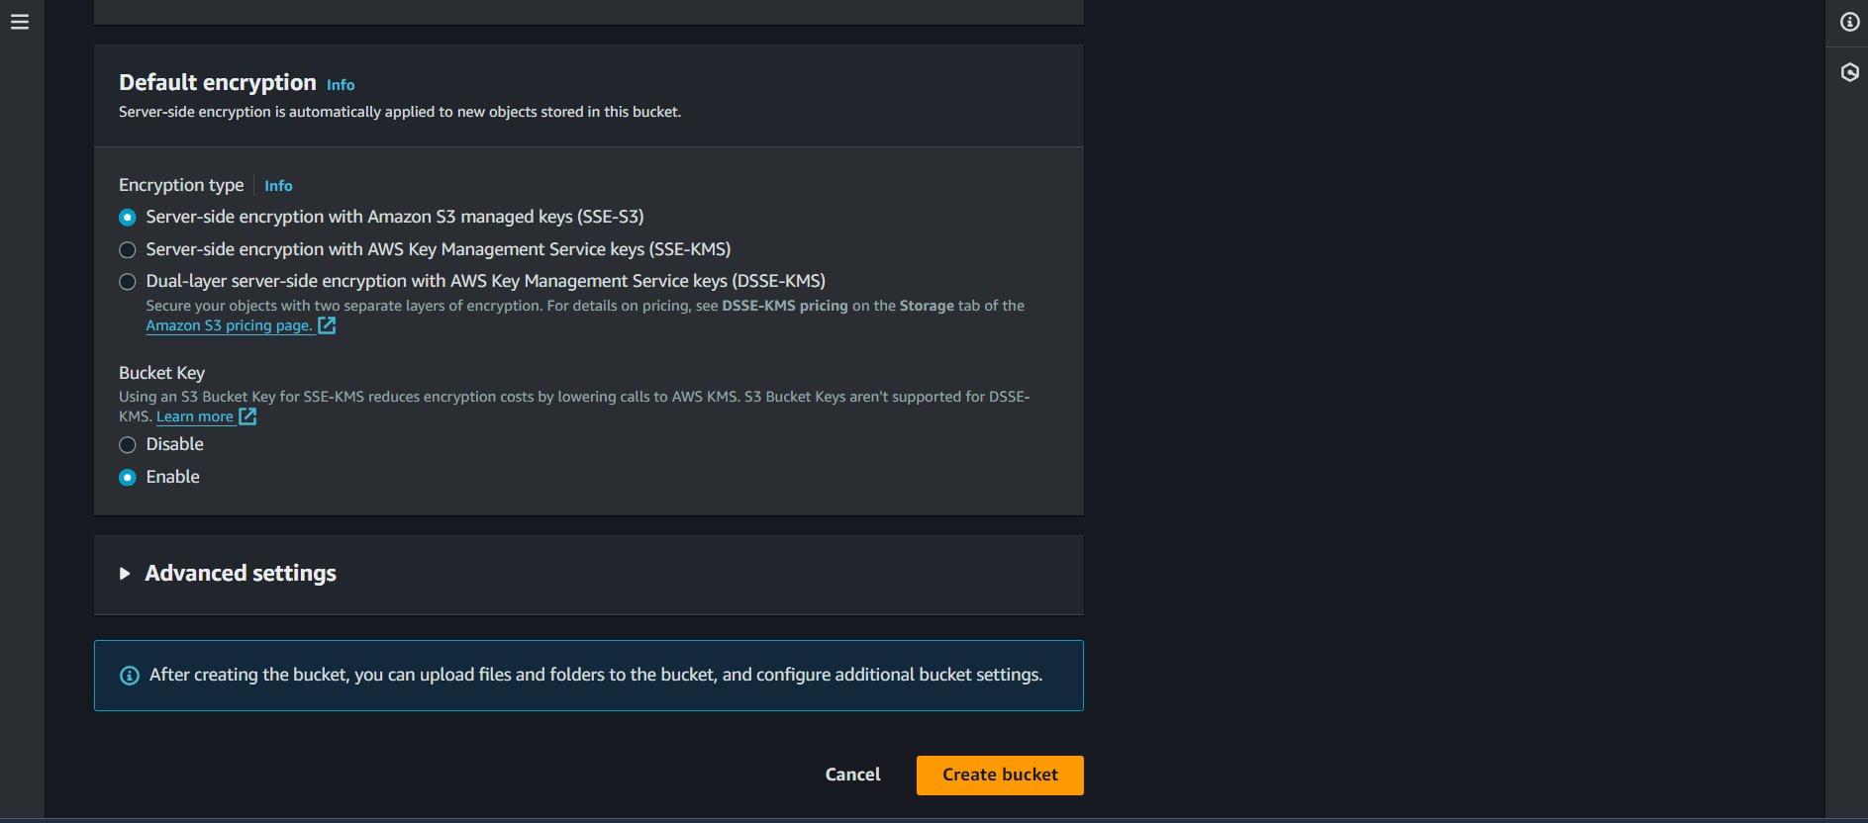

8.The bucket is created successfully.

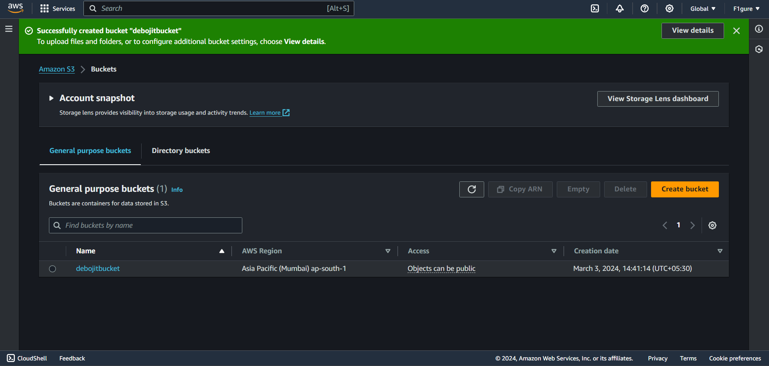

9. Now click on the bucket name.

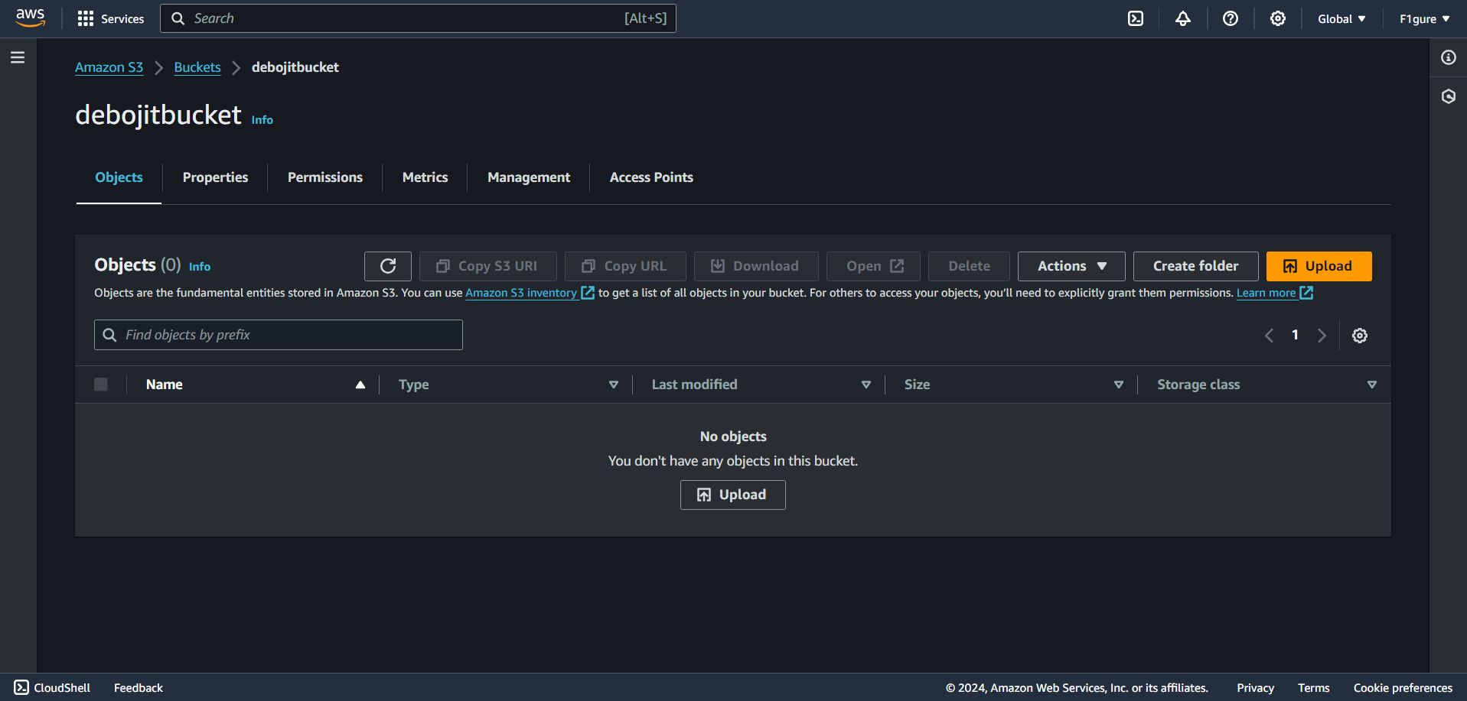

10. Choose the '**Upload'** option, which will lead to the opening of the subsequent window. From there, click on **'Add files'** and proceed to upload your desired file into the selected bucket. In this case, add the 3 HTML files.

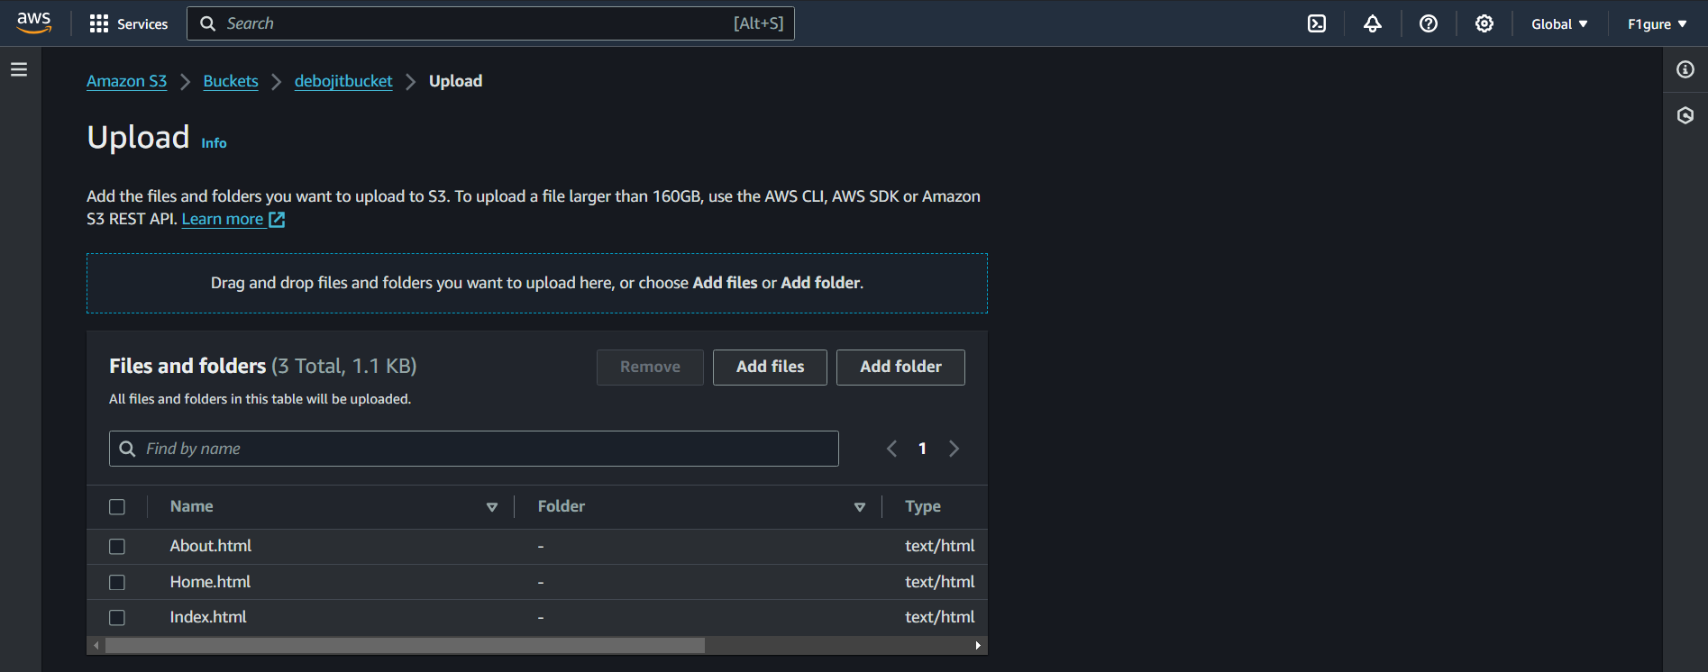

11. Select all three files and proceed to the **Permissions** settings.

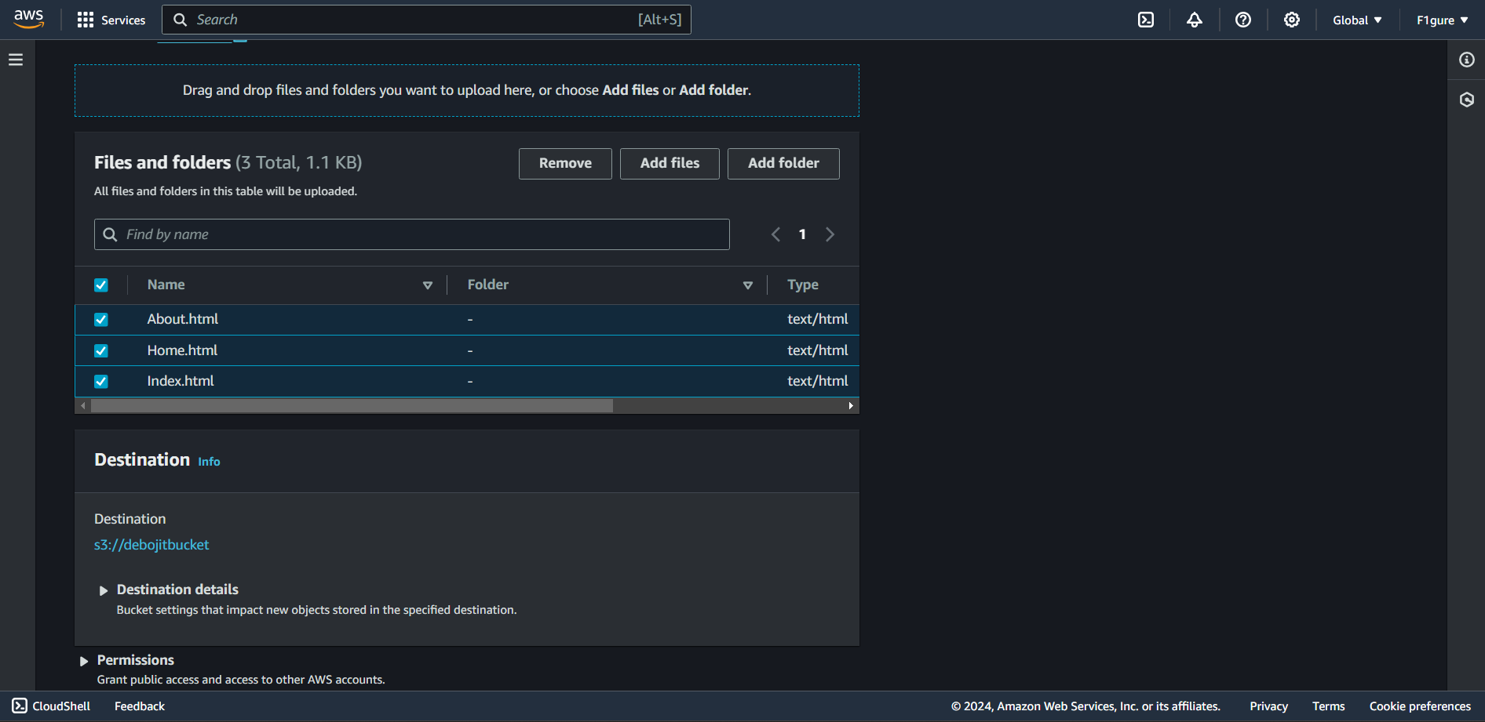

12. Next, click to **Grant public read access** and then ensure to mark the checkbox provided below. Then click on **Upload**.

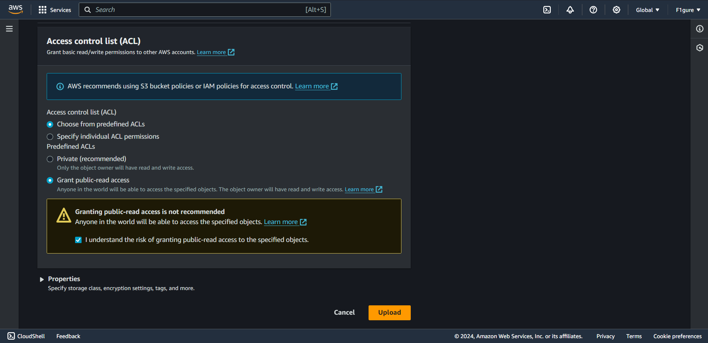

13. The notification confirms that the file has been successfully uploaded. Click on **'Close'** to return.

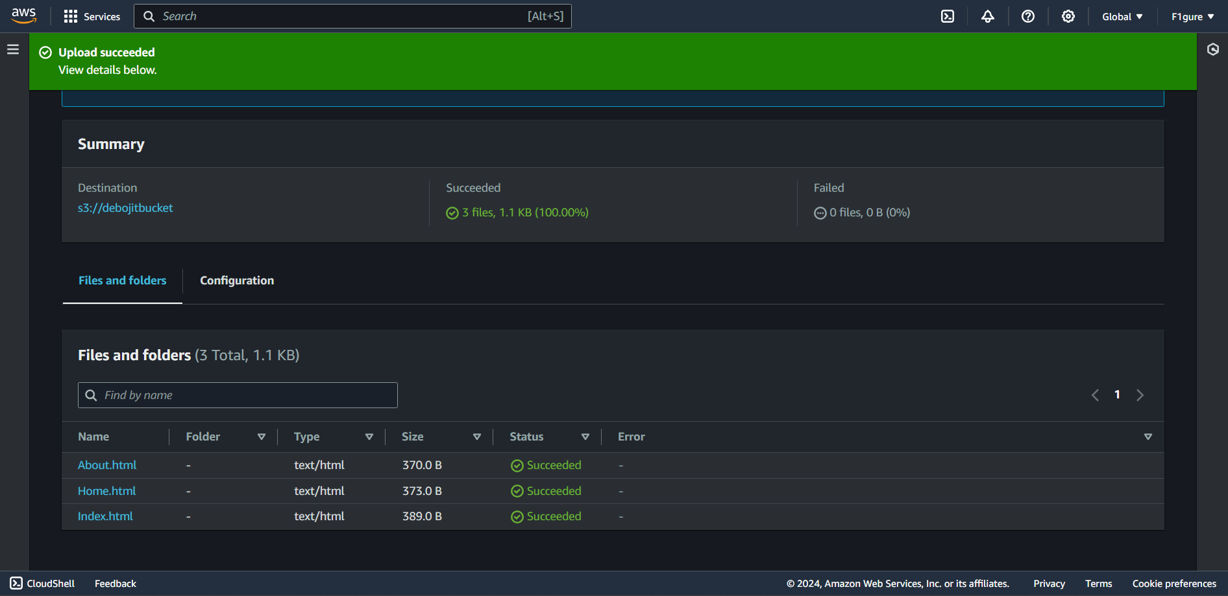

14. Proceed to the **Properties** section now.

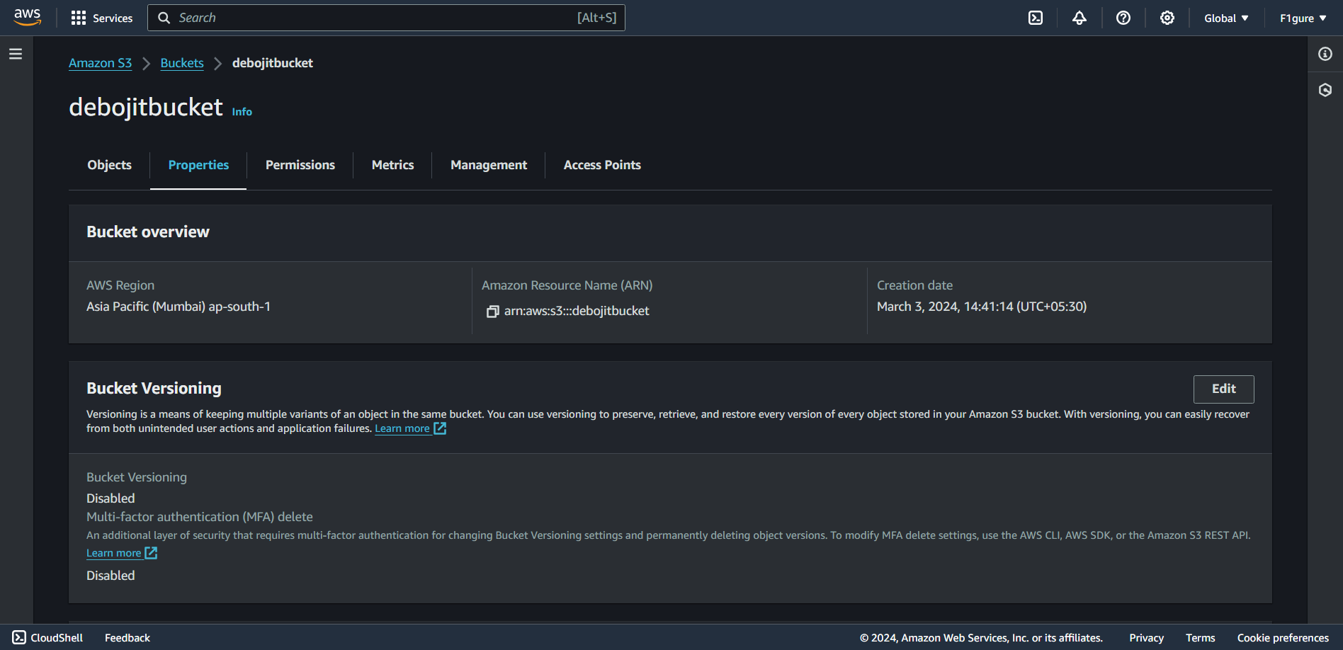

15. Continue scrolling downwards and locate the option for **static website hosting**, then proceed to click on the "**Edit**" button.

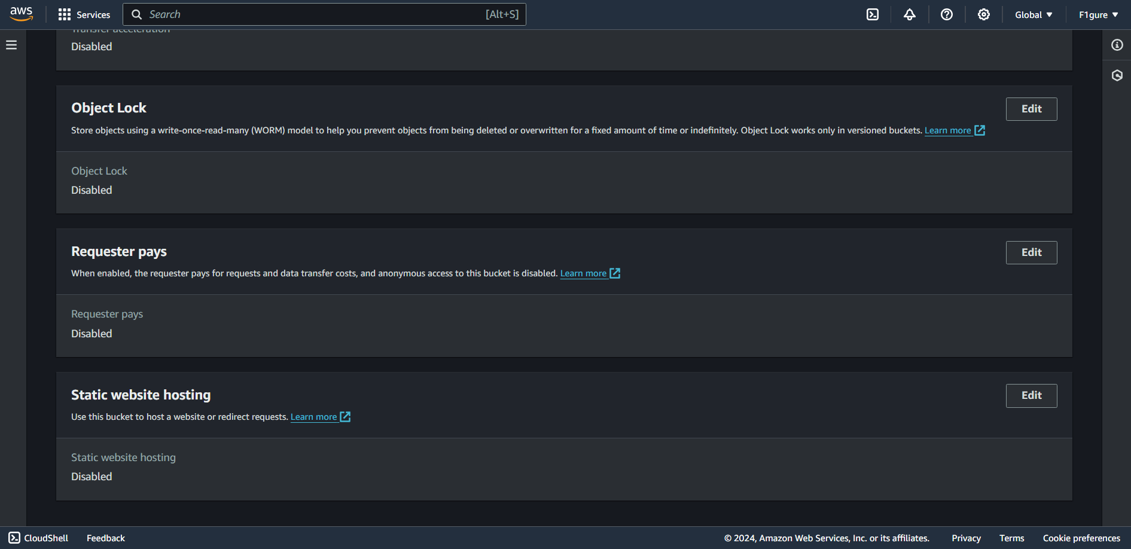

16. Under ‘**Static website hosting’**, click on ‘**Enable**’, then fill in the name of index document and click on **Save changes**.

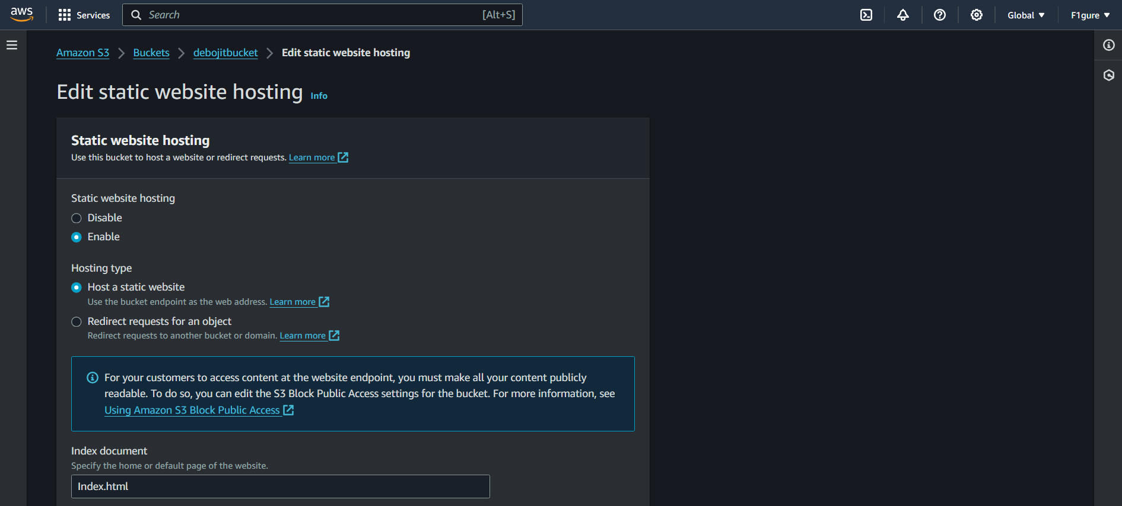

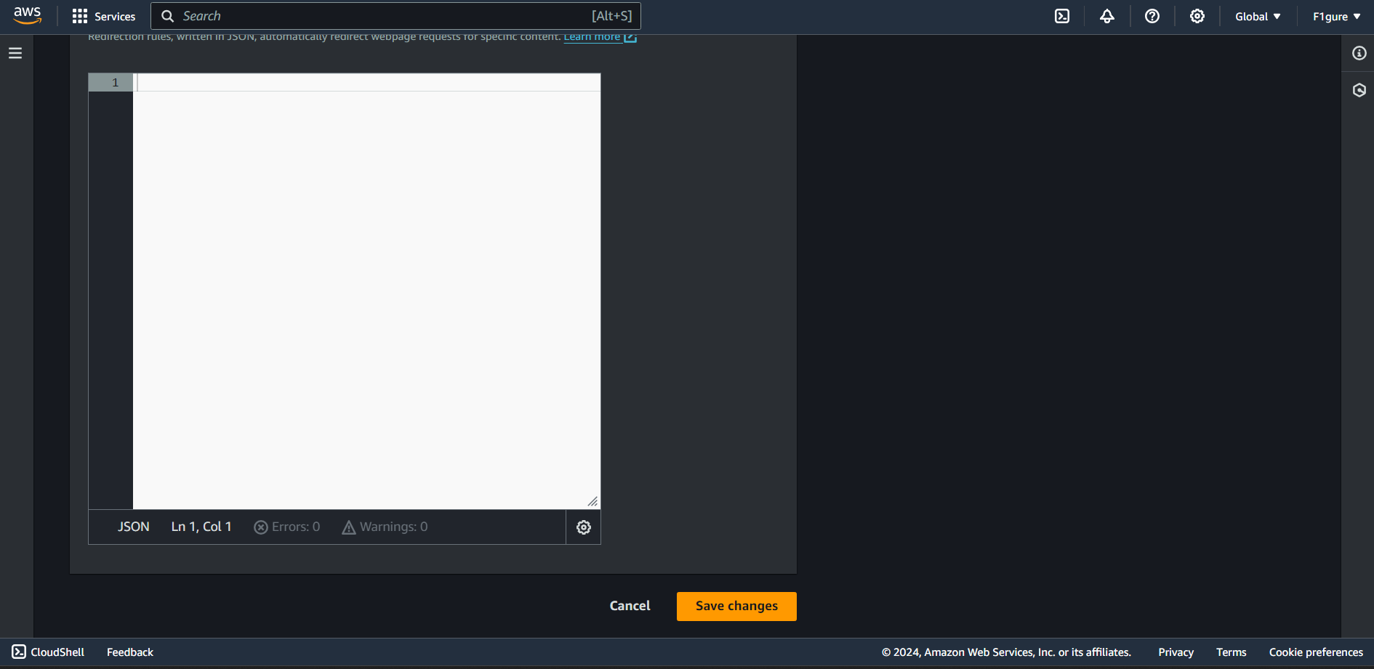

17. The notification confirms that static website hosting has been updated.

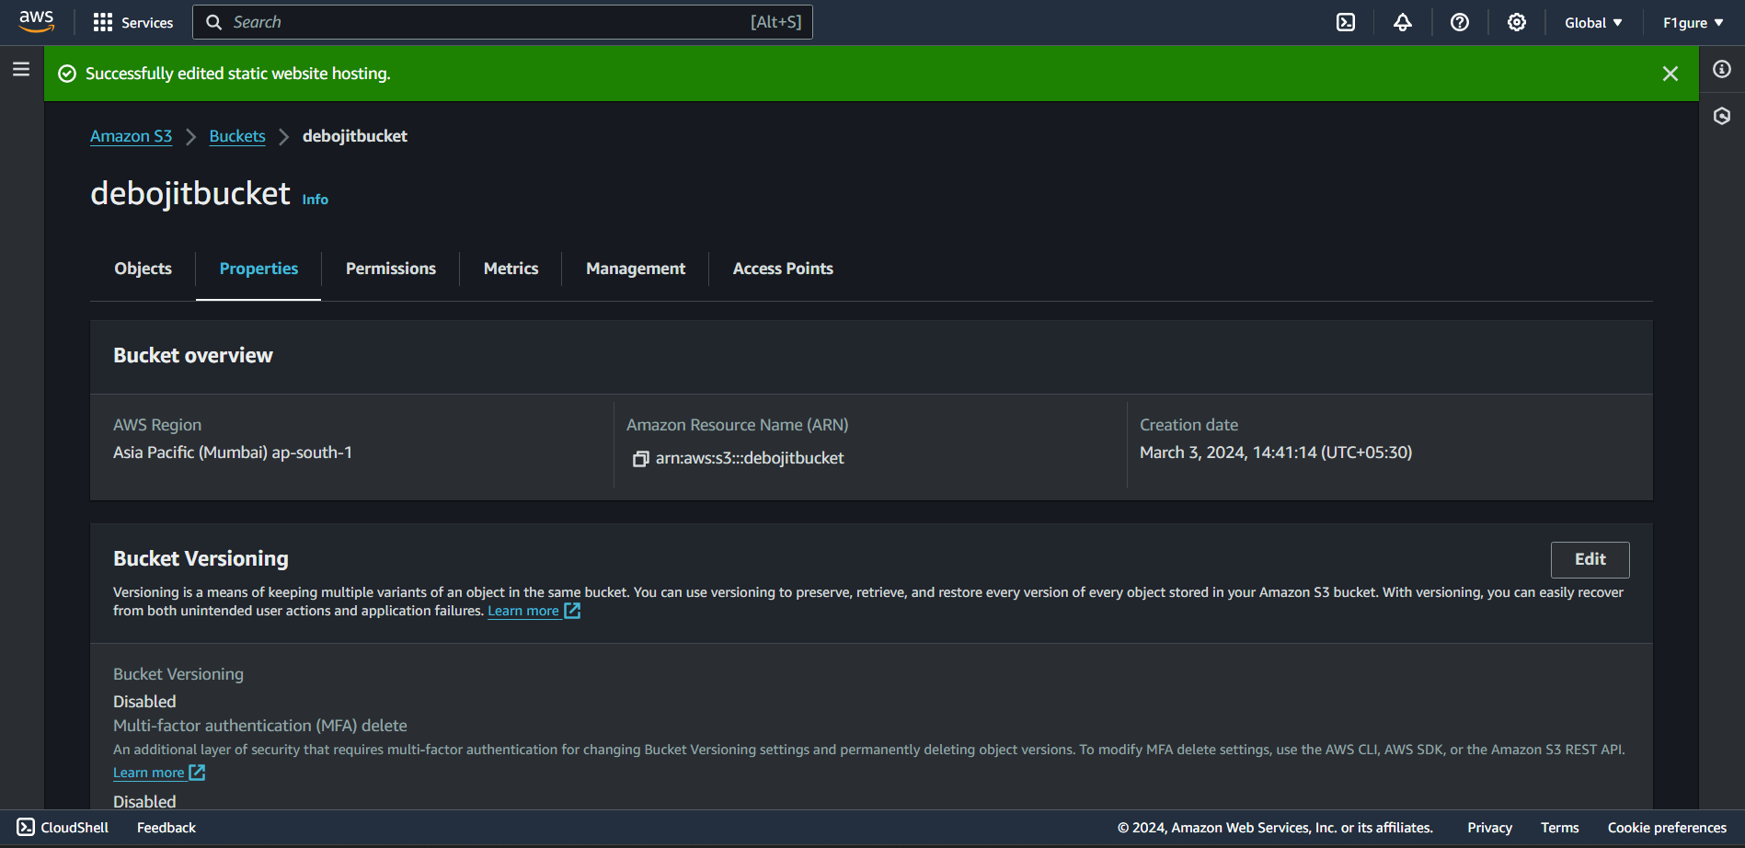

18. Scroll further down and then copy the **endpoint for the bucket website**.

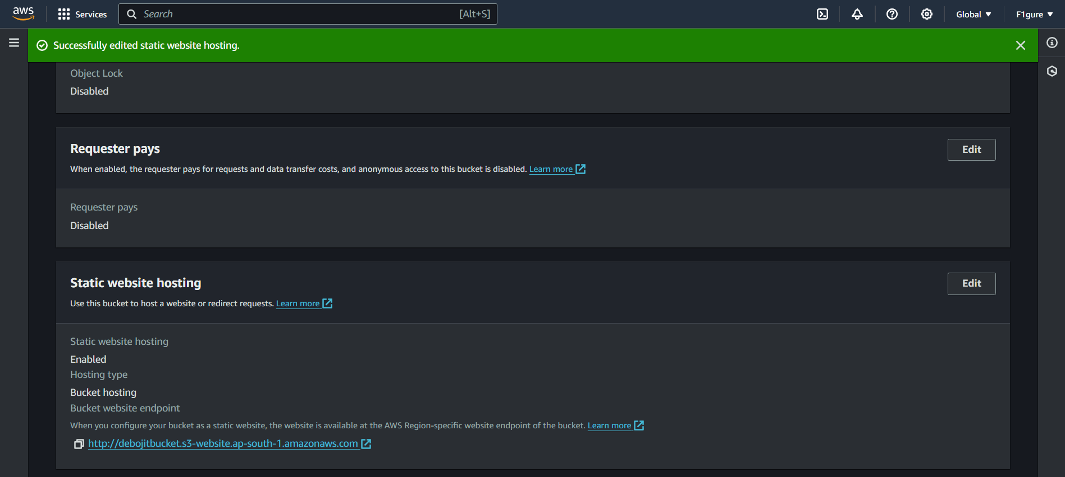

19. Open a new browser tab and paste the 'Bucket website endpoint' into the address bar. The 3 pages will be displayed as per your written code.

