**Assignment No:12**

**Problem Statement:** Deploy and run the project in AWS without using the port.

The steps are as follows: -

1. Navigate to AWS and locate the EC2 service. Choose the first option listed under the EC2 services.

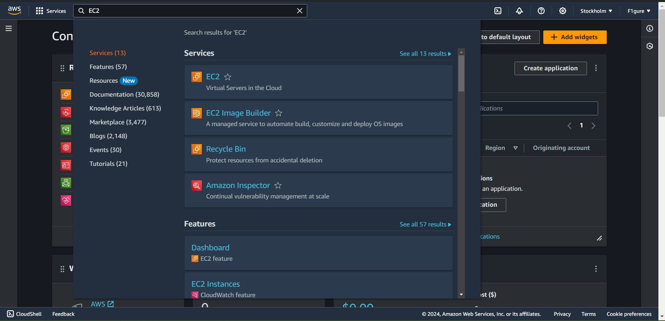

2. Select the "**Security group"** option.

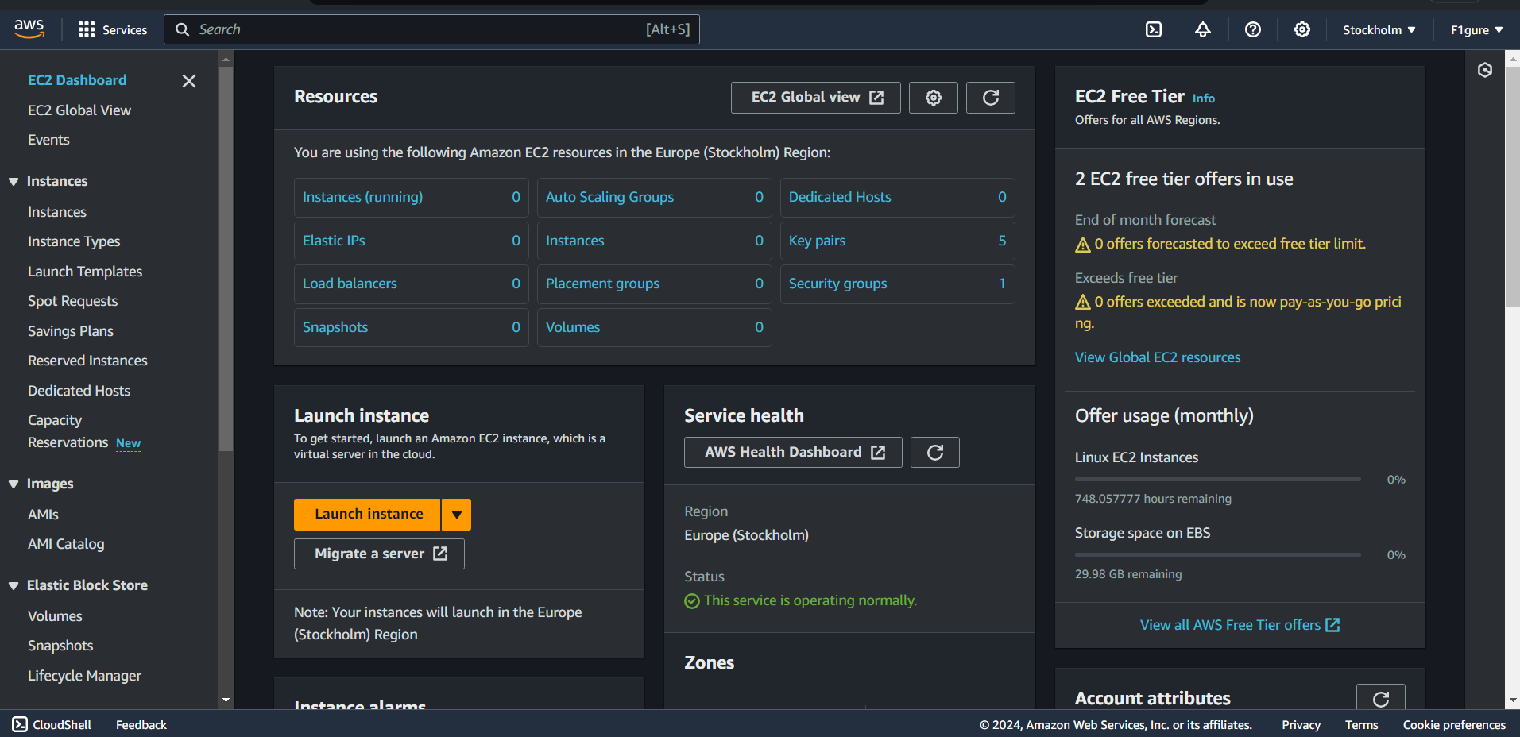

3.Now, select “**create security group”.**

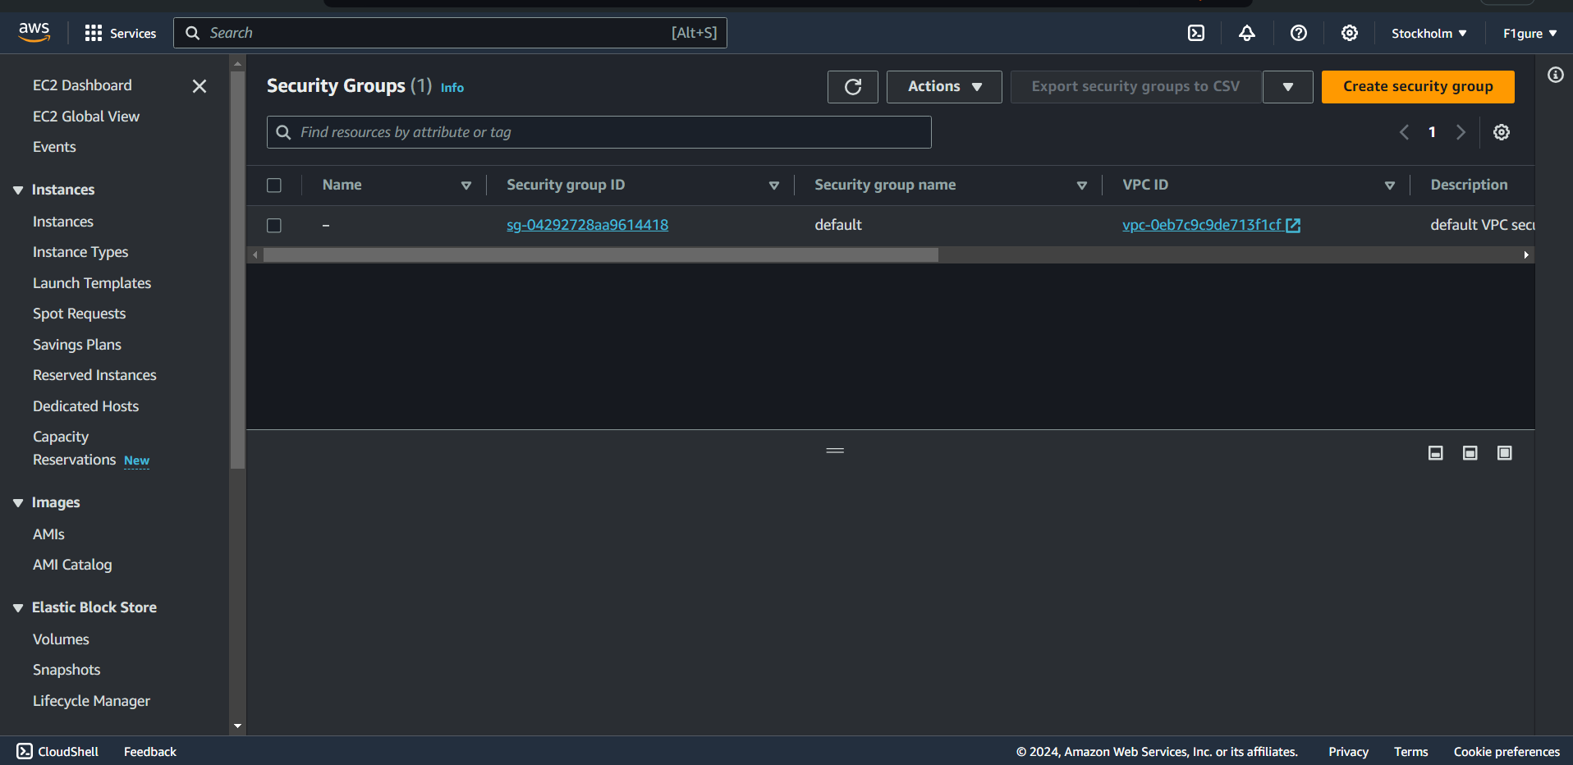

4.Choose an appropriate and valid name for the group (for instance, we've used " **debojitsecurity** " here). You can also copy the same name into the **'Description**' field, or provide any other relevant information.

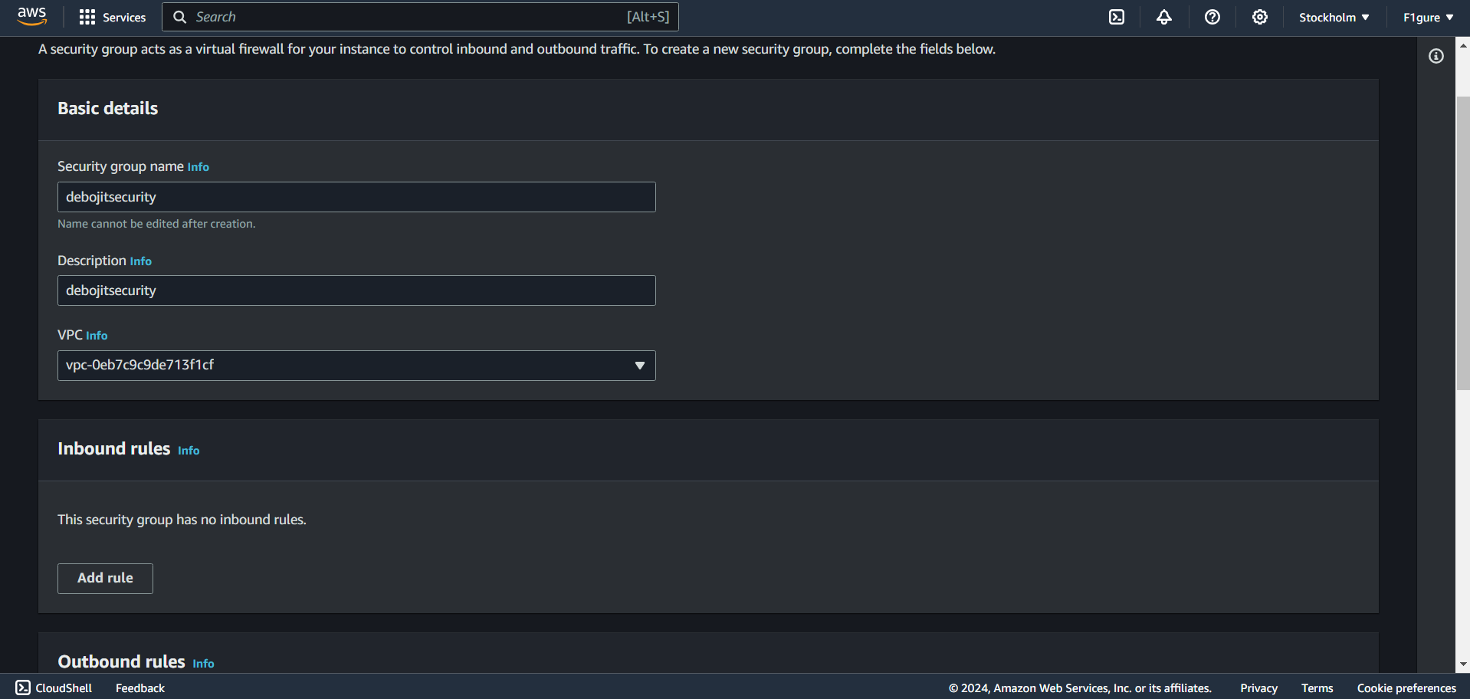

5. Within the **'Inbound rules'** section, select **'Add rule'**.

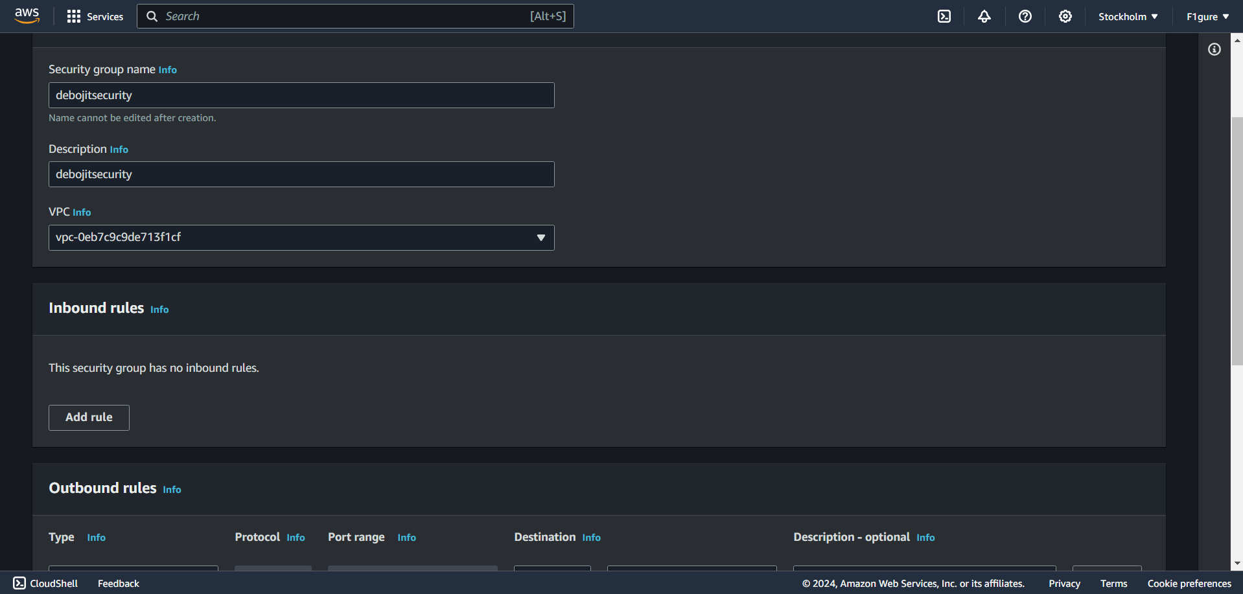

6. Since **'Custom TCP'** protocol is already chosen, input '**4000'** (as specified in the index.js) in the Port range field and select **'0.0.0.0/0'**. Then include the three protocols **SSH, HTTP, and HTTPS** from the dropdown list and select **'0.0.0.0/0'** for while adding each of them.

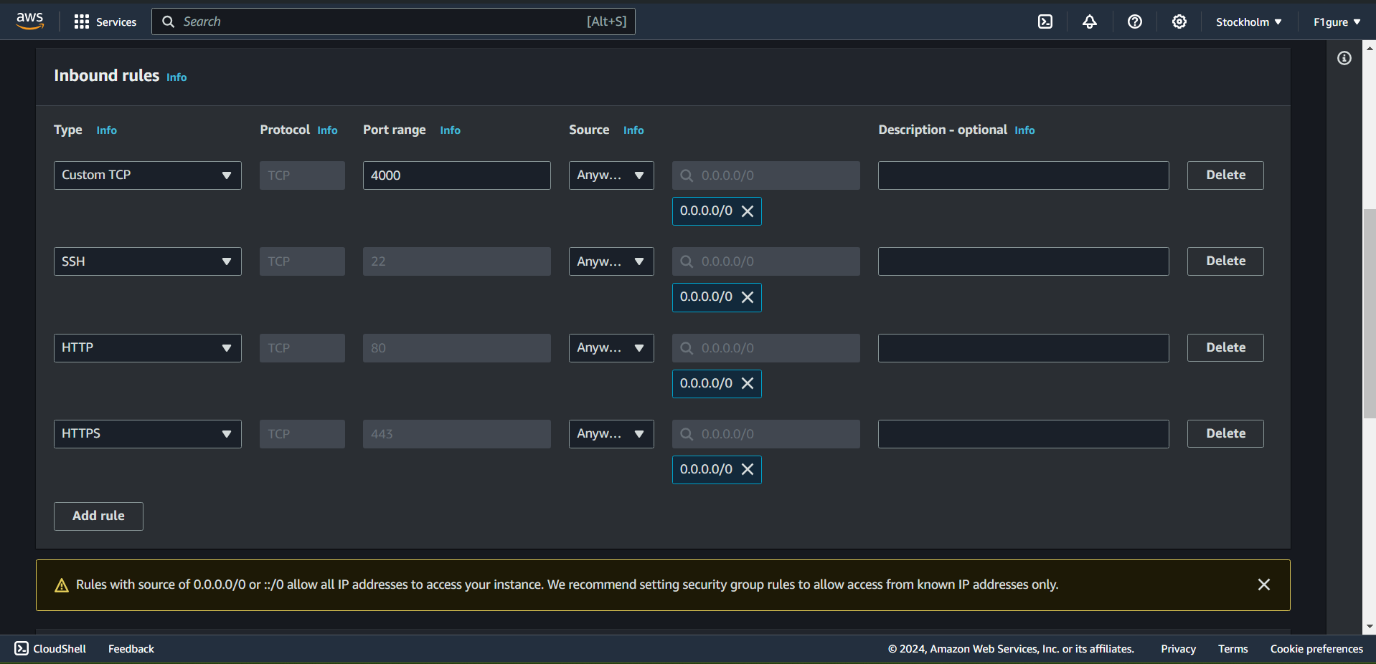

7. Scroll down without making any changes to the Outbound rules, then proceed to click on "**Create security group**".

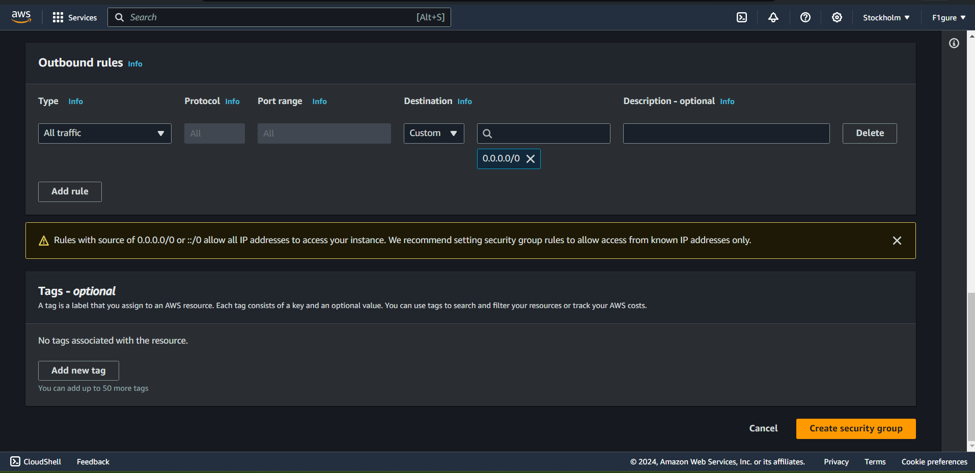

8. The security group is created successfully.

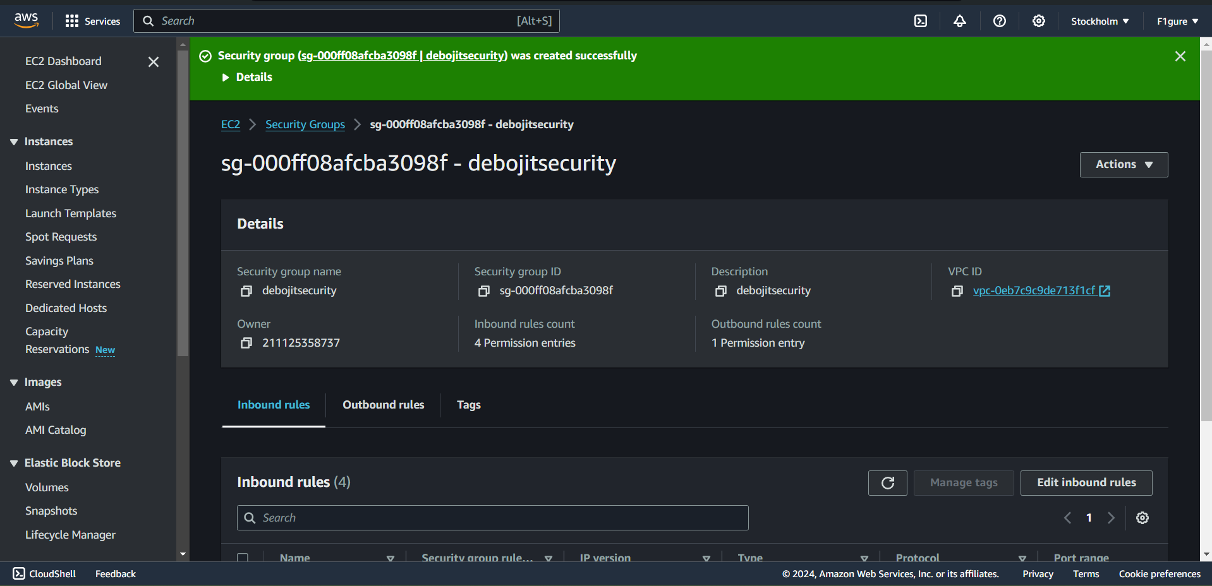

9. Return to the "**EC2 dashboard**" and select "**Launch Instance**".

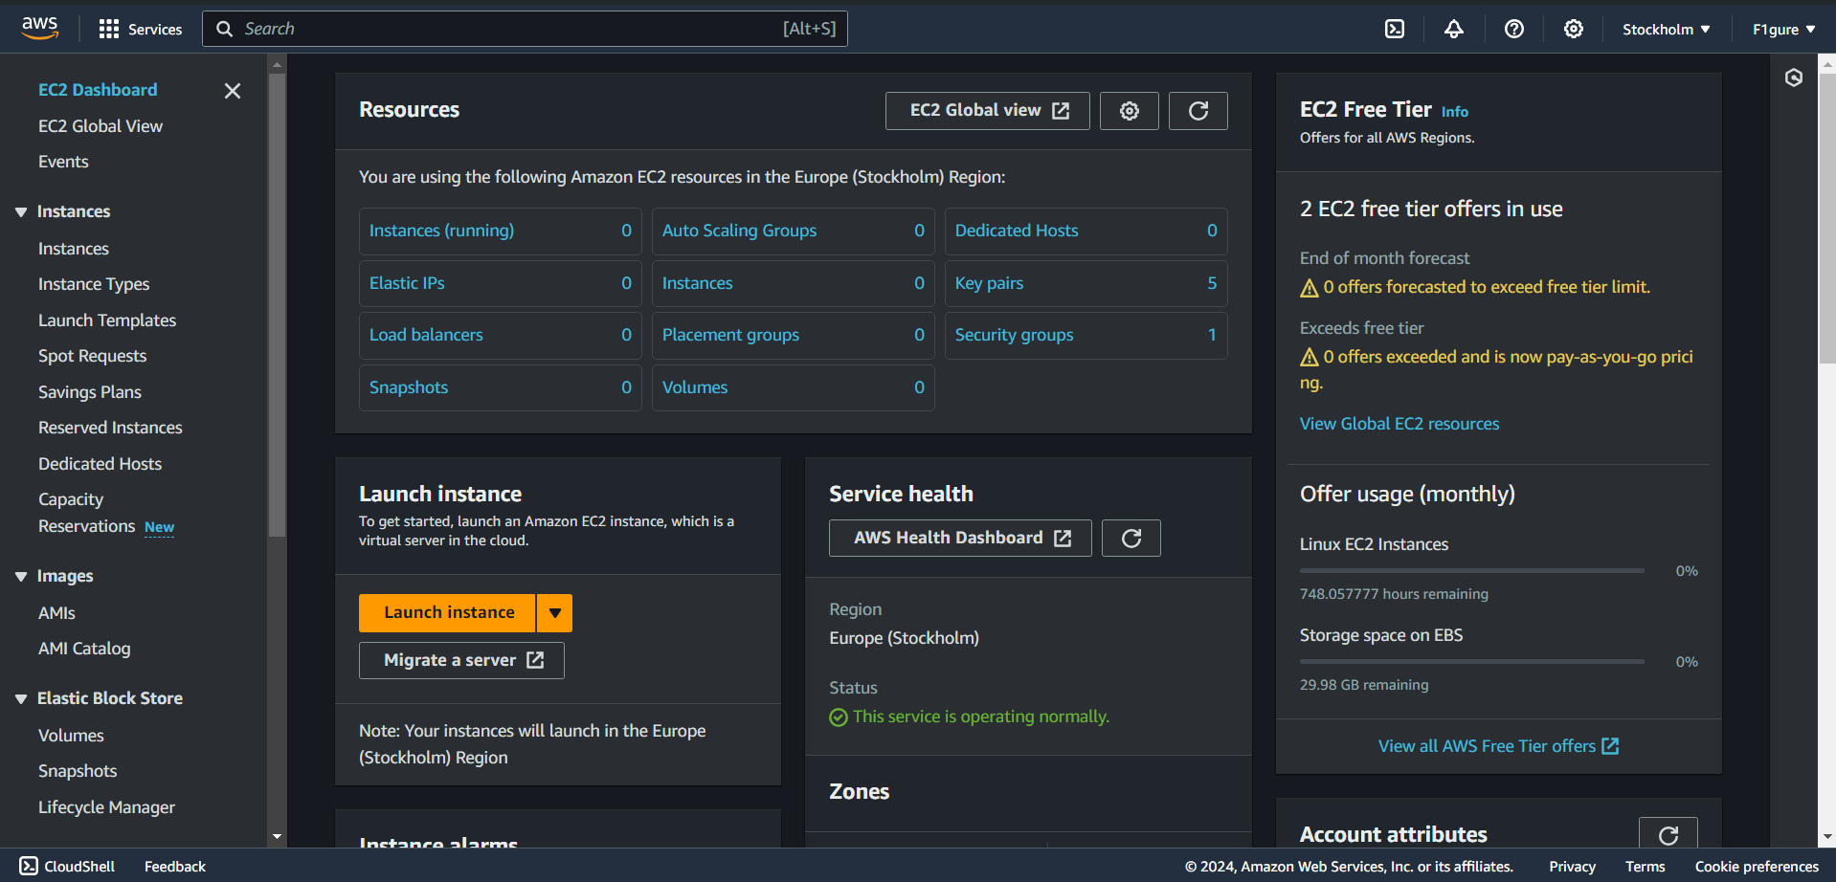

10.Enter a suitable and valid name for the instance (for instance, " **debec2**" in this example).

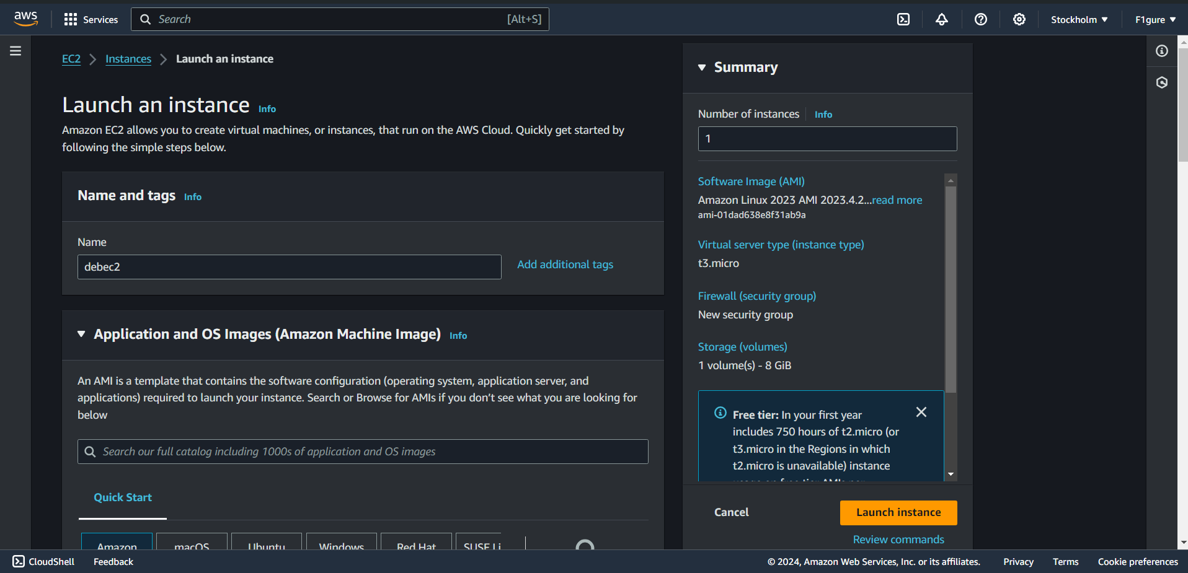

11. Choose "**Ubuntu**" as the AMI from the available options.

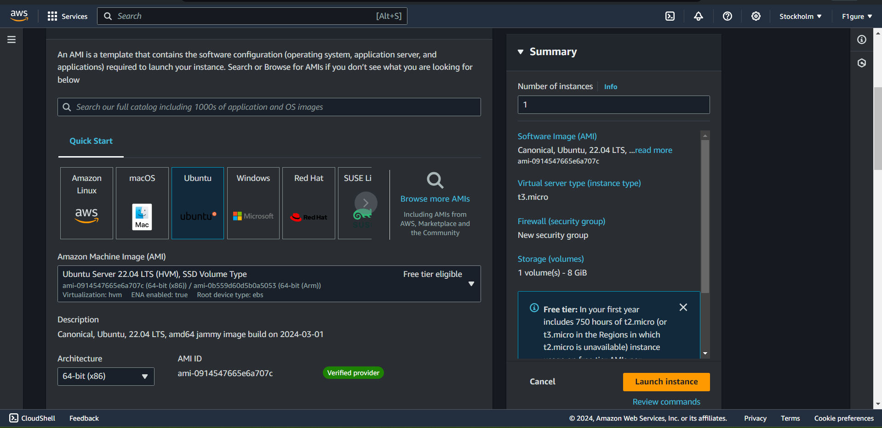

12. Choose an existing key pair, or alternatively, create a new key pair if necessary. In this case, the existing key pair named " **newkey1**" is utilized.

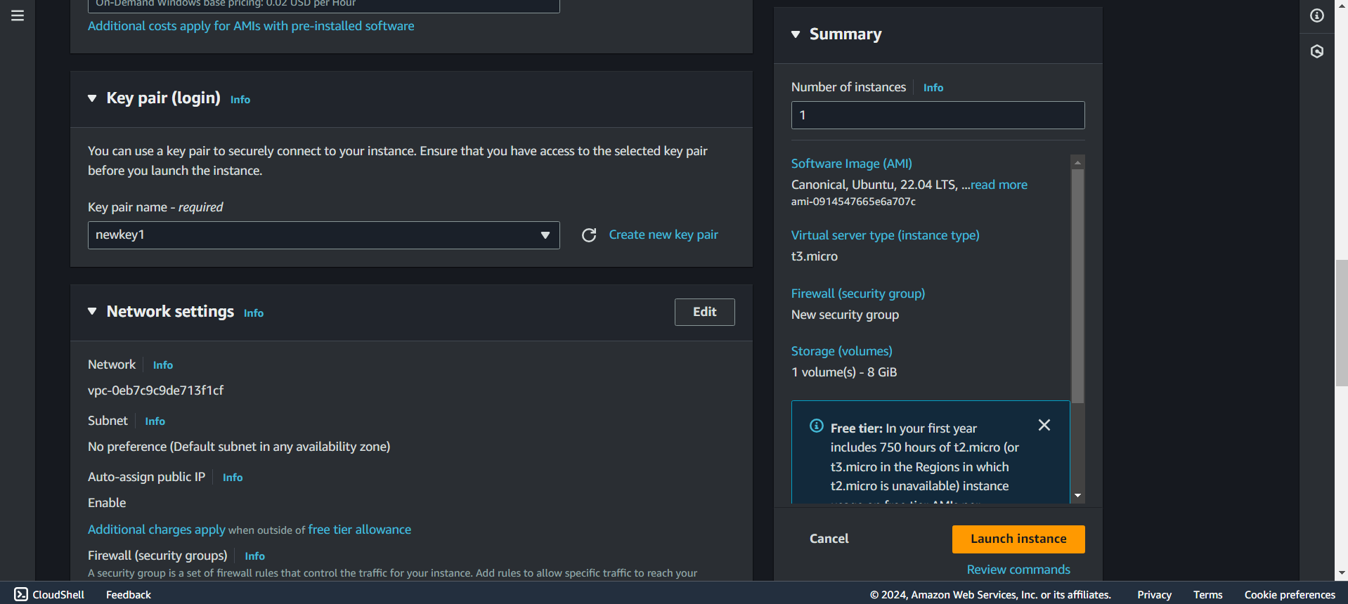

13.Next, click on the "**Select existing security group**" option. From the dropdown menu, choose the existing security group that was created as outlined in the previous steps.

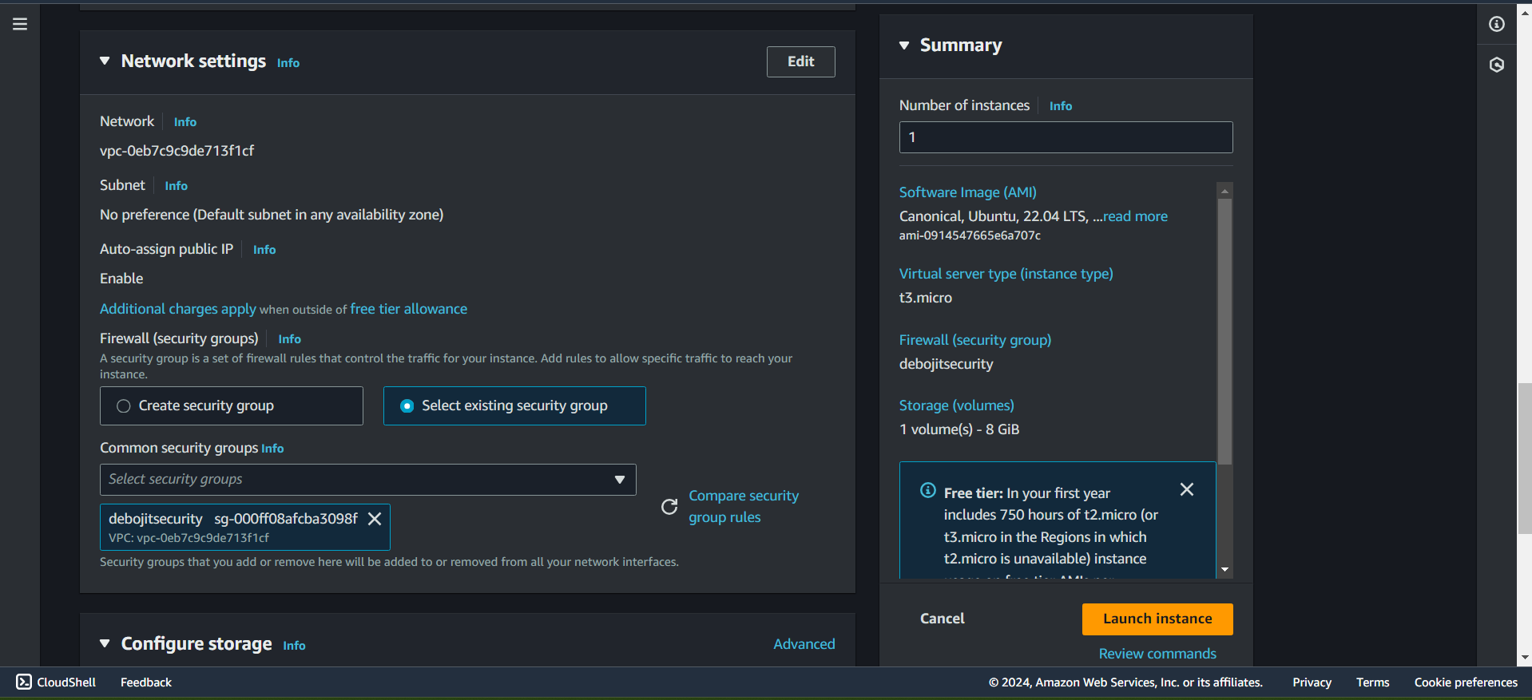

14. Then, proceed to click on "**launch instance**".

15.The instance has been successfully created utilizing the existing security group.

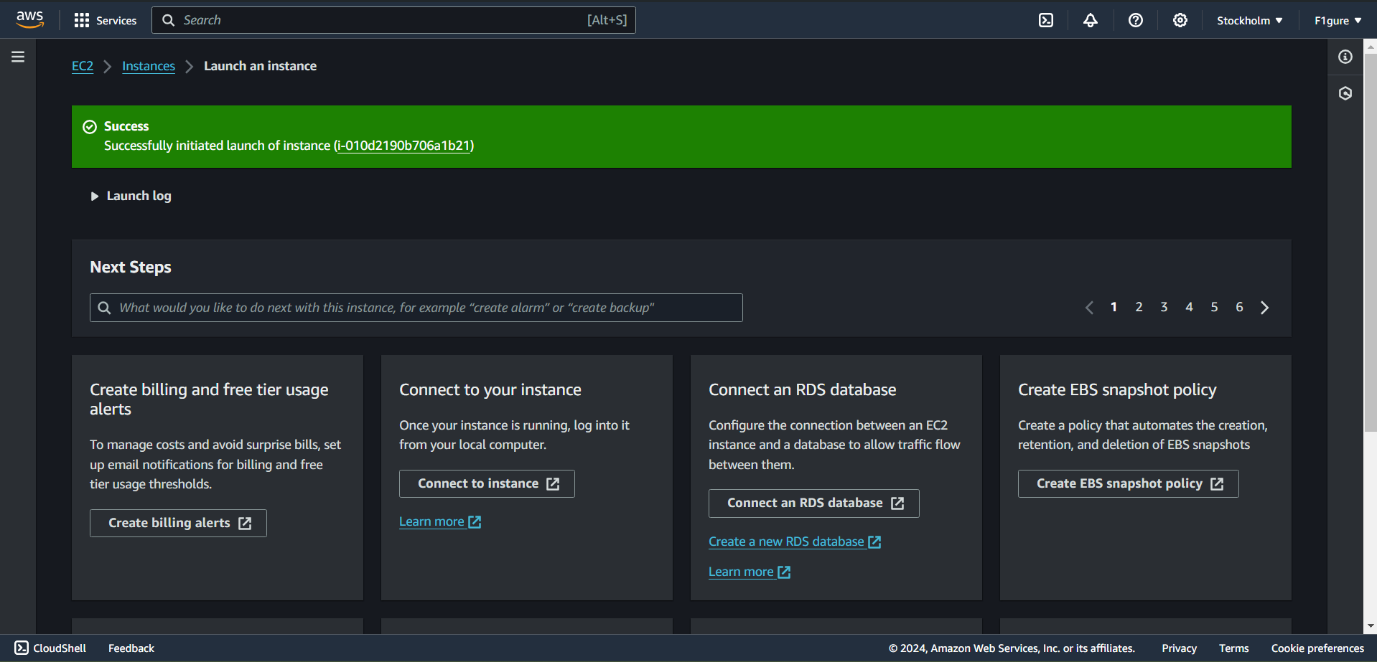

16. Navigate to the "**Instances**" section in the left pane. Then, identify and click on the instance ID of the newly created instance.

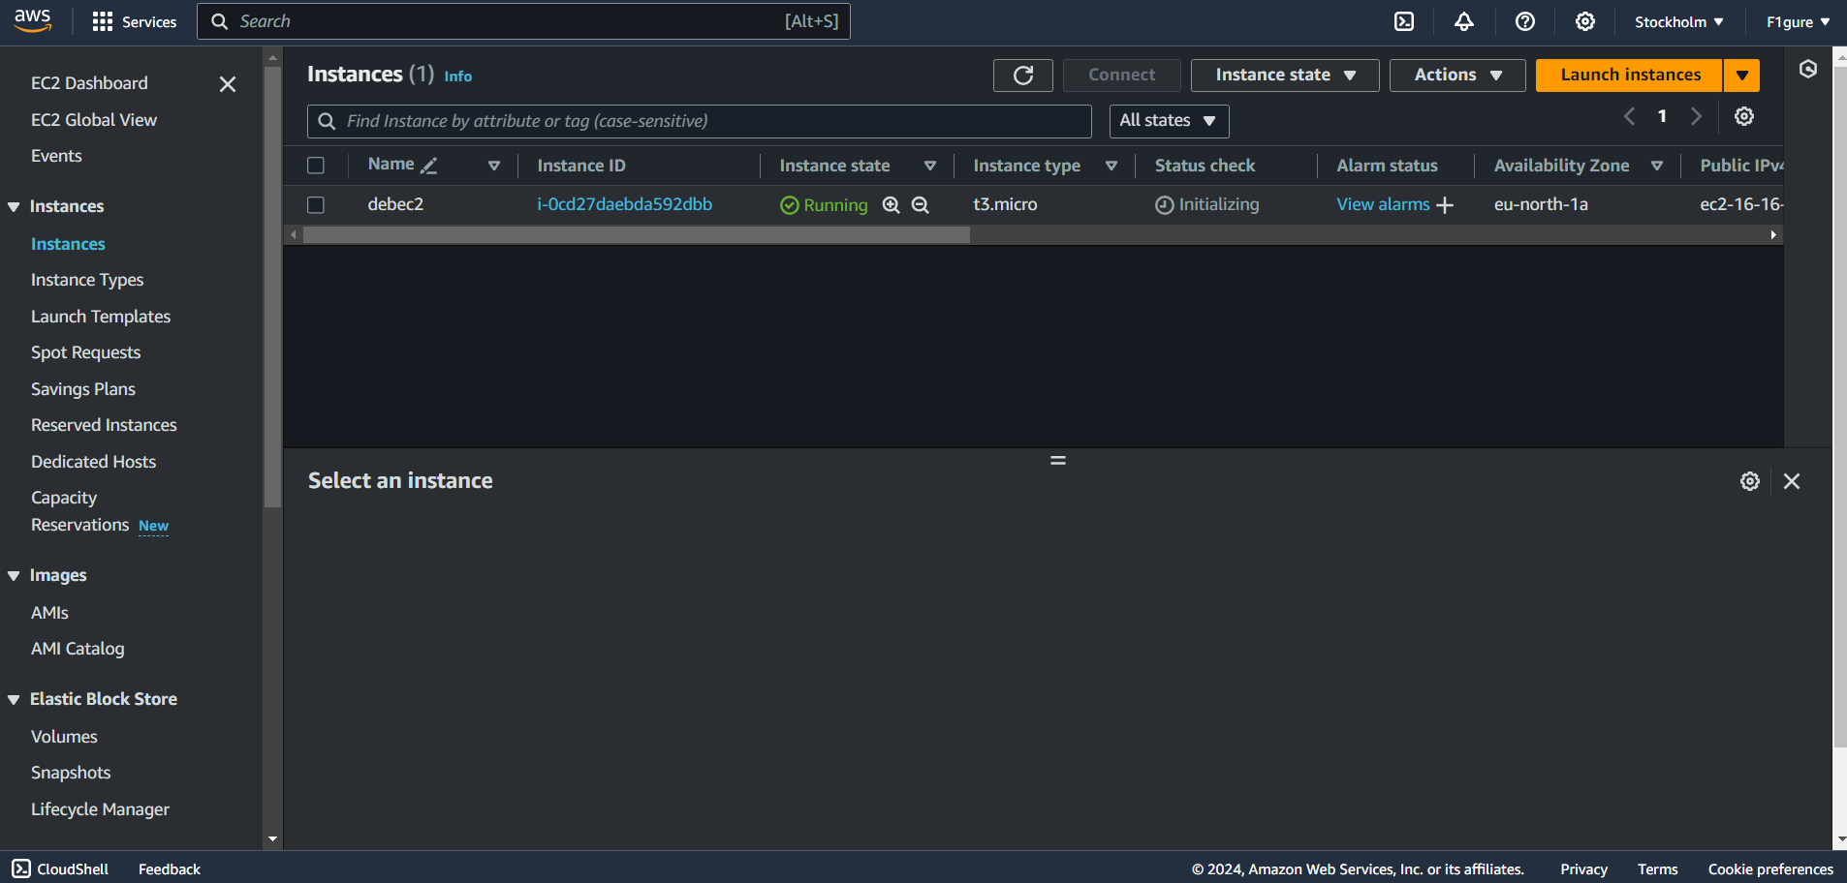

17. Copy the **Public IPv4 address.**

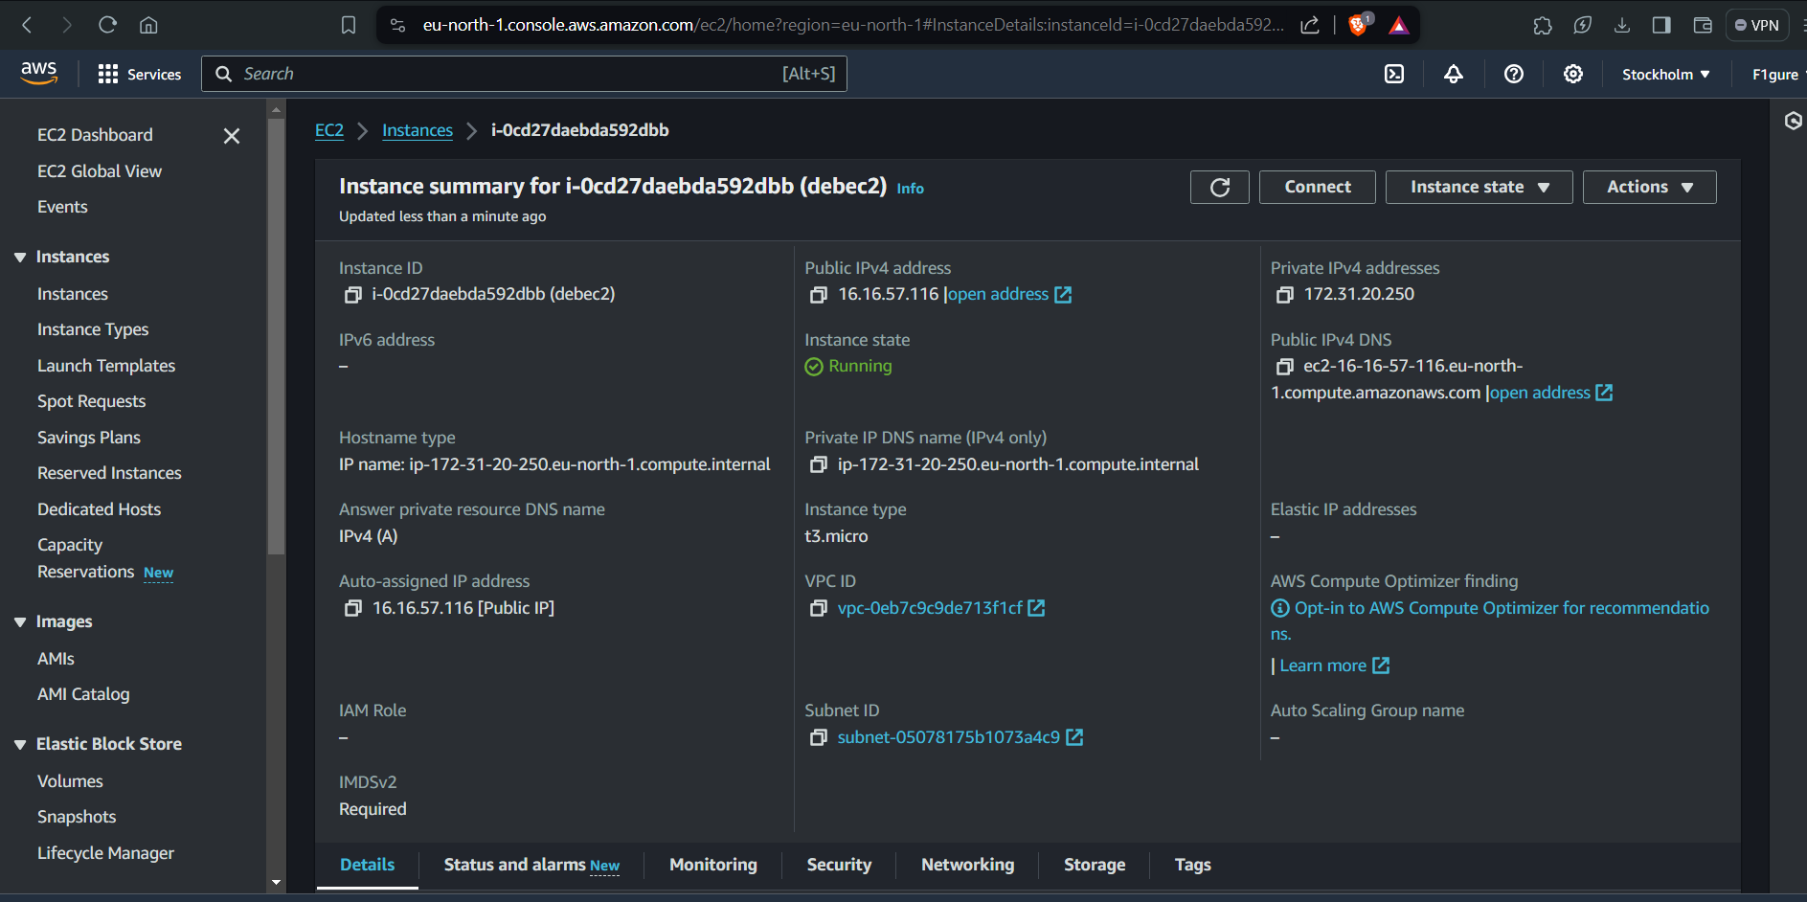

18. Launch Bitvise SSH Client and proceed to click on "**Login**" in the menu bar.

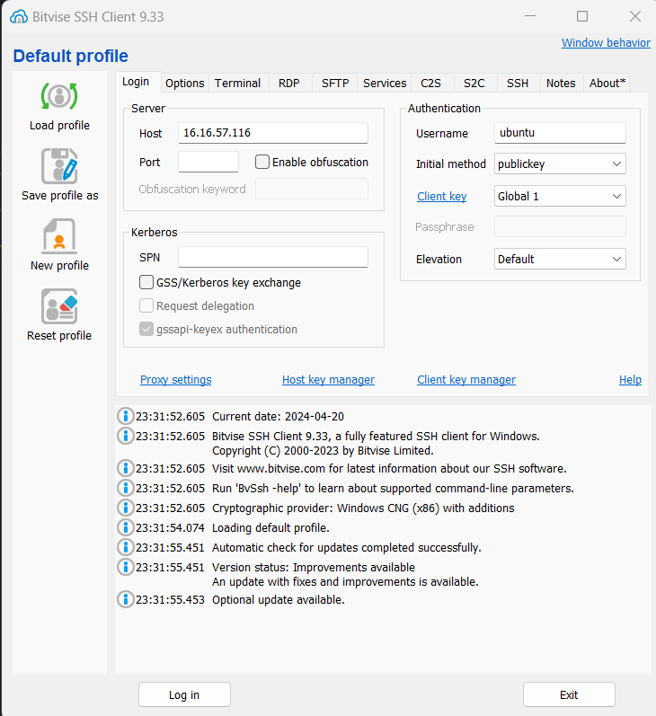

19. Paste the IPv4 address into the host field and enter "**ubuntu"** as the username. Also navigate to the client key manager to verify if the correct key is being used. If not, remove the existing key and import the correct one.



20. After logging in, click on "**Accept and Save**". Subsequently, the following window will appear.

21. Now click on “**New terminal console**”. The terminal console opens.

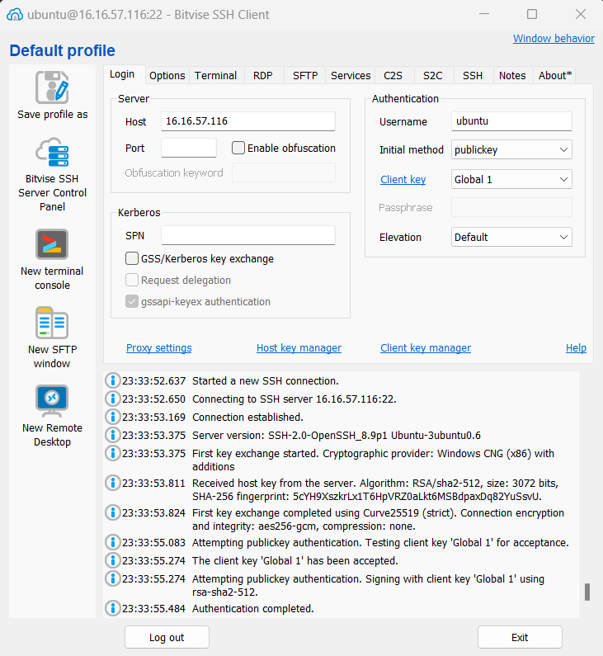

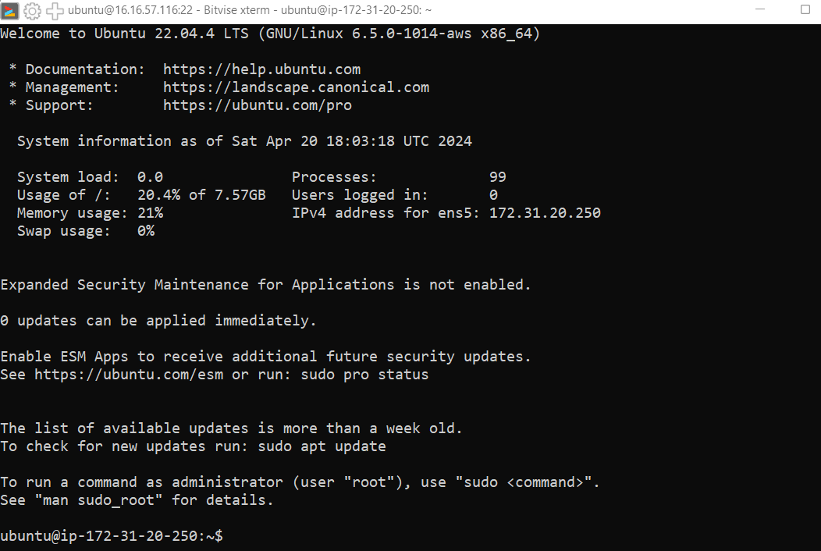

22. Proceed by entering the commands as listed below.

->***pwd***

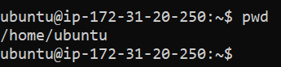

-> ***sudo apt-get update***

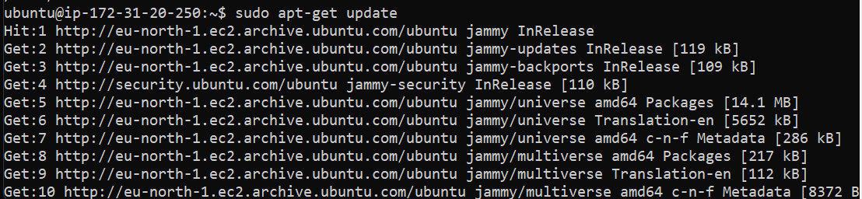

-> ***sudo apt-get upgrade***

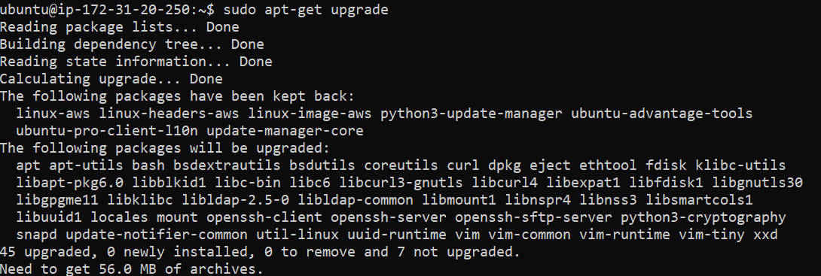

->***sudo apt-get install nginx***

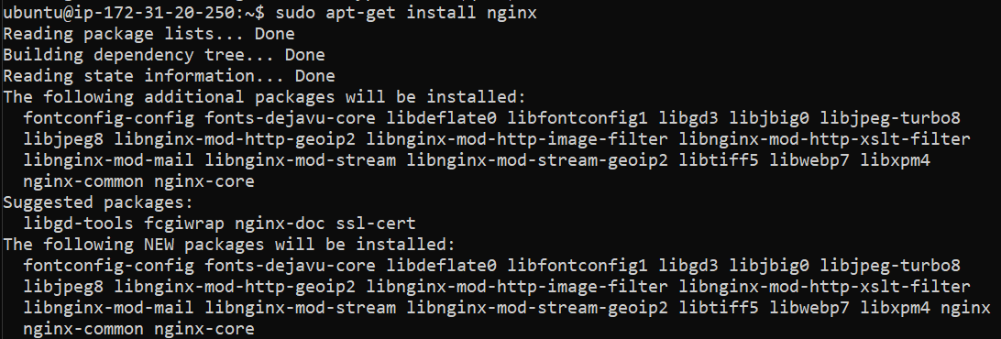

->***curl -SL*** [***https://deb.nodesource.com/setup_16.x*|*sudo***](https://deb.nodesource.com/setup_16.x|sudo) ***-E bash –***

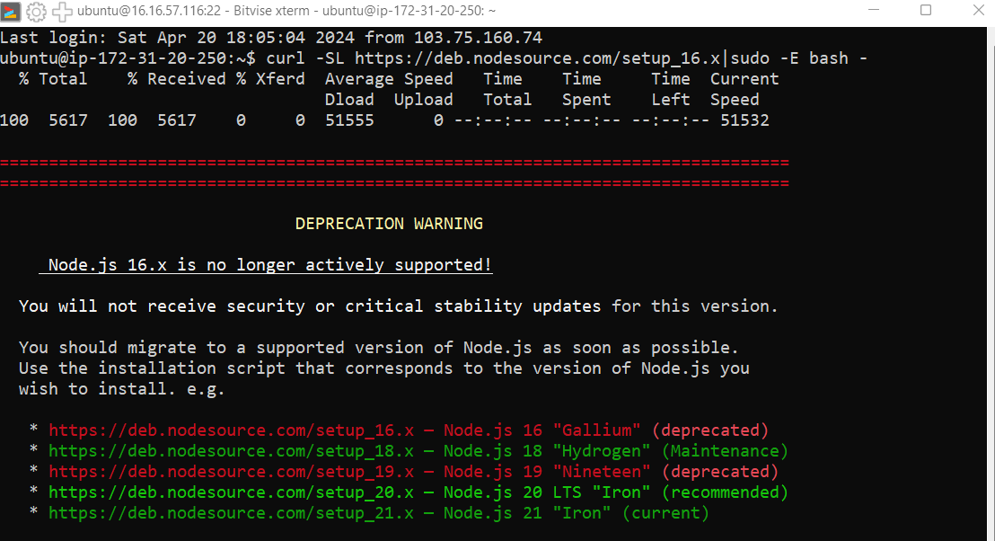

->***sudo apt install nodejs***

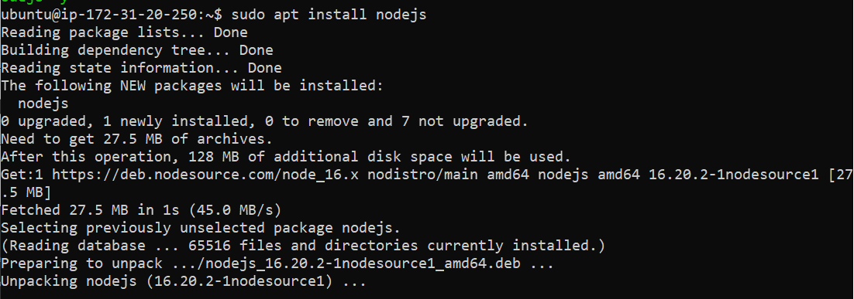

->***git clone <your repository path>***

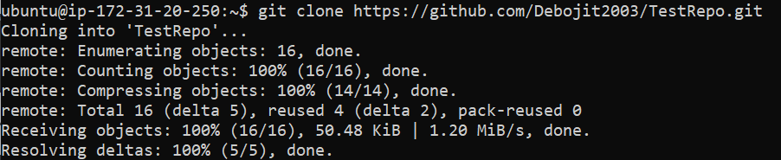

->***Now go inside the repository using cd and ls.***

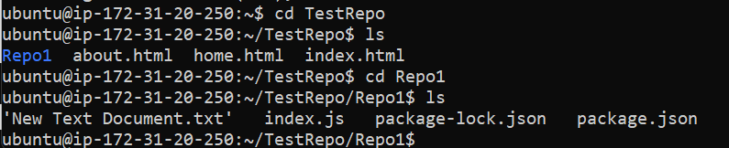

***->npm install***

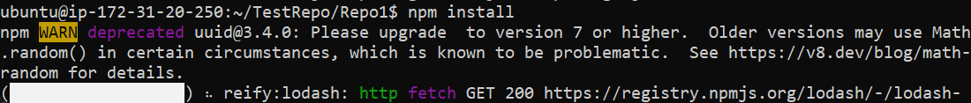

***->cd /***

***->pwd***

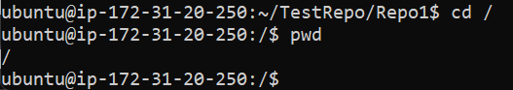

***-> cd etc/nginx/sites-available/***



->***sudo nano default***



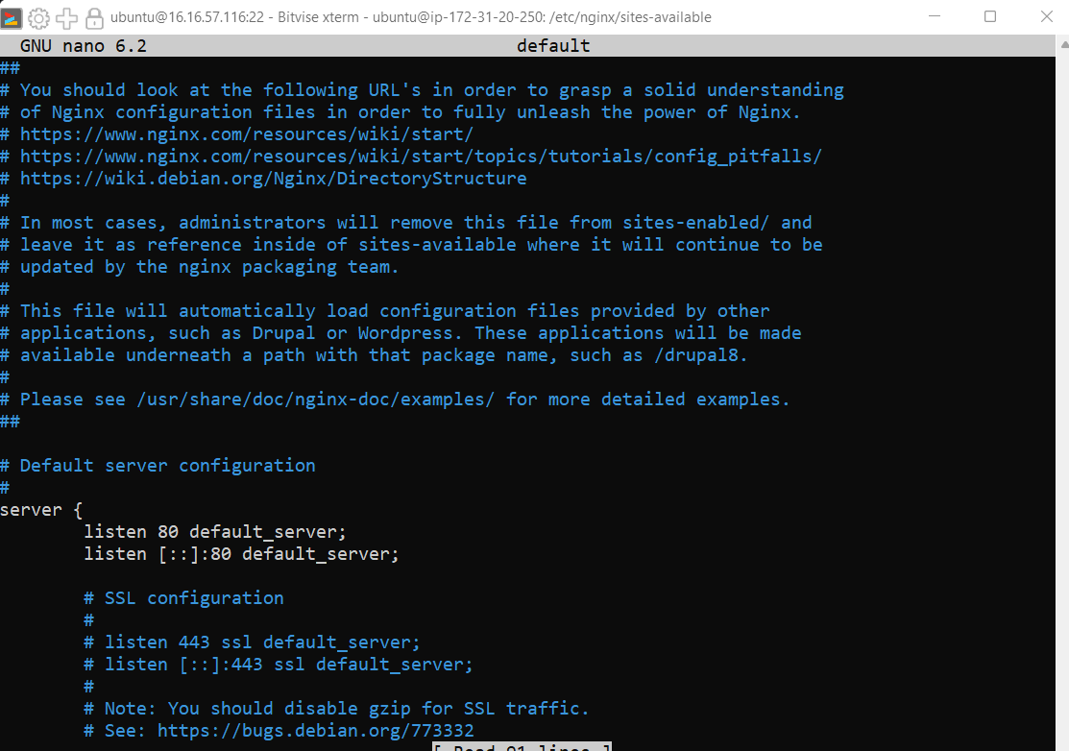

***->Scroll down and track “location” and comment the line using “#” along with two remaining lines.***

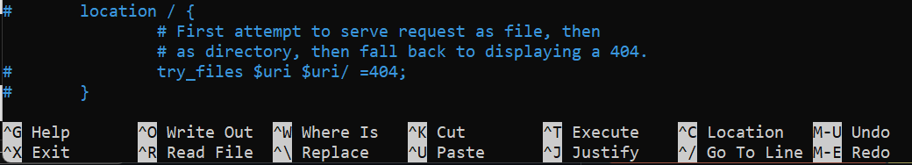

->***Copy the code provided and write it below “Server name”.***

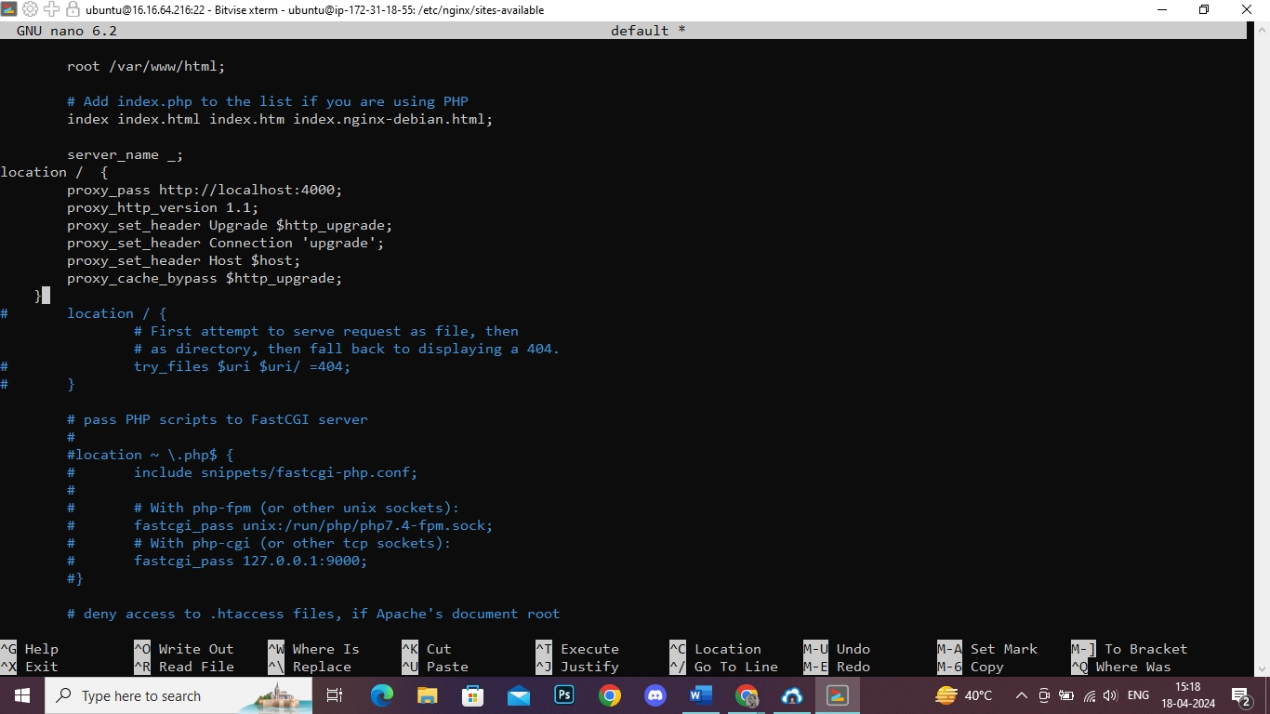

***->Now press “CTRL+x” and write “y” then press enter.***

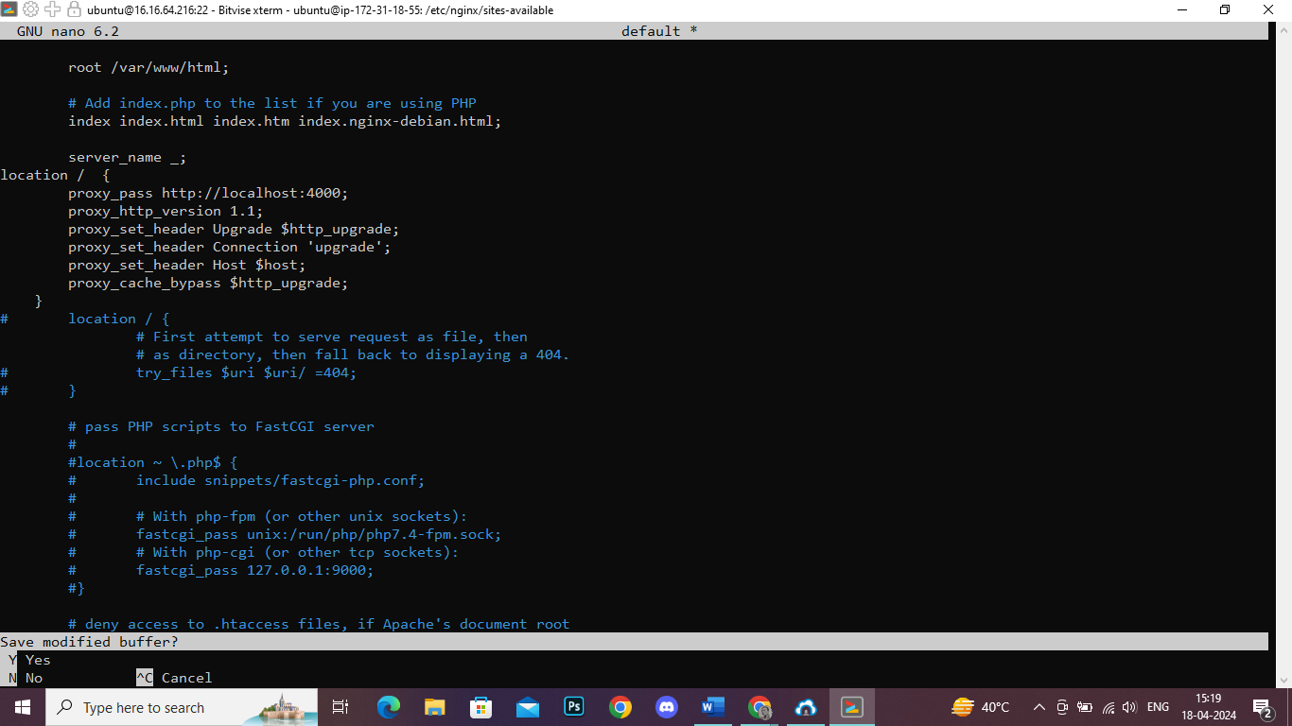

***-> Now go inside the repository using cd.***

***->sudo systemctl restart nginx***

***->node index.js***

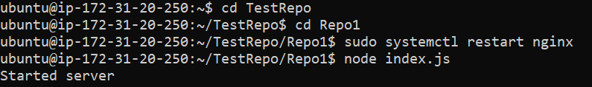

23.Open a new browser window and enter the IPv4 address.

