**Assignment No. 4:**

**Problem Statement:** Create a private bucket in AWS. Upload a file and check by reassigned URL whether you can access the file or not

The steps are as follows: -

1. Access the **AWS console**, search for **S3**, and select the top option from the search results.

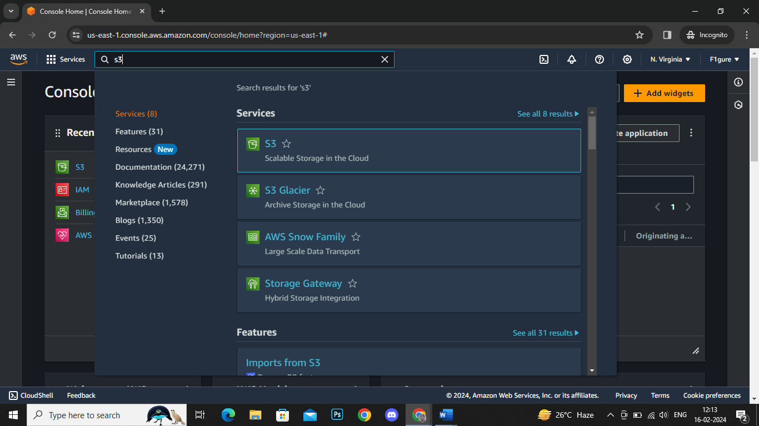

2.Click on **‘Create bucket’.**

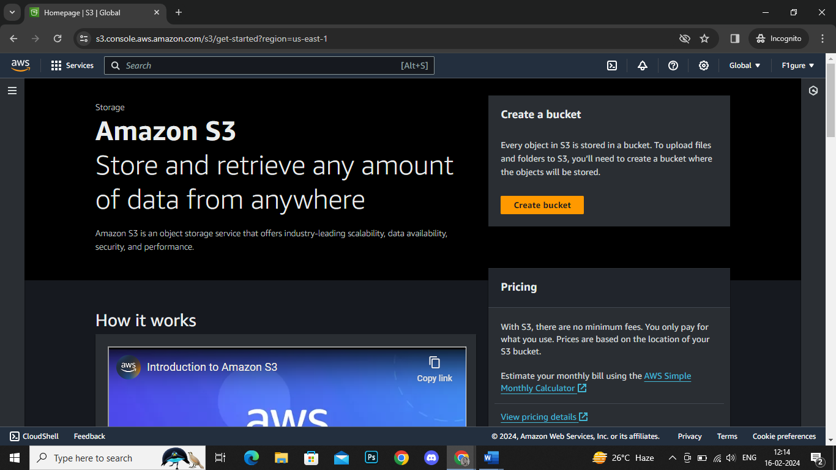

3. The subsequent window appears.

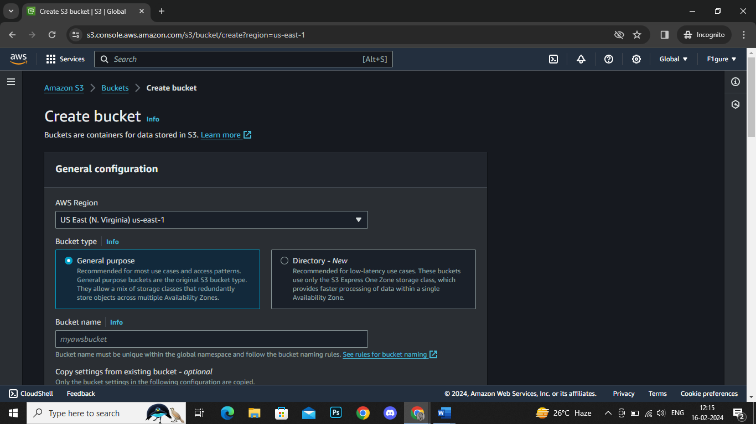

4. From the drop-down menu, select **'Asia Pacific (Mumbai) ap-south-1**' as the AWS Region. Next, specify a bucket name, such as '-debojitbucket'.

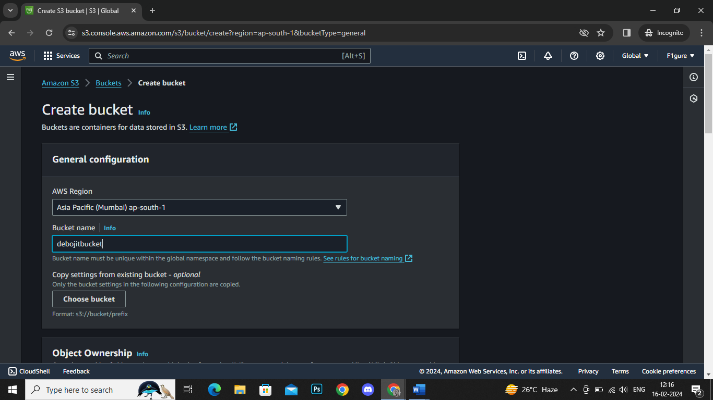

5. By default, the Object Ownership is set to **'ACLs disabled'** in this window. We will not make any adjustments as we are creating a **private bucket**.

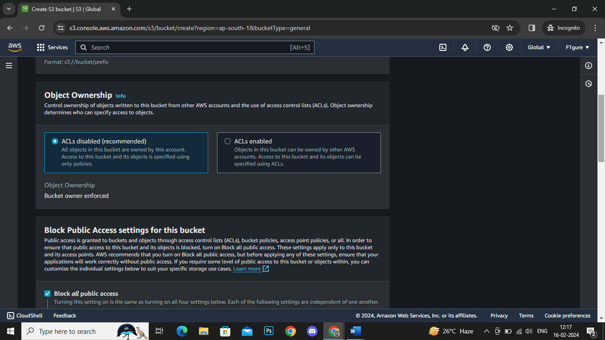

6. Similarly, we will leave the settings unchanged as the ‘**Block all public access’** checkbox is already selected by default, aligning with our intention to create a **private bucket.**

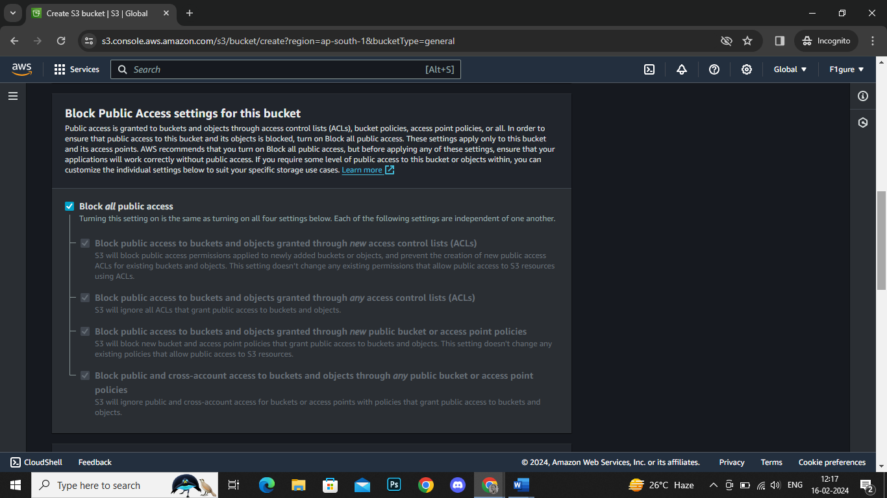

7. Now, without making any additional modifications, scroll down and proceed to click on **‘Create Bucket’**.

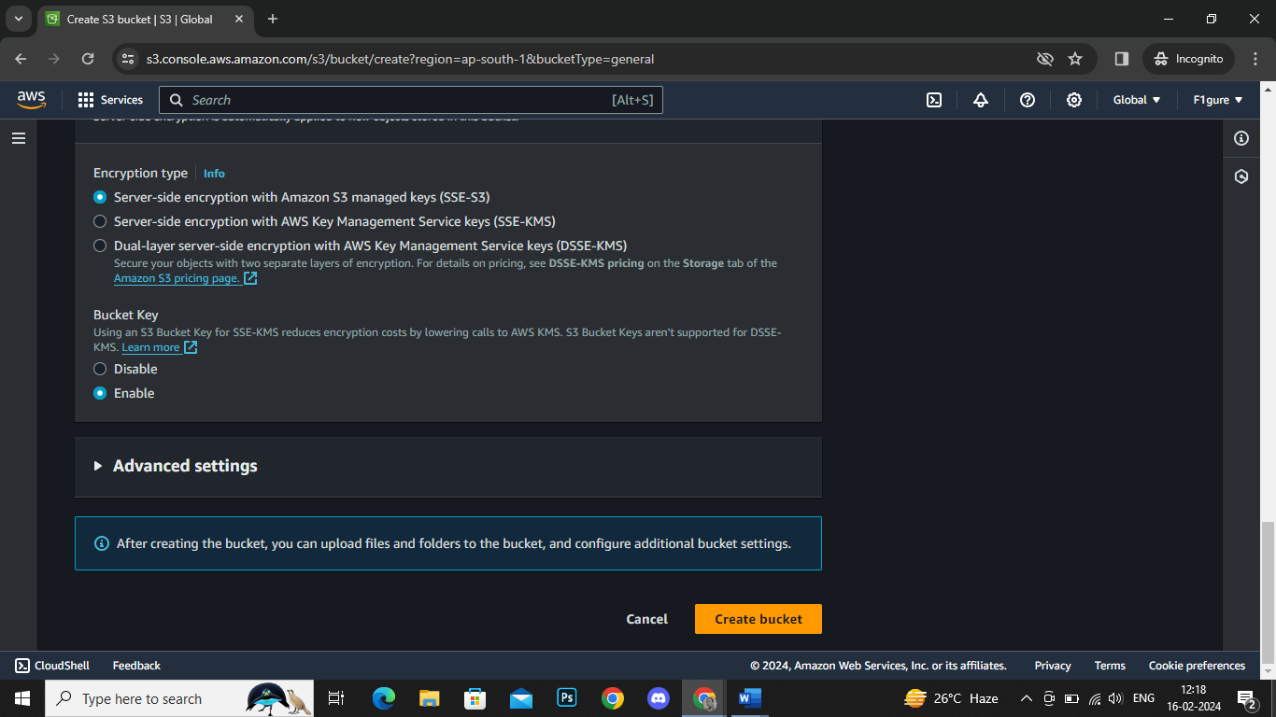

8. It's evident that the bucket has been successfully created.

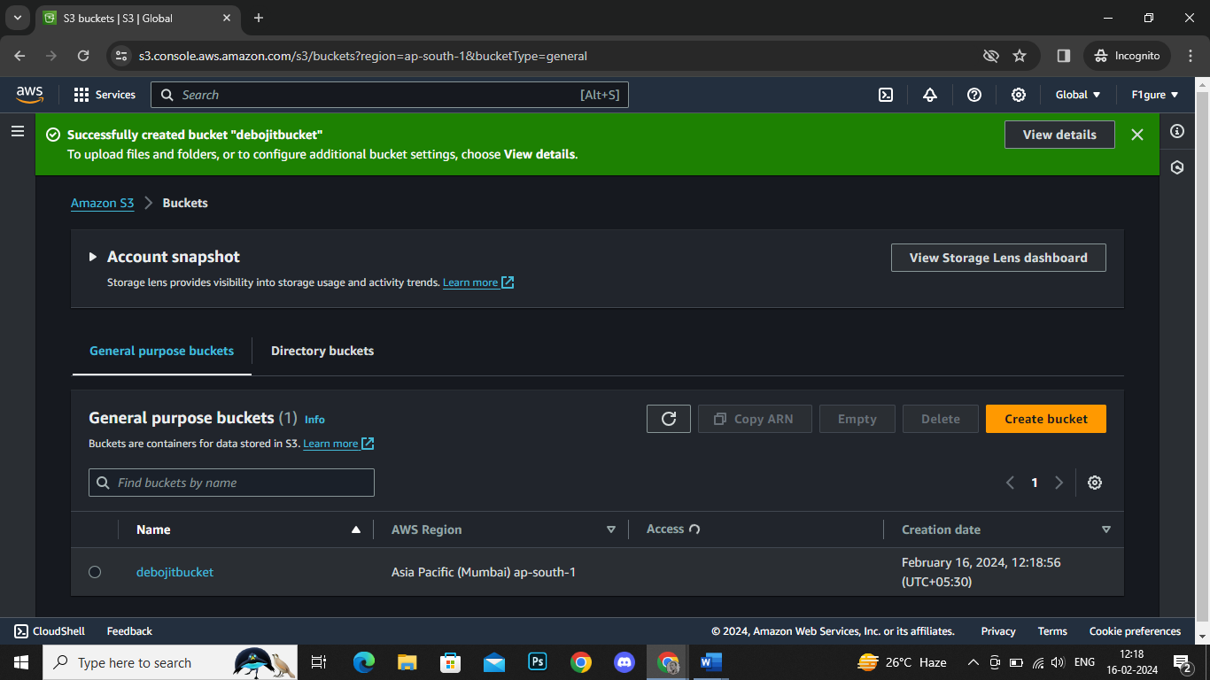

9.Now click on the bucket name.

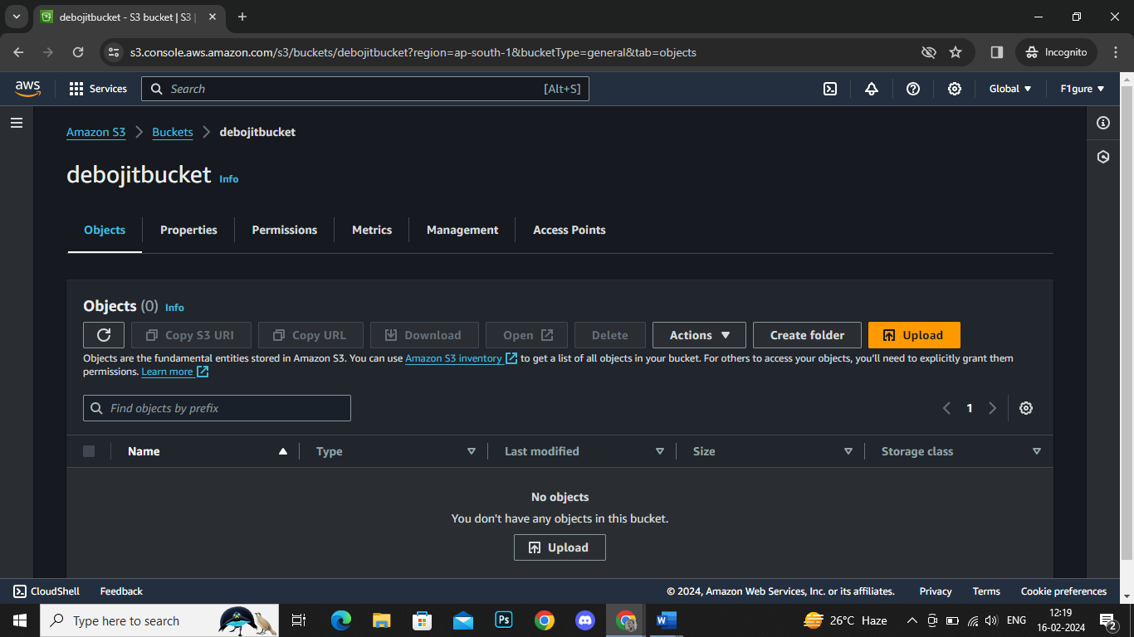

10. Choose the '**Upload'** option, which will lead to the opening of the subsequent window. From there, click on **'Add files'** and proceed to upload your desired file into the selected bucket (in this case, SQL Query Assignment1 Oracle.txt).

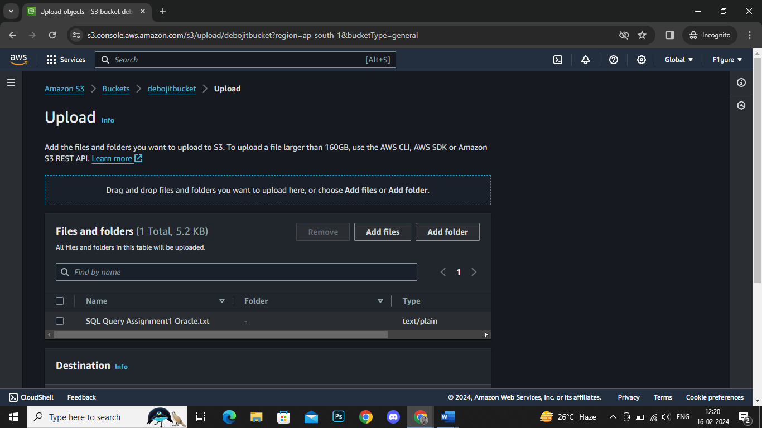

11. Scroll down and proceed to click on '**Upload'**.

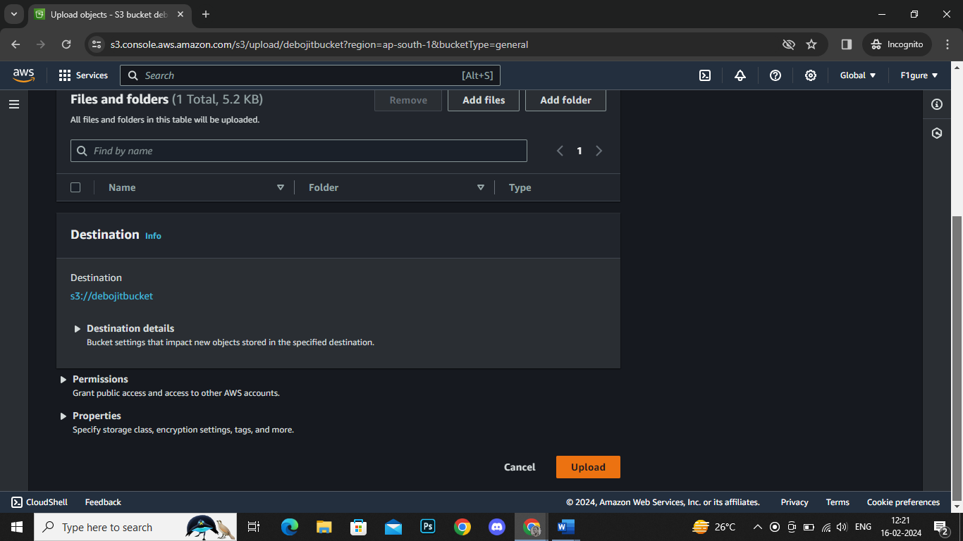

12. The notification confirms that the file has been successfully uploaded. Click on **'Close'** to return.

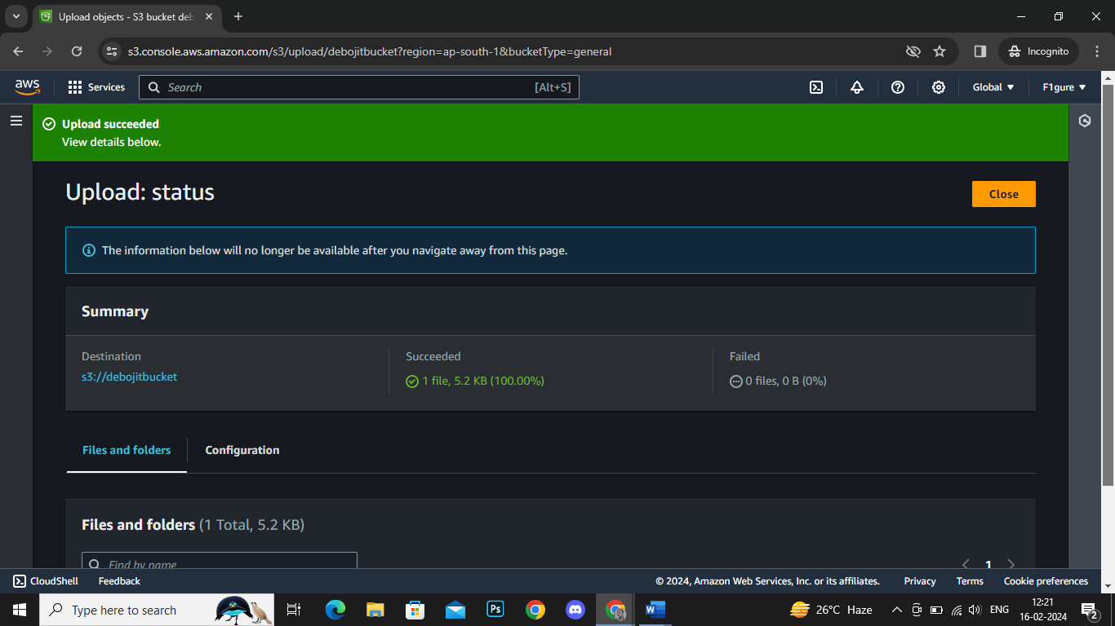

13. Now, select the checkbox next to the uploaded file, then click on **'Copy URL'**.

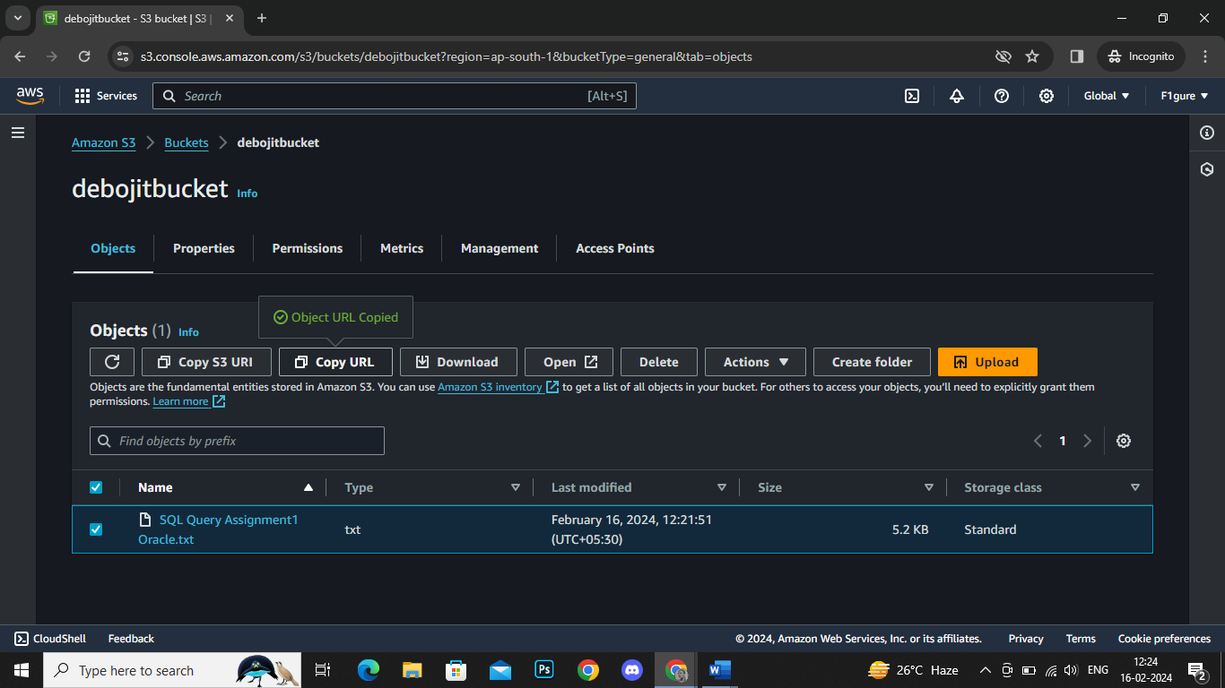

14.Navigate to a new window, paste the URL, and proceed with the search.

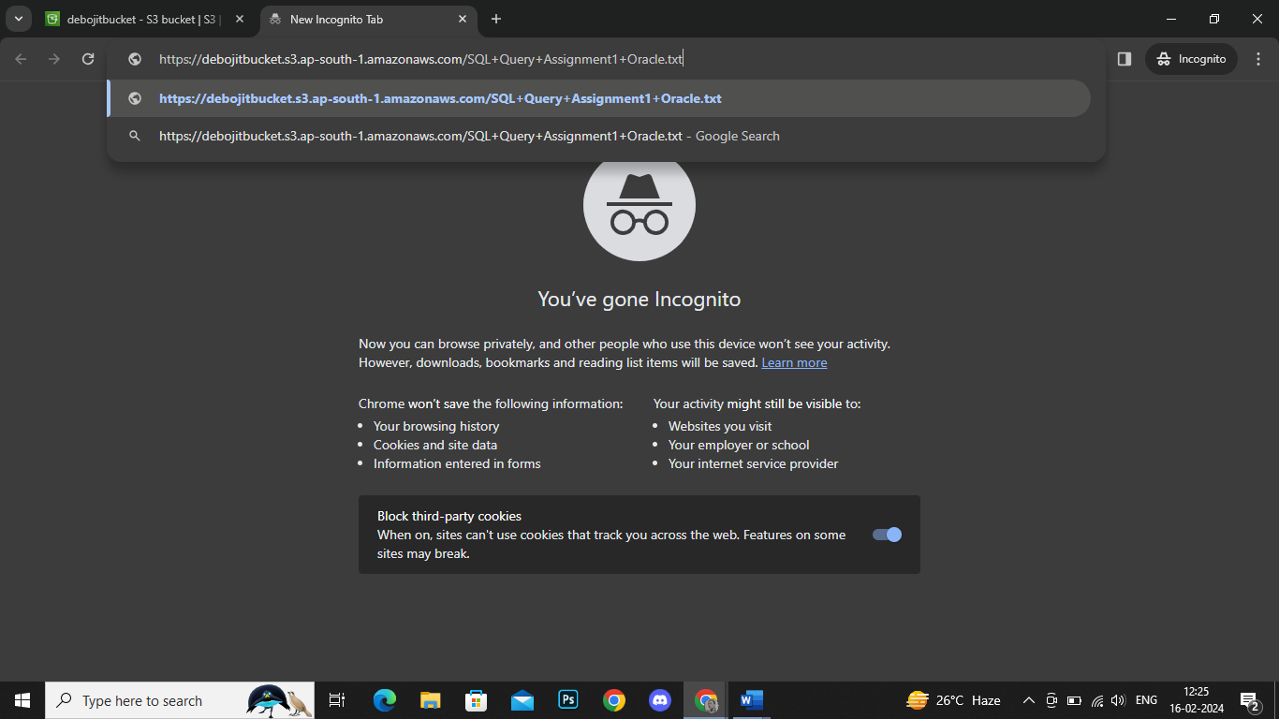

15. An error appears indicating that access to the contents is restricted since this is a private bucket.

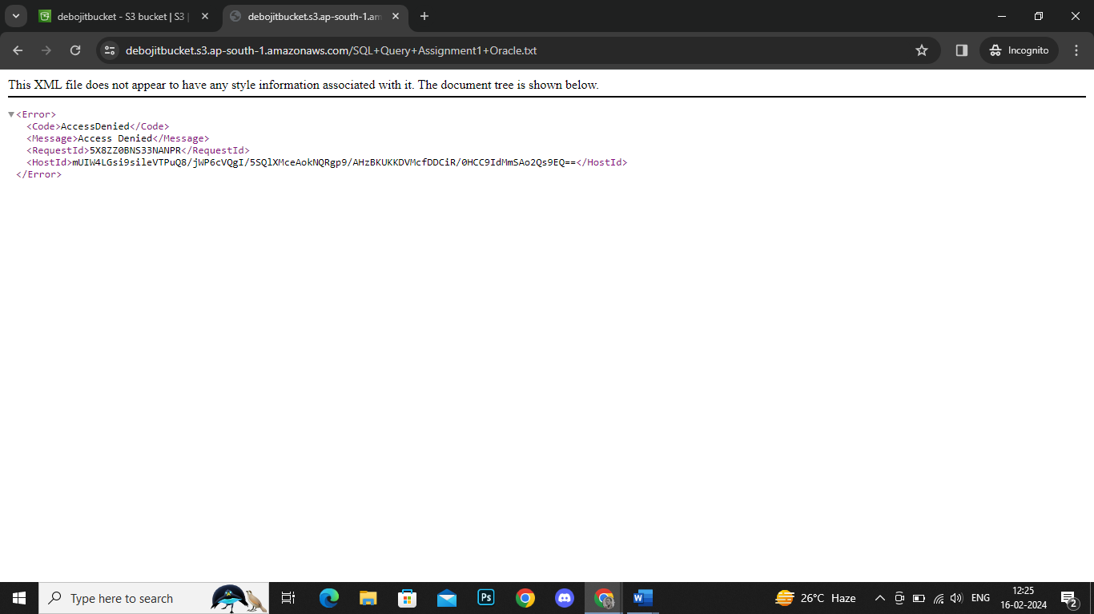

16. Close the current window, then navigate to **'Actions'** and choose **'Share with a presigned URL'**.

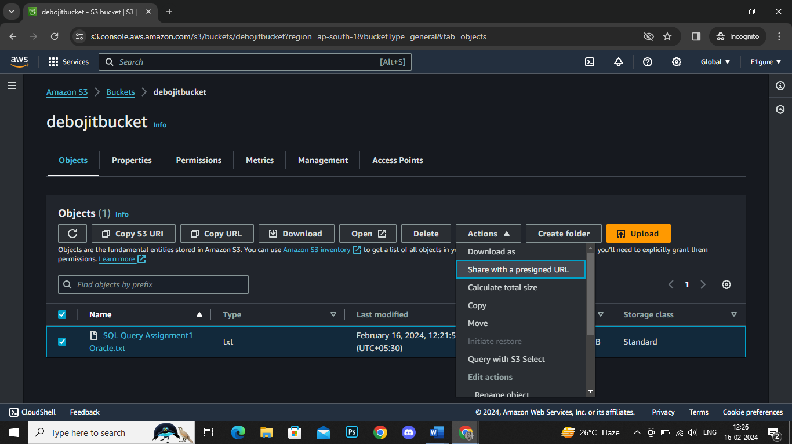

17. Select the desired duration until you want the presigned URL to expire.

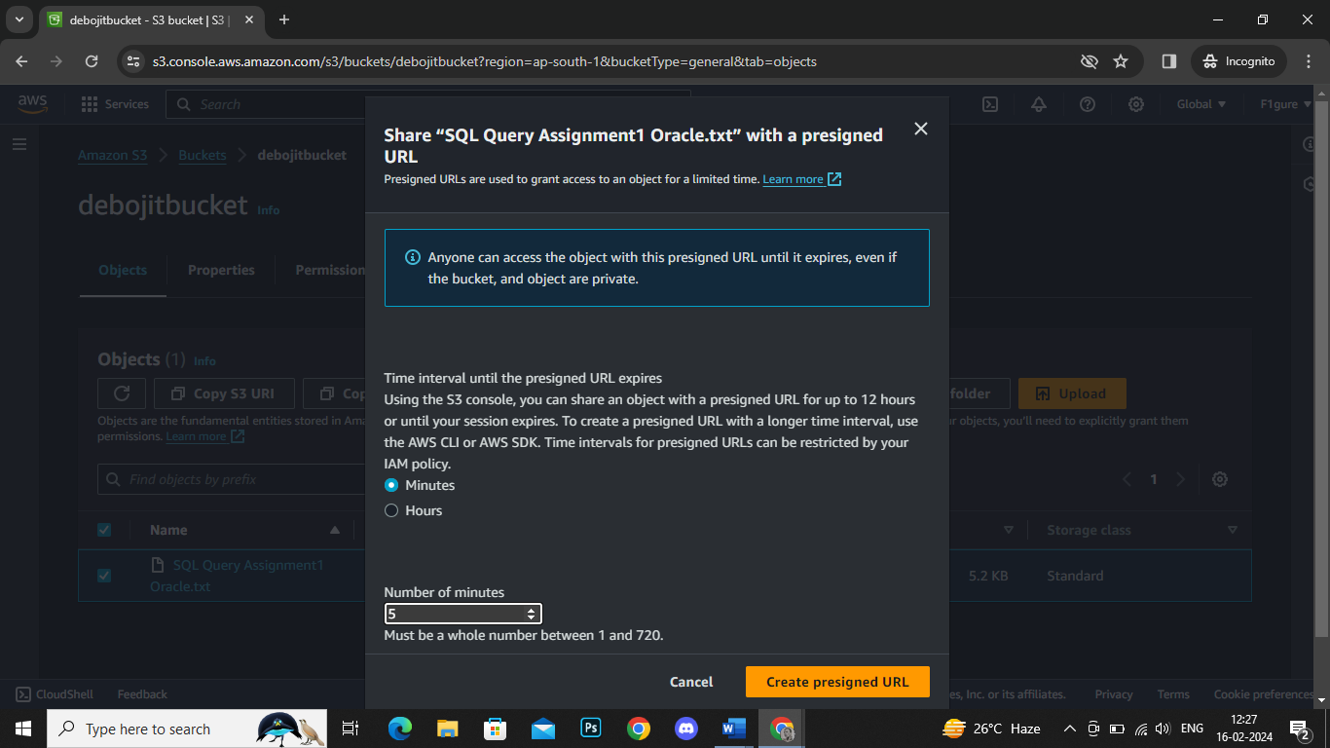

18. Copy the presigned URL.

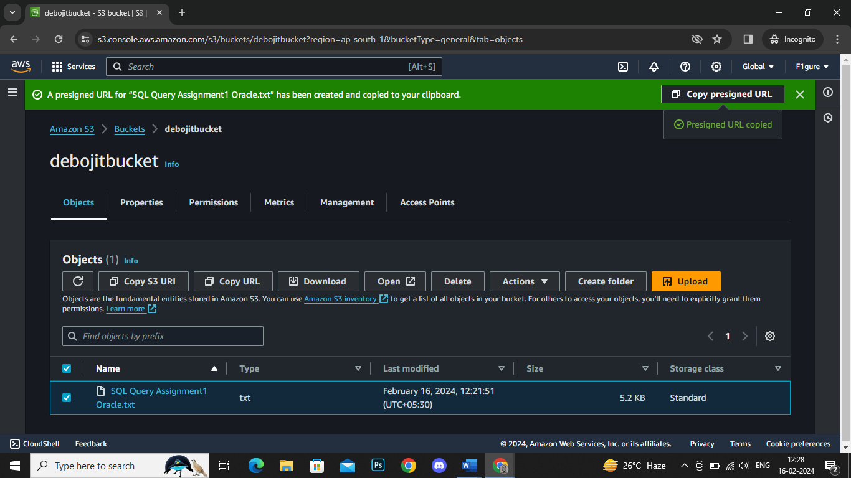

19. Open a new window and paste the URL. Now, you can view the uploaded file.

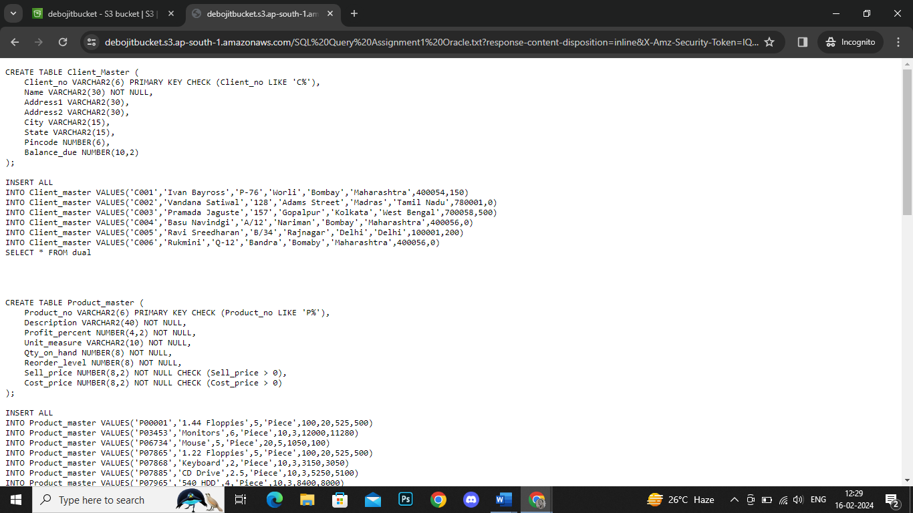

20. To delete the bucket, it must first be emptied. Therefore, close this window and return to your list of buckets. Select the desired bucket and proceed to click on '**Empty'**.

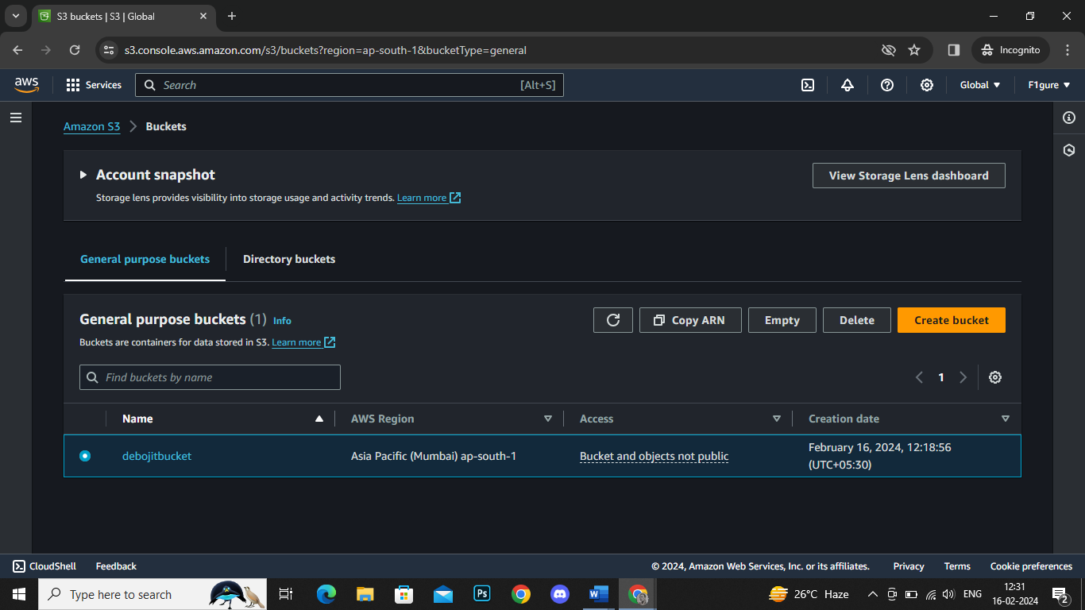

21. To confirm the action, input **'permanently delete'** and then click on **'Empty**'.

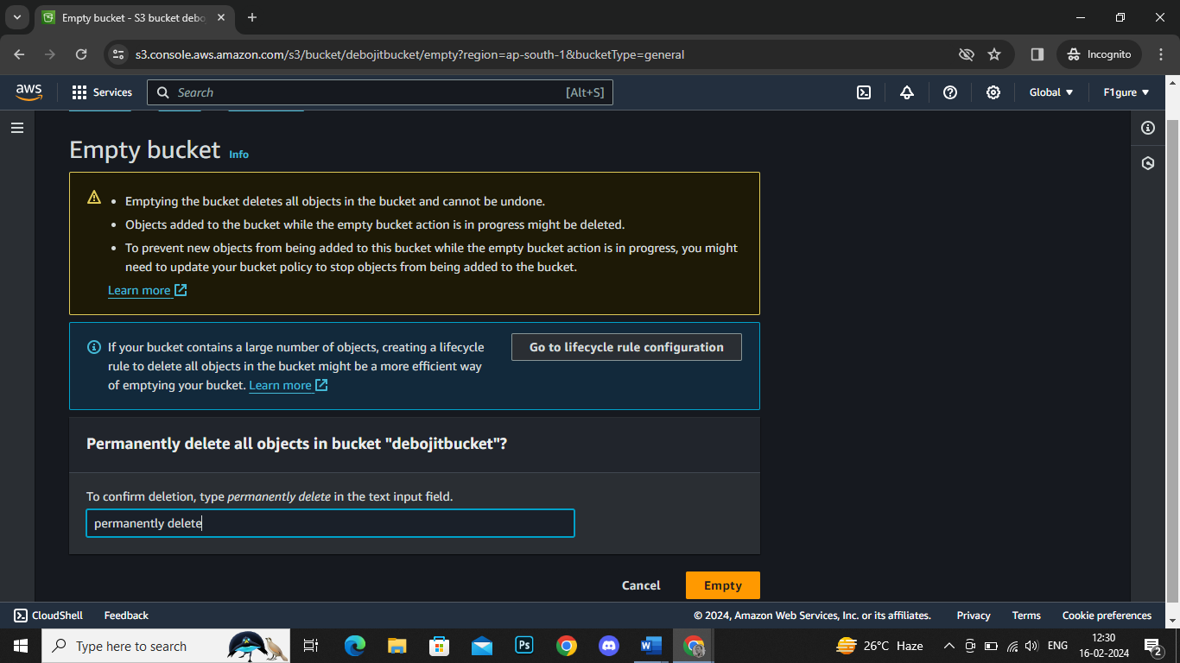

22. Once the action has been successfully completed, click on '**Exit**'.

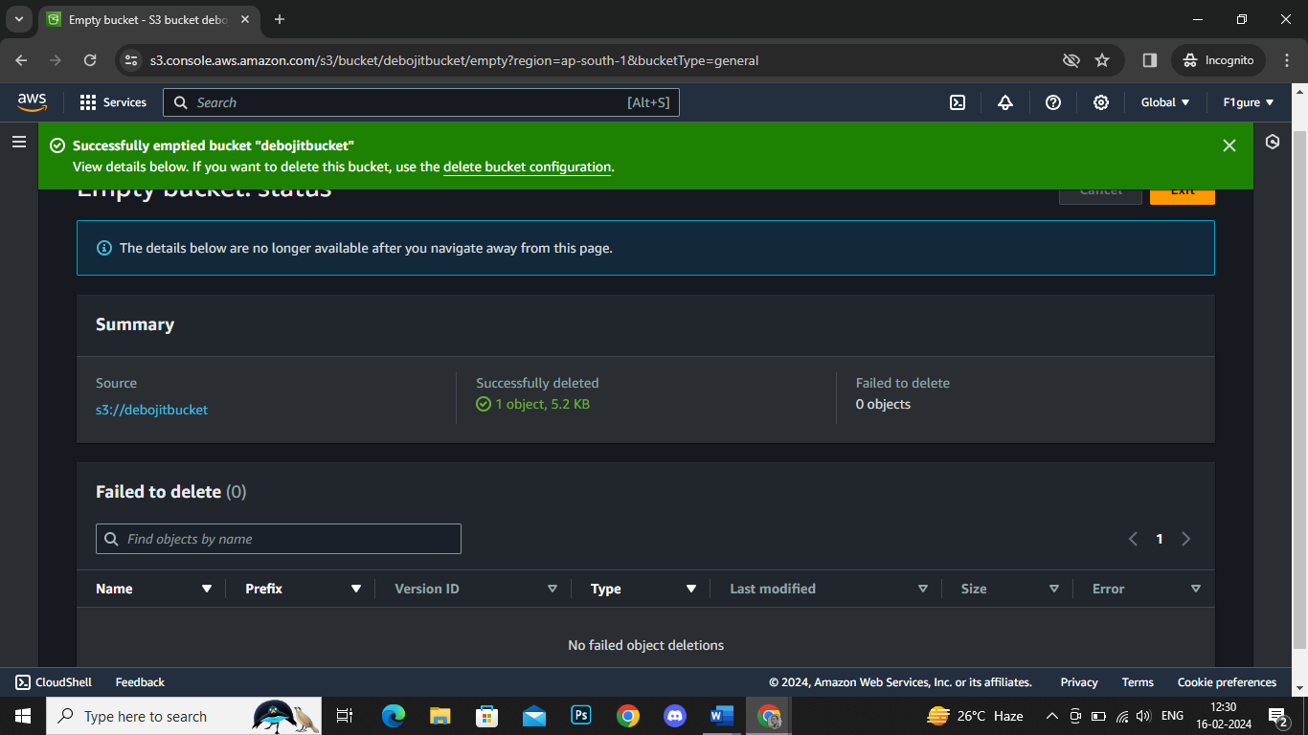

23. Now, choose '**Delete'**.

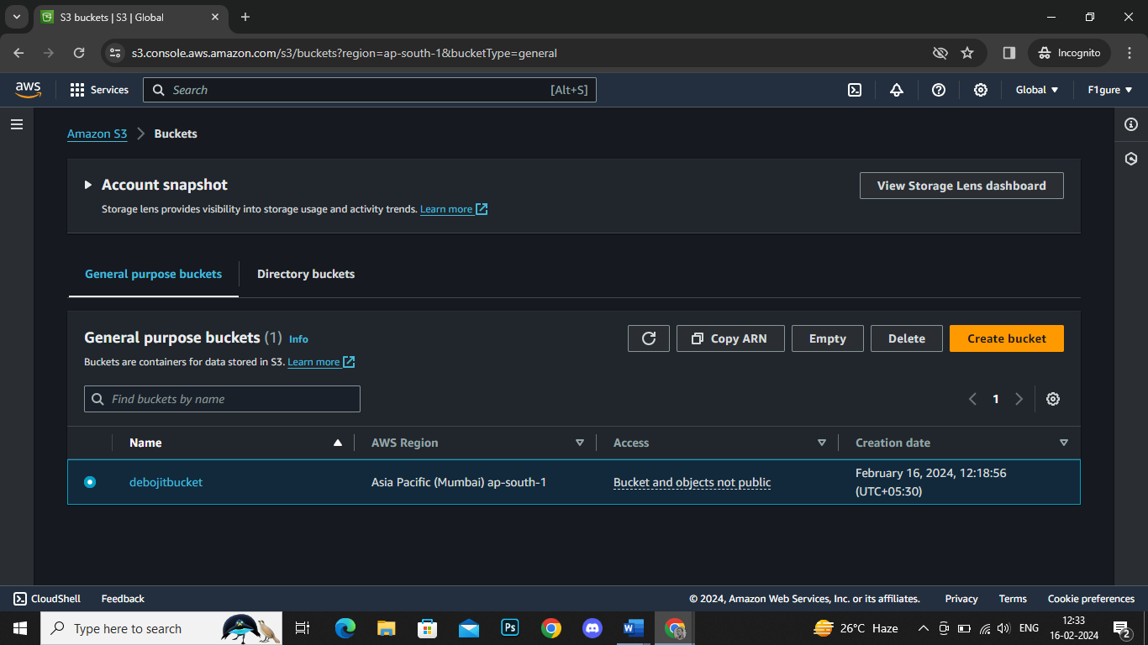

24. To confirm the deletion, enter your bucket name. Then, click on **'Delete bucket'**.

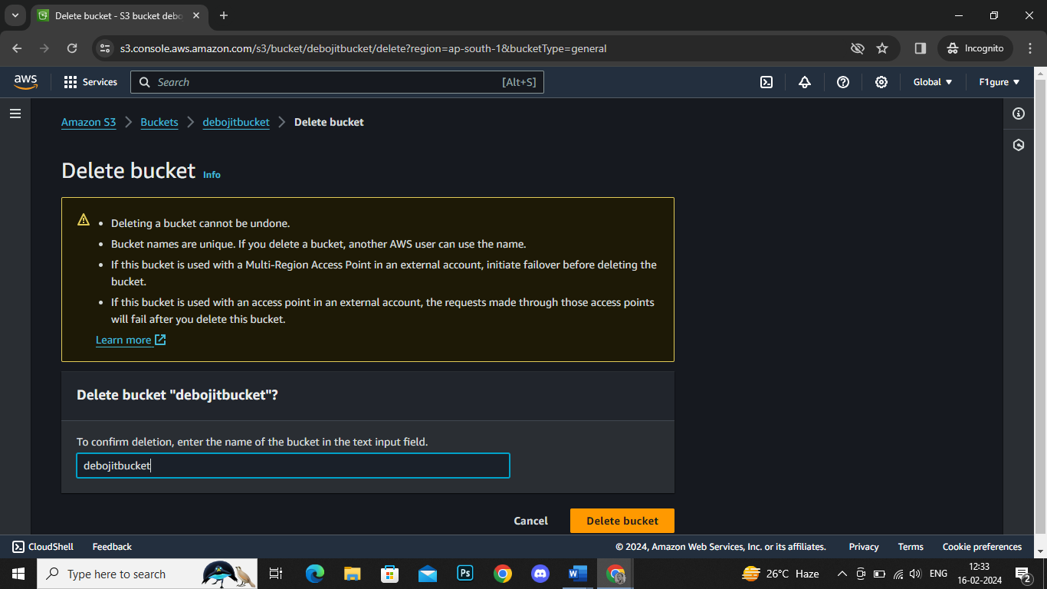

25. The deletion has been successfully completed.

