**Assignment No. 5:**

**Problem Statement:** Create a public Bucket in AWS. Upload a file and give the necessary permission to check whether file the URL is working.

The steps are as follows: -

1.Access the **AWS console**, search for **S3**, and select the top option from the search results.

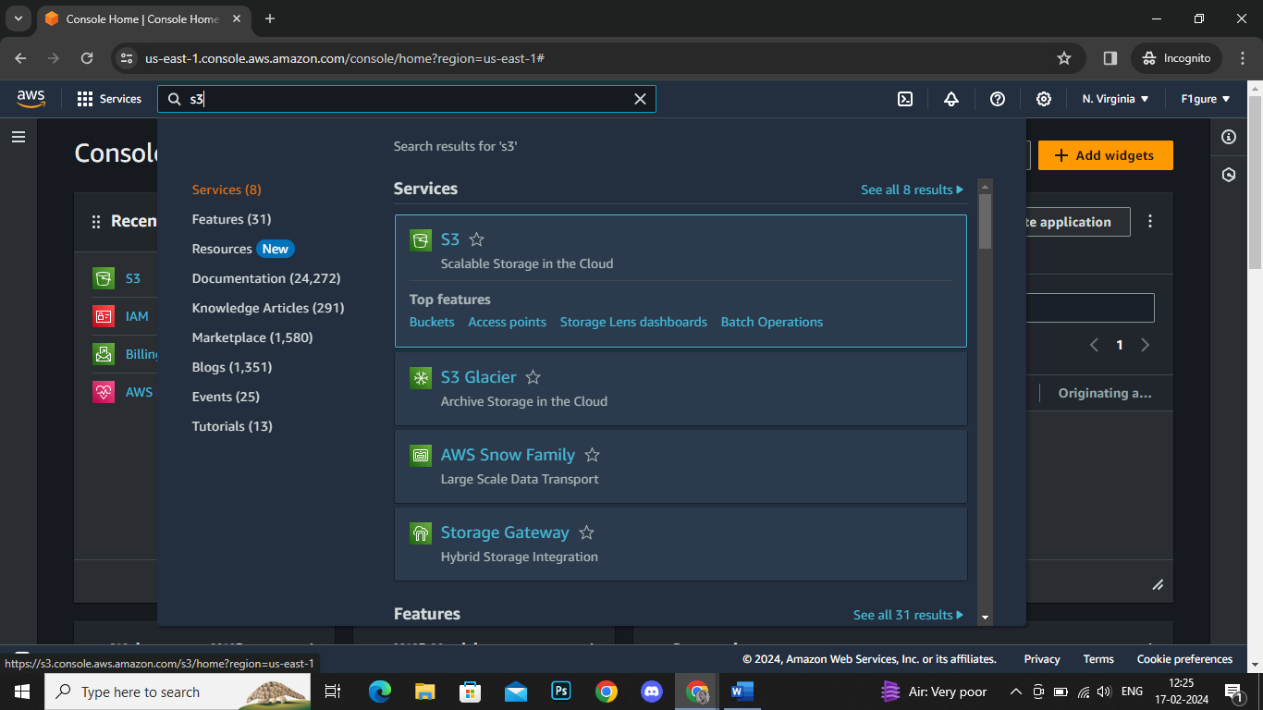

2. Click on **‘Create bucket’.**

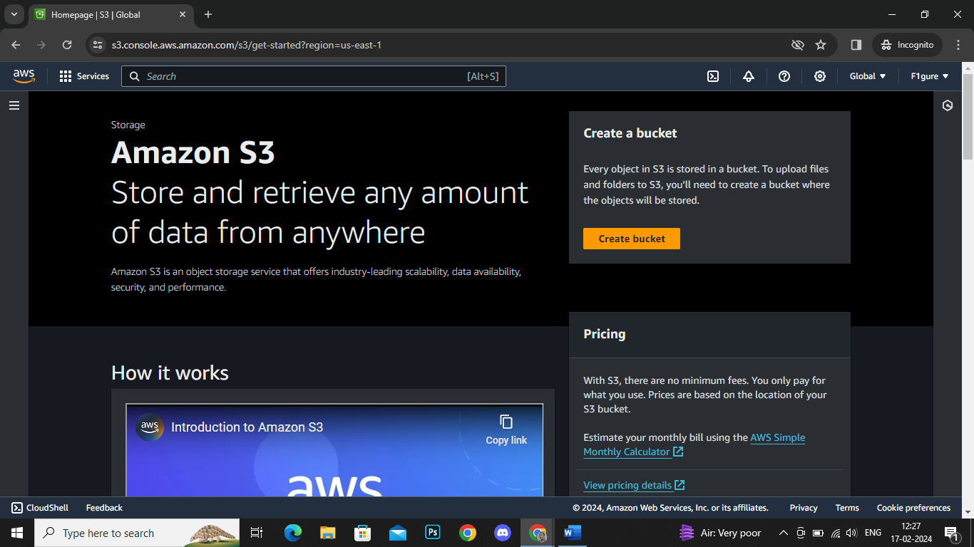

3. The subsequent window appears.

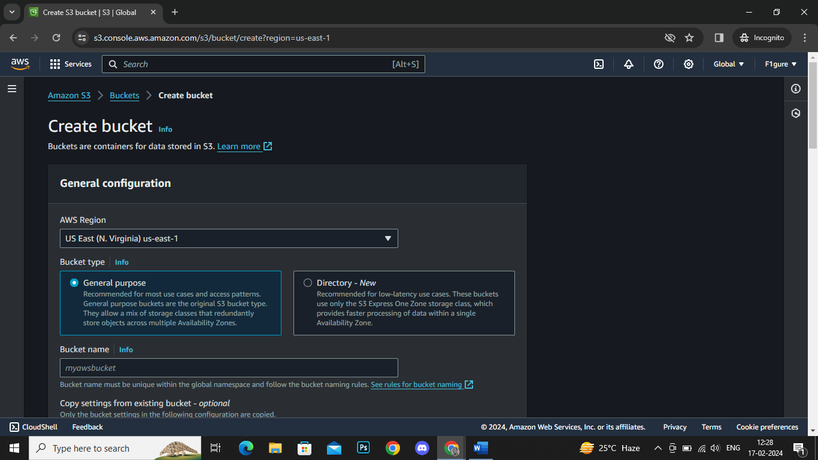

4. From the drop-down menu, select **'Asia Pacific (Mumbai) ap-south-1**' as the AWS Region. Next specify a bucket name, here it is ‘bucketdebojit’.

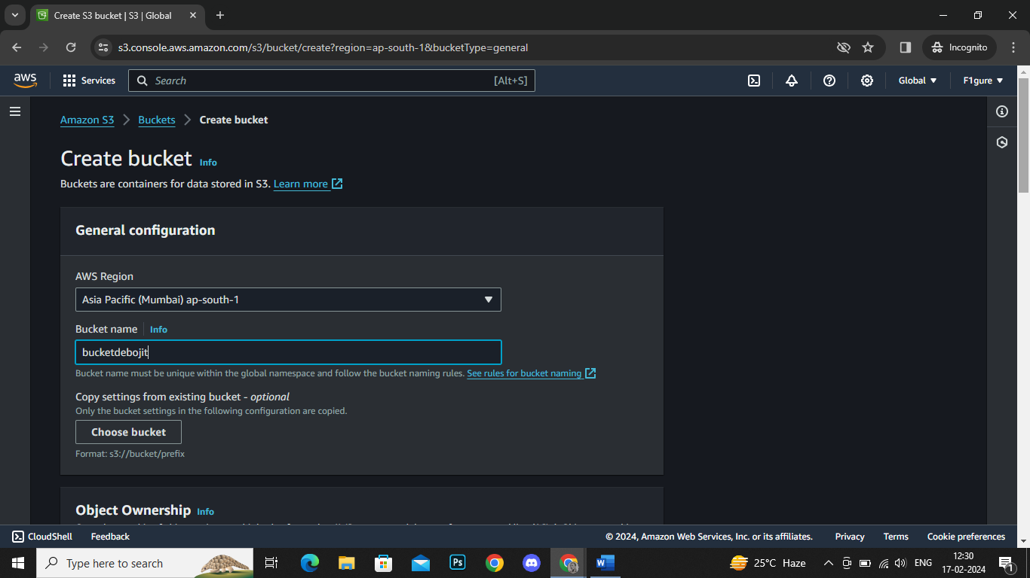

5. By default, the Object Ownership is set to **'ACLs disabled'** in this window. Select **'ACLs enabled'** since we are creating a **public bucket**.

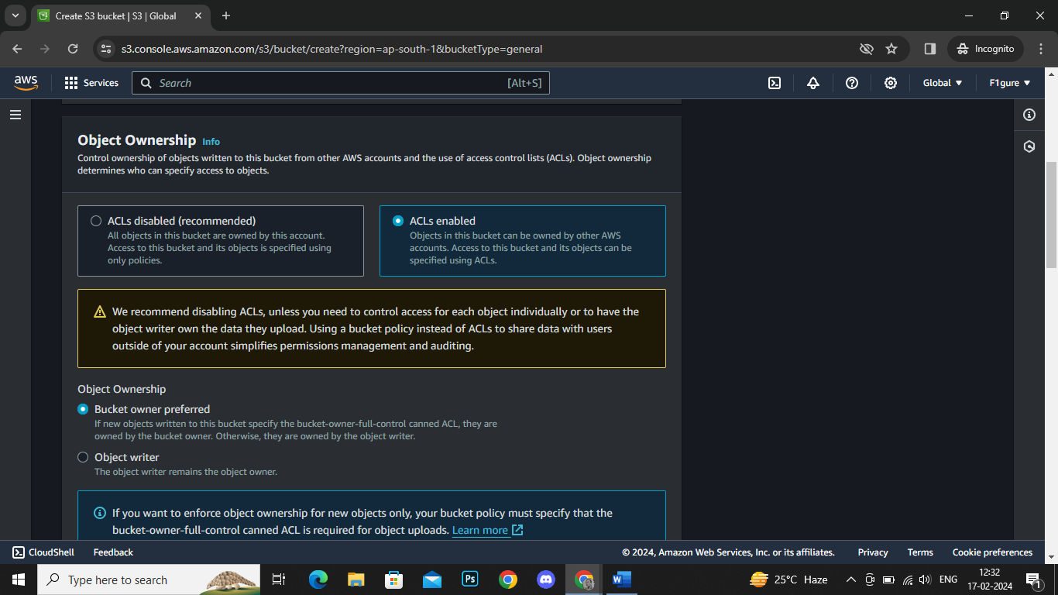

6. Now, uncheck the box for **'block all public access'**. At the bottom of the window, check the box confirming that the current setting changes may result in a **public bucket.**

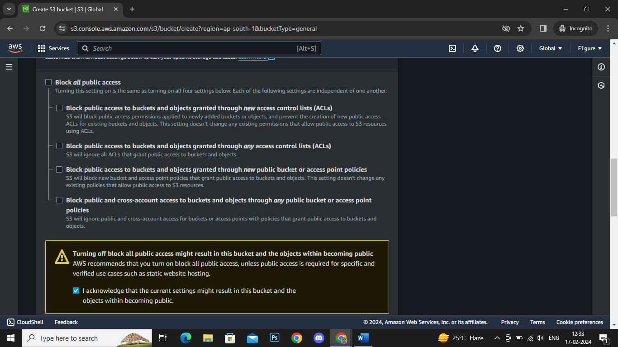

7. Scroll down without any further modifications and proceed to click on **'Create Bucket'.**

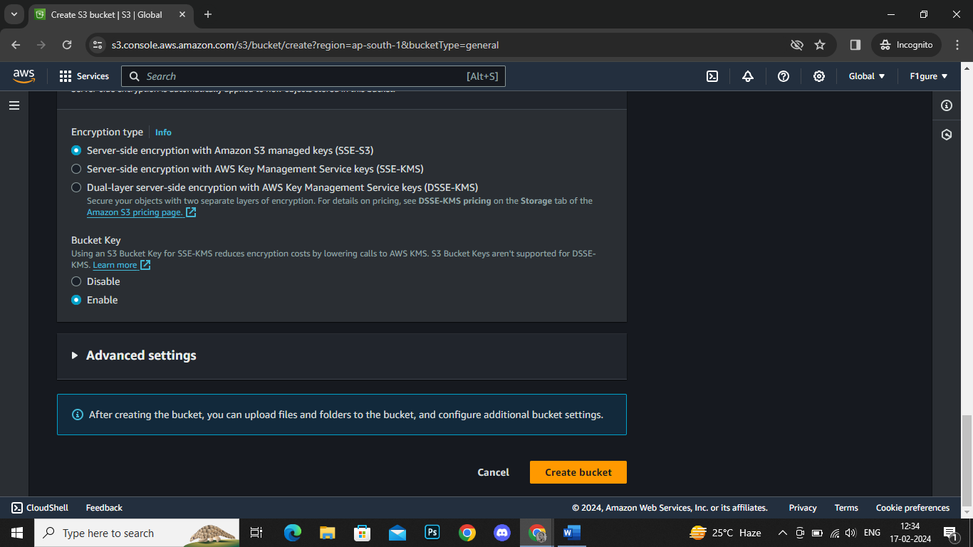

8. It's evident that the bucket has been successfully created.

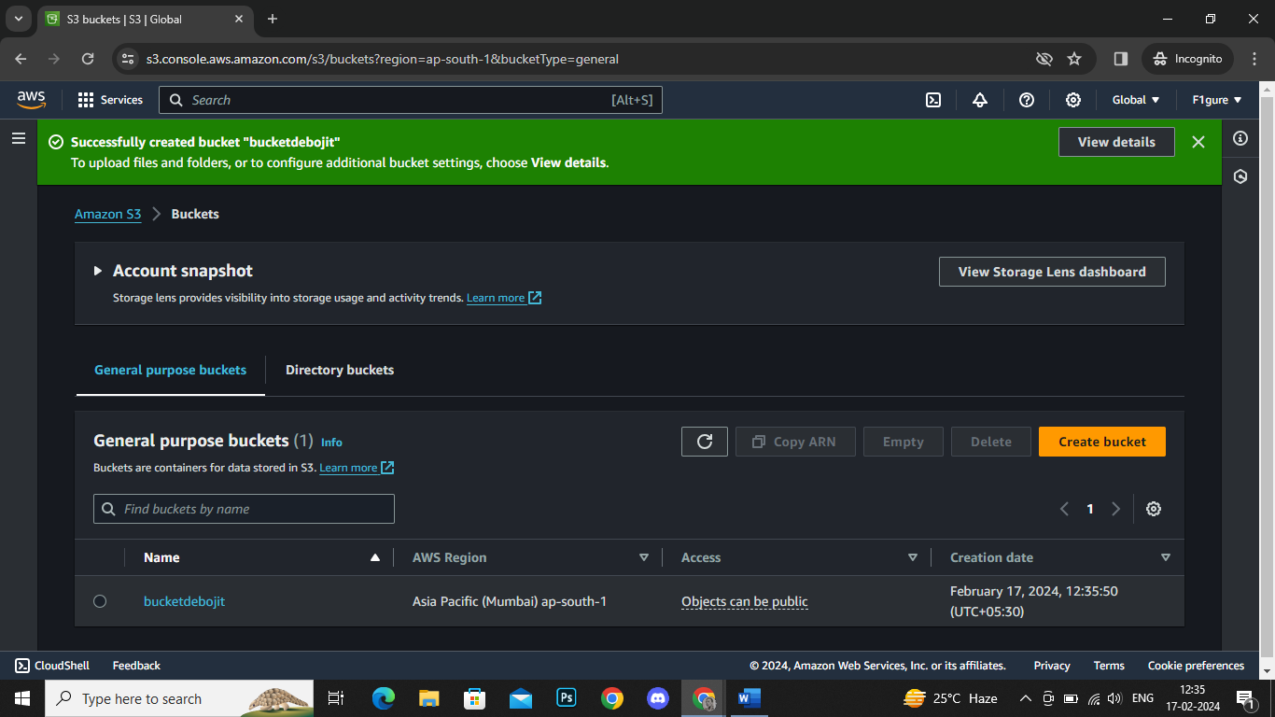

9. Now click on the bucket name.

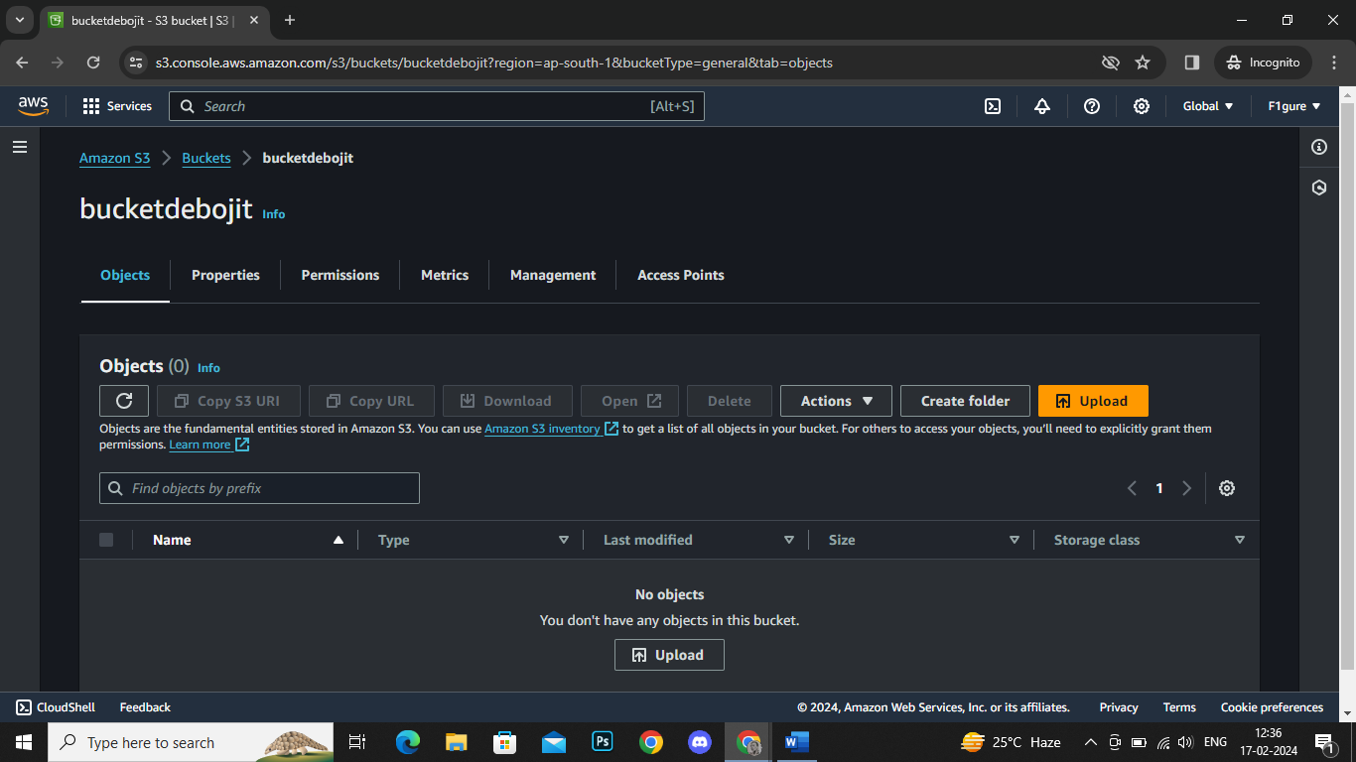

10. Choose the '**Upload'** option, which will lead to the opening of the subsequent window. From there, click on **'Add files'** and proceed to upload your desired file into the selected bucket (here it is : Basic function).

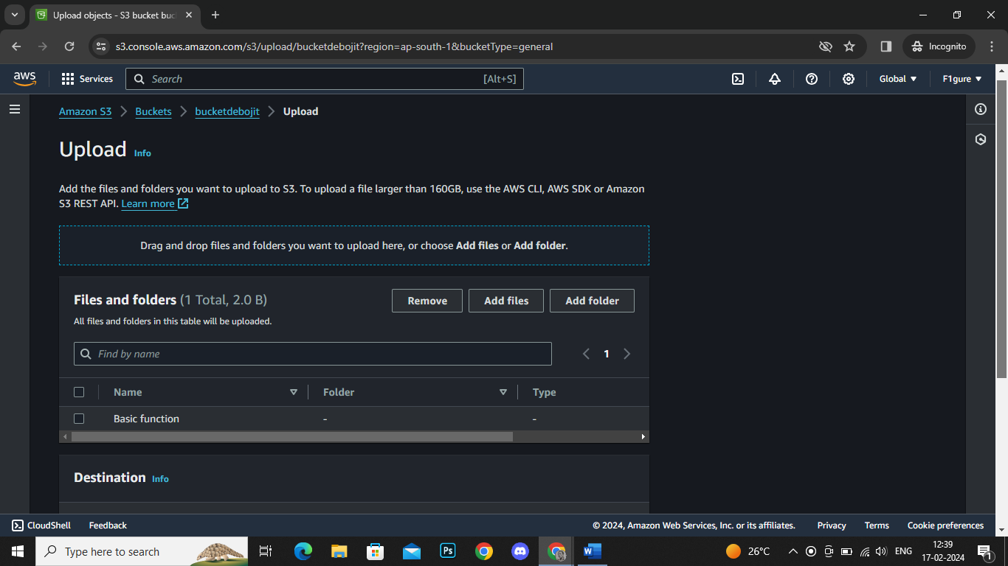

11. Scroll down and proceed to click on '**Upload'**.

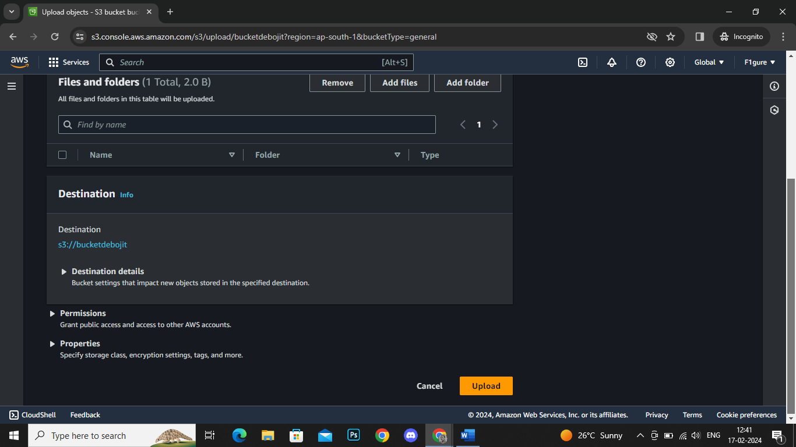

12. The notification confirms that the file has been successfully uploaded. Click on **'Close'** to return.

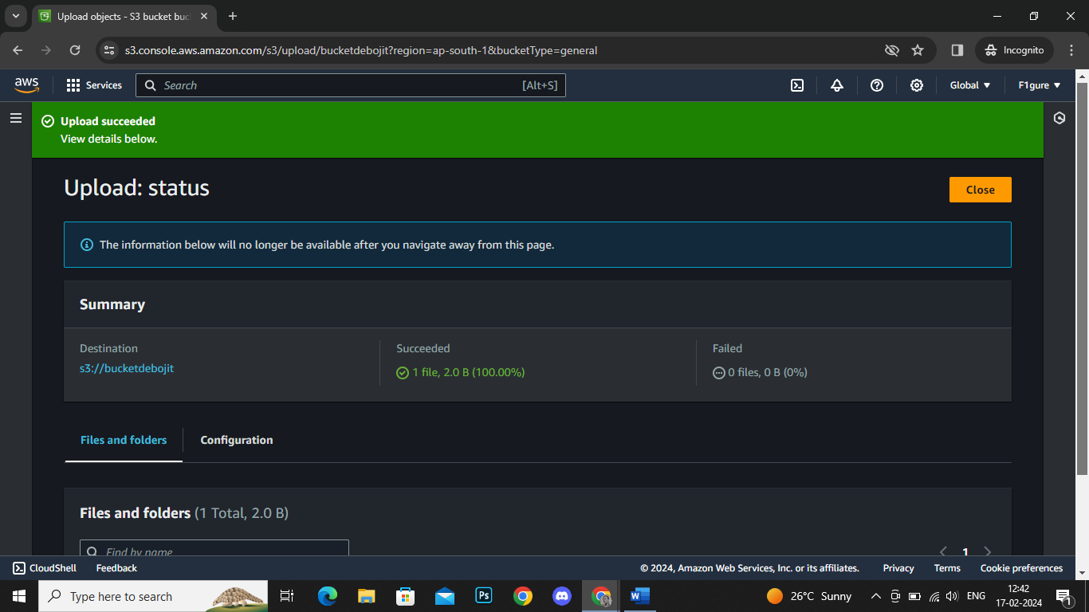

13. Now, select the checkbox next to the uploaded file, then click on **'Copy URL'**.

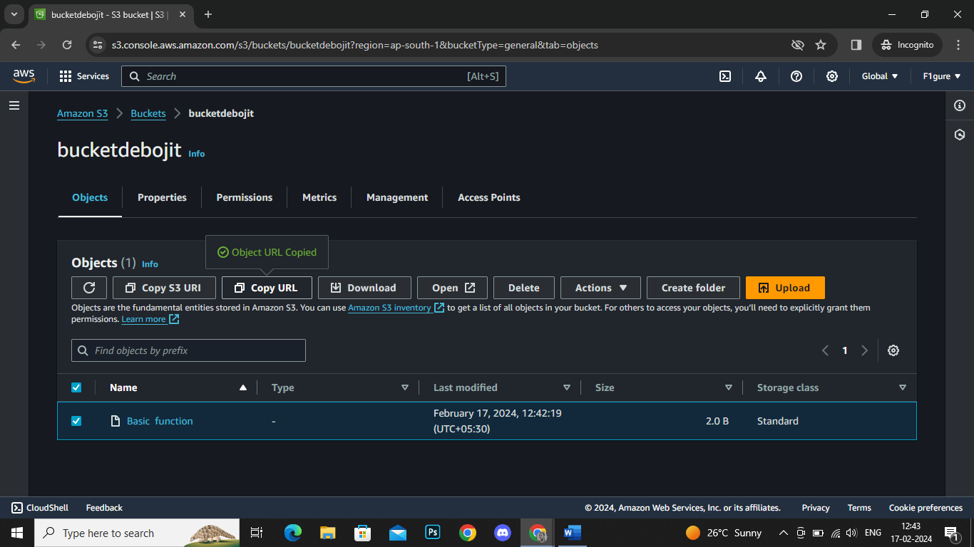

14. Navigate to a new window, paste the URL, and proceed with the search.

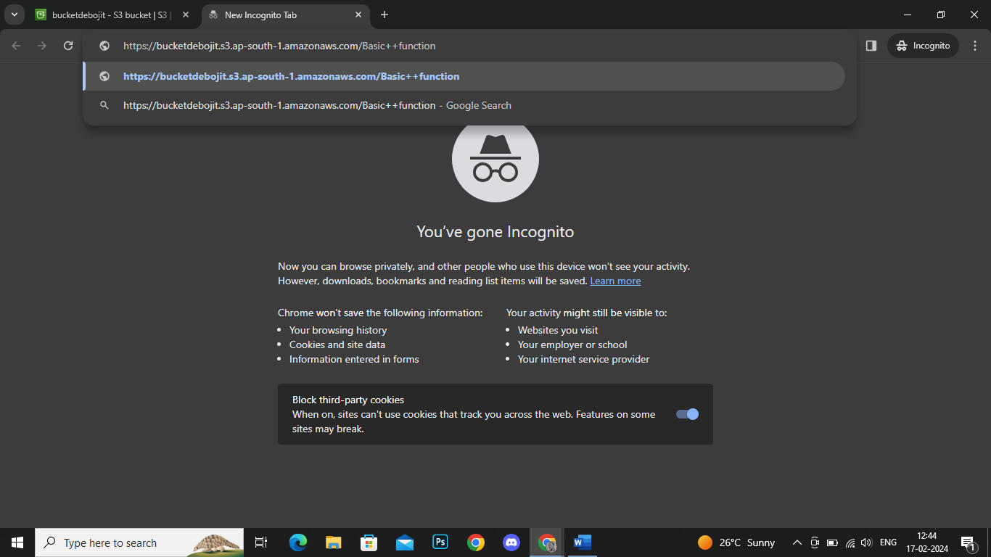

15. An error appears indicating that access to the contents is restricted.

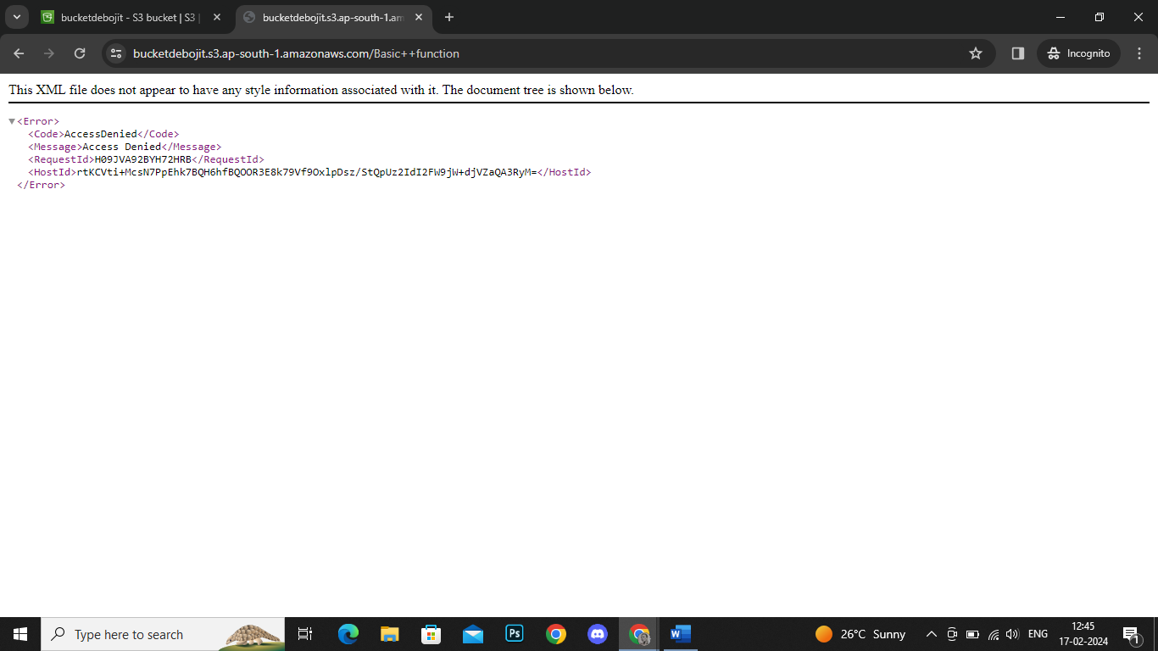

16. Close the current window, then proceed to upload a new file or folder as desired.

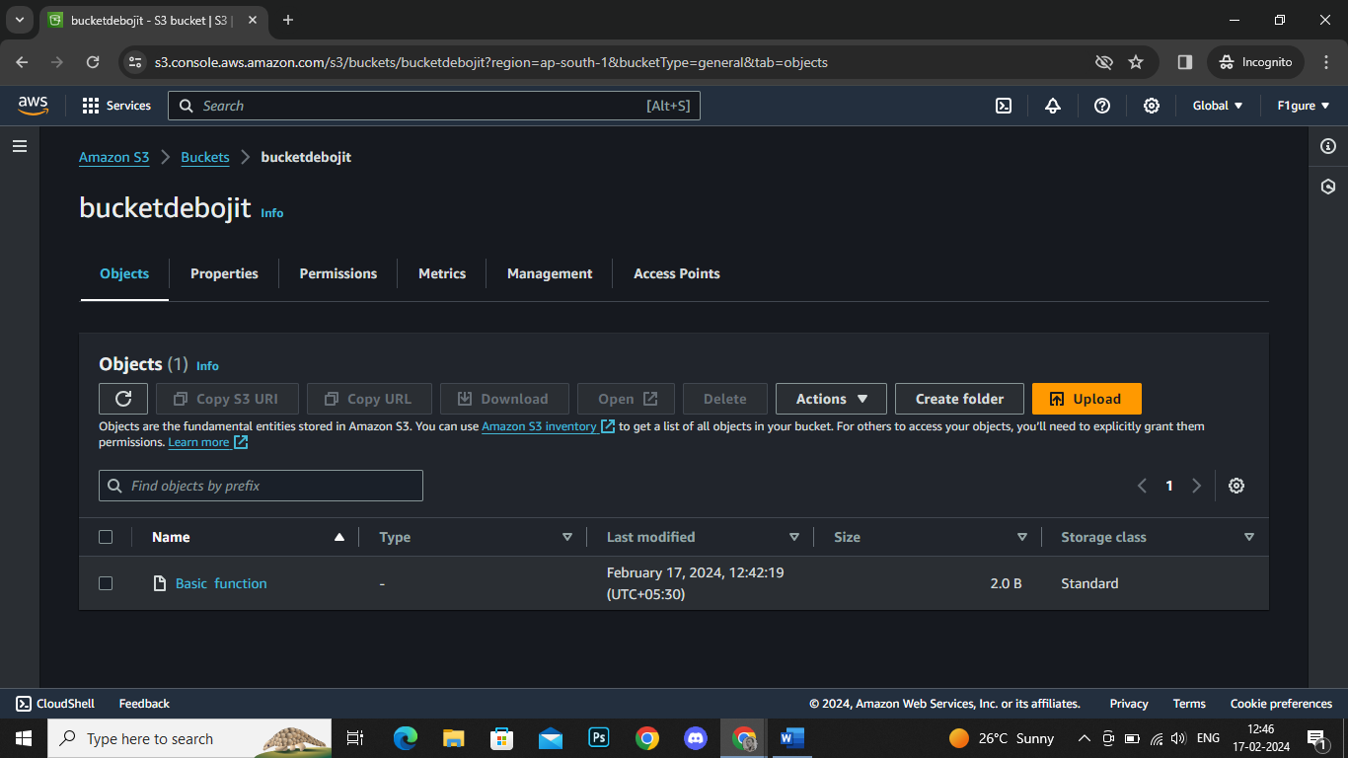

17. In this instance, a new file named printing.py has been uploaded.

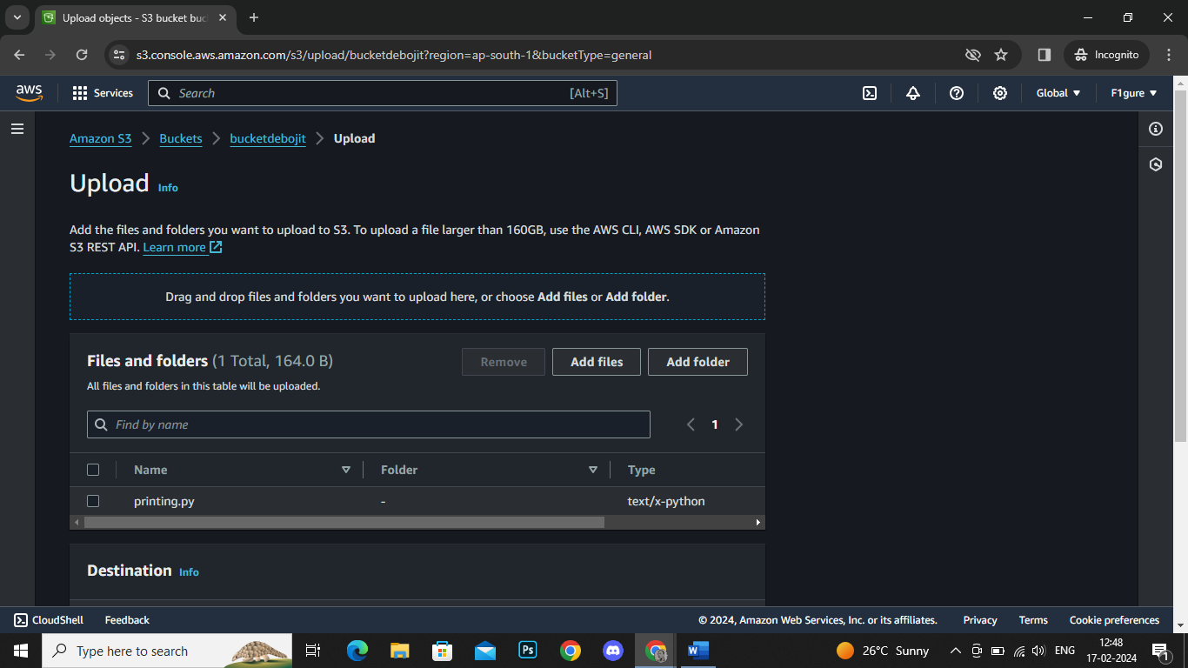

18. Next, scroll down and select the '**Permission'** option.

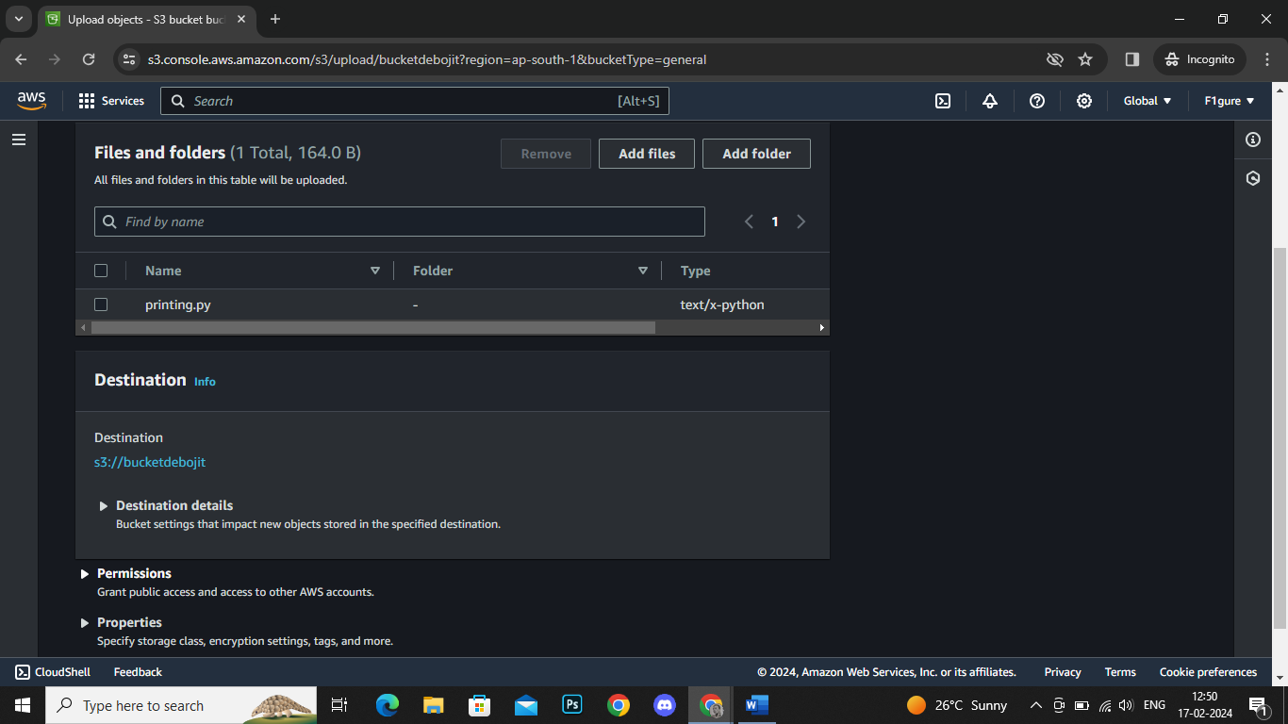

19. Modify the selection in **'Predefined ACLs'** to **'Grant public access'** to ensure the file is publicly accessible. Then, proceed to click on 'Upload'.

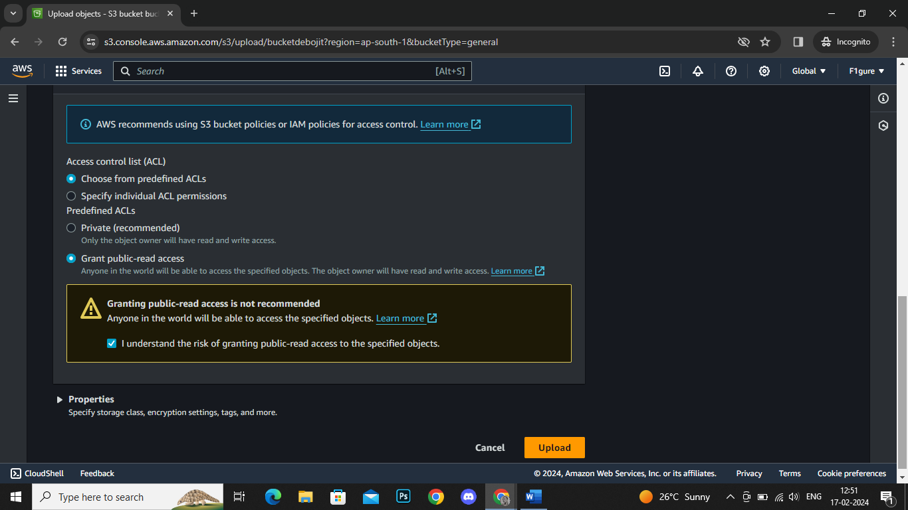

20. The notification confirms that the file has been successfully uploaded. Click on **'Close'** to return.

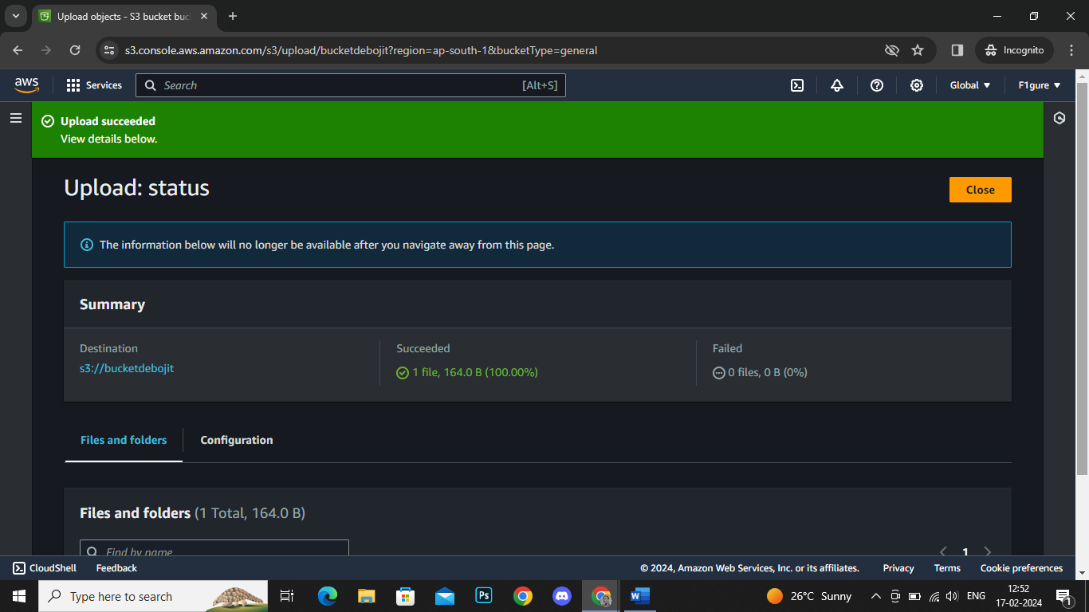

21. Now, choose the file that has been granted public access, then proceed to **'copy the URL'**.

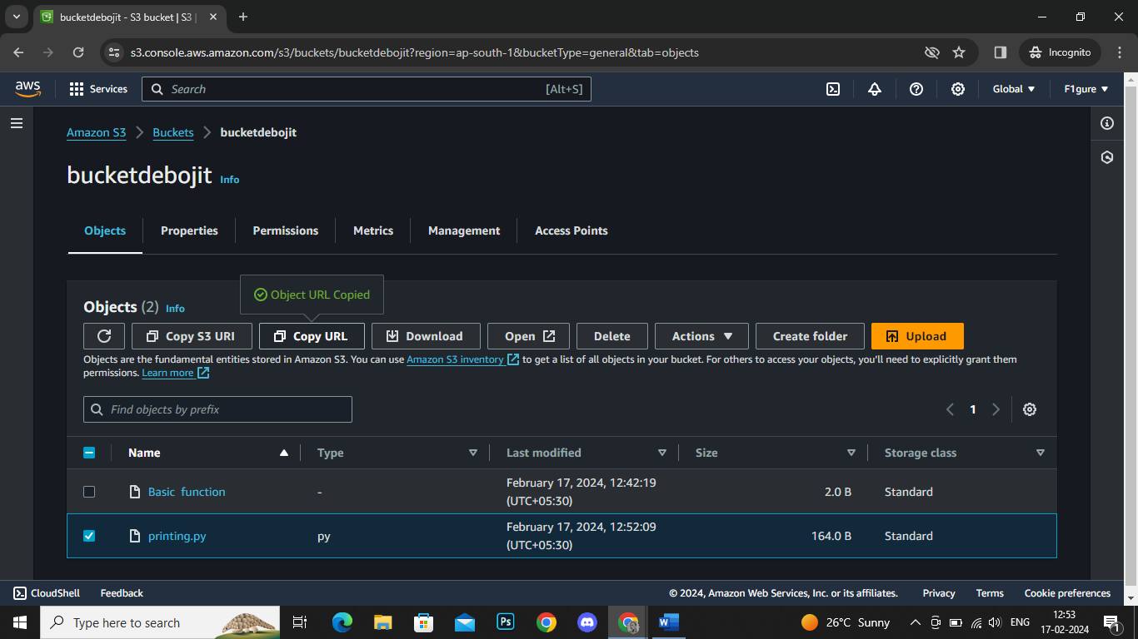

22. Open a new Chrome window, paste the URL, and proceed with the search.

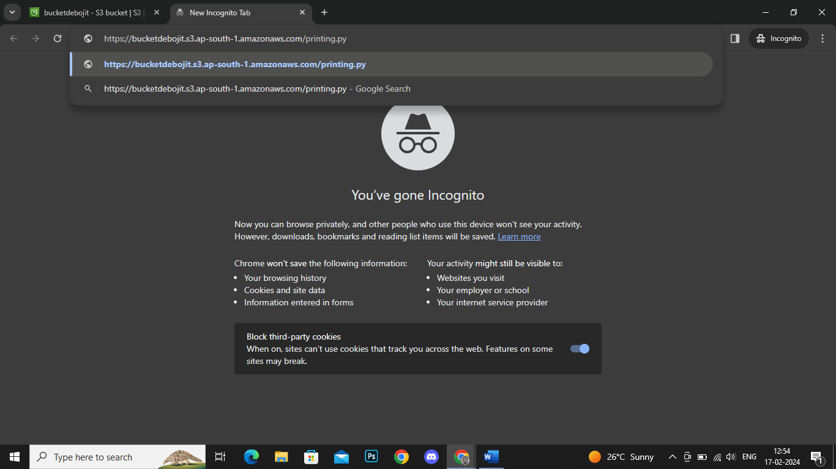

23. The uploaded file opens successfully.

