Exercise 03: Preparation of Irrigation Thematic Maps for Bangladesh

Introduction:
Bangladesh feeds itself through irrigation. Rain sustains the Aman season, but the dry Rabi season (November–March) runs almost entirely on artificial water supply — and how well each district manages that supply determines national food security.
This report examines irrigation across all 64 districts of Bangladesh using Rabi 2023–24 data from BADC, distributed by CEGIS. Five maps were prepared to answer five distinct questions: how much cultivated land is actually irrigated, how much relies on surface water, how much on groundwater, what power source drives the pumps, and how deep the groundwater table has fallen. Together these parameters capture not just current irrigation coverage but the condition of the resource base supporting it.
The key variables mapped are: Net Cultivated Area, Total Irrigated Area, Non-Irrigated Area, Surface Water Irrigated Area, Groundwater Irrigated Area, Electricity and Diesel powered irrigation areas, and Groundwater Level depth by upazila. All figures are in hectares except groundwater depth, which is in metres below ground level.
These maps are needed because aggregate national statistics hide sharp internal divides. A 72% national irrigation rate tells you very little about whether that water is sustainable, who has access to it, what it costs farmers to run, and which regions are being left behind. The district-level spatial view answers those questions in ways a table cannot.
What this report delivers is a ground-level picture of where Bangladesh's irrigation system is strong, where it is structurally limited, and where it is under quiet but measurable stress.

Data Preparation & Methodology:
Data Source: Irrigation data provided by CEGIS, originally prepared by BADC — the primary government body for agricultural statistics in Bangladesh.
Datasets:
- District_02 (Shapefile): 64 district polygons with DISTCODE, division name, and boundary geometry — but no irrigation data.
- Irrigation_03.xlsx: Tabular irrigation statistics for all 64 districts, containing area figures (in hectares) for total area, cultivated area, irrigated area, surface water, groundwater, electricity, and diesel-powered irrigation.
Coordinate System:
All maps use Bangladesh Transverse Mercator (BTM) — the national standard projection based on the Everest 1830 datum, centered on 90°E, with a scale factor of 0.9996. The GWL_2023 shapefile was originally in WGS 1984 (unprojected) and was assigned BTM using the Define Projection tool in ArcGIS Pro.
Data Join: Excel data was joined to the shapefile via Add Join using DISTCODE as the common key, linking irrigation statistics to district geometries for mapping.
Base Layers:
All maps include: District Boundary, Major Rivers, Sundarbans, Kaptai Lake, and Bay of Bengal.

Map 1 — Net Cultivated, Total Irrigated & Non-Irrigated Area
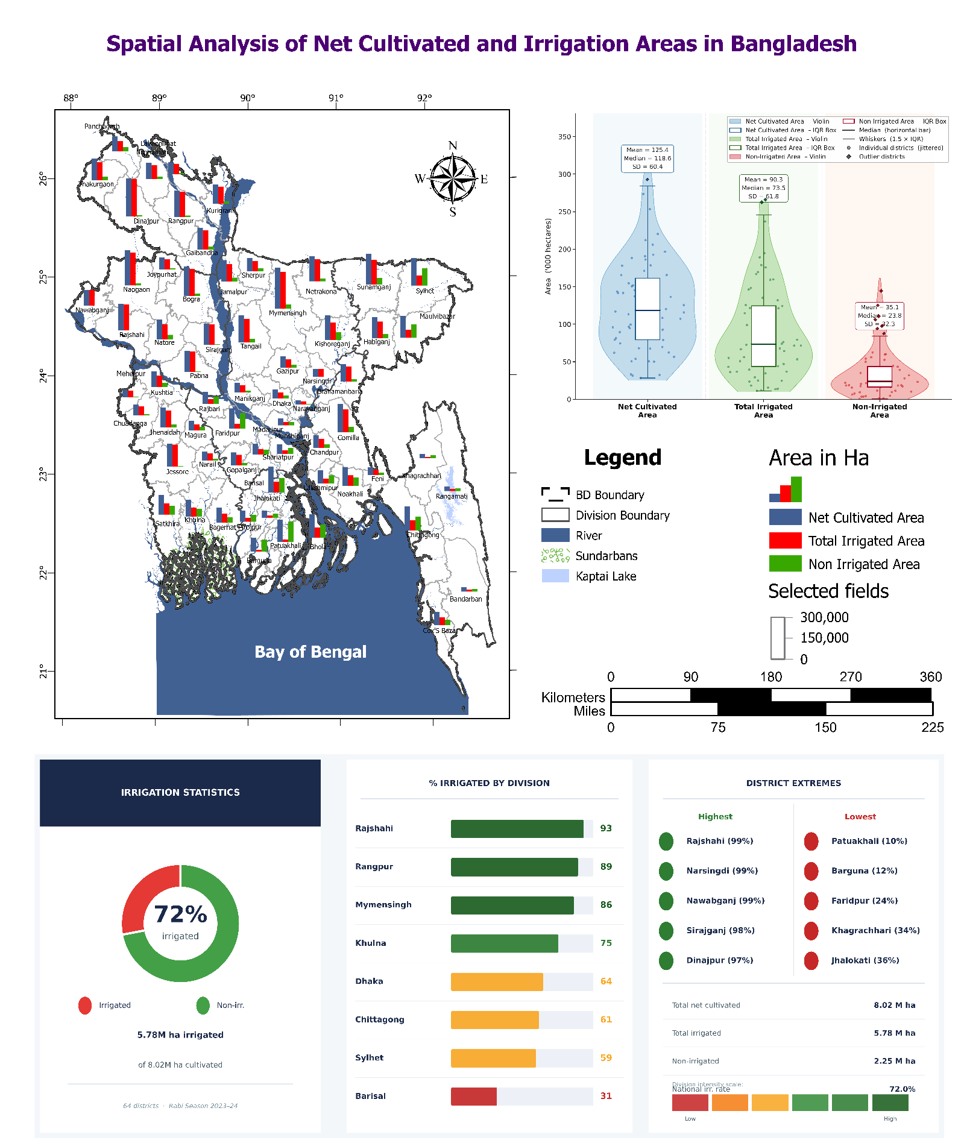
Methodology:
Bar chart symbology applied on district shapefile. Three fields selected: Net_Cultivated_Area (blue), Total_Irrigated_Area (red), Non_Irrigated_Area (green). Colors assigned manually. Statistical violin-box plot generated via Python.
Fig1: Spatial Analysis of Net Cultivated and Irrigation Areas in Bangladesh
Map Description:
Each district shows three side-by-side bars, allowing direct visual comparison of cultivated vs. irrigated vs. non-irrigated land. Northwest districts show tall red bars close to blue, meaning most cultivated land is irrigated. Southern and hill-tract districts show dominant green bars — large non-irrigated portions.
Key Observations & Findings:
- 72% of net cultivated area (8.02 M ha) is irrigated nationally — 5.78 M ha
- Rajshahi, Rangpur, and Mymensingh divisions lead with 93%, 89%, 86% irrigation rates
- Rajshahi, Narsingdi, Nawabganj individually reach 99% — near-complete irrigation coverage
- Barisal division is lowest at 31% — due to salinity, flooding, and tidal influence limiting irrigation infrastructure
- Hill tracts (Bandarban, Rangamati, Khagrachhari) also low — terrain restricts pump deployment
- 2.25 M ha remains non-irrigated, concentrated in coastal south and CHT — most drought-vulnerable during Rabi season
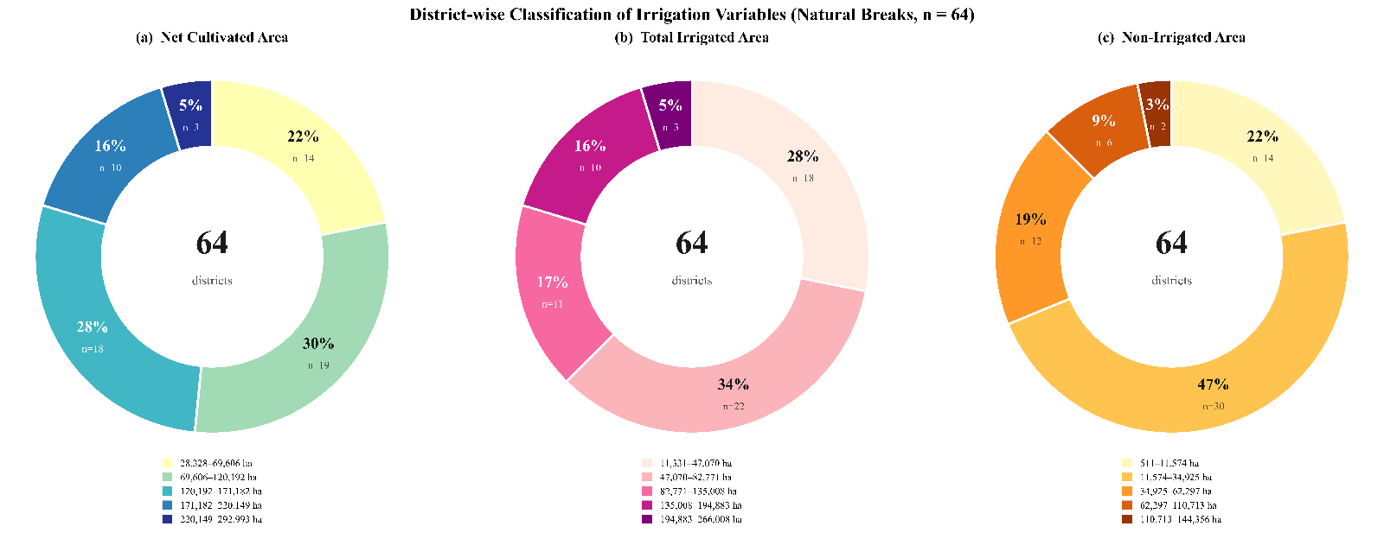
Fig2: District-wise Classification of Irrigation Variables

Findings:
- Most districts are small-to-medium cultivators — 52% fall in the bottom two NCA classes
- Irrigation is concentrated in few districts — 62% sit in lowest two irrigated classes, only 3 districts exceed 194,883 ha
- Non-irrigated area is actually low in most districts (47% under 11,574 ha) — but the outlier tail (coastal + hill tracts) drags the national gap open

The bar chart map showed where the pattern exists geographically. These donuts explain how the districts distribute statistically. Together they confirm: Bangladesh's irrigation coverage is genuinely high in the northwest due to flat terrain, shallow groundwater, and deep tube well density — but a structurally resistant tail of coastal-saline and hilly districts keeps the national non-irrigated area from falling further. The 72% national rate masks this internal divide sharply.

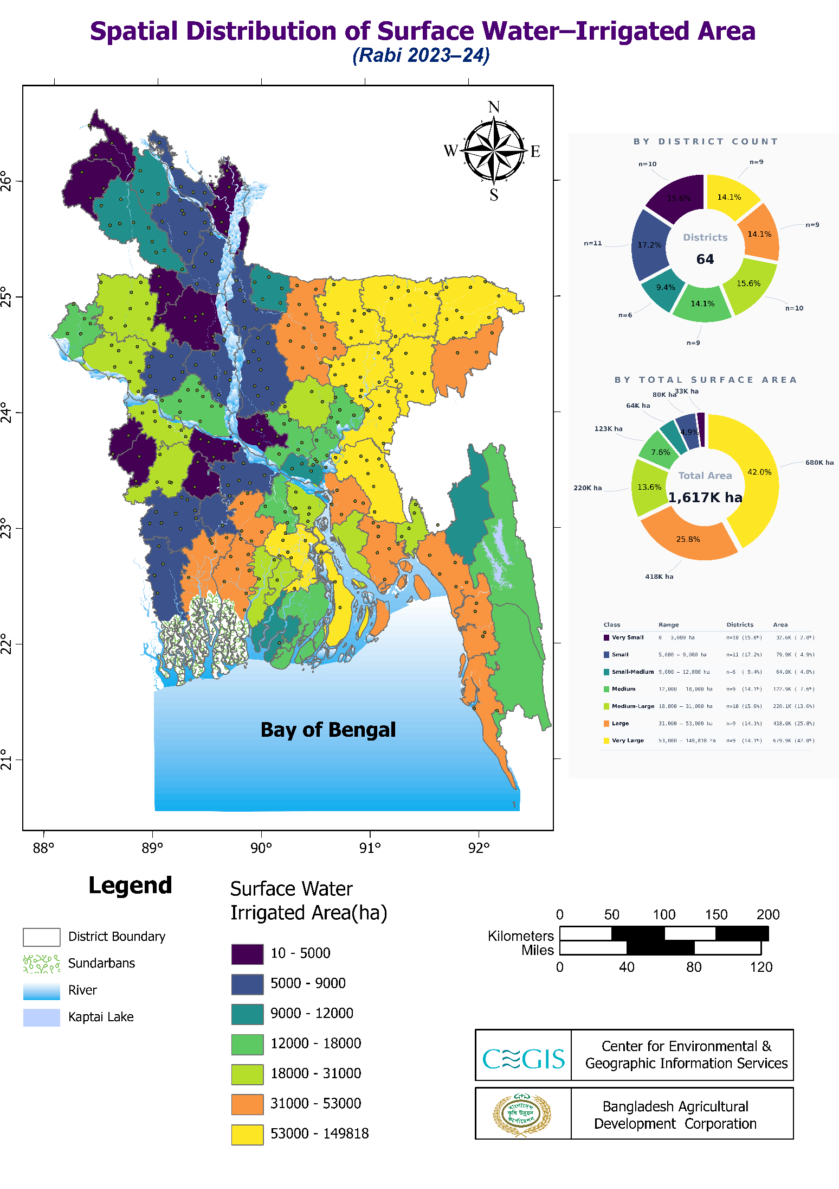
Map 2 — Surface Water Irrigated Area (Rabi 2023–24)
Fig3: Spatial Distribution of Surface Water-Irrigated Area
Methodology:
Choropleth map with 7 manual classes (equal-ish interval). Single field: SurfaceWater_Irrigated_Area. Colors range dark purple (lowest) to yellow (highest). District count and area share charts generated via Python.
Map Description:
Surface water irrigation — canals, rivers, low-lift pumps drawing from surface sources — mapped across 64 districts. Yellow and orange dominate the central-south (Sylhet, Sunamganj, Barisal belt) and parts of Chittagong. Northwest appears dark purple — low surface water use despite high overall irrigation, because groundwater dominates there.
Key Observations & Findings:
- Total surface water irrigated area: 1,617K ha nationally
- Top class (53,000–149,818 ha) holds only 9 districts but covers 42% (680K ha) of all surface-irrigated land — heavy concentration
- Sunamganj, Sylhet, Gopalganj, Barisal-belt districts are the largest users — these sit on active floodplains with perennial river access
- Northwest (Rajshahi, Rangpur) shows very low surface water use (dark purple, 10–5,000 ha) — not because less irrigation, but because groundwater via tube wells replaced surface sources decades ago
- Hill tracts also low — rivers are fast-flowing and uncontrolled, unsuitable for low-lift pumping
Surface water irrigation is a geography story. Where rivers are slow, wide, and seasonally full — the south and northeast — it works well. Where groundwater is shallow and reliable — the northwest — it was simply abandoned in favour of tube wells. The 1,617K ha total sounds large but is only 28% of total irrigated area, confirming groundwater's national dominance.

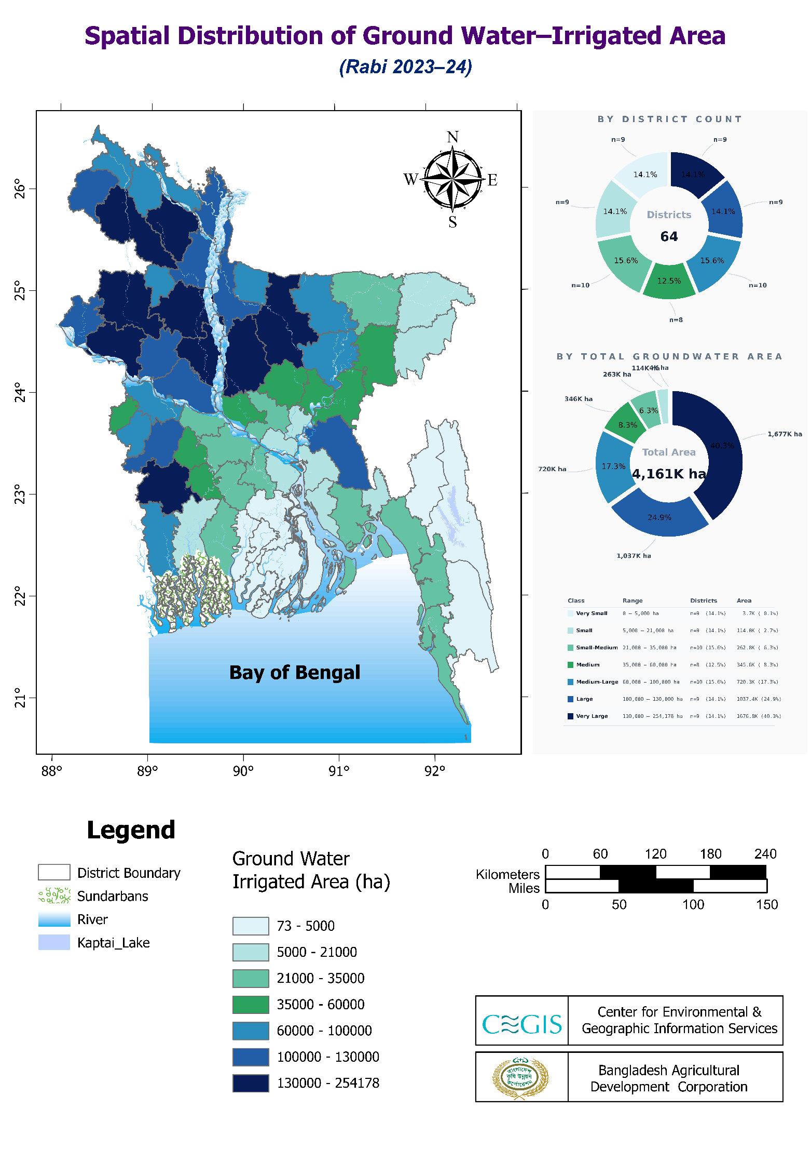
Map 3 — Groundwater Irrigated Area (Rabi 2023–24)
Fig4: Spatial Distribution of Ground Water-Irrigated Area
Methodology:
Choropleth, single field: Groundwater_Irrigated_Area. 7 classes, light-to-dark blue gradient. Python generated district count and area share donuts.
Map Description:
Dark blues dominate the northwest — Rajshahi, Rangpur, and Mymensingh divisions. South and southeast remain light — coastal and hill-tract districts. The contrast is sharper here than the surface water map, confirming groundwater is the primary driver of irrigation geography in Bangladesh.
Key Observations & Findings:
- Total groundwater irrigated area: 4,161K ha — nearly 2.6× surface water (1,617K ha)
- Top 9 districts (Very Large: 130,000–254,178 ha) cover 40.3% (1,677K ha) of all groundwater irrigation
- Bottom 9 districts (Very Small: 73–5,000 ha) contribute only 0.1% (3.7K ha) — effectively negligible
- Northwest concentration is structural: shallow water table (3–7m depth), flat alluvial plain, and decades of STW/DTW investment make extraction cheap and reliable
- Southern districts (Barisal, Khulna coast) show near-zero groundwater use — saline intrusion makes extracted water unsuitable for crops
- Hill tracts low for different reason — hard rock aquifers limit yield, and terrain blocks tube well deployment
Groundwater carries Bangladesh's irrigation system. At 4,161K ha it accounts for 72% of total irrigated area. But that dependence is geographically uneven — the northwest is built on it, while the south has almost none. This raises a long-term risk: the same northwest districts showing 99% irrigation rates are drawing the aquifer down annually, making groundwater zoning (Map 5) the most critical planning layer in this entire report.

Map 4 — Irrigation by Diesel & Electric Power (Rabi 2023–24)
Methodology:
Pie chart symbology per district. Two fields: Electricity_Area (green), Diesel_Area (red). Division-level bar chart and dominance donut generated via Python.
Map Description:
Each district shows a pie split between electric and diesel-powered irrigation. Red-dominant pies spread across south, southeast, and Sylhet. Green grows heavier moving northwest — Rajshahi stands out as the most electricity-reliant division.
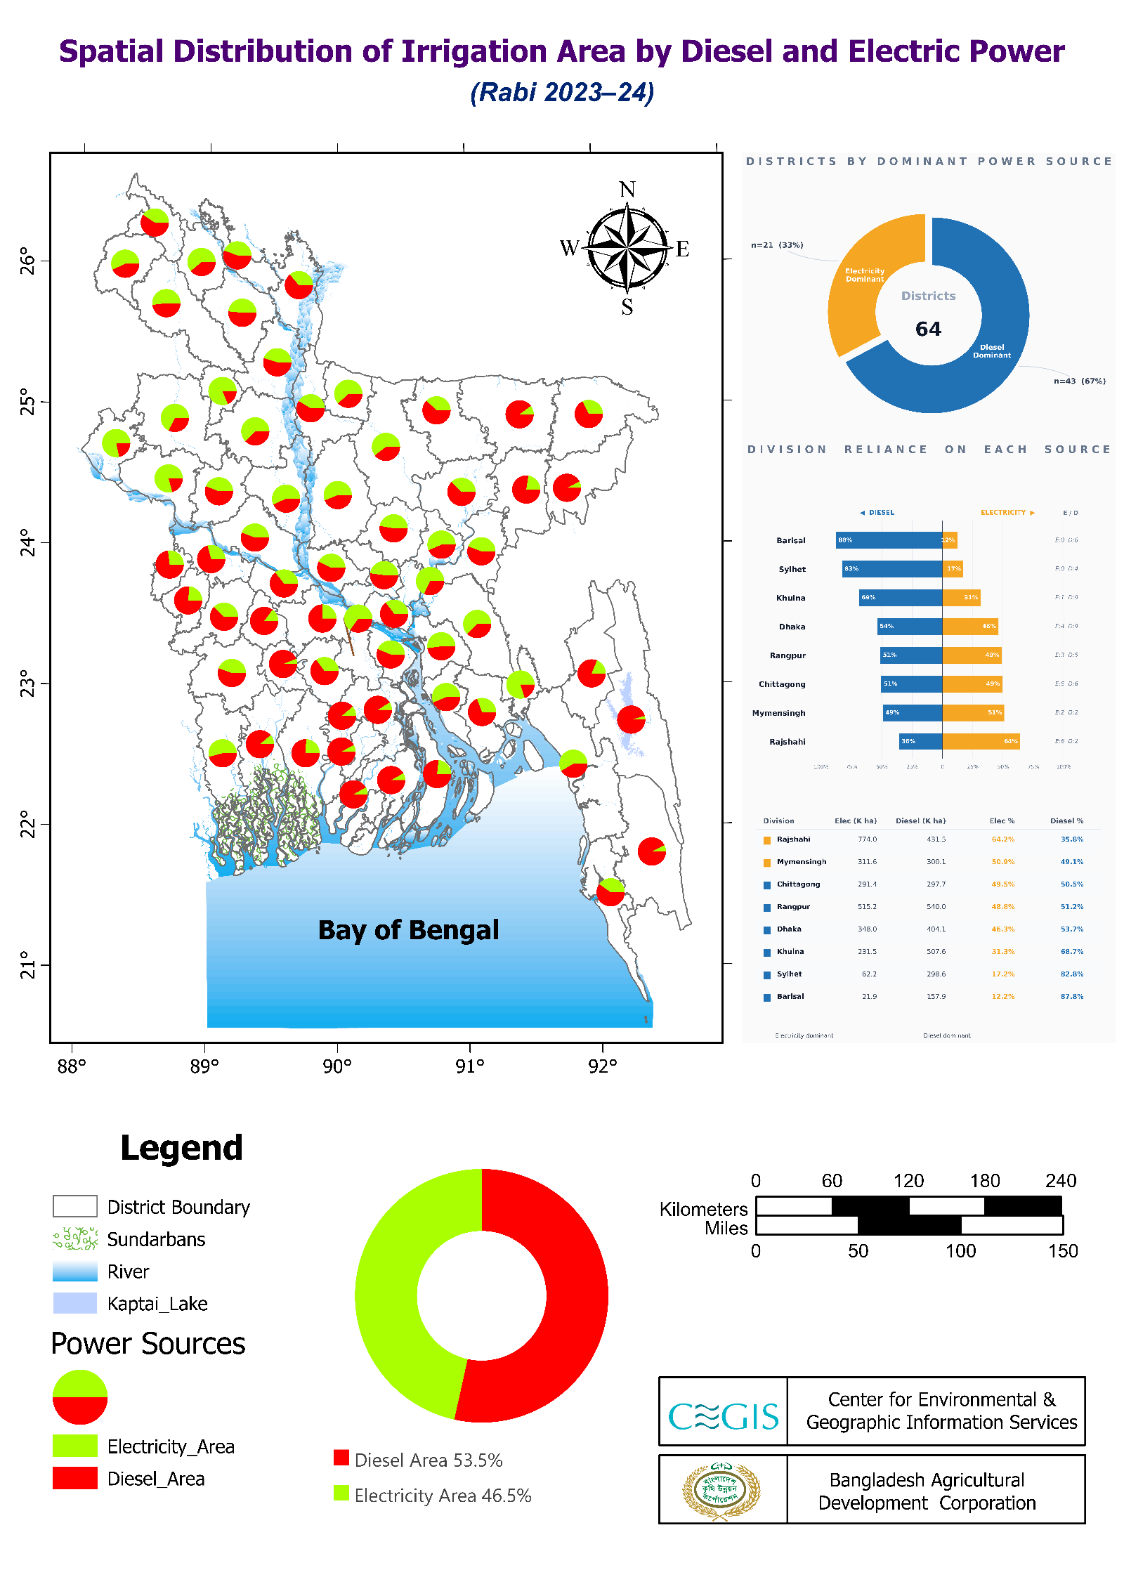
Fig5: Spatial Distribution of Irrigation Area by Diesel and Electric Power
Key Observations & Findings:
- Nationally: Diesel 53.5%, Electricity 46.5% — diesel still leads but narrowly
- 43 districts (67%) are diesel-dominant; only 21 (33%) are electricity-dominant
- Rajshahi leads electricity adoption — 64.2% electric, reflecting mature rural electrification and STW/DTW grid connections built over decades
- Mymensingh and Chittagong nearly balanced (~50/50)
- Barisal most diesel-dependent — 87.8% diesel, because grid connectivity in coastal chars and remote areas remains poor
- Sylhet 82.8% diesel — hilly terrain and dispersed settlement made grid extension costly
- Khulna 68.7% diesel — salinity-affected areas have fewer permanent pump installations
Diesel dominance in 67% of districts is an economic and environmental liability — diesel pumps cost more to run per hectare and emit more carbon than electric pumps. The northwest's shift toward electricity shows what's possible with grid investment. The south and southeast lag because infrastructure hasn't followed — not because electricity is unavailable nationally. Closing this gap would directly reduce irrigation costs for smallholder farmers.

Map 5 — Groundwater Depth Zoning
Methodology:
Source: GWL_2023 point shapefile (upazila-level groundwater level readings, 2023). Before interpolation, a Definition Query was applied to remove sampling points in Khagrachhari, Bandarban, and Rangamati — hill tract districts excluded due to hard-rock aquifer conditions incomparable to alluvial plains. These 3 districts were also removed from the district shapefile. Spatial interpolation performed using Kriging (Spatial Analyst Tool) — method: Ordinary Kriging, semivariogram model: Spherical. Output raster clipped to the remaining district boundary. Result classified into 4 zones per exercise specification: Safe <7.6m (green), Critical 7.61–11.3m (orange), Deep 11.31–20m (red), Very Deep >20.1m (dark brown). Statistical charts generated via Python across 362 upazilas.
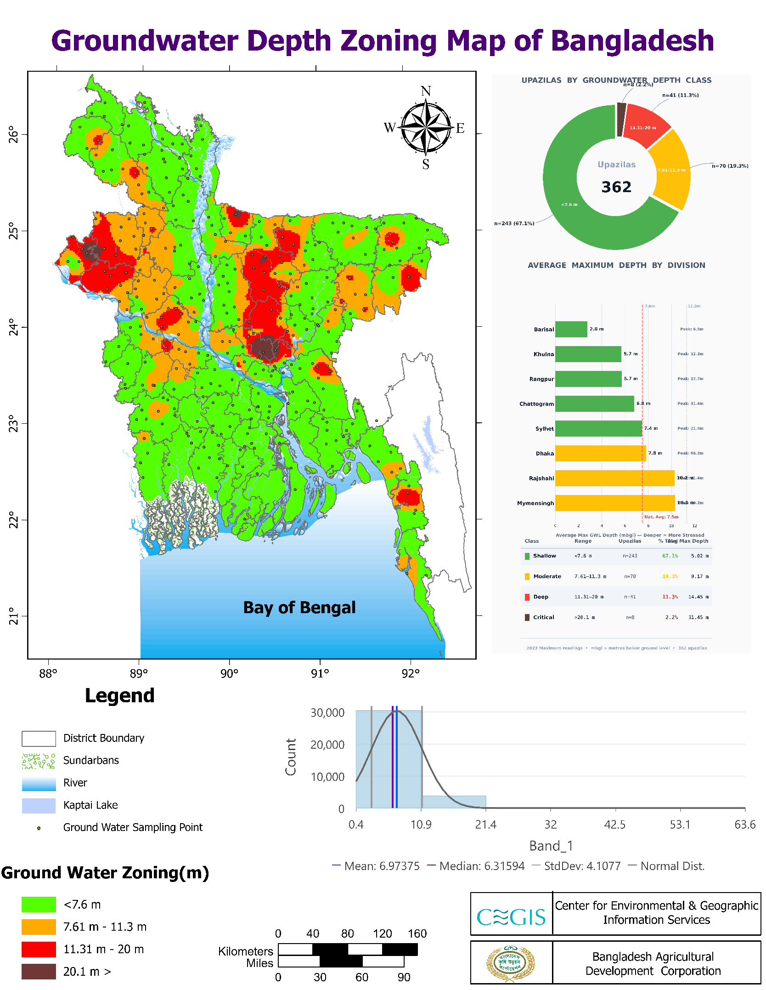
Fig6: Groundwater Depth Zoning Map of Bangladesh
Map Description:
Green dominates most of the country — majority of upazilas still have shallow, accessible groundwater. But red and orange cluster heavily in northwest Rajshahi, parts of Mymensingh, and scattered pockets in Dhaka division. These are exactly the districts identified in Maps 3 and 4 as the heaviest groundwater users.
Key Observations & Findings:
- 243 upazilas (67.1%) are in safe zone (<7.6m) — national average depth: 6.97m, median: 6.32m
- 70 upazilas (19.3%) moderate (7.61–11.3m, avg 9.17m)
- 41 upazilas (11.3%) deep (11.31–20m, avg 14.45m)
- 8 upazilas (2.2%) critical (>20.1m, avg 31.45m) — these are severe stress zones
- Rajshahi and Mymensingh average >10m — both already in moderate-to-deep territory as divisional averages, meaning individual hotspot upazilas are far worse
- Barisal lowest at 2.8m average — shallow table, but saline so unusable for irrigation
- SD of 4.1m with right-skewed histogram confirms most upazilas cluster shallow but a stressed tail pulls the mean up
Cross-referencing with Map 3 confirms the risk directly: the districts pumping the most groundwater (northwest) are the same ones showing deepest water tables. This is active aquifer depletion — not a future risk, a current one. The 8 critical upazilas at >20m average depth are early warning signals. Without extraction limits or recharge interventions, the northwest's 99% irrigation rate built on groundwater becomes its biggest vulnerability.

Conclusion:
Bangladesh irrigates 72% of its net cultivated land during Rabi season — an achievement almost entirely built on groundwater in the northwest. Rajshahi, Rangpur, and Mymensingh carry the system. The south sits at the opposite end, limited by salinity and terrain that tube wells cannot fix.
The groundwater zoning map is the most important layer in this report. The districts driving irrigation success are showing the deepest water tables — critical upazilas already at 20–31 metres. This is current depletion, not a future warning.
Diesel still powers 53.5% of irrigated area, costing farmers more per hectare, while Rajshahi's 64% electric share proves the transition is achievable with grid investment.
Three gaps need attention: surface water strategies for the 2.25 million non-irrigated hectares in the south; groundwater regulation in the northwest before extraction outruns recharge; and diesel-to-electric transition in the south and Sylhet. The system works — but its foundation is narrower than the 72% headline suggests.

